Chapter 1
- Key topics
- Importance of business communication
- Key trend in workplace
- Ethical communication
- Information flow and media choices
- Why business communication is important?
- Enhance critical thinking, problem solving and decision making
- Increased efficiency workflow and productivity
- Improved professional image, business relationship and team work
- Most important skills in Canada? (survey)
- Communication
- Writing
- Customer service and relationship
- Sales
- Organizational skills
- Microsoft office
- Communication in the current workplace
- Organizational change:
Flatter organization
Teamwork and collaborative environment
Business on a global scale
Diverse employee base
- Technological change:
Advancing communication technologies
Applications and social media
- Functions of business communication
- Inform
- Persuade
- Convey goodwill ( e.g. someone in a company congratulating employee for new baby born = goodwill)
- Communication flow and media choices
- Internal vs. External
Audience is within vs. outside organization
- Formal vs. Informal
Letters, memos, reports, proposals vs. “through the grapevine”
- Horizontal vs. Vertical
Super subordinate vs. same level

- Oral communication

- Written communication

Chapter 2

- Soft skills vs. Hard skill
- Soft: emotional intelligent ( communication, leadership skills)
- Hard: IQ skills ( comprehension skills, statistical analysis)
- Why form teams
- Perspective
- Different ideas
- Team development
Forming
Storming
Norming
Performing
- Be a team player not a hater
- Contribute information
- Show interest by listening (eye contact, paraphrasing)
- Encourage team members to participate
- Be on time (punctual)
- Non verbal communication
Eye contact
Smiling
Use their entire place
Posture
Be professional

Chapter 3

- Cross- culture communication
- Culture : shared customs and patterns of behaviour of a particular group of society
Language, rules, beliefs, social structures
- Ethnocentrism: belief that your culture is better than others
- Cross culture- competence: to be aware of many cultures
- National culture differences

- Low context vs. High- context cultures
- High context:
Relational
How you say it(e.g. Inshallak)
Collectivist
Intuitive
Contemplative

Japan, china, Saudi Arabia

- Low context:
Logical
Linear
What you say is what you mean (e.g. you guys will work hard
Individualism
Action- oriented

Canada, USA, Swiss, Germany

Chapter 4
- Key topics
- Communication process and barriers
- Audience analysis
- Writing process

- When writing in the business world ( effective business writing)
- Plain, direct, simple, specific, economical
- Identify your problem and tackle it
- Define audience (audience oriented)
- Define purpose ( purposeful)
- Word count as minimal as possible
- Use active voice
- Cut the unnecessary
- Include bullet points
- Use the right tone
- Proofread!

- The communication process
- 1) Encoding: sender sends the idea of the message
- 2) Decoding: receiver decodes the message (would probably also get feedback)
- Barriers to effective communication
- Bypassing: different meaning to the same word (e.g. probably, always, never, usually)
- Different frame of reference (e.g. everyone has a different frame)
- Lack of language skill: unfamiliar words, unrecognizable abbreviation
- Distractions: noise, mood, interruptions
- Physical and digital distractions (e.g. cell phones)
- Information overloaded (e.g. too much information in a small time frame)
- The 3x3 writing process

- Audience analysis and adaptation

- When is a team unity necessary?
When there’s a short deadline
When projects are big
When expertise is required
- “You” view
Remove words such as “us”, “we”, and “our”
(e.g.) To help you process your order, you need to fill out costumer information.
- Conversational yet professional
(e.g.) As you requested on April 1st, we are sending to your Oakdale office your item.
- Positive statements
Remove negative connotation
(e.g.) You need to fill in all the blanks for us to issue you a new password.
- Plain language and familiar words
(e.g. ) We are offering money that only managers compensate.
- Precise and vigorous
Make it more specific
(e.g.) management is predicting a drop in earning after the first of the year.

Chapter 5
- Research- How to find data?
- Interview
- Survey
- Observation
- Experiment
- Secondary sources, including (e.g.) E-Books, articles, etc.
- Organize
- Brainstorm
- Group ideas to show relationship
- Create an outline
- Sentence types of variety
- Simple: one independent clause
(e.g.) We love to eat.
- Compound: 2 independent clause
- Complex: dependant clause + 2 independent clause
- Writing techniques
Remember to:
- Stress important ideas
- Use active passive voice effectively
- Use parallelism (You do not repeat the subject. (e.g.) To improve your listening skills you should stop talking, control your surroundings, listen to main points and keep, and open mind.)
Avoid:
- Dangling and misplaced modifiers
- Fragments and run-on sentences
- Effective paragraphs
- Single topic sentence (main idea)
- Direct vs. Pivoting vs. Indirect paragraphs: purpose of each one?
- Paragraph coherence- linking techniques (e.g.) transitional expressions
- Short paragraphs
- Active vs. Passive voice
- Active : has a subject
(e.g.) Sarita invited everyone to a pool party.
- Passive: remove subject
(e.g.) A pool party was being placed.

Chapter 6
- Edit for consciousness
- Lighten the message
- Eliminate flabby expressions ( trim the fact)
- Limit long lead-ins
- Drop unnecessary there is/ there are and it is/ it was words
- Reject redundancies (repetition)
- Remove empty words
- Write concisely
- Edit for clarity
-keep it short and simple
- drop cliché, slangs
- Rescue buried verbs
- Use familiar words
- “In lieu of” = instead of
- “FYI” = for your information
- “job pays peanuts”= pays too little
- Edit for readability
Have headings and sub-headings
Bullet listed information
- Proofread
- Print copy
- Take a break to clear your mind before tackling it
- Read slowly, word for word, consider reading aloud
- Check: names , facts, figures, numbering, formatting, grammar, punctuation

Chapter 7

- Memo and Email formatting
- Cloud Computing
Store and access data with software applications and remote networks
- Why people complain about emails?
- Confusing
- Poorly written emails
- No distinction between work and personal emails
- Leaves trails (proof)
- Why is email appropriate?
- Short, informal messages
- Messages sent to multiple receivers
- Attachments
** Not a substitute for face-to-face communication**
- Professional email
Subject line
Greeting
Organized body, readability and tone
Close effectively (action statement, due dates and request)
- Interoffice memo
- Too long for emails
- Require permanent record
- Demand formality
- Inform employees that don’t have emails
- **use for complex internal messages**
Require: 1)heading, 2) bullet list, 3) enumerated items
- Public free instant messages (IM)
- AOL instant messages
- Google talk
- Windows live messages
- Yahoo
- Instant messages (IM)

- Low cost substitute for voice call
- Notify from bank accounts

- Distraction
- Company records
- Reveal privileged information
- Legal liability

** be careful what you send! No sensitive information (pictures, videos), follow company’s policy, don’t text and drive, know when to say goodbye!**
- Security
- Phishing
- Viruses
- Malware
- Spams

- Podcasts and webcasts
- Podcasts
TV show and radio
Youtube and videos
Avoid costly telecommunication
- Wikis
Create doc, access doc, modify doc
4 types:
- Global wikis
- Knowledge based wikis
- Meeting wikis
- Project management wikis
- Blogs
Inform
Interact
Get feedback
- Identify audience,
- Choose hostile site
- Pick keywords
- Blog often
- Monitor traffic
- Safe social networking guidelines
- Establish boundaries (don’t share individual’s information)
- Distrust privacy settings
- Ask before tagging someone
- Beware of friend request (and who you accept)
- Expect unexpected
Chapter 9
- Negative messages
- Policy changes not benefitting: rejections, refusal
- Disciplinary notices: poor performance appraisals
- Product recalls: insulting intrusive requests
- 3x3 writing process
- Analysis
- Anticipate
- Reduce pain
- Legal liability
- Abusive language
- Defamation: harmful language that ruins someone’s reputation
- Libel: written defamation
- Slander: spoken defamation
- Careless language
- Damaging
- Misinterpreted
- Good- Guy Syndrome
Statements that ease your consciousness and make you look good
- Indirect strategy

**Apologizing:
- Recognize: acknowledge the offence
- Responsibility: take responsibility for offence
- Remorse: “I apologize for...”
- Restitution: explain what you will do about it
-repeating: promise it will not happen again **

- Types of negative news
- Indirect organizations
- Reject request
- Decline invitations
- Rate increase
- Denying claims
- Direct organizations
- Bad news within organization
(e.g.) refusing request, bad news to employee
- Buffer
(e.g.) Providing free cell report with warrantee phone, will add greatly to the price of our phones.
- Provide reasons
- Deliver bad news
- Alternatives
- Close positively

Chapter 10

- Persuasive and Sales messages
- Persuasion
- Influence
- Transmit message
- Require free choice
- Subtle and misleading
- Complex and impersonal
- 3x3 writing process
1)Analyse purpose
2)Adapt messages to audience
3)persuasive data
4)Use AIDA (attention, interest desire and action)
- AIDA

- Avoid “double speak”
- Don’t manipulate and use twisted words
- Persuasive claims
- How will you resolve the problem?
- Explain what happened and why the claim is legitimate?
- Support claim
- State what you have done
- Sales messages
- Pre-write
- Gain attention
- Build interest
- Rational and emotional appeals
- Reduce resistance
- E-mails Sales messages
- Write a catchy subject line
- Short, conversational and focused message
- Include answers to the 5W (Where?What?When?Why?Who?)
Chapter 11
- E-mail format
- “ Subject”: concise, clear subject line
- “REQ”: reminds receiver that a response is required
- Open with “receiver’s name” and “greeting” to express friendliness and mark beginning of message
- Use “bullet points” to improve readiness
- Close with “full contact information”
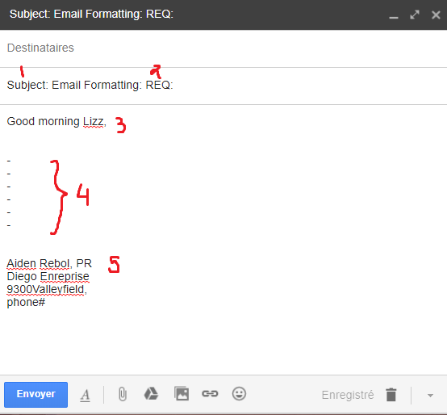
- Memo formatting
- Allign all headings and words with those following subjects:
- Date:
- To:
- From :
- Subject:
- leave “side margins to 3.2cm”
- include initials after printed name and title
- headings, colomns, bold and white space to hghlight information
- ommit closing
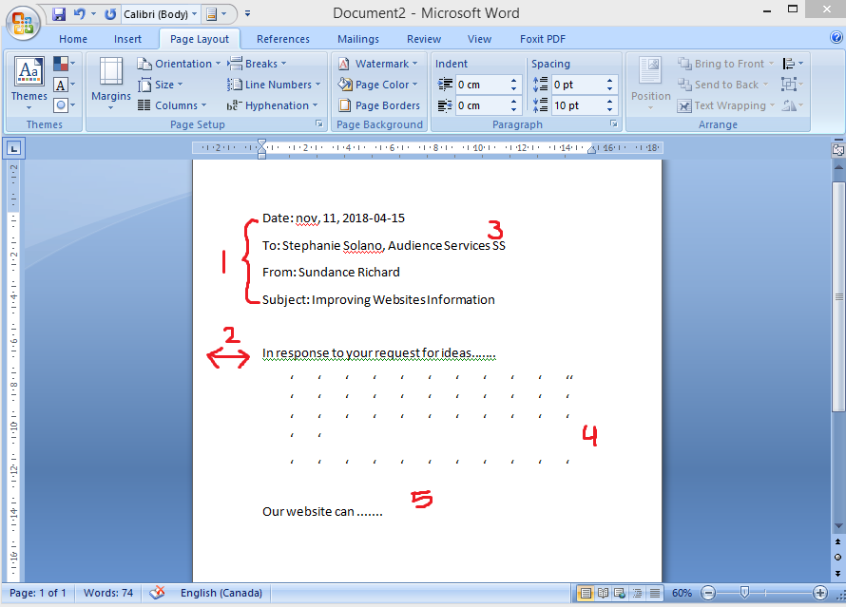

Key words
- Limitation: boundaries or the work
- Scope: what your trying to achieve
- Significance: importance of the project (will it save money? Will it save time?)
- Purpose: the purpose of the study (similar to scope)

