ELG2336: Lab 2
Oscilloscope and Function Generator

Professor: Riadh Habash

Group member:
Nan Shi

- Objective:
The objective of this experiment was to understand the fundamental concepts of a capacitor in the AC circuit.

- Introduction
The goal of this lab is to introduce the oscilloscope and the function generator, the oscilloscope is a measuring instrument and the function generator is a signal source. A series RC circuit include a resistor and a capacitor was conducted to analyze the effects on voltage by alternating frequency of the function generator from 1KHz to 10KHz. Measured experimental values then compared with theoretical values simulated in Multisim. Graphs of Vo against frequency and phases against frequency were. We concluded that the phase difference between Vo and the source is proportional to the frequency while the voltage on capacitor is negatively correlated to the frequency.

- Equipments:
- Oscilloscope
- Function generator
- 46000 Ω resistors
- 0.47pf capacitor
- Breadboard
- Coaxial cables with BNC (Bayonet Neill–Concelman) connector

- Procedure:
- Set the oscilloscope, turn on the power switch, then apply coaxial cable to channel 1. Next, select auto Scale, which quickly display any analog or digital active signals. Next, press the measurement key. Then rotating the entry knob to enable the selection.
- Set up the function generator to produce a 1 kHz sine wave. First, turn the device on and attach the coaxial cable to BNC connector. Second, press the Parameter button to change the parameters of a signal such as frequency, amplitude, and phase of a signal. Third, Press the Channel button, the signal is ready for the output. Finally, press the button 5, the signal will be generated at the output as shown in Figure 1
- Connect the alligator clip of the black lead from the function generator to the alligator clip of the black lead from the oscilloscope and do the same with the red leads.
- Implement the following circuit (Figure 2) to measure VR and VS and then calculate IC. Use 46Kohm resistor and 0.47pf capacitor. Change the Frequencies from 1Khz to 10Khz and read the data of Pk-Pk(2) and Phase(1→2).

- Lab data
Frequencies | 1Khz | 2Khz | 4Khz | 6Khz | 8Khz | 10Khz
Vo | 1.13V | 2.13V | 3.9V | 5.1V | 5.9V | 6.5V
Phase Diff.  (Vo and Vs) | -80.04︒ | -72.53︒ | -59.22︒ | -49.28︒ | -40.71︒ | -34.21︒

- Calculation
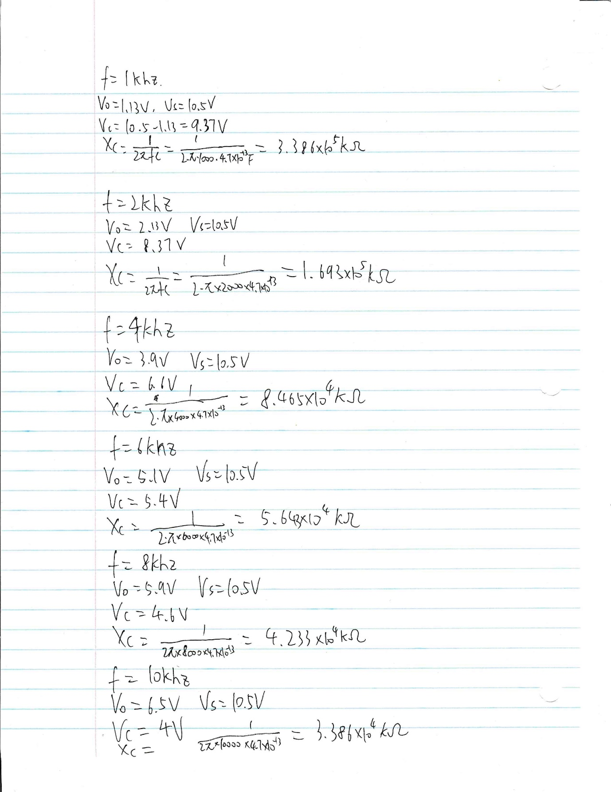
- Discussion
- In the prelab, I used 1Kohm resistor and 330nf capacitor to do the simulation, however in the lab, this combination cannot get the difference of Vo with change the frequencies.
- With the increase of the frequencies of Vs, Vo is increase while the absolute value of the phase difference is decrease.
- The situation happened because the Capacitive resistance decrease while the frequency increase, therefore the voltage of resistor become larger.
- The phase angle of current and voltage in capacitor is 90︒, the impedance of circuit according to formula of Z=R+iXc, Z=4600+1/(2*pi*f*C)
- Conclusion
The experiment shows that the simulation performed in NI Multisim software does not match with the values measured in the breadboard circuit, so we change the resistor and capacitor until we have the desired result. The function generator produces waveforms as the analogic voltage sources. Overall, during the frequency permutation it was observed that as more the frequency increases, the lower the voltage of capacitor decreases, so setting consequently an inverse proportion.

