Chapter 1 Knowledge of Law as a Business Asset
- Knowledge of the law is a business asset that can assist owners and managers in reaching their goals and objectives.
- Business law: a set of established rules governing commercial relationships, including the enforcement of rights.
  - Defines general rules of commerce
  - Protects business ideas and more tangible forms of property
  - Provides mechanisms that permit businesspeople to select their desired degree of participation and exposure to risk in business ventures
  - Seeks to ensure that losses are borne by those who are responsible for them.
  - Facilitates planning by ensuring compliance with commitments.
- Law is a set of rules and principles intended to guide conduct in society, primarily by protecting persons and their property, facilitating personal and commercial interactions, and providing mechanisms for dispute resolution.
  - Protecting persons and their property:
    - The law protects members of society in two ways:
      - It sets rules with penalties in order to encourage compliance
      - It seeks to hole those who break the law accountable for their misconducts.
    - The law also protects businesses by setting penalties and ensuring accountability.
    - Breach of contract: failure to comply with a contractual promise.
    - Age of majority 法定成年年龄: the age at which a person becomes an adult for legal purposes. In Canada, this ranges from 18 to 19 years of age, depending on the province.
  - Facilitating personal and commercial interactions:
    - by providing rules concerning marriage, adoption, and the disposal of property upon the owner’s death, to name a few examples.
    - By providing rules governing the marketplace.
    - The law of contract合同法, e.g., provides a way for parties to enter into binding agreement, thereby creating a measure of security and certainty in their business operations.
    - Contract law allows business enterprises to plan for the future and to enforce their expectations.
    - Litigation: the process involved when one person sues another
  - Providing Mechanisms for dispute resolution:
    - the legal system offers mediation and arbitration as ways of avoiding litigation. Thus, the law provides a number of mechanisms for settling disputes short of a courtroom battle.
    - Mediation: a process through which the parties to dispute endeavor to reach a resolution with the assistance of a neutral person
    - Arbitration: a process through which a neutral party makes a decision (usually binding) that resolves a dispute.
    - Liability: legal responsibility for the event has occurred.
- Legal risk management plan: to identify the legal risks associated with a business and implementing concrete measures for managing those risks. The objective is to identify and plan for risks before they occur.

Chapter 2 The Canadian Legal System
- The Canadian legal system is the machinery that comprises and regulates government.
- The Canadian Constitution宪法:
the written elements of Constitution include the:
  - Constitution Act, 1867: part of which divides legislative power between the federal and provincial governenments.
  - Canadian Charter of Rights and Freedoms: identifies the rights and freedoms that are guaranteed in Canada
  - Relevant decisions by judges concerning constitutional law
Constitutional conventions: Important rules that are not enforceable by a court of law but that practically determine how a given power is exercised by government.

The Canadian Constitution provides for the three branches of government:
- The Legislative Branch of Government: Creates a form of law known as statute law or legislation. Statute law e.g., the Criminal Code of Canada, which prohibits a variety of offences, such as assault, theft, and fraud.
Three levels of government: the federal, provincial, and municipal levels- make legislation in Canada.
Parliament, the federal legislative branch, is composed of the House of Commons and the Senate.
Municipalities: which are created by provincial legislation, have legislative bodie often called city council.
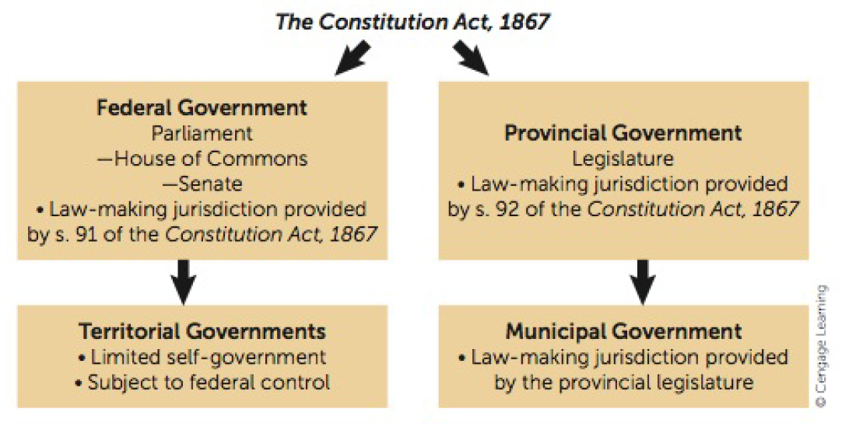

- The Executive Branch of Government: has formal, ceremonial function, as well as a political one.
The executive branch supplies the head of the Canadian state, the Queen.
Formal executive: the branch of government responsible for the ceremonial features of government.
Political executive: the branch of government responsible for day-to-day operations, including formulating policy, as well as administering all departments of government.
- The Judicial Branch of Government: the judiciary is composed of judges who are appointed by both federal and provincial government.
Courts Dealing with Commercial Disputes:
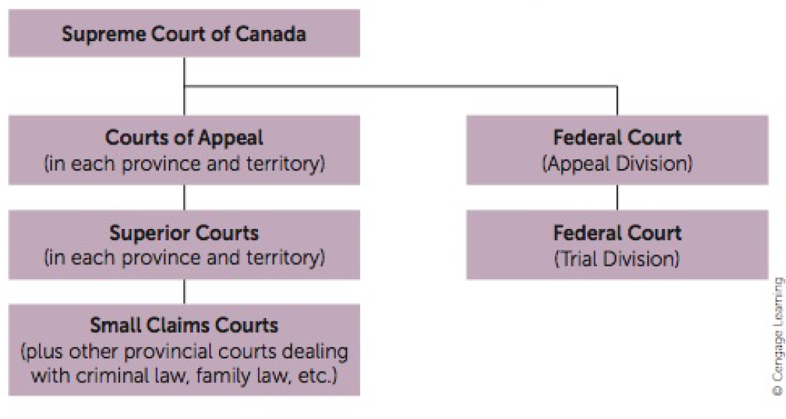

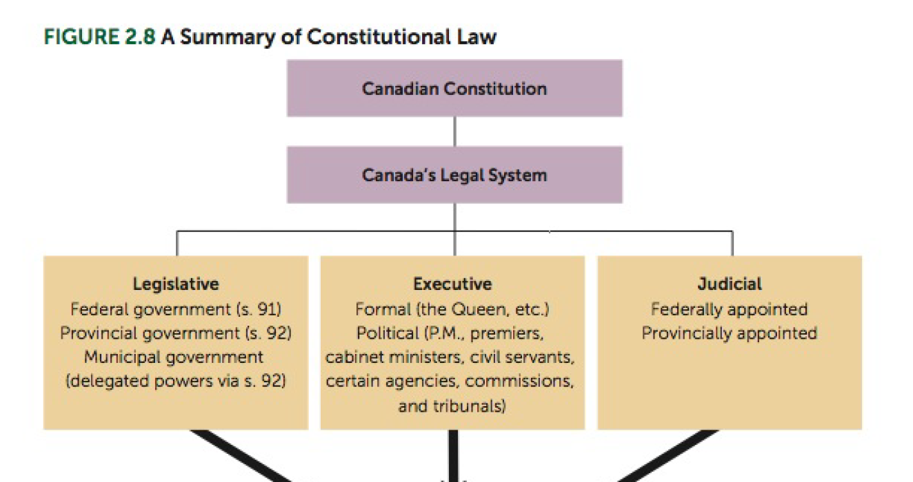

Supreme Court of Canada: the final court for appeals in the country.
Federal Court of Canada: the court that deals with some types of litigation involving the federal government.

The Canadian Charter of Rights and Freedoms: a guarantee of specific rights and freedoms enshrined in the Constitution and enforceable by the judiciary.
Charter of Rights: defines our society into fundamental elements.
- Examples of Charter protections:
  - The right to freedom of expression and of religion
  - The right to a fair and speedy trail
  - Equality rights
  - The right to vote
Rule of law:
- Everyone is equal
- All subject to the law
Fundamental Freedoms:
- Freedom of conscience and religion;
- Freedom of thought, belief, opinion and expression
- Freedom of peaceful assembly
- Freedom of association
Democratic rights:
- Right to vote (have to be a citizen)
Mobility rights:
- Right to enter and leave Canada to earn a livelihood (have to have 6 months’ residency)
Legal rights:
- Life, liberty, security
Equality Rights:
- Every individual is equal before and under the law and has the right to the equal protection.

Chapter 4 Dispute Resolution
Alternative dispute Resolution:
- Negotiation: is a problem-solving process in which parties discuss their differences and attempt to reach a mutually agreeable resolution.
- Mediations: whereby a neutral person, called mediator, assists the parties in reaching a settlement of their dispute. Usually used it family disputes and divorce issues, and commercial disputes
- Arbitration: a method for resolving a dispute whereby a third person, called an arbitrator, appointed by the parties makes a decision. (commercial and business disputes)
- The Litigation Process (Judgement by the Court): the plaintiff or claimant sue the defendant. Litigation should be deployed only when all other feasible methods have failed and the claim cannot realistically be abandoned.
- The legal foundation and outcome of a lawsuit are governed by legal rules contained in common law and statute law.
Four stages of a lawsuit: in superior courts, a lawsuit that goes through the full court process comprises four stages
- Pleadings: the formal documents concerning the basis for a lawsuit
- Discovery: the process of disclosing evidence to support the claims in a lawsuit
- Trial and decision: trail: a formal hearing before a judge that results in a binding decision. And decision: the judgment of the court that specifies which party is successful and why.
- Enforcement: the winner of the suit must enforce the judgment with the assistance of the court.
Appeals
Appeal: the process of arguing to higher court that a court decision is wrong
Appeal courts tend to confirm trial decisions unless serious errors have been demonstrated.
After the court of appeal rules, the unsuccessful party can consider a further appeal to the Supreme Court of Canada.
- a party who wishes to appeal the decision of a lower court must obtain permission, or leave to appeal, from the Count.
- appeals “as a right”
- the court provides advisory opinions on questions referred to it by the Governor in Council
The Court of Ontario has two division:
- the Superior Court of Justice
- The Ontario Court of Justice: if go to appealthe Court of Appeal for Ontario

Chapter 3 Managing Legal Risks
- Legal risk management attempts to identify and then manage threats that could generate negative legal consequences such as fines, penalties, compliance orders, licence suspensions, and liability for the payment of money.
- Legal Risk Management plan:
Four steps to create a legal risk management plan:
- Identify the legal risks (four elements):
  - Assess the organization’s functional areas.
  - Review the organization’s business decisions.
  - Examine the organization’s business relationships.
  - Analyze the organization’s operations and transactions.
- Evaluate the risks:
  - Assess the probability of loss
  - Assess the severity of loss
- Devise a risk management plan:
  - Avoid or eliminate the risk
  - Reduce the risk
  - Transfer the risk
  - Retain the risk
- Implement the Plan:
  - Carry out the plan
  - Monitor and revise the plan

Chapter 13 The Agency Relationship
Agency is the relationship between two persons that permits one person, the agent, to affect the legal relationships of another, known in law as the principal.
Agency: a relationship that exists when one party represents another party in the formation of legal relations.
Agent: a person who is authorized to act on behalf of another.
Principal: a person who has permitted another to act on her behalf.
Agency relationships are created in a variety of ways:
- Agency by agreement: an agency relationship created by contract normally involves the principal authorizing an agent to act on her behalf and the agent agreeing to do so in return for some fee.
The agency agreement may be express or implied, oral, in writing, or in writing under seal.
A special type of express agency agreement is the power of attorney (an agency agreement in writing and under seal).
- The Concept of Authority: the authority of the agent determines whether there is a contract between the principal and the outsider.
- The principal will be obligated by the contract when the agent has actual authority or when the agent has apparent authority.
- Actual Authority: an agent’s actual authority can be both express and implied.
  - Express authority is the written or oral authority granted by the principal to the agent and is an authority that the agent actually has.
  - Implied authority is an authority that the agent actually has, but it is present by implication only. An agent will have implied authority when that authority:
    - is inferred from the position the agent occupies.
    - Is reasonably necessary to carry out or otherwise implement the agent’s express authority.
    - Arises by virtue of a well-recognized custom in a particular trade, industry, or profession.
  - Apparent Authority: is the authority that a third party or outsider would reasonably believe the agent has, given the conduct of the principal.
- Agency by Estoppel: an agency relationship created when the principal acts such that third partied reasonably conclude that an agency relationship exists.
- Agency by Ratification: an agency relationship created when one party adopts a contract entered into on his behalf by another who at the time acted without authority.
- The agency by necessity: exists when you are in a critical situation and there is a need for intervention to secure
Duties of the Agent: an agency relationship created by contract imposes on an agent certain duty to perform.
- Fiduciary duty: a duty imposed on a person who has a special relationship of trust with another. The agent has a duty of good faith toward the principal because of their relationship.
  - Make full disclosure of all material information that may affect the principal’s position.
  - Avoid any conflict of interest that affects the interests of the principal.
  - Avoid acting for two principals in the same transaction.
  - Avoid using the principal’s property, money, or information to secure personal gain.
  - Avoid accepting or making a secret commission or profit.
Duties of the Principal:
- Pay the agent a specified fee.
- Assist the agent in the manner described in the contract.
- Reimburse the agent for reasonable expenses associated with carrying out his agency duties.
- Indemnify against losses incurred in carrying out the agency business.

Chapter 28 Insurance
Insurance: a person is provided a coverage or compensation when specific events occur causing damages, death or other specified hardship.
Three kind of insurance:
- Life and disability insurance: provides payments on the death or disability of the insured.
- Property insurance (fire insurance): provides payment when property of the insured is damaged or destroyed through accidents.
- Liability insurance (casualty insurance): provides payment in circumstances where the insured is held legally responsible for causing loss or damage to another, known as the third party.
Specific clause for insurance:
- Deductible: the part of a loss for which the insured is responsible
- Duty to disclose: Look for an obligation to provide all information related to the risk of insurance.
- Insurance interest: a financial stake in what being insured
- Salvage: an insurer’s right to title of what remains of property after paying for a total loss.
- Forfeiture rule: can never profit from a crime. E.g., people who burn down their business to cover for their loss
- Indemnity: the insured is not supposed to profit from the happening of the insured-against event. e.g., can’t have 3 insurance policies on one car
- Subrogation: the insurer also has what is called a right of subrogation. This right means that when an insurer compensates the insured, it has the right to sue a third party (who caused the loss) and to recover from that party what it has already paid out to its insured.
- Coinsurance: the insurance company will only pay for the value of protection of the actual insurance coverage; will only pay in proportion of the exact insurance

Chapter 14 Partnership
Partnership: a business carried on by two or more persons with the intention of making a profit.
Partnership involves 4 elements:
- A relation – means that there’s a contract (doesn’t specify that it has to be in writing. Partnership can be verbal)
- Between persons – anything ex individual, trustee etc
- Carry on a business – defined in the definition.
- With a view to profit – idea is to make not just a surplus, but a profit distributed.
Rules for determining existence of partnership:
- Joint tenancy, tenancy in common, joint property, common property or part ownership does not of itself create a partnership as to anything so held or owned, whether the tenants or owners do or do not share any profits made by the use thereof
- The sharing of gross returns does not of itself create a partnership, whether the persons sharing such returns have or have not a joint or common right or interest in any property from which, or from the use of which, the returns are derived;
- The receipt by a person of a share of the profits of a business is prima facie evidence that he is a partner in the business, but the receipt of such a share, or of a payment contingent on or varying with the profits of the business, does not of itself make him a partner in the business and, in particular,
  - the receipt by a person of a debt or other liquidated amount by instalments or otherwise out of the accruing profits of a business does not of itself make him a partner in the business or liable as such,
  - a contract for the remuneration of a servant or agent of a person engaged in a business by a share of the profits of the business does not of itself make the servant or agent a partner in the business or liable as such,
  - a person being the surviving spouse or a child of a deceased partner, and receiving by way of annuity a portion of the profits made in the business in which the deceased person was a partner, is not by reason only of such receipt a partner in the business or liable as such,
  - the advance of money by way of loan to a person engaged or about to engage in any business on a contract with that person that the lender shall receive a rate of interest varying with the profits, or shall receive a share of the profits arising from carrying on the business, does not of itself make the lender a partner with the person or persons carrying on the business or liable as such, provided that the contract is in writing and signed by or on behalf of all the parties thereto;
  - a person receiving by way of annuity or otherwise, a portion of the profits of a business in consideration of the sale by him of the goodwill of the business is not by reason only of such receipt a partner in the business or liable as such.

Firm: persons who have entered into partnership with one another are for the purposes of this Act called collectively a "firm", and the name under which their business is carried on is called the "firm name". Firm means partnership in law.

Relations of Partners to Persons Dealing with Them
- power of partner to bind firm:
  - For carrying on in the usual way business of the kind carried on by the firm of which he or her is member
- Partners bound by acts on behalf of firm:
  - Act or instrument relating to the business of the firm and done or executed in the firm name, or in any other manner showing an intention to bind the firm by the person thereto authorized
- Liability of partner:
  - Every partner in a firm is liable jointly with the other partners for all debts and obligations of the firm incurred while he is a partner, and after his death his estate is also severally liable in due course of administration for such debts and obligations, so far as they remain unsatisfied, but subject to the prior payment of his separate debts.
- Limited liability partnerships (LLP) – partner in a limited liability partnership is not liable, by means of indemnification, contribution or otherwise, for,
- (a) the debts, liabilities or obligations of the partnership or any partner arising from the negligent or wrongful acts or omissions that another partner or an employee, agent or representative of the partnership commits in the course of the partnership business while the partnership is a limited liability partnership; or
- (b) any other debts or obligations of the partnership that are incurred while the partnership is a limited liability partnership

Limitations – need to be able to raise the issue when you see criminal events arising

Relation of Partners to One Another:
- Variation by consent of terms of partnership – the mutual rights and duties of partners, whether ascertained by agreement or defined by this Act, may be varied by the consent of all the partners, and such consent may be either expressed or inferred from a course of dealing
- Partnership property – all property and rights and interests in property originally brought into the partnership stock or acquired, whether by purchase or otherwise, on account of the firm, or for the purposes and in the course of the partnership business, are called in this Act “partnership property”, and must be held and applied by the partners exclusively for the purposes of the partnership and in accordance with the partnership agreement
- Rules as to interests and duties of partners – The interests of partners in the partnership property and their rights and duties in relation to the partnership shall be determined, subject to any agreement express or implied between the partners, by the following rules:
  - All the partners are entitled to share equally in the capital and profits of the business
  - The firm must indemnify every partner in respect of payments made and personal liability
  - Every partner may take part in the management of the partnership business
  - No partner is entitled to remuneration for acting in the partnership business.
  - No person may be introduced as a partner without the consent of all existing partners.

