Regulatory sequences in protein coding genes

SUMMARY OF LAST LECTURE:

- Enhancer elements (promoter proximal and enhancers)
- Identify control sequences through linker scanning (for small DNA intervals) or deletion analysis (for large chromosome regions)
- Enhancers can stimulate transcription from eukaryotic promoters (repressors are rare in eukaryotes)
- Most eukaryotic genes are regulated by multiple transcription control elements.
  - Elements DNA sequences: some are very close to the promoter, some are very far.
  - Very close to promoter Promoters elements
  - Far Enhancers
  - We don’t know how they manipulate things, because we’re limited by molecular biology.

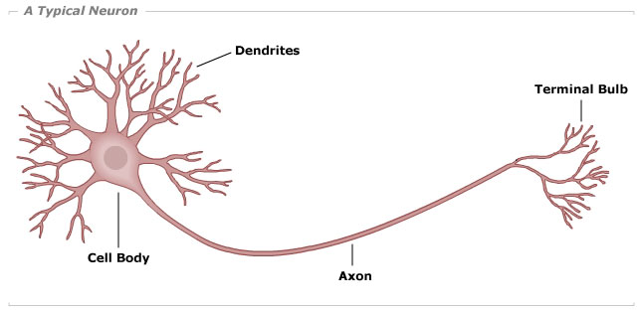
- You can create from the same DNA material, incredibly different cell types.
- With a cell that has essentially the same DNA material, you create a structure (neuronal cells) that has dendrites, terminal bulbs…
- The genome has to provide the mechanism for a cell to differentiate itself. And they way it does that, is by allowing transcriptional activators to come into contact with DNA sequences that can initiate events that are involved in differentiation

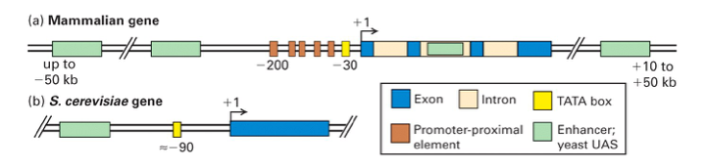

- Expression of eukaryotic protein-coding genes is regulated through multiple protein-binding transcription-control regions located at various distances from the transcription start site.
- Promoters direct binding of RNA polymerase II to DNA, determine the site of transcription initiation, and influence the frequency of transcription initiation. In this course, the term promoter will be used for the TATA box or other sequence that recruits RNA polymerase to the transcription start site.
- Other sequences near the promoter (within 100-200 bp) can regulate transcription. These are called promoter-proximal elements. (can be cell-type specific)
  - TATA box (yellow). Upstream of TATA box we have those little bars that are little sequences that require to make the promoter stronger which means make RNA pol II work better.
  - We have other things also upstream (green) enhancers: can be very difficult, because they can be far away. They can be up to 50 kb away. By the time you can actually test these things, you are at the limit of what bacterial cells could manage for your essay.

Recombinant technology: DNA cloning in a plasmid vector permits amplification of a DNA fragment
- 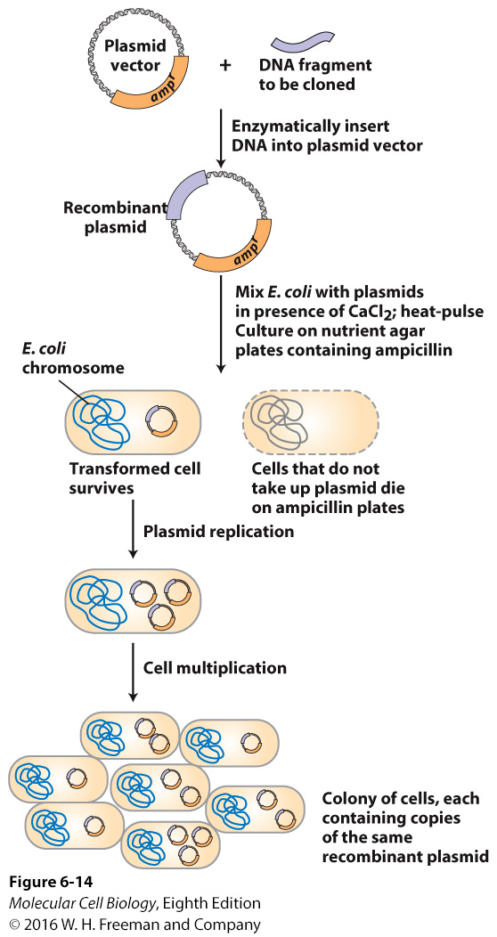All of the assays revolve on a reporter.
- I have a genome that I’m interested in. I want to know the sequences that are required for its expression: what do I do?
    - I try to clone it.
    - If it is more than 20 kb I break it down.
- But whatever you do, you have to put it into a plasmid that’s going to be expressed by a bacteria or cell line. So you cut things randomly, you clone them in, and then, as part of the mixture what you select for are things that can’t survive, because they are expressing B-lactamase.
- Things go on and make a circle, E.coli par ex. They replicate, they duplicate, and what we get at the end is a large quantity of the protein of the RNA that you’re looking for that is driven by the selection of E.coli sensitivity to different kinds of drugs

Northern Blot analysis to detect mRNA
- 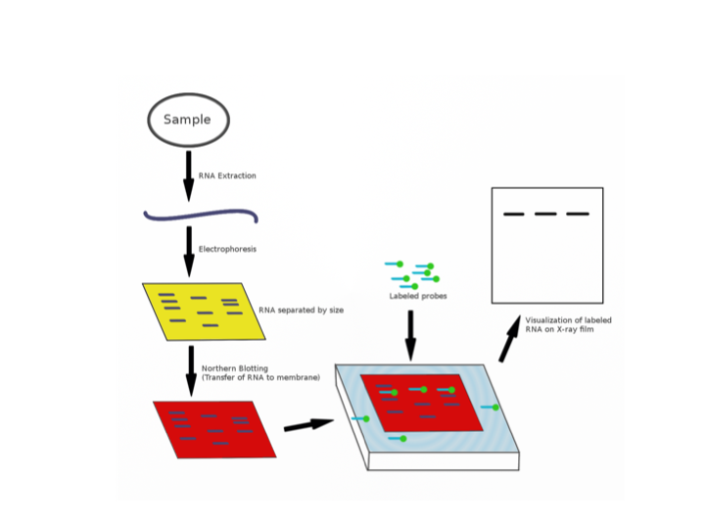If I ask what the promoter elements of a gene are. What do we do?
- We have to clone some upstream sequence that you can manage, and then you can do the next thing: voir next slide.

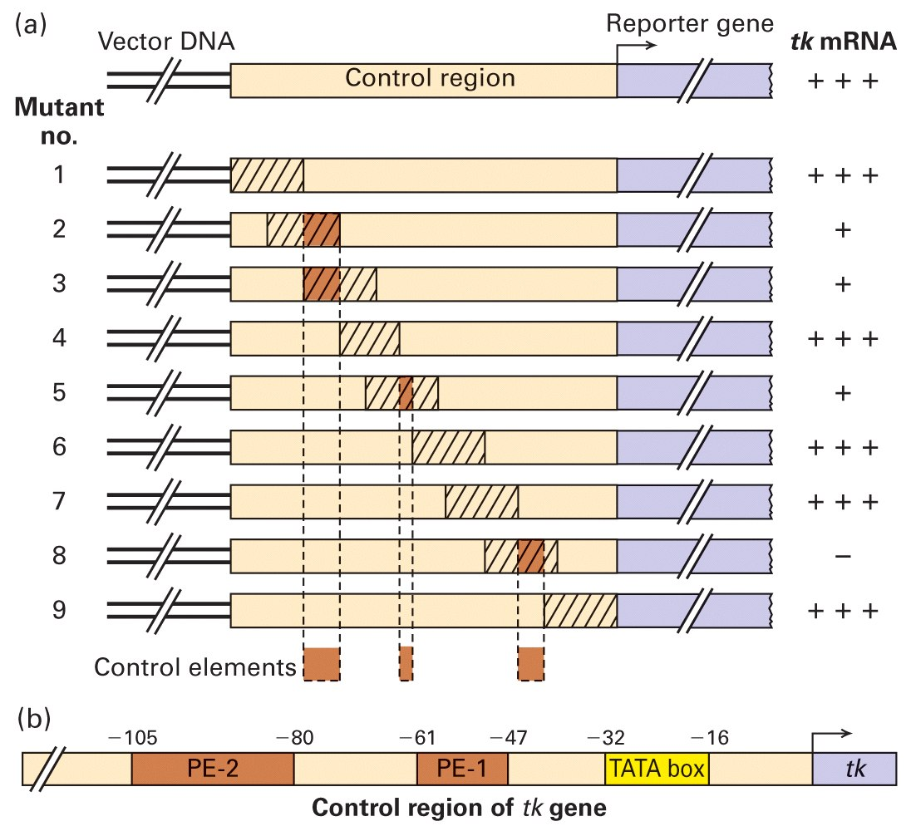Linker-scanning mutations can be used to find promoter-proximal elements

This experimental approach is good for detailed analysis of a short stretch of DNA
- Linker scanning !!!! is on a small scale. It is asking what the sequence is nearby or required for.
- So, after doing our clone, we can do linker-scanning. Which means you can change certain nucleotides in your sequence in your clone, and it maintains positions. So the positioning relative to the TATA box is maintained.
- Schema: we have a reporter region, we have a control region, and we want to know what parts of the control region (which is like an unknown piece of DNA) are required for transcription of your gene. So your start scrambling them up.
- IMPORTANT: we have a control. It is doing ok. We can express some reporter R-gene or RNA. Not important what it is, but the fact that we can do it. Now relative to that reporter gene RNA we can ask: that if I remove pieces or if I change them, do I affect transcription, because if I do, that can help me identify where the transcription of the gene is. Because I cloned the gene.
- So we make a series of mutants. We have to construct those things, to genetically engineer those mutants, and construct deletion or scanning mutations mutants, that are going to be scrambled for these particular sequences. If you scrambled for this particular sequence (1, partie rayee), compared to your control, there’s no effect. Now if you do it in this particular sequence (2) (going a little bit to the right), you have an effect (regarde a droite, les +, c’est pas comme le control). And if you do another series (4) no effect.
- So if we leave this part and this part (1 et 4) there is no effect. And if we continue to scramble…, we get to one that has a negative value, you just can’t initiate transcription (8). And so that position is defining what particular DNA promoter sequence.

- Linker-scanning: You introduce random nucleotides into the sequence.
- The real reason that it is an effective method to study RNA transcription is because it maintains the distance between whatever you were studying (the point that was mutated), and the transcription initiation point. So, you maintain the specter: so RNA pol II could come in. other techniques aren’t like that. So we can approach in some area.
- Whenever we mutate those things in the scrambling, it’s still maintains that there is no deletion, so the ability of RNA pol II to bind is maintained. So are these sequences required for the promoter to work is the question. Everything else is already solved.
- Do we have to do a Northern blot? Yes.

Enhancers:
- Enhancers are long distance transcription control elements that can be thousands of bp away from the transcription start
- Can be >50 kb away from the gene they regulate.
- Can be upstream from a promoter, downstream from a promoter, within an intron, or even downstream of the final exon of a gene.
- Deletion analysis can identify these elements.

- Difficult to define, because it can be much further than 50kb.
- You have a promoter, you have RNA pol, and everything loops around. The loop can be big, and how you define these things, is really a question how you can test whether those sequences that you have manage to clone into bacteria or some other X, are capable of what? Improving base of levels of transcription.
- Enhancers take crappy pol II and make it better.
- When you have to bend chromatin and make contact between protein complexes, you have to have a distance that will accommodate. So to handle the bending enhancers are positioned far away.
- We don’t know where enhancers are, unless we can identify them.
- Our ability to know where an enhancer is our ability to do series of experiment which is a sub-clone: a huge piece of DNA, in front of the gene that you’re interested in. stick it in to a vector and put in some sort of assay and ask: can it increase transcription.
- Can be upstream: very far away, they can be downstream. Can be lodge in an intron, so downstream.
- So these are the sequences that can interact with whatever is going on at the promoter, and increase transcription from that site.
- Deletion analysis only way to identify these elements.
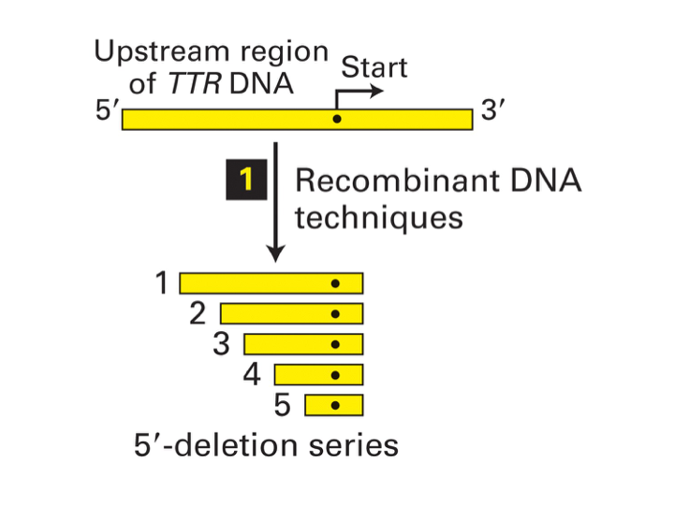
- A nested series of segments of the DNA upstream of the transcription start site can identify control elements.
  - Looking at enhancers, we’re talking about Kilo base pairings not base pairing, so they are really far away. So how do you identify how a gene is regulated by something that is really far away?
  - The major experiment have relied on using reporter constructs, like TTR DNA. We have a start of transcription (point noir ds l’image). And we use DNA recombinant techniques, to ask the question:
  - What it is required for this thing to transcribe to a normal level.
  - You cut down stuff, you remove sequences. You’re left with some clones. Can these deletions support transcription of this gene?
  - Deletion analysis we start with a gene: here is the TTR DNA. What do we need of the upstream sequence to get a normal transcription. So using recombinant DNA techniques, (that means we use restriction enzymes, to cut out certain sequences) we create a diverse set of nested series of segments of the upstream region.
  - When we talked about scrambling in linker-scanning, we talked about base pairs. Here, we talked about KILO base pair: a much larger scale.
  - We create a series of recombinant DNA sequences. One of them is -4k, one 5 one 3, each is going to be missing a certain number of base pairs (it’s decided by the restriction enzymes) relative to the one before it.
  - You have a region that you want to examine, and you have some stuff that you removed to see what happens with these.
  - The only way to do that is by putting the sequences in a gene construct (voir schema suivant) plasmid vector where we have easily reported gene. You put the little fragments in front of the reported gene, and see if it can express the reported gene.
  - Here, a known example: B-Gal, expressed in bacteria, in the presence of a certain substrate the cells will turn blue. Easy way to assay whether or not we have transcription activation from that transcript.
  - So we get all different vector. One has everything, and each one has less base pair. What we do is reduce the size of the promoter region that you’re assaying, and what is the overlap, what are the regions that are required for the transcription of my reported gene.
  - You have different constructs. Each one has the same reported gene, but less material from the upstream promoter region that you’re testing.
  - You individually introduce each one of these (3eme schema) into culture cells. And see if can anyone support transcription of the reporter. And the reported plasmid in terms of the B-Gal, will produce the reporter enzyme, B-Gal; and if you give it the right substrate, it will turn blue.
  - You know which sequences are involved, bc you can go back and look at which colony produced blue cells, vs white cells.
  - Than we have a reported plasmid and a reported enzyme (schema 4). That reporter plasmid create reporter enzyme. That reported mRNA may or may not be able to support the reporter enzyme production. So you prepare the cell extract and you assay the activity of reporter enzyme and you get:
    - if you have plasmid #1: you have everything until 4kb, so reported gene expression is good: can act as positive control
    - #2 -3Kb still good
    - #3 -2.2kb drops, which means that the sequences between -3kb and -2.2 kb (those 800bp) are required, drive reported genes expression to the level of control.
    - -1.5 kb acts the same as -2.2, so in it there is nothing really in your assay that drives transcription. BUT when you drop to
    - -0.7kb problem so between -0.7 and -1.5, you have another element which can contribute to the expression of the reported gene that you are assaying.
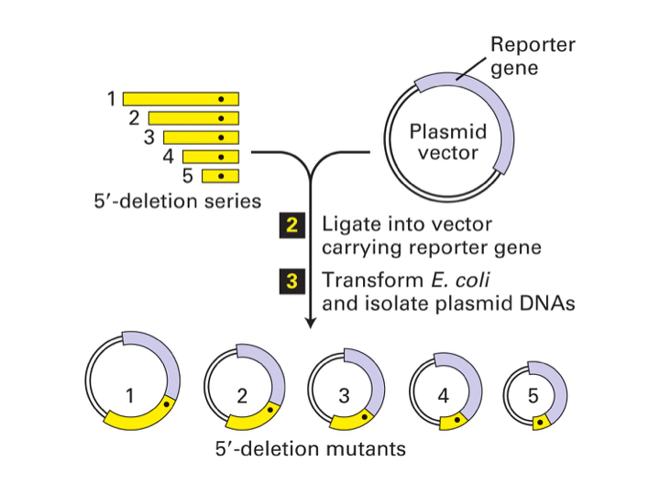
- Reporter gene: encodes
an easily measured enzyme (like β-Gal)

  - So you take your deletions (that are ligated into a vector) and you express it in another cell type. And you ask the question, Do I need those sequences to express this gene?

  - 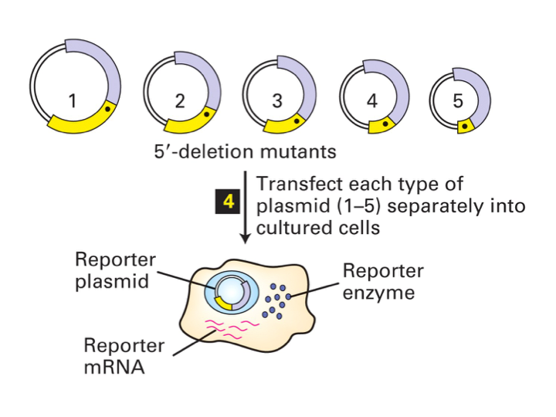You transfect each one of these. When you transfect a bacteria or any other type of cells, it is one per colony. So each cell will have one type of construct which will proliferate along with its replication cycle, and will give rise to whatever you’re looking for.
  - So you transcribe each type of the plasmids, 1 to 5, and you culture them; and you have the reporter enzyme. can I express this gene without this particular sequence?
  - 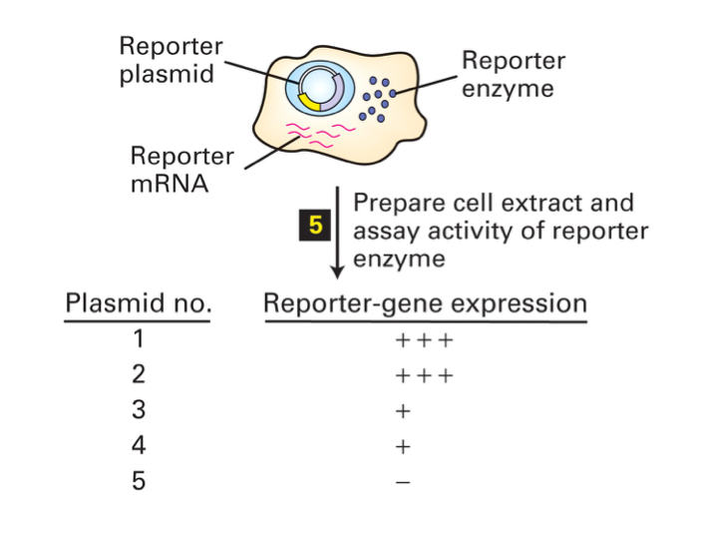An element that activates transcription must be between -2.2 and -3 kb.
  - Another element that activates transcription must be between -0.7 and -1.5 kb.

  - You have the reporter plasmid, the reporter enzyme, reporter mRNA.
  - The plasmid is inside the nucleus. Each one is different. You have a reporter enzyme that is produced from a reporter mRNA that is exported.
  - So each one of the cell is different and you put them in different biles: and you ask the question: if they are missing these sequences: are they required for transcription?
  - Plasmid no 1 -4kb it has excellent expression. -4 is our control that we can actually repel transcription of a gene
  - 2 -3kb active
  - 3 -2.2 we have a drop in gene transcription.
  - 4 We have another element that activate the transcription.
  - 5 only one that is completely at zero: between -1.5 kb and -0.7 kb. Why would we have complete zero between those sequences? You can delete something in that region and it is required.
  - The only other minus that we can have in a promoter.
  - Difference between +++ and +: +++ is OK. (measured by northern blot analysis). If now you’re removing some sequences. You’re missing 1kb: is there any sequence required for transcription?
  - DNA sequence between -3 and -4 not required
  - -2.2 and -3 are required. You get something, but it behaves
  - -1.5 and -2.2 you get something.
  - -0.7 and -1.5 nothing
  - INTERPRETATION: between -0.7 and -1.5 there was a promoter element like a TATA box. If we dt have that thing we dt have transcription.
Between 2.2 and 3 there was something.

- Can a TATA box be 700 bp away? Depending on the organism YES
- Distance is not negotiable with TATA and with the proximal factors. Many of them interact with the Taf binding protein, so there’s an architectural constraint.

- Recombinant DNA techniques.
- Ligate into vector carrying reporter gene.
- Transform E. coli, and isolate plasmid DNAs
- Transfer each type of plasmid (1-5) separately into cultured cells.
- Prepare cell extract and assay activity of reporter enzyme.
- -4kb means that is relative to the +1 site.

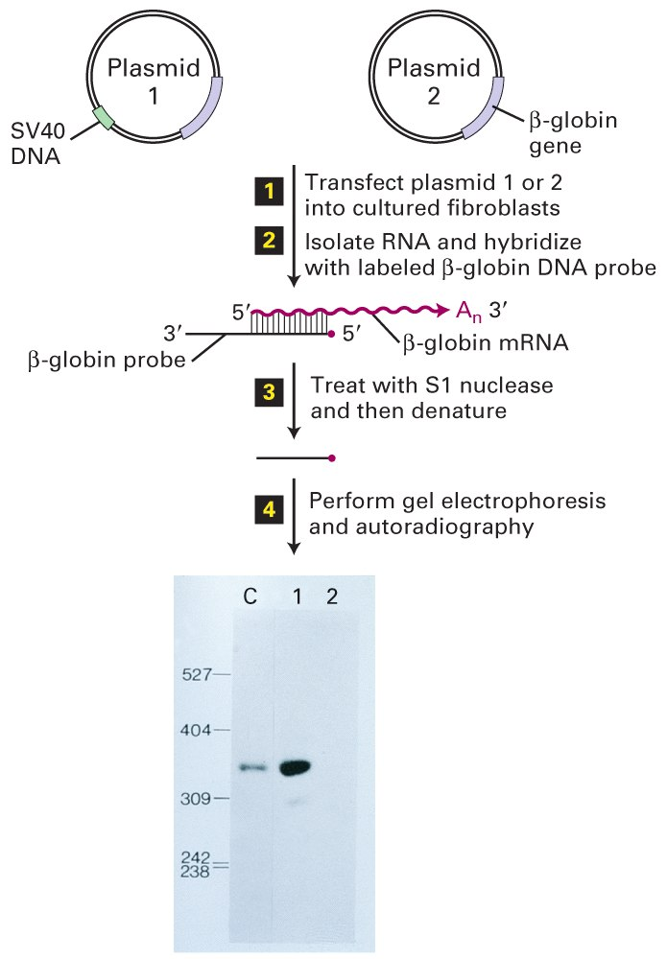How to test the Effect of Enhancers
- A transfection assay illustrates the activity of the SV40 enhancer.
- Plasmid 2 has only the β- globin gene, plasmid 1 has both the β-globin gene and the SV40 enhancer.
- Much more β-globin mRNA is synthesized by the cells containing plasmid 1.
  - They created 2 plasmids, one of them had the SV40 promoter, enhancer DNA. They were using as an assay the B-globin gene.
  - In the control they were using the B-globin gene without the SV40.
  - SV40 DNA was the first enhancer identified. First DNA sequence that was identified to drive transcription of other genes. It was a virus that infect our cells and drive a lot of transcriptions.
  - They transfected the plasmids 1 or 2 into cultured fibroblasts (different cells lines).
  - Cultured fibroblasts don’t express the B-globin.
  - To look whether an enhancer is capable of driving cell transcription in a cell type, it shouldn’t be expressed there in any way.
  - And what they did next, is isolate the RNA and hybridize with labeled B-globin DNA probe. Here, we have base-pair hybridization between B-globin mRNA that theoretically will be produced in the presence of the enhancer. The probe which is provided: it is all in vitro at this point. When these base pair binds and treat them to digestion with S1 nuclease, S1 nuclease will digest everything that is not a DNA/RNA hybrid. So suddenly, you have a 1:1 ratio between your probe and the RNA that is being produced from the thing that you’re assaying.
  - Then you perform gel electrophoresis and autoradiography. Get in the control lane the B-globin. With plasmid 1, we get tons of products in the presence of the promotor, SV40 enhancer DNA. In the absence you do not.

Most eukaryotic genes are regulated by multiple transcriptional control elements:

- The distinction between promoter-proximal elements and enhancers is unclear; a spectrum of different elements can regulate genes from different distances.
- Many yeast genes have a regulatory element called UAS (upstream activating sequence) that works like an enhancer. In yeast the TATA box is about 90 bp upstream from the start site.
  - Regulated by multiple transcriptional elements. +1 transcription initiation start site. Upstream: TATA box (yellow) which orients RNA pol II to the +1 site; proximal promoter elements nearby (brown), that helped orient + to recruit RNA pol II. Enhancers elements (green) could be 50kb away, they get pol II to the promoter also.

Transcription-control regions of the mouse Pax6 gene:

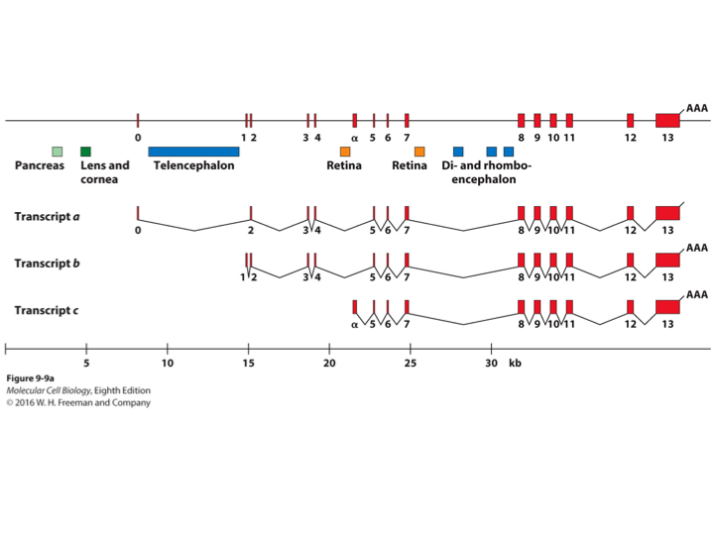

  - How many different tissues is this gene expressed in, in the pancreas, lens and corneas, telencephalon, Retina…
  - So in completely different tissues, this same piece of DNA has to be regulated in a very precise, specific way so that it can give rise to developmental fates, which are very diversely from one another.
Summary:
- Enhancer elements (promotor proximal and enhancers)
- Identify control sequences through linker scanning (for small DNA intervals) or deletion analysis (for large chromosome regions)
- Enhancers can stimulate transcription from eukaryotic promoters (repressors are rare in eukaryotes)
- Most eukaryotic genes are regulated by multiple transcription control elements.

