Overview of eukaryotic gene control

Three eukaryotic RNA polymerases:
1-RNA polymerase I
– Located in the nucleolus
– Transcribes only precursor ribosomal RNA (rRNA)
2-RNA polymerase II
– Transcribes messenger RNAs (mRNAs) and four small nuclear RNAs (snRNA) that take part in RNA splicing
3-RNA polymerase III
– Transcribes transfer RNA (tRNA), 5S rRNA, and other small stable RNAs including one involved in RNA splicing. (much smaller target load)

- All have a similar structure as they interact with DNA, but they all do different things.
- 2 of them are involved in transcribing repetitive things that make up ribosomes and things like that, and the other one is more gene specific (pol II involved in disease)
- 5S rRNA creating the translating machine

Proteins can be separated by chromatography:

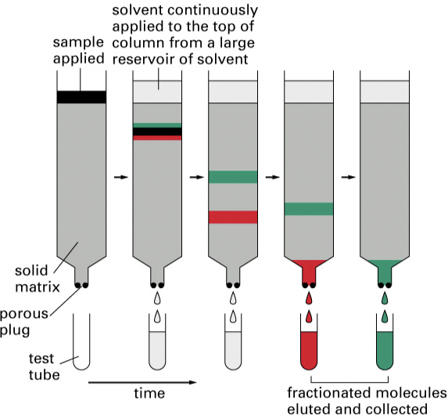

- The way we can distinguish between these RNA polymerases by biochemistry
- It is based on chromatography provide in a tube: slurry reagents (wherever you pile in there will capture what you put on top).
- All the stuff put on top will move through the column at a certain pace; based on size, charge, attraction to the slurry.
- You put extract on top, you let it bind, and then you wash it. And when you wash it, stuff starts coming out.
- The first fraction, depending on what the slurry is attracting to the protein contact.
- Then we repeat the washing and add a solvent on top continuously, to get more fractions. (fractionated molecules eluted and collected).
- The experience has to happen in a cold room: 4 degrees.

- So what really happens is:
You have a slurry, you have some beads, they have an attraction for the material you’re putting on, and as you put the solvent (on top), we get continuously elusions from the slurry.

Three commonly used liquid chromatographic techniques separate proteins:

Based on charge, size and affinity to antibodies.

- Gel filtration chromatography: separates proteins on basis of size.
- Separate things on size.
- Beads of a certain type: bigger stuff goes through; small stuff gets held up inside the bead.
- We have a layer sample on column; we add buffer to wash proteins through column. We get some polymer gel bead. We collect the fractions. We get Eluted Fraction.

- Ion-exchange chromatography: separates proteins on basis of net charge.
- Separate things on charge
- Beads with different properties that will bind based on charges.
- If beads are positively charged, they are going to bind proteins that are negatively charged. If negative beads proteins that have positive charge over all.
- As we take the fractions that crossed, we get the least tightly bind molecules (least bind to the column).
- We have a layer sample column. We have negatively charged protein and positively charged proteins. Cations elute out. Anions are retained by beads. We will get an Elute negatively charged protein with salt solution (NaCl) + eluted fractions.

- Antibody affinity chromatography: binds a specific protein on basis of antibody interaction
- Usually last step, because raising antibodies to do this kind of experiment is very laborious.
- Very specific recognize other proteins characteristics of the protein we’re trying to isolate. It can bring it down. And you can couple it to the column using a set of instructions from the company.
- Last step: can I pulled down enough of my stuff to do my experiment.
- We have proteins recognized by antibody; proteins not recognized by antibody that were load in pH 7 buffer. We wash, then Elute with pH 3 buffer. We get eluted fractions.

Successive liquid chromatography columns can purify proteins (to useful concentrations)

Purpose: examine a particular protein function.
So you need enough of it in order to play with it, to work with it in vitro.
And see if our protein is doing what we think we’re doing or not.

You begin with a salt concentration based or charged. You put your beads on. If we’re interested on a specific enzymatic activity, what do we do?
We’re gonna have like 100 of fractions. We have to assay if those fractions have these enzymatic activities.
We take those fractions, we’re always trying to concentrate, doing a larger concentration of the enzymatic activity. We go to the next step. We pool the fractions and apply them to the next column. We pool again another column that is separated by charge, and again apply them to the next column.
Final step: we take the column with antibodies, pull it down, and assay for activity. So the relative amount of our protein at the end, versus at the beginning is enormous. What we’ve done is that we concentrated our protein to a level that we can actually work with it.

One of the ways we can assay that kind of things in terms of transcription is: a Northern

Northern blot analysis detects RNA transcripts

- Northern is very similar to a southern.
- You have to isolate RNA, (you’re not probing DNA), and you’re probing with as probe that’s radio-labeled.
- We have a sample RNA extraction (horrible: if we breath, there is RNA. RNA is everywhere) when got a good RNA sample, that is well protected, nobody got near it electrophoresis separate RNA by size transfer it to a membrane Northern Blotting (transfer of RNA to membrane) add labeled probes can visualize labeled RNA on X-ray film

- Probes: can be RNA or DNA, labeled that can incubate with your RNA sample that can identify whether you have it or not.

- If we’re trying to isolate RNA polymerase do the protein purification. We will have hundreds of test tubes to know which test tube worked in terms of presence of activity, is by doing the Northern. Or you won’t know which one of the hundreds is competent for activity.

If we do that we will get:

Eukaryotes have 3 RNA polymerases that can be biochemically purified by column chromatography and have different sensitivities to alpha-Amanitin:

- Graph: with total proteins + Pol I + Pol II + Pol III
- Based on these experiences; Eukaryotes have 3 RNA polymerases
- RNA synthesis goes up at certain fraction number: it goes up between 20-30 fractions, and it goes up at 47-52.
- RNA synthesis happens in the areas of >20 (based on the graph). And that actually lineated 3 RNA polymerases.
- In the graph here, it’s in the presence of α-Amanitin

α-Amanitin interferes with RNA synthesis by reducing the rate of Pol II translocation

- α-Amanitin: is a mushroom that grows almost everywhere north the 55th parallel. (sweet, tasty).
- It produces a toxin that slows down the rate of transcription by RNA polymerases.
- Do this in many ways.
- Amanita phalloides (Death Cap)
- Each of the polymerases has a different reaction to the toxin in terms of the assay. If the assay is that you put a template and give all the rNTPs that they need, do the fraction, how fast can this fraction transcribe relative to another fraction.
- FRACTION: the part that when you wash the slurry you get 0.5 mL
- How are we testing for the activity: we use a template, We provide rNTPs, and the fraction and see if it transcribe and at which level.
There is no RNA. RNA is used as an assay to say that the fraction we’re using is positive. (just water, template and rNTPs)
- We had fractions: ex 2 fractions, both are positive. Question: is it the same proteins doing same things or is it different proteins doing different things. And that’s where alpha-Amanitin came in.
- Pol I is insensitive, it is resistant. Pol II is sensitive. Pol III is semi- sensitive. Very toxic for Pol II. (to alpha-amanitin)
- Pol II translocation = when the enzyme move from one nucleotide to the next (along the template)

Classes of RNA transcribed by the three eukaryotic Nuclear RNA polymerases and their functions:

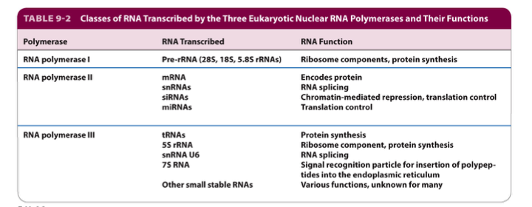

- Pol II transcribed all of the proteins coding genes
- Pol II responsible to the winding of chromatin in a proper way.
- Know the table!!!!
- Each of the RNA polymerases have different targets, but they are very similar in structures.

Comparison of three-dimensional structures of bacterial and eukaryotic
RNA polymerases

- Bacterial RNA polymerase:
We have the 5 subunits: alpha I, alpha II, Beta, Beta’, omega
They are coordinated

- Yeast RNA polymerase II:
The essential structure is maintained. And the structure we see represent the work done physically by isolating RNA polymerase from yeast, and comparing that structure to the Bacterial structure.
In all cases we have the same components in place: RBP1 beta’
RBP2 beta.

- Yeast RNA Polymerase II
It is assembled.
Omega brings the whole thing together
The structure of the whole complex is conserved, and that makes sense, because it deals with DNA, and DNA doesn’t change in structure.

In terms of RNA polymerase III, what is the role in transcribing the sRNAs it transcribes all of them.

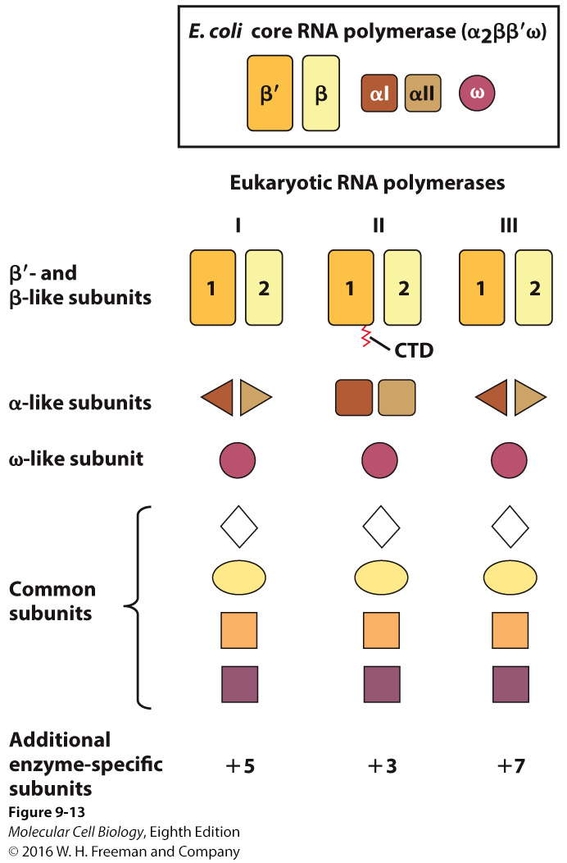Schematic representation
of the subunit
composition of the three
yeast RNA polymerases
and
E. coli
RNA core
polymerase

- Pictogram showing the E. coli complex.
- In the eukaryotic polymerases, we have the subunits.
- It is in different shades, because they are not exactly the same.
- When you take all. The data together, they reflect in space and time the function of the protein.
- They have the w subunit that helps bring everything together.
- They have other stuff that goes along: core complex related structurally to bacteria.
- RNA POL II has something that is called CTD (C terminal domain) that is not present on the other polymerases.
- POL II transcribes almost all of the protein coding genes.
- CTD: protein that wags off of POL II and can be modified. When modified in the right way, it can bring factors that are required to processing the RNA.

The largest subunit of RNA P II has a carboxy-terminal domain (CTD)

- In mammals, the CTD is made up of 52 nearly identical repeats of
Tyr-Ser-Pro-Thr-Ser-Pro-Ser (pas a connaitre)
(those units, as they get off the polymerase can be modified)

- RNA polymerase molecules that initiate transcription have an unphosphorylated CTD. Multiple phosphorylation events occur over the transcription cycle and they are reversible.
you initiate transcription, you start to pull away, and the transcript kind of goes out. You move away from the promoter. You’re dragging 2 things: the CTD tail, and the nascent transcript. And as you continue that process, those things get longer. When you modify the CTD tail, you can drag other factors that will be involved in processing and in making RNA stability and processing. So you’re actually creating a concentration of the stuff that you need.

- RNA polymerase molecules that are actively transcribing have phosphorylated CTD.

- Serves as a flexible binding scaffold for numerous nuclear factors; which factors bind is determined by the phosphorylation patterns on the CTD repeats. (Capping, elongation, and splicing factors)
It is a protein tail that you drag along that can attract other proteins that are required to process a thing that is being dragged along with it.

The CTD of RNA pol II is phosphorylated during in vivo transcription

Phosphorylated CTD is stained red, unphosphorylated CTD is stained green. (Overlap is yellow)

The fat parts of the chromosomes (puffs) are where lots of transcription is occurring.
They are red, so only phosphorylated CTD is present there.

- The CTD active red. Phosphorylated green
- Puffs lot of transcription

Model for the sequential assembly of an RNA polymerase II preinitiation complex.

Transcription initiation requires formation of the pre-initiation complex.

The pre-initiation complex contains many general transcription factors (TFII for factors associated with RNA polymerase II) in addition to RNA polymerase.

Transcription initiation can be studied in vitro (in a test tube with defined components), and in vivo using genetic techniques.

- Putting I and II together or I and III together and see if we get transcription.
- Assembly order of things recruit RNA pol II, Enable interaction of pol II with DNA sequence and allow transcription that you can measure by a normal blood analysis.

- Three eukaryotic RNA polymerases.
- Proteins can be separated by chromatography.
- Three commonly used liquid chromatographic techniques separate proteins.
- Successive liquid chromatography columns can purify proteins (to useful concentrations)
- Northern blot analysis detects RNA transcripts.
- Eukaryotes have 3 RNA polymerases that can be biochemically purified by column chromatography and have different sensitivities to alpha-Amanitin.
- α-Amanitin interferes with RNA synthesis by reducing the rate of Pol II translocation.
- Classes of RNA transcribed by the three eukaryotic Nuclear RNA polymerases and their functions.
- Comparison of three-dimensional structures of bacterial and eukaryotic.
- RNA polymerases.
- The CTD of RNA pol II is phosphorylated during in vivo transcription.
- Model for the sequential assembly of an RNA polymerase II preinitiation complex.

