RNA Pol II promoters and transcription initiation

SUMMARY (last chapter):

- Liquid chromatography can be used to sequentially purify a specific protein from a complex mixture: (one based on charge, one on size, one on the affinity to antibodies)
- Eukaryotes have 3 RNA polymerases that can be distinguished by differential sensitivity to α-amanatin:
Pol I is insensitive to 1μg/ml and 10μg/ml
Pol II is sensitive to 1μg/ml
Pol III is insensitive to 1μg/ml but sensitive to10μg/ml

- Eukaryotes have 3 RNA polymerases containing subunits that have homology to bacterial RNAP (β, β’ αI, αII, ω)
(very conservative: has to deal with the same template. So all the subunits it must deal with DNA)

- RNA Pol II has a carboxy terminal domain (CTD) that is phosphorylated in actively transcribing polymerases (CTD additional mechanism for regulation)
  - Tail that is not present in other polymerases in eukaryotes
  - RNA pol II decides all of: how cell divide, when, what it’s going to become, differentiation, when it will die….
  - The other pol help out, because they provide the housekeeping function, the accessory functions, and sometimes some specific functions.
  - So RNA pol II driven transcription

---------------------------------------------------------------------
Readings

RNA pol II promoters and the genes that they regulate are almost always driven by the idea that you have to recruit the RNA pol II complex to the gene.

Model for the sequential assembly of an RNA polymerase II preinitiation complex.

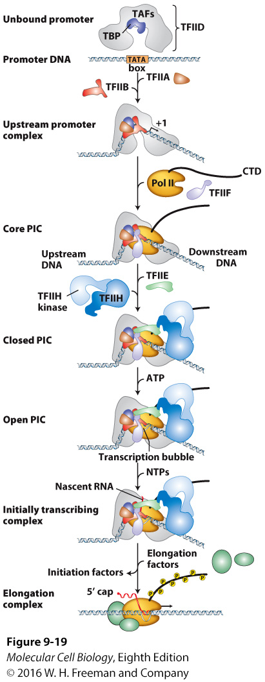
- Transcription initiation requires formation of the pre-initiation complex.
  - You have to land all the proteins on the transcription initiation start site.
  - But how do you find out?

- The pre-initiation complex contains many general transcription factors (GTFs; TFII for factors associated with RNA polymerase II) in addition to RNA polymerase.
  - What they do helps find the DNA sequence.
  - And bend it, and give an architecture that can recruit other proteins including pol II
  - You have to identify the sequence, the protein binds, there’s a conformation change that allows other proteins to bind. And that allows a complex to be build that will give stability to that DNA-protein complex interaction and give the cell a sense that is ready to go, it can start initiation.

- GTFs bind to promotors of genes transcribed by RNA Pol II. These function to
1.Position RNA Pol II at the start site
2.Assist in initiation
- The groups that binds to the TBP factors are the GTFs
- General transcription factors but that doesn’t mean they are everywhere. The pol II GTFs are the GTFIIs. They will associate with pol II
- Really important, because when you eliminate them, you won’t have transcription on your template. It is required that they be present. They are guiding RNA pol II into the promoter.

- Transcription initiation can be studied in vitro (in a test tube with defined components), and in vivo using genetic techniques.

- 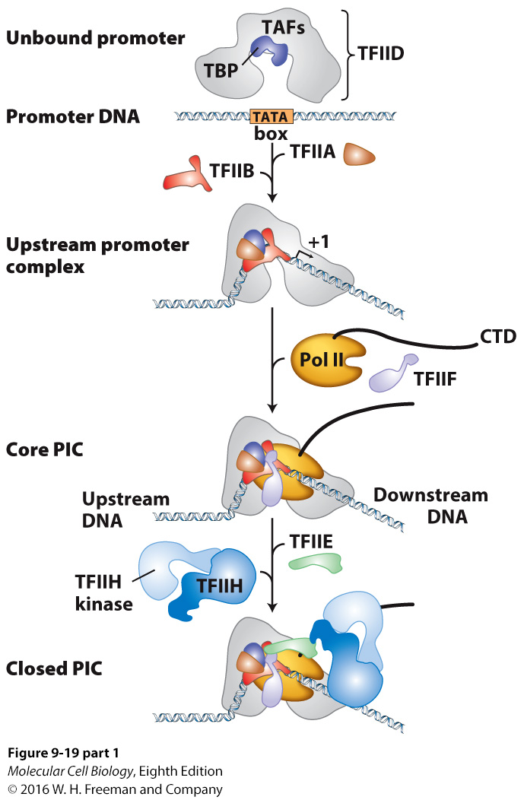TBP = TATA-box binding protein. Binding of TBP to the DNA is the first step of transcription initiation.

- In vivo, TBP is part of TFIID, a complex of TBP and 13 other subunits called TAFs (TBP- associated factors).
- Once TFIID has bound, TFIIA and TFIIB can bind in a complex with TFIID and the TATA-box.
- Once TFIIB has bound, preformed complex of TFIIF and Pol II bind (core PIC)
- TFIIE then binds and creates a docking site for TFIIH (10 subunits; has kinase and helicase activity)
- Closed PIC is formed

  - First thing that happened is that we have a TATA box.
  - Some proteins are able to bend DNA, and one component of the TFIID (multi-subunit complex) is TBPs. TATA box binding proteins will recognize that sequence. It will associate with a bunch of other proteins. There’s 13 of them in eukaryotes. It will form a complex that will associate around the TATA box and can recruit to the promoter (TATA box) pol II.
  - Pol II comes in with the CTD tail. It comes in a complex with TFIIF. They make the core pre-initiation complex. Now pol II is in the right place.
  - TFIIE will bind and create a docking site for TFIIH.
  - TFIIH is a complex that is already pre-formed. It brings in a couple of enzymatic abilities: kinase and helicase. Both are critical for RNA pol II to get started and initiate transcription.
  - So we have the formation of a pre-initiation complex.
  - So we go from a closed complex, we will go to an open one.

  - These recruitments of factors as complexes or liberally (like TFIIA and TFIIB and help stabilize a pre-form complex)
  - So we have a TATA box.
    - TBP will recognize the TATA box, and brings about 13 other members of a complex called TFIID.
    - That whole complex TFIID including TBP is then bound and form a map for other proteins factors to come in and recognize that place as the place where they should assemble.
    - Among these factors, we have first TFIIA and TFIIB. They allow bending of DNA. And then you can recruit the Pol II
    - Pol II comes in and binds. (out of the AT rich regions of the genome, pol II was placed at the right place).
  - TBP is the critical factor that comes in and allow the bend. As. The other protein complex come-in and stabilize that structure, so they also help in the bending process.

- 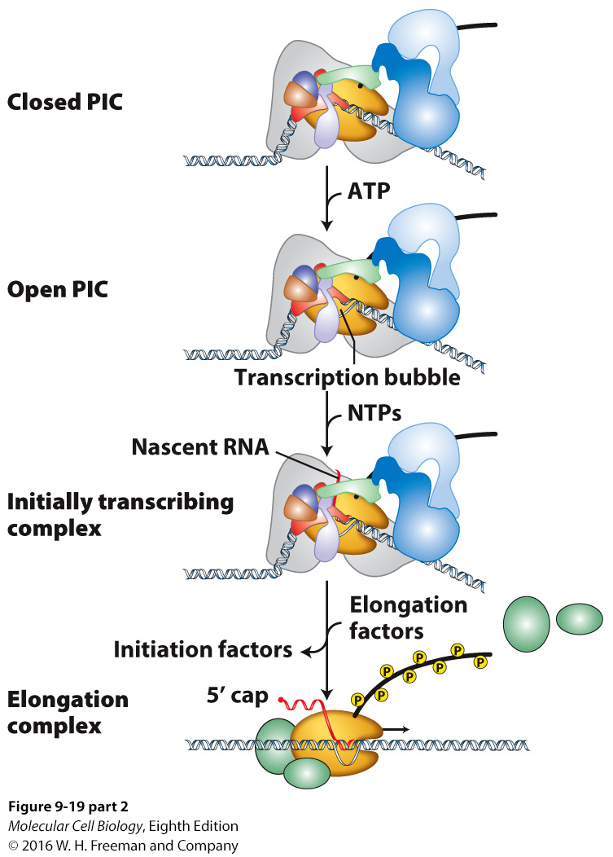Helicase activity of one of core subunits of TFIIH uses ATP to unwind DNA duplex at start site and Pol II forms an open complex (Open PIC)

- Transcription initiates, TFIIH kinase subunit phosphorylates CTD of Pol II

- General transcription factors dissociate from promotor

  - Once you arrive at a close PSD, you have everything there. Critically, you have the helicase activity of TFIIH. And what TFIIH does when it is drowned into the complex (as a docking site through TFIIE); once it’s docked at the pre-initiation complex, it brings in 2 activities that are critical for initiating transcription from that particular locus.
Helicase activity of one of core subunits of TFIIH uses ATP to unwind DNA duplex at start site and Pol II forms an open complex (Open PIC).
So now we went from close to open.

  - So Pol II forms an Open complex called the PIC. And that allows the RNA pol to make a transcription bubble, make the first couple phosphate diester linkages, and then, you are actively in an elongation phase.
  - When transcription initiate TFIIH, kinase subunit phosphorylates CTD of Pol II. And that will identify as actively transcribing to the rest of the cell.

  - (Phosphate group from ATP). (need ATP to put a phosphate group on the CTD tail).
  - The helicase activity is ATP driven, so it has to hydrolyse ATP in order to actually create the Energy to unwind both strands. So, both processes depend on the same product. You can actually stop transcription in the cell, by withdrawing local concentration of ATPs.

  - So when you hit the elongation phase, it is important that TFIIH has its kinase activity which will phosphorylate the tail.

  - Pol II tail that is phosphorylated will exit the complex, still phosphorylated, and will actually recruit other factors that are required for slicing.
  - WHY WOULD WE WANT THE PHOSPHORYLATED TAIL?
It is part of the process that identify that this transcript needs to be processed, capped (5’cap), and sliced.
The phosphorylation actually attracts other proteins that were before invisible. But now that they are phosphorylated, they know its part of a moving target that is being actually transcribed and so should be processed.
So in a way it couples RNA processing to RNA transcription.
Some of the RNA splicing factors associate with the phosphorylated tail.

  - The reason we have the tail in the picture is that it signals to the cell that we have an elongating transcript.
  - What are we doing with an elongating transcript?

  - We identify boundaries of the introns and exons, and those boundaries and the protein bound to them attract the splicing factors. So it’s a multi-step process.

  - When it is not phosphorylated it is free to interact with the promoter

  - THE PHOSPHORYLATION IS PART OF THE ELONGATION, NOT THE INITIATION.
Once you open up the DNA and make a couple of nucleotides and join them together, you phosphorylate the tail. So you must leave the promoter.

Transcriptional control
Usually the major mechanism for controlling production of the protein encoded by a given gene.
Transcription of a gene can be repressed (little or no mRNA is synthesized) or activated (up to 1000x or more mRNA is synthesized)
- We don’t generally make a bunch of a gene in terms of a transcript or even of a protein product and then degrade those things when we don’t need them. What we do is produce things specifically on time, in tissues and cells that are required to have those proteins products. So almost 70%, everything is controlled by protein transcription initiation.
- It is not about degrading the RNA once you make it, or making the protein, and then degrading it. It is really about what is going to do. If it is not required, you just don’t initiate it, because it requires resources. Why would you do something that you don’t need to then degrade it? All of that takes energy.

Unicellular versus multicellular organisms
- Single-celled organisms
Genes are regulated to adjust to changes in the nutritional and physical environment. A cell usually produces only the proteins required for survival and proliferation under the particular environmental conditions it experiences.
- Multicellular organisms
Genes are regulated to ensure coordination during embryonic development and tissue differentiation.
- Different response in single cell, and multicellular organism
- In single-celled, genes adjust to environment, especially nutritional or pH. Cell is just waiting for the next disaster to happen, to produce a gene and try to encounter it. It produces the protein for survival.
- Multicellular DNA completely different. You have to regulate genes to ensure coordination, to do embryonic development, you pattern yourself: have different tissue types, … so it is not like single-celled: respond to the environment; that’s why we require more transcriptional control, in terms of transcription initiation.
- Multicellular can survive more temp extreme, sodium extreme… because we are buffered by a lot of cells. Their job is to buffer you and express many things in order to do that.
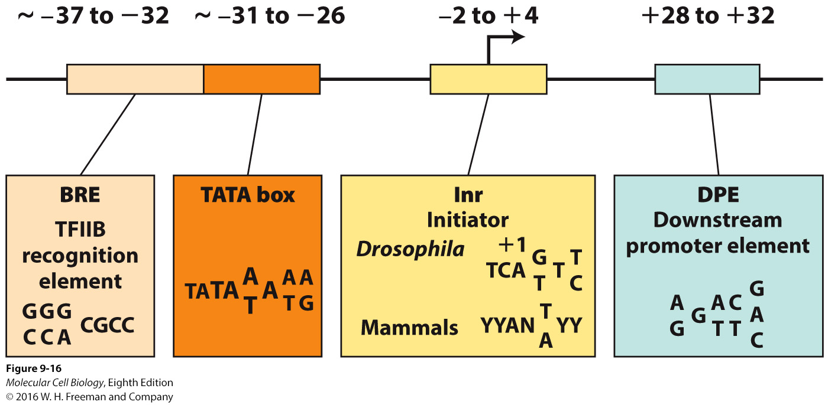Regulatory sequences in protein-coding genes (DNA)
Genes that are transcribed at high levels (have strong promoters) have a TATA box starting 35 bp upstream of the start site.
Some genes have an initiator element (Inr) which includes a C at the -1 position and an A at the +1 position. No good consensus sequence has been defined.
  - RNA pol II: will be dragged
  - Those are DNA sequences that will help you do that.
    - +1 transcription initiation
    - TATA box: A T rich, there is a wiggle because if we take many TATA boxes in the genome and study them, we find that the first 4 are always lining up (TATA), then there’s a difference in the next one, can have an A in some, a T in others. This will be followed by an invariant A, then by a variant A or T than A or G.
But you can bind the sequences, and the more you line up, the more you get a consensus, the more accurate you get.
    - Genes that are transcribed at high levels, are usually marked by a TATA box. They are really good, because they interact with TBP, which is already involved with assembling TFIID, and then you get all the other stuff.
    - There are other things that could do this stuff. Some of them work independently, and some of them help in the process.
    - Some genes have an initiator element at -2 +4. This is in the untranslated region, but it is transcribed. If we are at +1 for the initiation, the initiator element is transcribed. It often relies on another element that is downstream, still in the transcriptional region, which is the downstream element (DPE).
    - The initiator and DPE are a lot less conserved. Inr very wiggly sequence, can be a little less wiggly if it has a DPE next to it.
    - BRE is another element that is upstream non-transcribed. Helps stabilize the complex by interacting with TFIIB.
    - How do these initiators and DPE can interact with other proteins in TFIID. Even if they have a weak interaction with the TATA box binding protein, if there’s not a good TATA box, the fact that there’s a good initiator and maybe a good DPE, will interact with other TBP associative proteins within that complex and make a contact which will stabilize TFIID.
    - If we don’t have a contact, a good one with the TATA box, we have other protein components (13) that can contact the DNA. By making more of them, you stabilize the complex association with the DNA. So you do the function of the TATA box by adding more points of contact that are weaker.
    - In between +1 and the TATA box, you cannot wiggle the region. If you delete some nucleotides, it doesn’t work anymore, that tells about the complex that it needs that much space to dug properly pol II.
    - You can have much longer distance between +1 and the initiator element.

    - Purpose of binding TFIIA and TFIIB come into the complex, create a docking site for other proteins, and help stabilize the whole thing
    - BRE is an element that interacts with TFIIB. So TFIIB makes contact with a sequence a little bit upstream of the TATA box. And it can take a weak TATA box and make it stronger by making contact.
    - So, you might have sequences that will directly interact, and TBP will come and bind it. But sometimes, TBP doesn’t recognize a sequence, but what the whole complex recognizes is an architecture of sequences, each one of the subunits binds to it. It can create specificity.
    - Strong TATA box means you have all the residues.
    - If weak TATA box, you need other things to bring pol II. So, you’re creating other DNA interaction with the other subunits, so you’re creating specificity.
    - Promoters are what brings in the RNA polymerases
    - Initiator is not translated! It is in the downstream. But isn’t translated.
    - DOES EVERY GENE HAS ALL OF THOSE SEQUENCES? NO. some just have a strong TATA box, and it is enough. Some have all 4. Some have weak this one, strong that one… and that’s how they manage to a direct specificity by initiation by pol II.
    - Before you get to this phase, you have to open up first the chromatin!!!!

Transcription of most protein coding genes in mammals initiates in CpG Islands
- Transcription of genes with promotors containing a TATA box or initiator element begins at a well-defined initiation site (positions RNA Pol II active site)
- Transcription of some genes initiates at multiple alternative sites within a 100-1000 bp region.
- These genes lack a TATA box or an initiator element but contain a CG- rich stretch of 20-50 bp (called a CpG island) within ~100 bp of the start-site region. ~70% of genes (so do a messy business of bringing in pol II)

- CpG islands: in the 5’ 3’ reading strand of the DNA, refers to a cytosine hooked up to a guanine. You have the clusters of these repeats which are parts of the DNA sequences. The transcription of these genes, housekeeping stuff, enzymes that help you digest, ribosomes… it’s housekeeping: it’s to make sure that the cell has all the enzymes to do the background work.
- These differ from pol II transcription, because it starts at a well-defined site. Those have a function to place RNA pol II over +1. Some genes initiate a multiple origin sites. You dt care about putting more E to it, because if you ever dropped the level of transcription of these genes, you will be dead; like ribosomes factors.
- Generate a reproduceable and dependable system without opening the chromatin and produce a population of proteins required for your survival
- Repetitive blocks that occurred in the genome
- What they mean by CpG is that it is linked by a phosphate diester linkage. We have these placements of these kind of repeats in front of genes that are generally the ones that you need. The basic housekeeping functions of any gene, of any organism.
- These genes lack a TATA box, but contain a CG rich region (20-50bp). Within a 100 bp of the start region, it can vary. The reason we know that: next part experiment.

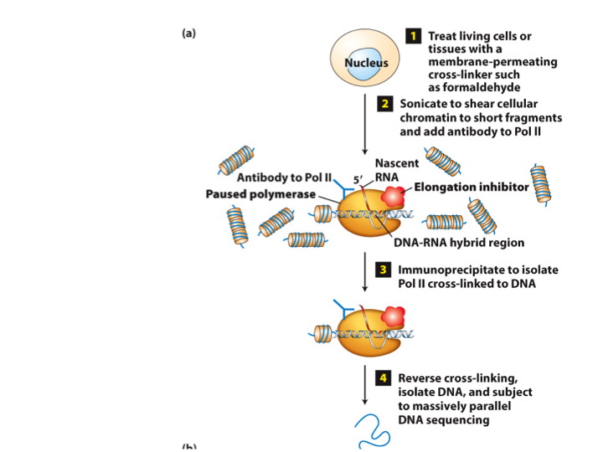Chromatin immunoprecipitation using an antibody to RNA polymerase II
- What they do is generate a reproduceable dependable level of transcription, without involving any other mechanism.
- We dt have to open up the chromatin or express a chromatin modifier that goes to the activation region and opens it all up. This step is happening all the time and is creating the population of proteins required for cellular survival.

- If you treat living cells or tissues with a membrane: you take cells, you centrifuge them, you treat them with cross-linker like formaldehyde, and what happens is that chemically, you create a contact with the proteins as they were in vivo.

- If you create those links between RNA pol II and the proteins in the region of the region elongating or transcribing form, you are physically to a piece of DNA that is transcribing at that time.
- Purpose of that experiment: is that by doing that cross linking and physically making sure that pol II is physically bound to the DNA that it is transcribing, we can ask what it is transcribing, and in which direction.

- Do CpG island matter? Testing: testing the frequency with which you have RNA pol II associating with promoters that are associated with CpG island. So you pull down RNA pol II and you see how often the RNA pol II that is pull down is associated with CpG island.

- When you link protein with formaldehyde, you cross-link: you actually grab physically on to smthg else, and you can pull it on physically.
- you sonicate.
- We used antibody to pol II. You paused the polymerase, because you don’t want it to move around when you’re trying to catch it at the transcription initiation start site. immunoprecipitated.
- Immunoprecipitated you have an antibody coupled to a column, that recognizes ELONGATING. identifying RNA Pol II (use antibody that are specific to pol II, bring them down, and then separation of proteins from the DNA. And then we will see what are the DNA sequences. Puisque notre but est d’identifier a quelle sequence RNA pol II binds to) and we can do this by reverse cross-linking.
- THERE IS NO ANTIBODY FOR INITIATION.
- then we want to know where the Pol II is bind to in terms of CpG island. The best way would be to examine by parallel sequencing.

Evidence for divergent transcription from CpG island promoters in mammals
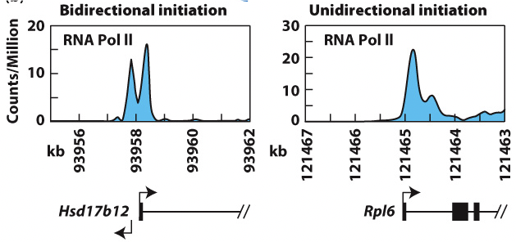
- We have evidence for divergent transcription.
- Parallel sequencing they take all of the RNA that is produced in the cell and give it a number. And above that number, background, they ask how much is your sequence actually transcribed so a control.
- Bidirectional transcription if you do parallel sequencing, we have counts/Million sur l’axe des ordonnees, so this is above the control of whatever you swept up. And we see in a particular gene (axe des abscisses) from embryonic stem cells, RNA Pol II that goes in 2 directions: we have 2 peaks, the RNA is being transcribed in 2 ways.
- Unidirectional initiation: in another gene, it only goes in one way.

- Why would do this? For highly transcribed genes, it may just be good enough to keep it open and deal with the slope. The antisense will be degraded and the forward sense is going to create a product.

Summary
- Transcription initiation by RNA Pol II requires GTFs that position it at start site and assist in initiation (position the active site of the polymerase.
- TFIID (TBF + 13 TAFs), TFIIA, TFIIB, TFIIF + Pol II (preformed complex) = CLOSED COMPLEX (Pol II positioned over transcription start site
- TFIIE, TFIIH (helicase + kinase subunits) = OPEN COMPLEX (DNA at start site unwound and template bound at Pol II active site)

- TATA Box, Initiators, and CpG Islands function as promotors in eukaryotes
- In TATA-less promotors, the TAFs of TFIID can function in initiating transcription (DPE sequence that increases TFII binding)
- BRE sequence optimizes TFIIB binding and is present in strongest promotors.
- Spatial conservation of distances between elements
- CpG islands can recruit RNA pol II, common for housekeeping genes transcribed at low levels
1. Transcription initiates at different sites for the same gene, therefore the 5’UTR differs in mRNAs from the same gene
2. Transcription is divergent (initiated in both directions) but only transcription from template strand results in mRNA product

  - Promoter is something that can recruit RNA pol II and position it on +1.

