Psychology Lecture 1: Introduction and History
History and Definition of Psychology
Early psychological science
Psychological science develops
Behaviourism
Freudian
Humanistic
Cognitive
Contemporary psychology
Evolutionary
Behaviour genetics
Cross-cultural
Gender
Positive
Psychology’s three main levels of analysis
Bio-psycho-social model
Definition of Psychology
Formal and Informal

What is Psychology?
A science that seeks to answer questions about us all- how and why we think, feel, and act as we do.

- Nature/Nurture Questions
  - What do genes contribute to behaviour?
    - How do our genes environment interact to make us who we are?
  - How are we shaped by our homes and daily environments?
- Interpersonal Differences and Similarities
  - How are we the same
  - How are we different
(how are we the same or diff. According to race, culture, gender, sexual orientation etc.)
- Why do we dream?
  - Just physiological (a byproduct of nighttime brain activity)
  - To consolidate memory
  - Some have thought-dreams could be systematically analyzed to assist people in their daily lives (By tapping into the )
- What do Babies Think?
  - What do babies sense, perceive, and think
- What is intelligence?
  - Are some people born smarter?
  - Does being smart relate to other abilities?
  - Are there different kinds of intelligence? (some researches think so)
  - Or is there a general intelligence
- What about electronic media?
  - How do our electronic devices influence our thinking, learning about our relationships?
- What about Psychological Disorders
  - What triggers good and bad moods?
  - What is the line between mood wing and psychological disorder?
  - When should help be requested?

History of Psychology
- Early Psychological science
- Psychological science develops
- Contemporary psychology
- Psychology’s three main levels of analysis
- Fields of study in psychology

Early Psychological Science

Birth of Psychological Science

- Aristotle-Birth of Psychological Sciences
  - used observations and questioning to understand the body-psyche relationship
  - Questions were answered through observation
- Wilhelm Wundt- Psychological Science is Born
  - Defined psychology as “science of mental life”
  - Added two key elements to enhance the scientific nature of psychology:
    - Carefully measured observations
    - Experiments

- Edward Titchener- Structuralism
  - Mentored by Wundt
  - Encouraged introspection → reporting on sensations and other elements of experience in reaction to stimuli.
  - Used these introspective reports to build a view of the mind’s structure
- William James- Functionalism
  - Studied human thoughts, feelings, and behaviours and asked:
    - What functions might they serve?
    - How might they have helped our ancestors?
  - Authour Principles of Psychology

First Women in Psychology
- Mary Whiton Calkins
  - Became memory researcher and first APA female president (1905)
  - Studied with James but discriminated against and denied PhD
  - Fought for the right to vote
- Margaret Floy Washburn-First female PhD
  - Became second APA female prez
  - Wrote The Animal Mind
  - Studied with Titchener but barred from his experimental psychology organization
  - Master’s thesis was published by Wundt

Development of Psychological

Early Development:
- Behaviourism
- Defined psychology as “Scientific study of observable behaviour” without reference to mental processes
- Proponents
  - John B. Watson (Classical Conditioning
  - B.F Skinner (Operant Conditioning)
- Watson and Rayner conducted famous “LITTLE ALBERT” experiment
- Conditioned 11-month old baby to fear white rats
- Skinner tested Animal Behaviour (Developed the skinner box)
- Freudian Psychology
- Sigmund Freud
  - Emphasized ways unconscious thought processes and emotional responses to childhood experiences later affect later behaviour.

- Humanistic Psychology
- Revived interest in the study of mental processes
- Focused on ways current environments nurture or limit growth potential, (ex importance of having need for love and acceptance satisfied)
- Carl Rogers and Abraham Maslow
- Cognitive Psychology
- Known as the cognitive revolution
- Occurred in 1960s → focus returned to an interest in the mental process
- Cognitive psychology
  - Scientifically explored ways in which information is perceived, processed and remembered.
  - The interdisciplinary field of cognitive neuroscience ties the science of mental processes (Cognitive psychology) and the science of the brain (neuroscience) and focused on brain activity underlying mental activity.

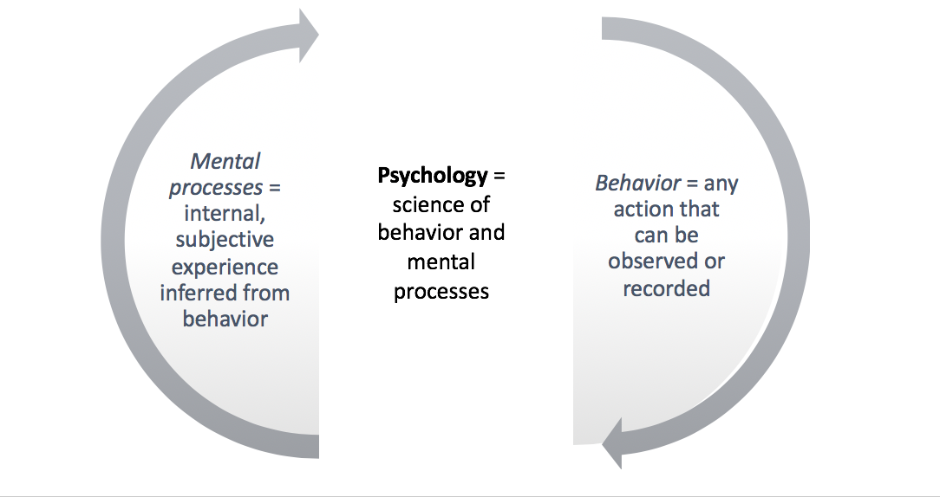

Contemporary Psychology

- The field of psychology is growing and globalizing
  - Psychology’s pioneers have come from many fields
    - Physiology
    - Philosophy
    - Medicine
  - Advances in psychology also have been made in many countries; psychology has spread rapidly with 182 member nations in IUPS
  - This contributed to the growing understanding of biology and its relationship to experience
    - Fueled nature-nurture debate
- The big Nature-Nurture question continues
  - To what extent are our traits already set in place at birth (Nature)
  - To what extent do our traits develop in response to our environment/experience (Nurture)
  - How do we differ according to differences in gene expression (epigenetics)

 | Definitions
Evolutionary Psychology | - Focus on how humans are alike because of common biology and evolutionary history
Behaviour Genetics | - Focus on differences related to different genes and environments
Cross-cultural Psychology | - Focus on ways culture shapes behaviour, but the same underlying processes are universal
Gender Psychology | - Focus on differences; males and females are overwhelmingly similar.

Nature | Nurture
- Plato  - Character and intelligence inherited some ideas inborn  - Descartes  - Some ideas are intuitive  - Darwin  - Some traits, behaviours, and instincts are part of species; natural selection | - Aristotle  - The content of mind comes through senses  - Locke  - The mind is a blank state

Positive psychology: Martin Seligman:
  - Explores human flourishing
  - Uses scientific methods to investigate the building of a good life that engages skill-building and a meaningful life that extends beyond self.

Psychology’s Three Main Levels of Analysis
BIO-PSYCHO-SOCIAL MODEL
- Biological Influence
  - Genetic predispositions (genetically influenced traits)
  - Genetic Mutations
  - Natural selection of adaptive traits and behaviours passed down through generations
  - Genest Responding to the Environment
- Psychological Influences
  - Learned fears and other learned expectations
  - Emotional responses
  - Cognitive processing and perceptual interpretations
- Social-cultural Influences
  - Presence of others
  - Cultural, societal and family expectations
  - Peer and other group influences
  - Compelling models (such as in the media)

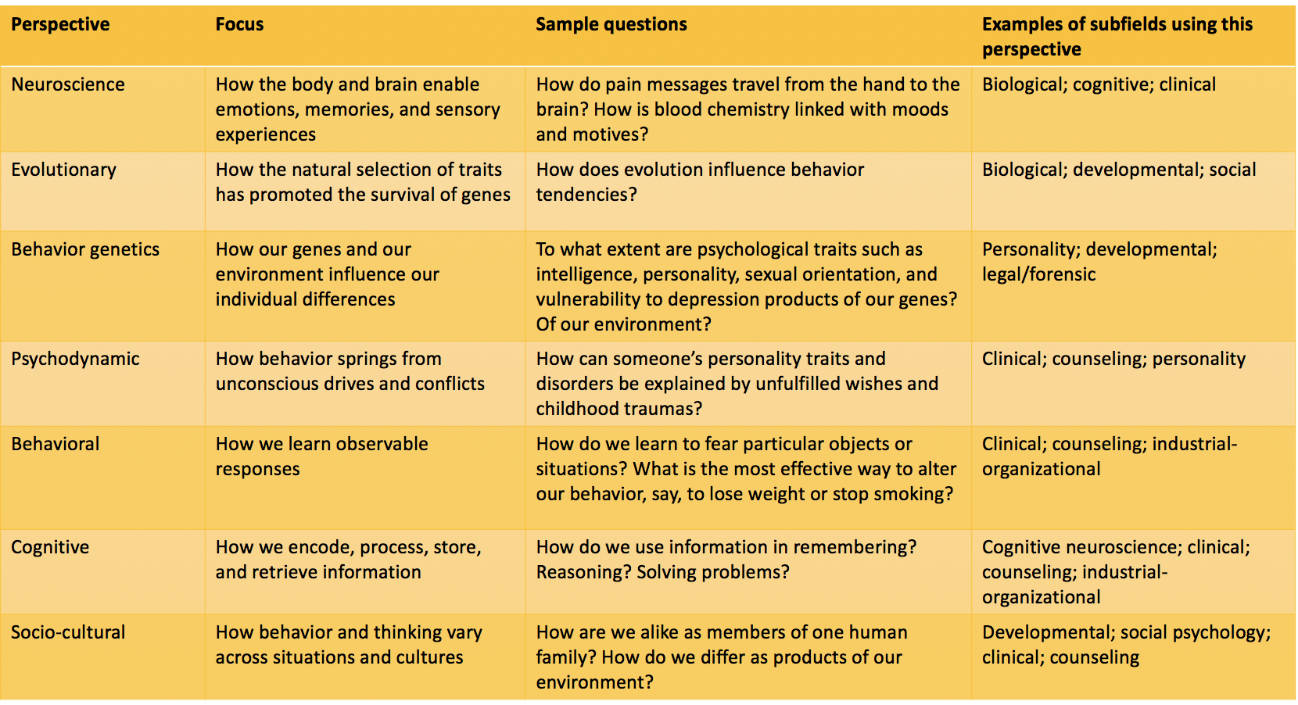
Psychology’s Subfield

