Motivation
What is Motivation?
- Motivation: extent to which persistent effort is directed towards a goal
- Motivation determines what employees do at a given moment – the direction in which their effort is channelled
- Once direction is decided, motivation goes on to determine how hard an employee works (intensity) and for how long (persistence)
- Engagement: a widely used term in contemporary workplaces that has different meanings depending on the context; most often refers to motivation, but can refer to affective commitment
  - Engaged employees invest themselves and their energies into their jobs
  - Outwardly – devote a lot of energy, striving hard to take initiative and get job done
  - Inwardly – focus a great deal of attention and concentration on their work, becoming absorbed, involved, and interests in their tasks that they lose track of time

Intrinsic vs. Extrinsic Motivation
- Intrinsic: motivation that stems from the direct relationship between the worker and the task
  - Doing something because it is inherently interesting or enjoyable
  - Ex. Enjoyment, skill development, accomplishment, personal expression
- Extrinsic: motivation that stems from the work environment external to the task itself
  - Doing something to get a reward
  - Ex. Bonuses, promotions, praise (acknowledgment for successful performance)

Why Are Some Employees More Motivated Than Others? Theories of Work Motivation
- Expectancy Theory: describes the cognitive process that employees go through to make choices among different voluntary responses
  - Employees will be motivated to perform work activities that they find attractive, feel they can accomplish, and lead to valued outcomes
  - Need to see clear links between effort, performance, and outcomes
  - 3 beliefs that help determine work efforts;
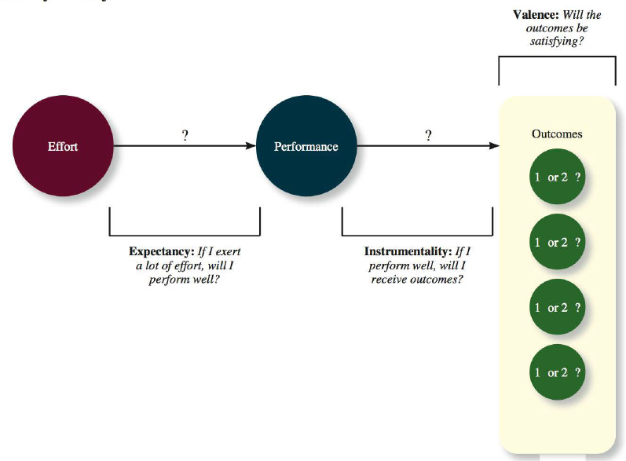
  - Expectancy: the belief that exerting a high level of effort will result in the successful performance of some task (E P)
    - Subjective probability, ranging from 0 to 1, that a specific amount of effort will result in a specific level of performance
    - Affected by self-efficacy: the belief that a person has the capabilities needed to perform the behaviors required on some task;
      - Past experiences
      - Vicarious experiences – observations and discussions with other who have performed such tasks
      - Verbal persuasion – friends, co-workers, and leaders can persuade employees that they can get the job done
      - Emotional cues – feelings of fear or anxiety can create doubts about task accomplishment, and pride and enthusiasm can bolster confidence levels
  - Instrumentality: the belief that successful performance will result in some outcomes (P O)
    - Subjective probability, ranging from 0 to 1, that successful performance will bring a set of outcomes
  - Valence: degree to which an outcome is valued by an individual (V)
    - Positive valence: salary increases, bonuses, informal rewards
    - Negative valence: disciplinary actions, demotions, and terminations
    - Outcomes are deemed more attractive when they help to satisfy needs (cognitive groupings or clusters of outcomes that are viewed as having critical psychological or physiological consequences)
      - Maslow hierarchy of needs
  - Motivational force: the direction of effort that is dictated by the three beliefs – expectancy, instrumentality, and valence
    - E P x ∑ [(P O) x V]
    - Motivational force will equal 0 if any of the beliefs are 0

- Goal Setting Theory: goals are the primary drivers of the intensity and persistence of effort
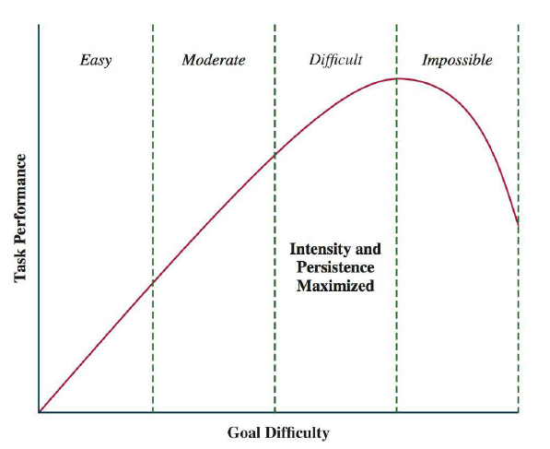
  - Goals: the objective or aim of and action – typically refers to attaining a specific standard of proficiency (often within a specific time limit)
  - Need to assign specific and difficult goals: will result in higher levels of performance instead of assigning no goals, easy goals, or ‘do your best’ goals – gives people something to shoot for and can be used to tell them how hard they need to work and for how long
  - Self-set goals: internalized goals people use to monitor their own progress – goal setting works better when the assigned goals alter the level of self-set (personal) goal
    - If assigned goals are unable to change internal goals, motivation and performance will be unaffected
    - “You can lead a horse to water, but you can’t make it drink” – The critical motivation factor is what the horse intends to do
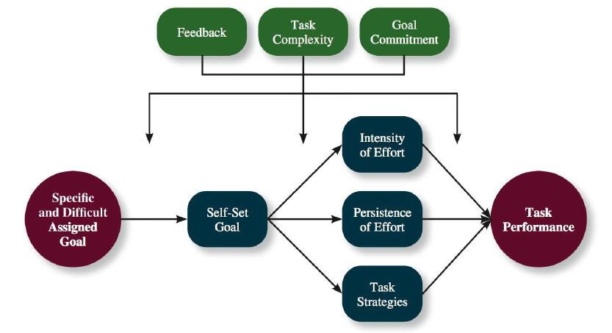
  - 3 variables that specify when assigned goals will have stronger or weaker effects on task performance (moderators)
    - Feedback: updates on employee progress towards goal attainment
    - Task Complexity: how complicated the information and actions involved in a task are, and how much the task changes
    - Goal Commitment: degree to which a person accepts a goal and is determined to try and reach it
- Equity Theory: motivation doesn’t only depend on your own beliefs and circumstances, but also what happens to other people
  - Mental ledger of the outcomes (rewards) one gets from their job duties as well as inputs (contributions and investments) they bring to the job duties
    - Outcome examples: pay, seniority benefits, fringe benefits, status symbols
    - Input examples: effort, performance, skills, education, experience, training, seniority
    - Ratio of O:I
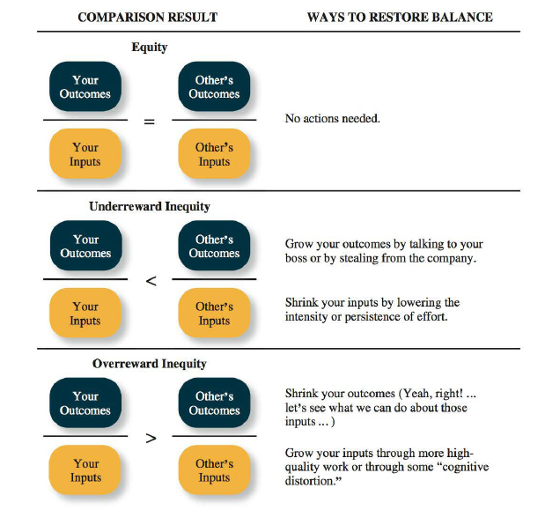
  - Comparison Other: some person who seems to provide an intuitive frame of reference for judging equity – can perform cognitive calculus (comparison of ratios)
  - $\frac{My Outcomes}{My Inputs} = \frac{Other's Outcomes}{Other's Inputs}$
  - Any imbalance in the equation, especially if yours is less than your comparison other’s, will cause equity distress: an internal tension that results from being overrewarded or under-rewarded relative to some comparison other
  - 3 possible outcomes of equity theory comparisons See diagram
- Psychological Empowerment: an energy rooted in the belief that tasks are contributing to some larger purpose
  - Can be a form of intrinsic motivation
  - 4 concepts that can make work tasks more intrinsically motivating;
  - Meaningfulness: reflects one’s feelings about work tasks, goals, and purposes, and the degree to which they contribute to society and fulfill one’s ideals and passions
    - High meaning = makes it easier to concentrate on that task and get excited about it
  - Self-determination: a sense of choice in the initiation and continuance of work tasks
    - Employees with high self determination can choose what tasks to work on, how to structure those tasks, and how long to pursue those tasks
    - Is a strong driver of intrinsic motivation because it allows employees to pursue activities that they themselves find meaningful and interesting
  - Competence: capability to perform work tasks successfully
    - Identical to self-efficacy
    - Strong competence = employees believe they can execute the particular behaviors needed to achieve success at work
    - Sense of pride and mastery felt can be intrinsically motivating
  - Impact: the sense that a person’s actions ‘make a difference’ – that progress is being made towards fulfilling some important purpose

