Personality, Cultural Values, and Ability
Definitions
- Personality (what people are like): an individual’s characteristic patterns of thought, emotion, and behavior
  - Creates social reputation – how they’re perceived by friends, family, co-workers, and supervisors
  - Personality is a collection of multiple traits like easygoing, polite, reserved (Traits: recurring regularities or trends in people’s responses to their environment)
- Cultural Values (what people are like): shared beliefs about modes of conduct in a given culture
  - Capturing what culture is like; traditional, informal, risk-averse, or assertive are adjectives that can be used to summarize a nation’s culture
  - Can influence development of people’s personality traits
- Ability (what people can do): relatively stable capabilities people have to perform a particular range of different but related activities
  - Skills can be improved over time with training and experience, but ability is relatively stable
  - Level of given ability generally limits how much a person can improve

The Big Five – Five Broad Factors/Dimensions Used to Summarize Personalities
- CANOE
- Conscientiousness: dimension of personality-reflecting traits like being dependable, organized, reliable, ambitious, hard-working, and persevering
  - Ex. Ready to get all the materials, would red all the chapters before a case analysis
  - Beneficial to have this in all jobs – most valuable, biggest influence out of the five
  - Priority - accomplishment striving: strong desire to accomplish task-related goals
    - Most helpful in sales – would set higher sales goals for themselves
- Agreeableness: traits like being kind, cooperative, sympathetic, helpful, courteous, and warm
  - Priority – communication striving: desire to obtain acceptance in personal relationships
  - Focus on getting alone rather than getting ahead
  - Beneficial: service jobs where you need to be face to face with customers – agreeableness
  - Not beneficial: managers may need to prioritize effectiveness in over a desire to gain acceptance amongst their employees
- Neuroticism: traits like being nervous, moody, emotional, insecure, jealous, and unstable
  - 2nd most important
  - Opposite of neuroticism: emotional stability, emotional adjustment
  - Synonymous with negative affectivity: dispositional tendency to experience unpleasant moods such as hostility, nervousness, and annoyance – explains lower satisfaction with job and life in general
  - More likely to appraise situations as stressful
  - Have a negative external locus of control – these types of people attribute the causes of events to the external environment rather than themselves
    - Internal locus of control = meaning that they believe that their own behavior dictates events
  - Implications for job performance?
- Openness to experience: traits like being curious, imaginative, creative, complex, refined, and sophisticated
  - Synonymous with inquisitiveness or intellectualness
  - Beneficial: jobs that are very fluid and dynamic, with rapid changes in job demands – new hires tend to have high curiosity and a built-in desire to learn, thus excel in learning
  - BMW works to create a culture of innovation, where there’s never a penalty for suggesting new and outlandish ways to improve its cars
- Extraversion: traits like being talkative, sociable, passionate, assertive, bold, and dominant
  - In a zero-acquaintance situation (two people have just met), you’d be able to easily judge whether one is extraverted or introverted
  - Priority – status striving: desire to obtain influence and power within a social structure
  - Have high positive affectivity: a tendency to experience positive moods (enthusiasms, elation, excitement) across situations – explains higher satisfaction with jobs

Cultural Values
- Culture: shared values, beliefs, motives, identities, and interpretations that result from common experiences of members of a society and are transmitted across generations
- Geert Hofstede’s Study – discovered five basic dimensions for taxonomy of cultural values
  - Individualism/Collectivism: degree to which a culture has a loosely knit social framework (individualism) or a tight social framework (collectivism)
    - Loose knit = Canada, France
    - Tight = China, Indonesia
  - Power Distance: degree to which a culture prefers equal power distribution (low power distance) or an unequal power distribution (high power distance)
    - Low = Canada, Germany
    - High = Russia, China
  - Uncertainty Avoidance: degree to which a culture tolerates ambiguous situations (low uncertainty avoidance) or feels threatened by them (high uncertainty avoidance)
    - Low = Canada, Indonesia – they like change
    - High = Japan, Russia, France – they avoid uncertainty
  - Masculinity-Femininity: degree to which a culture values stereotypically male traits (masculinity) or stereotypically female traits (femininity)
    - Masculine = Canada, Japan – values male traits such as assertiveness and the acquisition of money and things
    - Feminine = Netherlands, Russia – value female traits such as caring for others and caring about QOL
  - Long-term/Short-term Orientation: degree to which a culture stresses values that are past- and present-oriented (short-term orientation) or future-oriented (long-term orientation)
    - Short-term = Canada, Russia – values that are more past- and present-oriented (respect for traditions, fulfilling obligations)
    - Long-term = China, Japan – values more future-oriented, such as persistence, prudence, and thrift

How Can We Describe What Employees Are Like?
- Use the five big dimensions (personality)
- Beyond personality, what employees are like also depends on the culture in which they were raised – they influence employees’ thoughts, emotions, and behaviors (cultural values)
- Personality and cultural values will reveal to managers what employees are like – important to build the team needed for the job

How Can We Describe What Employees Can Do? – Ability
- Abilities will capture what people can do
- 3 general categories;
  - Cognitive: capabilities related to the acquisition and application of knowledge in problem solving
    - Tests like MCAT, LSAT test cognitive ability by presenting people with a variety of different questions
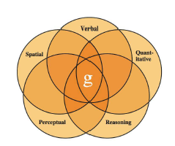
    - Types (facets) of cognitive abilities: verbal (oral and written comprehension), quantitative (number operations, mathematical reasoning), reasoning (problem sensitivity, deductive reasoning, originality), spatial (spatial orientation, visualization), and perceptual (making sense of info, finding patterns)
    - General cognitive ability (g factor): underlies or causes all of the more specific cognitive abilities discussed earlier – Overlapping in the diagram exists because each of the specific abilities depends somewhat on the brain’s ability to process information effectively
  - Emotional: a set of abilities related to the understanding and use of emotions that affect social functioning. Types (facets);
    - Self-awareness: appraisal and expression of emotions in oneself – understand one’s own emotions, willingly acknowledge them, and have the capability to express them naturally
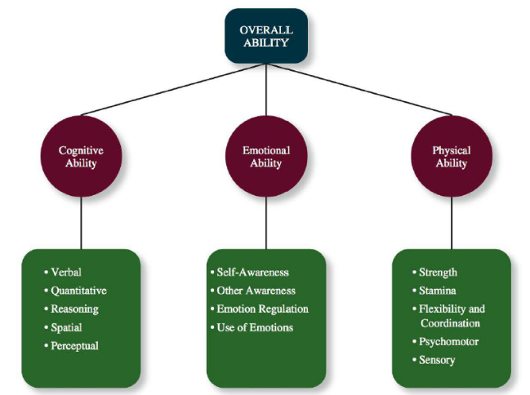
    - Other awareness: appraisal and recognition of emotion in others – ability to recognize and understand the emotions that others are feeling
    - Emotional regulation: being able to recover quickly from emotional experiences
    - Use of emotions: harness emotions and employ them to improve their chances of being successful in whatever they are seeking to do
  - Physical: to be physical able. Includes;
    - Strength
    - Stamina
    - Flexibility/coordination
    - Psychomotor
    - Sensory
- These abilities play an important role in determining how effecting we can be at different tasks and jobs

