Experiment 2: Heart Rate, ECG and Peripheral Blood Flow

Notes: There will be a quiz worth 3% of your final grade at the conclusion of this lab.
It is recommended to attend this lab with comfortable clothing to perform some of the exercises. Students with cardiovascular difficulties, those who are ill or are on any medication should NOT take part as subjects. However, they should co-ordinate and monitor the experiments.

Exercise 1. Schneider Cardiovascular Fitness Test

This is a simple test of cardiovascular fitness that can be used on people in a wide range of physical conditions since it requires only mild exertion.

Experimental Procedure:
- Plug the DIN connector of the plethysmograph into the Channel 3 outlet.
- Place the plethysmograph on the volar surface of the distal segment of the middle finger on your left hand and wrap the Velcro strap around the end of the finger to attach the unit firmly in place.
- Click Settings, select the Exercise Performance setting.
- The subject must lie on his/her back, relaxing for five minutes.
- Click Record to begin the recording. Type “Reclining Heart Rate” in the comment line, press Enter.
- When the heart rate becomes constant, click Stop but leave the plethysmograph in place. Record the pulse rate and determine your score from Table A.
- The subject should now rise and stand carefully. After allowing 2 minutes for the cardiovascular mechanisms to become adjusted, click Record. Type “Standing Heart Rate” in the comment line, press Enter.
- When the heart rate stabilizes, click Stop. Calculate the difference between the reclining and standing heart rate and determine your score from Table A.
- Rest for a sufficient amount of time until the heart rate returns to its normal pattern. Stand comfortably and click Record. Type “Before Exercise” in the comment line and press Enter. After 30 seconds click Stop. This is your standing heart rate in Table B.
- Disconnect the plethysmograph from the iWorx unit but do not remove from the subject’s finger. Pedal on a stationary bike at a speed of 15 km/h for 15 seconds with the tension control set to 3.
- Immediately after exercise, re-connect the plethysmograph to the iWorx unit and click Record while sitting. Type “After Exercise” in the comment line, Enter.
- Continue recording until the heart rate has returned to the normal standing rate. Discontinue after 2 min. If the heart rate still has not returned to normal, record the number of beats/min above normal at that time. From the end of the trace, count backwards in 15 second intervals to determine your final score.

Note: In the exercise, if the heart rate is not recording properly, you can calculate the heart rate from the interbeat interval.

Record:
- The increase in heart rate over the 15-second period immediately after exercise (Table B).
- The return to normal (Table C). In computing this return, count from the end of the 15 seconds of exercise to the beginning of the first normal 15 second count.
- Add the total of the five scores (from Tables A, B, and C) and make note of sex, height (in cm), weight (in kg), and age (in years) of the subject.

Exercise 2. Effects of Exercise on Heart Rate and Electrocardiogram (ECG)

The cardiac cycle involves a sequential contraction of the atria and the ventricles. When the cardiac impulse passes through the heart to trigger these contractions, electrical current also spreads from the heart into the adjacent tissues. Instantaneously, a small portion of the current spreads all the way to the surface of the body where the electrodes are placed to detect the current. The electrical potentials are produced by the current and recorded as an electrocardiogram or ECG. The normal electrocardiogram is composed of a P wave, a QRS complex and a T wave. The P wave is produced by atrial depolarization before atrial contraction begins. The QRS complex is caused by ventricular depolarization before contraction, as the depolarization wave spreads through the ventricles. The atrial repolarization is usually hidden under the QRS complex. The T wave is caused by ventricular repolarization, as the ventricles recover from the state of depolarization. In this exercise, you will study how each wave in the ECG is affected by exercise.

Experimental Procedure:
- Plug the DIN connector of the plethysmograph cable into the Channel 3 outlet.
- Remove all jewelry from your wrists and ankles and use an alcohol swab to clean a region on each wrist and the right ankle. The subject should relax, with arms and legs wide apart, in order to obtain a good ECG signal.
- Attach the AAMI connector of the gray patient cable to the isolated Channel 1 and 2 inputs on the iWorx unit. Attach three color-coded electrode cables to the ground (green) and Channel 1 inputs (red and black) on the grey pedestal and snap the other ends onto the disposable electrodes, so that the:
red “+1” lead is attached to the right wrist. black”-1”lead is connected to the left wrist, green “C” lead is connected to the right ankle.
- Attach the pulse plethysmograph to the middle finger of the left hand.
- Click Settings and select Heart Rate, ECG and Peripheral Blood Flow.
- Click the Record button and record for one minute. Use the Invert and AutoScale functions to orient the pulse if required. You must optimize the pulse signal in the Heart Rate Channel using AutoScale so that it will accurately trigger the heart rate channel.
- After recording, remove all connections from the wrists and ankle, but leave the disposable electrodes in place. Unplug the plethysmograph from the unit but do not remove it from the subject’s finger. In the recording window right click on the ECG graph. Select units from the drop down menu and then select simple. To convert the units from Volts to Millivolts move the decimal place 3 places to the right (a factor of 1000). Change the unit name to mv from V.
- The subject should exercise vigorously enough to elevate heart rate, by pedaling at a speed of 20 km/h (or 50 rpm) on a stationary bike for 5 minutes. The tension control should be set to 4, equivalent to a power output of 100 watts.
- As quickly as possible after exercise, reattach all of the connectors and click Record to begin recordings for at least one minute. Use the AutoScale function as required during and after the recording as sometimes there may not be a trace in the Heart Rate Channel. If the heart rate is not recording properly, you can calculate the heart rate from the interbeat interval (Refer to the introduction lab if needed).
- Click Stop to halt the recordings.

Use the Analysis window to measure the following parameters during rest and after exercise:
- The amplitude (V2-V1 from Q to R) of three QRS complexes sampled at random.
- The amplitude (V2-V1 from base to peak) of three P waves.
- The amplitude (V2-V1 from base to peak) of three T waves and the time interval (T2-T1) between four adjacent R waves.

Calculate the average amplitude of the P wave, the QRS complex, the T wave, the average time interval between R waves and the heart rate in the Table 1.

Table 1. Effect of exercise on ECG and heart rate.

 | At Rest | After Exercise
Average amplitude of the P wave
Average amplitude of the QRS wave
Average amplitude of the T wave
Average time interval between R waves
Average heart rate

Exercise 3. Effect of Gravity on Peripheral Circulation

In this exercise, you will examine the effect of gravity on peripheral circulation. As you move your hands from your lap to your head, you will see the direct change in the size of the finger pulse. Disregard the artifacts that are produced by the movement of your hands.

Experimental Procedures:

- Click the Settings menu and select the Peripheral Circulation settings file.
- Attach the plethysmograph to the subject's middle finger and place hands in his/her lap.
- Click Record. Type “Hands in Lap” in the comment line and press Enter. Record the pulse for one minute. Do not Stop the recording.
- Type “Hands on Head” in the comment line. Continue recording as the subject places both hands on head. Press Enter to insert the annotation. Record for one minute.
- Type “Hands High” in the comment line. The subject should then extend both hands as high as possible, without stretching the plethysmograph cable. Press Enter and record the pulse for one minute. If you are getting unstable readings, rest the hand on top of the hard drive tower.
- Type “Partner – Hands High” in the comment line. The subject should lower his/her arms and relax them at the sides. Press Enter and record the pulse for one minute. The partner should now gradually raise both arms of the subject. It is important that the subject not use any muscle power to perform this exercise.
Hint: Expand the trace on your screen to better view the recording over time.
- Click Stop to halt recording.

Note: You will see artifacts which are produced when you move the hands from lap to head.
Ignore artifacts when analyzing your data.

Analysis questions
You should consider the following questions/issues as you prepare for the quiz. Exercise 1
- What does the Schneider score suggest about relative fitness of the individual?

The Schneider score is chiefly meant for assessing the circulatory efficiency of an individual and indirectly his physical efficiency. It is also said to give a quantitative idea of the degree of fatigue.

- What are some of the advantages and disadvantages of using the Schneider test to assess fitness?
Advantages
-cheap to run, not much equipment required.

Disadvantages
-human error
-lack of hi-tech timers make timing difficult

Exercise 2
- At rest, which parts of the ECG correspond to which parts of the finger pulse?

The pressure of the QRS created on ECG corresponds to finger pulse.

- Why does the size of the finger pulse change as a result of exercise? (Hint: think about blood shunting)

When the heart rate increases the T-P shortens due to the complexes being in closer proximity. the pulse amplitude is smaller after exercise because all the blood is rushing to the muscle that needs oxygen

- Explain the effect of exercise on the heart rate and ECG.

The increase in heart rate during exercise causes a shortening of diastole and systole.
The altered action potential duration, conduction velocity, and contractile velocity associated with the increase in heart rate during exercise results in a number of ECG changes in normal people, including the following:
- RR interval decreases
- P-wave amplitude and morphology undergo minor changes
- Septal Q-wave amplitude increases
- R-wave height increases from rest to submaximal exercise and then reduces to a minimum at maximal exercise
- The QRS complex experiences minimal shortening
- J-point depression occurs
- Tall, peaked T waves occur (high interindividual variability)
- ST segment becomes upsloping
- QT interval experiences a rate-related shortening
- Superimposition of P waves and T waves on successive beats may be observed

Exercise 3
- If the size of the finger pulse signal provides an index of blood flow and transmural pressure, what
happens to blood flow, blood pressure and transmural pressure in the finger when the hands are raised over the head?

When the hands are raised over the head, the cardiac output increases, therefore pressure and blood flow increases, resistance decreases.

There is a decrease in heart rate when raising your arms is a normal response to change in venous return. Cardiac output can be calculated as heart rate multiplied by stroke volume. If your stroke volume increases, your heart rate drops in order to maintain a constant cardiac output.

One way in which stroke volume changes is by increasing the return of blood to the heart. When you raise your arms, blood has a much easier time returning to the heart. Rather than working against gravity, the blood in your arms is suddenly being pulled back into the heart by gravity. In this moment, the venous return of blood to the heart is significantly increased. The heart’s rebuttal to the increased blood flow is a greater stroke volume.

By adjusting the return of blood to the heart, stroke volume must increase to match output with input. According to the equation, in order to maintain a stable cardiac output, heart rate must drop. This process is known as reflex bradycardia, or reflex decreased heart rate. This delicately tuned feedback system keeps you alive when these variables are altered. In this case, raising your arms produces a normal and predictable drop in heart rate.

Feedback System
The feedback mechanism for controlling heart rate involves pressure sensors in your carotid artery. This major blood vessel is the one that carries blood to your brain; you can feel your carotid pulse in your neck. This artery supplies your brain with oxygen and nutrients. The moment cardiac output changes and pressures increase or decrease in this artery, the baroreceptors in the carotid artery detect the change in pressure and respond by changing the heart rate accordingly. The heart rate is controlled by the level of adrenaline released by the baroreceptors. In the case of raising your arms, cardiac output has increased, so the release of adrenaline decreases, thus lowering the heart rate.

- Was there a difference in the finger pulse signal when the subject raised the arms independently versus having assistance from the partner? If so, why?

Useful References:
Guyton: Chapters 11, 14, 15, 17, 18, 72 and 84

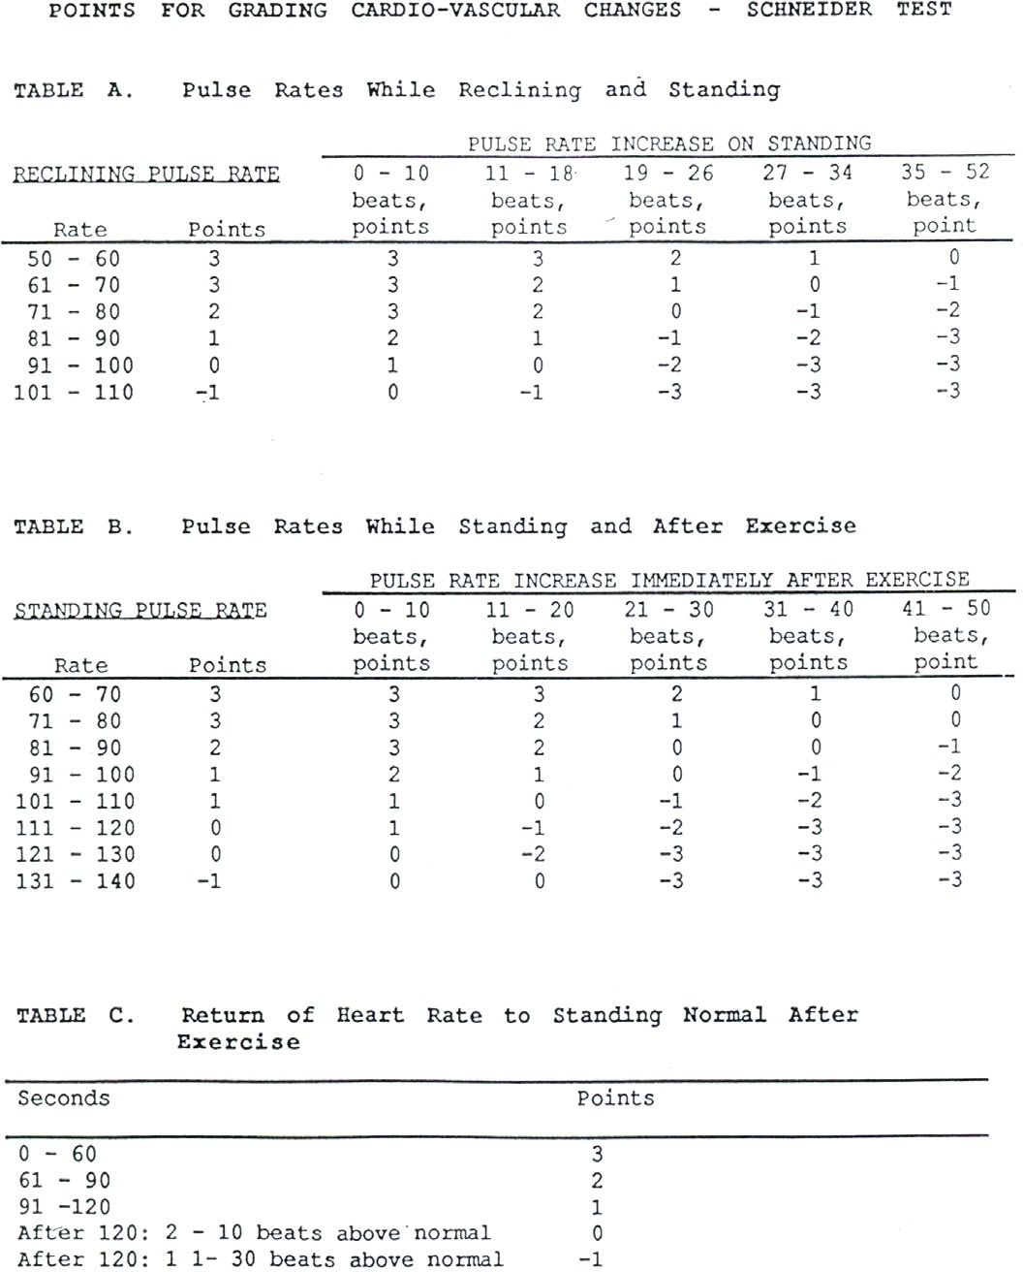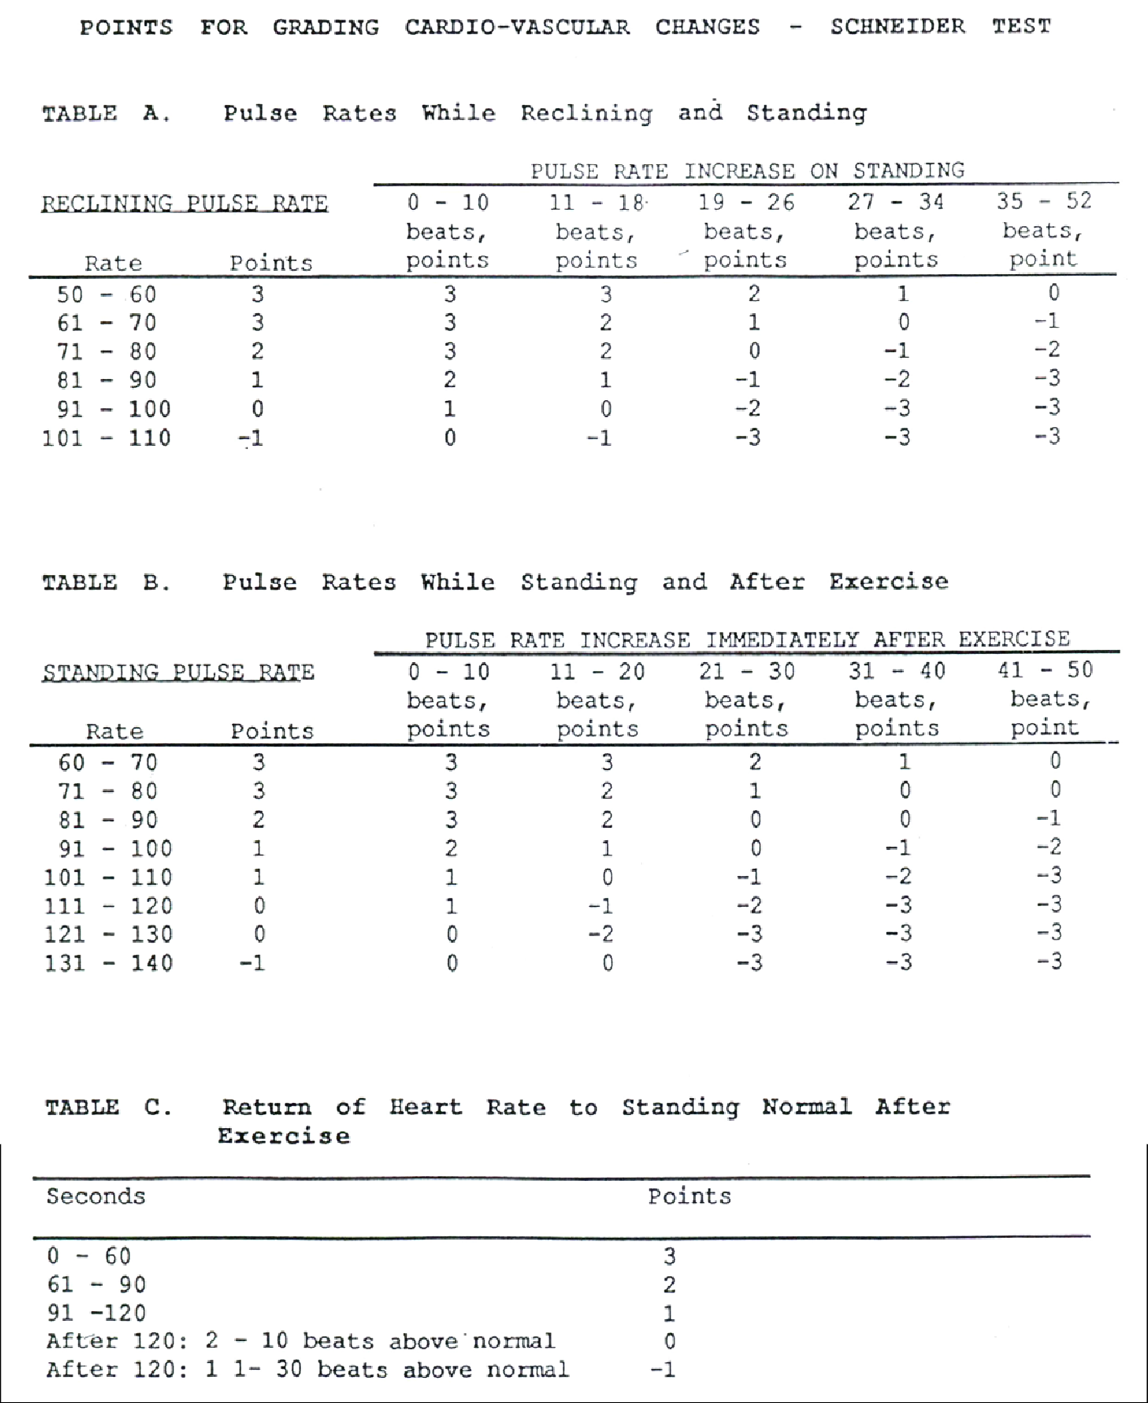

= 5 scores in total
= 5 scores in total

1. 2.

3. 4.

5.

1.
2.
3.
4.

5.

