ASSIGNMENT 1
Linear Programming (LP)
Formulation, Graphical Method and Excel Solver

Kamila Foudil-Bey
300012030
ADM2302[M]

Integrity Sheet

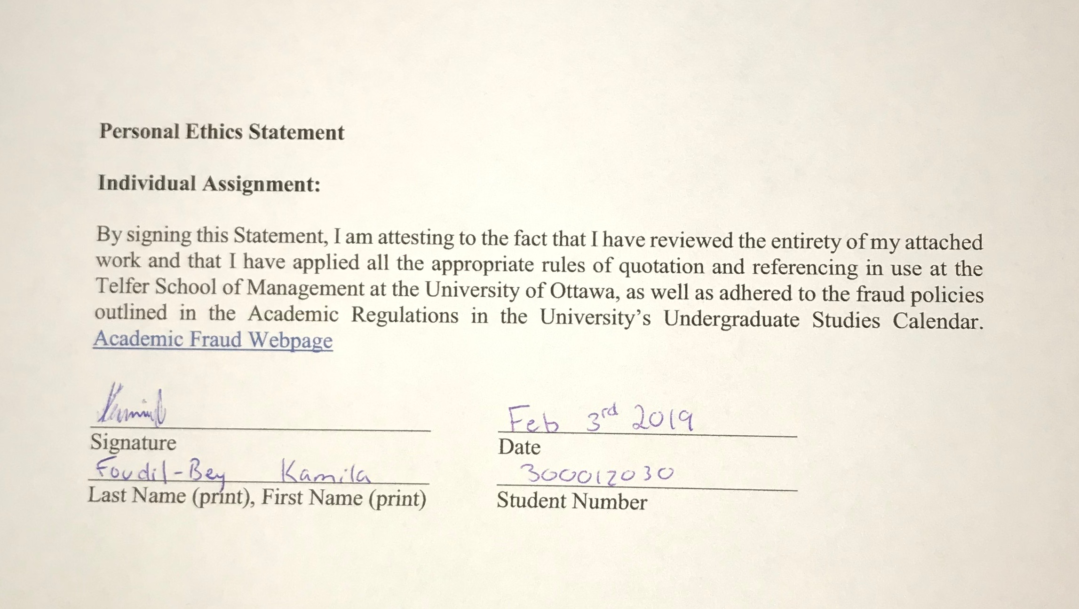

Problem 1:

- The 0.40 in the objective function represents the profit on selling one box of regular chips.
- The product of the 0.30 and x₂ in the objective function represents the total amount profit by selling crinkle cut chips.
- The 144 minutes in the cutting constraint represent that the cutting time in the factory must be less than or equal to 144 minutes for boxes of regular chips and crinkle cut chips.
- The 4.80 in the packing constraint represents the time taken for packaging of a single regular chip box.
- x₂ ≥ 20 boxes represent that the minimum number of crinkle chips should be at least 20 in the production constraints.
- The product of 3.2 and x₁ in the frying constraint represents the time taken for frying regular chips is equal to 3.2 minutes, meaning that 3.2 and x₁ represents the total time spent in frying the regular chips.
- They two key questions that can be answered by this model are:
  - What is the maximum profit that can be obtained by making fixed batch of regular and crinkle chips?
  - Appropriate amount of time to create each resource.
- Amount of each resource that will be used:
  - Cutting:
    - 3.6(15) + 0.80(70) = 110 minutes
  - Frying
    - 3.2(15) + 1.6(70) = 160 minutes
  - Packing
    - 4.8(15) + 7.2(70) = 576 seconds
- Amount of slack for each resource
  - Cutting:
    - 144 – 110 = 34 minutes
  - Frying:
    - 160 – 160 = 0
  - Packing:
    - 576 – 576 = 0
  - Therefore, there are 34 minutes left over of cutting resource, 0 minutes for frying resource, and 0 seconds for packing resource.

Problem 2:

- Constraint 1: 3x₁ + 5x₂ = 30
When x₂ = 0 x₁ = 10
When x₁ = 0 x₂ = 6
Therefore, (10,0) & (0,6)

Constraint 2: 6x₁ + 4x₂ = 48
When x₂ = 0 x₁ = 8
When x₁ = 0 x₂ = 12
Therefore, (8,0) & (0,12)
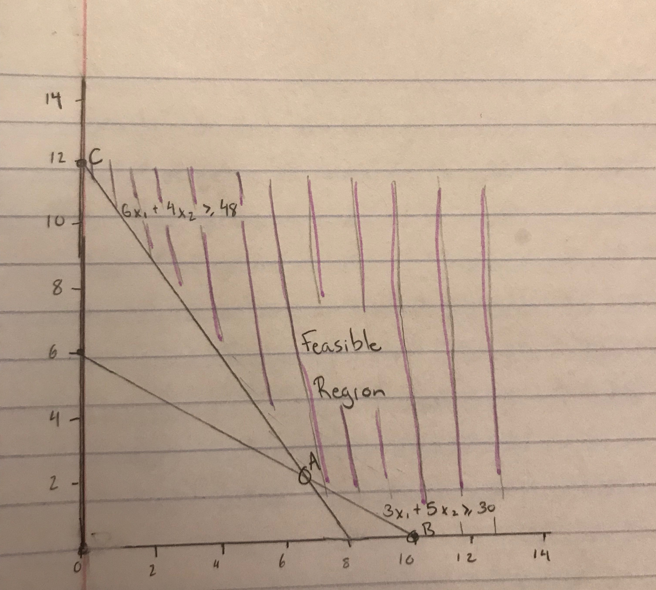

- Optimal solution will be determined by using the corner point method:
A = (3,3)
Calculations for point A
B 3x₁ + 5x₂ =30 & C 6x₁ + 4x₂ = 48
x₁ = 10 – 5/3x₂, therefore sub x₁ into equation C
C 60 - 10x₂ + 4x₂ = 48
6x₂ = 12
x₂ = 2
Sub x₂ into equation C
6x₁ + 4(2) = 48
x₁ = 20/3
Therefore, corner point for A is (20/3, 2)
Z = 0.40(20/3) + 0.40(2) = 3.47

B = (10,0)
Z = 0.40(10) + 0.40(0) = 4

C = (0,12)
Z = 0.40(0) + 0.40(12) = 4.8

Therefore, the optimal solution which allows for minimization is point A (20/3, 2) which gives a minimum cost of $3.47.

- For the objective function line to be parallel to the carbohydrate’s constraint:

Carbohydrate constraint: 6x₁ + 4x₂= 48

Let K= new cost of x₁
Minimize Z= K(x₁) + 0.4(x₂)

Ratio of coefficients of same variables must be equal to become parallel:
$\frac{k}{6}$ = $\frac{0.4}{4}$
K= $\frac{6(0.4)}{4}$ = 0.6
Therefore, the cost of x₁ would have to be $0.6 in order for the objective
function to be parallel to the carbohydrate constraint.

Problem 3:
- Constraint 1: x₁ + x2 = 6
When x₂ = 0 x₁ = 6
When x₁ = 0 x₂ = 6
Therefore, (6,0) & (0,6)
Constraint 2: x₁ – x₂ = 0
When x₂ = 0 x₁ = 0
When x₁ = 0 x₂ = 0

Therefore, (0,0) & (0,0)

Constraint 3: x₁ + x₂ = 3
When x₂ = 0 x₁ = 3
When x₁ = 0 x₂ = 3
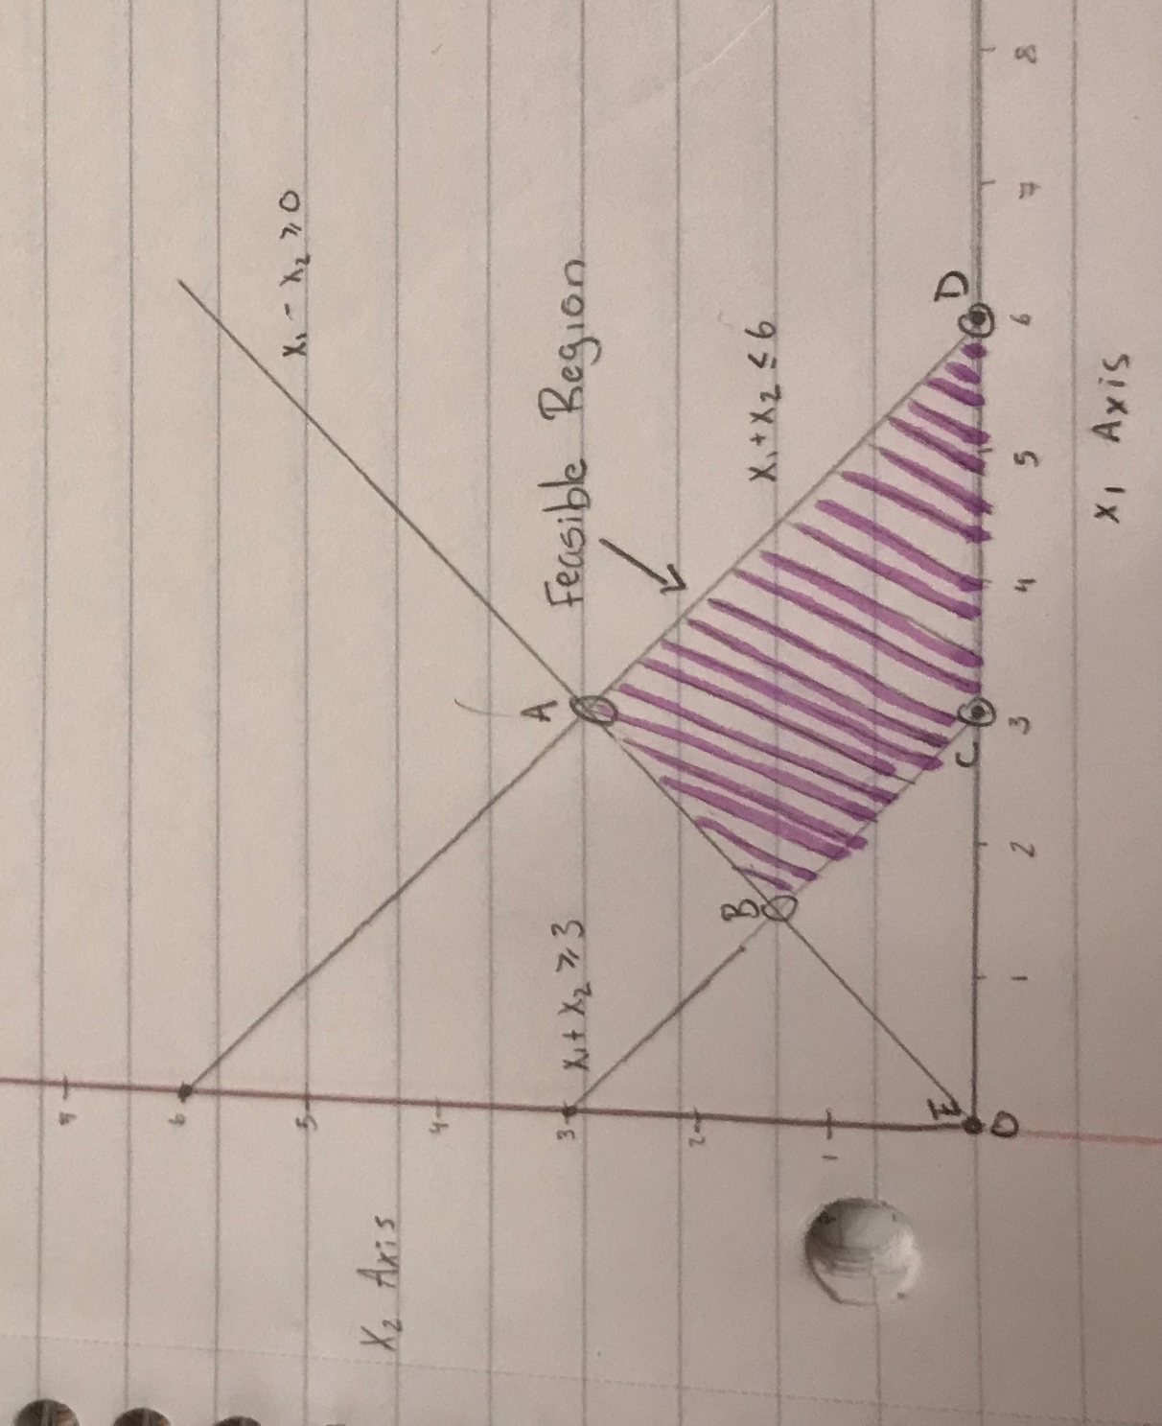
Therefore, (3,0) & (0,3)

- Optimal solution will be determined by using the corner point method:
A = (3,3)
Calculations for point A
E x₁ – x₂ = 0 & D x₁ + x₂ = 6
x₁ = x₂, therefore sub x₁ into equation D
D x₂ + x₂ = 6
2x₂ = 6
x₂ = 3
Sub x₂ into equation D
x₁ + 3 = 6
x₁ = 3
Therefore, corner point for A is (3,3)
Z = 3 + 2(3) = 9

B = (1.5,1.5)
Calculations for point B
E x₁ – x₂ = 0 & C x₁ + x₂ = 3
x₁ = x₂, therefore sub x₁ into equation C
D x₂ + x₂ = 3
2x₂ = 3
x₂ = 1.5
Sub x₂ into equation C
x₁ + 1.5 = 3
x₁ = 1.5
Therefore, corner point for B is (1.5,1.5)
Z = 1.5 + 2(1.5) = 4.5

C = (3,0)
Z = 3 + 2(0) = 3

D = (6,0)
Z = 6 + 2(0) = 6

E = (0,0)
Z = 0 + 2(0) = 0

Therefore, the optimal solution which allows for maximization is point A (3,3) which gives a maximum value of 9.

- To determine which constraints are binding, we must calculate the slack of each resource.
Constraint 1 x₁ + x₂ = 6
3 + 3 = 6
6 = 6 Slack = 6 – 6 = 0
Constraint 2 x₁ – x₂ = 0
3 – 3 = 0
0 = 0 Slack = 0 – 0 = 0
Constraint 3 x₁ + x₂ = 3
3 + 3 = 3
6 = 3 Slack = 6 – 3 = 3

Therefore, x1 + x2 ≤ 6 and x1 – x2 ≥ 0 are binding.

Problem 4:
- Let x₁ be number of tables produced and let x₂ be the number of tables produced.

Max Z = 400x₁ + 100x₂ Represents the Total Profit
Subject to:
50x₁ + 25x₂ ≤ 2500lbs Represents Total Quantity of Oaks
6x₁ + 6x₂ ≤ 480 hours Represents Total Labor Hours
2x1 -x2 ≤ 0 Represents the Proportion of Tables vs Chairs
x₁, x₂ ≥ 0 Non-negative constraint

Excel Solver Solution: Therefore, according to the optimal solution, the company is to make 25 tables and 50 chairs for a maximum profit of $15,000.


