chapter 1

What is marketing?
“Marketing is an organizational functions and processes for creating, communicating and delivering value to a customer and creating customer relationships that will benefit the organization and the stakeholders.”
All of the activities that help business reach their target market effectively.
The ultimate outcome for marketing is a successful exchange.
Many successful companies focus in consumer oriented marketing, examining their everyday lives to create products that feel their needs.
Marketing attracts new customers, and retaining and growing current customers.
Activities included in marketing:
- Public Relations
- Sales Promotion
- Advertising
- Social Media
- Pricing
- Distribution
Many others…..

The marketing process

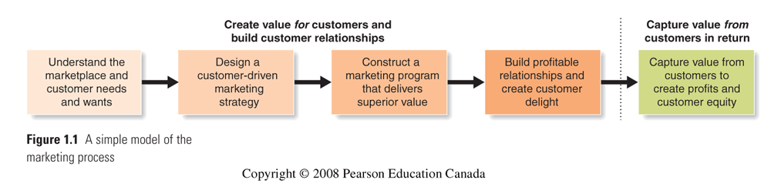

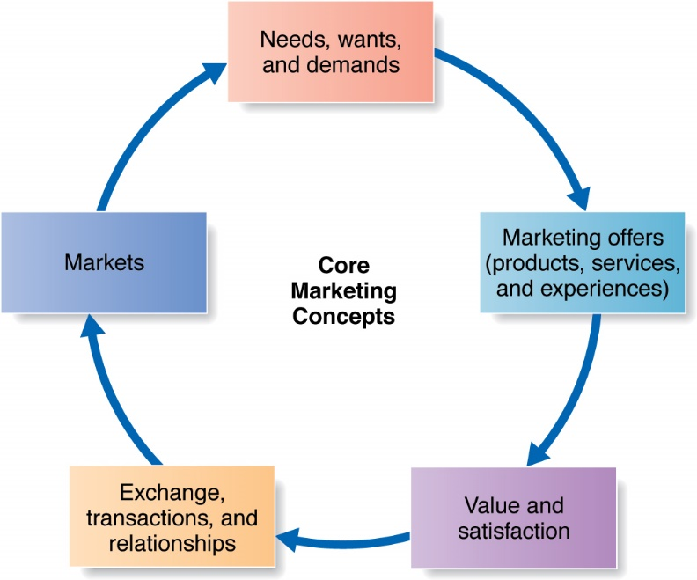

Core Concepts

Step 1 understand the market place and customers needs and wants
- Needs, wants, and demands
- Needs – state of deprivation e.g. I’m thirsty
- Wants- The form of needs as shaped by culture and the individuals personality e.g. I am thirsty , so I want ( coke, water , sprite , juice)
- Demands – wants which are backed by buying power.
- Marketing offers: including products, services and experiences
- Combination of products, services, information or experiences that satisfy a need or want
- Should focus on providing a solution
- Value and satisfaction
- Value
- Customers form expectations regarding value
- Marketers must deliver value to consumers
- Satisfaction
-A satisfied customer will buy again and tell others about their good experience

- Exchange, transactions and relationships
1. The act of obtaining a desired object from someone by offering something in return

- Markets
1. Set of actual and potential buyers of a product
2. Marketers seek buyers that are profitable

Step 2 – Designing a customer – driven marketing startegy

Marketing management - choosing and targeting markets to build profitable relationships with them.
A winning marketing strategy – CUSTOMER CENTERED MAREKTING STRATEGY
- What customers will we serve? Market?
  - Market segmentation and target marketing. Market segmentation is creating groups of similar consumer together. This helps them better target their marketing, by sending the right message to the right consumers.
TARGET MARKETING
- Evaluating the attractiveness of each market segment
- Selection of segments with greatest long-term profitability
- Deciding which segment(s) to enter
- A company can choose one or several segments to target
MARKET SEGMENTATION
- Dividing a market into groups with distinct needs who might require (respond to) different marketing mixes
- Market segment is a group of consumers who respond in similar ways to marketing efforts
- Bases for segmentation
MARKET POSITIONING
- The place the product occupies in the consumer’s mind
- Products are positioned relative to competing products
- Marketers look for clear, distinctive and desirable places in positioning
- Differentiation by offering and delivering greater value

  - Marketers select customers that can be served profitably
- How can we serve these customers best?
  - By defining a value proposition that will differentiate and position the brand in the marketplace. Why is our brand better?
  - Is set of benefits or values a company promises to deliver to consumers in order to satisfy their needs

Marketing management orientations
- Production Concept
  - Consumers will favor available/affordable products
  - Focus on improving production/distribution efficiency
  - Still useful when demand exceeds supply
- Product Concept
  - Consumers favor products with the best:
    - Quality
    - Performance
    - Features
  - Focus on continuous product improvements
- Selling concept:
  - Products need large-scale selling/promotion effort
  - Focus on the hard sell
  - Unsought goods, or when company has overcapacity
  - Manufactures the product first
  - Sales volume oriented
- The marketing concept:
  - Achieve organizational objectives by
    - Determining needs and wants of target consumers
    - Delivering satisfaction
    - Better than competitors
    - Identifies the customer first
    - Customer satisfaction with profit oriented

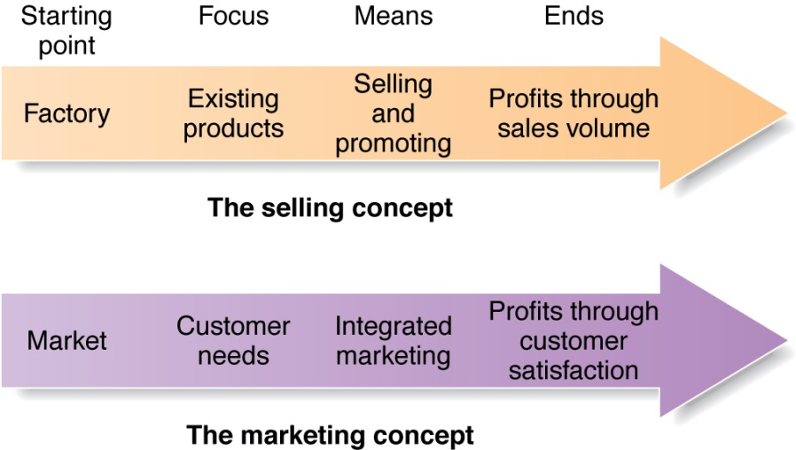

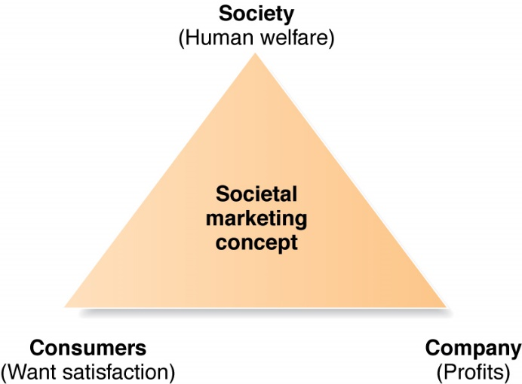
- The Societal Marketing Concept e.g. technological new innovation or educational ( creating awareness about various social issues through promotional campaigns)
Companies should make good marketing decisions by considering:
  - Consumer’s wants
  - Company’s requirement
  - Consumer’s long-run interest
  - Society’s long-run interest

- Objectives

  - To maintain a long term relationship with customers
  - To create a better image in the society for the company than its competitors
  - To carry out its social responsibilities. Developing community awareness towards its brands.
  - To increase he consumer base market share.
- Benefits
- It helps to build a better image of the company
- Gives a competitive advantage over the competitors
- Useful in customer retention and long term relationship
- Increases the sales and market share
Facilitate expansion and growth in the long term.
- Drawbacks
- Useful for mass marketing products but difficult to implement for products aimed at a specific target market
- Social conscience is not present in all companies
- Lack of adequate encouragement from the government.

Step 3 PREPARING a marketing plan and program

Build customer relationships by transforming the marketing strategy into action
Marketing is made up of 4 elements. The elements should be used in a cohesive plan to effectively target the consumer.
Product and price – target customers
Promotion and place – intended positioning
- Product – physical product or service
- Quality and design
- Brand name
- Packaging
- Labelling
- Warranty
- Features
- Services
- Price- the amount a consumer pays
- Pricing tactics :
- Discounting
- Physiological pricing
- Product bundle
- Allowances
- Payment period
- Credit terms

- Place – where the product is purchased and how
- Channels
- Retailer
- Wholesaler
- By the manufacturer
- Coverage
- Locations
- Transportation
- Promotion – tools used to get the message out
- Advertising
- Sales promotion
- Personal selling
- Public relations

step 4 building customer relationships

CRM – CUSTOME REALTIONSHIP MANAGEMENT
Building and maintaining profitable customer’s relationships by delivering superior customer vale and satisfaction. It deals with all aspects of acquiring, keeping and growing customers.
Relationship building blocks: Value and satisfaction
- Customer Perceived Value
  - The customers’ evaluation of the difference between benefits and costs.
  - Customers often do not judge values and costs accurately or objectively.
- Customer Satisfaction
  - Product’s perceived performance relative to customers’ expectations.
CUSTOMER RELATIONSHIPS LEVELS AND TOOLS
- Basic relationships - low margin customers
- Full partnerships -key customers
- Frequency marketing programs - Reward customers who buy frequently or in large amounts
- Club marketing programs - Offer members special discounts and create member communities
Partnership Relationship Management
- Working closely with partners in other company departments and outside the company to jointly bring greater value to customers
- Partners Inside the Company
- Partners Outside the Firm
  - Strategic partners
  - Supply chain management

STEP 5 CAPTURINF VALE FOM CUSTOMERS

- Creating Customer Loyalty and Retention
  - Customer delight leads to emotional relationships and loyalty
  - Customer lifetime value shows true worth of a customer
- Growing Share of Customer
  - The portion of the customer’s purchasing that a company gets in its product categories.
  - Achieved through offering greater variety, cross-sell and up-sell strategies
CUSTOMER EQUITY
- Building Customer Equity
  - The combined customer lifetime values of all current and potential customers
  - Measures a firm’s performance, but in a manner that looks to the future
  - Choosing the “best” customers is key
- Customer equity vs. Market share
  - Market share: Measurement of past/current performance
  - Customer equity: Measurement of future performance
  - Cadillac vs. BMW in 70s and 80s
    - Cadillac:
      - Higher market share & “North American Luxury”
      - Brand image was old & traditional Couldn’t attract young buyers Customer equity was falling as time goes on
      - Only 15%(?) of market share (Current)
    - BMW:
      - Lower market share, but “youthful & vigorous” image
      - Could attract younger buyers Higher customer equity
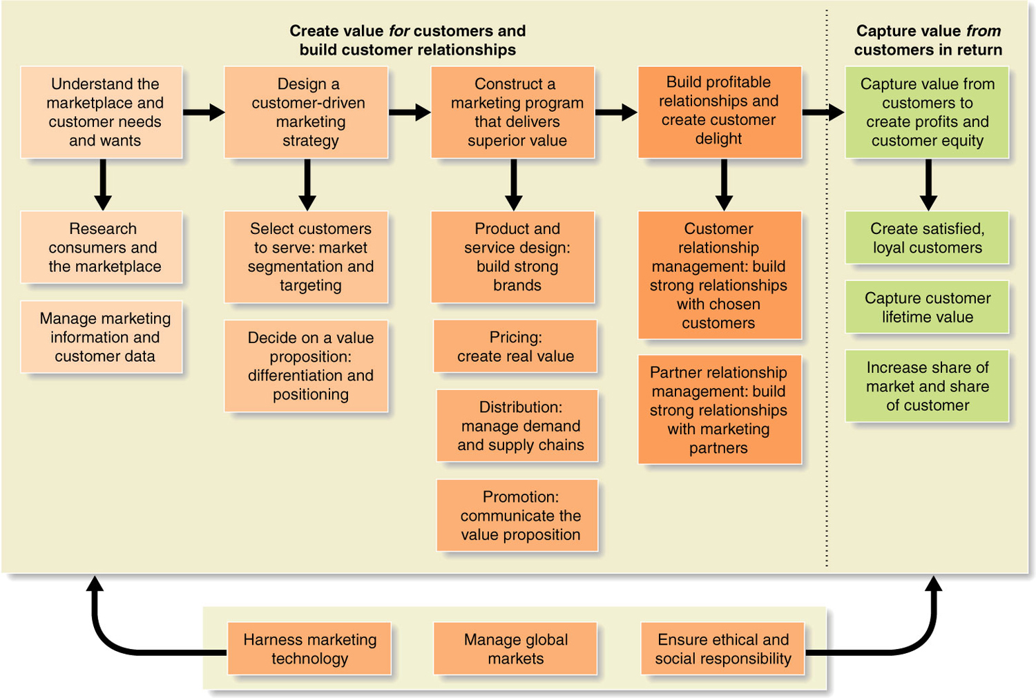

CHAPTER 2

Marketing sTRATEGY

- Strategic Planning:
  - An overall company strategy for long-run growth and profitability
  - developing/maintaining a strategic fit between
    - organizational goals and capabilities, and

    - changing marketing opportunities

The three levels of strategy in an organization:
- CORPORATE LEVEL
Mission
Goal
Business portfolio

- BUSINESS UNIT LEVEL

- FUNCTIONAL STRATEGY
Information systems
Research and development
Finance
Marketing
Manufacturing
Human Resources

step 1 mission statement

Mission statement
- A statement of the organization’s purpose
  - What it wants to accomplish in the larger environment
- “Invisible hand”
- The mission statement must avoid being too narrow or too broad
- A good mission statement should be:
  - Market oriented, not product oriented
  - Realistic
  - Specific
  - Motivating

step 2 setting company objectives and goals

- The mission is turned into detailed business and marketing objectives
- Marketing strategies and programs must develop to support marketing objectives
- Type of goals:
  - Profit
  - Revenue
  - Market share
  - Quality
  - Customer satisfaction

step 3 designing the business portafolio

- A business portfolio is the collection of businesses and products that make up the company
- Business portfolio planning involves two steps:
  - Analyzing its current business portfolio
Analyzing the Current Business Portfolio
- Portfolio analysis is a strategic planning tool to identify/evaluate businesses that make up the firm and make resource allocation decisions
Strategic business unit (SBU):
- Unit with separate mission and objectives
- Planned independently from other company businesses
- Used as the building block of portfolio analysis
  - Shaping the future portfolio by developing strategies for growth and down sizing

BCG Matrix

  - STAR
- High share of high growth market, but may not generate enough cash to support their own demanding needs.

  - CASH COW
- Dominant share of slow-growth “mature” market
- Generates large amounts of cash
- Able to be used for company overhead and new investment
- QUESTION MARK
- Products with a low share of a high growth market.
- Requires lots of cash to maintain market share.
- Mgmt. must decide if continued investment is justified
- DOG
- Products with a low share of a low growth market.
- Do not hold promise of becoming winners

- Developing Strategies for growth and Downsizing
  - Marketing must identify, evaluate, and select market opportunities and lay down strategies for capturing them
  - Product Market Expansion Grid
    - A portfolio-planning tool for identifying company growth opportunities
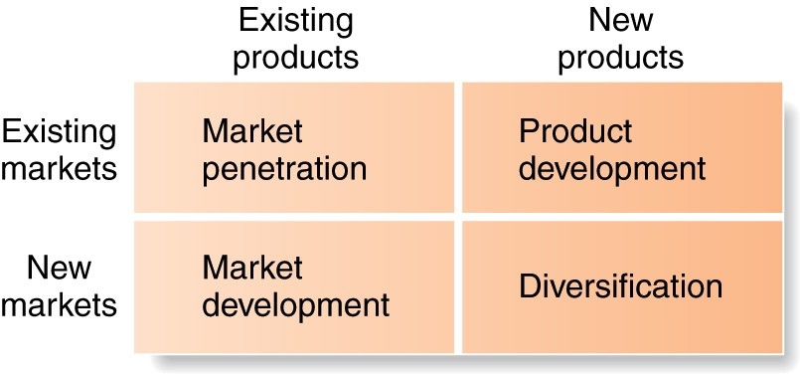

PARTNERING TO BUILD CUSTOMER REALTIONSHIPS

- Value chain:
  - Series of departments that carry out value-creating activities
  - Design, produce, market, deliver, and support a firm’s products
- Value delivery network:
  - Company, suppliers, distributors, and customers
  - Partner with each other to
  - Improve the performance of the whole system

- Marketing Strategy
  - The marketing logic by which the business unit hopes to achieve its marketing objectives
- Marketing Mix
  - The company designs a mix made up of factors under its control
- The company engages in marketing analysis, planning, implementation, and control

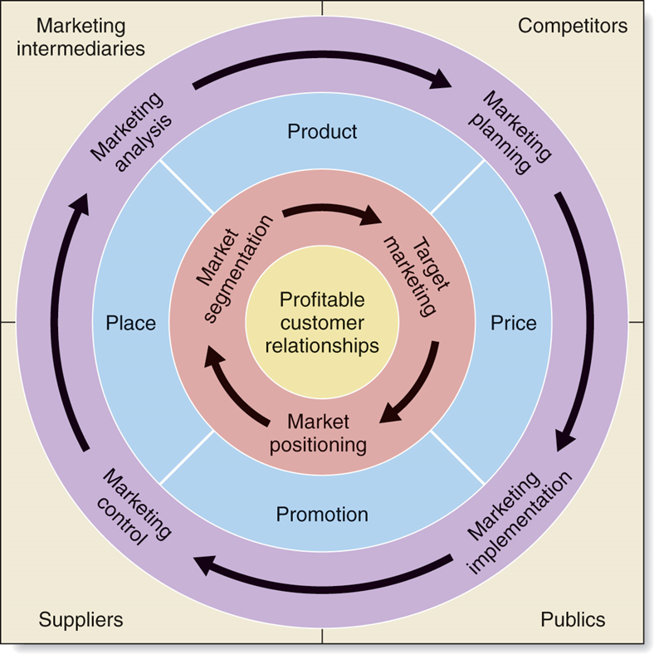

MANAGING THE MARKET EFFORT

- 4 marketing management functions:
  - Marketing Analysis: internal analysis (strengths/weaknesses), external analysis (opportunities and threats)
  - Marketing Planning: deciding on marketing strategies to attain objectives
  - Implementation: turning plans into action (“doing things right” is as important as “doing the right things”)
  - Control: evaluating results (operational control, strategic control)

- Return on marketing (marketing ROI)
  - The net return from a marketing investment divided by the costs of the investments

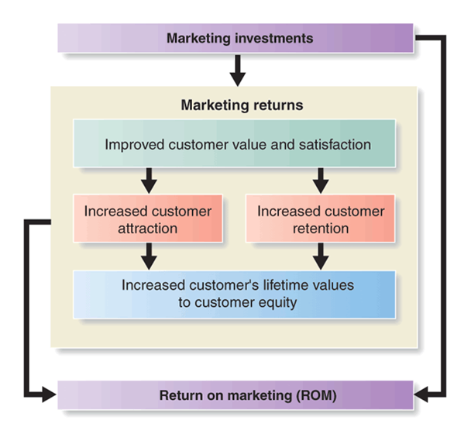

CHAPTER 3

MARKETING ENVIRONMENT AND swot

THE MARKETING ENVIRONMENT
- Marketing Environment:
  - The actors and forces outside marketing that affect marketing management’s ability to build and maintain successful relationships with target customers
- Micro environment
  - Includes the actors close to the company

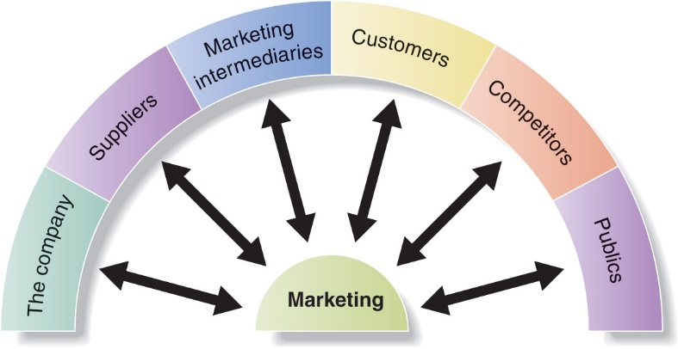

- Effective partnership relationship management with suppliers is essential
- Companies must work with their intermediaries as partners rather than simply as channels through which they sell their products.
- The five types of customer markets
  - Consumer
  - Business
  - Reseller
  - Government
  - International
- A marketer must monitor its competitors’ offerings to create strategic advantage
- Seven publics include:
  - Financial
  - Media
  - Government
  - Citizen-action
  - Local
  - General
  - Internal

- Macro environment
  - Involves larger societal forces
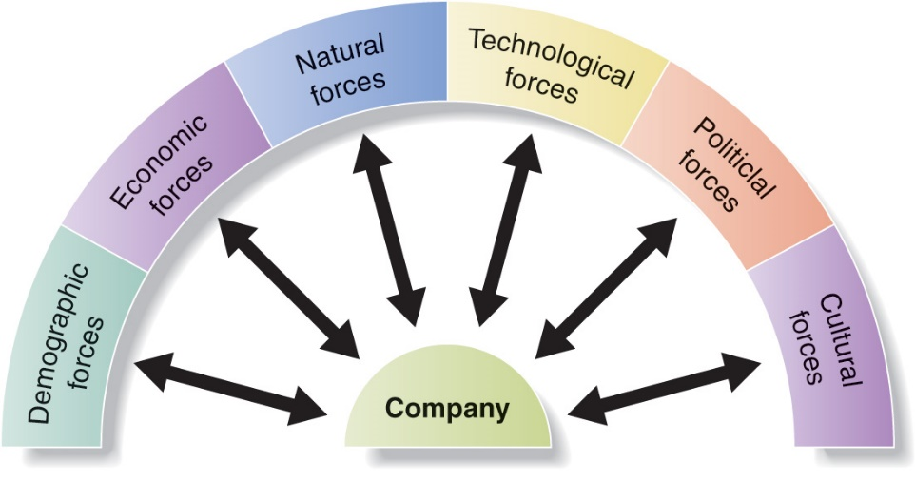

- Demographic Environment:
  - The study of human populations in terms of size, density, location, age, gender, race, occupation and other statistics
  - World population will exceed 8.1 billion by 2030
- The Changing Canadian Household
  - The nuclear family has led to the “crowded nest” with boomerang kids, and extended families
  - Delayed marriages
  - Common-law arrangements
  - Fewer children
  - High divorce rate
  - Single-parent families
  - Working women: 48% of work force
  - More dual-income families
- Geographic Shifts in Population
  - Growth in population is not uniform
  - Continued movement from rural to urban areas
  - Interprovincial moves
  - Growth of suburban areas
  - People who “telecommute” has increased creating a booming SOHO market

ECONOMIC FORCES
- Factors that affect consumer buying power and spending patterns
- Types of economy will influence resources to work with
- Changes in Income
- Marketers should pay attention to income distribution as well as average income.
  - Upper class, middle class, working class, and underclass
- The distribution of income has created a two-tiered market: the affluent and the less affluent
- Changing Consumer Spending Patterns
- Engel’s laws: amount spent on various categories changes as income rises
NATURAL ENVIRONMENT
- Involves the natural resources that are needed as inputs by marketers or that are affected by marketing activities
- Trends
  - Shortages of raw materials
  - Increased pollution
  - Increased government intervention
  - Canadian federal law: Environmental Protection Act (1989)
  - Green movement
  - Focus on environmental sustainability strategies
TECHNOLOGICAL ENVIRONMENT
- The most dramatic force shaping our destiny
- Rapidly changing force which creates many new marketing opportunities but also turns many existing products extinct
- Research and development is a key element
  - Canadian spending on R&D is low, ranked 15th in the world
  - Many government programs to encourage more R&D spending
- Government agencies to regulate new product safety
POLITICAL ENVIRONMENT
- Consists of laws, government agencies, and pressure groups that influence or limit various organizations and individuals in a given society
  - Legislation affecting businesses worldwide has increased
  - Laws protect companies, consumers and the interests of society
  - Increased emphasis on socially responsible actions

CULTURAL ENVIRONMENT
- Made up of institutions and other forces that affect a society’s basic values, perceptions, preferences and behaviors.
- Persistence of Cultural Values
- Secondary Cultural Values are more open to change
  - People’s views of themselves, others, organizations, society, nature, and the universe

CULTURAL ENVORONMENT INCLUDES PEOPLES VIEWS OF………

- Themselves - Identify with brands for self-expression
- Others -Recent shift from “me” to “we” society
- Organizations -Trend of decline in trust and loyalty to companies
- Society -Patriotism on the rise
- Nature -“lifestyles of health and sustainability” (LOHAS) consumer segment
- Universe -Includes religion and spirituality

SWOT

1)
- Internal factors (microenvironment) identify Strength and Weakness
  - Internal factors (Controllable)
    - Financial resources
    - Technological expertise (R&D, patent & MIS, etc.)
    - Cost Structure
    - Relationship with suppliers
    - Relationship with customers
    - Human resources

- External factors (macro environment) identify Opportunities and Threats
    - Competition
    - Political/Regulatory
    - Economic
    - Social/Cultural
    - Technological

- Together, they form the raw material of the SWOT analysis.
2) Evaluate the impact of each relevant factor
  - Internal factors are usually evaluated against both existing and potential competitive rivals
  - Positive factors (Strengths)
    - What are our competitive advantages? What distinct competencies do we have?
  - Negative factors (Weaknesses)
    - In what areas are we vulnerable? Do we understand our resource limitations?
  - External factors are evaluated with respect to the positive and negative factors just identified
  - Positive factors (Opportunities)
    - What might we do? What do we do best? What must we do to take advantage?
  - Negative factors (Threats)
    - What are the potential risks? Will we lose our competitive advantage? Are there any obstacles? What are the possible constraints?

chapter 5

competitor analysis and marketing research

COMPETITOR ANALYSIS
  - Analyze competition
    - Identify Competitive Advantage
    - Identify Competitors
    - Analyze Competitors

FRAMEWORK OF COMPETITIVE ADVANTAGE

Positions of Advantage
- Costs
- Market Position
- Technology/Product

Sources of Advantage
- Superior Skills
- Superior Resources
- Effective Org processes
Performance Outcomes
- Satisfaction
- Customer Loyalty
- Increased Market Share
- Improved Profitability

IDENTIFYING COMPETITIVE ADVANTAGE
- Something that your company does especially well in comparison to your competitors.
  - Must be difficult for a competitor to imitate.
- Types:
  - High Quality products
  - Low Cost/Low Price
  - Superior Customer Service
  - Convenient Distribution

MARKET INFO SYSTMES & MARKETING RESEARCH PROCESS

- Assessing information needs
- The MIS serves company managers as well as external partners
- The MIS must balance needs against feasibility:
  - Not all information can be obtained
  - Obtaining, processing, sorting, and delivering information is costly

- Developing needed information
Internal databases
- Information collected from different sources within the company, and stored within the organization’s information system
  - Accounting system
  - Operations/production
  - Sales reporting system
  - Past research studies
- Internal data is cheap, quick, and easy
- May not be in a usable form for the decision to be made
- May be incomplete or inappropriate to a particular situation

Marketing Intelligence
- Marketing intelligence is the systematic collection and analysis of publicly available information about competitors and trends in the marketing environment.
- Proactive approach to keeping track of what is going on within the organization’s marketing environment
- Many sources of competitive information exist:
  - Employees, customers, trade shows, websites, marketing communications, suppliers, resellers, professional information services, and “dumpster diving”
Marketing Research
- Marketing research is the systematic design, collection, analysis, and reporting of data relevant to a specific marketing situation facing an organization.
  - A multi-step, purpose-driven process
  - Measure effectiveness of marketing actions, sales potential, try to understand consumer behaviour
  - Can be done by company personnel or contracted out to outside companies

Define the problem & research objectives
Develop the research plan
Secondary data collection
Primary data collection
Implementing the research plan
Interpret the findings & Present the findings
- Distributing and using information

Steps in the Marketing Research Process
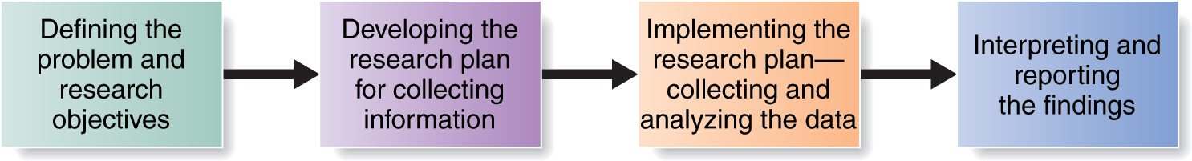
Step 1: Defining the problem and research objectives

- Exploratory research:
  - Research conducted to gather information to help better define problems and opportunities observation and interview are commonly used for this purpose
- Descriptive research:
  - Research conducted to better describe marketing problems, situations, or markets, such as
  - Demographic characteristics of markets, attitudes of consumers, and market potential for a product
  - Surveys and personal interviews are commonly used
- Causal research:
  - Research to test cause and effect relationships between variables of interest
  - Experimental approach

Step 2: Developing the Research Plan
- Translating the research objectives into specific information needs
- Research plan is a written document which outlines the type of problem, objectives, data needed, and the usefulness of the results. Includes:
  - Secondary data: Information collected for another purpose which already exists
  - Primary data: Information collected for the specific purpose at hand. Primary research decisions:
  - Research approaches
  - Observation research using people or machines : Discovers behavior but not motivations
  - Survey research: Effective for descriptive information
  - Experimental research: investigates cause and effect relationships
  - Contact methods :
- Key Contact Methods include:
- Mail surveys
- Telephone surveys
- Personal interviewing: Individual or focus group
- Online research
  - Sampling plan
- Sample: subgroup of population from whom information will be collected
- Sampling Plan Decisions:
  - Sampling unit
  - Sample size
  - Sampling procedure:
    - Probability samples
    - Non-probability samples

  - Research instruments
- Questionnaires
  - Include open-ended and closed-ended questions
  - Phrasing and question order are key
- Mechanical instruments
  - Nielsen’s people meters
  - Checkout scanners
  - Eye cameras
Step 3: Implementing the Research Plan
- Data is collected by the company or an outside firm
- The data is then processed and checked for accuracy and completeness and coded for analysis
- Finally the data is analyzed by a variety of statistical methods

Step 4: Interpreting and Reporting the Findings
- The research interprets the finding, draws conclusions and reports to management
- Managers and researchers must work together to interpret results for useful decision making

Marketing Info Systems
Distributing and Using Marketing Information
- Routine reporting makes information available in a timely manner.
- User-friendly databases allow for special queries.
- Intranets and extranets help distribute information to company employees and value-network members.

chapter 6 - Consumer Buyer Behavior
Model of Buyer Behavior
- Buyer behaviour model:
  - Consumers are exposed to many stimuli including the marketing mix and other external factors
  - Buyer characteristics influence how these stimuli are perceived and processed
  - Buyer decision process results in behavior
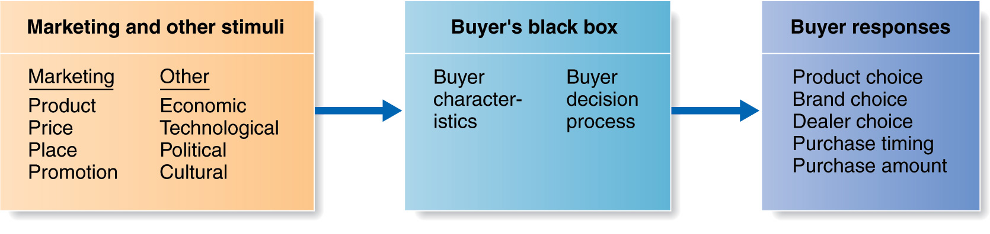
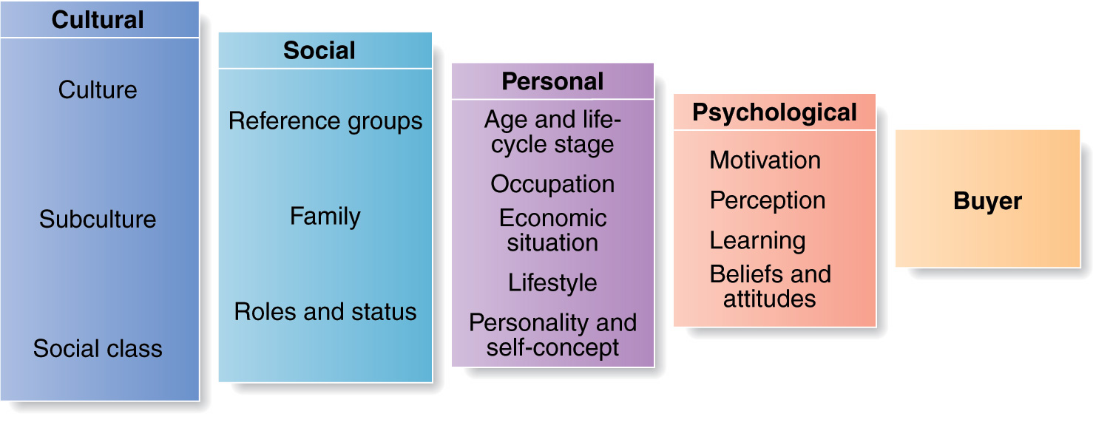
Factors Influencing Consumer Behavior

Outcome:
Buy/not buy
Individual-level
factors
Larger society & group-level factors

- Culture:
  - Set of basic values, perceptions, wants and behaviors
  - Learned from family and important institutions
  - Core values remain stable, while secondary values change slowly
  - Growing sense of wanting to be distinct from the U.S., despite media spillover
  - Differences between cultures are important to international trade
- Subculture:
  - Group of people with shared value systems
  - Based on common life experiences and situations

- Social classes:
  - Relatively permanent and ordered divisions in a society
  - Whose members share similar values, interests, and behaviors
  - Measured by a combination of income, occupation, education, wealth, and other variables
  - Marketers are interested because consumption behavior tends to be consistent within a given social class
- Groups:
  - Consumers belong to membership groups
  - Compare themselves to reference groups
  - May aspire to becoming a member of a group
  - Group influence varies across products and brands; strongest when the product is visible to (respected) others; symbolic nature
- Opinion leader:
  - Person within a reference group
  - Skills, knowledge, personality
  - Who has exerts influence on others

- Family:
  - First and strongest influence on behavior
  - Roles and influences within the family have been extensively researched
  - Past assumptions about gender influence are less valid today
  - Children learn consumption behavior early on

- Roles and status:
  - Consumers play many roles, each requiring some type of consumption behavior
  - Products can be used to show status
Age and Lifecycle stage

Occupation

Economic situation

Lifestyle

Personality and Self-concept

- Personal factors:
  - Consumer needs change over their lifetimes in (somewhat) predictable ways
- Family life cycle: combines age with marital status and presence of children to classify consumers into groups
LIFE-CYCLE STAGES:

Older
Older married
Older unmarried
Older with children again
Middle-aged
Single
Same-sex couples
Married without children
Married with children
Divorced without children
Divorced with children
Young

Single with children
Married without children
Married with children
Divorced with children

- Occupation:
  - The type of work performed may necessitate different consumption patterns, such as blue collar versus white collar
  - Will also indirectly affect how much income is available
- Economic situation:
  - How much income (or ability to borrow) is available for consumption
  - Economic indicators such as employment, inflation, interest rates, and consumer debt levels are used to predict changes in buying power

- Lifestyle:
  - A person’s pattern of living as expressed by their activities, interests, and opinions (AIO’s)
  - Lifestyle segmentation
- Personality:
  - Unique psychological characteristics leading to relatively consistent and lasting responses to one’s own environment
  - Traits (e.g., self-confidence, autonomy, aggressiveness, sociability)
  - Useful for analyzing product and brand choices

- Motivation:
  - Humans are characterized by goal-directed behavior
  - Different needs/wants produce different behavior
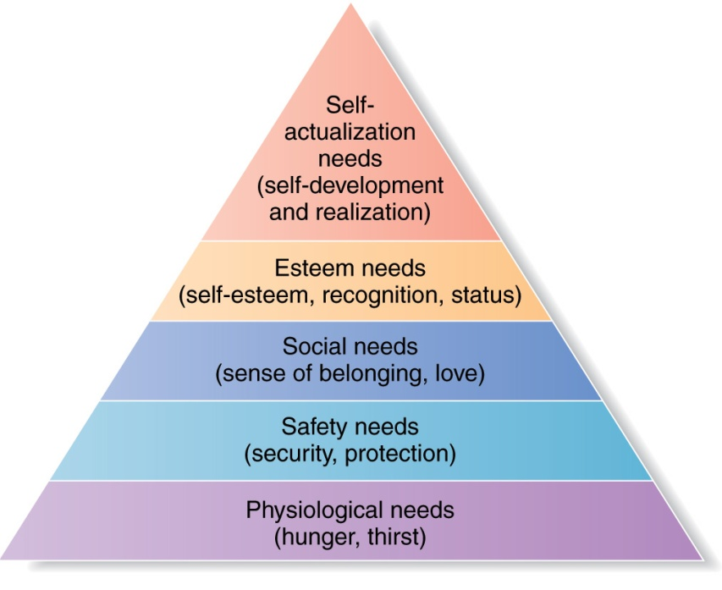
  - A need that is sufficiently pressing to direct the person to seek satisfaction
- Freud’s work focused on hidden and unconscious urges directing our behavior
- Maslow’s hierarchy of needs focuses on how needs can be classified and ordered in terms of importance
- Individuals are motivated to satisfy needs at a particular level before moving on

- Perception:
  - The process by which people select, organize, and interpret information
  - To form a meaningful picture of the world

Consumer retains the information that supports personal attitudes and beliefs
Selective
Retention
Selective
Distortion
Consumer interprets information in a way that will support what they already believe
Consumer screens out most of the information to which they are exposed
Selective
Attention
- Learning:
  - Changes in an individual’s behavior arising from experience
  - Most learning occurs through drives, stimuli, cues, responses, and reinforcement
  - Consumers learn what satisfies their needs and what does not
- Beliefs:
  - A descriptive thought about something
- Attitudes:
  - A person’s consistently favourable or unfavourable evaluations, feelings, and tendencies towards something
  - They are difficult to change
- Fishbein Reasoned Action Model
  - Beliefs -> Attitudes -> Behavior

The Buyer Decision Process

- Need recognition:
  - Triggered by internal or external stimuli
  - Must reach an intensity high enough to become a drive
  - Needs are basic, wants are learned behavior to satisfy them
- Information search:
  - Influenced by level of involvement (interest) in the decision
  - Memory (internal) search
  - External search: personal, commercial, public, experiential sources of information
  - Word-of-mouth sources are most influential (credibility)
Less risk
More knowledge
More product experience
Low level of interest
More risk
Less knowledge
Less product experience
High level of interest
Need More
Information
Need Less
Information

- Evaluation of alternatives:
  - Evaluation procedure depends on the consumer and the buying situation
  - Attributes and importance weights are chosen as criteria
  - Alternatives compared against the criteria
  - Marketers can influence this stage; personal selling

- Purchase decision:
  - Two factors intercede between purchase intentions and the actual decision:
    - Attitudes of others
    - Unexpected situational factors

- Postpurchase behaviour:
  - What the consumer thinks and does after purchasing and using the product or service
  - Relationship between consumer expectation and perceived performance
- Cognitive dissonance:
  - Buyer discomfort caused by postpurchase conflict
  - Customers want to believe that they make good decisions; will look for proof and discount information to the contrary
  - A good reason for customer follow-up programs
Types of Buying Decision Behaviour
- Degree of involvement:
  - How much the consumer cares about the purchase decision
  - Higher levels for products that are expensive, risky, purchased infrequently, and highly self-expressive
- Degree of perceived differences between brands

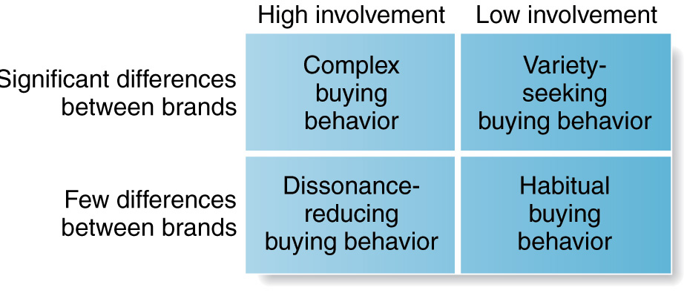
- The type of decision will influence the promotional strategy most likely to be effective

Buyer Decision Process for New Products

- New Products
  - Good, service or idea that is perceived by customers as new.
- The Adoption Process
  - Mental process through which an individual passes from first hearing about an innovation to final adoption.
- Five Stages in the Adoption Process
  - Awareness, interest, evaluation, trial, and adoption.
Consumer Factors
- Individual Differences in Innovativeness
  - Consumers can be classified into five adopter categories, each of which behaves differently toward new products.

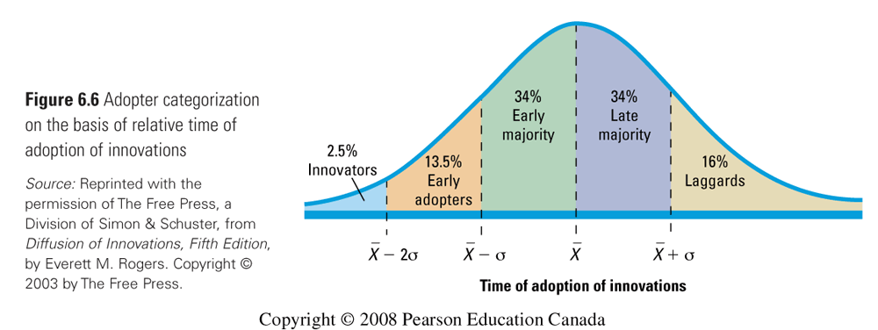

Buyer Decision Process for New Products
Product factors
- Influence of Product Characteristics on Rate of Adoption
  - Relative Advantage
  - Compatibility
  - Complexity
  - Divisibility
  - Communicability

chapter 8

SEGMENTS MOST BE CONSUMERS

ALTERNATIVE MARKETPLACE APPROACHES:
From – mass market approach:
- One product fits all (one product will satisfy all clients)
- Target all consumers with one product.
To- market segmentation approach:
- Products differentiate to meet customers needs (totally different products )
- Multiple customer groups
- For different types of clients
- Helps to make best price for a product – optimal price.
- Most profit

Why segment the market ?
- Efficiency – target those consumers with the greatest likelihood of buying the product, making marketing efforts more efficient
- Divide and conquer- tailor the marketing mix program (4ps) within each targeted segment to best match customer needs and provide superior value compared to the competitors.
- Opportunity- identify new opportunities not discovered by competitors.

STEPS IN MARKETING SEGEMNTATION
- MARKET SEGMENTATION : dividing market into distinct groups with distinct needs, characteristics, or behaviours, who might require separate products or marketing mixes. – similar behaviour in the same group.
- Identify bases for segmenting the market
- Develop segment profiles
- TARGET MARKETING : evaluating each market segments to attractiveness and selecting one or more of the market segments to serve
- Develop measure segments attractiveness
- Select target segments
- MARKET POSITIONING : creating a clear, distinctive , and desirable position in the target consumers mind, relative to competition.
- Develop positioning for target segments
- Develop a marketing mix for each segment ( product , price , place, promotion)

BASES FOR SEGMENTATION
- GEOGRAPHIC – Region, city vs. rural , climate , density

- DEMOGRAPHIC –Age , gender , family size, occupation , education , race , nationality, income(not people)

- PHYCHOGRAPHIC – Social class ( upper/middle/low) , lifestyle ( care about environment, shopping a lot ) , personality ( compulsive, ambitious )

- BEHAVIORAL Occasions ( mothers day, Halloween ), Benefits ( seeks form products) , User status ( new customer, exiting ) , Usage rate ( high/light/heavy- consumers) how often a consumer uses a product) Loyalty status

SEGMENTING MARKET EFFECTIVELY (each segment should be)
- Measurable- size, purchasing power and profile of segment
- Accessible – cane be reached and served
- Substantial – large and profitable enough to serve
- Differentiable – respond differently
- Actionable – effective programs can be developed

TARGET MARKETING
Consists of a set of buyers who share common needs or characteristics that the company decides to serve.
Evaluating market segments (before choosing your segment )
- Segments size and growth (chose the largest size, expect large competition and potential growth)
- Segment structural attractiveness:
- Level of competition
- Substitute products
- Power of buyers
- Powerful suppliers
-Companies objectives and resources (is the segment related to the objective)

TARGET MARKETING STRATEGIES

1- UNDIFFERENTIATED (MASS) MARKETING – WHOLE MARKET WITH ONE OFFER E.G. Coca-Cola classic coke.
In general not the best way to market
Advantages: lower cost, potential saving on production and marketing cost.
Disadvantages: hard to satisfy all consumer, company more susceptible to competition, hard to compete with competitors with more focused firm.

2- DIFFERENCIATED (SEGMENTED) MARKETING – TARGETING SEVERAL MARKETS SEGMENTS AND DESIGNING SEPARTE OFFERS FOR EACH. E.g. coco-cola created diet coke, coke zero
Advantages: strong position within several segments, more total sales.
Disadvantages: more costly , cannibalization ( offer full product line )

3- CONCENTRATED ( NICHE) MARKETING – TARGETING 1 OR 2 SEGMENTS
Looking for high market share, serve 1 or 2 products.
Advantages: competitive advantage, more effectively and efficient, an opportunity for small company to compete, can be highly profitable.
Disadvantages: threat from large competitors , higher than normal risks.

4- MICROMARKETING (LOCAL OR INDIVIDUAL MAREKTING) - EACH INDIVIDUAL IS A SEGMENT, ONE TO ONE MARKETING.
Tailoring products and marketing programs to the needs/wants of specific individuals and local customer groups.
Local marketing. Only serve a local community. E.g. Concordia book store.
Individual marketing: the extreme of micromarketing.
Advantages : easy to build , fine tunes products/ services, and easy to build long term customer relationships
Disadvantages: high cost, low economies of scale , logistic problems , brand image dilution.

CHOOSING A TARGET MARKETING STRATEGY
- Company resources: e.g. limited resources- concentrate marketing )
- Product variability: (uniform products -undifferentiated marketing)
- Product’s life- cycle stage: new product
- Market variability:
- Competitors marketing strategies

Target marketing problems
SOCIALLY RESPONSIBLE TARGETING
- Some segments, especially children re at risk
- Spillover from adult to children markets
- Many potential abuses on the internet, including fraud internet shoppers
- Products of questionable benefit

POSITIONING
- Segmentation is the firms view of the customer
- Positioning leads to the customers view of the firms and its position .
PERCEPTUAL MAPS
Good tools to understand: a key to positioning a product effectively is to understand consumers’ perceptions.
- Evaluations of the important attributes for a product class.
-Judgements of the existing brands with the important attributes.
-Ratings of an “ideal” brands attributes.

CHOOSING A POSITIONING STRATEGY

- Identifying possible competitive advantages – products , services , channels , people , image
- Choosing the right competitive advantage – unique selling proposition, several benefits.
- Selecting an overall positioning strategy – value propositions represent the full position of the brand:
- More for more
- More for the same
- More for less
- The same for less
- Less for much less
DEVELOPING A POSITIONING STATEMENT
- A positioning statement summarizes the company or brand positioning.

COMMUNICATING AND DELIVERING THE CHOSEN POSITION
- Companies must take strong steps to deliver and communicate the desired position to target consumers.
- The marketing mix efforts must support the positioning strategy
- Positions must be monitored and adapted over time to match changes in consumer needs and competitors strategies.
APPROACHES TO PRODUCT POSITIONING
- Head-to-head positioning : competing directly with competitors on similar attributes in the same target market. Direct competition e.g. Coca-Cola classic vs. Pepsi classic
- Away/ differentiation positioning: relate to existing mental structure in the consumers mind. Position the product against something consumers already know. Usually away from the leader. Avoid direct competition.

REPOSITIONING
Involves changing the place an offering occupies in a consumers mind relative to competitive offerings. Have to re-change 4ps.
e.g. chocolate milk. Changing the product package.

