STRUCTURE AND SPIRIT OF THE FEDERATION IN 1867
British spirit of the bna act
- Not everything had to be written in the BNA act = because it was a british law (Britts thought that not everything had to be written down) –
- Nothing on individual rights, amending formula or responsible government was written = until the constitution in 1982
- The BNA act was mostly concerned about the divisions of powers between the federal and provincial

→ * federation = multiple orders of government = divisions of power between federal and provincial government
→ * municipal governments = delegation of powers from provincial governments = they’re able to take their powers back because the provincial government is sovereign = municipal government is a government but not a protected one

BNA act gives the federal government exclusive authority over
Trade and commerce
Shipping and fisheries
Inter provincial transport
Currency, banking, postal services
Defence
Foreign affairs
* sections 91/92 of BNA act
- all these powers are directly related to economy and territorial expansion

BNA act gives provincial governments exclusive authority over (all authority is related to local matters to protect local identities)
- Education
- Civil law
- Health care

Gives shared authority to both federal and provincial governments over
Agriculture = because every province has different environments
Immigration = QC gives criteria to immigration, but federal government has authority over refugees
* all immigration laws must be approved by the federal government

BNA act: an evolving federation
A. highly centralized

- Most significant powers reserved for the federal government = healthcare and education wasn’t important = provincial government didn’t have much say/much to do
- * Macdonald didn’t want a federation but Cartier did – the USA federation wasn’t decent and Canada didn’t want that *
- provinces are financially dependent on federal government

- limited to direct taxation – problem = most people didn’t go out and buy things, they would make/grow what they needed = taxes were limited and the provinces didn’t have money
- money transferred from federal to provincial governments = one government has less money than the other so they rely on the government with more money to provide/give them money to run the state

B. quasi federal state
- Federal government has power to disallow provincial laws
- If PEI wants to pass law, it must be approved by the federal government
- Federal government can stop provincial bills from becoming laws = through governor general and lieutenant governors

- Peace, order and good government = POGG (proactive federal measures)
- Residual powers, issues of national dimension, emergency situations or federal paramountcy
→ Imposing something that reflects the will of the federal government
- Power to disallow provincial laws = reactive responses to provincial initiatives

- Over time the federation has become less centralized (positive thing)
A. change in practice of government = power to disallow provincial laws = not used today
- Power to disallow provincial laws = used in early days to stop provincial economic policies to contradict national policy goals
- POGG is narrowed and has not been used since 1975

B. province building dynamics
- Increasing importance of provincial jurisdictions
- Education, welfare state, healthcare = society evolving in areas that didn’t exist in 1867
- Expansion of direct taxations revenues
- * federal government increased its presence in canadian lives via the federal government spending power and equalization payments

federalism today
1. Federal government spending power
- power/capacity to spend in any jurisdiction, even in provincial jurisdictions (with strings attached) = although prov gov gained money from direct taxation, they don’t have enough to take care of health and education
- federal government collects most of the money, but doesn’t have many purposes = fed gov uses their spending power to propose $/aid when being asked for $

- in return, they will ask for their implementations of laws/bills to be respected
- * will give $ but will tell how to spend it * (ex. They tell provincial government how to deal with healthcare)
- no systematic opt-out option with funding for provinces (health care transfer/social transfer)

- origins = over capacity to spend – raising fees, raising taxes, tax cuts = collecting more $ in taxation than they need to = they collect and then give it to the provincial government to spend

fiscal imbalance = provincial should be collecting more than the federal since the provincial deals with social services
- federal government dumps deficit problems
main advantage = ensure minimum acceptable level of public service across canada
main disadvantage = interference in jurisdictions for which federal government is not constitutionally competent

2. Equalization payments
- federal program to address fiscal disparities between provinces
- so each provincial government has sufficient revenues to provide comparable levels of public service at comparable levels of taxation = same services in poorer provinces compared to wealthier provinces
- redistribution from “have” (rich) to “have not” (poor) provinces complex per capita wealth formula
- provinces free to spend money how they wish = no strings = follows the will to live together and the will to live apart
- first equalization payment system = in 1957 = became entrenched in the 1982 constitution act

THREE PILLARS OF CANADA'S CONSTITUTION
THE CHARTER OF RIGHTS AND FREEDOM PT. 1

1982: third pillar added to the canadian constitution = the charter of rights and freedoms

pillar 1: parliamentary government = sets the stage for majority rule and self government
pillar 2: federalism = sets the stage for regional division of powers
pillar 3: the charter = sets the stage for protection of individuals and minorities

origins: shift in public opinion
- growing importance of rights discourse and social diversity
- UNs declaration of human rights (1948)
- USA civil rights movement
- Increasing social and cultural diversity in canada (not every view is the same = different cultural background)
- Canada’s bill of rights (1960) = first tangible gesture

- Growing distrust in legislatures for protecting rights
- * all laws passed after the implementation of the charter must respect the charter *
- human rights slowly making their way to political institutions
- courts and legislatures more concerned with fed/prov division of power than with rights (even with the implementation of the bill of rights)
- 1960 bill of rights is easily modifiable by parliament

* parliamentary protection is not enough = in 1982, the charter becomes entrenched in the constitution *
- content and structure
→ s. 2 = fundamental freedoms
→ s. 3, 4, 5 = democratic rights
→ s. 6 = mobility rights
→ s. 7-14 = legal rights
→ s. 15 = equality rights (sexual orientation rights added into the charter in 1995)

The charter is seeking balance between individual and community rights = only about individuals but also special rights for certain groups = they always remain individuals but recognized for people who belong in certain groups (membership of individuals to special groups)
- a change of governing principle = charter is a blow to parliamentary supremacy
→ * parliamentary supremacy: parliaments authority is superior to that of all other institutions of government = parliament is supreme
→ * constitutional supremacy superseded parliamentary supremacy

constitutional supremacy
- legislatures (federal or provincial) cannot pass laws that go against provisions set in the constitution
- parliament holds freedoms but they’re set within the constitution

two ways the C.S is practiced:
- after a law is passed = binding decision – once the supreme court rules, the decision is binded
- before a law is passed = opinion of the court – only upon request for advice from government (court will deliberate opinions, send back to the government to let them know what’s violated)
example: Harper gov did so when wanting to reform senate – went against same sex marriage laws

THE CHARTER OF RIGHTS AND FREEDOM PT. 2

The charter: a change of governing principle (slide 2)

Know the difference between: Constitutional vs parliamentary: parliament was supreme to everything, there were no limits to what and how they would legislate

- vestige of parliamentary supremacy (limitations)
Section 1
- Rights and freedoms: the canadian constitution gave you rights and freedoms
- We have to give up some of these rights to be free
- They are not completely sacred
- They aren't about individuals they are about a whole society
- It doesn't mean you have to give them up but
- What is the restriction on rights and freedom?
- 4 criteria if they are reasonable or not → only looking at 2
- The importance of the objective you're pursuing
- If the objective is pursued by the legislative - it must be of great importance
2) they have to be proportionate the objectives taken (they’re related)
- You take means that are proportionate to your objective
- The bigger the proportion the more important the objective

Example 1- bill 101
- Banning the language would be too much, but there should be proportionate
- In order for a law to be apart of the constitution they should modify bill 101
- Principle of dialogue between the courts and canada

Example 2 - kirpan school case
- The ruling of the supreme court
- The kirpan had to be sealed (1st recommendation but wasn't enough)
- It had to be hidden

Section 33: notwithstanding clause
- It enables either legislature (fed. Or prov) to declare that a law shall operate even if it violates the fundamental freedoms(s. 2), legal rights (s.7-s.14) or equality rights (s.15) sections of the charter.
- What the charter gives, the legislature may take away
- Its used by simple votes in parliament - very simple anyone can vote but since the principle is about giving power back to the people - sec 33 is only valid for up to 5 years
- Why 5 years ? bc 5 years is what the constitution set that the government can be in power
- If the government uses section 33 to respect the people then it must give the people a chance to stop using section 33
- Section 33 has rarely been used
- Political rights are not included here. Why? They must change it every 5 years because or else the party is permanent and not re elected

Main cases
- Bill 178 (1988)
- Alberta's definition of marriage (2000)

Charter includes a culture shift

- From british to american style of politics
- More prominent role for unelected judges (and related decline of elected legislature)
- Increase in use of courts to resolve political disputes → tv shows and people suing - we get that from an american side in politics
- From collectivist values (tradition, order, continuity) to values stressing individual interests
2. Centralizing impact
- Provides national standards (power game) you impower national standards and you weaken the power of the provinces
- Creates strong pole of identification for canadians
- Explains quebec govt. Ambivalent position

3. Depoliticization of politics
- Charter discourse is less “debate - focused”
→ the political arguments we have we leave them behind closed doors
- It mainly involves judges and their interpretation
- Charter “judiciales politics and politicizes the judiciary”

4. Parliament is increasingly squeezed” between the over dominance of the executive power and the over dominance of the judicial power

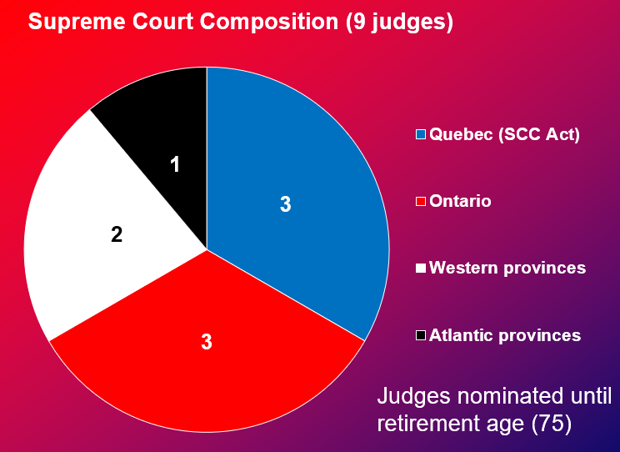

Harper formula
- What is the problem with harpers formula? → does not put restrictions
- Who appoints the minister → the prime minister
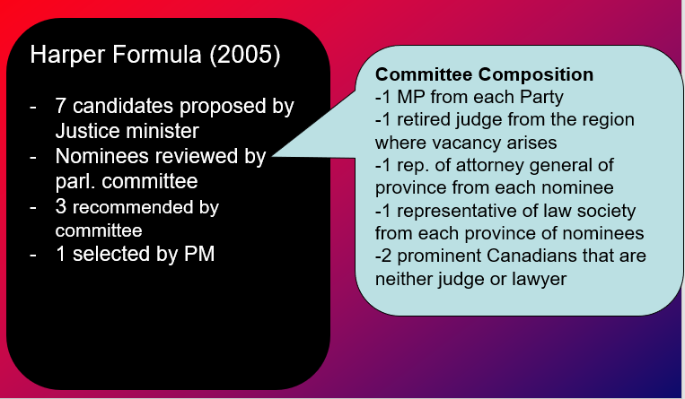
Trudeau Formula
- Lawyers submit their candidacy
- Government doesn't control the majority of the members
*don't need to know the members of the committee
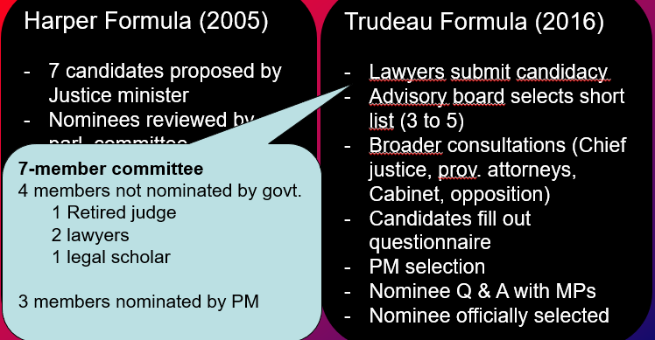

Amending the constitution: a view from all 3 pillars
- Parliamentary government
- No constitution to be amended; conventions/ court decisions
2. Federalism (BNA act) - british law
- No established procedure to change the constitution
- If it's not in canada its not in reach for the house of commons and canadian government to modify
- When would there be a problem?
- Requests have to be made to the british parliament → who says the requests
- No guideline on who would have to agree on content of requests sent to london
3. Supreme court decision - patriation reference case
Ambiguous ruling:
- consultation with provinces is necessary (but unclear)
- Constitutional conventions with no legal power → why do they say that → to make changes in the quebec constitution → they cant bc of the veto → removed the act and the compact theory
- No veto for quebec or any other provinces
3. The 1982 constitutional act (including the charter)
- Ottawa + 7/10 - 50%
- Creation of new provinces
- Power of the senate and the method of selecting senators
B. ottawa + 10/10
- If a province is not on board it wont work
- Composition of supreme court
- Queen, governor general
- Changing amending procedure
- Use of french or english
C. ottawa and provinces concerned
- Alterations of provincial boundaries
- Ex: catholic and protestant school boards

***what they all have in common: you always need the federal governments to modify the constitution***

Amending the constitution: A deadlock
- Difficult formula to modify the constitution and recent developments mean that amending the constitution is practically impossible

Amending the constitution requires taking into account:
- The amending formula (1982)
- Popular consultation (informally)
- From meech lake to charlottetown accords
- From elite bargaining to popular consultations
- Referendum in each province
**Amending the constitution is nearly impossible

PARTIES AND ELECTIONS

- The canadian electoral system - the “first past the post”
- Single member constituency, one vote (voting method|)
- Canada currently has 338 federal constituencies (or riding) → each general election is actually 338 local elections
- Different methods of voting

Plurality system, not majority system ( counting method)
- Most MPS are elected without the majority of votes

The local candidate, not the party, wins the seat
- Candidates ordered by family names on ballow, not by party names

Federal elections now held at fixed dates every 4 years
- Third monday of october in the fourth calendar year following polling day of last general election, but still the PM’s prerogative

The canadian electoral system: the way it works
- Electors of each constituency choose one representative in their constituency
- Notion of “geographic” community of interests

- System favours parties/ candidates with regionally concentrated support
- Forces the building of “large” coalitions of voters

- Generally favours “mainstream” and moderate” parties/candidates at the expense of small parties (ex: green party)
- Limits numbers of parties/candidates in elections

The canadian electoral system
**The larger number of wins but with smaller proportions there will be a smaller distortion of % of seats to number of votes

Pros and cons
Negative:
- Disadvantage small parties, reduce number of parties
- Underrepresents social and political diversity
- Favours “majorities” over “minorities”
- Favours low election turnout

Positive:
- Bridges interests and favours consensus building
- Favours community specificity

Need for a new electoral system?

Nov 19, 2018

B. brokerage politics in canada
- It refers to the desire of political parties to build coalitions and support by balancing the interests of the different groups or regions (carty and cross, 2010)
- But why do parties in canada practice brokerage politics more so than in other countries
→ canada is a very large country with different regions and political culture, interests - coalition
- The way people refer to themselves is how people evolve (french- canadian, english- canadian ) etc.

- Existence of many “group” cleavages in canada
- French vs. english; catholics vs protestants; west, east, and central canada; ethnic communities
- “Canada is a community of communities” (joe clark)

- Lack of national integration (in party system and in society)
- Conservative and liberal parties were initially lose coalitions
- J.A Macdonald and robert baldwin (canada west)
- G.E Cartier and lafontaine (Canada east)

- Brokerage politics emerged out of need to build coalitions in order to win elections and to govern
- What can we campaign for in order to win the majority
- Plurality: you don't need the majority
- We don't have a lot of parties
- If you want to win you need to have a strong voice
- You need to represent as many interests as you can

- And… electoral system did not favour the multiplicity of parties

Brokerage politics in canada implies..

- Every election, parties try to build a winning coalition of voters
→ flexible voters and parties
→ parties are motivated by electoral pragmatism

2. regional , religious, linguistic cleavages rather than class or ideological ones
→ “weak” ideological politics (limited left/ right politics)
→ limited class politics in elections
→ elections are issue oriented

3. Predominant role of leaders
→ have great autonomy to shape platform and winning coalition
→ canadian parties among most organizationally weak

Examples of brokerage politics

- Historical success of the liberal party of canada
- The lpc is one of the most successful parties in the world
→ LPC has formed the govt. For about ⅔ of the years since 1867
→ LPC “was” said to be the natural governing party of canada

The origins of this success?
One of the longest and most stable coalition: French canadians, catholics, ontario, canadians and non european origins

2. The 1984 and 1988 mulroney governments
→ in 1984 and 1988 the progressive conservative party took power by forming a coalition of three conservative/regional streams
- Westerners (social conservatives)
- Ontarians (fiscal conservatives)
- Quebecers (quebec nationalists)

The 1993 “conservative” coalition failure
- Westerners (went to the reform party)
- Ontarians (stayed with PC or shifted to liberal)
- Quebecers (went to bloc quebecois)

3. The end of brokerage politics?

LANGUAGE POLITICS AND QUEBEC NATIONALISM

the first 150 years
From 1774 to the middle of the 20th century
- French canadian society organized around the dominant role of the catholic church (pervasive, omnipresent)
- Sole institution that is “really” connected to french canadians “institutional door” opened with quebec act
- French canada is french and catholic (la race canadienne française)
- No immigration, high birth rate (la revanche des berceaux)
- Ideology: “La survivance”
→ survival/resistance against pressure from dominant culture
→ literature: menaud maître draveur; maria chapdelaine

The building up to the quiet revolution
1940: slow beginning of a new “era”
- New social and economic reality “modernization” → urban population; manufacturing economy
- Open challenge to old order “unholy alliance” → catholic church, “anglophone capital” and union national
- Ideology of “rattrapage” which is catching up → quebec state and power structure lag behind new reality, “rufus global” Paul Emile Borduas

1960 - victory of quebec liberal party (Jean lesage)
→ death of maurice duplessis, turmoil with union national
→ end of “la grande noirceur” and the beginning of the quiet revolution

The quiet revolution
- Focus shifts from catholic church to quebec state
- Increased role of the state in areas traditionally occupied by church and in economy
Social services ex: public health care
Education ex: ministry of education
Economy: ex: nationalization of hydro - electricity, la caisse de dépôt et placement

From french canadians to quebecois
- From ethnic conception to territorial one
- Other french canadians more or less abandoned “warm corpses”

Ideology shifts from “la survivance” to “breaking dependency”
Objectives
- To break economic and political dependence
- To take means to ensure development/expansion

The old and new nationalism

Main actor: catholic church vs quebec state
Reference group: french canadians across canada (race and religion) vs quebec territory
Ideology: la survivance vs. le rattrapage - breaking dependency
→ ideology movement evolved from survival ensured by catholic church to survival but also development/ expansion, ensure by quebec state

Language politics and quebec nationalism
- Is with new quebec nationalism that the option for an independent quebec is really brought up to the table
Be careful: NEW QUEBEC NATIONALISM DOES NOT EQUAL INDEPENDENCE MOVEMENT

Two streams within the new quebec nationalism
- Federalist stream (liberal party of quebec, Jean Lesage)
→ seeks to ensure quebec development within canada
→ but nevertheless has numerous demands for ottawa
- The sovereignist stream (parti quebecois)
→ seeks to ensure quebec development outside federation or under new partnership with canada
**New quebec nationalism (both streams) reasserts two-nation compact perspective of canada

A few key moments
1960 - liberal government (J.Lesage) - quiet revolution
1963- beginning of royal commission on bilingualism and biculturalism
1968 - creation of parti quebecois and P.E. Trudeau government
1969 - federal government official languages act
1974 - loi sur la langue officielle (Quebec) - Loi 22
1976 - parti quebecois government
1977 - la charte de la langue française - loi 101
1980 - Referendum on souverainete association
1982 - new constitution (charter and amending formula)
1984 - Mulroney government and promise to bring back quebec in constitution with honour and enthusiasm - “Le beau risque” de Rene Levesque
1987 - Meech Lake Accord
1990 - Failure of the Meech Lake Accord

Federal Government. Official languages act (1969)
- English and french the official languages of canada (adopted under P.E trudeau)
- Establishment of commissioner of official languages → handles complaints, inquiries, and recommendations
3 objectives
- Public's right to be served by federal. Govt. in the official language of their choice (very little french services) TODAY: great improvement
- Equitable representation of francophones and anglophones in federal public service (Franco under represented) TODAY: Franco over-represented
- Ability of federal public servants to work in official language of their choice (language of work was mainly English) TODAY: English still language in workplace

Loi 101: La charte de la langue française
- Loi 101 applies everywhere in quebec but was mostly designed to address the linguistic situation in Montreal

The montreal context
- Until the 1970’s, Montreal was primarily an English-speaking city even though it was in majority French-speaking
- Signs were mostly in English
- Language in workplaces was primarily in English
- Service in stores was primarily in English
- Most immigrants adopted English language
- Bill 101 aimed at changing this situation to reflect the predominance of the french speaking population

4 main features of Bill 10
- Official language of quebec and quebec institutions is French → 1979: supreme court ruled that this was against section 133 of the BNA act (equal status of French and English in Quebec institutions)
- Workplace is in French (for business of 50+ employees)
- Public signs have to be in French
→ controversial feature: 1988 supreme court and bill 178 (section 33), Bill 86
- Mandatory french education
→ exception for parents/siblings educated in English in Quebec
→ 1984 supreme court decision (violation of section 23 of charter); exception was extended to “in Canada”
→ remember: the charter was adopted in 1982, Bill 101 in 1977

Meech Lake Accord
- Robert Bourassa (Quebec Premier) gave five conditions in order for Quebec to “sign on” the new 1982 constitution (bare minimum)
- A recognition of Quebec as a “distinct society”
- A constitutional veto for Quebec
- Increased provincial powers with respect to immigration
- Right for financial compensation to any province that chooses to opt out of any future federal programs
- Provincial input in appointing Senators and Supreme Court Judges

** All conditions centered around 2-nation “compact theory”
- The government had 3 years to get the Accord approved by all 10 provinces and the federal parliament (June 1990)
- In the end the Accord failed to be ratified (NFLD & Manitoba) - there was strong opposition, especially to “distinct society”

- Against “contract theory” of 10 equal provinces
- Strong opposition to “asymmetrical federalism”
- Against equality of individuals (rights and freedoms)
- Against equality of cultures and cultural origins
- Undermined view of Canada as one nation
- Lack of attention to indigenous issues

** Clash between the axes of diversity in Canadian politics

Is quebec nationalism: Dead, dormant or still quite alive?
- The main determinants (contemporary) Quebec nationalism

- Feeling of self confidence
Increased with quiet revolution
“Success” of quebecers around the world
- Feeling of rejection
Post Meech Lake Accord was best example
- Fear of disappearance
Official bilingualism and Bill 101 were attempts to address this fear
Data on linguistic assimilation (inside and outside Quebec)

MULTICULTURALISM

- Multiculturalism as a demographic reality

- Change in origins of immigrants in Canada post 1960’s → shift from Europe to Asia, Africa, Middle East and Caribbean
- Origins of shift
→ end of immigrant selection based on country of origin = 1910 immigration act
→ beginning of point system (1967) = immigrants not selected anymore based on ethnic background and origin but rather on a set of criteria linked to employability
- Increased in annual intake of immigrants (around 250, 000)
→ every decade, more than 2.5 millions immigrants settle in Canada
→ more to come: 450,000 annually by 2020
- Increasing shift also in “classes” of immigrants admitted

Demographic increase of immigrants and “visible minorities” in Canadian population
2016 Census = 21.9% of immigrants, 17.7 % of 2nd generation immigrants, 22.3% of visible minorities

Demographic decline of Canadians of British and French origins
1967 - 90% british or french
1981 - 67% british or french
2001 - 46% british or french

2. Multiculturalism as a political philosophy
- Philosophy recognizing, accommodating, and supporting cultural pluralism in society
- Cultural neutrality does not exist and such absence penalizes minorities
EX: main official holidays are religious (Christian); religious minorities need accommodation. Absence of accommodation might result in inequalities. There is greater equality when governments explicitly promote diversity.
- Multiculturalism is a liberal philosophy, not communitarian
- Limits multicultural rights
→ external protection (yes) ; internal restriction (no)

3. Multiculturalism as a public policy
- Three major initiatives have been put in place in recent canadian history to protect and promote cultural diversity

- The 1971 policy of multiculturalism
Context
- new growing cultural diversity
Objective:
- Acceptance of cultural diversity as part of legitimate and integral part of canadian society
- Cultural maintenance for minority groups
- Strong symbolic value
Specific objectives:
- Establishing funding and ethnocultural groups for cultural survival “song and dance” aspect
- Removal or cultural barriers to full participation in canadian society
- Promote cultural exchanges

2. The charter of rights and freedoms (1982)
Context:
- Greater change in ethnic composition (visible minorities)
- Prevalent discrimination
Objective
- To provide legal protection for multiculturalism
→ section 27 empowers the courts to take canada's multicultural reality into account at the highest level of decision making
→ “the charter shall be interpreted in a manner consistent with the preservation and enhancement of the multicultural heritage of canadians”
→ section 15 (equality)
(15.1) protection against discrimination (race, ethnic, origin, colour)
(15.2) allows for positive discrimination

3. The 1988 multiculturalism act
Context:
- Urgency to fight discrimination and actively promote equality
Objectives
- Formally acknowledges multiculturalism in canada as a characteristic that must be taken into account into decision - making process of government
- Promote equality and fight discrimination through all federal government ministries and agencies
Specific objectives
- Cultural understanding
- Social and economic integration
- Fighting discrimination
- Institutional reform to promote equality of chances

From the 1971 policy of multiculturalism to the 1988 multiculturalism act
 | Legal status | Main objective | Influence reach
1971 | policy | Promote cultural diversity (cultural maintenance) | Mostly symbolic
1982 | constitution | Protect against discrimination and inequality (protection) | Must be respected by ministries and government agencies and society (reactive)
1988 | law/ act | Fight discrimination and inequality (seek and destroy) | Must guide ministries and government agencies (proactive)

*How are countries doing? Chart on ppt

Multiculturalism (conclusions)
- Multiculturalism as a set of policies
- Just a symbol? Limited budget and limited services but a powerful symbol
- An effective tool for immigrant integration? W.kymlicka, I bloemraad (yes) Neil Bissoondath (no)
- An effective tool to promote tolerance and acceptance?
- Limited evidence to assess impact of multiculturalism policy
- Each country has a unique geographic, political, social, economic, and historical reality
- Immigrant integration and tolerance are not rooted only on presence or absence of multiculturalism policy
- Most societies are struggling with increasing diversity
- Multiculturalism as a demographic reality is there to stay

INDIGENOUS POLITICS

The “real” beginning
Many terms used to ‘name’ Indigenous people in Canada: Indians, Aboriginals, Natives, First Nations, Indigenous
→ In all cases, it refers to the communities who already lived in Canada before the arrival of European settlers.
- Indian: christophe Colomb + the legal term to talk about an indigenous person who is registered under the indian act

Consequences for indigenous of cohabitation with “whites”
- Introduction of alcohol in indigenous “lifestyle”
- Before europeans arrival, alcohol was not used among indigenous
- Alcohol exchanged for fur
- Alcoholism became rampant among indigenous
- Alcoholism is still a major problem today in indigenous communities
- Population displacement
- As number of Europeans expanded, they wanted more land
- As a consequence, many native communities were forced to move
- This dramatically affected indigenous lifestyle and culture
- Indigenous reserves still moved around nowadays to accommodate “white” economic development → ex: hydro- electric development

Indigenous society today
- Lower than average income
- Higher unemployment
- Lower graduation rates and education levels
- Lower standards of living, including housing, community services, and public utilities
- Higher rates of crime and incarceration
- Poorer health outcomes

Five important ‘policy moments’ for indigenous politics

- Indian act (1876)
- First official document which defines how the government of canada interacts with first nations
- An act to assimilate indigenous people
- Federal government controls reserves and indigenous development
- Particularly offensive to women
- White paper on aboriginal reform (1996)
- Proposed by minister of indian affairs and northern development jean chretien and prime minister pierre trudeau
- Attempt to end reserve system and abolition of indian status
- Strong opposition - threatens land claims and treaties
- The reform was never adopted
- Report to the royal commission on aboriginal people (RCAP 1991 - 1996)
- To investigate the relationship between indigenous peoples, the canadian government and canadian society
- The RCAP recognizes the damage that the assimilationist policies brought about to the indigenous societies and suggest measures to prevent such damage from occurring again
- Suggests self government as a policy that allows indigenous peoples to have more control over their own affairs
- More than 20 years later: still waiting for change
- Truth and reconciliation commission of canada on indian residential schools (2007-2015)
- To learn the truth about what happened in the residential schools
- Anyone affected by the residential schools experience had the oppurtunity to share his or her story
- To inform all canadians about what happened in the schools
- The principle of free, prior, and informed consent (FPIC)
- Since UNDRIP (2007): the principle of FPIC has become increasingly important
- “States shall consult and cooperate in good faith with the indigenous peoples concerned through their own representative institutions in order to obtain their free, prior, and informed consent before adopting and implementing legislative or administrative measures that may affect them.”
- 2016: canada dropped its objector status to the declaration and formally adopted plans to implement it in accordance to the canadian constitution
- Ongoing debate over its precise meaning

Idle no more
A grassroots movement for indigenous sovereignty, indigenous rights and respect for the treaties. Goals include stopping environmental degradation and economic and social inequality.

