Nov 5, 2018

The charter: a change of governing principle (slide 2)

Know the difference between: Constitutional vs parliamentary: parliament was supreme to everything, there were no limits to what and how they would legislate

- vestige of parliamentary supremacy (limitations)
Section 1
- Rights and freedoms: the canadian constitution gave you rights and freedoms
- We have to give up some of these rights to be free
- They are not completely sacred
- They aren't about individuals they are about a whole society
- It doesn't mean you have to give them up but
- What is the restriction on rights and freedom?
- 4 criteria if they are reasonable or not → only looking at 2
- The importance of the objective you're pursuing
- If the objective is pursued by the legislative - it must be of great importance
2) they have to be proportionate the objectives taken (they’re related)
- You take means that are proportionate to your objective
- The bigger the proportion the more important the objective

Example 1- bill 101
- Banning the language would be too much, but there should be proportionate
- In order for a law to be apart of the constitution they should modify bill 101
- Principle of dialogue between the courts and canada

Example 2 - kirpan school case
- The ruling of the supreme court
- The kirpan had to be sealed (1st recommendation but wasn't enough)
- It had to be hidden

Section 33: notwithstanding clause
- What the charter gives, the legislature may take away
- Its used by simple votes in parliament - very simple anyone can vote but since the principle is about giving power back to the people - sec 33 is only valid for up to 5 years
- Why 5 years ? bc 5 years is what the constitution set that the government can be in power
- If the government uses section 33 to respect the people then it must give the people a chance to stop using section 33
- Section 33 has rarely been used
- Political rights are not included here. Why? They must change it every 5 years because or else the party is permanent and not re elected

Main cases
- Bill 178 (1988)
- Alberta's definition of marriage (2000)

Charter includes a culture shift

- From british to american style of politics
- More porminent role for unelected judges (and related decline of elected legislature)
- Increase in use of courts to solve political disputes → tv shows and people suing - we get that from an american side in politics
- From collectivist values (tradition, order, continuity) to values stressing individual interests
2. Centralizing impact
- Provides national standards (power game) you impower national standards and you weaken the power of the provinces
- Creates strong pole of identification for canadians
- Explains quebec govt. Ambivalent position

3. Depoliticization of politics
- Charter discourse is less “debate - focused”
→ the political arguments we have we leave them behind closed doors
- It mainly involves judges and their interpretation
- Charter “judiciales politics and politicizes the judiciary”

4. Parliament is increasingly squeezed” between the over dominance of the executive power and the over dominance of the judicial power

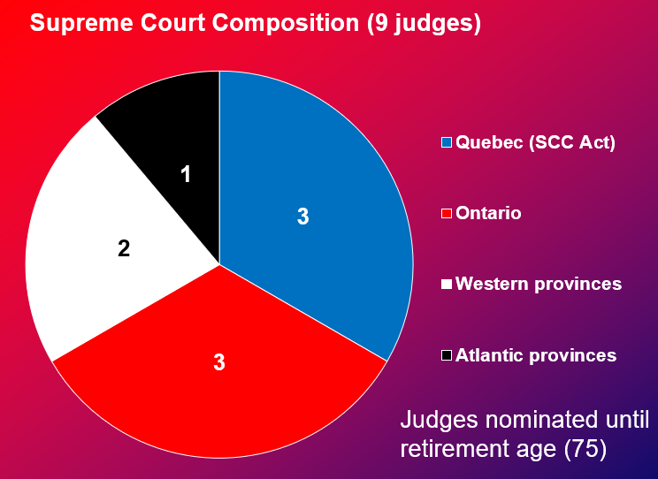

November 12, 2018

Cont from last powerpoint

Harper formula
- What is the problem with harpers formula? → does not put restrictions
- Who appoints the minister → the prime minister

Trudeau Formula
- Lawyers submit their candidacy
- Government doesn't control the majority of the members
*don't need to know the members of the committee

Amending the constitution: a view from all 3 pillars
- Parliamentary government
- No constitution to be amended; conventions/ court decisions
2. Federalism (BNA act) - british law
- If its not in canada its not in reach for the house of commons and canadian government to modify
- When would there be a problem?
- Requests have to be made to the british parliament → who says the requests
- No guideline
3. Supreme court decision - patriation reference case
- Ambiguous ruling:
- consultation with provinces is necessary (but unclear)
- Constitutional conventions with no legal power → why do they say that → to make changes in the quebec constitution → they cant bc of the veto → removed the act and the compact theory
- No veto for quebec or any other provinces
3. The 1982 constitutional act (including the charter)
- Ottawa + 7/10 - 50%
- Creation of new provinces
- Power of the senate and the method of selecting senators
B. ottawa + 10/10
- If a province is not on board it wont work
- Composition of supreme court
- Queen, governor general
- Changing amending procedure
- Use of french or english
C. ottawa and provinces concerned
- Alterations of provincial boundaries
- Ex: catholic and protestant school boards

***what they all have in common: you always need the federal governments to modify the constitution***

Next powerpoint - parties and elections

- The canadian electoral system - the “first past the post”
- Single member constituency, one vote (voting method|)
- Canada currently has 338 federal constituencies (or riding) → each general election is actually 338 local elections
- Different methods of voting

Allocation of seats in the house of commons
→

Plurality system, not majority system ( counting method)
- Most MPS are elected without the majority of votes

The local candidate, not the party, wins the seat
- Candidates ordered by family names on ballow, not by party names

Federal elections now held at fixed dates every 4 years
- Third monday of october in the fourth calendar year following polling day of last general election, but still the PM’s prerogative

The canadian electoral system: the way it works
- Electors of each constituency choose one representative in their constituency
- Notion of “geographic” community of interests

- System favours parties/ candidates with regionally concentrated support
- Forces the building of “large” coalitions of voters

- Generally favours “mainstream” and moderate” parties/candidates at the expense of small parties (ex: green party)
- Limits numbers of parties/candidates in elections

The canadian electoral system
**The larger number of wins but with smaller proportions there will be a smaller distortion of % of seats to number of votes

Pros and cons
Negative:
- Disadvantage small parties, reduce number of parties
- Underrepresents social and political diversity
- Favours “majorities” over “minorities”
- Favours low election turnout

Positive:
- Bridges interests and favours consensus building
- Favours community specificity

Need for a new electoral system?

