CHANDLER
Concepts:
- Economy of Scale:
Saving costs gained by an increased level of production
- Globalization (lead to economy of scale) because it caused cheaper resources around the world
- Cost/unit drops as volume of output rises
- (e.g.) with internet, you can reduce tome and cost
- Economy of Scope:
Average total cost of production decreases as a result of increasing the number of different goods produced.
- (e.g.) train carries both passengers and freight. This is more cheap than having separate trains
- First Mover:
When you see a market and decide to invest in it because you see potential (by advertising, by investing, etc.)
- Logic and Managerialism
Set of logical routine practices (way of doing)
- In order to capitalise economies of scale/scope
- Diversification
- When big is not logical
- Sometimes we choose without our logic, but with our emotions
- Management Hierarchy
Separation of upper and lower level management

Claim: Successful firms capitalise on economies of scale and scope; they have a functional management structure and invest in research and development and grow from related diversification.
- This will allow them to stay ahead of competition.

GREINER
Concepts:
Greiner looks at Evolution and Revolution.
- 2 variables: age and size
Key forces in development:
- Age of organization
- Size of organization
- Stages of evolution
- Stages of revolution
- Growth of revolution
5 growth phases:
- Growth through creativity
- Focus: make and sell
- Structure: informal
- Style: entrepreneurial
- Control: market results
- Rewards: ownership
- Crisis: leadership
- Growth through direction
- Focus: operational efficiency
- Structure: centralised
- Control: standards, cost
- Rewards: salary, merit
- Crisis: autonomy
- Growth through delegation
- Focus: expansion of market
- Structure: de-centralised
- Style: delegation
- Rewards: individual bonus
- Crisis: control
- Growth through coordination
- Focus: consideration
- Structure: products groups
- Style: watchdog
- Control: plans, investments
- Rewards: profit sharing
- Crisis: red-tape
- Growth through collaboration
- Focus: innovation
- Structure: matrix of teams
- Style: participation
- Control: mutual goal set ting
- Rewards: team bonus
- Crisis: ?
4 growth phases from Revolution:
- crisis of leadership
- Crisis of autonomy
- Crisis of control
- Crisis of red-type

Claim: organizational growth is done in 5 phases and by implementing the right strategies and managerial structures, they can reduce the crisis and move on.

BARNEY
Concepts:
Competitive advantage is shaped by 1) environmental threats and opportunities and 2) internal strengths and weaknesses (Barney)
SWOT analysis (evaluates both internal and external threats and opportunities NOT Barney’s analysis)
- Strength
- Weakness
- Opportunities
- Threats
External environment:
- Society
- Industries
- Environment competitors
- Government regulations
Competitive advantage (VRIO) and questions about resources and capabilities
- Valuable: is this resource helping the organization in a way that the organization can either exploit an opportunity or neutralize a threat?
- Rareness: how many organizations have the same resources and capabilities? The more rare, the better
- Inimitable: how difficult is it to imitate the resource? How costly is it?
Look at:
a) history (what help the organization to become successful in the past),
b) numerous small decisions (small ides being adopted),
c) socially complex resources (reputation, trust, teamwork ...)
- Organization to allow exploit full potential: is the firm well organised to the point where they can exploit their full potential of their resource?
Firms resources and capabilities:
- Financial
Debts, equity, retained earnings...
- Physical
Machines, manufacturing facilities, buildings...
- Human
Experience, knowledge...
- Organisational to produce and service its consumers
History, relationships, trust, culture, formal reporting structure, patents...

Complete competitive advantage:
- V, R, I,O
Complete competitive disadvantage:
- doesn’t comply to the VRIO framework
Temporary competitive advantage:
- Valuable, Rare, but easy to imitate (not costly)
Sustained competitive advantage:
- Valuable, Rare, costly to imitate

Claim: A firm will sustain a competitive advantage if its resources and capabilities are valuable, rare, inimitable, and organized in a way that allows them to exploit potential opportunities.

COLLINS & PORRAS
Concepts:
Good companies know the difference between what should never change and what should be open to change
Companies that enjoy enduring success have core value and core purpose
2 major components:
- Core ideology
- Envisioned future

Claim: Companies that enjoy enduring success (Chandler) have core values and a core purpose that remain fixed while their business strategies and practices adapt to a changing world.

Sub- articles
- The next big bet; Samsung
Claim:
If Samsung steps up its game and goes from batteries to car, to medical, to LED lights to solar panels, they might risk losing all they have.
- Built for growth
Claim:
Of you leave your current work because you believe you are destines for something greater, and your talent is going to waist, might as well became an entrepreneur.
- “Land-grabber” or Farming’s future?
Claim:
Pangea convinces farmers that by generating spinoffs in the region where they live will benefit them as an entrepreneur and will equally generate income.
- Open Wide
Claim:
If the actual dentists become more of an aesthetic and cosmetic dentistry, they might succeed more.
- Fairphone
Claim:
Fairphone goes beyond being a company- it’s trying to create purpose while generating income
- Lululemon:
Claim:
Lululemon is changing and evolving as it allows employees to face new challenges and learning abilities, by allowing them to achieve beyond the brand (entrepreneurship, education etc.).
- Megabus Effect
Claim:
Megabus operates using a cheaper operator in contrast to Curb side. Not only is it more economical, but it also reduces great amount if gasoline.
- Made Smarter in Canada
Claim:
Magna International inc (Toyota) was struggling to stay operational due to its poor management.
- The cobbler conundrum
Claim:
Tom’s shoe where mainly for donation- that is how they were being innovative-not by producing and selling their goods, but by compensating and donating their product as well.

HERBERG

Concepts
- Hygiene factors: The Dissatisfied and Satisfier motivators

Needed to ensure an employee does not become dissatisfied
They do not lead to motivation, but without them, possibility of dissatisfaction
(e.g.) working conditions, quality of supervision, status, security, salary, company policies, interpersonal relationships

- Motivators

Need to motivate an employee into higher performance motivators are the primary source of satisfaction.
(e.g.) achievement, responsibility, growth, advancement for higher level tasks, interest in job, recognition for achievement.

- Dissatisfaction
- Satisfaction
Dissatisfaction = Satisfaction
Company policy achievement
Supervision recognition
Relationship with boss work itself
Work conditions responsibility
Salary achievement
Relationship with person growth

2 types of needs: a) physical need (e.g. money), 2) physiological (e.g. achievement)

- Job environment/ vertical job loading

- Adding meaningful tasks that will lead to growth
- Additional tasks that permit growth and provide motivating factors
- **employees learn and grow thanks to the opportunities**

- Job enlargement/ horizontal job loading

- Adding tasks to a job but not responsibilities
- The meaning of the job is simply increased
- ** little motivation in this approach**

- Positive KITA (kick in the ass)

- Pushing someone with negative/ positive incentives to do something
- Only provides short run success

- Positive KITA
Questions:
- If there is a management in company, how to assure satisfaction?
- Provide hygiene factors to avoid dissatisfaction
- Intrinsic factors to the work itself so employees are satisfied
- “Job enrichment is required for intrinsic motivation, and that it is continuous management process”
- According to Herzberg:
- Job should have challenges to utilize full ability to the employee
- Employees with increasing levels of ability should be given increasingly levels of responsibilities
- If person is not utilize, there will be a motivation problem (hire people with less levelled skills in that situation)

Claim: Herzberg two factor principles are that if you improve the satisfier factors it will increase job satisfaction, and if you improve the hygiene factors it decreases job dissatisfaction.
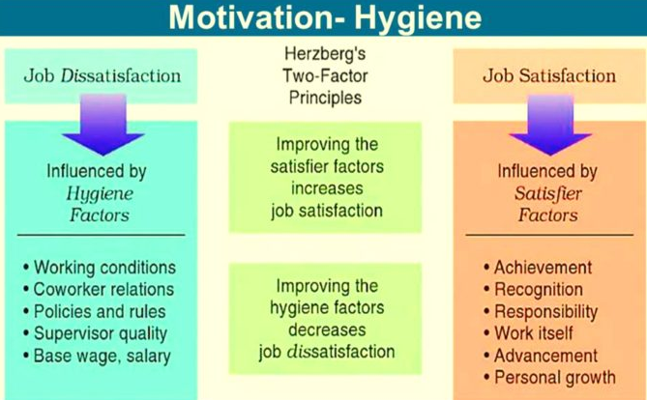
MINTZBERG
Talks about the importance of the manager’s role
Myth: Manager’s plan, organizes, coordinate, control
Realities

- 5 basic parts of the organization
- Operating core

- 4 prime structure
- Securing input of production (buying, receiving...)
- Transform input to output (assembling and producing products)
- Distributing the output (selling)
- Direct support to output, input, transformation functions (maintenance, inventory, raw materials)

- Strategic apex
Ensures that the organization serves its mission effectively, and serves the need of those in control
- 3 sets of duties
- Direct supervision (managers)
- Management of the organization boundaries conditions on relation with environment
- Development of the organizations strategies

- The middle line

- Techno structure

- Analysis who effect work and others
- They design, plan and change it
- 3 types of analysis
- Work study analysis: standardize work process
- Planning and control analysis: standardize output
- Personal analysis: standardize skills

- Support staff

- Many support “people” / staffs in a company
- Board of directors: vice president marketing, president staff, manager, vice president marketing, president staff, district sales managers etc
Question:
Becoming more effective managers, how?
- Be aware of the roles you prefer
- Reduce workload by giving subordinates the information they need
- Avoid superficial decision making by taking advantage of experts analysts
- Force yourself to do things you believe are important
Claim: Henry Mintzberg claims that in order for a business to succeed it needs specific type of manager.

FRENCH AND RAVEN
Concept
They talk about the types of power ( “who holds it over who”)
- Reduced power
- Ability to mediate rewards
- Coercive power
- Ability to mediate punishment
- Legitimate power
- Prescribe behaviour
- Reference power
- Identification with the other
- Expert power
- Special knowledge or expertise

Claim:
French and Raven state that power is divided into 5 separate and different forms. They also state that power and leadership are closely linked, and how the 5 forms of power concept affect a person’s leadership and success.

KAPLAN AND NORTON
Concept
Balanced scorecard: A widely used framework for assessment achievement of financial and non-financial objectives.
- Goal of scorecard
To align business activities to vision and strategies the business, improve internal and external communication and monitor business performance against strategic goals.

Key features of scorecard:
- Top down approach
- Mission and vision of business
- Key performance in directors from 4 different perspectives
- Importance of non-financial measures

- 4 perspective of balanced scorecard
Vision & Strategies
- Financial: financial performance and profit to shareholders
- Internal business perspective: business efficiency (product and services)
- Organizational Capacity: knowledge and innovation
- Costumer: customer satisfaction Claim: The balanced scorecard will help companies become more strategic (not controlling) by using 4 strategies and visions: 1. Financial, 2. Internal process, 3. Organizational capacity, 4. Costumer.
HANDY
Focuses on Organization’s culture
Culture: attitude, traits, behavioural patterns which govern the way an individual interacts with others in terms of culture.
Concepts
- 4 types of cultures
- Power culture
- Power authorities in organization, where the employees don’t have the power
- Task culture
- Formation of teams within an organization who have some interest.
- Solve critical problems follow the task culture
- Person culture
- Employee feel more important than company
- Individual more concerned about self rather than company
- Employee come in office for the purpose of making money, not for company
- Role culture
- Every employee has a role and responsibility according to his knowledge, education, qualifications etc.
- Power comes with responsibilities in such a work culture
Organization culture: beliefs and principles of a particular organization. The culture followed by organization has deep impact on the employees and their relationship amongst themselves.
- 2 types of organizations
- Weak organization culture and Strong organization culture
- - employees not all disciplined
- Not bothered by regulations and rules
- Reach office at their conveniences
- Loaf, talk, gossip
- - employee friendly policies
- Employees are on time
- Follow a certain culture

- Threats of organization
- Negative attitudes and ego are in fact the 2 biggest threats
- Favouritism
- Lack of communication
- Setbacks of organization culture
- Organization culture not formed in 1 day
- Adjustment problems to work culture
- Culture can become a liability to some organization
- Long-term workers can develop habits and mindset (e.g. someone who was once use to entering work at whatever time, now need to come in at time)
- Hard to implement new ideas and concepts in a culture which has been practiced for several years

- Concept of good management
- The Sigmoid Curve
- Sums up story of life itself
- Starts slowly, experimentally, flatteringly
- Represents: the story of an organization’s rise and fall
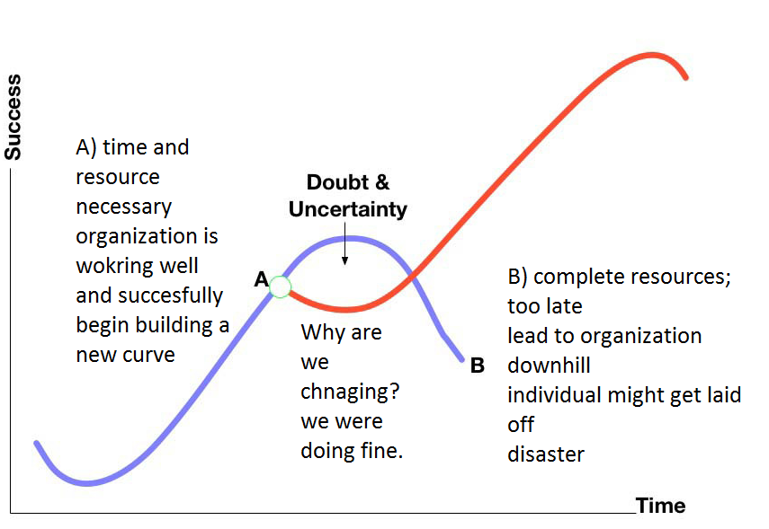
- Cultural hubris/ arrogance
- Think that company will always remain successful
** Handy model looks at contradictory behaviour (he contradicts GREINER, because he says that you don’t need Greiner’s model if you follow his)
** According to Greiner you want to plan evolution before revolution.
Claim: According to Handy, the secret to constant growth is to start a new sigmoid curve before the first one begins to diminish. When a company is left at point B, new people will be able to lift the organization to the second curve.

TANNENBAUM AND SCHMIDT
Concepts
- Leadership theory
- Level of freedom given to team
- Authority used by manager

- Tannenbaum and Schmidt continuum
Model of leadership theory which shows the relationship between the level of freedom that a manager chooses to give to a team and the level of authority used by managers

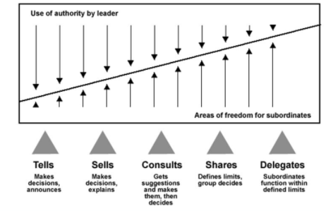
** More freedom= Less manager authority**
- As a manger should delegate the team: team should make their own decision according to their ability
- Overtime, manager reduce his authority and give his employees more freedom

- Delegated freedom
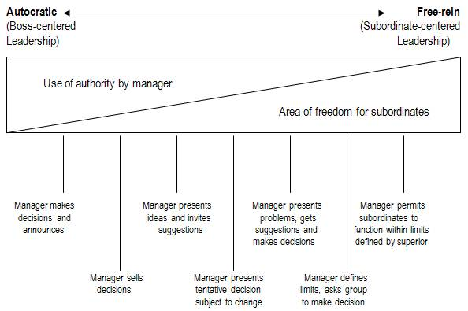
** Goes against BARNEY’S view**
Claim:
Tennenbaum and Schmidt continuum studies the range of leadership behaviors, ranging from manager-centered (task) to subordinate-centered (relationship).
Tannenbaum and Schmidt Continuum model shows the relationship between the levels of freedom that a manager chooses to give to a team, and the level of authority used by the manager.

