Part A:

The structures cannot be superimposed and are enantiomers.
R – configuration S – configuration
There are no other stereoisomers. There are only the two enantiomers.

Molecules i and ii are mirror images and cannot be superimposed. They are enantiomers.
i is a diasteromer with iii and iv.
iii is a diastereomer with i and ii.

They are enantiomers.
There is no chiral centre.
The structure is non-superimposable.

The compound is a meso-compound.
The compound is superimposable.
The compound is achiral.

Part B:

Part C:

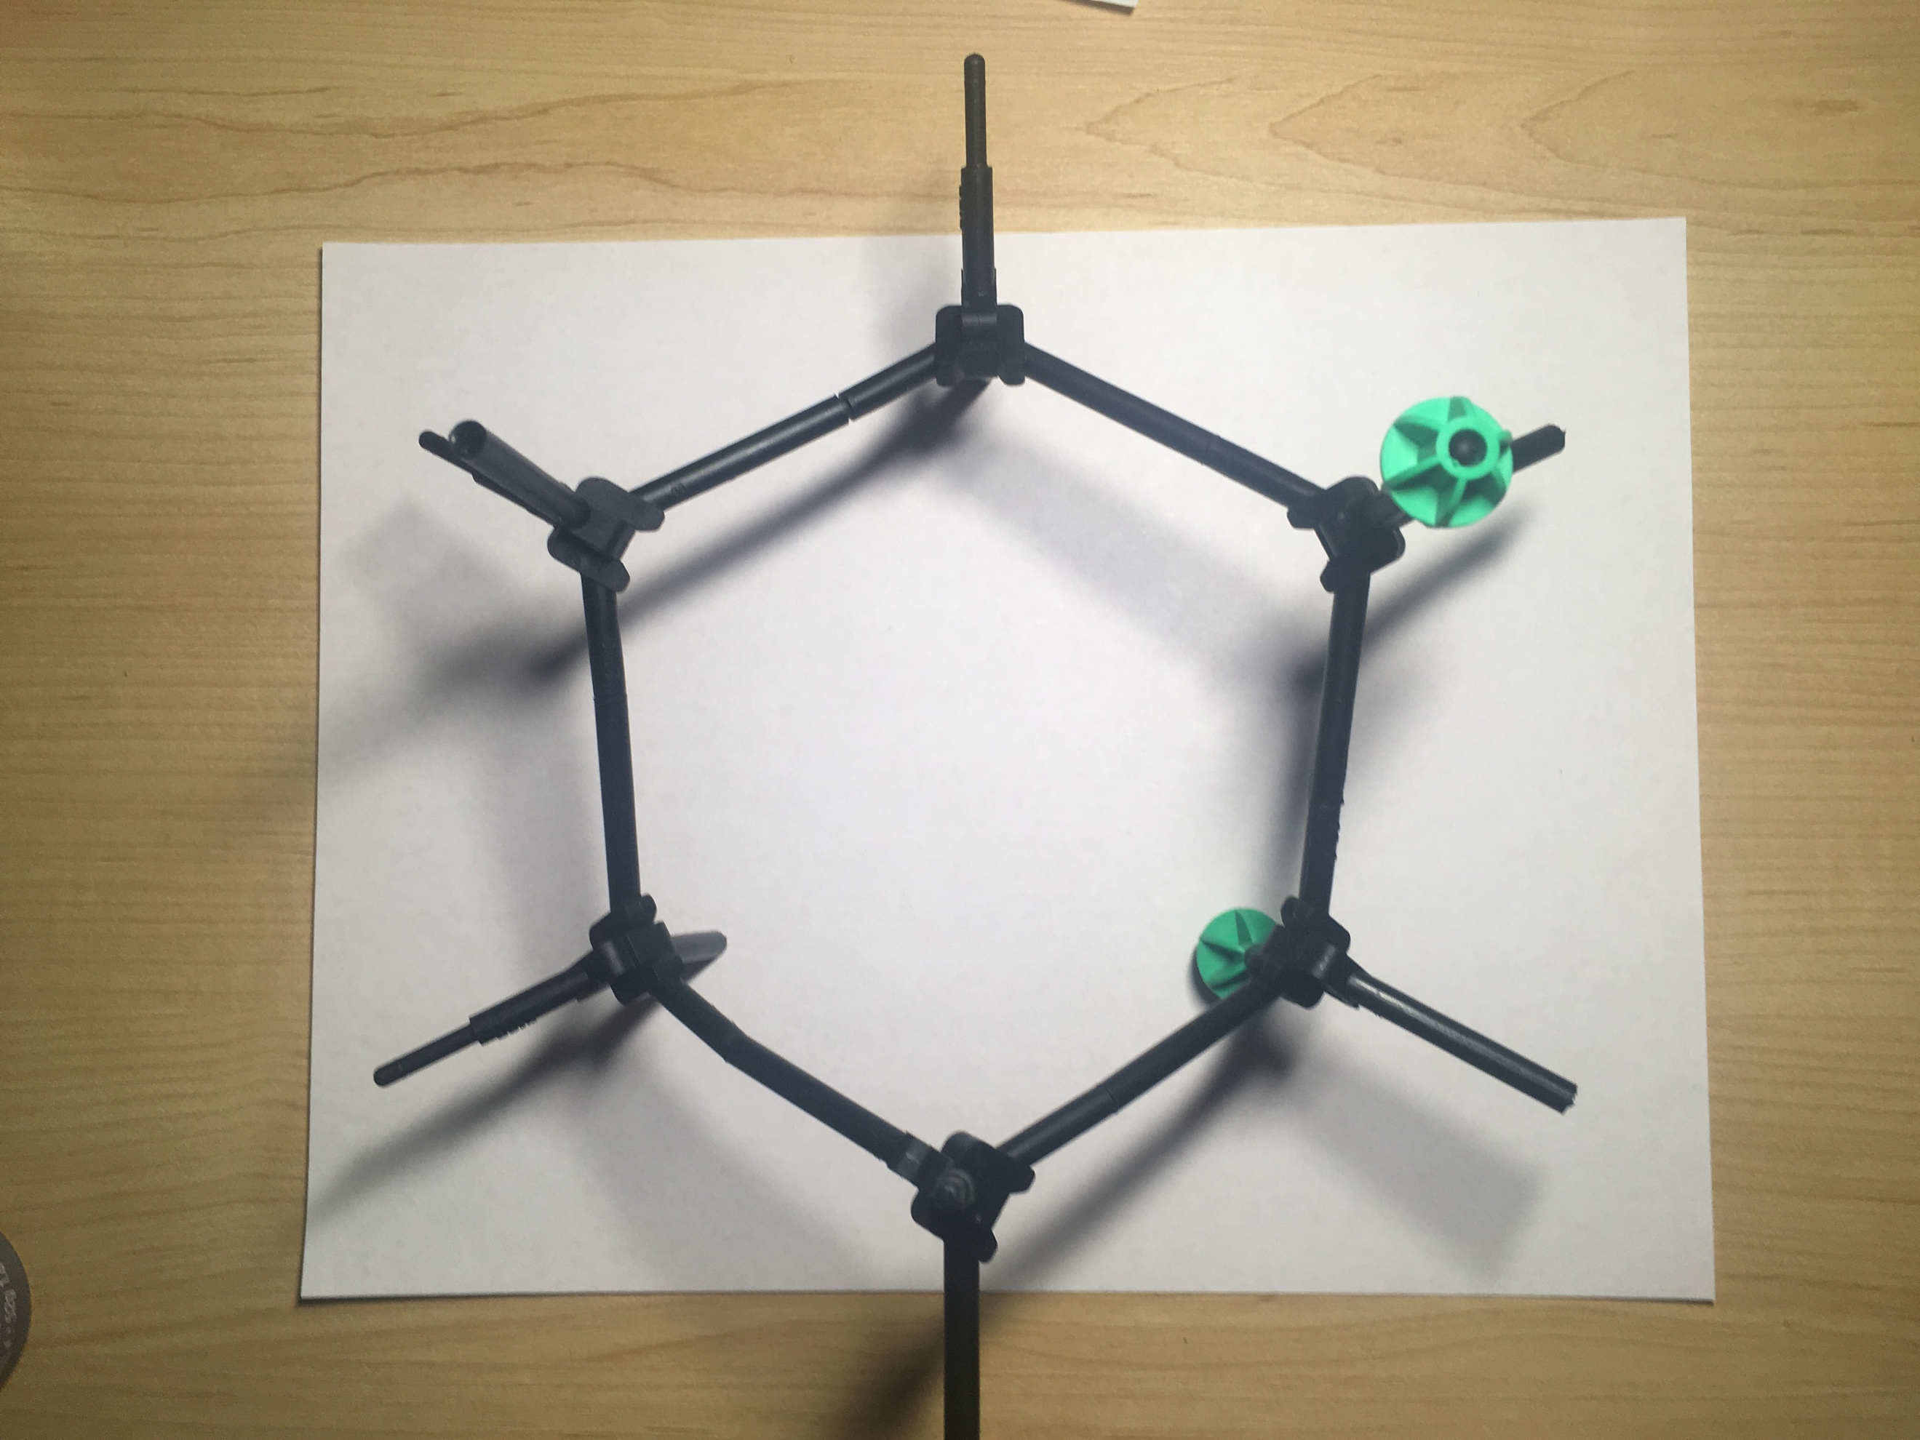
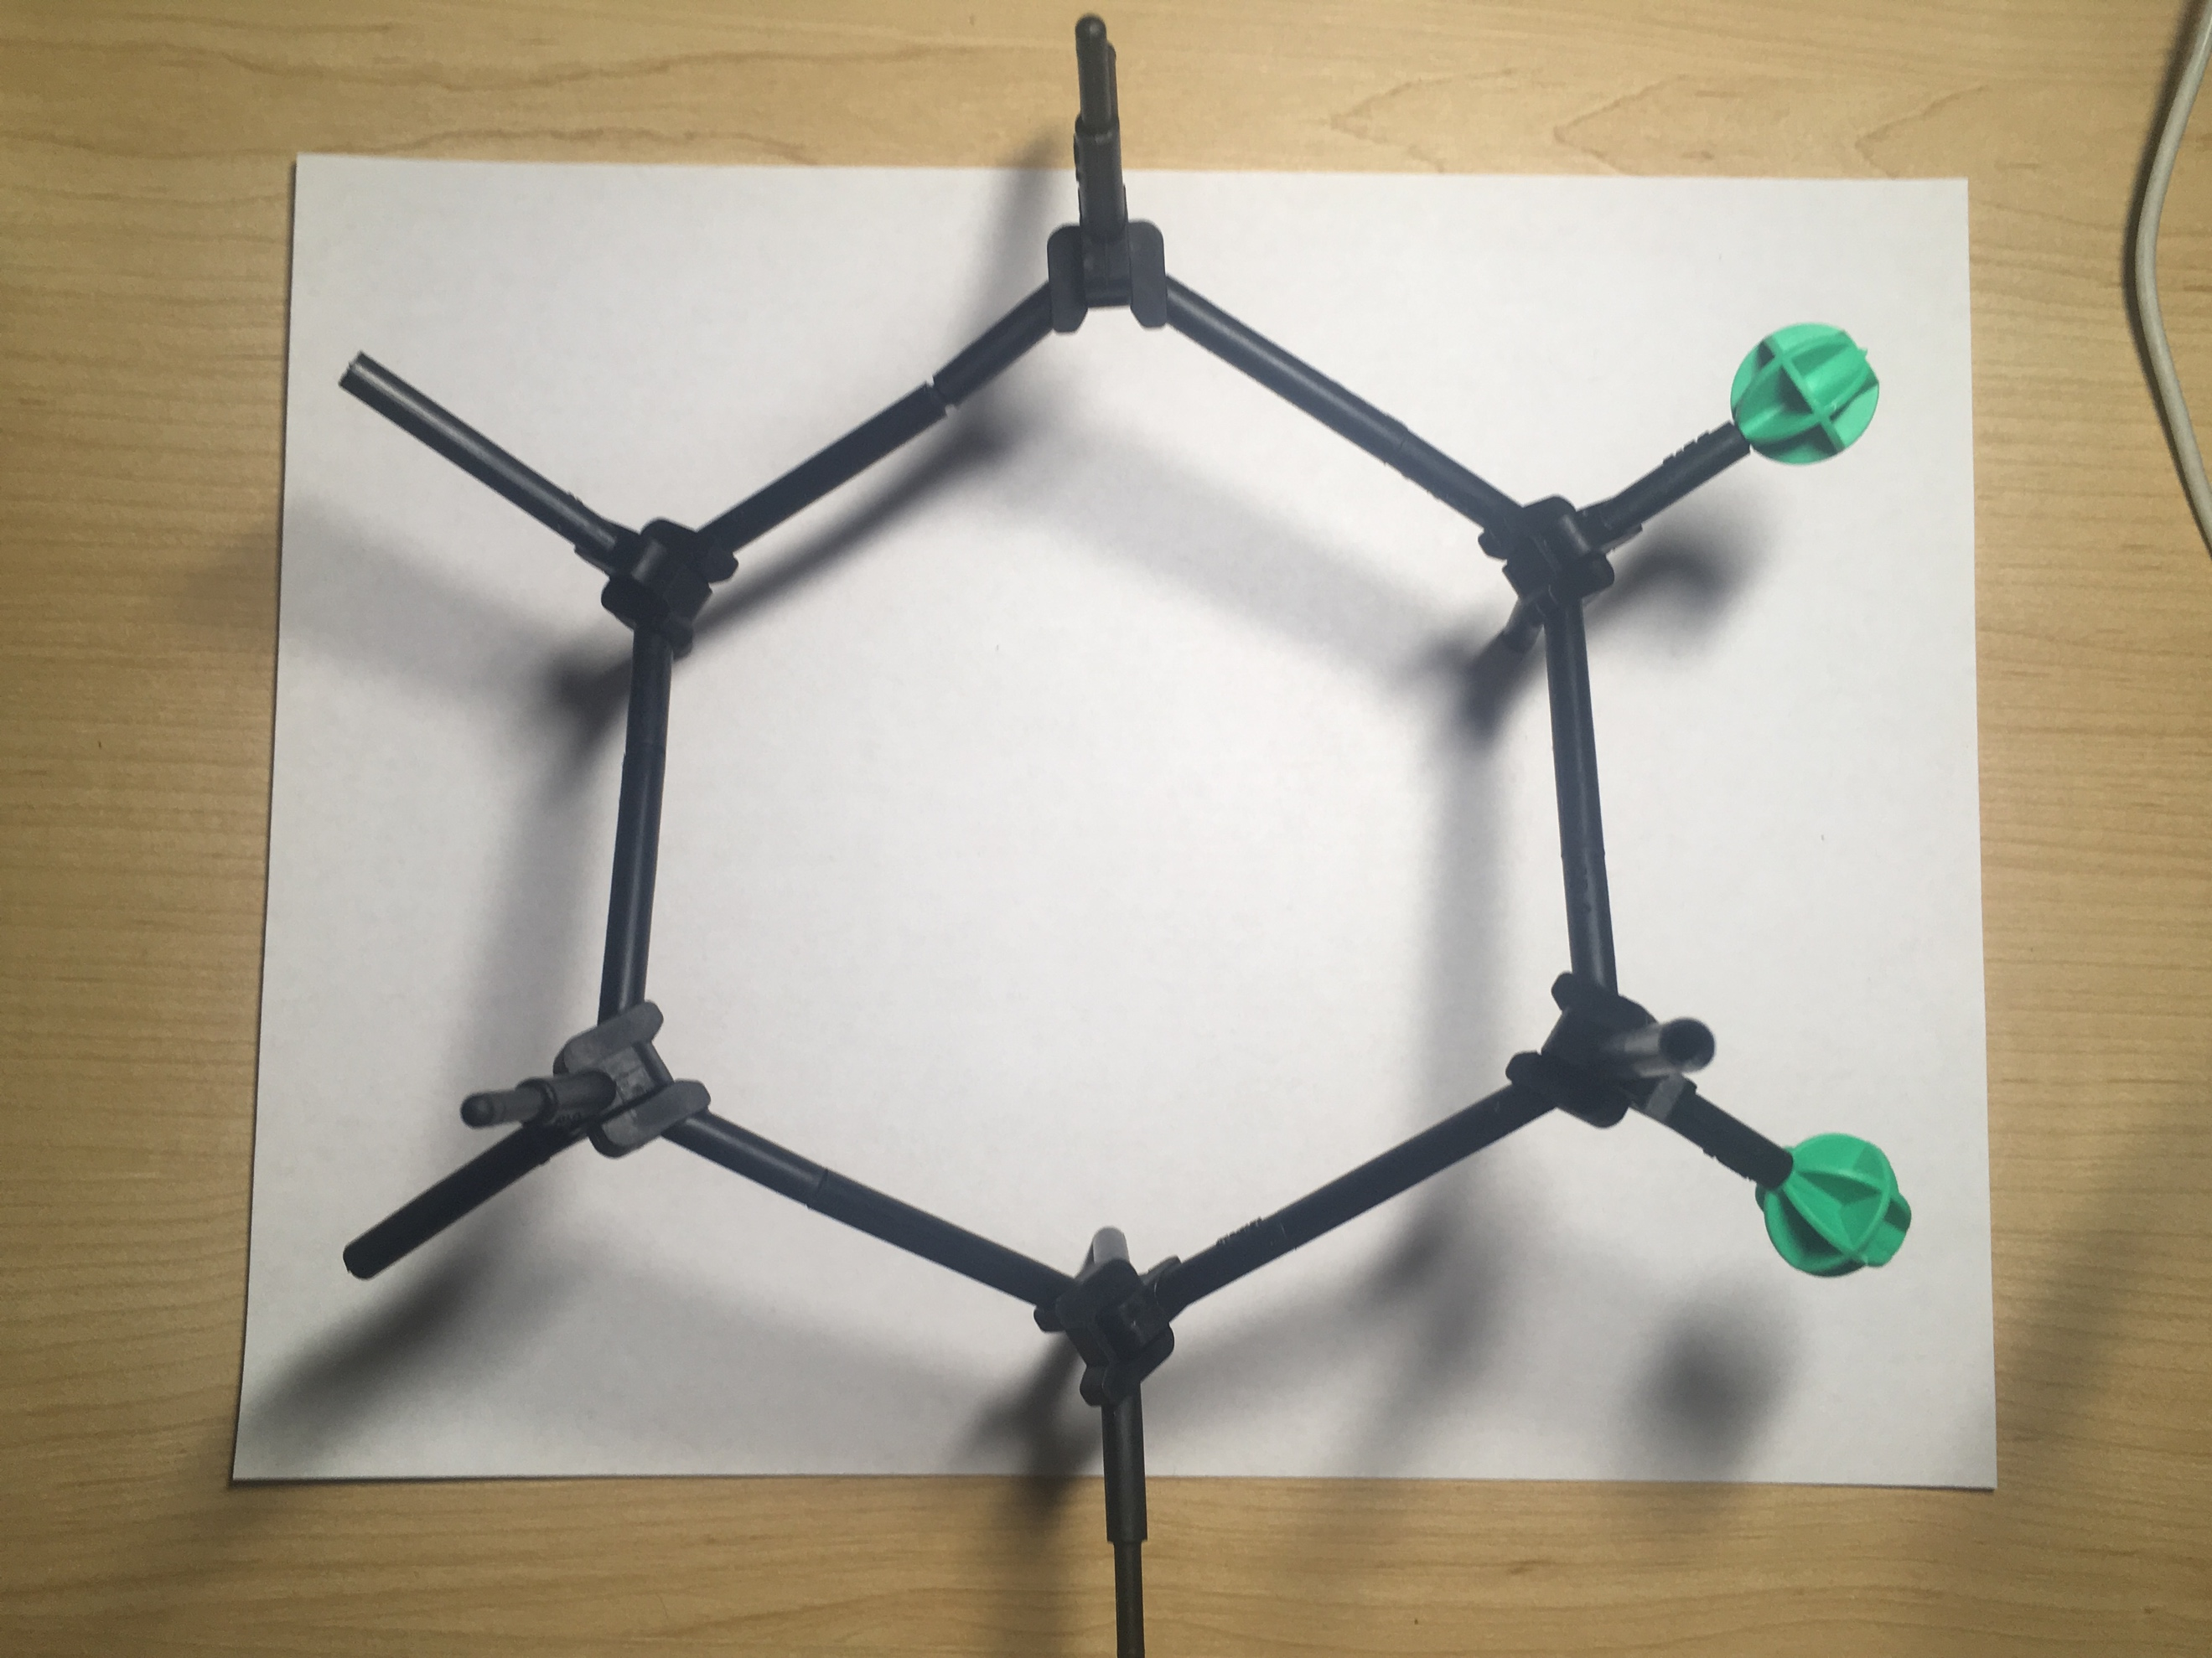
I would expect the formation is most stable when both chlorine and fluorine are equatorial.

