ACCO 360 – Principles of Auditing

Professor – Stanley Schulman

Week 1

Eight Framework Components (focusing on 5)

COSO Internal Control Integrated Framework Components
- Control environment (1 to 5 in PPT 3) – Set of standards, processes & structures that provide a basis or structure for carrying out effective internal control activities across an enterprise.
- Demonstrate commitment to integrity & ethical values – Hardnosed (strict) or Easy
  - Code of ethic in place (p.57 & 62 in book)
    - Must be acknowledged & actively followed
    - Needs to be a mechanism for reporting code violations

- Commitment to competence
- Ensure that BoD & audit committee exercises oversight responsibility
  - Establish oversight responsibilities
  - Apply relevant expertise
  - Operate independently
  - Provide oversight fir the system of internal controls
  - SEE PPT
- Management’s philosophy & operating style
- Organizational structure – establish structures, reporting lines, authorities & responsibilities
**The stronger these elements are, the stronger the control environment is**
- Risk assessment – The process for determining how all levels of risks will be managed, and a precondition to risk assessment is the establishment of risk-related objectives, linked at different levels of enterprise operations (Company-wide Objectives, Process-level Objectives, Risk Identification & Analysis, Managing change)
**The more complex an enterprise is, the more complex is the risk assessment**
- Specifying Appropriate Objectives (p.62)
  - There are always some risks in any business activity & there is no practical way to reduce all of them
  - Management must determine how much risk is to be prudently accepted and strive to maintain risk within these limits, understanding how much tolerance it has for exceeding its target risk levels
- Identifying & Analyzing risks
  - Consideration of all risks within an enterprise, including its subunits and operational functions, such as finance, HR, marketing, production, purchasing, and IT management.
  - This process should consider internal and external risks originating from outsourced service providers, key suppliers, and channel partners that directly or indirectly impact an enterprise’s achievement of objectives.
- Evaluating Fraud Risks (p.63)
  - A fraud risk assessment is a process that an enterprise should utilize to determine its exposure to internal & external fraud
  - The assessment should review operations and controls, including policies & procedures to determine where gaps exist that could allow a person or group of persons to carry out a fraud against the enterprise
- Identifying Changes Affecting Internal Controls
  - Management should consider acting on each of the four basic risk response strategies
- Internal control activities – Established through enterprise policies & procedures that help ensure that management’s directives to mitigate risks to the achievement of objectives are carried out. (look at the components as strengths & weaknesses in your analysis in an exam question) Types: Verifications (e.g. counting merchandise when it comes in and initial a paper), reconciliations (e.g. reconciling books) , authorizations & approvals (e.g. proper segregation of duties) , physical controls (e.g. employee access cards), controls over standing data, supervisory controls.
- Policies & procedures
- Security (application & network)
- Application change management
- Business continuity/Backups
- Outsourcing
- Information & communication – Means by which information is disseminated throughout an enterprise, flowing up, down, and across the entity. It enables personnel to receive clear messages from senior management that control responsibilities must be taken seriously.
- Quality of information
  - Record transactions as they occur, breaking them into components, parts
- Effectiveness of communication
  - Process, summarize, and report that information for management purposes and pure accounting purposes
  - Store captured & processed data in formats that can be summarized, audited, reviewed, and reported quickly & easily
  - Report that information in a format that can be used for management analysis & internal control purposes
- Monitoring – Assess whether each of the other objectives or components of COSO internal control, including the control environment, risk assessment, and others, are present & functioning.
- Ongoing Monitoring
- Separate evaluations
- Reporting deficiencies
See Figure 4.1 in Textbook

Internal Control: A process, effected by an entity’s board of directors, management, and other personnel, designed to provide reasonable assurance regarding the achievement of objectives in the following categories:
- Effectiveness & efficiency of operations
- Reliability of financial reporting
- Compliance with applicable laws & regulations

Audit Committee
Responsibilities:
- Overseeing the financial reporting & disclosure process

CASE – IN-CLASS
- Control Environment
  - Code of ethics – Strength
  - Policy practices - strength
  - Flow of responsibilities – weakness

- Risk Assessment
  - Analyze and changes – Strength
  - Physical Access – Weakness
  - Potential lawsuit - Weakness

- Control Activities
  - Step increasing security – Strength
  - Firewalls – Weakness
  - Limit access comp – Weakness

- Information & Communication
  - External legal advice – Strength
  - Contact & security – Strength
  - Hotline – Strength

- Monitoring
  - Implementation program – Strength
  - Follow-up – Weakness
  - Identify risk – Weakness

Week 3 – Chapter 4 – Enterprise Risk Management (COSO ERM)
ERM
An approach to allow an enterprise and internal audit to consider and assess its risks at all levels, whether it be in an individual area such as an IT development project, or global risks regarding an international expansion.
While released by the same COSO guidance-setting function that has developed and maintains the COSO internal controls framework, COSO ERM sometimes looks like its internal controls brother, but it has a much different feel and approach.

ERM Framework Defines:
There are various important ERM frameworks, each of which describes an approach for identifying, analyzing, responding to, and monitoring risks and opportunities, within the internal and external environment facing the enterprise. Management selects a risk response strategy for specific risks identified and analyzed, which may include:
- Avoidance: exiting the activities giving rise to risk
- Reduction: taking action to reduce the likelihood or impact related to the risk
- Alternative Actions: deciding and considering other feasible steps to minimize risks
- Share or Insure: transferring or sharing a portion of the risk, to finance it
- Accept: no action is taken, due to a cost/benefit decision
In the exam, all the COSO elements stays the same expect for the risk assessment

Risk Management Fundamentals
- An effective risk management process requires 4 steps:
- Risk Identification
  - The idea here is not to just list every possible risk but to identify those that might have more major impact on operations, within a reasonable time period. Understand the objective of organization and analyze the risks might hurt it.
  - Then you need to assess the likelihood and relative significance (use a matrix)

- Quantitative or qualitative assessment of the documented risks (Risk Assessment)
  - After identifying enterprise risks, a next step should be to assess their likelihood & relative significance
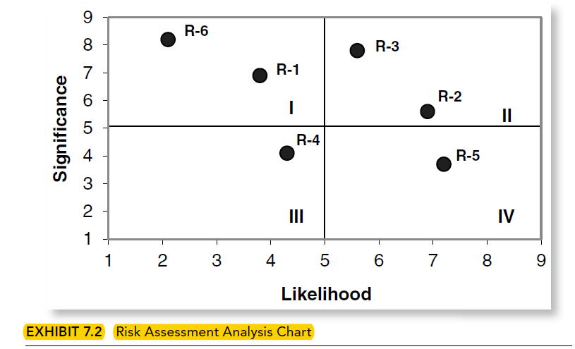
    - Risk Ranking: Using the likelihood + significance scores from exhibit 7.2 the product of these 2 give the relative risk rankings C & G have the highest-ranking score EXAM QUESTION
    - FORMULA: Expect Cost = (Significance probability * Likelihood probability) * Cost Impact
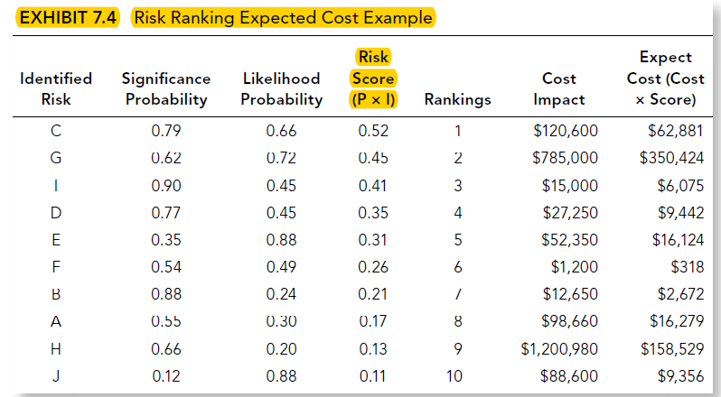
- Risk prioritization and response planning
  - Expected cost is just the product of the cost impact and the risk score, if the estimate of what it will cost an enterprise to incur, some risk, risk C, has the high likelihood + significance as well as fairly high expected cost to correct – candidate for corrective actions. Risk G has a high expected cost and a low-cost impact – management may decide to accept the risk or develop some other form of corrective plan.
- Risk Monitoring
  - This risk monitoring can be performed by the process owner or by an independent reviewer. Internal audit is often a very credible and good source to monitor the current status of identified risks

Internal Environment
- Risk management philosophy
- Risk appetite
- Board of directors’ attitudes
- Integrity and ethical values
- Commitment to competence
- Organizational structure
- Assignment of authority and responsibility
- Human resources standards
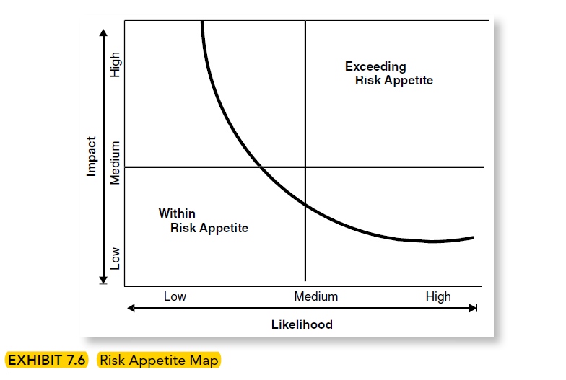
Objective setting outlines important conditions to help management create an effective ERM process. COSO ERM calls for an enterprise to formally define its goals with a direct linkage to its mission statement, along with measurement criteria to assess if it is achieving these risk management objectives.
You have to make a plan and policy of the organization.

Event Identification
- External economic events – Short-long term events
- Natural environment events – Flood, earthquake
- Political events – New Laws, regulations, tariffs
- Internal infrastructures events – Strong demand, new product
- Internal process-related events
- External and internal technological events – e.g. M.L launched it cash management account in 1980s caused major stir in the industry
**A currency default may increase an enterprise e-risk-relative event

Inherent Risk: Potential for waste, loss, unauthorized use, or misappropriation due to the nature of an activity itself – Loss of key raw material
Residual Risk: This is the risk that remains after other management responses to risk threats and countermeasures have been applied. There will virtually always be some level of residual risk
- Major Factors:
  - Management sophistication
  - Strengths
  - Budget

ERM Monitoring
INCLUDE:
- Implementation of ongoing reporting mechanism
- Periodic risk-related alert reporting processes that monitor key aspects of established risk criteria
- Current and periodic status reporting of risk-related findings and recommendations
- Updated risk-related information from sources (e.g. government revised rules, industry trends)

Week 4 – Chapter 5 – Performing Effective Internal Audit

Differences between the Internal & External Auditor
 | External Audit | Internal Audit
Reports to | Shareholders or members who are outside the organization’s governance structure | The board and senior managements who are within the organization’s governance
Objectives | Add credibility and reliability to financial reports from the organisation to its stakeholders by giving opinion on the report | Evaluate and improve the effectiveness of governance, risk management, and control processes. This provides members of the board and senior management with assurance that helps them fulfill their duties to the organisation and its stakeholders
Coverage | Financial reports, financial reporting risks | All categories of risk, their management, including reporting on them
Responsibility to Improvement | Non, however there is a duty to report problems | Improvement is fundamental to the purpose of internal auditing. But it is done by advising, coaching and facilitating in order to not undermine the responsibility of management.

Engagement Letter
- Addressee – to manager directly responsible for the unit being audited
- Objectives + Scope of the planned audit – Auditees s/b advised of the purpose of the planned internal audit + areas it will cover
- Expected Start Date + Duration – should give auditee some understanding of the timing of the audit
- Persons responsible for performing the review – Main person in charge auditor. It gives auditee management to identify this person
- Advice preparation needed – Any requirements needed in advance of the field visit or at the audit site should be outlined
- Engagement letter copies – s/e directed to the appropriate persons in the entity with a need to know

CASE 5.7 – Identifying Assertions & Supporting Evidence
Good short answer for final – KNOW THE 7 ASSERTIONS FOR SURE THERE’S A QUESTION ON THE EXAM
Assertion | Supporting Evidence
- Existence | Obtain evidence that the securities are legitimate and held by Lauzon
- Occurrence | Obtain evidence that the loan transaction and securities purchase transactions actually took place during the year of audit. WHY?
- Completeness | Obtain evidence that all the securities purchase transactions were recorded
- Ownership rights | Obtain evidence that the securities are owned by Lauzon
- Obligation | Obtain evidence that $250,000 is the amount actually owed on the loan
- Valuation | Obtain evidence of the cost and market value of the securities held at Dec. 31. Decide whether any write-downs to market are required
- Presentation & Disclosure | Obtain evidence of the committed nature of the assets, which should mean they should be in a non-current classification like the loan. Obtain evidence that restrictions on the use of the assets are disclosed fully and agree with the loan documents.

2 types of confirmation (positive & negative). When the confirmation is positive, a response is required.

Application 5.9 – Assertions & evidence
Inventory assertion most at risk for this client:
- Valuation will be at risk because the constantly changing nature of the type of merchandise held suggests that items will become obsolete (and their value impaired) each season. The special branding and promotional packaging will make it difficult for the client to sell these items to the supplier.
  - Evidence
    - Auditor should inspect the terms of the contract with supplier to determine if there is any provision for return of item not sold
    - Inspection of inventory records to determine if any items are held for long periods suggesting they could be obsolete
** SEE PICTURES FOR THE REST 01-11-2018**

Chapter 7 – Introduction to Audit & Assurance

Define an Assurance Engagement
Defined as an engagement where a practitioner (auditor or consultant) issues a written report & concludes on a subject matter for which the accountable party is responsible.
- Requires the existence of an accountability relationship where one party is answerable to another for the subject matter
Assurance – Engagement where an auditor or consultant is hired to provide an opinion on a subject matter.
- Done to enhance the reliability of the information
Term | Definition
Applicable Financial Reporting Framework | The financial framework chosen by management to prepare a company’s financial statement (IFRS/ASPE)
Assertions | Statements made by management regarding the recognition, measurement, & presentation & disclosure of items in the financial statements.
Audit Evidence | Information used by the auditor to support audit opinion
Audit File | The file where the evidence and documentation of the work performed are kept as a permanent record to support the opinion issued
Audit Plan | The list or description of audit procedures to be performed
Audit Risk | The risk that the auditor may express an inappropriate opinion. This means the auditor may indicate that the financial statements are not materially misstated when in fact they are
Financial Statements | A structured representation of historical financial information, including the related notes
Independent auditor’s report | The auditor’s formal expression of opinion on whether the financial statements are in accordance with the applicable financial reporting framework
Internal Control | The processes implemented & maintained by management to help the entity achieve its objectives
Material | An amount or disclosure that is significant enough to make a difference to a user
Materiality | The maximum amount of misstatement or omission that the auditor can tolerate and still issue an unmodified/clean audit opinion
Sufficient & appropriate evidence | The quantity & quality of the evidence collected by the auditor
Unmodified Opinion | The auditor’s opinion concluding that the financial statements are fairly presented
Working Papers | Paper/electronic documentation of the audit created by the audit team as evidence of the work completed

Demand for Audit & Assurance Services

Financial Statement Users
- Include current & potential investors, suppliers, customers, lenders, employees, governments, & the general public.
  - Investors – determine if they should invest or not, buy, hold or sell shares in the entity.
    - Interested in the return on their investment & concerned that the entity will remain a going concern in the foreseeable future
  - Suppliers – Determine whether the entity can pay them for goods supplied
    - Interested in whether the company will remain a going concern
  - Customers – If they rely on the entity for their business, they want to determine whether the entity will remain a going concern
  - Lenders – Determine whether the entity can pay the interest & principal on their loans when they are due.
  - Employees – determine if the entity can pay salary
  - Governments – determine whether the entity is complying with regulations & paying a fair amount of taxes and gain a better understanding of the entity
  - General Public – Determine whether they should associate with the entity (as employee, supplier, or customer) and gain a better understanding of the entity

Sources of Demand for Audit & Assurance Services
Primary reason is to reduce information risk – risk that users will rely on incorrect information to make a decision. The causes of information risk include:
- Remoteness – Most users do not have access to the entity under review
- Complexity – Most users don’t have the accounting & legal knowledge
- Competing incentives – Management has incentives to disclose the information contained in the financial statements in a way that helps them achieve their own objectives
- Reliability – Users are concerned with the reliability of the information contained.
Auditors have access to entity records, so they are not remote. They are trained accountants & have a detailed knowledge about the complex technical accounting & disclosure issues. They have no incentive to aid the entity in presenting its result positively. They are concerned with ensuring that the information contained is reliable and free from material misstatements (error/ fraud).

Theoretical Frameworks
The reasons for demanding audit & assurance services have led to the development of 3 theoretical frameworks that have been used to explain why audits occurred prior to regulations requiring that they be done.
- Agency Theory
- Due to the remoteness of the owners from the entity, the complexity of items included in the financial statements, and competing incentives between the owners & managers, the owners (principal) have an incentive to hire an auditor (incur a monitoring cost) to assess the fair presentation of the information contained in the financial statements prepared by their managers (agents)
- Information Hypothesis
- The greater the perceived quality of the information contained in the financial statements, the more likely it will be relied upon by the users. This theory tells us that due to the demand for reliable, high-quality information, various user groups, including shareholders, banks & other lenders, will demand that financial statements be audited to aid their decision-making.
- Insurance Hypothesis
- According to this theory, an audit is one way for investors to insure against at least a part of their loss should the company they invest in fail. It tells us that investors will demand that financial statements be audited as a way of insuring against some of their loss if their investment fail.

Demand in a Voluntary Setting
It is becoming more common for companies to voluntarily disclose CSR information in their annual report, on their websites & in separate stand-alone report in response to shareholders’ demand that companies be more accountable for their impact on the environment & on society.
- Stakeholders are concerned about the reliability of environmental & other CSR disclosures
- Not required

Different Assurance Services

Financial Statement Audits
- The objective is for the auditor to express an opinion about whether the financial statements are prepared in all material respects in accordance with a financial reporting framework (GAAP).
  - This means that when a set of financial statements has been audited, the information presented has been verified by an independent auditor. This lends credibility to the information
- The CSA requires listed entities to publish audited financial statements annually. It is the auditor’s responsibility to form an opinion on the fair presentation of the financial statements
  - Consistent & faithful application of the accounting standards.
- Process
  - An audit is a systematic process involving the gathering of evidence in a logical fashion to substantiate the balances & disclosures in the financial statements.
  - Steps:
- Planning Stage
    - Performing an overall risk assessment. The auditor documents an understanding of the business, its environment, and its processes to determine where the greatest risks may be.
- Audit Strategy
    - Allow the auditor to plan when to perform the “field work”, who will do it, and what exactly needs to be done.
    - Tasks are usually divided by business cycle or financial statement groupings
- Execution Stage
    - The auditor typically works at the client’s premises
    - As the work is done, it is documented in the audit file.
      - The documentation is done through the use of narrative, memos, or schedules with audit “ticks”.
      - The audit programs are initialled by audit members once completed
    - Each completed section is then reviewed by a more senior auditor, as work must be properly supervised
- Audit Review
    - If the partner believes there is sufficient & appropriate evidence in the audit file, and the financial statements appear fairly stated, he will approve and issue and unmodified audit opinion.
- Limitations
  - It is not a guarantee that the financial statements are free from fraud & error
  - Result from the nature of financial reporting (use of judgement), the nature of audit procedures (reliance on evidence provided by the client & its management), & the need for the audit to be conducted within a reasonable period of time & at a reasonable cost
  - If the auditor does not have access to all the information relevant to the audit, there is a limitation in the scope of the audit
  - If a sample is not representative of all items available for testing, and auditor may arrive at an invalid conclusion

Compliance Audits
Involves gathering evidence to ascertain whether the person or entity under review has followed the applicable rules, policies, procedures, laws, and regulations

Operational Audits
Concerned with the economy, efficiency & effectiveness of an organization’s activities. Important to keep a balance
- Economy refers to the cost of inputs, including wages & materials.
- Efficiency refers to the relationship between inputs and outputs
  - Use of minimum amount of inputs to achieve a given output
- Effectiveness refers to the achievement of certain goals or the production of a certain level of outputs

Comprehensive Audits
May encompass elements of a financial statement audit, a compliance audit, and an operational audit.
- For example, an auditor may report on whether an entity has met its efficiency targets
- Most commonly occur in the public sector

Internal Audits
Conducted to provide assurance about various aspects of an organization’s activities.
- The function of internal audit is determined by those charged with governance and management within the organization
- The external auditor may consider the work done by the internal auditors

Different Levels of Assurance

Reasonable Assurance
The objective of a reasonable assurance engagement is to perform sufficient procedures & gather sufficient evidence upon which to form a positive expression of an opinion regarding whether the information being assured is presented fairly.
- Does not reflect absolute assurance, as an auditor can never be 100% certain that there are no errors or omissions
- Highest level of assurance

Moderate Assurance
The objective of a moderate assurance engagement is to perform sufficient procedures & gather sufficient evidence upon which to express a negative assurance form of communication regarding the reliability of the information being assured.
- The auditor has done adequate work to report whether or not anything came to their attention that would lead them to believe that the information being assured is not worthy of belief
- The auditor is not in a position to say that in their opinion, the financial statements are in accordance with the relevant law and accounting standards, and does present fairly the financial position & performance of the reporting entity
- The auditor is able to say only that the information is plausible, in that nothing makes them believe otherwise
- A review engagement may be requested when the client requires some assurance over the financial statements but does not require an audit level of assurance.

No Assurance
An example of an engagement where no assurance is provided is a compilation engagement.
- The accountant ensures that the information is mathematically correct but does not perform any procedures to assure that the information is not materially misstated, & therefore no expression of assurance is provided.
  - However, the auditor must ensure that they are not associated with the information that may be false or misleading
  - To ensure that users are aware that no assurance is being provided, the auditor attaches a notice to reader

Different Audit Opinions
The most common audit report is unmodified and contains an unmodified opinion (clean opinion)
- May have an unmodified opinion & include an emphasis of matter paragraph
  - Draws the attention of the reader to an issue that the auditor believes has been adequately & accurately explained in a note to f/s
  - Purpose is to ensure that the reader pays appropriate attention to the issue when treading the f/s

Qualified Opinion – Material but NOT pervasive
Issued when the auditor believes that “except for” the effects of a matter that is explained in the audit report, the f/s can be relied upon by the reader.
- Used when the matter of concern can be identified, quantified, and explained in the audit report.

Adverse or Disclaimer Opinion
Adverse: Appropriate if the auditor has evidence that identified misstatements, individually or in aggregate, are material & pervasive to the f/s.
Disclaimer: Used when the auditor is unable to obtain sufficient appropriate audit evidence on which to base the opinion & concludes that the possible effects on the f/s could be material & pervasive

Preparers & Auditors
It is the responsibility of those charged with governance (generally BoD & management of an entity) to prepare the f/s. They must ensure that the information included in the f/s is fairly presented & complies with Canadian accounting standards & interpretation.
- BoD & Management – Charged with governance are responsible for:
  - Identifying the financial reporting framework to be used in the preparation & presentation of their f/s
  - Reporting, establishing & maintaining internal controls that are effective in preventing & detecting material misstatements finding their way in to the f/s.
  - Selecting & applying appropriate accounting policies & making reasonable accounting estimates

Preparer Responsibility
It is the responsibility of those charged with governance to ensure that the information contained in their f/s is relevant, reliable, comparable, understandable & fairly presented
- Relevant
  - The information included in the financial statements should be relevant to the users of that report. Information is relevant if it has an impact on the decisions made by users regarding the performance of the entity.
  - Users require information that helps them evaluate past, present & future events relating to the entity.
- Reliable
  - Information is reliable when is it free from material misstatements
    - Errors or fraud
- Comparable
  - The information in the f/s should be comparable through time
  - Users need to be able to trace an entity’s performance to identify any trends that may influence their perception of how well the entity is doing
    - Need to be able to benchmark the performance of the entity against similar organizations
- Understandable
  - Users need to understand the information presented in order to make appropriate decisions
  - The notes to the f/s are used to provide additional details to aid in the interpretation of the accounting information provided.
- Fairly Presented
  - “Presented fairly” or “truth & fairness” refers to the consistent & faithful application of the accounting standards or an applicable framework when preparing the f/s.
  - It is the responsibility of the auditor to form an opinion on the fair presentation or the truth & fairness of the f/s.

Auditor Responsibility
When undertaking an audit, the auditor should use professional scepticism, professional judgement & due care.
- Professional Scepticism
  - An attitude adopted by the auditor when conducting the audit.
  - The auditor remains independent of the entity, its management, and its staff when completing the audit work.
    - Maintain a questioning mind & thoroughly investigates all evidence presented by the client – must also seek independent evidence to corroborate information provided by the client
- Professional Judgement
  - Level of expertise, knowledge, & training that an auditor uses while conducting an audit.
- Due Care
  - Due care refers to being diligent while conducting an audit, applying technical & statute-backed standards, & documenting each stage in the audit process

Audit Expectation Gap
The audit expectation gap occurs when there is a difference between the expectation of assurance providers & f/s users.
- Occurs when users beliefs do not align with what an auditor has actually done
  - Caused by unrealistic user expectations such as:
    - Auditor providing complete assurance
    - Auditor guaranteeing the future viability of the entity
    - An unqualified audit opinion is an indicator of complete accuracy

CHAPTER 8 – AUDIT PLANNING 1

Stages of an Audit

Planning Stage
Involves gaining an understanding of the client, identifying factors that may impact the risk of a material misstatement in the financial statements, performing a risk & materiality assessment & developing an audit strategy.
- Required step to reduce audit risk to an acceptable low level.
  - Reduce the risk that the auditor issues an unmodified/clean opinion when the f/s are in fact materially misstated
- In order to plan an efficient (amount of time spent gathering audit evidence) & effective (minimization of audit risk) audit, an auditor must:
  - Understand the entity & its environment to make a reasonable preliminary assessment of audit risk & materiality
  - Identify any significant risks or unique features of the entity or the environment that may impact the audit planning
- When planning an audit, the auditor will assess the risk of material misstatement due to fraud and consider whether it is appropriate to assume that their client will remain as a going concern.

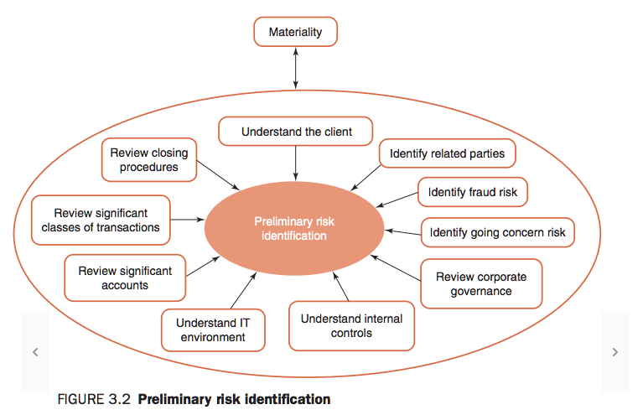

- Auditor must gain an understanding of their client’s system of internal controls
  - Consider the impact of IT
- Auditor can structure their audit testing to ensure that adequate time is spent testing these accounts & classes of transactions.
  - Also consider the adequacy of the client’s closing procedures

Performing an Audit
The performance/execution stage of the audit involves detailed testing of controls, transactions, & balances.
- If an auditor plans to rely on the client’s system of internal controls, they will conduct tests of control
  - Provides the evidence that the auditor requires to determine whether the f/s are fairly presented

Concluding & Reporting on an Audit
Auditor will draw on their understanding of the client, their knowledge of the risks faced by the client, and the conclusions drawn when testing the client’s controls, transactions, and account balances.

Gaining an Understanding of the Client
- Allows the auditor to make a reasonable preliminary risk assessment and to assess planning materiality
- Allows the auditor to determine the appropriateness of the entity’s accounting policies, identify areas where additional audit work may be required, & develop expectations for analytics
- Ensures the auditor is able to assess the risk that the f/s contain a material misstatement due to:
  - The nature of the client’s business
  - The industry in which the client operates
  - The level of competition within that industry
  - The client’s customers & suppliers
  - The regulatory environment in which the client operates

Steps
- Make inquiries of management and of others within the entity who may have information to help identify the risk of material misstatements
  - Includes making inquiries of both financial & non-financial staff at all levels of the organization, including those charged with governance, internal audit, sales & operational personnel.
- Perform analytical procedures at the planning stage of the audit to identify any unusual or unexpected relationships that may highlight where risks exist.
  - Analytical procedures are a study of plausible relationships between both financial & non-financial data
- Perform an observation & inspection procedure to corroborate the responses made by management & others.
  - Also provide information about the entity’s environment
By performing these activities, the auditor will gain an understanding of the issues at the entity level, the industry level & the economy level.
- ENTITY LEVEL
  - Knowledge about the entity is gained through interviews with client personnel
  - Auditor will ask questions about:
    - What the client does
    - How the client functions
    - How its ownership is structured
    - What are the client’s sources of financing?
  - For new clients, this process is very detailed & time consuming
  - For a continuing client, this process is less onerous & involves updating the knowledge gained on previous audits
  - Major customers are identified
    - Identify whether those customers have a good reputation, are on good terms with the client – are they likely to remain a customer, affecting the going concern assumption (if a client only have a few customers, this risk is increased)
  - Major supplier are identified
    - Identify whether they are reputable & supply quality goods on a timely basis – level of goods that are returned to supplier as faulty
    - What are the contract terms of payment – does the client pay suppliers on a timely basis
  - Whether the client is an importer or exporter of goods
    - Stability of the foreign currency the client trades in
    - Effectiveness of any risk management policies used to limit exposure to currency fluctuations
  - The client’s capacity to adapt to changes in technology & other trends
    - Whether the client is up to date with changes in technology & customer demand
  - Nature of warranties provided to customers
    - Assess the likelihood that goods will be returned
    - Risk that the client has underprovided for that rate of return
    - Attention to goods returned for similar problems
  - The terms of discounts given
    - Assess the client’s bargaining power with its customers & suppliers
    - Assess the client’s reputation – poor reputation places future profits at risk
  - Client operations
    - Where the client operates – number of locations – dispersion of locations
      - The more spread out, the harder it is for the client to effectively control & coordinate its operations increasing the risk of errors in the f/s.
  - Nature of employment contracts & client’s relations with employees
    - Way employees are paid
    - Mix of wages and bonuses
    - Level of unionization among the workforce
    - Attitude of staff to their employer
      - The more complex a payroll system, the more likely errors can occur
  - Client’s sources of financing
    - Assess debt sources
    - Reliability of future sources of financing
    - Structure of debt
    - Reliance on debt versus equity
  - The client’s ownership structure
    - Amount of debt funding relative to equity
    - Use of different forms of shares
    - Differing rights of shareholder groups
    - Dividend policy & ability to meet dividend payments out of operating cash flow
- INDUSTRY LEVEL
  - Level of competition
    - The more competitive, the more pressure placed on client’s profits
    - A key issue for an auditor is their client’s position among its competitors & its ability to withstand downturns in the economy
  - Client’s reputation
    - Relative to competitors
    - By reading articles in the press & industry publications
  - Government support for the client’s industry
    - Important if the industry faces competition internationally or new industry
  - Government regulations on the client’s industry
    - Tariffs on goods, trade restrictions, foreign exchange policies
    - Can affect a client’s viability & continued profitability
    - Consider the level of taxation
  - Level of demand for the goods sold in the industry
    - Seasonal?
    - Technological changes?
- ECONOMY LEVEL
  - Client’s susceptibility to:
    - Economic upturns/downturns
    - Changes in interest rates
    - Currency fluctuations

Related Parties
Include parent companies, subsidiaries, joint venture, associates, company management, and close family members of key management. Related party transactions not only increase the susceptibility of the f/s to material misstatement due to fraud or error, they may also impact the overall f/s results
- Discuss with the engagement team the susceptibility of the f/s to material misstatement due to fraud or error that could result from the entity’s related party relations & transactions
- Ask management to identify all related parties & to provide an explanation as to the nature, type & purpose of transactions with these entities
- Obtain an understanding of the processes & procedures management has in place to ensure all related party transactions are identified, authorized, accounted for, & disclosed in accordance with the chosen financial reporting framework
- Remain alert when inspecting documents such as bank confirmations, unusual sales & purchase invoices, minutes of BoD & shareholders meetings & contracts for indicators that related party transactions may not have been identified or disclosed to the auditor
- Identify & assess the risk that transactions may not be normal course of operations.
  - Inspect any underlying documents & determine the business rationale to ensure that they are not an attempt to fraudulently misstate the financial results

Fraud Risk
Fraud is an intentional act to obtain an unjust or illegal advantage through the use of deception.
- An auditor can use red flags to alert them to the possibility that a fraud may have occurred:
  - Key finance personnel refusing to take leave
  - Overly dominant management
  - Poor compensation practices
  - Inadequate training programs
  - Complex business structure
  - No/ineffective internal auditing staff
  - High turnover of auditors
  - Unusual transactions
  - Weak internal controls

2 Kinds of Fraud
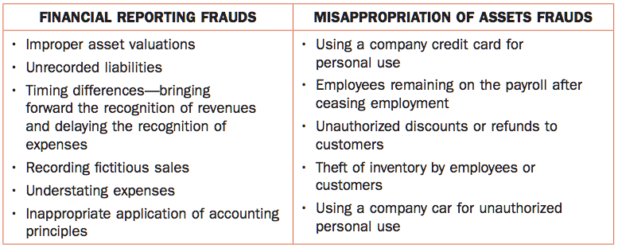

Incentives & Pressures to Commit a Fraud
- Use of professional scepticism
- Examples of incentives & pressures that increase the risk of a client committing fraud:
  - Operation in a highly competitive industry
  - Significant decline in demand
  - Threat of takeover
  - Threat of bankruptcy
  - Ongoing losses
  - Rapid growth
  - Poor cash flows combined with high earnings
  - Pressure to meet market expectations
  - Planning to list on a stock exchange
  - Planning to raise debt or renegotiate a loan
  - About to enter into a significant new contract
  - Significant proportion of remuneration tied to earnings – bonuses/options

Opportunities to Perpetrate a Fraud
Auditor will use their knowledge of how other frauds have been perpetrated to assess whether the same opportunities exist at the client
- Use of professional judgement
- Examples of opportunities that increase the risk that a fraud may have been perpetrated include:
  - Accounts that rely on estimates & judgement
  - High volume of transactions close to year end
  - Significant adjusting entries & reversals after year-end
  - Significant related party transactions
  - Poor corporate governance mechanisms
  - Poor internal controls
  - High turnover of staff
  - Reliance on complex transactions
  - Transaction out of character for a business

Attitudes & Rationalization to Justify a Fraud
Attitude refers to ethical beliefs about right & wrong, & rationalization refers to an ability to justify an act
- Examples of attitudes & rationalization used to justify a fraud include:
  - Poor tone at the top
  - The view that implementing an effective internal control structure is not a priority
  - An excessive focus on maximization of profits &/or share price
  - Poor attitude to compliance with accounting regulations
  - Rationalization that other companies make the same inappropriate accounting choices

Audit Procedures Relating to Fraud
- The auditor should ask management and those charged with governance if they are aware of a known fraud or suspect there has been a fraud
- All members of the audit team, including the partner, should attend a team planning meeting.
  - During this meeting, the significant fraud risk factors & where f/s may be particularly susceptible to fraud should be reviewed
- The auditor should perform preliminary analytics to identify any unusual relationships that may indicate fraud and thus require further investigation during the audit
- The auditor must consider the risk of management override
  - Test a sample of journal entries
  - Review accounting estimates
  - Contemplate the risk of earnings management
  - Examine unusual business transactions
- If the auditor finds a fraud, he must:
  - Contemplate their legal & professional responsibilities
  - Seek legal advice to determine if there is a requirement to report the fraud to an outside party
  - Consider withdrawing from the engagement
  - Report the fraud to the level of management above that under which the fraud occurred
  - Report the fraud to the audit committee

Going Concern
The going concern assumption is made when it is believed that a company will remain in business for the foreseeable future
- Under this assumption, assets are valued on the basis that they will continue to be used for the purposes of conducting a business & liabilities are classified as current & non-current on the basis that the client will pay its debt as they fall due in the years to come.

Going Concern Risk – Indicators
An auditor will use its professional judgement to assess whether the going concern assumption is valid
- List of events & conditions that place doubt on the going concern assumption:
  - Significant debt-to-equity ratio
  - Long-term loans reaching maturity without alternative financing in place
  - Prolonged losses
  - Inability to pay debt when they fall due
  - Supplier reluctance to provide goods on credit
  - Loss of a major market, key customer, franchise, or licence
  - Overreliance on a few customers or suppliers
  - High staff turnover
  - Staff regularly out on strike
  - Shortage of a key input or raw material
  - Rapid growth with insufficient planning
  - Being under investigation for non-compliance with legislation
  - Falling behind competitors
- If the auditor believes that there is an unresolved going concern issue outstanding, an assessment is made of the appropriateness of management disclosures in the notes to f/s.
  - Further procedures are undertaken
    - Assessment of CF
    - Assessment of revenue & expense items
    - Assessment of interim f/s
    - Review of debt contracts
    - Review of board & other meetings
    - Discussions with client management & lawyers
    - Identification & assessment of mitigating factors

Going Concern Risk – Mitigating Factors
- Mitigating factors include:
  - Letter of guarantee from a parent company
  - Availability of non-core assets, which can be sold to provided needed cash, without interrupting the company’s operating capacity
  - Ability to raise additional funds though the sale of shares
  - Ability to raise additional funds though borrowing
  - Ability to sell an unprofitable segment of the business

Information Technology
IT is a part of most companies’ accounting processes, which include the transaction initiation, recording, processing, correction as necessary, transfer to the general ledger, and compilation of the financial report
- Risks associated with IT include
  - Unauthorized access to computers, software & data
  - Errors in programs
  - Lack of backups
  - Loss of data
- 2 broad categories of controls used to reduce IT risk
  - General Controls
    - Policies & procedures that relate to many applications & support the effective functioning of application controls
    - They include procedures for:
      - Purchasing, changing & maintaining new computers/software
      - Use of passwords & other security measures to minimize the risk of unauthorized access
      - Procedures to ensure appropriate segregation of duties
  - Application Controls
    - Manual or automated procedures that typically operate at a business process level & apply to the processing of transactions by individual applications
    - Designed to prevent/detect a material misstatement in the f/s by ensuring all transactions are recorded only once & rejected transactions are identified & corrected
    - They include:
      - Reconciliations between input & output data
      - Automated checks on data entered to ensure accuracy

Closing Procedures
Auditor is concerned that transactions & events have been recorded in the correct accounting period
- Auditor can check monthly & quarterly f/s for internal/external purposes to assess the accuracy of the client’s closing procedures
- Check the accuracy of accrual calculations around year-end
- Look at earning trends to assess whether the reported income is in line with similar periods
If an auditor believes that their client is under pressure to report strong results, there is a risk that revenues earned after year-end will be included in the current year’s income & expenses excluded. Opposite happens if the client is under pressure to smooth income.

CHAPTER 9 – AUDIT PLANNING II

Audit Risk
The risk that an auditor expresses an inappropriate audit opinion when the f/s are materially misstated.
- The auditor reports that, in their opinion, the f/s are fairly presented when, in fact, they contain significant error or fraud, and therefore are materially misstated
- Audit risk can be reduced at the planning stage of the audit by identifying the key risks faced by the client & allocating more audit time to gathering sufficient & appropriate evidence where the risk of material misstatement is highest

- First Stage – Inherent Risk Assessment
The auditor considers the risk of material misstatement before consideration of any internal controls.
- Considering:
  - The nature of the business
  - The industry
  - Previous experience with the client
  - Assertion level for classes of transactions, account balances & disclosures
- When classifying risks as being significant, consideration is given to whether the risk:
  - Involves fraud
  - Is related to significant economic or accounting developments
  - Involves complex transactions
  - Involves significant subjectivity in measurement of financial information
  - Involves significant transactions outside the client’s normal course of business
- Second Stage – Control Risk Assessment
Evaluation of the client’s system of internal controls. The auditor wants to know if the client has controls in place to minimize the risk of material misstatement.
- Final Stage
Detailed testing of each identified account to the extent determined necessary

The Audit Risk Model & its Components
Audit risk is a function of the risk of material misstatement & detection risk.
- The risk of material misstatement exists at the f/s level & at the assertion level
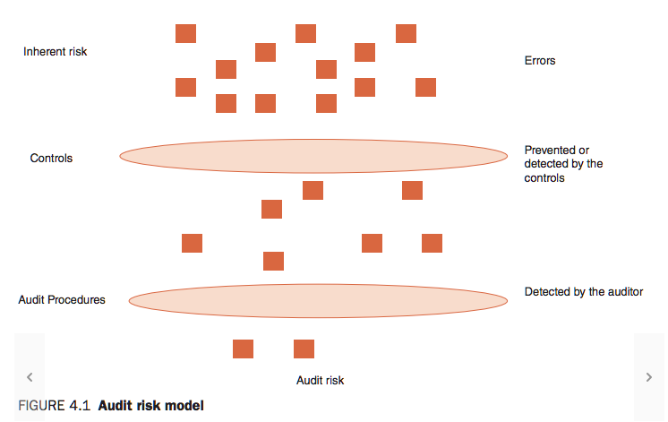

- If control risk is assessed as high, where the auditor believes the controls are ineffective, the auditor will do the minimum work required on the controls and then perform more detailed work on the year-end balances
- If control risk is assessed as low, where he believes controls are effective, the auditor will plan to rely on the controls and therefore perform less detailed audit work on the year-end balances
- After assessing the inherent & control risks, the auditor will determine the detection risk
  - The risk that the auditor’s testing procedures fail to detect a material misstatement
  - If an error was made by the client, & the controls did not detect it, will the auditor’s procedures detect it?
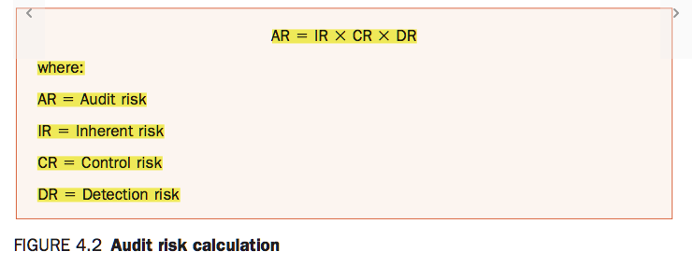
- The acceptable AR is determined by the auditor at the beginning of the audit. Then the IR & CR are assessed, and the auditor determines the acceptable level of detection risk
- Inverse relationship between IR & CR together against DR
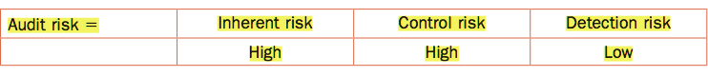
If IR & CR are high, the auditor will perform a more detailed audit work on the year-end balances which reduces the detection risk.

Quantification of the Audit Risk Model
- Detection risk is the only element of the AR model the auditor can change in response to the client’s risk of material misstatement
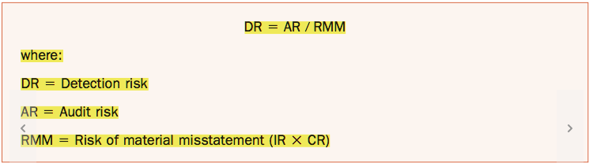
- Most auditors assess an acceptable level of AR as no more than 5%.
  - Meaning that the auditor is willing to accept a 5% likelihood that the f/s are materially misstated, or the auditor is seeking a 95% assurance that there are no material misstatement

Materiality
Used to guide audit testing & to assess the validity of information contained in the f/s & their notes.
- Information is considered material if it impacts the decision-making process of the users of the f/s
  - Includes information that is misstated or omitted but should be disclosed
- Materiality is assessed during the planning stage

Qualitative & Quantitative Factors
When determining materiality, the auditors needs to consider both quantitative & qualitative factors as information can be considered material because of its nature and/or its magnitude.
- Qualitative Factors
  - Factors other than the magnitude of misstatements can affect the decision-making process
  - If an auditor believes that an inaccurate disclosure or omission will affect a user’s decision-making process, the inaccuracy or omission is considered to be material, and the auditor will request that the client amend the disclosure or include any omitted information
  - Items that should be considered significant due to their nature include:
    - Change in accounting method
    - Related party transactions
    - Change in operations that affects the level of risk faced
    - Danger of breaching a debt covenant
- Quantitative Materiality Factors
  - Information that exceeds an auditor’s preliminary materiality assessment
  - Materiality is a percentage of an appropriate base.
    - The auditor selects the appropriate base & then decide on the percentage to use depending on the client’s circumstances
    - In selecting the appropriate base, an auditor can choose an item from the balance sheet (total assets or total equity) or income statement (profit before tax, revenue, expenses, or gross profit)
      - Auditor uses professional judgement
    - If a client is publicly listed, net income before tax is relevant as it drives dividends & return-on-investment decisions
    - If a client is a not-for-profit organization, either assets or expenses are more likely to be used as a base when a client is in a loss position
    - When profits vary significantly from one year to the next, the auditor may use either an average of net income, or revenue as a base.
    - For newly established companies with little or no revenue, equity or total assets are generally preferred as a base
  - Once a base is selected, consideration should be given to whether there are any unusual or non-recurring items that may need to be “normalized” or adjusted for.
  - When using profit before tax
    - Normally, any items that is 10% or greater of profit before tax is considered to be material & any item that is less than 5% of profit before tax is considered to be immaterial.
    - The determination of the appropriate percentages is a matter of professional judgement.
  - When using total assets or revenue
    - The percentages fall to 0.5-2%
  - When equity is used
    - 1-5%
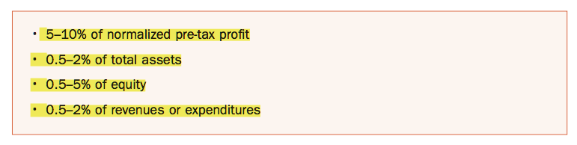
  - When a lower planning materiality level is established, an auditor increases the quality & quantity of evidence that needs to be gathered
- Performance Materiality
  - Amount less than materiality, which is set by the auditor to reduce the likelihood that any uncorrected & undetected misstatement within a class of transactions, accounts balances, or disclosures, in aggregate, do not exceed overall materiality
    - 60-85% of overall materiality may be appropriate
- Specific Materiality
  - Relevant when some areas of the f/s are expected to influence the economic decisions made by users of the f/s

Materiality & Audit Risk
Both considered in identifying & assessing the risk of a material misstatement. They both determine the nature, timing, & extent of the audit work performed, & they are both considered when evaluating the effect of uncorrected misstatements on the f/s & in forming the opinion in the auditor’s report
- The auditor should not use audit risk to make the materiality determination
  - Audit risk is based on factors related to the entity, while materiality is based on the needs of the users of the f/s

Audit Strategy
Sets the scope, timing & direction of the audit & provides the basis for developing a detailed audit plan.
- The audit strategy chosen depends on the auditor’s preliminary inherent & control risk assessment
- High IR & CR
  - Means that detection risk will be low
  - The auditor will adopt a substantive audit strategy
    - Auditor will gain the minimum necessary knowledge of the client’s system of internal controls, but will generally not conduct tests of those controls, because the auditor is not planning on relying on them.
    - Auditor will increase their level of reliance on detailed substantive procedures, which involves intensive testing of year-end account balances & transactions from throughout the year.
- Low IR & CR
  - Means that detection risk will be high
  - The auditor will adopt a combined audit strategy
    - Auditor obtains a detailed understanding of the client’s system of internal controls and plans to rely on that system to identify, prevent, and detect material misstatements.
    - Auditor will then conduct extensive tests of those controls
      - When the cost of testing > benefits expected, the auditor may decide not to test internal controls
    - Can’t rely solely on a client’s system of internal controls, the auditor will always conduct some substantive procedures to gather independent evidence regarding the numbers that appear in the f/s.

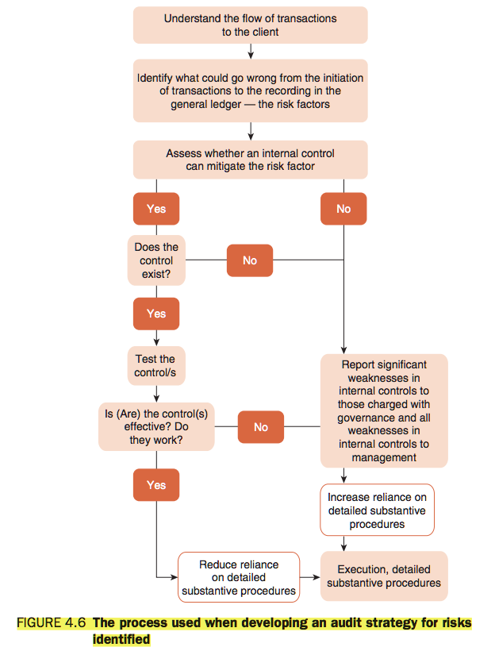

Client Approaches to Measuring Performance
- Key Performance Indicators (KPIs)
  - Used by a client to monitor & assess its own performance & the performance of its senior staff
  - Provide the auditor with insight into the accounts that their client focuses on when compiling f/s & indicate which accounts are potentially at risk for material misstatement
  - Different KPIs for every company & can change every year

Profitability
- Companies are concerned about their shareholders (owners)
  - Price-Earnings (PE) ratio
    - Market price per share / earnings per share
    - Shows how much a shareholder is willing to pay per dollar of earnings
  - Earnings per Share (EPS)
    - Profit / WA shares issued
    - Reflects to book value of the company
  - When a PE or EPS are in decline, an auditor may be concerned that management may be under pressure to manipulate earnings
- Retailers & manufacturers are concerned about their inventory
  - Inventory Turnover
    - COGS / Inventory
  - When a inventory turnover falls sharply, an auditor may be concerned that stock is overvalued

Liquidity
Ability of a company to meet its need for cash in the short & long term. It is vital for a company to have access to cash to pay its debts when they fall due.
- By understanding how their client measures & assesses its own performance and any restrictions implied by debt covenants, an auditor will gain a deeper understanding of the accounts potentially at risk of material misstatement
- The auditor will use its own ratio calculations & trend analyses to identify any unusual fluctuations that warrant future investigation – analytical procedures

Analytical Procedures
An evaluation of financial information by studying plausible relationships among both financial & non-financial data. They involve the identification of fluctuations in accounts that are inconsistent with the auditor’s expectations based upon their understanding of their client.
- It is essential that the auditor have clear expectations about the client’s results for the reporting period before conducting analytical procedures, so that unexpected fluctuations can be correctly identified & investigated
- During the planning stage, analytical procedures are used to aid in the risk identification process
  - Highlight unusual fluctuations in accounts
  - Aid in the identification of risk
  - Enhance the understanding of a client
  - Identify accounts at risk of material misstatement
  - Reduce audit risk by concentrating audit effort where the risk of material misstatement is greatest
- During the execution stage, analytical procedures are an efficient method of identifying differences between recorded amounts & the auditor’s expected values that require further investigation.
- At the final stage, analytical procedures are used to assess whether the f/s reflect the auditor’s knowledge of their client.

Comparisons
Simple comparisons are made between account balances for the current year & the previous year & for the current year budget.
- When comparing account balances from one year to the next, significant changes in light of their expectations based on their understanding of the client and any changes can be tracked and investigated further by the auditor
- The auditor will identify areas where the calculated results are different from expectations based on the knowledge of the business & evidence gathered to date, and will highlight the areas that may require further audit work

Trend Analysis – Horizontal Analysis
Involves a comparison of account balances over time
- Conducted by selecting a base year and then restating all accounts in subsequent years as a percentage of that base
- Allows the auditor to gain an appreciation of how various accounts have changed over time
- Important for the auditor to consider significant changes in economy-wide factors, such as recession, which may affect the interpretation of the trend

Common-Size Analysis – Vertical Analysis
Involves a comparison of account balances with a single line item
- In the balance sheet, the line item used is generally total assets
- In the income statement, the line item is generally sales or revenue
- Allows the auditor to gain a deeper appreciation of how much each account contributes to the totals presented in the f/s.
- By preparing vertical analysis for a number of years, the auditor can trace the relative contribution of various accounts through time

Ratio Analysis
- Profitability Ratios
  - Reflect a company’s ability to generate earnings and ultimately the cash flow required to pay debts, meet other obligations, and fund future expansion
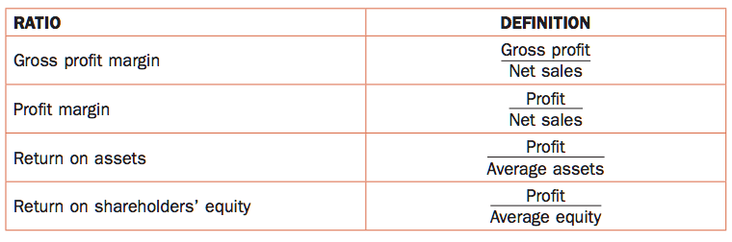
- Liquidity Ratios
  - Reflect a company’s ability to meet its short-term debt obligations
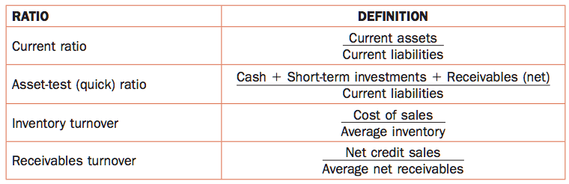
- Solvency Ratios
  - Used to assess the long-term viability of a company.
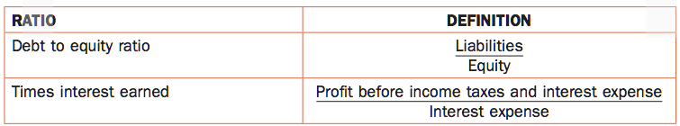

Factors to Consider When Conducting Analytical Procedures
- Reliability of client data
  - If the auditor believes there is a significant risk that the client’s records are unreliable due to, for example, poor internal controls, the auditor is less likely to rely on analytical procedures
- Ability to make comparisons over time
  - If the client has changed accounting methods, this will reduce the comparability of the underlying data
  - In this case, the auditor will need to restate prior year’s f/s using the current accounting methods before making any comparisons
- Reliable Information Sources
  - Information generated by an accounting system that has effective internal controls
  - Information generated by an independent reputable external source
  - Audited information
  - Information generated using consistent accounting methods
  - Information form a source internal to the client that has proven to be accurate in the past.

CHAPTER 10 – AUDIT EVIDENCE

Assertions
Auditors use assertions for transactions, account balances, & presentation & disclosures when assessing the risk of material misstatement & when designing their audit procedures.
- Transaction based assertions focus on the transactions that took place during the period as opposed to the account balance
  - Income Statement Items
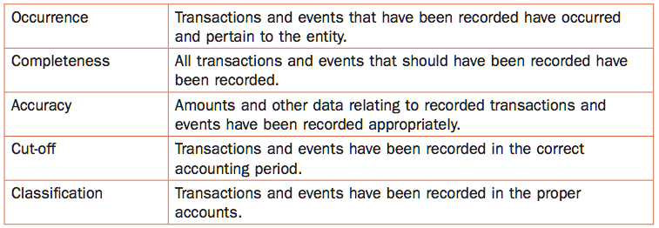
    - Occurrence – auditor verifies that a recorded action (e.g. revenue/expense), took place & relates to the entity. Important when the auditor believes that there is a risk of overstatement
    - Completeness – auditor searches for transactions & makes sure that they have been recorded. Important when the auditor believes there’s a risk of understatement
    - Accuracy – Auditor searches for evidence that transactions have been recorded at appropriate amounts. Important when the auditor believes there’s a risk that the reported amounts are inaccurate
    - Cut-Off – auditor searches for evidence that transactions have been recorded in the correct period. Important for transactions close to year-end
    - Classification – auditor ensures that transactions have been recorded in proper accounts
  - Balance Sheet Items
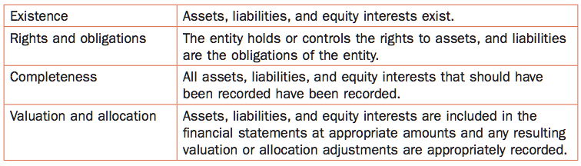
    - Existence – auditor searches for evidence to verify that asset, liability & equity items included in the account balances that appear in the f/s actually exist. Important when the auditor believes there’s a risk of overstatement
    - Rights & Obligation – auditor searches for evidence to verify that recorded assets are owned by the entity & that recorded liabilities represent commitments of the entity. Important when the auditor believes there is a risk that recorded assets/liabilities are not owned by the entity (may exist but not be owned)
    - Completeness – auditor searches for assets, liabilities, and equity items & ensures that they have been recorded. Important when the auditor believes there is a risk of understatement
    - Valuation & Allocation – Auditor searches for evidence that assets, liabilities, and equity items have been recorded at appropriate amounts in the correct GL accounts. Important when the auditor believes there’s a risk of over/undervaluation

  - Presentation & disclosure
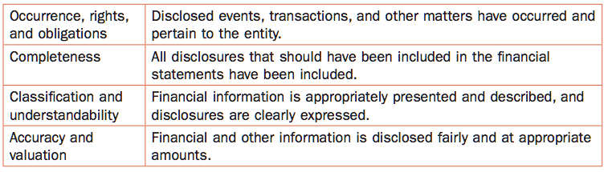

Types of Audit Evidence

Sufficient Appropriate Audit Evidence
- Audit risk affects the quantity & quality of evidence gathered by an auditor during the execution stage of the audit
  - When there’s a significant risk that an account will be misstated, and the client’s system of internal control is considered ineffective, detection risk is low & more evidence will be required
- There is a direct relationship between the risk of material misstatement (IR & CR) and the amount of evidence gathered when testing transactions and balances
- Evidence is considered relevant if it provides confirmation about an assertion most at risk of material misstatement
  - By identifying the key risk areas for the client, an auditor is able to focus on gathering more high-quality evidence where the risk of material misstatement is believed to be most significant
- Reliability refers to whether the evidence reflects the true state of the information. The auditor should consider:
  - The source of information – important for the information to be unbiased
  - The expertise of the respondent
  - The consistency of the information – evidence that is consistent from one source to another is more reliable
  - The source of the information & whether it is produced where internal controls operate effectively

External Confirmations
Sent directly by an auditor to a third-party, who is asked to respond to the auditor on the matters included in the confirmation letter
- Can be sent to the client’s bank, lawyers, lenders & debtors, and third-parties holding the client’s inventory
- Bank Confirmation
  - Request for information about the amount of cash held in the bank or in overdraft, details of any loans with the bank, details of any pledges of assets made to guarantee loans, and interest rates charged
  - Information used to confirm that the asset “cash at bank” is recorded at the appropriate amount (valuation & allocation assertion) and is in the client’s name (rights & obligations assertion), and that all loans with the bank are included in the liability section of the b/s (completeness assertion). The bank confirmation also requests details of interest rates paid on cash deposits and term deposits, and interest rates charged on bank overdrafts & loans (accuracy assertion)
- Positive confirmations – ask the recipient to reply in all circumstances (provide superior evidence)
- Negative confirmations – ask the recipient to reply only if they disagree with the information provided

Documentary Evidence
Includes invoices, suppliers’ statements, bank statements, minutes of meetings, correspondence, and legal agreements. It may be internally generated or externally generated. Internally generated documents are produced by the client. Externally generated are produced by third parties (the persuasiveness of evidence varies depending on its source).
- There are a number of ways that documentary evidence can be used during an audit.
  - An auditor can trace details recorded in a client’s accounting records to supporting (external) documents to verify the amount recorded.
    - E.g. details of the price paid for inventory may be traced to a supplier’s invoice to verify the amount recorded – provides evidence on the accuracy of the purchase price (accuracy assertion)
    - E.g. Trace recorded investments to share certificates to make sure they exist (existence assertion) and that they are owned by the client (rights & obligations assertion)
    - E.g. documents can be read, and details traced to a client’s accounting record & f/s to ensure that items are included correctly (classification & understandability assertion)
    - E.g. ensure that all inventory confirmed as held by a third party is included in the client’s record (completeness assertion)

Representations
When the auditor has reason to believe that there are legal issues that may impact the financial statements (e.g. the client being sued), a legal letter is requested from the legal firm that the client deals with
- A legal letter can include:
  - Any legal matters involving the client
  - The lawyer’s opinion on the client’s description of any outstanding legal matters & whether the client’s evaluation of those matters appears reasonable
  - A request to provide details of any legal matters on which the lawyer is in disagreement with the client
- A management representation letter generally includes:
  - An acknowledgement that management is responsible for the preparation of the f/s
  - Written details of any verbal representations made by management during the course of the audit
  - Undertaking that laws & regulations have been complied with, that there have been no material frauds or errors that would impact the f/s, and that the internal control system is effective
  - Acknowledgement that the auditor was provided with access to all documents, records & other evidence as requested
  - Undertaking that the f/s include the required disclosures in relation to related parties, share options, and contingent liabilities and that the company owns all assets listed

Verbal Evidence
Used when gaining an understanding of the client and its internal control system. Can be used to corroborate other forms of evidence.

Computational Evidence
Gathered when an auditor checks the mathematical accuracy of the numbers that appear in the f/s (accuracy + valuation & allocation assertions)
- Involves re-adding the entries included in a client’s journal & ledgers
- Involves recomputing more complex calculations such as
  - Foreign currency transactions
  - Employee benefits
  - Interest of loans outstanding
  - Fair value modelling

Physical Evidence
Gathered through inspection of a client’s tangible assets, such as its inventory & fixed assets
- An auditor traces recorded amounts to assets to gain evidence that they exist (existence assertion)
- An auditor traces details of tangible assets on hand back to the recorded amount (completeness assertion)
- An auditor inspects a client’s physical assets to ascertain whether:
  - machinery is functioning
  - inventory appear to be in good repair
  - fixed assets are well looked after
    - in order to determine whether assets should be written down below current value (valuation & allocation assertion)

Electronic Evidence
Includes data held on client’s computer, files sent by e-mail to the auditor, and items scanned & faxed.
- If a company initiates and completes a transaction electronically, its auditor will use the electronic evidence to establish that the transaction occurred (occurrence assertion)

Persuasiveness of Audit Evidence

Internally Generated Evidence – Least Persuasive
Held by the client and includes records of cheques sent, copies of invoices & statements sent to customers, purchase orders, company documentation regarding policies & procedures, contracts, minutes of meeting, journals, ledger, trial balances, spreadsheets, worksheets, reconciliations, calculations, & computations – may be manipulated or omitted
- Auditors document their working paper details of their meetings with client management & staff to gain an understanding of the client’s business & system of internal controls

Externally Generated Evidence Held by the Client – Quite Persuasive
Includes suppler invoices & statements, customer orders, bank statements, contracts, lease agreements, & tax assessments
- Quite persuasive because they are produced by third parties
  - However, its possible for the client to manipulate them which reduces the reliability for the auditor
  - Reliability also reduced if auditor provided with photocopies

Externally Generated Evidence Sent Directly to Auditor – Most Reliable
Includes bank confirmations, customer confirmations, correspondence with the client’s lawyers, including confirmations & representations, & expert valuations
- Independent of the client, and the latter does not have the opportunity to alter it

Using the Work of an Expert
It may be necessary to engage the services of an expert if an auditor does not have the requisite skills and knowledge to assess the validity of an account or a transaction
- Experts commonly used by auditors include:
  - Valuators for things such as real estate, work of art, collections & jewellery
  - Actuaries to calculate liabilities related to employee future benefits, and oil & gas reserves
- If an expert is required, the auditor must determine the scope of the work to be carried out
  - Auditor must assess the competence & capability of the expert
  - Once the work is completed, an auditor assesses the work & draws conclusions based on the assessment

Using the Work of Another Auditor
The auditor who’s responsible for signing the audit report (the group engagement partner) may need to rely on evidence provided by another auditor for certain components of a client’s f/s.
- Occurs when a client operates in a number of locations, has divisions or subsidiaries spread around the country or globe, or has significant assets in other locations.
- The auditor should consider the proportion of the f/s for which they will rely on the component auditor
  - The group engagement partner should audit the majority of the f/s & be knowledgeable about components of the f/s that they do not audit themselves.
  - The group engagement partner determines the work to be conducted by a component auditor
- If a group engagement partner is concerned that a component auditor has not been able to gather sufficient appropriate audit evidence regarding the component of the f/s audited, he will ask that further evidence to be gathered
- If the component auditor cannot access sufficient evidence, the engagement partner will consider issuing a modified audit opinion due to a scope limitation

Evidence-Gathering Procedures
- Confirmations generally provide evidence that items such as cash & accounts receivable exist (existence assertion)
- Inspection involves examining records & documents & physically examining assets
  - Records & documents are inspected when conducting substantive testing to check, for example, the dates of transactions (cut-off assertion), that purchases were made by the client (rights & obligation assertion), and that a transaction has occurred (occurrence assertion)
  - Tangible assets are physically inspected to provide evidence that they exist (existence assertion) and appear to be in good repair or are damaged or past their use-by-date (valuation & allocation assertion).
  - Inventory test counts (completeness & existence assertions)
- Observation only provides evidence of a process at the time the auditor observes it being carried out
- Inquiry is used when gaining an understanding of the client & to corroborate other evidence gathered throughout the audit
- Recalculations are used to check the mathematical accuracy of client files & records
- Re-performance means following a process used by a client
  - When testing controls, client procedures are re-performed to check that controls are effective
- Analytical Procedures are used to appraise relationships between financial and non-financial information.

Drawing Conclusions
Sufficient appropriate audit evidence must be gathered to enable an auditor to draw a conclusion on which to base their opinion regarding the fair presentation of the client’s f/s.
- Matter of professional judgement
- If an auditor believes that a client has internal controls that can reduce the likelihood of a material misstatement for an identified risk, they will test those controls
  - Meaning that the evidence will be gathered to establish whether the internal controls are effective
- Once testing of control is complete, the auditor will gather further evidence through their substantive testing of transactions & balances
- If an auditor decides that a client does not have in place appropriate controls for the identified risk, an auditor will adopt a substantive approach
  - The auditor will increase his reliance on evidence gathered through his details substantive tests of transactions & account balances

Documentation – Audit Working Papers
An auditor will document each stage of the audit & procedures used
- During the planning stage, the auditor will document his:
  - Understanding of the client
  - The risks identified
  - Analytical procedures used to aid in risk identification
  - Materiality assessment
  - Understanding of the client’s system of internal controls
  - Understanding of the client’s information technology
  - Related parties identified
  - Any going concern matters
- During the execution stage, the auditor will document his:
  - Audit program
  - Details of tests undertaken
  - Copies of significant documents sighted
  - Correspondence with the client’s lawyer & bankers
  - Confirmations received from account receivable customers
  - Inquiries of management
- An audit working paper generally includes:
  - The client name
  - The period under audit
  - A title describing the contents of the working paper
  - A file reference indicating where the working paper fits in the audit file
  - Initials identifying the preparer of the working paper together with the date the working paper was prepared
  - Initials identifying the reviewers of the working paper together with the dates the working paper was reviewed
  - Cross-referencing between working papers indicating where further work & evidence is summarized elsewhere
- 2 main files held for each client:
  - Permanent file – includes documents that pertain to a client for more than one audit (checked and updated at the beginning of each audit)
    - client’s head office address
    - contact details
    - organizational chart
    - copies of long-term contracts & agreements
    - debt covenants
    - key long-term investments
    - details of the board of directors & subcommittees
    - minutes of significant meetings
    - details of bonus and options scheme for senior staff
    - principal accounting policies & methodologies
    - prior f/s
    - prior analytical procedures
    - system of internal controls
    - reports of previous audits
  - Current file – details of the work completed and evidence gathered that relate to the current audit
    - Details of all testing and evidence gathered
    - Correspondence between the auditor and the client and the client’s bankers & lawyers
    - Correspondence with other auditors, experts & relevant third parties
    - Engagement letter, management letter, representation letter & confirmation letters
    - Extracts from the minutes of meetings
    - Details of the audit planning conducted & procedures performed
    - Details of the analytical procedures, tests of controls, and detailed substantive testing undertaken
    - Conclusions drawn

CHAPTER 11 – SAMPLING & OVERVIEW OF THE RISK RESPONSE PHASE OF THE AUDIT

Audit Sampling
When there are numerous transactions or items within an account balance available for testing, an auditor must decide how best to select a sample that is representative of the entire population of items available for testing.
- There are 2 elements of sampling risk:
  - Sampling risk
    - Risk associate with using sampling for testing
  - Non-sampling risk
    - Other risks

Sampling & Non-Sampling Risk

Sampling Risk & Tests of Controls
- Sampling risk
  - The risk that the sample chosen by the auditor is not representative of the population of transactions or items within an account balance available for testing &, as a consequence, the auditor arrives at an inappropriate conclusion.
- Consequences of Sampling Risk
  - Risk that the audit will be ineffective
  - Risk that the audit will be inefficient
- When testing controls, sampling risk is the risk that an auditor relies on their client’s system of internal controls when they should not, and the risk that an auditor concludes that the client’s internal controls are less reliable than they are
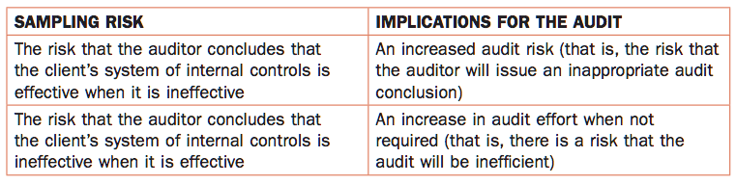

Sampling Risk & Substantive Procedures
When conducting substantive tests, sampling risk is the risk that an auditor concludes that a material misstatement does not exist when it does, or an auditor concludes that a material misstatement exists when it does not.
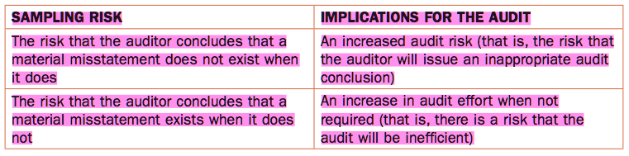
- E.g. a client has 4 warehouses. The auditor has selected a sample of inventory in the one warehouse near the client’s head office. The auditor has not tested material inventory items held at other warehouses. As a consequence, the auditor has not detected as significant error in valuing inventory at one of the warehouses.
  - If the auditor has selected a sample for testing from each warehouse, the risk of arriving at an incorrect conclusion, would have been reduced (though not eliminated)

Non-Sampling Risk
Risk that an auditor arrives at an inappropriate conclusion for a reason unrelated to sampling issues.
- Can occur when an auditor uses an inappropriate audit procedure, relies too heavily on unreliable evidence, or spends too little time testing the accounts most at risk of material misstatement.
- When testing controls, non-sampling risk is the risk that an auditor designs tests that are ineffective & do not provide evidence that a control is operating properly.
  - E.g. a client uses passwords to restrict access to its computer programs. To test that the passwords are operating effectively, an auditor observes client personnel accessing programs using their passwords. This is not effective in assessing whether the client’s programs prevent access to users with invalid passwords, since the test is focused on users with valid passwords. An effective test would be to enter invalid passwords to see if access is denied.
- When conducting substantive procedures, there are a number of non-sampling risks. One non-sampling risk is the risk that an auditor relies too heavily on less persuasive evidence.
  - E.g. an auditor may rely too heavily on management representations without gathering independent corroborating evidence.
- Non-sampling risk is also the risk that an auditor spends most of their time testing assertions where the risk of material error is low & ignores or spends insufficient time testing assertions most at risk of material misstatement.
  - E.g. a client sells pearls. There is a significant risk that recorded inventory does not exist, yet the auditor spends more time testing for completeness.

Statistical & Non-Statistical Sampling
- Statistical Sampling
  - Involves random selection & probability theory to determine the sample size & evaluate the results, including sampling risk.
    - Any sample selection that does not incorporate random selection & probability theory is not statistical sampling
    - E.g. when an auditor uses judgement alone to select the sample size & the items to include in the items to include in the sample for testing
  - An advantage of statistical sampling is that it allows an auditor to measure sampling risk; that is, the risk that the sample chosen by the auditor is not representative
  - A disadvantage of statistical sampling is the cost involved in using this technique.
- Non-statistical Sampling
  - Easier to use than statistical sampling, is lower cost, and allows an auditor to select a sample that they believe is appropriate
- Most audit firms use a combination of statistical & non-statistical sampling as both methods provide appropriate audit evidence & allow the auditor to form a conclusion on the items being tested.

Sampling Techniques & Factors Affecting Sampling

Sampling Techniques
- Random Selection
  - Requires that the person selecting the sample does not influence the choice of items selected
  - The resulting sample is then free from bias & each item within the population has an equal chance of being selected
- Stratification
  - Can be used ahead of random selection to improve audit efficiency
  - An auditor partitions a population ahead of sampling by identifying sub populations with similar characteristics (e.g high-dollar items/balances that are overdue for accounts receivable)
  - Can be used to ensure that the sample includes items that have the characteristics required by the auditor, such as material/risky items, and remain a statistical sampling technique when items are randomly selected.
- Systematic Selection
  - Involves the selection of a sample for testing by dividing the number of items in a population by the sample size, resulting in a sampling interval (n).
  - Once the sampling interval has been determined, a starting point is selected, which is an item in the population below the sampling interval
  - The sample is selected by selecting the 1st item & then every nth item after that.
  - The risk is that items will be listed in such a way that by selecting every nth item, the auditor is selecting items that are related in some way
    - E.G. if the sampling interval is 7 and items represent the daily sales of a particular product, then the auditor will select sales made on the same day each week
    - Risk can be reduced by reviewing the items in a population before calculating the sampling interval
- Haphazard Selection
  - Involves the selection of a sample by an auditor without using a methodical technique
  - Risk that the auditor will avoid selecting some items or ensure other items are included in the sample
    - E.g. an item that is going to be difficult to test because the documentation is held in another location may be purposefully omitted by the auditor, while an item that looks large or unusual & catches the auditor’s eye may be purposefully included.
  - This is a non-statistical technique as human bias may impact the sample selected, & therefore prevent the sample from being a true random sample
- Block Selection
  - Involves the selection of items that are grouped together within the population of items available
  - Non-statistical technique
    - E.g. transactions are generally grouped in date order. By using block selection, the items selected will not be representative of transactions made throughout the year
- Judgemental Selection
  - Involves the selection of items that an auditor believes should be included in the sample for testing
    - When testing controls, judgement may be used to ensure that transactions processed when a new computer is installed are included in the sample.
    - When conducting substantive testing, judgement may be used to include in the sample large or unusual items
  - Non-statistical technique

Factors to Consider when Selecting a Sample
When selecting a sample, the auditor will use his judgement & knowledge of the client to determine control risk, detection risk, and planning materiality, all of which impact the sample size.
- The lower the control risk, the smaller the sample size when testing controls
- The lower the detection risk, the larger the sample size when conducting detailed substantive procedures
- The sample size must be large enough to reduce the sampling risk to an acceptable level
- An auditor will use their professional judgement to determine the tolerable error/misstatement and required level of confidence
  - The tolerable misstatement is the maximum error that an auditor is willing to accept within the population tested
  - When testing controls, this is the tolerable rate of deviation that an auditor is willing to accept before concluding that controls are ineffective
- The required level of confidence is a function of control risk when testing controls & of detection risk when conducting substantive procedures
- When DR is determined as low, an auditor will require a high level of confidence that the transactions & accounts are not materially misstated
  - Increase the sample size
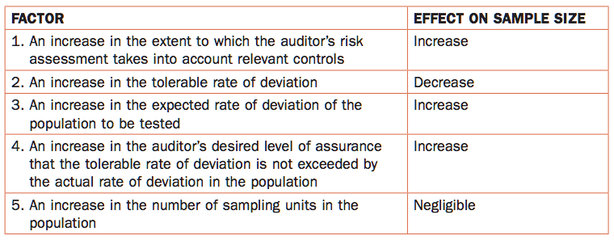
- 1st Factor
  - If an auditor believes that a control will be effective in reducing an identified risk of material misstatement, his audit strategy will be to increase testing of that control to ensure it is effective.
  - When concluding that a control is effective, the auditor will rely on that control to prevent & detect a material misstatement, and reduce their detailed substantive procedures
- 2nd Factor
  - There is an inverse relationship between the tolerable rate of deviation & the sample size.
  - If an auditor intends to rely on a control to prevent & detect a material misstatement, a lower tolerable error rate will be set, & the sample size will be increased to provide the auditor with the evidence required to demonstrate that the control is effective
  - If the auditor expects to place relatively more reliance on their substantive procedures & reduce their reliance on internal control, they will increase the tolerable rate of deviation & reduce the sample size when testing the control
- 3rd Factor
  - If an auditor believes that the rate of deviation has increased when compared to previous audit, they will increase the sample size to accurately evaluate the impact of the changed circumstances
- 4th Factor
  - When CR is assessed as low for a risk factor, an auditor’s required level of confidence in the effectiveness of their client’s internal control is higher than when CR is assessed as medium to high

Factors that Influence the Sample Size – Substantive Testing

Factors that Influence Sample Size when Performing Substantive Test
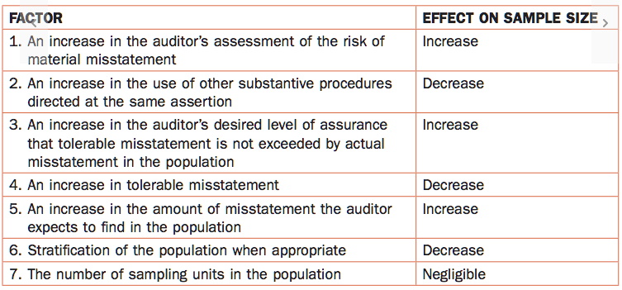

Techniques for Performing Substantive Tests
2 main techniques:
- Key Item Testing
- When conducting substantive testing, the auditor uses either a statistical basis or professional judgement to identify & test key items within a balance
- Their focus is on selecting the largest transactions (or other individually significant items) within a balance to obtain “coverage” over the total.
  - E.g. an auditor is testing a/r existence using a/r confirmations. The total receivables are $3 million, with 2 key item trade receivables due from customers totalling $2.75 million of the balance. By selecting these 2 accounts & sending confirmation requests to them, assuming they reply, the auditor is able to conclude that because 91.7% of a/r exist as at the confirmation date, it is reasonable that total a/r of $3M exist as well.
- Representative Sampling
- After key items have been segregated, there may remain a large population of items that are individually unimportant but significant in total.
- If risk assessment indicates the results of key item testing do not provide sufficient evidence to conclude that the population is free from material errors, the auditor obtains additional required evidence by sampling from the remainder of the population (after excluding the key items)
- 3 sampling strategies
  - Representative Sampling Using Audit Risk Tables
    - The auditor uses this technique when they do not expect errors, or they expect a low number of errors; that is, the risk of material misstatement has been assessed as low, and their primary concern is with the overstatement in an account balance
  - Variables Estimation Sampling
    - The auditor uses this technique if they expect more than a few errors in an account balance
    - Differs from representative sampling in that it can be used when the concern is both an understatement & overstatement.
    - Usually applied to detect misstatement of the book values (carrying amounts/recorded values) of populations
  - Attribute Sampling
    - The auditor uses this technique to supplement other substantive procedures to obtain audit assurance related to tests of transactions when they don’t expect errors (or low number of errors)
    - Used to obtain a level of confidence, based on a statistically valid sample of transactions, that key attributes in existence for the sample tested can be inferred to be in existence with the entire population

Evaluating Sample Test Results
- When testing controls, an auditor will consider whether the results of the tests applied to a sample provide evidence that the control tested is effective within the entire population.
- When testing transactions & balances, an auditor will consider whether the results of the tests applied to a sample provide evidence that the class of transactions/account balance tested if fairly stated
- If the auditor discovers departures from prescribed controls when testing controls, they will calculate deviation rate (proportion of departure within the sample)
  - If the rate of deviation exceeds the tolerable rate, the auditor will extend their testing & gather further evidence of other controls that may be aimed at reducing the identified risk of material misstatement

Tests of Controls & Substantive Procedures
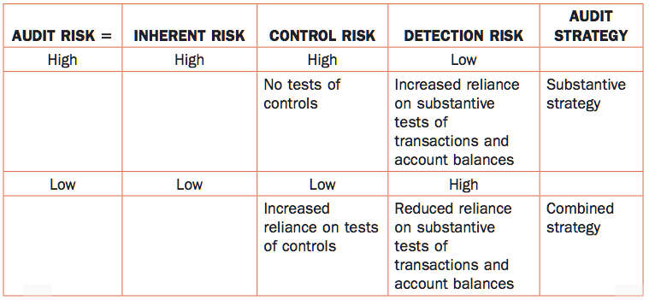

Tests of Controls
Before an auditor can conclude that CR is medium or low, they test the controls to check their effectiveness.
- If controls prove effective, the auditor can reduce their reliance on detailed substantive procedures
- If controls prove ineffective, the auditor reassesses CR as higher than before & increases his reliance on detailed substantive procedures

CHAPTER 12 – UNDERSTANDING & TESTING THE CLIENT’S SYSTEM OF INTERNAL CONTROLS

Internal Control Defined
When controls are effective, the organization is more likely to achieve its strategic & operating objectives. Internal control is defined as: the process designed, implemented & maintained by those charged with governance, management & other personnel to provide reasonable assurance about the achievement of the entity’s objectives with regard to reliability of its financial reporting, effectiveness & efficiency of operations, and compliance with applicable laws & regulations.
- Understanding internal control is a key component of the overall audit risk assessment & provides evidence that influences the resulting strategy developed by the auditor

Objectives of Internal Controls
The objective of controls is to connect the auditor’s understanding of why the controls are important with the issues they are designed to prevent.
- The reason an organization puts controls in place to ensure errors in the processing of transactions do not occur, and if they do, that these errors are identified & rectified quickly
- 7 generally accepted objectives of internal controls
  - REAL – there are controls in place to ensure that fictitious or duplicate transactions are not included in the books and records of the organization
    - Occurrence
    - Rights & obligations
    - Existence
  - RECORDED – There are controls in place that will prevent or detect the omission of transactions from the books & records of the organization
    - Accuracy
    - Completeness
    - Valuation & allocation
  - VALUED – There are controls in place to ensure that the correct amounts are assigned to the transactions
    - Accuracy
    - Valuation & allocation
  - CLASSIFIED – there are controls in place to ensure that transactions are charged and allocated to the correct GL account
    - Accuracy
    - Classification
    - Valuation & allocation
  - SUMMARIZED – there are controls in place to ensure that the transactions in the books and records are summarized and totalled correctly
    - Accuracy
    - Valuation & allocation
  - POSTED – There are controls in place to ensure that the accumulated totals in the transaction file are recorded correctly transferred to the GL and subsidiary ledgers
    - Accuracy
    - Classification
    - Valuation & allocation
  - TIMELY – There are controls in place to ensure that transactions are recorded in the correct accounting period
    - Cut-off
    - Completeness
- The assertion relating to classification & understandability, which is a presentation & disclosure assertion, is not specifically addressed by these internal control objectives.
- By focusing on each of these objectives, the auditor will be able to select the appropriate controls to test to gain the greatest level of assurance possible that the client’s system of internal controls is operating effectively
- When the objectives are not met, it is considered to be a deficiency in internal control
- Limitations of internal controls
  - Human error that results in a breakdown in internal controls
  - Ineffective understanding of the purpose of a control
  - Collusion by 2 or more individuals to circumvent a control
  - A control within a software program being overridden or disabled

Entity-Level Internal Controls
Internal controls consist of 5 components – entity-level controls
- Control Environment
- Entity’s risk assessment process
- Information system, including the related business processes, relevant to financial reporting & communication
- Control activities
- Monitoring of controls

The Control Environment
The control environment sets the tone of an entity & influences the control consciousness of its people.
- It reflects the overall attitude, awareness, and actions of management, the BoD, others charged with governance, and the owners concerning the importance of controls & the emphasis given to controls in determining the organization’s policies, processes, and organizational structure.
- Referred as the tone at the top
- Sets foundation for effective internal control, providing discipline & structure, and includes:
  - Communication & enforcement of integrity & ethical values
  - Commitment to competence
  - Participation by those charged with governance
  - Management’s philosophy & operating style
  - Organizational structure
  - Assignment of authority & responsibility
  - Human resources policies & practices

Types of Controls
- Transaction-level controls
  - Relates to identifying & assessing the risks of material misstatement through understanding the entity and its environment
  - Controls that affect a particular transaction or group of transactions
  - Responds to things that can go wrong with transactions
  - Must be sensitive enough to either prevent an error from occurring or to detect the error, report it, and have it rectified on a timely basis
  - Controls can include any procedures the client uses & relies on to prevent errors from occurring during the processing of transactions, or to detect & correct errors that may occur in these transactions
  - 4 types of controls
    - Manual
    - Automated
    - Information technology general controls (ITGCs)
    - Combination of control types referred to as IT-dependent manual controls

Preventive & Detective Controls
Test of controls are the audit procedures performed to test the operating effectiveness of controls in preventing, or detecting & correcting, material misstatements at the assertion level.
- Controls are tested to determine if they are properly applied throughout the entire period
- This testing is required if the auditor plans to rely on the controls to reduce the amount of substantive work to be performed
Preventive controls
- Can be applied to each transaction during normal processing to avoid errors occurring.
- To be effective, controls over transactions should ideally include both preventive & detective controls
  - This is because without the underlying preventive controls, detective controls may not be sufficiently sensitive to identify & correct misstatements
- When designing controls, consider what can go wrong (WCGWs) with the transaction, that would result in an error
  - Effective preventive controls should prevent the WCGWs from occurring
- Preventive controls do not always produce physical evidence indicating whether the control was performed, who performed it, or how well it was performed
  - In other cases, there may be evidence that the control was performed, but evidence as to the effectiveness of the control may not be available
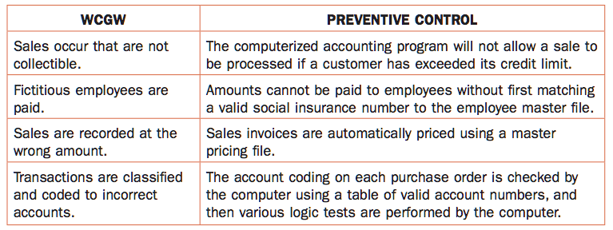
- A lack of effective preventive controls increases the risk that errors will occur or that fraud may occur and therefore increases the need for controls that are sensitive enough to detect these errors should they occur
Detective Controls
- The purpose is to discover fraud or errors that may have occurred during transaction processing (in spite of any preventive controls) and to rectify those errors.
- Applied outside the normal flow of individual transactions to groups of transactions that have been fully or partially processed
- Detective controls can depend on the nature of the client’s business and on the competence, preferences & imagination of the people who perform the controls.
- They can be formally established procedures
  - Such as the preparation of a monthly reconciliation
- They can be procedures that employees regularly perform & typically document
  - Such as the financial accountant keeping a list of standard month-end journal entries
- Often unofficial procedures
- Important that effective controls:
  - Completely & accurately capture all relevant data
  - Identify all potentially significant errors
  - Are performed consistently & regularly
  - Include timely follow-up & correction for any misstatements or issues detected
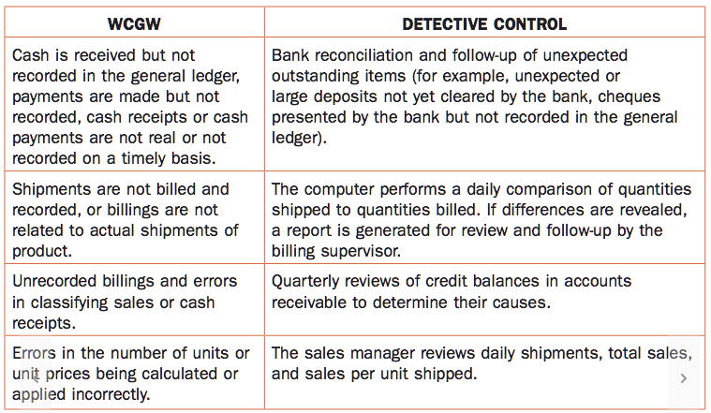
- Detective controls are often accompanied by physical evidence, such as monthly reconciliation
- When assessing detective controls, it is not necessary for the auditor to re-perform all of the steps in

Manual & Automated Controls
- Manual controls
  - Purely manual controls are those that do not rely on the client’s IT environment for their operation
    - E.g. a locked safe for cash to which only a few authorized staff have access
    - May use IT-produced information from third-parties
- Automated controls
  - Controls generally rely on the client’s IT applications/software in some way
    - Important to identify how much a control is automated in order to determine how IT will affect the evaluation of controls
- IT general controls (ITGCs)
  - The client’s controls over the hardware & software it uses, including acquisition & maintenance of equipment, backup, and recovery procedures, and the organization of the IT department to ensure the appropriate segregation of duties.
    - Support the ongoing functioning of the automated aspects of preventive & detective controls & also provide the auditor with a basis for relying on electronic audit evidence
  - 3 types of ITGCs:
    - Program change controls – only appropriately authorized, tested, and approved changes are made to applications, interfaces, databases, and operating systems
    - Logical access controls – only authorized personnel have access to IT equipment, data files, programs, and applications, and these personnel can perform only authorized tasks & functions
    - Other ITGCs (including IT operations) – often difficult to identify in smaller organizations, these include controls such as ensuring regular and timely backups of data, following up & resolving program faults and errors regularly, following up any deviations from scheduled processing on a timely basis, and planning regular upgrades to programs & applications, as well as ensuring of a disaster recovery plan.
  - Important because they impact the effectiveness of both application controls and IT-dependent manual controls, as well as potentially affecting the reliability of electronic audit evidence the auditor may wish to rely on during the audit
- Application Controls
  - Fully automated controls that apply to the processing of individual transactions.
  - Driven by the particular software application being used
  - 3 categories:
    - Input controls – designed to detect & prevent errors during the data input stage
      - Verification controls to check input to previously entered data
      - Missing data checks to ensure all required data have been input & no data are missing
      - Check digits to prevent input errors by applying a mathematical formula
    - Processing controls – in place to ensure the data are processed as intended and no data are lost, added, duplicated, or altered during processing
      - Control totals ensure that input totals are balanced & reconciled
      - Reasonable checks compare actual data to expected data & ensure they are reasonable
      - Sequence tests review sequential data & produce exception reports for missing numbers
    - Output controls – ensure that the processed results are correct and that only authorized personnel have access to the output
      - Reconciling totals to ensure that input totals agree with the output totals
      - Uploading output to a secure server location if read-only format
      - Printing output on a secure printer with limited access
  - Application controls may also be important in enforcing the segregation of incompatible duties, particularly large organizations
- IT-dependent manual controls
  - The auditor identifies preventive or detective controls that have both manual & automated aspects

Selecting & Designing Tests of Controls

Which Controls Should be Selected for Testing?
- Select those controls that will provide the most efficient and effective audit evidence
- To improve efficiency, the auditor will test only those controls that he believes are critical or key to his opinion
- Also considers which controls provide reasonable assurance that the controls operated effectively throughout the period of reliance
- The best controls to test are those that address the WCGWs most effectively with the least amount of testing required
  - If one control addresses multiple WCGWs, it stands to reason that this control would be selected

How Much Testing Does the Auditor Need to Do?
- Decision driven by the frequency of the control in question
- The more assurance the auditor wants from the performance of the controls, the more testing they need to do
  - If they are intending to reduce CR, they perform more testing
- Factors to consider:
  - How often the control is performed
  - The degree to which the auditor intends to rely on the control as a basis for limiting their substantive tests
  - Persuasiveness of the evidence produced by the control
  - The need to be satisfied that the control operated as intended throughout the period of reliance
  - The existence of a combination of controls that may reduce the level of assurance needed from any one of the controls
  - The relative importance of the WCGW questions or statements being considered
  - Likelihood that a control operated as intended
- In determining the extent of tests of a control, the auditor considers several other factors that affect the auditor’s perception of the likelihood that a control operated as intended throughout the period of reliance, including:
  - The competence & integrity of the employee performing the control, the employee’s independence from the related processing procedures, the degree to which the employee is supervised, and the extent of employee turnover
  - Quality of the control environment
    - Likelihood that a control is bypassed during peak processing periods
    - Potential for management to override a control
    - Extent to which the internal auditors have performed similar/related tests during the year
    - Likelihood in a good control environment that a control will continue to operate as intended throughout the period
    - Changes in the accounting system
    - Unexplained changes in related account balances
    - The auditor’s prior-period experiences with the engagement
- Attribute Sampling – a sampling technique used to reach a conclusion about a population in terms of a rate of occurrence (frequency)
  - Most often used for tests of controls – rather than as a substantive test of account balances
  - The auditor is able to determine with a certain level of confidence (90% or more) that the error rate for control exceptions is acceptably low
- Application Controls
  - The functioning is tested to determine whether it can be relied on as an effective control
  - 2 methods:
    - Focusing on manual follow-up procedures that support the application control
    - Testing controls over program changes and/or access to data files – testing the ITGCs
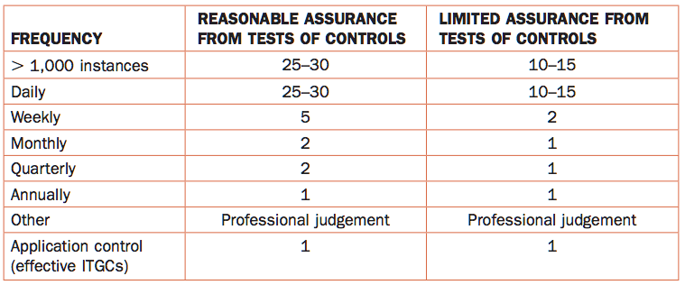

Documenting & Testing Internal Controls
- Narratives – most common form of documentation, used in smaller environments
  - The auditor describes in words each step of the flow of transactions from start to finish
- Flowcharts – used in larger & more complex environments
  - The auditor summarizes (using flowcharts/boxes) each step of the flow of transaction from start to finish
  - Longer to prepare
  - Simple to read
- Combinations of narratives & flowchart
  - Typically, a page divided in 2 sections with the process flowchart on the left-hand side/top side and the narrative describing each step on the right-hand side/bottom page
- Checklists & preformatted questionnaires
  - Another technique used to systematically identify the most common types of internal control procedures that should be present

Testing Internal Controls
Techniques used to test controls
- Enquiry – auditor asking questions to determine how the control is performed and whether it appears to have been carried out properly & on a timely basis
- Observation – auditor observing the actual control being performed
- Inspection of Physical Evidence – relies on the auditor testing the physical evidence to verify that a control has been performed properly
- Re-performance – auditor reperforming the control to test its effectiveness

Results of the Auditor’s Testing
- If the test controls confirm the auditor’s preliminary evaluation of controls (& CR), the planned substantive audit procedures are not modified.
- If the test results do not confirm their preliminary evaluation of controls (& CR), the auditor revises the overall audit risk assessment for the related account & the planned audit strategy (increase the level of substantive procedures)
- The auditor needs to investigate any control exceptions (deviations) they identify during their testing to find out, to the extent practical, the causes, the amounts involved, the f/s accounts affected, & the potential effect on other audit procedures
- The auditor is required to document the resolution of any control exceptions & report the control exceptions in management letter to those charged with governance, as they are considered matters of governance interest
- In trying to determine whether there is a need for additional detailed tests of controls, the following factors are considered:
  - Result of enquiries & observations
  - Evidence provided by other tests
  - Changes in the overall control environment

CHAPTER 13 – EXECUTION OF THE AUDIT – PERFORMING SUBSTANTIVE PROCEDURES

Overview of Substantive Procedures
The nature, timing, & extent of audit procedures are determined in response to the risk assessment for each significant account & assertion using the formula for audit risk. This determination requires the use of professional judgement
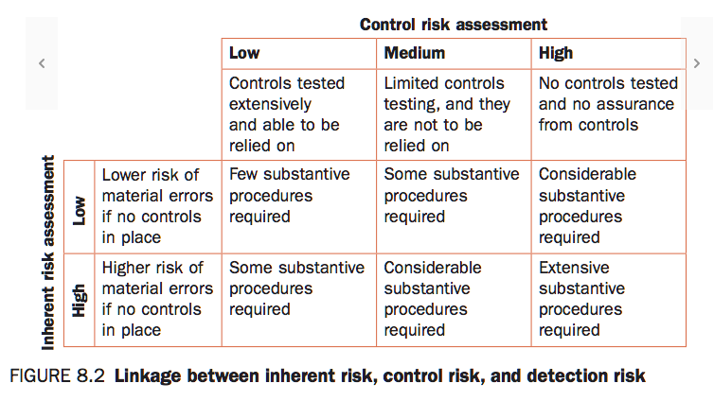
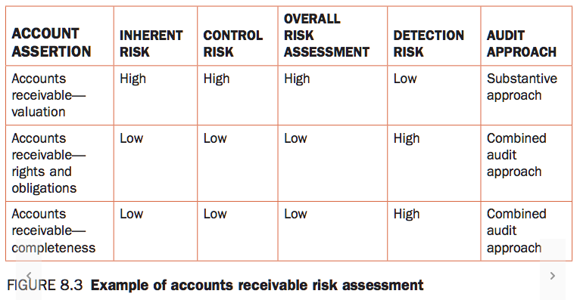
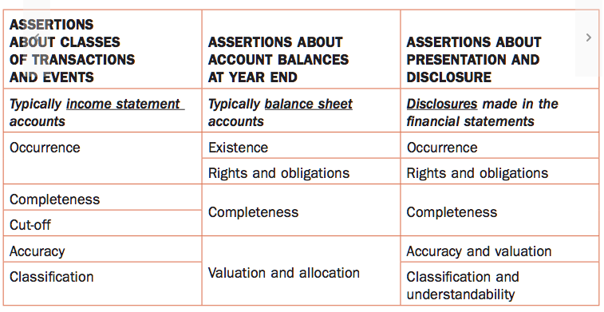

Definition of Substantive Procedures
Designed to obtain direct evidence of the completeness, accuracy, and validity of data, and the reasonableness of the estimates and other information contained in the f/s.
- Include:
  - Inspection
  - Observation
  - Enquiry
  - Confirmation
  - Recalculation
  - Re-performance
  - Analytical reviews
- Several other factors that influence how much & when substantive procedures are performed:
  - The nature of the test
  - The level of assurance necessary
  - The type of evidence required
  - The complexity of the client’s data-capturing systems
- It is ordinarily more efficient to test & rely on controls than to carry out substantive procedures
- The types of procedures used to reduce DR to an acceptable level consist of tests of details & analytical procedures

Relationship Between Risk Assessment & the Nature, Timing, & Extent of Substantive Procedures
- The more work the auditor performs prior to the year-end visit, the less year-end work they will need to perform during the audit firms “busy season”.
- When the control environment is ineffective or there are specific ineffective controls, the auditor considers whether or not it’s appropriate to perform substantive procedures at an interim date.
- The timing of the substantive procedures is most flexible when controls have been assessed as effective & tested to confirm this assessment.
  - In these circumstances, the substantive procedures may be performed earlier in the year.
- Whenever substantive procedures are performed prior to year-end, the auditor performs roll-forward procedures to update their findings from the time of the interim procedures through to year-end
  - Matters of judgement & responsive to the risk assessment
- The auditor might also perform substantive procedures prior to year-end because of a client reporting requirement
- In the absence of specific effective controls, it may be acceptable for the auditor to perform substantive procedures prior to year-end when they are able to conclude overall that the client’s control environment is effective & the likelihood of errors is not high, or when they can perform sufficient procedures both at an interim date & during the intervening period

Substantive Audit Procedures

Tests of Details
Transactions predominantly designed to verify a balance or a transaction back to supporting documentation – vouching or tracing
- Vouching – when a balance or transaction is taken from the underlying accounting records and verified by agreeing the details to supporting evidence outside the accounting records of the company
- Tracing – when a source document is traced back to the underlying accounting records
- Sometimes, tests of details transactions are dual purpose tests in that the procedures performed provide evidence of a control’s effectiveness (test of controls) and also indicate if an item is being recorded properly (substantive test).
- Test of details of balances – support the ending GL balance of an account.
  - e.g. the auditor sends out accounts receivable confirmations
  - when agreeing a balance or transaction to supporting documentation, the auditor must consider the type of evidence that is available
  - Auditors do not ordinarily audit an entire balance or class of transactions and that’s why they use audit sampling
- Another key factor impacting the nature, timing & extent of testing is the auditor’s ability (or inability) to rely on computer-generated data or reports
  - When the auditor is unable to rely on IT general controls or application controls of a client, CR is assessed as high; in this case, the sample size when conducting substantive testing is likely to be larger and will be subject to a higher level of precision or confidence in the test result
- A decision on the amount of testing to perform (the extent of testing) is a matter of professional judgement.
  - Testing needs to be sufficient to allow the auditor to conclude that the underlying data are free from material misstatement
- If the auditor identifies errors when performing these tests, he requests the client to investigate the reason for the errors.
  - The reason the client provides will help the auditor determine the impact these errors may have on their risk assessment & the resultant change to the auditor’s planned audit approach

Analytical Procedures
- May be used:
  - As primary (persuasive) tests of a balance
  - As corroborative tests in combination with other procedures
  - To provide at least some minimal level of support for the conclusion
- The extent to which analytical procedures can reduce the extent of, or eliminate, other substantive procedures will depend on the risk assessment and the level of assurance provided by the analytical procedures
- Types of analytical procedures:
  - Absolute data comparisons – comparing current year to previous year, budget & forecasts
  - Ratio analysis – activity, liquidity, profitability, & leverage ratios
  - Trend analysis – comparing certain data for several accounting periods
  - Preparation of common-size f/s
  - Break-even analysis
  - Pattern analysis & regression analysis – sophisticated techniques not often used on audits
- Analytical procedures may not be useful when they are used on a company with significantly diverse operations & geographical segments
- The analytical procedure is adversely affected if the industry data are unreliable or not comparable to the client’s data
- The more effective the controls over the data that the auditor intends to use in an analytical procedure, the more the analytical procedure can be relied on as a substantive procedure
Substantive Analytical Procedures – Summary
- Identify the computation, comparison, or relationship to be made or to be investigated
- Assess the reliability of any data to be used
- Estimate the probable balance in the account or the probable outcome of the computation
- Make whatever computations are need using data in the client’s records or data from reliable outside sources
- Compare the estimated amount with the computed or recorded amount & evaluate whether the difference, if any, is significant
- Determine appropriate procedures for investigating the reasons for the difference if it is significant
- Perform the procedures
- Draw conclusions

Level of Evidence
- Persuasive
  - When the procedures generate an amount that the auditor believes is a reasonable estimate of what the balance should be, this enabling them to conclude that the account balance is free from material errors
  - No further substantive procedures need to be performed on the related account balance
- Corroborative
  - If:
    - Confirms audit findings from other procedures
    - Supports management representations or otherwise decrease the level or audit scepticism
- Minimal
  - Simple comparison with previous year to help identify problems or trends, and not to reduce the extent of other substantive procedures
- General

AP 8.3
This is a vouching substantive procedure that will give evidence of accuracy & occurrence of the revenue account by comparing a sample of the journal entries with the invoices related to those sales.
AP 8.4
The first test provides assurance about the occurrence assertion because we ensure that recorded transaction actually occurred. The other test is giving the auditor assurance about the completeness assertion to ensure that all transaction that should’ve been recorded, have be recorded
AP 8.8
Martin should determine the sampling method he is going to be using. As transactions seem to be dispersed, I would suggest to use stratified sampling selection in order to separate small and large tools sales, as well as standard and costumed sales. Then Martin should use professional judgement to determine the tolerable deviation risk and the EPDR in order to determine the sample size. Then using vouching procedures, martin will pick the sales transactions from the stratified sample and get external evidence, such as invoices, contracts, orders entered, to give evidence on the occurrence and accuracy of the sales.
AP 8.10
- 2 key accounts that are at risk in this situation are:
  - Sales revenue/Unearned revenue, because many of the client’s payments are received in advance, there is a risk of overstatement of the sales revenue
  - Fixed asset, because this is a new machine that is at risk of being prohibited in Canada. It is important that it is valued accurately
- The key assertions most at risk:
  - Cut-off & accuracy & occurrence assertion to ensure that the sales are recorded in the correct accounting period at the correct amount given the fact that many payments are received in advance, there is a risk of overstatement of sales revenue / understatement depending on management incentives.
  - Valuation & allocation, and rights and obligation to ensure that the new assets are valued and impaired correctly and that the client owns the machinery.
- Test of details:
  - Vouching procedure to take a transaction and verify the related documents such as the invoice, and the payment approvals in order to confirm the date the revenue should be recognized, the amount that should be recorded and that the sales did actually occurred
  - Use a confirmation from an expert to help you value the machinery and make sure it is valued at the right amount – tracing
AP 8.11
Analytical Procedures to calculate estimated revenue for people staying in the centre:
- Compare number of people currently staying in the centre with prior years revenues
  - See how much each tenant would spend on average on services and calculate an average spending / tenant
- Compare revenue per patient in similar facilities
- Use personnel and other operational data to estimate reasonableness of patient data

