CHM1321[Z08]

Experiment 2: Purifying Chemicals by Distillation

Date Due: 2019/07/24

Prof: Dr. K.-S. Focsaneanu (Fox)

Procedure:

The lab procedure as instructed can be found within the CHM 1321 Lab manual. The procedure as performed within the experiment is described below. First, the distillation apparatus was set up similar to the diagram below, with the receiving flask being substituted for a 50 mL graduated cylinder. Additionally, a heating pad is placed underneath the distilling flask in order to increase the temperature of the solution to a desired value.
Diagram 1: A simple distillation apparatus.
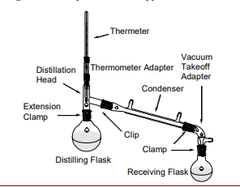
Once this has been complete, the apparatus was partially disassembled in order to add 50 mL of a 50:50 dichloromethane and ethyl acetate, the apparatus was reassembled, and the heating pad was turned on, and set to 70℃. As each mL of the distillate has moved to the receiving flask, the temperature is recorded. As some of the solution was lost to evaporation, once all of the solution had been distilled it was discarded, and a new solution was prepared for the fractional distillation portion of the experiment. When testing the effect of the fractional distillation apparatus, the apparatus was first modified so that it appeared like the diagram below, with the receiving flask substituted for a 50 mL graduated cylinder.
Diagram 2: A sample fractured distillation apparatus.
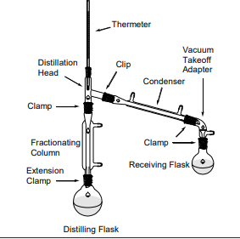
In this part of the experiment, a 25 mL 50:50 solution of dichloromethane and ethyl acetate was again added to the distillation
Refer to the lab manual. Department of Chemistry. (2019, Winter). CHM1321 Lab Manual. Ottawa, Ontario: University of Ottawa.

Modifications:
Instead of a receiving flask, a 50mL graduated cylinder was used.

Observations:
Table 1.1. Qualititative observations of 50:50 mixture of dichloromethane and ethyl actate
50:50 mixture of dichloromethane and ethyl acetate | The mixture is a clear colorless solution with a poignant “chemical” or acetone smell.

Table 1.2. Quantitative observations of the volume in the receiving graduated cylinder(mL) and the temperature (℃) of vapor going into the condenser at the time the volume was achieved, values were obtain from the simple distillation of a 50:50 mixture of ethyl acetate and dichlorometane.
Volume in receiving graduated cylinder (mL) | Temperature (℃) of vapor going into the condenser
2.6 | 50.0
3.2 | 51.5
4.8 | 52.5
5 | 53.5
6 | 54.5
7 | 55.5
8 | 56.0
9 | 57.0
10 | 58.5
11 | 60
12 | 60.5
13 | 62.5
14 | 63.5
15 | 64.8
16 | 66.0
17 | 67.5
18 | 68.5
19 | 70.0
20 | 73.0
21 | 74.0
22 | 74.9
23 | 75.0
24 | 76.0
25 | 78.0

Table 1.3. Quantitative observations of the volume in the receiving graduated cylinder(mL) and the temperature (℃) of vapor going into the condenser at the time the volume was achieved, values were obtain from the fractional distillation of a 50:50 mixture of ethyl acetate and dichlorometane.
Volume in receiving graduated cylinder (mL) | Temperature (℃) of vapor going into the condenser
2.6 | 39.5
3.2 | 40.0
4.8 | 41.0
5 | 41.5
6 | 42.0
7 | 43.0
8 | 44.4
9 | 46.2
10 | 47.5
11 | 49.0
12 | 51.5
13 | 55.8
14 | 60.5
15 | 65.5
16 | 54.0

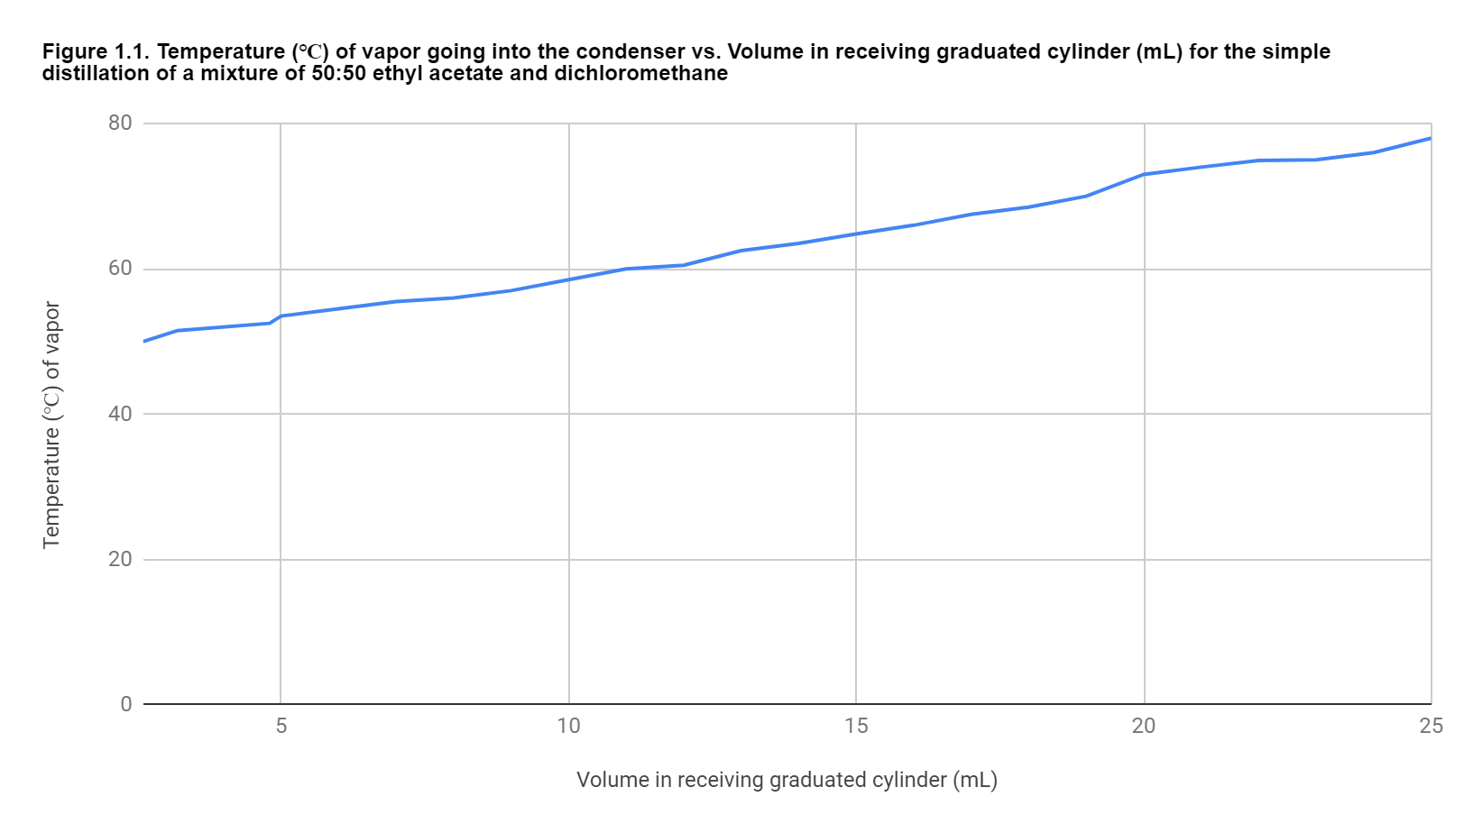

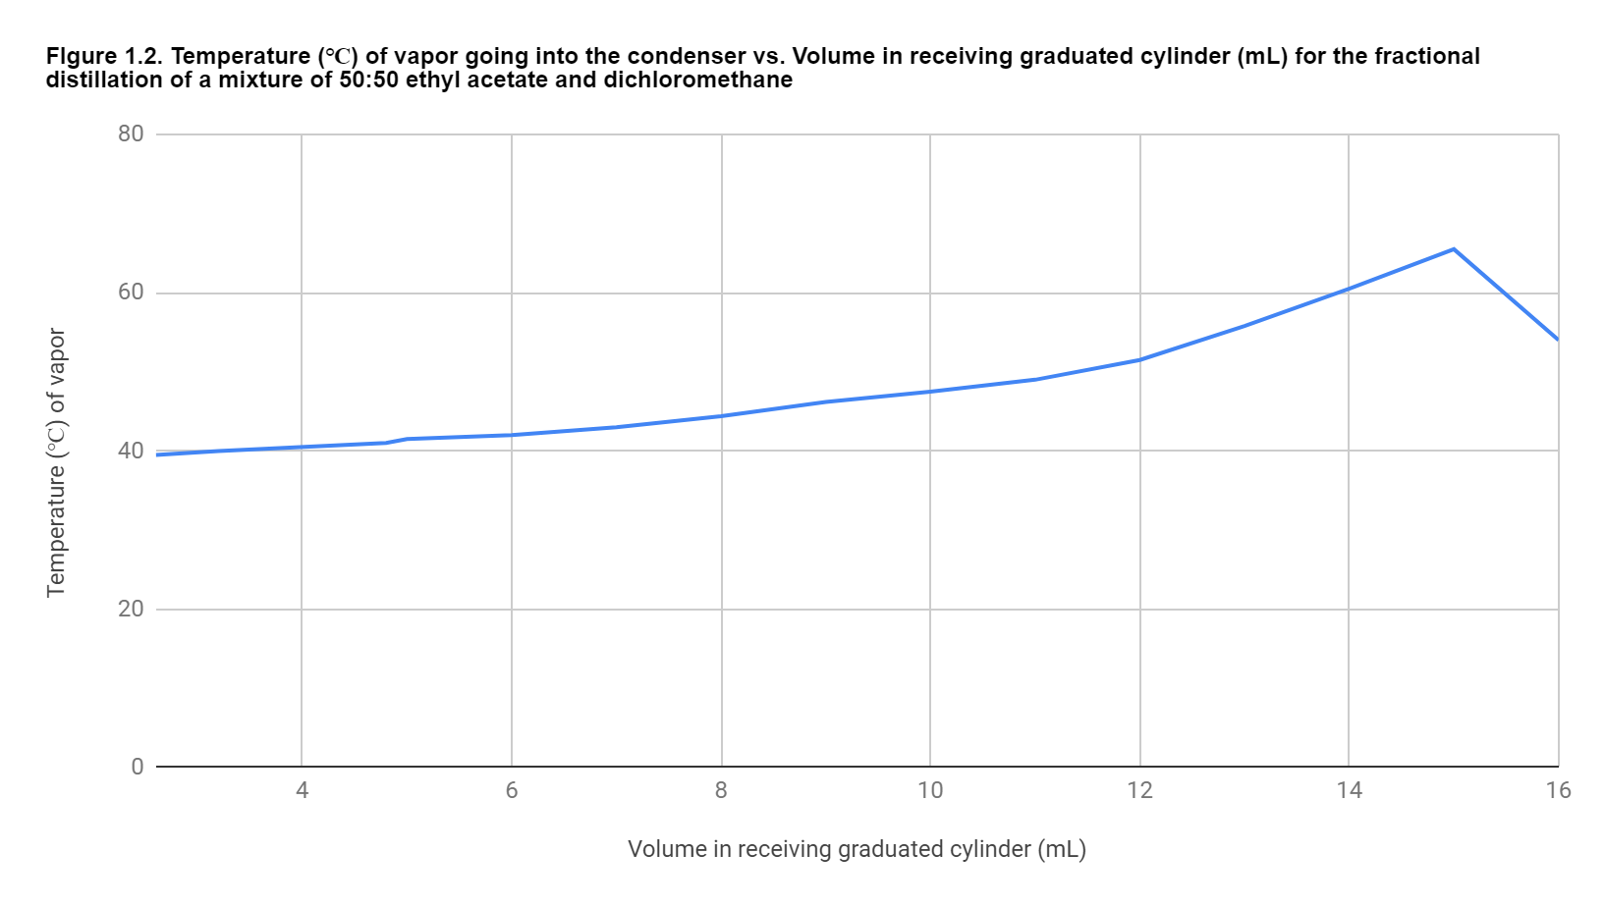

Questions:
- The boiling point of ethanol is 78.3℃, whereas the boiling point of toluene is 110.6 ℃ since the Δt is less than 100 °C theoretically a fractional distillation should be able to separate the two mixtures as it is more ideally suited to distillations where the Δt of the solution than 100 °C. Unfortunately, a mixture of ethanol and toluene creates an azeotrope which has a boiling point of 76.9 ℃. The ethanol will separate from the toluene until the mixture reaches a 68% m/m composition of toluene. At this point in the distillation, the distilled mixture will contain more of the toluene, should the distillation be continued past this point the distilled solution and that original solution will have the same exact composition and properties.

- It is important to maintain a smooth temperature gradient in the fractionating column to be able to complete an efficient distillation. The process of distillation in a fractionating column operates on the principles that in the column some of the condensate will be re-vaporized by the incoming hot vapor (this new vapor is now richer in the more volatile component of the mixture ) or the condensate will flow back down into the distilling flask (this solution is now richer in the less volatile component). If the fractionating column were not properly insulated at the point where the vapor meets the condensate then perhaps some of the heat from the vapor would be lost to the surroundings and therefore would not be able to re-vapourize the condensate as efficiently (or at all ) due to the decreased temperature. Moreover, if the fractionating column were insulated poorly, then it is possible that the temperature gradient could be destroyed and that no condensate would even form early enough in the column to be re-vapourised (due to the column getting too hot), which would then effectively turn the process into a simple distillation.

- As the boiling point of a liquid is the point at which the liquid’s vapour pressure is equal to the pressure of its surroundings, the vapour pressure for dichloromethane at 39.6℃ would be equal to the atmospheric pressure around it, which in standard conditions is equal to 101.3 kPa.

- The Clausius-Clapeyron equation describes the relationship between a pair of vapour pressures and temperatures as equal to,
$$ln(\frac{p_{2}}{p_{1}}) = \frac{-Δ_{vaporization}H}{R}(\frac{1}{T_{2}}-\frac{1}{T_{1}})$$
Where p₁ is the pressure at temperature T₁, p₂ is the pressure at temperature T₂, R is the ideal gas constant, and Δ_{vaporization}H is the enthalpy of vaporization. As R is a constant, and for small temperature changes the enthalpy of vaporization can also be considered a constant, we can simplify this equation as,
$$ln(\frac{p_{2}}{p_{1}}) = -(\frac{1}{T_{2}}-\frac{1}{T_{1}})*Constant$$
From here we can see that as p₂ increases over p₁, $(\frac{1}{T_{2}}-\frac{1}{T_{1}})$ must also increase in the negative direction at the same rate in order for the equation to remain true. If we assume our p₁ and T₁ to be our initial boiling temperature and pressure, this means that as the atmospheric pressure increases, the temperature at which our compound boils must also increase, as $\frac{1}{T_{2}}$ must become increasingly smaller than $\frac{1}{T_{1}}$for the Clausius-Clapeyron equation to remain true.

- It is important to always fill the condenser from the bottom of the device and not the top of it, as this ensures that the entire condenser is fully filled with water, and able to cool the vapourized solution that we are examining. If we instead attempted to fill from the top stem of the condenser, what would happen is that there would remain a pocket of air at the very top of the device, as water would flow downwards beside this pocket as it exited the stem, and this in turn would cause the condenser to be less efficient at pulling heat away from the gases that enter it.

- The vapor pressure of the solution can be determined using Raoult's Law (since the two compounds are miscible and therefore a correction for the composition of the solution must be made)
$P_{A}=P_{A°} ×N_{A}$
$P_{B}=P_{B°} ×N_{B}$
$P_{Total}=P_{A} +P_{B}$
Using the given data (vapor pressure of each compound at 95℃ and the mole fraction of the solution, the vapor pressure of the mixture can be determined).
$$P_{A}=350_{mmHg} ×\frac{4}{5}=280_{mmHg}$$
$$P_{B}=140_{mmHG} ×\frac{1}{5 }=28_{mmHg}$$
$P_{Total}= 280_{mmHg}+28_{mmHg} = 308_{mmHg}$
Therefore the vapor pressure of a 4:1 mixture of A and B at 95℃ will be 308 mm Hg

Discussion:

In this laboratory experiment, a simple and fractional distillation were performed on a 50:50 mixture of ethyl acetate and dichloromethane. The purpose of the experiment was to compare the two different methods of distillation. Theoretically, the fractional distillation should be more effective as the difference in boiling points of the two chemicals (39.6 ℃ for dichloromethane and and 77.1℃ for ethyl acetate) is less than 100℃ then the fractional distillation will be more effective.
Firstly, the simple distillation equipment was set up, making sure the water source was at the bottom of the condenser and the output was at the top and that the thermometer was placed in a manner that allowed the bulb to be slightly below the exit arm of the still head. These measures were taken to ensure that the distillation process was as effective as possible and to ensure the most accurate measurement of temperature. For every milliliter of distillate the temperature was recorded and the point was subsequently plotted onto a graph(see figure 1.1). For the first 12 mL of distillate the temperature began at 50℃ and made its way to 60.5℃ by the twelfth milliliter. Optimally, the distillate at this point should have been comprised of mostly dichloromethane (as it is the more volatile component of the solution due to its lower boiling point). In an ideal scenario, the graph would depict a smooth curve, where it begins at the lower temperature and increases the rate of change of temperature around the halfway point (representing the temperature of the vapour rising as it has to match the higher boiling point of the less volatile component) then continues almost linearly until the end of the distillate(boiling point of the less volatile component has been reached and it is only a matter of time before it is all evaporated).THe increase in the rate of change should ideally occur around 12.5 ml as this is a 50:50 compound and therefore at 12.5 ml the majority of the dichloromethane should comprise less of the solution in the distilling flask than the ethyl acetate which requires a higher boiling temperature. In the experiment performed, the graph depicts an almost linear rate of change of temperature, with no significant changes throughout the experiment. This proves that a simple distillation was most likely not the most efficient way to seperate the two compounds as the point where they seperate cannot be clearly identified. In comparison, the graph for boiling a single compound in the distillation apparatus would look very similar to the one obtained from the observations of the experiment.

The maximum temperature reached was 78℃ which is only 1℃ higher than the boiling point of ethyl acetate. Because this temperature was reached on the last milliliter, it can be assumed that much of the ethyl acetate was comprising the vapour that was being boiled away earlier, and that the composition of the vapour earlier in the distillation was not as homogenous as ideally expected. The entire process of the simple distillation took no longer than 30 minutes and was significantly faster than the fractional distillation (which is theoretically expected, as the fractional distillation requires the constant condensation and re-vaporisation of the solution, whereas this process only happens once in a simple distillation)

Secondly, a fractional distillation was set up. The main difference between the equipment of the simple distillation and the fractional distillation was the addition of a fractionating column between the distillation head and the distillation flask. The purpose of the fractionating column is to allow the solution to be vaporized, then it will condense in the fractionating column, where the more volatile compound in the solution will be re-vapourized by the heat of the incoming vapour and the the less volatile compound will drip back into the distillation flask. This allows for a greater degree of homogenization of the vapour and for a more efficient distillation; this happens at the expense of time, as the whole process takes longer than a simple distillation. Temperature and volume observations were noted in the same manner as described above for the simple distillation. Theoretically, the graph of these points plotted should be increasing linearly in the beginning, then it should go through a sudden jump in temperature and continue to increase linearly after the jump. The jump corresponds to when the majority of the more volatile compound (dichloromethane) is in the receiving flask (or in this case receive graduated cylinder) and the temperature begins to rise in accordance to the boiling point of the less volatile compound (ethyl acetate) of which the majority is left in the distillation flask. In the experiment the results did not match the theoretical expectations.
At first the temperature for the first milliliter was 39.5℃ which corresponds almost exactly to the boiling point of dichloromethane. The temperature then continued to rise until 51.5 ℃ at the twelfth milliliter. At this point in the experiment the efficiency of the fractional distillation compared to the simple distillation can be noted, already the temperature of the vapour began at a much lower temperature (about 20℃) and rose at a much slower rate. This is an indication that the majority of the condensate is the more volatile dichloromethane. At the twelfth milliliter is where the jump in temperature should be observed. Through the observation of the graph at the twelfth milliliter is when the rate of change of the temperature against volume begins to increase, although this is not as extreme a jump as what would be optimally expected. The temperature continue to increase sharply (when compared to the increase in temperature over the first 12 mL) until it reaches 65.5℃ at 15mL, this is the most drastic increase and can be noted in the graph. At this point is where the graph wildly deviated from the expected outcome, ideally the temperature should have stabilised around 77.1℃ which is the boiling point of ethyl acetate. In reality the temperature plummeted to 54.0 ℃, never even having reached the boiling point of ethyl acetate. At this point the experiment had to be halted as the fractional distillation had been going on for more than 1.5 hours and the time allotted for the laboratory experiment was at an end. It can be assumed that the majority of the liquid left in the distilling flask is composed mostly of ethyl acetate, as the temperatures reached throughout the distillation where not close to the boiling point. The causes for the experiment to vary from the expectation can most likely be pinpointed to a source of error which will be elaborated on below.

In this laboratory investigation, there where multiple sources of error that could have affected the observations and results of the experiment. Firstly, the researcher ability to conduct the experiment could have played a role in the final results. For example, if the equipment for distillation was not set up properly then the distillation itself would not represent the expectations. For example, if the ground glass joints were not properly locked then it is possible that vapour could have escaped. If vapour escaped then the actual composition of the vapour would not be a representative of the composition of the solution, and would lead to less distillate being produced then there was original solution. It would also lead to an improper temperature gradient in the fractionating column (the effects of this are discussed in question 2).Furthermore, another consequence of vapour escaping is the length to complete the distillation would increase, as temperature would not rise as steadily and therefore while the first half of the distillation would go faster (because the boiling point of dichloromethane is relatively low) but the second half would go much more slowly as the higher temperature of 77.1℃ would have to be reached. Secondly, the accuracy of the equipment used in the investigation may have affected the observations of the experiment. For example, it is possible that not all of the vapour produced could then condense and drip into the receiving graduated cylinder, some may have stayed on the walls of the glass equipment or in the packing for the fractional distillation, this would lead to a smaller amount of distillate then solution. Moreover the optimal placement of the thermometer was a rough point (top of the bulb below the exit arm of the glass head) and it is entirely possible this procedure was followed but a slight variation in where the bulb sat could have affected the observed temperatures, causing data which would either lead to temperatures that are too high (suggesting less of the volatile component of the solution then there actually is) or too low (suggesting more of the volatile component of the solution then there actually is). Finally, another source of error is the time allotted to complete the experiment, due to variations in the different fractionating columns it is possible that some had less packing on the inside then others. A greater amount of packing would lead to a longer distillation time as the vapour would have more surface area to cool on, this would create more condensate to drip back down and would make the re-vapourization process lengthier, as the time for the incoming vapour to reach the necessary temperatures would also increase (as the incoming vapour is being cooled faster ).
Some ameliorations to the experiment include devising a method to check if there are leaks at the joints of the equipment (covering the joints in soapy water, if there are bubbles then a leak is identified). And perhaps using equipment that can measure the temperature electronically, so that the temperature would be more accurate and them measuring equipment could perhaps be placed in the exact same spot during each trial (instead of one long skinny tube, a stop could be implemented, which would ensure that the probe could only reach a maximum depth (which ideally would be near the exit arm of the still head) which would be the standardized point to take the temperature from. Finally a simple allotment of more time could help to deal with any variations in the experiment and allow for a complete collection of all the possible data.

Conclusion:
In conlusion the goal of this experiment was to compare the fractional distillation method with the simple distillation method. Through observations of the plotted data points that were observed, it was found that the simple distillation was most likely less effective than the fractional distillation at seperationg the the compounds but the simple distillation was faster. Whereas in the experiment the fractional distillation could not seem to vapourise the less volatile compound (ethyl acetate) in the solution and the tempratures observed correlated with the vapourisation only of the dichloromethane, this coupled with a significant amount of solution left in the distilling flask leads to the conclusion that the majority of the ethyl acetate remained in the distilling flask. The reason for this could be attributed to errors discussed in the section above.

Refrences:
“Toluene.” National Center for Biotechnology Information. PubChem Compound Database, U.S. National Library of Medicine, pubchem.ncbi.nlm.nih.gov/compound/toluene.

“Ethyl Acetate.” National Center for Biotechnology Information. PubChem Compound Database, U.S. National Library of Medicine, pubchem.ncbi.nlm.nih.gov/compound/ethyl_acetate.

Zhu, Zhaoyou & Wang, Lili & Ma, Yixin & Wang, Wanling & Wang, Yinglong. (2015). Separating an Azeotropic Mixture of Toluene and Ethanol via Heat Integration Pressure Swing Distillation. Computers & Chemical Engineering. 76. 10.1016/j.compchemeng. 2015.02.016.

Raw Data:


