Chapter 2

Strategic Planning and Human Resources
- Strategic planning
: procedures for making decision about the organization’s long-term goals and strategies
- Human resources planning (HRP)
: The process of anticipating and providing for the movement of people into, within, and out of an organization
- Strategic human resources management (SHRM)
: the pattern of human resources deployments and activities that enable an organization to achieve its strategic goals
  - Strategy formulation: providing input as to what is possible given the types and numbers of people available
  - Strategy implementation: making resource allocation decisions, including decisions related to structure, processes, and human capital.

Step 1: Mission, vision, and values
- Mission
: the basic purpose of the organization as well as its scope of operations
- Strategic vision
: a statement about where the company is going and what it can become in the future; clarifies the long-term direction of the company and its strategic intent
- Core value
: the strong and enduring beliefs and principles that the company uses as a foundation for its decisions
- Developing a mission statement
  - What is my organization’s reason for being? What need do we fulfill that isn’t already being met by another firm or could be better met?
  - For whom would the firm fulfill the need? Who are our customers?
  - How do we fulfill, or better fulfill, the need?
  - Where is our market and our customers? Where will we operate? Locally, geographically, or globally?
  - What core values do the people in my organization share and will continue to embrace as part of our mission? How do these values differentiate us form other companies?
- Core value are as follows?
  - Putting people first
  - Pursuing excellence
  - Embracing changing
  - Acting with integrity
  - Serving our world

Step 2: External analysis
- Environmental scanning
: systematic monitoring of the major external forces influencing the organization
- Economic and ecological changes: general, regional, and global conditions
- Technological changes: information technology and automation
- Demographic changes and labour market trends: education, age, composition, literacy, immigration
- Social changes: priorities toward work, childcare, eldercare
- Legal and regulatory changes: laws and rulings

- Linking Strategic Planning and HRP
  - Strategic analysis
: what human resources are needed an what are available?
  - Strategic formulation
: what is required and necessary in support of the human resources strategy?
  - Strategic implementation
: how will the human resources be allocated for structure, processes, and human capital decisions?
Human Resources Planning Strategic Planning

Step 3: internal analysis
- Internal analysis
1. Culture 2.Capabilities 3. Composition
- Core capabilities
  - Core capabilities
: integrated knowledge sets within an organization that distinguish it from its competitors and deliver value to customers
  - Value creation
: what the firm adds to a product or service by virtue of making it; the amount of benefits provided by the product or service once the costs of making it are subtracted
- Sustaining a competitive advantage through people
  - The resources must be valuable
  - The resources must be rare
  - The resources must be difficult to imitate
  - The resources must be organized
- Corporate culture
  - Corporate culture
: audits of the culture and quality of work life in an organization
  - Value-based hiring
The process of outlining the behaviours that exemplify a firm’s corporate culture and then hiring people who are a fit for them
- Culture: vales, assumptions, beliefs, and expectations (VABEs)
  - Audits of the culture and quality of work life in an organization
    - How do employees spend their time?
    - How do they interacted with each others?
    - Are employees empowered?
    - What is the predominant leadership style of managers?
    - How do employees advance within the organization?
- Forecasting
  - Forecasting: a critical element of planning
    - Forecasting the demand for labour
    - Forecasting the supply of labour
    - Balancing supply and demand considerations
  - Forecasting a Firm’s demand for employees
    - Trend analysis
: a quantitative approach to forecasting labour demand based on an organizational index such as sales
    - Management forecasts
: the opinions (judgments) of supervisors, department managers, experts, or others knowledgeable about the organization’s future employment needs

  - Forecasting supply of employees: internal labour supply
    - Staffing tables
: graphic representations of all organizational jobs, along with the numbers of employees currently occupying those jobs and future (monthly or yearly) employment requirements
    - Markov analysis
: a method for tracking the pattern of employee movements through various jobs
    - Skill/management inventories
: files of personnel education, experience, interests, and skills that allow managers to quickly match job opening with employee backgrounds
    - Replacement charts
: listings of current jobholders and people who are potential replacements if an opening occurs
    - Succession planning
: the process of identifying, developing, and tracking key individuals for executive position
  - Figure 2.4: Model of HR Forecasting
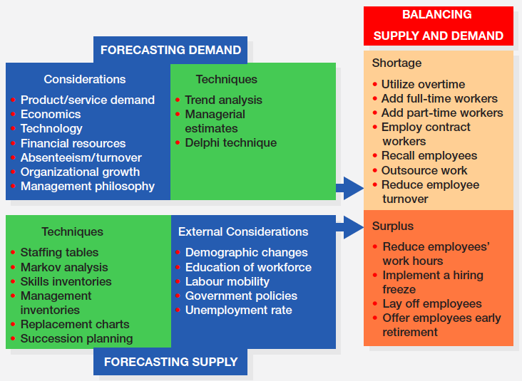

Step 4: Formulating strategy
- Strategy formulation
: moving from simple analysis to devising an coherent course of action
- SWOT analysis
  - A comparison of strengths, weaknesses, opportunities and threats for strategy formulation purposes
  - Using the strengths of the organization to capitalize on opportunities, counteract threats and alleviate internal weaknesses
  - Example of SWOT analysis for LIZ CLAIBORNE
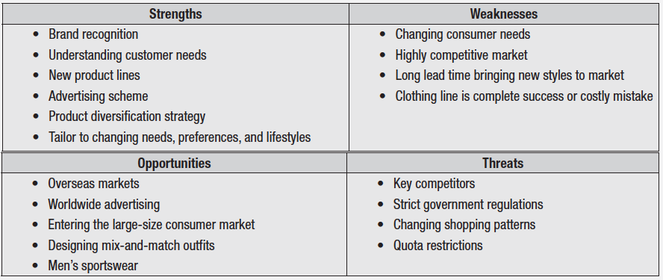
- Corporate strategy
- Growth and diversification
- Strategic alliances and joint ventures
- Mergers and acquisitions
- Business strategy
  - Value creation
: what the firm adds to a product or service by virtue of making it; the amount of benefits provided by the product or service one the cost of making it are subtracted
(value = benefits – costs)
    - Low-cost strategy: competing on productivity and efficiency
      - Keeping costs low to offer an attractive price to customers (relative to competitors)
    - Differentiation strategy: competing on added value
      - Involves providing something unique and distinctive to customers that they value
  - Functional Strategy: Ensuring Alignment
    - Vertical fit/alignment
: focuses on the connection b/w the business objectives and the major initiatives in HR
    - Horizontal fit/ alignment
: aligning HR practices with one another internally to establish a configuration that is mutually reinforcing

Step 5: Strategy implementation
- 7-S Framework
  - HRM is instrumental to almost every aspect of strategy implementation
Hard S Middle Soft S
Strategy Skills
Structure Share value Style
System staff
- Taking Action: Reconciling supply and demand
  - Demand considerations
: based on forecasted trends in business activity
  - Supply considerations
: involve determining where and own candidates with the required qualifications can be found to fill an firm’s vacancies
  - A labour surplus exists when the internal supply or employees exceeds the organization’s demend
- Dealing with Surplus employees
- Layoffs
  - Based on seniority and/or ability
- Attrition
  - A natural departure of employees form organizations through quits, retirements, and deaths
  - Hiring Freeze
: a practice whereby new workers are not hired as planned or worker who have left the organization are not replaced
- Termination strategies
  - Termination
: practice initiated by an employer to separate an employee from the organization permanently
    - It is different from firing, in which an employee is released for such causes as poor performance, high absenteeism and unethical behaviour
    - Purpose: to reduce the size of workforce and thereby save money
  - Severance pay
: the process of measuring one’s own services and practice against the recognized leaders in order to identify areas for improvement
- Dealing with labour shortage
  - Labour shortage
: exists when the internal supply or human resources cannot meet the organization’s needs
  - Labour shortage – employers respond with
- Overtime
- Add full time work (external recruitment)
- App part time worker (temporary employees)
- Employ contract workers
- Recall employees
- Outsource work
- Reduce employee turnover

Step 6: Evaluation and assessment
- Evaluation and assessment issues
  - Benchmarking
: the process of comparing the organization’s processes and practices to those of other companies
  - Human capital metrics
    - Assess aspects of the workforce
  - HR metrics
    - Assess the performance of the HR function itself
- Measuring a firm’s strategic alignment
  - Balanced Scorecard (BSC)
: a measurement framework that helps managers translate strategic goals into operational objectives
    - Financial
    - Customer
    - Processes
    - Learning
- Ensuring Strategic flexibility for the future
  - Organizational capability
: capacity of the organization to continuously act and changes in pursuit of sustainable competitive advantage
  - Coordination flexibility
: the ability to rapidly reallocate resources to new or changing needs
  - Resource flexibility
: having human resources who can do many different things in different ways

Appendix
- Employee turnover rates
  - Computing turnover rate
  - $\frac{number of separations during the month}{total number of employees at mid month }×100$

- employee absenteeism rate
  - computing absenteeism rate
  - $\frac{number of worker-days lost through job absence during period}{average number of employee x number of workdays}× 100$

