Chapter 1

Why study Human Resources management?
- HRM (human resources management)
: the process of managing human talent to achieve an organization’s objective
- Human Capital
: the knowledge, skills and capabilities of individuals that have economic value to an organization
- Overall framework for human resources management
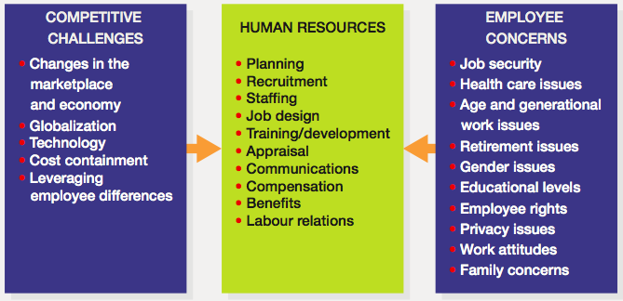

Competitive issues and human resources management
- Issue1: responding strategically to changes in the local and global marketplace
  - HR Managers and Business Strategy
    - Organizations use to modify the way they operate to be more successful
- Six Sigma
: a set of principles and practices whose core ideas include understanding customer needs, doing things right the first time, and striving for continuous improvement
- Reengineering
: the fundamental rethinking and radical redesign of business processes to achieve dramatic improvement in cost, quality, service, and speed
- Downsizing
: planned elimination of jobs
- Outsourcing
: contracting out work that was formerly done by employees
- Change management
: changes management is a systematic way of bringing about and managing both organizational changes and changes on the individual level
- Total quality management
: an approach that organizations use to improve their internal processes and increase customer satisfaction
    - Some of the strategic changes company pursue
    - Reactive changes – changes that occur after external forces have already affected performance
    - Proactive changes – change initiated to take advantage of targeted opportunities

  - Competing, Recruiting, and Staffing Globally
    - Globalization
: the trend to opening up foreign markets to international trade and investment
      - Approximately 70-85 percent of the Canadian economy today is affected by international competition
      - Impact of Globalization
        - “anything, anytime, anywhere” markets
        - partnerships with foreign firms
        - lower trade and tariff barriers

    - Offshoring (global sourcing)
: the business practice of sending jobs to other countries
- Issue2: Setting and achieving Corporate Social Responsibility and sustainability goals
  - Corporate social responsibility
: the responsibility of the firm to act in the best interests of the people and communities affected by its activities

- Issue3: Advancing HRM with technology
  - Collaborate software
: software that allows worker to interface and share information with on another electronically

  - From touch labour to knowledge worker
    - Knowledge worker
: workers whose responsibilities extend beyond the physical execution of work to include planning, decision making, and problem solving

  - Influence of technology on HRM
    - Human resource information system (HRIS)
: a computerized system that provides current and accurate data for purposes of control and decision making

- Issue4: containing costs while retaining top talent and maximizing productivity
  - Downsizing
    - Whatever the reason, whereas some firms improve efficiency (and lower costs) with layoffs, many others do not obtain such benefits
    - Advocates of a no-layoff policy often note that layoffs may backfire after taking into account hidden costs, such as following:
- Severance and rehiring costs
- Accrued vacation and sick-day payout
- Pension and benefit payoffs
- Potential lawsuits from aggrieved workers
- Loss of institutional memory and trust in management

  - Furloughing
    - Furloughing
: a situation in which an organization asks or requires employees to take time off for either no pay or reduce pay

  - Outsourcing
    - 자체 인력, 설비, 부픔 등을 이용해 하던 일을 비용 절감과 효율성 증대를 목적으로 외부 용역이나 부품으로 대체하는 것

  - Offshoring
    - Offshoring
: the business practice of sending jobs to other countries
    - Nearshoring
: the process of moving jobs closer to one’s home country

  - Employee Leasing
    - Employee leasing
: the process of dismissing employees who are then hired by a leasing company (which handles all HR-related activities) and contracting with that company to lease back the employees

  - Productivity Enhancements

- Issue5: responding to the demographic and diversity challenges of the workforce
  - Demographic change
: significant challenge for managers are demographic changes occurring in Canada because they affect the workforce of an employer, these changes –– in background, age, gender, and education –– are important topic
    - More diverse workforce
    - Aging workforce
    - More educated workforce
  - The diversity/ immigration
    - Being aware of characteristics common to employees, while also managing employees as individuals
  - Age distribution of employees
  - Gender distribution of workforce
    - 61% of graduating is women
    - working parents
      - offering them parental leave,
      - part-time employment
      - flexible work schedule
      - job sharing
      - telecommuting
      - childcare
      - eldercare assistance
  - Other factors
    - Cultural and societal changes affecting the workforce
    - Balancing work and family
    - Changing attitudes toward work
    - Changing nature of the job
    - Privacy concerns of employees
    - Employee rights
    - Cultural and social changes affecting the workforce

  - lecture
: a recent survey, almost half of the organizations surveyed reported that the biggest investment challenge facing them over the next 10 years is obtaining human capital land optimizing their human capital investments

The partnership of line manager and HR departments
- Line e work of manager
Non-hr managers who are responsible for overseeing the work of other employees

- Responsibilities of the HR manager
- Advice and counsel
- Service
- Policy formulation and implementation
- Employee advocacy

- HR competency model


