Exam Plan
Electronics I:
- Diodes:
- DC analysis of Ideal Diodes
- ON: Short Circuit, I_{d} > 0
- OFF: Open Circuit: V_{d} < 0
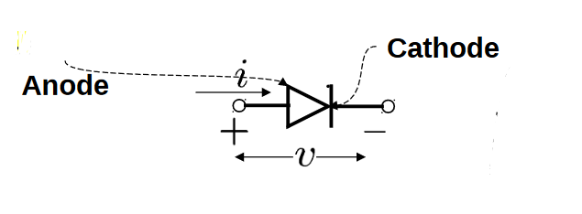
- Real Diode (PN Junction Diode)
- PN function formulas
- Analysis of PN junction Diodes (Models + Plotting)
- Models:
- Battery Model
- Battery + Ideal Diode + Resistance Model
- Simple Diode Model
- Small-Signal Model
- Zener Diode
- Zener Diode Model (Vzo + rz)
- The Shunt Regulator/Voltage Divider
- Line Regulation
- Load Regulation
- Rectifiers
- Half Wave Rectifier
- Full Wave Rectifier
- Bridge Rectifier
- Filter Capacitor (The Peak Rectifier)
- Voltage Regulator (Zener Diode)

- Bipolar Junction Transistor (BJT) (coming out on exam)
THE E NODE WILL BE AT THE ARROW IN THE BJT SYMBOL
- BJT parameters
- β: common – emitter current gain
- α = β/ (β+1)
- DC analysis of NPN BJT
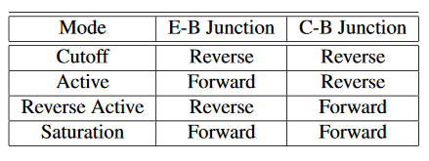
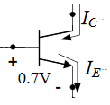

- Active:
V_{C} > V_{B}, V_{E} < V_{B}, I_{B} > 0, I_{c} = β I_{B}, I_{E} = (β+1) I_{B} = I_{c} + I_{B}, I_{C} = α I_{E}, V_{BE} = 0.7V
- Saturation
V_{C} < V_{B}, V_{E} < V_{B}, I_{B} > 0 V_{BE} = 0.7, V_{CE} = 0.2V, V_{BC} = 0.5V [If otherwise, it will be specified with the BJT]
- Cutoff
V_{C} < V_{B}, V_{E} < V_{B}, I_{B} = I_{C} = I_{E} = 0
- DC analysis of PNP BJT
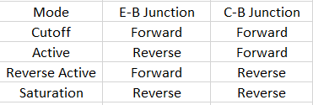
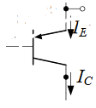
- Active
V_{C} < V_{B}, V_{E} > V_{B}, I_{c} = β I_{B}, I_{E} = (β+1) I_{B} = I_{c} + I_{B}, I_{C} = α I_{E}, I_{B} > 0, V_{BE} = - 0.7V
- Saturation
V_{C} > V_{B}, V_{E} > V_{B}, V_{BE} = - 0.7, V_{CE} = - 0.2V, V_{BC} = - 0.5V [If otherwise, it will be specified with the BJT]
- Cutoff
V_{C} > V_{B}, V_{E} > V_{B}, I_{B} = I_{C} = I_{E} = 0
- BJT as an amplifier
- Amplification mode: Active
A_{v} (Voltage Gain) = v_{o}/v_{i}
v_{o}/v_{sig} = A_{v} R_{in}/ (R_{in} + R_{sig}) R_{L}/(R_{L}+R_{o})
g_{m} (Transconductance) = I_{C}/V_{T} Ω⁻¹ (V_{T} = 0.025 V)
- BJT Models:
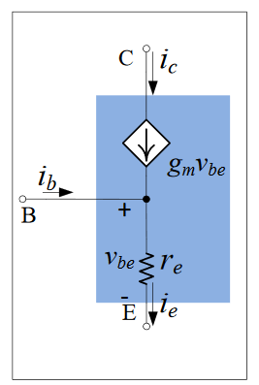

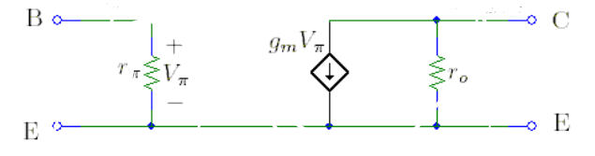

T-Model, r_{e} = α/g_{m}
Current Source: g_{m} v_{be} = α i_{e}
Hybrid pi model, r_{π} = β /g_{m} , r_{o} = V_{A}/I_{C}
Current Source g_{m} v_{be} = β i_{b}
- Steps
- DC analysis: Open all capacitors, short all AC voltage sources, open all AC current sources, short inductors. Find I_{C}/g_{m}.
- AC analysis: Short all capacitors, short all DC voltage sources, open all DC current sources, open all inductors. Find variables specified by question.
- Amplifier names
- There are three nodes the base, the emitter, and the collector. The input signal will be at one and the output will come from another. The remaining node would then be in the name: Common Remaining node. (e.g. Common Base, Common Emitter, Common collector.
- Name: Common Remaining node with a node resistor: only if its common node has a resister parallel to a capacitor.
- If the amplifier is a voltage follower (Av = 0) it will then be called the output node follower. (e.g. Emitter follower)
- Metal Oxide Semiconductor Field-Effect Transistor (MOSFETs)
THE S NODE WILL BE AT THE ARROW IN THE MOSFET SYMBOL
- MOSFET parameters
- μ_{n}: The mobility of electrons
- μ_{p}: The mobility of holes
- Cox: The Capacitance per unit gate area.
- W: Gate width
- L: Channel Length
- V_{A} = 1/λ (Channel Modulation)
- DC analysis of NMOS Transistors (D on top, S on bottom)
V_{OV} = V_{GS} – V_{Th}
- Cutoff:
V_{GS} < V_{T}: I_{d} = I_{s} = 0
- Saturation:
V_{GS} ≥ V_{T}, V_{DS} ≥ V_{GS} – V_{t}, I_{D} = I_{S} = ½ μ_{n} Cox W/L (V_{GS} – V_{T})² (1+ λV_{DS})
- Triode
V_{GS} ≥ V_{T}, V_{DS} < V_{GS} – V_{T}, I_{D} = I_{S} = μ_{n} Cox W/L [(V_{GS} – V_{T}) V_{DS} – ½ V²_{DS})
- DC analysis of PMOS Transistors (S on top, D on bottom)
- Cutoff:
V_{GS} > V_{T}: I_{d} = I_{s} = 0
- Saturation:
V_{GS} ≤ V_{T}, V_{DS} < V_{GS} – V_{t}, I_{D} = I_{S} = ½ μ_{p} Cox W/L (V_{GS} – V_{T})² (1+ λV_{DS})
- Triode
V_{GS} ≤ V_{T}, V_{DS} ≥ V_{GS} – V_{T}, I_{D} = I_{S} = μ_{p} Cox W/L [(V_{GS} – V_{T}) V_{DS} – ½ V²_{DS})
- MOSFETs as an amplifier:
- Amplification Mode: Saturation
- Small – Signal Model
g_{m} = $\sqrt{2μC_{ox}\frac{w}{L}I_{D}}$
r_{o} = 1/(λ I_{D}), [if (λ = 0.0) then r_{o} is an open circuit]
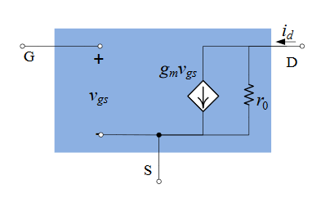
- Steps
- DC analysis: Open all capacitors, short all AC voltage sources, open all AC current sources, short inductors. Find I_{D}.
- AC analysis: Short all capacitors, short all DC voltage sources, open all DC current sources, open all inductors. Find variables specified by question.
- Amplifier names
- There are three nodes the gate, the drain, and the source. The input signal will be at one and the output will come from another. The remaining node would then be in the name: Common Remaining node. (e.g. Common Gate, Common Drain, Common Source.
- Name: Common Remaining node with a node resistor: only if its common node has a resister parallel to a capacitor.
- There are two nodes that are not the base of the transistor (emitter and collector) if it’s a common Drain, it would be a Source follower and the other way around.

- Digital Circuits
- Noise Margins
- NM_{H} = V_{OH} – V_{IH} = NM_{L} = V_{OL} – V_{IL} = V_{OH}/2 = (Supply Voltage) * ½
Noise Margins exist in 5 regions: 0 < Vin < Vt, Vt < Vin < Vdd/2 , Vin = Vdd/2, Vdd/2 < Vin < Vdd – Vt, Vdd – Vt < Vin < Vt
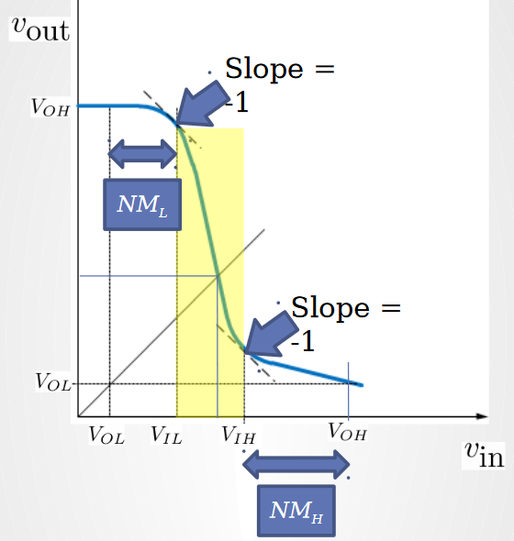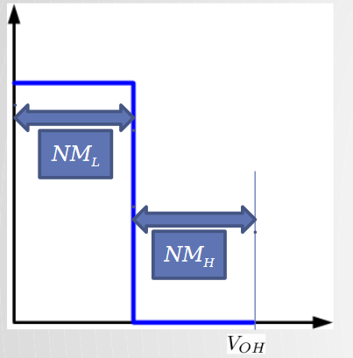
- CMOS circuits are used to model Logic Gates
- Solving CMOS Logic Gates
Find Modes in all five graphical regions for VTC (Voltage Transfer Characteristics)
0 < Vin < Vt, Vt < Vin < Vdd/2 , Vin = Vdd/2, Vdd/2 < Vin < Vdd – Vt, Vdd – Vt < Vin < Vt

If Vout is not a constant Vout must be modeled in terms of Vin

Model Vout in terms of Vin by creating a equation between them
Then
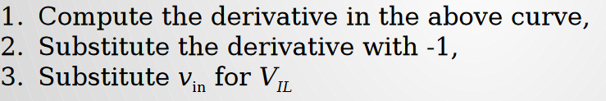
- CMOS inverter

