Lab BCH2333
Section: Z07 (Tuesday afternoon)

Lab 2: Amino Acids and Peptides

Chris Sarmales - Murga

Tuesday, January 29, 2019

Team #17
Lillian Low 300007119

Purpose
There were two experiments performed in this lab. The goal of experiment 1 was to separate three components of a mixture of glycine, aspartic acid, and lysine by performing ion – exchange chromatography. The goal of experiment 2 was to determine the molecular weight of an unknown protein by performing an electrophoresis on a polyacrylamide gel in the presence of SDS

Results
R1. Glycine, Aspartic Acid and Lysine
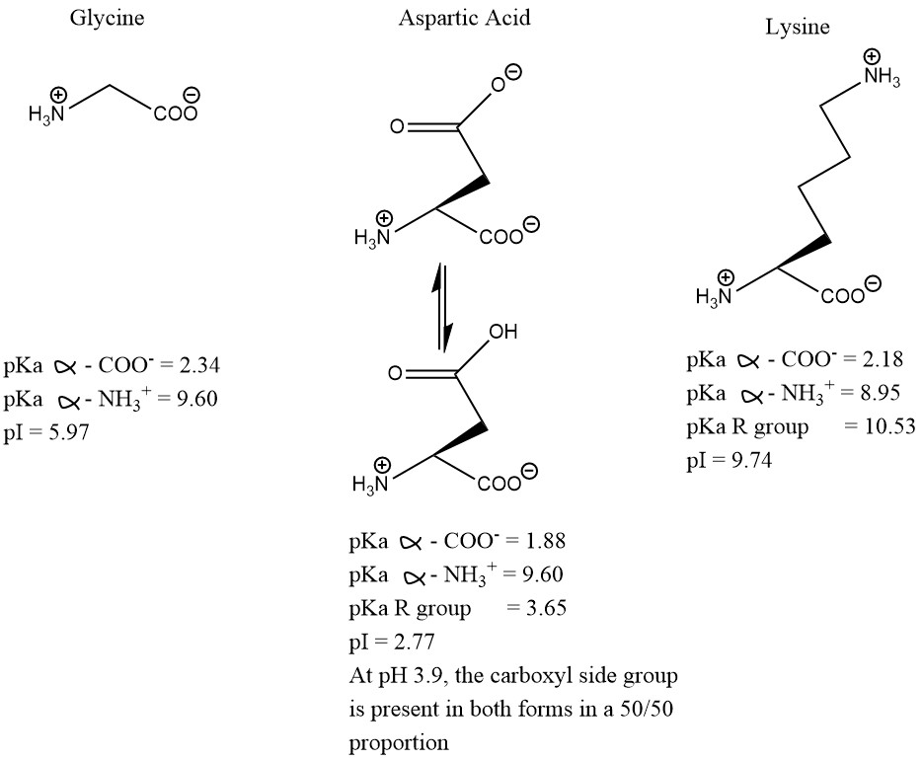
Figure 1. Structures, pKa and pI of glycine, aspartic acid, and lysine at pH 3.9.
Calculation of pI
Glycine:
$pI=\frac{pKa2+pKa1}{2}$ $= \frac{2.34+9.60}{2}$ $=5.97$
Aspartic Acid:
$pI=\frac{pKa3+pKa1}{2}$ $= \frac{1.88+3.65}{2}$ $=2.77$
Lysine:
$pI=\frac{pKa2+pKa3}{2}$ $= \frac{10.53+8.95}{2}$ $=9.74$

R2. Ion – Exchange Chromatography Results
Table 1. Column elution results for the blank and the amino acid standards.
Sample | A₅₇₀ | A₅₇₀ corrected | Conc. (mM)
Blank | 0.065 | 0 | 0
Aspartic Acid Reference | 0.759 | 0.694 | 1.0
Glycine Reference | 0.844 | 0.779 | 1.0
Lysine Reference | 0.939 | 0.874 | 1.0

Table 2. Column elution results for 16 fractions containing various amounts of amino acid solution. The elution column was pre-packed as indicated in the Lab Manual. 4mL of the amino acid mixture (2.5mM glycine, 2.5mM lysine, 2.5mM aspartic acid, in water) were added to the column through the syringe. 16 fractions were eluted with a pH gradient made from a pH 4 and pH 12.5 buffer. The fraction collector was set to 120 drops and the average fraction volume was calculated to be 4.80 mL. 100 μL of each fraction was transferred to a new test tube, and 100 μL of Ninhydrin reagent was added. The tubes were vortexed and heated at 100 ℃ for 15 minutes in an oven. The pH was taken based off the initial fraction liquid. The tubes were removed from the oven and 2.5 mL of ethanol-water was added to each tube. The absorbances of these final solutions was measured and corrected using a blank tube that contained 100 μL of NaH₂PO₄ at pH 4.0 and 100 μL of Ninhydrin reagent, also heated at 100 ℃. The absorbance values for glycine, aspartic acid, and lysine are 0.844, 0.759, and 0.939 respectively.
Fraction # | Elution Volume (mL) | pH | A₅₇₀ | A₅₇₀ corrected | Concentration  (mM) | μmole
1 | 4.80 | 3.70 | 0.056 | -0.009* | 0 | 0
2 | 9.60 | 3.68 | 0.053 | -0.012* | 0 | 0
3 | 14.4 | 3.71 | 0.081 | 0.016 | 0.0231 | 0.111
4 | 19.2 | 3.96 | 0.682 | 0.617 | 0.889 | 4.27
5 | 24.0 | 3.77 | 0.377 | 0.312 | 0.450 | 2.16
6 | 28.8 | 3.75 | 0.223 | 0.158 | 0.228 | 1.09
7 | 33.6 | 4.14 | 0.296 | 0.231 | 0.333 | 1.60
8 | 38.4 | 6.21 | 0.521 | 0.456 | 0.585 | 2.81
9 | 43.2 | 6.82 | 0.388 | 0.323 | 0.414 | 1.99
10 | 48.0 | 7.21 | 0.296 | 0.231 | 0.296 | 1.42
11 | 52.8 | 7.77 | 0.379 | 0.314 | 0.403 | 1.93
12 | 57.6 | 10.55 | 0.708 | 0.643 | 0.736 | 3.53
13 | 62.4 | 11.13 | 0.685 | 0.620 | 0.709 | 3.40
14 | 67.2 | 11.39 | 0.550 | 0.485 | 0.555 | 2.66
15 | 72.0 | 11.62 | 0.521 | 0.456 | 0.522 | 2.50
16 | 76.8 | 11.81 | 0.496 | 0.431 | 0.493 | 2.37
* The negative values were corrected to zero in Figure 2 and for the concentration calculations.
Based on the pH values of each fraction, fractions 1-7 correspond to aspartic acid, fractions 8-11 correspond to glycine, and fractions 12-16 correspond to lysine.

Sample Calculations:
Average Volume:
${ V}_{avg}=\frac{V_{1}+V_{2}+V_{3}}{3}$ $=\frac{4.6mL+5.0mL+4.8 mL}{3}$ $=4.8 mL$
Therefore, the average fraction volume is 4.8 mL

Aspartic Acid (Fraction #3):
A₅₇₀ corrected:
Fraction 3 reading = 0.081
Blank reading = 0.065
A₅₇₀ corrected = Fraction reading – blank reading
= 0.081 – 0.065
= 0.016
Concentration:
Where A_{s} = absorbance of the standard; C_{s} = concentration of the standard; A_{f} = absorbance of the fraction; and C_{f} = concentration of the fraction
$C_{f}=\frac{C_{s}A_{f}}{A_{s}}$ $= \frac{1.0 mM×0.016}{0.694}$ $=0.0231 mM$
Therefore, the concentration of aspartic acid in fraction 3 is 0.0231 mM.
μ mole:
Where n = moles; V = volume of fraction; and C = concentration of fraction
$n=CV$ $=0.0231mM×0.0048L$ $=0.111 μmol$
Therefore, the number of moles of aspartic acid in fraction 3 is 0.111 μmol.

Glycine (Fraction #8):
A₅₇₀ corrected:
Fraction 8 reading = 0.521
Blank reading = 0.065
A₅₇₀ corrected = Fraction reading – blank reading
= 0.521 – 0.065
= 0.456
Concentration:
Where A_{s} = absorbance of the standard; C_{s} = concentration of the standard; A_{f} = absorbance of the fraction; and C_{f} = concentration of the fraction
$C_{f}=\frac{C_{s}A_{f}}{A_{s}}$ $= \frac{1.0 mM×0.456}{0.779}$ $=0.585 mM$
Therefore, the concentration of glycine in fraction 8 is 0.585 mM.
μ mole:
Where n = moles; V = volume of fraction; and C = concentration of fraction
$n=CV$ $=0.585mM×0.0048L$ $=2.81 μmol$
Therefore, the number of moles of glycine in fraction 8 is 2.81 μmol.

Lysine (Fraction #12):
A₅₇₀ corrected:
Fraction 12 reading = 0.708
Blank reading = 0.065
A₅₇₀ corrected = Fraction reading – blank reading
= 0.708 – 0.065
= 0.643
Concentration:
Where A_{s} = absorbance of the standard; C_{s} = concentration of the standard; A_{f} = absorbance of the fraction; and C_{f} = concentration of the fraction
$C_{f}=\frac{C_{s}A_{f}}{A_{s}}$ $= \frac{1.0 mM×0.643}{0.874}$ $= 0.736mM$
Therefore, the concentration of lysine in fraction 12 is 0.736 mM.
μ mole:
Where n = moles; V = volume of fraction; and C = concentration of fraction
$n=CV$ $=0.736mM×0.0048L$ $=3.53 μmol$
Therefore, the number of moles of lysine in fraction 12 is 3.53 μmol.

R3. pH and Concentration vs Elution Volume
1
2
3
Figure 2. pH and concentration vs elution volume of the column for each of the 16 fractions. The elution column was pre-packed as indicated in the Lab Manual. 4mL of the amino acid mixture (2.5mM glycine, 2.5mM lysine, 2.5mM aspartic acid, in water) were added to the column through the syringe. 16 fractions were eluted with a pH gradient made from a pH 4 and pH 12.5 buffer. The fraction collector was set to 120 drops and the average fraction volume was calculated to be 4.8 mL. 100 μL of each fraction was transferred to a new test tube, and 100 μL of Ninhydrin reagent was added. The pH of the fractions was measured, and the concentrations were calculated as described in R1. The pH and concentration values are plotted on separate y axes against the elution volume on the x axis.

Analysis of Results
There are three peaks indicated on the graphs by “1”, “2”, and “3”, which correspond to the three amino acids present in the fractions. Peak 1 appears at a concentration of 0.889 mM and corresponds to aspartic acid (fractions 1-7). Peak 2 appears at a concentration of 0.585 mM and corresponds to glycine (fractions 8-11). Peak 3 appears at a concentration of 0.736 mM and corresponds to lysine (fractions 12-16). These peaks are well separated which indicates no outliers in the data. To increase the resolution and the peak separation, more fractions could be collected and the number of drops per fraction could be increased.

R4. Estimated Recovery Yield
Table 3. Estimated recovery yield for each amino acid. The recovery yields were calculated as described below using the fractions that corresponded to each amino acid.
Amino Acid | Estimated Recovery Yield (%)
Glycine | 92.3
Aspartic Acid | 81.5
Lysine | 145

Sample Calculations:
Aspartic Acid:
$n_{theoretical}= C_{a.a}V_{mix}$ $=(0.0025 M)(0.004 L)$ $=10 μ mol$
$n_{actual}= \sum_{7}^{1}{n=\left(0+0+0.111+4.27+2.16+1.09+1.60\right)μ mol=9.231 μ mol }$
$\% yield= \frac{n_{actual}}{n_{theoretical}}×100\%= \frac{9.231 μ mol}{10 μ mol}×100\%=92.3\%$
Where n_{theoretical} = theoretical yield (μ mol); C_{a.a} = concentration of the aspartic acid; V_{mix} = volume of the amino acid mixture; n_{actual} = actual yield, calculated by adding up the moles of each fraction containing aspartic acid (fractions 1-7).
Therefore, the estimated recovery yield for aspartic acid is 92.3%.
Glycine:
$n_{theoretical}= C_{a.a}V_{mix}$ $=(0.0025 M)(0.004 L)$ $=10 μ mol$
$n_{actual}= \sum_{11}^{8}{n=\left(2.81+1.99+1.42+1.93\right)μ mol=8.15 μ mol }$
$\% yield= \frac{n_{actual}}{n_{theoretical}}×100\%= \frac{8.15 μ mol}{10 μ mol}×100\%=8.15\%$
Where n_{theoretical} = theoretical yield (μ mol); C_{a.a} = concentration of the glycine; V_{mix} = volume of the amino acid mixture; n_{actual} = actual yield, calculated by adding up the moles of each fraction containing glycine (fractions 8-11).
Therefore, the estimated recovery yield for glycine is 81.5%.

Lysine:
$n_{theoretical}= C_{a.a}V_{mix}$ $=(0.0025 M)(0.004 L)$ $=10 μ mol$
$n_{actual}= \sum_{16}^{12}{n=\left(3.53+3.40+2.66+2.50+2.37\right)μ mol=14.46 μ mol }$
$\% yield= \frac{n_{actual}}{n_{theoretical}}×100\%= \frac{14.46 μ mol}{10 μ mol}×100\%=145\%$
Where n_{theoretical} = theoretical yield (μ mol); C_{a.a} = concentration of the lysine; V_{mix} = volume of the amino acid mixture; n_{actual} = actual yield, calculated by adding up the moles of each fraction containing lysine (fractions 12-16).
Therefore, the estimated recovery yield for lysine is 145%.

R5. Gel Electrophoresis Results
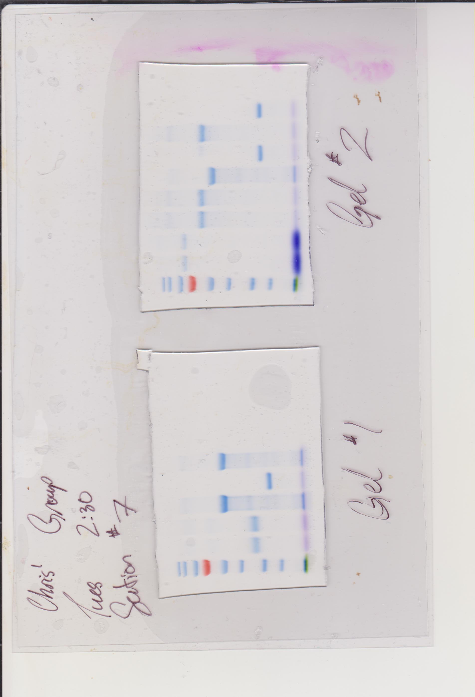
MW
markers
1
3

5
6

2

4

7
8

9

Figure 3. Gel electrophoresis results. The gel was prepared as indicated in the Lab Manual. 10 μL of unknown sample 19 was pipetted into well 9 (indicated by the black arrow) of gel 2 and the electrophoresis apparatus was turned on and allowed to run for about 40 minutes. The current and the power supply were turned off once the tracking dye reached the bottom of the gel. Well 1 contains 5 μL of the molecular weight marker EZ - RunTM Rec.

Table 4. Quantitative molecular weight ladder and estimation of migration distance. The estimated migration distance was measured from the top of the gel to the middle of each gel marker using a 15cm ruler. The molecular weight of each marker was determined based on the SDS-PAGE (outlined in the Lab Manual). These values were used to produce the plot in Figure 4.
Band Number | Migration Distance (cm) | Molecular Weight (kDa) | Log of Molecular Weight
1 | 1.3 | 170 | 2.23
2 | 1.7 | 130 | 2.11
3 | 2.3 | 95 | 1.98
4 | 3.5 | 72 | 1.86
5 | 4.0 | 55 | 1.74
6 | 5.0 | 43 | 1.63
7 | 6.3 | 34 | 1.53
8 | 7.3 | 26 | 1.41
9 | 8.7 | 10 | 1.00

Figure 4. Log of the molecular weight plotted against the migration distance of each molecular marker. The molecular weight of each marker was obtained from the SDS-PAGE as outlined in the Lab Manual. The distances were found by measuring the distance between the top of the gel and the middle of the marker. The equation of the linear regression, given on the graph, is y=-0.1454x + 2.369. This equation will be used to calculate the molecular weight of the unknown sample.

Calculation
Molecular Weight of Unknown Sample #19:
$y= -0.1454x+2.369$ $= -0.1454\left(6.7 cm\right)+2.369$ $=1.39482$
Where x = migration distance of the unknown sample, indicated by the arrow in Figure 3.
$MW= {10}^{y}$ $= {10}^{1.39482}=24.8 kDa$
Where MW = molecular weight of the unknown sample
Therefore, the molecular weight of unknown sample #19 is 24.8 kDa.

