Discrete Time Dynamical Systems (DTDS)

Updating Functions
- Gives you one future step from starting point
  - Can only go one step at a time
- m_{t} is measurement @ beginning (or starting point)
- m_{t+1} is measurement in one time step
- $m_{t+1}=f\left(m_{t}\right)$ where “f” is the function written in terms of m_{t+1}

Solutions
  - General solution and solution
- For processes repeated many times
  - Allows you to “jump” steps
- m₀ is measurement at the beginning
- m_{t} is measurement ‘t’ units of time after the beginning
  - ie. m_{1 ,} m_{2,} m_{3,} etc.
- to calculate m_{t} we need to apply “f” ‘t’ times
- if updating function is $m_{t}=rm_{t}$ (where r is the rate) then solution is $m_{t}=m_{0}*r^{t}$
- updating function $m_{t+1}=m_{t}+a$ (where a is fixed #) has the solution is $m_{t}=m_{0}+at$
**so if you add, you multiply; if you multiply, you power
- written in terms of m_{t}
**general solution is equation
**solution is values when given original amount

Composition
- allows you to skip 1 time step
- $\left(f∘f\right)\left(m_{t}\right)=m_{t+2}$ or $f\left(f\left(m_{t}\right)\right)=m_{t+2}$

Inverse
- Gives you previous step
- $x_{t}=f^{-1}\left(x_{t+1}\right)$

Equilibria
  - Determining equilibria
- Solve for x* by making f(x) or y = x* and x= x* and solve for x*
  - $f\left(x^{*}\right)=x^{*}$
  - For the updating function
- Equilibria is the value it is approaching
  - Just a solution, don’t give physical meaning to it
  - Methods to determine if equilibria is stable or unstable
** always use the line y=x as a comparison
Quick Trick
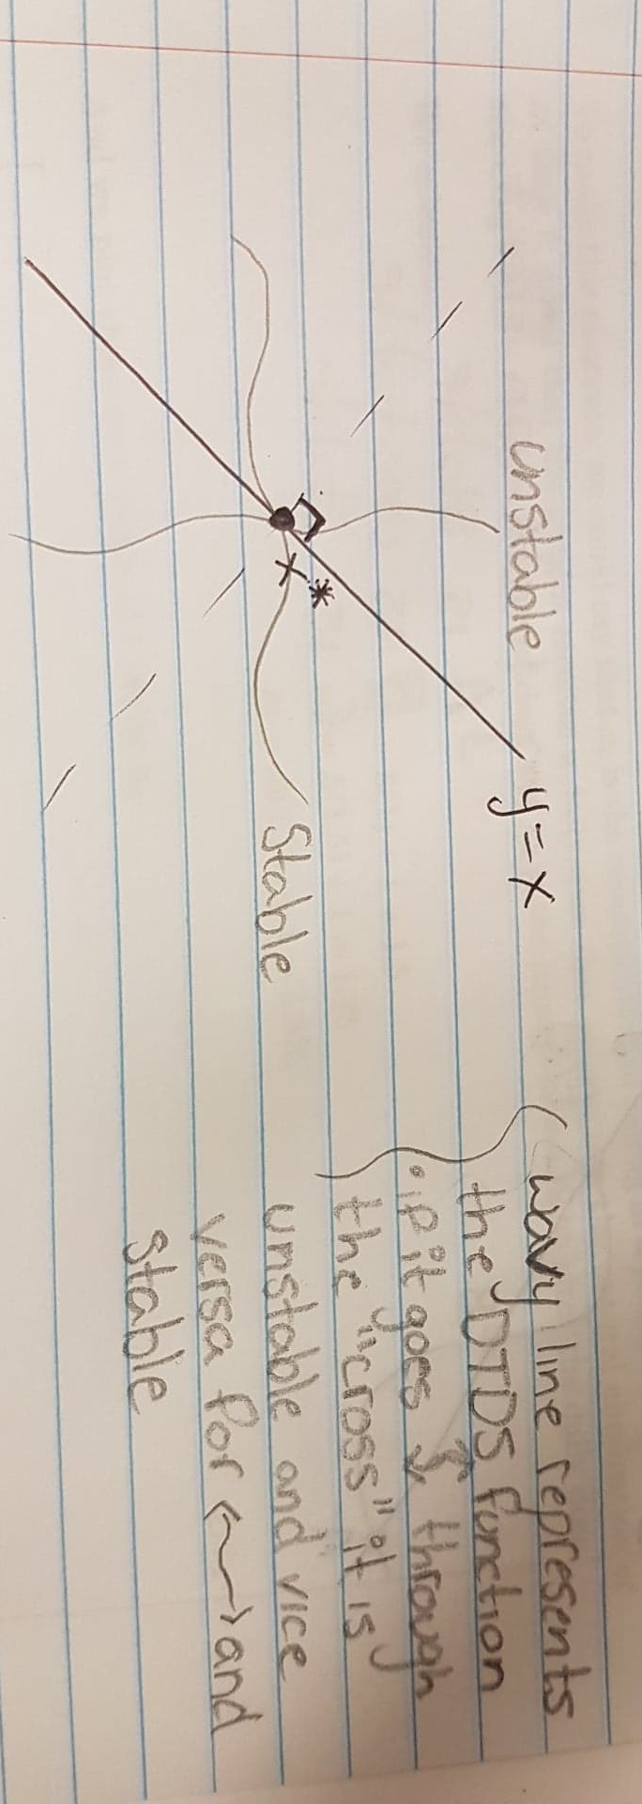
Cobwebbing
**equilibrium points are points where the general solution intersects with the line y=x
- Plot y=x and the general solution
  - to plot gen. sol. (0, x₀), (1, x₁), (2, x₂) etc.
- pick any point on the x axis and draw line to the function, then to the diagonal, and back and forth
- if the line goes toward the equilibria point (POI) it is stable, if it moves away from it is unstable
Algebraically
- calculate values for x₀ , x₁, x₂ for the updating function and compare them to eachother
- Stable
  - If the initial value starts and remains near point
  - Ie if x₀ is near x*
- Unstable
  - If the initial value starts near point and eventually goes away

