Sensation and Perception
- Sensation = the detection of environmental stimuli - sounds, objects and smells
  - Will be the same for everyone
- Perception = the experience of detecting those environmental stimuli - how our brains organize and interpret sounds, objects and smells
  - Interpretation can be different from one person to the next
- Bottom up processing = sensory receptors relay information to the brain and the brain interprets this information
- Top-down processing = previous experience and expectations affect the detection and analysis of information from the senses
  - Ex. flower made of guns:
    - Florist - sees the flower first
    - Cop - sees the guns first
    - Same sensation, different interpretation
- Psychophysics = methods that measure the strength of a stimulus and the observer’s sensitivity to the stimulus
  - Absolute threshold = minimum stimulus necessary to detect a stimulus half of the time
    - How efficient our senses are
    - Significance: minimum threshold can be used to determine how loud the traffic light beep needs to be for blind people when crossing the street
  - Difference threshold = minimal change in a stimulus that can just barely be detected
    - Weber’s law: for a difference to be perceptible, two stimuli must differ by a constant proportion rather than an amount
      - For weight: 2%
      - For sound: 0.3%
      - For light: 2%
- Significance: For new cell phones, have a just noticeable difference of 2% to make the new phone noticeably lighter
  - Sensory adaptation = diminishing sensitivity to an unchanging stimulus
    - Benefit: freedom to focus on informative changes without uninformative background stimulation
    - We perceive the world not as it actually is, but as it is useful for use to perceive it

The Senses

1. VISION
- Transforms light energy into neural signals
- Represents objects in the environment in terms of shape, size, colour and location

Light Energy
- We only see VISIBLE light
- Hue = the colour experienced
- Wavelength = distance from one peak to the other
- Intensity = determined by the wave’s amplitude

Visual Pathway
- Both eyes are needed for depth
- Objects in the right visual field stimulate the left half of retinas
- Objects in the left visual field stimulate the right half of retinas
- Axons of ganglion cells form the optic nerve
- Retina routes visual info over the optic chiasm to visual area in the thalamus
- Thalamus sends information to the hypothalamus where it is stored as memories
  - Information also stimulates the amygdala

Parallel Processing
- The brain processes colour, movement, form, and depth simultaneously in different areas
- The brain integrates the separate, parallel dimensions of visual info interpreted in different areas

2. HEARING
- Audition = the sens or act of hearing

The Ear
- Outer ear = sound waves are collected
- Pinna = visible outer ear on either side of the head; helps pinpoint and locate sound
- Auditory canal = where sound travels to reach the eardrum

- Middle Ear = sound waves are amplified
  - Eardrum = tightly stretched membrane that vibrates when hit by sound waves
  - Ossicles = three tiny bones that pick up eardrum vibrations, amplify them and pass them along to the cochlea in the inner ear
- Inner ear = sound waves are transduced into coded neural messages
  - Cochlea = a coiled, bony, fluid filled tube through which sound waves are transduced into nerve impulses
  - Semicircular canals = fluid filled channels that help maintain balance by orienting the brain
  - Auditory nerve to brain = converged nerve cells fibres; sends neural messages to the brain’s thalamus and auditory cortex in the temporal lobe
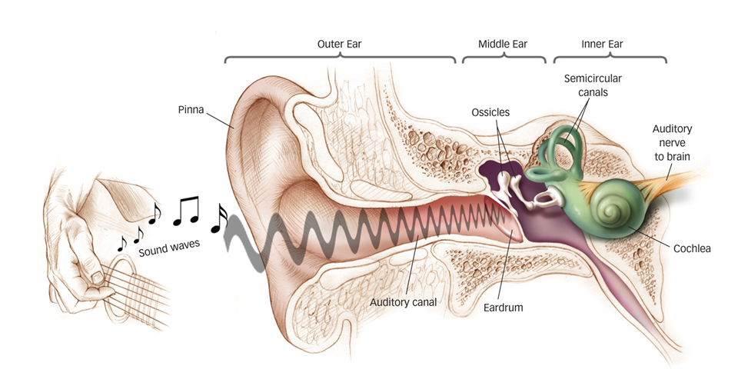

Properties of Sound Waves
- Frequency = pitch
  - Diagram:

- Amplitude = loudness
  - Diagram:

- Complexity = timbre (sound quality or resonance)
  - Diagram:

- Consequences of working in a loud environment:
  - Psychological: stress, irritability, decreased ability to concentrate
  - Physiological: tinnitus (permanent ringing), hearing loss, balance issues
- As you get older, you become more sensitive to noise

3. THE BODY SENSES
- Touch = pressure, warmth, cold, and pain
- Proprioception = information about body position
- Kinesthesis = position and movement of the parts of your body
- Vestibular sense = balance, sensing the orientation of your head/body in space

Touch Sensors
- Tickle = touching two receptors that are close to each other at the same time
- Itch
- Wet = something really cold might feel wet
- Searing hot

Pain
- Unpleasant sensory or emotional experience, warns us about actual or potential tissue damage
- C fibers = transmit longer lasting, duller pain
- A-delta fibers = fast acting, transmit sharp pain
- Nociceptors = pain receptors
- Gate control theory = the spinal cord contains a neurological gate that
  - Blocks pain signals via larger fibers
  - Allows pain signals to pass to the brain through small nerve fibers
  - We can only manage one type of sensation at a time:
    - If we create a new signal like rubbing ot shaking it, pain will go away temporarily - NOT long term

Biopsychological Approach to Pain
- Biological influences
  - Activity in spinal cord’s large and small fibers
  - Genetic differences in endorphin production
  - Brain’s interpretation of CNS activity
- Psychological Influences
  - Attention to pain - distraction = less pain
  - Learning based on experience - a child will learn that pain elicits empathy from parents
  - Expectations - placebo effect
- Social-cultural Influences
  - Presence of others
  - Empathy for others’ pain
  - Cultural expectations

4. TASTE
Do taste sensations have survival functions?
- Sweet = energy source
- Umami (savoury) = proteins to grow and repair tissue
- Salty = sodium is essential for physiological processes
- Sour = potentially toxic acid
- Bitter = potential poison

The Taste System
- Human mouth contains 5000-10 000 taste buds
- Each bud includes 50-100 tastes receptor cells
- All five tastes can be sensed by receptors all over the tongue

5. SMELL
- Airborne odor molecules are inhaled through the nose
- Olfactory receptor cells in the nasal cavity are stimulated
- Receptor cell stimulation converted to neural signals to olfactory bulb

Olfactory Neural Pathways
- Olfactory neurons are the ONLY neurons that directly link the brain to the outside world
- Connect to temporal lobe of neural pathway involved in conscious recognition of smells
- Structures in the limbic system regulate emotional reactions to smells

Perception

Gestalt
- People organize sensations into a meaningful whole
- Form Perception = Part of seeing gestalt is to view faces and objects as distinct from their surroundings
- Reversible figure-and-ground illustrations shows that the same stimulus can trigger more than one perception
- Grouping = the tendency to organize stimuli into coherent groups
  - Proximity - splitting class down the middle
  - Similarity - split class into boys and girls
  - Continuity - we see two continuous lines rather than multiple line fragments:

  - Closure - even though lines do not touch, we still see a square

  - Connectedness - we see three pairs of circles rather than six circles

- What you perceive depends on the effect of prior knowledge and expectations

Context Effects
- Perception is…
  - Innate and learned
  - Fed by sensation, cognition and emotion
  - Influenced by culture
- Biological influences:
  - Sensory analysis
  - Unlearned sensory abilities
  - Critical period for sensory development
- Psychological influences
  - Gestalt principles
  - Learned schemas
  - Context effects
  - Perceptual set
- Social-cultural influences
  - Cultural assumptions and expectations

Operant Conditioning and Observational Learning
Classical conditioning
- Learning = a relatively permanent change in behaviour due to experience
- Associative learning = linking two events that occur close together in time
- Conditioning = the process of learning associations between events and behavioural responses
- Classical conditioning = a type of learning where we learn to associate two stimuli and anticipate events

Operant conditioning
- Associate a response and its consequences
- Learn to repeat behaviours followed by desirable results
- Learn to avoid behaviours followed by undesirable results

Pavlov
- Accidentally discovered classical conditioning through his work on salivation with dogs
- Investigated this phenomenon further through experimentation

Classical Conditioning Terms
- US = unconditioned stimulus
- UR = unconditioned response
- NS = neutral stimulus
- CS = conditioned stimulus
- CR = conditioned response
- How does it work?
  - Food (US) → drooling (UR)
  - Bell (NS) at beginning of experiment (no response initially) → dogs get fed
  - Bell (NS) + Food (US) → drooling (UR)
  - Bell (CS) → drooling (CR) (as the experiment goes on, the dogs associate the bell with getting food)
- Acquisition = The initial learning of the stimulus-response (S-R) relationship
  - As the NS and US are paired more often, the CR becomes stronger
- Extinction = The diminished CR when an US no longer follows the CS
  - Tuna (US) → happiness (UR)
  - Can opener (NS) + tuna (US) → happiness (UR)
  - Can opener (CS) → happiness (CR)
    - Cat comes running whenever it hears the can opener
    - If tuna was not given at all over a certain period of time, it will no longer come running when can opener is picked up
- Spontaneous recovery = the reappearance of a weakened CR after a pause, suggests that extinction suppresses the CR rather than extinguishes it
- Higher order conditioning = when the CS in one experience is paired with a different NS to create a second CS
  - Tuna (US) → happiness (UR)
  - “surprise” (NS) + tuna (US) → happiness (UR)
  - “surprise” (CS) → happiness (CR)
- Generalization = once a response has been conditioned, the tendency to respond in a similar way to stimuli similar to the CS
- Discrimination = the learned ability to distinguish between a CS and other similar stimuli that do not signal a US
  - Ex. calling random names vs. calling your name - you only respond to your name

Little Albert Experiments
- Watson believed that human emotions and behaviours are merely a bundle of conditioned responses
- Watson and a colleague conditioned a baby to associate white rats (CS) with a loud noise (US) and fear them (CR)
  - Loud noise (US) → fear and crying (UR)
  - White rat (NS) + loud noise (US) → fear and crying (UR)
  - White rat (CS) → fear and crying (CR)
  - When shown a white rabbit → generalization → fear and crying

Application of Classical Conditioning
- Extinction processes or new conditioning can help change unwanted responses to stimuli
- Exposure therapy or systematic desensitization therapy combat psychological disorders using classical conditioning principles
  - Exposure therapy = you get thrown into a cage with a spider and after two days nothing bad happens, no more fear, all good
  - Slow exposure = taking one step closer to the spider everyday, using deep breathing techniques when anxiety rises

Systematic Desensitization
- Establish anxiety stimulus hierarchy
- Learn the mechanism response
- Relaxation training
- Connect stimulus to the incompatible response or coping method by counter conditioning

Classical Conditioning | Operant conditioning
Organisms form associations between stimuli - CS and US  - Learning associations between its behaviour and the resulting event | Organisms associate their own behaviour with consequences  - learning associations between events that it does not control
Involves automatic reactions to the stimuli (respondent behaviour) | Stimulus follows the response and strengthens it
Stimulus precedes the response and elicits it | Actions followed by reinforcers increase  Actions followed by punishers decrease

 | Classical Conditioning | Operant Conditioning
Response | Reflexive, involuntary behaviours | Non Reflexive, voluntary behaviours
Basis of learning | Associating two stimuli (CS+US) | Associating a response and the consequence
Extinction process | CR decreases when CS is repeatedly presented alone | Responding decreases when reinforcement stops
Cognitive processes | Organisms develop expectations that CS signals the arrival of US | Organisms develop expectations that a response will be reinforced or punished.  - Actions followed by reinforcers increase  - Actions followed by punishers decrease  Organisms exhibit latent learning without reinforcement
Biological predisposition | Natural predispositions constrain what stimuli and responses can easily be associated | Organisms best learn behaviours similar to their natural behaviours. Unnatural behaviours instinctively drift back to natural ones

Thorndike and the Law of Effect
- Placed cats in a puzzle box with a food reward outside the box
- Recorded the amount of time it took them to figure out how to escape
  - First time: takes a long time
  - Second time: the cat will not understand what it is doing but will repeat behaviors to get the reward
- Law of effect = rewarded behaviour is likely to recur

Reinforcers
- An event that increases the likelihood of a behaviour being repeated
- Negative reinforcement = removing an unpleasant stimulus after a response
- Positive reinforcement = presenting a rewarding stimulus after a response
- Primary reinforcers = naturally reinforcing
  - Medication to stop pain
  - Water when thirsty
  - Food when hungry
  - More effective BUT the person must be in pain, hungry or thirsty for these to work
- Secondary (conditioned) reinforcers = effective through learned association with primary reinforcers (ex. Money = buying food)
- Continuous reinforcement = the desired response is reinforced each time it occurs
- Partial reinforcement = responses are sometimes reinforced and sometimes not reinforced

Punishment
- Decreases the frequency of a behaviour
- Positive punishment = administering an aversive stimulus
- Negative punishment = withdrawing a desirable stimulus

Reinforcement Schedules
- Fixed ratio schedule
  - Reinforce behaviour after a set number of responses
  - Produces high rates of response
  - Ex. mcdonalds coffee cards
- Variable ratio schedule
  - Reinforce behaviour after an unpredictable number of responses
  - Produces high rates of response
  - E. roll up the rim
- Fixed interval schedule
  - Reinforce first response after a fixed time period
  - Produces a choppy stop-start pattern of response
  - Ex. pay day
- Variable interval schedules
  - Reinforce the first response after varying time intervals
  - Produces slow, steady response

Shaping Behaviour
- Successive approximations
- Reward behaviour that approaches the desired behaviour
- Allows animal trainers to get animals to perform complex behaviours

Observational Learning
- Learning by observing others
- Learning by imitating models
- Learning without direct experience
- Modelling = observing and imitating specific behaviors
- Latent learning = learning that becomes apparent only when there is an incentive to demonstrate it
  - Cognitive map = a mental representation of the physical features in the environment
  - Going from A → B, you can learn the route but not demonstrate this knowledge until you need to drive

Memory

What is Memory?
- Learning that has persisted over time
- Information that has been stored over time
- Information that can be retrieved over time

Memory Processes
- Encoding = Gettinging informations into memory
- Storage = retaining information in memory
- Retrieval = recalling ot using previously encoded and stored information

Three Stage Model of Memory
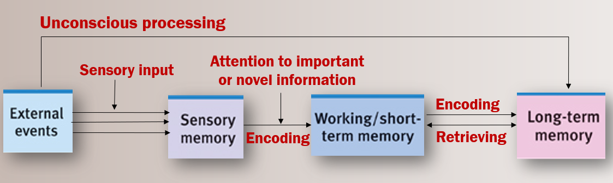
- Sensory input for the environment is recorded as fleeting sensory memory
- Information is processed in short term memory
- Information is encoded into long term memory for later retrieval
- Connectionism = views memories as products of interconnected neural networks = Every time you learn something new, your brain’s neural connections change, forming and strengthening pathways

Sensory Memory
- The immediate, initial recording of sensory information in the memory system
- Visual: iconic memory - duration is less than a second
- Auditory: echoic memory - duration is a few seconds

Working Memory (Short term)
- Active processing of information
- Associates new and old information
- Solves problems

Short Term Memory | Long Term Memory
Limited in capacity - seven bits of information can be stored. Recall is better fo random digits than for random letters | Unlimited capacity, but not as accurate as sensory memory or short term memory
Recall is better for what we hear than what we see | Organizes and stores information
Most people can retain 4 information chunks in their short term memory | Information not stored in precise locations
 | Duration of memory storage thought by some to be permanent

Encoding
- Visual encoding
- Encoding failure
  - leads to forgetting
  - some information can not be encoded without effort
- Strategy for successful encoding = deep processing
  - Semantic judgement = thinking about a word’s meaning = deeper processing and best for memory
  - Rhyme judgement = attending to the word’s sound = shallow processing
  - Visual judgement = attending to how a ward looks = shallowest processing

Processing
- How information gets encoded into the memory
- Automatic processing = the unconscious encoding of information about space, time, frequency, and well-learned information - usually associated with implicit memories
  - Ex. what you ate for dinner yesterday
  - Ex. riding a bike
  - Space = you often encode the place on a page where certain material appears; later you may visualize its location on the page to remember
  - Time = unintentionally note the sequence of the day’s events
  - Frequency = You effortlessly keep track of how many times things happen in a day
- Effortful processing = encoding that requires attention and conscious effort usually associated with explicit memories
  - Ex. learning the concepts in this chapter
- Hermann Ebbinghaus = try repetition for better memory
  - Retention curve
  - Tried to learn (memorize) a list of nonsense syllables
  - The more ties he rehearsed the list on day one, teh less time it took to memorize the list on day two
  - We learn more when our learning involves more time and repetition
  - This result applies to learning novel and meaningless information
  - It was estimated that learning meaningful information would take 1/10 of the effort

Storage
- Spacing effect
  - Information is retained better when rehearsal is distributed over tie
  - Distributed study produces better long term recall
  - Massed practice (studying all in one day)produces speedy short term learning but poorer long term recall
- Serial position effect = the tendency to remember the first and last items in a list
  - You rehearse the first items more therefore recalling them easier
  - The least items in the list are the most recent and may still be in the working memory = easy recall

Types
- Implicit (nondeclarative) memory
  - Retention is independent of conscious recollection
  - Processed by cerebellum and other brain areas
  - Motor and cognitive skills
  - Amnesia patient HM retained implicit memory. He could learn new skills such as copying a picture using a mirror
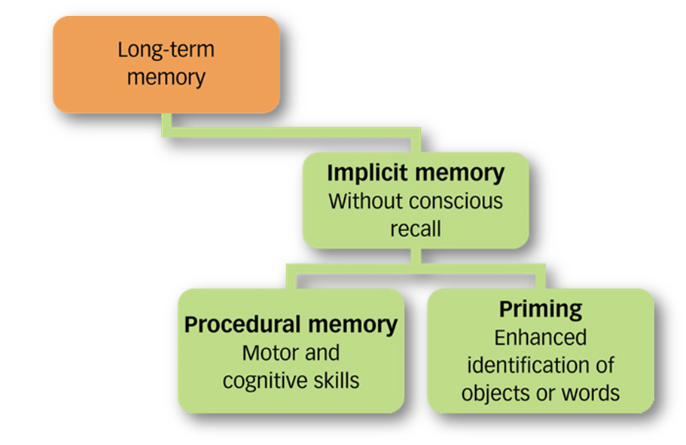
- Explicit (declarative) Memory
  - Processed in hippocampus
  - Memory of facts and general knowledge
  - Memory of personally experienced events
  - Memory that can consciously be recalled
  - Amnesia patient HM was unable to form new explicit memories. He could not recall new events or facts in his life such as spending time on lessons with researchers
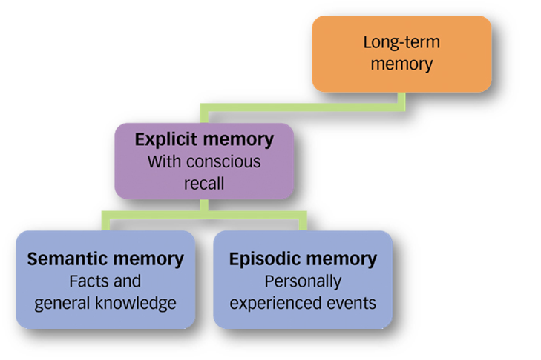

- Hierarchies
  - A few broad concepts divided into smaller concepts and facts
  - Subdivided into even narrower concepts and facts
  - Can be used to learn concepts = organizational encoding
- Flashbulb memories
  - Clear, detailed memories of emotionally significant events
  - Dramatic experiences remain bright and clear in our memory in part because we rehearse them. We think about them and describe them to others. Memories of our best experiences, which we enjoy recalling and recounting, also endure
  - Ex. september 11th 2001
- Emotional memory
  - Can be persistent
  - Heightens the body’s stress response
  - Spurs production of stress hormones
  - Can be a key symptom of PTSD
  - Experimental treatments include drugs to block memory

Strategies
- Chunking
- Mnemonic = memory aid that uses visual imagery
- Priming = activation of an existing memory by a stimulus
  - the activation, often unconsciously, of particular associations in memory
  - Ex. seeing or hearing the word rabbit → activities concept → primes spelling the spoken word hair/hare as HARE
- Emotions and memory
  - excitement , stress, or strong emotion can strengthen memories
  - This is adaptive
  - Emotion-triggered stress hormones increase glucose production, which signals to the brain that something important has happened. The amygdala boosts activity and proteins in the brain’s memory areas.
- How to improve memory?
  - Use distributed (spaced) practice.
  - Make the material meaningful.
  - Activate retrieval cues.
  - Use mnemonic devices.
  - Minimize interference.
  - Sleep more.
  - Test yourself!

Physiology
- Patient HM suffered from epileptic seizures and had parts of his temporal lobes removed to prevent seizures
- HM had explicit memories from before the surgery but could not remember what happened after the surgery
- Lost explicit memory for events after the surgery
- Retained implicit memory: performed normally on procedural memory and priming tasks
- Suggested that explicit memories are processed by hippocampus
- Implicit memories are processed elsewhere in the brain
- The hippocampus
  - Processes explicit memories for facts and episodes (ex. Names, images, events)
    - With left-hippocampus damage, people have trouble remembering verbal information, but they have no trouble recalling visual designs and locations. With right-hippocampus damage, the problem is reversed
  - Feeds memories to other brain areas for storage = memory consolidation
  - Part of the limbic system
  - Active during slow-wave sleep
  - Hippocampus and cortex display simultaneous activity during sleep
    - suspected that the brain is replaying the day’s experiences as it transfers them to the cortex for long-term storage
- The cerebellum
  - Crucial to the formation of implicit memories
  - Plays a key role in forming and storing memories created by classical conditioning
  - Damage to cerebellum disrupts forming conditioned reflexes
- Long term potentiation
  - Neural basis for learning and remembering associations
  - Synapses become more efficient at transmitting messages = more efficient neural circuits
    - sending neuron needs less prompting to release its neurotransmitter, and more connections exist between neurons
  - LTP blocking drugs interfere with memory
    - Mice that lack a enzyme needed for LTP can not navigate a maze
    - Injecting rates with a chemical that blocks LTP erases recent learning
    - Rats that ingest an LTP enhancing drug learn a maze with half the number of usual mistakes

Retrieval
- Getting information out of memory
- Recall = bringing previously learned information into conscious awareness
  - Ex. fill in the blank questions
- Recognition = correctly identifying previously learned information when exposed to it again
  - Ex. multiple choice questions
- Context effects = ability to recall is improved when in the same context as the initial experience
  - State dependent memory = recall is improved when encoding and retrieval of a memory happens in the same emotional or biological state
    - Ex. It is difficult to remember happy times when depressed - also explains why after a happy experience, people view the world through rose coloured glasses

Forgetting
- Encoding failure
- Storage decay
  - Memories decay gradually if they are not used
  - Information is at first rapidly forgotten
  - After a certain period of time, the forgetting levels off
- Retrieval failure
  - Tip of the tongue phenomenon
  - Interference
    - Proactive
      - Forward acting
      - The disruptive effect of prior learning on the recall of new information
      - A friend’s email address that was learned long ago may interfere with learning the new email address
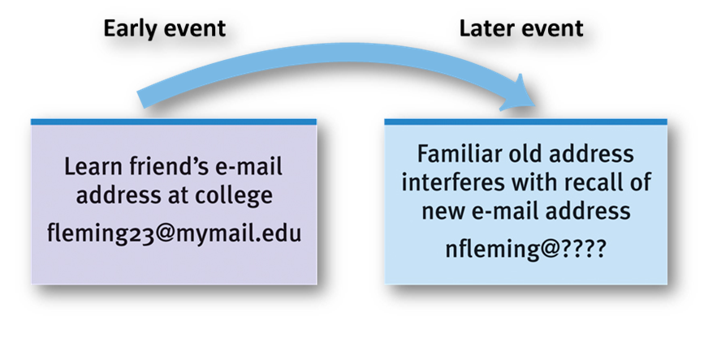
    - Retroactive
      - Backward acting
      - The disruptive effect of new learning on the recall of old information
      - Leaning a password for a new bank card can disrupt the recall of the password for your existing card
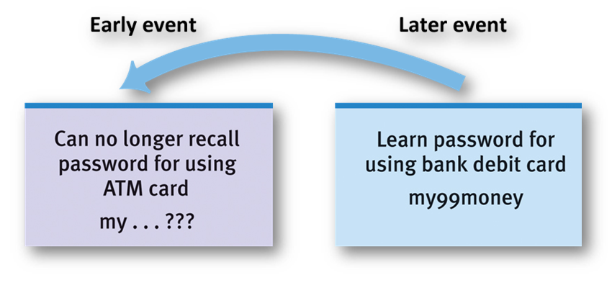
- Amnesia
  - Retrograde = inability to access memory before a certain date
  - Anterograde = inability to form or consolidate new memories after a certain date
    - HM

Not on Midterm:
- Motivated forgetting
  - Repression - Freudian defense mechanism that banishes an anxiety-producing memory from consciousness
  - Preserves self-concept
  - Memory may be retrieved through a cue or therapy.
  - Increasing number of memory researchers think repression rarely occurs.

