BU354 – Human Resources Management

CHAPTER 1: Strategic Human Resource Management [same section]

Human resource management helps organizations and their employees attain their goals.

Organizational Goals: an organization’s short- and long-term goals that human resource management aims to support and enable; economic, social, and environmental

HRM: the leadership and management of people within an organization using systems, methods, processes, and procedures that enable employees to optimize their performance and in turn their contribution to the organization and its goals.

Difference between HRM and an HR Department…
- HRM thus focuses on what leaders and managers should do as it relates to organizing human resource systems, policies, and procedures
- HR department is a specialized group with the primary focus of ensuring the most effective use of human resource systems across an organization to enhance employee performance and accomplish organizational goals
- Like other activities, human resource management activities must contribute to the organization’s goals and performance
- Strategic human resource management seeks to recognize that the choice of human resource tools will depend on what the organization is trying to achieve
- Strategies are often formulated at three levels:
  - corporate, involving the entire organization;
  - business, involving a major activity, business, or division in a large multi-business organization;
  - functional, involving managers of different activities, services (e.g., finance, marketing), or geographical areas

Strategic HRM: the process of integrating the strategic needs of an organization into our choice of human resource management systems and practices to support the organization’s overall mission, strategies, and performance; value-driven and proactive
- At the core, it is important that human resource strategies and tactics be mutually consistent and that they reflect the larger organizational mission and strategy

Proactive HRM: a human resources management approach wherein decision makers anticipate problems or challenges both inside and outside the organization and take action before they impact the organization; e.g. attracting talent from non-traditional labour pools

Reactive HRM: a human resource management approach wherein decision makers respond to problems or challenges as they arise rather than anticipate them.

Strategic HRM Process
Step 1: Organizational Mission, Goals & Strategy Analysis
- Mission Statement: statement outlining the purpose, long-term objectives, and activities the organization will pursue and the course for the future; “who we are, what we do, where we are headed”
- Cost Leadership Strategy: strategy to gain competitive advantage through lower costs of operations and lower prices for products
- Differentiation Strategy: strategy to gain competitive advantage by creating a distinct product or offering a unique service.
- Focus Strategy: strategy to gain a competitive advantage by focusing on the needs of a specific segment of the total market.
- Challenge facing HR leaders is that often the human resource strategy needs to be put in place before the corporate strategy can be successful the human resource strategy needs to be implemented so that the right people are in the right place at the right time to even initiate the corporate strategy

Step 2: Environmental Scan
- Economic Forces: economic factors facing Canadian business today, including global trade forces and the force to increase one’s own competitiveness and productivity levels.
  - Economic cycles boom and bust business cycles e.g. HR person faces challenges during recessionary period with layoffs
  - Global Trade ever-growing shift toward the global marketplace forces organizations to consider how they manage their employees.
  - Productivity (& Innovation Improvement): the ratio of a firm’s outputs (goods and services) divided by its inputs (people, capital, materials, energy); lower costs and improve profits
- Technological Forces
  - Flexible Work Design Technology brings considerable flexibility into when and where work is carried out
  - Connectivity connectivity and technology have disrupted the way organizations operate, often reducing costs or capitalizing on new opportunities; effective knowledge management process of capturing organizational knowledge & making it available for sharing/building new knowledge)
  - Mechanization: the shift toward converting work that was traditionally done by hand to being completed by mechanical or electronic devices; allows for flexibility in operations
- Demographic Forces
  - Gender Balance in the Workforce demographic changes: changes in the demographics of the labour force (e.g., education levels, age levels, participation rates) that occur slowly and are usually known in advance
  - Shift toward Knowledge Workers: members of occupations generating, processing, analyzing, or synthesizing ideas and information (such as scientists and management consultants); fastest-growing workers in Canadian labour force
  - Educational Attainment of Workers: the highest educational level attained by an individual worker, employee group, or population; increased dramatically, upward trend
    - “Employability skills” basic academic skills (e.g., communication, thinking, learning), personal management skills (e.g., positive attitudes and behaviours, ability to accept responsibility, adaptability to new challenges), and teamwork skills (e.g., ability to work with others, ability to lead a team)
  - Aging Population old age crisis – bottlenecks in industries for fear of post-retirement poverty; abolition of mandatory retirement
  - Generational Shift
    - Generation Xers are not averse to hard work, they place a premium on work–life balance and like to be active participants in decision making.⁶⁴ They are likely to show disdain for a “command and control” culture and are likely to have more loyalty to their profession and competency building than to their employers.
    - Gen Yers seek continuous learning, ongoing feedback, teamwork, up-to-date technology, security, respect, and work–life balance. Their biggest fear is boredom
- Cultural Forces: challenges facing a firm’s decision makers because of cultural differences among employees or changes in core cultural or social values occurring at the larger societal level.
  - Diversity cultural mosaic: Canadian ideal of encouraging each ethnic, racial, and social group to maintain its own cultural heritage, forming a national mosaic of different cultures.
  - Ethics greater demand today for more ethical conduct of business; many Canadian firms instituting a code of ethics or code of conduct for their employees

Step 3: Analysis of Organizational Character and Culture
- Organizational Character: the product of all the organization’s features—people, objectives, technology, size, age, unions, policies, successes, and failures; reflects past and shapes future
- Organizational Culture: core beliefs and assumptions that are widely shared by all organizational members; HR management has a role in shaping this – culture must be consistent w/ mission & strategy

Step 4: Choice & Implementation of HR Strategies
- Giving consideration to both the internal and external environments provides the opportunity for the human resource professional to begin evaluating potential human resource practices and activities and whether each is viable
- Strategic choice and implementation involves identifying, securing, organizing, and directing the use of resources both within and outside the organization
- HR strategy must reflect every change in the organizational strategy and support it
- In formulating strategies, the human resource department must continuously focus on the following five major groups of activities:
  - 1. PLANNING HUMAN RESOURCES Human resource planning enables the determination of demand and supply of various types of human resources within the firm; A second element of the planning process is the eventual choice of appropriate human resource practices
  - 2. ATTRACTING HUMAN RESOURCES Following the planning of human resources, managers must begin to take action in filling apparent gaps in either people or practices
  - 3. PLACING, DEVELOPING, AND EVALUATING HUMAN RESOURCES With the right talent in the right place, attention must turn to optimizing both the employee’s time as well as the activities and processes that guide human resources in a company
  - 4. MOTIVATING EMPLOYEES When employees perform acceptably, they must receive compensation
  - 5. MAINTAINING HIGH PERFORMANCE The human resource strategy should ensure that the productive contribution from every member is at the maximum possible level.

Step 5: Review, Evaluation, and Audit of HR Strategies
- An org’s contextual (e.g. technology/environments) and internal (e.g. membership/role definitions) necessitate regular strategy evaluations to ensure their continued appropriateness
- Evaluation gives feedback which is useful
- HR Audit: an (holistic) examination of the human resource policies, practices, and systems of a firm (or division) to eliminate deficiencies and improve ways to achieve goals

Preparing for the Future
- A proactive approach requires human resource managers and their staff to develop a future orientation; they must constantly scan their professional and social environment for clues about the future
- Evaluations and audits are backwards-looking

The Organization of HR Management
- A separate HR department usually emerges only when HR activities would otherwise become a burden to other departments in the org – when the expected benefits of an HR department exceed its costs
- Staff Authority: authority to advise, but not to direct, others; e.g. HR departments continue to be service and support departments
- Line Authority: authority to make decisions about production, performance, and people; possessed by managers of operating departments who are also responsible for promotions, job assignments and people-related decisions – ultimately responsible for performance
- Functional Authority: authority that allows staff experts to make decisions and take actions normally reserved for line managers; in highly technical or extremely routine situations; the HR department may be given functional authority e.g. with handling complex fringe benefits

Today’s HR Management Professional
- Despite its enormous growth, human resource management has been slow to evolve into a full-fledged profession
- To meet these ever-increasing challenges, human resource managers were expected to possess a number of competencies, including the following:
  - MASTERY OF HUMAN RESOURCE MANAGEMENT TOOLS as professionals, they should be familiar with state-of-the-art tools in areas such as staffing, training, compensation planning, performance appraisal and planning, employee relations and communication, and organizational change interventions
  - CHANGE MASTERY not only should HR professionals possess an abundance of problem-solving, critical thinking, negotiation, and interpersonal skills, they should also be well versed in using these to bring about changes in the organization and its various subsystems
  - PERSONAL CREDIBILITY The HR professional should project an image of a trustworthy, ethical, socially responsive, courageous leader who can build relationships and inspire others to work for larger causes
- Certified HR Professional (CHRP): human resource practitioner, formally accredited to practice, who reflects a threshold professional level of practice; based on a series of national standards

CHAPTER 2: Job Analysis & Design [Planning Human Resources]

Job Analysis: systematic study of a job to discover its specifications, skill requirements, and so on, for wage-setting, recruitment, training, or job-design purposes
- Jobs are at the core of every organization’s productivity
- If they are not well designed and done right, productivity suffers, profits fall, and the organization is less able to meet the demands of society, customers, employees, and other stakeholders

Job: group of related activities and duties.

Position: collection of tasks and responsibilities performed by an individual.

Steps in the Job Analysis Process – three phases preparation, collection of job information, use of info for improving organizational effectiveness
Step 1: Familiarization with the Organization and its Jobs
- Important to have an awareness of an organization’s objectives, strategies, structure, inputs (people, materials, and procedures), and desired outcomes
- Job analysis procedures are influenced by the organization character

Step 2: Determine Uses of Job Analysis Information
- Although the most common uses are in the recruitment process, designing performance appraisal, compensation systems, and training, job analysis may also be done to ensure fair treatment across all employee groups or to assist in job redesign

Step 3: Identify Jobs to be Analyzed
- Almost all jobs might benefit from an in-depth analysis, but resource and time constraints often preclude organizations from conducting job analyses
- Likely targets of job analysis are jobs that are critical to the success of an organization; jobs that are difficult to learn or perform (to determine the extent of training); jobs in which the firm continuously hires new employees (identification of clear job requirements assumes great importance); or jobs that exclude members of the protected classes described
Step 4: Determine Sources of Job Data

Step 5: Data Collection Instrument Design
- Job Analysis Questionnaires: Checklists used to collect information about jobs in a uniform manner
- Most standardized forms attempt to measure the following items:
  - IDENTIFICATION includes job title, division, and title of supervisor(s), and sometimes a job identification number such as a NOC code
  - DUTIES AND RESPONSIBILITIES a job analysis explains the purpose of the job, what the job accomplishes, and how the job is performed; versus summary, which provides quick overview
  - HUMAN CHARACTERISTICS AND WORKING CONDITIONS besides information about the job, analysts need to uncover the particular skills, abilities, training, education, experience, and other characteristics that jobholders need
  - PERFORMANCE STANDARDS the job analysis questionnaire also seeks information about standards, which are used to evaluate performance
- CRITICAL INCIDENT METHOD (CIM): involves identifying and describing specific events (incidents) when an employee performed really well and when they performed very poorly (such as inducing an accident); from these incidents, the job analyst identifies critical components of the job relating to the situation leading up to the event, the employee’s actions, the results of the employee’s actions, and the effectiveness of the employee’s behaviour
  - Goal of the CIM is to create a behaviourally focused description of work and related performance standards, in particular, those that differentiate excellent from average or poor performance

Step 6: Choice of Method for Data Collection
- Interviews: approach to collecting job- and performance-related information by a face-to-face meeting with jobholder, typically using a standardized checklist of questions; typically both jobholders and supervisors are interviews; some guidelines…
  - Interviews should be conducted with the jobholders, as well as with all others who may be expected to be knowledgeable about the job’s duties and responsibilities.
  - The interviewer should establish rapport with the interviewee before getting into the main theme; the interviewee should be briefed about the objectives of the interview and offered all relevant information to reduce defensiveness
  - A structured checklist of questions should be used, collecting information on a variety of matters I major purpose and outcomes of the jobs and the recipient of its outcomes; major duties and percentage of time spent on each and a couple more related items e.g. perf, standards and education and physical demands and major responsibilities
  - In those instances in which the respondent does not perform routine duties, the jobholder should be asked to list all duties, their relative importance to the overall success of the job, and the frequency of their occurrence
  - The information collected should be reviewed and verified by both the interviewee and the immediate supervisor
- Focus Groups: face-to-face meeting with five to seven knowledgeable experts on a job and a facilitator to collect job and performance-related information.
- Questionnaire: standardized surveys to collect information about jobs, working conditions, and other performance-related information; fast and less costly often – allows many jobs to be studied at once at little cost
- Employee Log: approach to collecting job- and performance-related information by asking the jobholder to summarize tasks, activities, and challenges in a diary format; time-consuming & costly; nuisance; decline in accuracy as entries become infrequent
- Observation: an approach to collecting job- and performance-related information by direct observation of jobholder by a specialist; low accuracy if you miss irregularly occurring activities and employees may know when they are being watched – perform different; good to confirm or remove doubts and also when there is language barrier
- Combination: concurrent use of two or more job techniques – key considerations include method-purpose fit, practical feasibility, cost, and reliability & validity

Phase 3: Use of Job Analysis Info put into such usable forms as job descriptions, job standards, job specifications and recently competency models

Job Description: a recognized list of functions, tasks, accountabilities, working conditions, and competencies for a particular occupation or job

Key Content of a Job Description:
- Job Identity: key part of a job description, including job title, location, and status
  - Job Code: a code that uses numbers, letters, or both to provide a quick summary of the job and its content
  - National Occupational Classification (NOC): an occupational classification created by federal government, using skill level and skill types of jobs; two major attributes…
  - SKILL LEVEL four skill level categories are identified in the NOC, describing the educational and training requirements of occupations
  - SKILL TYPE defined as the type of work performed. Ten broad occupational categories (0 to 9) are identified in the NOC
- Job Summary and Duties summarizes job in a few sentences (what it is, how it is done, why); description lists responsibilities/duties in simple, action-oriented style
- Working Conditions: facts about the situation in which the worker acts. Includes physical environment, hours, hazards, travel requirements, and so on, associated with a job

Approvals job descriptions’’ accuracy should be reviewed by selected jobholders and their supervisors, and supervisors are asked to approve the description; this approval serves as a further test of the job description and a further check on the collection of job analysis information

Job Specifications: a written statement that explains what a job demands of jobholders and the human skills and factors required; indicates human knowledge, skills, abilities and other characteristics (KSAOs) necessary to do a job; requirements include experience, education and physical and mental demands
- A job specification should include specific tools, actions, experiences, education, and training (i.e., the individual requirements of the job)

Job Performance Standards: the work performance expected from an employee on a particular job; standards serve two functions
- They become objectives or targets for employee efforts, which may serve to motivate employees; once standards are met, workers may feel accomplishment and achievement contributes to employee satisfaction
- Standards are criteria against which job success is measured; indispensable to managers or human resource specialists who attempt to promote good work performance without standards, there is no yardstick for good versus average or poor job performance

- Job analysis info for creating these standards is usually sufficient for jobs that have the following features:
  - Performance is quantified.
  - Performance is easily measurable.
  - Performance standards are understood by workers and supervisors.
  - Performance requires little interpretation
- Jobs with short work cycles exhibit these features e.g. assembly-line job

Competency Models (of framework): a list of competencies required in a particular job.
- Competency: knowledge, skill, ability, or behaviour required to be successful on the job; broader in scope than the KSAOs examples are communication, innovation, team orientation, and leadership
- Three differences between competency-based job analyses and other forms of job analyses…
  - Whereas duties or tasks might apply only to a single job within an organization, competencies may be job spanning, meaning that they contribute to success on multiple jobs (or even all jobs) within the organization
  - Job-spanning competencies may vary in importance across job roles
    - Competency Matrix: lists different levels of skill for a combination of competencies, and indicates to what level multiple jobs across the firm should have mastery of each competency
  - Competencies contribute not only to job performance, but also to the success of the organization competencies explicitly support the vision, strategic direction, and values of the firm
- Some organizations have used competencies as the foundation for job design, new performance ma[nagement systems, selection and career pathing, compensation, training and development, and, in a few cases, a highly integrated human resource management system called competency-based management
- Competencies are identified after a careful analysis of the work of high performers and thorough examination of the organization’s strategic direction
- Caution: When competencies become increasingly job-spanning and are no longer supported by specific duties and tasks, the legal defensibility of decisions based on these competencies is unknown

Job Design: identification of job duties, characteristics, competencies, and sequences taking into consideration technology, workforce, organization character, and environment; jobs are the central link between employees and the organization – productivity and quality of work life are tied to job design

Organizational Considerations
- Efficiency: achieving maximal output with minimal input; task specialization was suggested as a key strategy to improve efficiency – specialized jobs lead to shorter job cycles
- Work Flow: the sequence of and balance between jobs in an organization needed to produce the firm’s goods or services; influenced by nature of product/service

Ergonomic Considerations | Ergonomics: the study of relationships between physical attributes of workers and their work environment to reduce physical and mental strain and increase productivity and quality of work life
- Attention to details of work settings can lead to significant improvements in efficiency, productivity and safety; ergonomics will become more important as the Canadian workforce ages

Employee Considerations job designers draw heavily on behavioural research to provide a work environment that helps satisfy individual needs; jobs should be designed to maximize productivity and work-life balance
- Autonomy: in a job context, independence—having control over one’s work and one’s response to the work environment; the freedom to control one’s response to the environment; increases sense of recognition, self-esteem, job satisfaction and performance
- Variety: wherein the worker has the opportunity to use different skills and abilities, or perform different activities; lack thereof may cause boredom, which causes fatigue errors
- Task Identify: the feeling of responsibility or pride that results from doing an entire piece of work, not just a small part of it; lack thereof results in little sense of accomplishment, lowers job satisfaction
- Feedback: information that helps evaluate the success or failure of an action or system; lack thereof results in little motivation/guidance to perform better
- Task Significance: knowing that the work one does is important to others in the organization or to outsiders; pride, commitment, motivation, satisfaction and better performance are likely

Job Specialization Considerations as workers become more educated and affluent, routine jobs that are very specialized, such as assembly-line positions, hold less and less appeal for many people; no accomplishment, recognition, psychological growth or other sources of satisfaction; can use combination of the following to increase quality of work life…
- Job Rotation: moving employees from one job to another to allow them more variety and to learn new skills; provides personal growth and makes worker more valuable to organization
  - Caution: does not improve the jobs as the relationships between tasks/activities/objectives is unchanged
- Job Enlargement: adding more tasks to a job to increase the job cycle and draw on a wider range of employee skills; reduces monotony by expanding job cycle and drawing on a wider range of skills – “horizontal loading”
- Job Enrichment: adding more responsibilities and autonomy to a job, giving the worker greater powers to plan, do, and evaluate job performance; increases responsibility, autonomy and control – “vertical loading”
  - Attempts to add more planning and control responsibilities, vs. enlargement which adds just doing
  - Not a cure-all
- Employee Involvement & Work Teams to increase employee involvement at the workplace, work teams are increasingly used; work itself is increasingly being organized around teams and processes rather than activities or functions
- Job Families: groups of different jobs that are closely related by similar duties, responsibilities, skills, or job elements; e.g. word processor, clerk-typist and secretary constitute a job family; allow HR managers to plan job rotation programs and make employee transfer decisions

Environmental Considerations: the influence of the external environment on job design. Includes employee ability, availability, and social expectations
- Workforce Availability Efficiency considerations must be balanced against the abilities and availability of the people who will actually do the work
- Social Expectations: the larger society’s expectations about job challenge, working conditions, and quality of work life; job must meet the expectations of workers, or else = dissatisfaction etc.
- Work Practices: the set ways of performing work in an organization; HR department’s flexibility = limited

Job Analysis in Tomorrow’s “Jobless” World
- Global competition, fast technological obsolescence, changing worker profiles, and rapid increases in knowledge requirements for various jobs have made accurate and timely job descriptions difficult
- some writers have gone so far as to say that jobs as we see them today may not exist in the future
- Today’s global village has resulted in “boundary-less” and “de-jobbed” organizations, in which traditional boundaries between a firm, its suppliers, customers, and even competitors have disappeared and “jobs” as we knew them in the past have begun to disappear
- Many employees are no longer responsible for producing specific outcomes; rather, they are members of teams entrusted with many responsibilities
- In tomorrow’s world, a firm may be valued by its ideas rather than its assets or products
- How to adapt? one strategy has been to adopt a future-oriented style when describing job activities and specifications

CHAPTER 3: Human Resource Planning [Planning Human Resources]

Relationship of HR Planning to Strategic Planning
HRP: a process used to determine future human resource requirements by anticipating future business demands, analyzing the impacts of these demands on the organization, determining the current availability of human resources, and making decisions on how to effectively acquire and utilize firms’ human resources
- Major Objective: ensure the organization has the right people with the right skills at the right time in order for the organization to fulfill its organizational objectives
- Different strategies require different HR plans – e.g. expansion strategy acquired by aggressive hiring, training and promotion of employees
- Linking strategy to planning a firm’s long-range strategic plan is accomplished by the thoughtful execution of a series of short-range, tactical (or operational) plans that focus on current needs and operations
- HR Planning can vary from capturing basic info to a more sophisticated approach – see diagram
- Key diff. between level 4 and 5 is that 5 organizations utilize robust evaluation tools and highly sophisticated technology to create long-range plans to improve ROIs

The Human Resource Planning Process: Steps
- Forecast Demand for Resources “How many HRs will we need, when, and where?”
- Assess Internal & External Supply of Resources “what resources do we have both inside the org and in the external environment and what skills and competencies do these resources possess?”
- Develop HR Objectives what planners expect to accomplish as a result of their actions
- Design & Implement HRM Programs programs attempt to balance supply and demand; planners decide what type of HR programs will be developed to achieve their objectives
- Establish Program Evaluation “is there a tangible link between investments in HR programs and organizational sustainability, and to what degree?”

Forecasting Labour Demand organizations and their environments are continually changing; organizations quite likely will find themselves either in a position of having too many employees or not enough – a good HR plan reduces the risk of being out of balance

Forecasting – Identify the Causes that Will Drive Demand | Forecasts: estimates of future resource needs and changes
- Demographic Impacts helps human resource leaders regarding impending changes in their workforce
- Turnover the departure of employees from an org; effective human resource planning needs to be prepared to understand and predict employee departures as best as possible
- Legal Changes changes occurring in social, political, and legal spheres are easier to predict, but their implications are seldom clear
- Technological Changes normally difficult to predict, can affect both demand for, and supply of, human resources; typically reduces employment in one dept. and increases in another – makes planning difficult
- Competitors can affect org’s demand for HR, though not in any uniform manner
- Strategic Plan q1 organization’s strategic plan commits the firm to long-range objectives, such as growth rates, new products, markets, or services; these objectives determine the number/types of employees needed in future
- Budgets & Revenue Forecasts Budget increases or cuts are the most significant short-run influence on human resource needs; related to budgets are revenue forecasts
- New Ventures mean new HR demands
- Organizational & Job Design changes in org. structure have major implications for HR needs – new roles may be created or eliminated

Forecasting Techniques for Estimating HR Demand
- Expert Forecasts rely on those who are knowledgeable to estimate future HR needs; manager may simply be convinced that the workload justifies another employee – informal and instant forecast – not part of a systematic planning effort
  - Better method is for planers to survey managers (experts) about dept.’s future employment needs
  - Nominal Group Technique (NGT): focused group discussion where members meet face-to-face, write down their ideas, and share them; all new thoughts on a topic are recorded and ranked for importance
  - Delphi Technique: soliciting of predictions about specified future events from a panel of experts, using repeated surveys until convergence in opinions occurs; main diff. is group interaction vs. not
- Trend Projection Forecasts quickest forecasting technique is to project past trends; short-run approximations – inaccurate in long-range HR projections
  - Extrapolation: extending past rates of change into the future
  - Indexation: a method of estimating future employment needs by matching employment growth with a selected index, such as the ratio of production employees to sales; growth/decline rate in the labour force may be different during growth and downsizing periods – growth happens faster tho
  - Statistical Analysis `
- Other Forecasting Methods
  - Budget & Planning Analysis org’s generally have detailed budgets and long-range plans
  - New Venture Analysis planners estimate HR needs by comparison with firms that already have similar operations
  - Computer-Based Simulation & Predictive Models series of mathematical formulas that simultaneously use extrapolation, indexation, survey results and estimates of workforce changes to compute future HR needs

Converting a Forecast into HR Requirements
- Staffing Table: a list of anticipated employment openings for each type of job; neither complete nor wholly accurate – they are approximations that allow HR specialists to match short-run demand and supply

The Supply of Human Resources two sources of supply – internal and external; internal = present employees who can be promoted, transferred or demoted to meet anticipated needs

Internal Supply Estimates planners audit the present workforce to learn about the capabilities of present workers; this information allows planners to estimate tentatively which openings can be filled by present employees
- Human Resource Audits summarize the employee’s knowledge skills, and abilities and generate skills and management and leadership inventories that, in turn, facilitate the preparation of a replacement chart and replacement summaries
  - Skills Inventories: summaries of each worker’s skills and abilities; an inventory catalogue of the capabilities found in the org’s workforce; must be updated periodically (~2 years); can be applied to managerial and non-managerial roles
  - Management/Leadership Inventory: comprehensive reports of available management capabilities in the organization; updated periodically; include # employees supervised, type supervised, total budget managed, mgmt. training received, duties of subord’s, previous mgmt.
  - Replacement Charts: visual representations of who will replace whom when a job opening occurs; as mandatory retirement gets abolished increasingly unnecessary to include age in replacement charts – still desirable to gather retirement intentions in long-term planning; minimum information usually included, serve as a quick reference; replacement status consists of present performance and promotability
  - Replacement Summaries: lists of likely replacements for each job and their relative strengths and weaknesses; complements the chart; provides more data and allows for more informed decisions
- Transition Matrices & Markov Analysis
  - Markov Analysis: forecast of a firm’s future human resource supplies, using transitional probability matrices reflecting historical or expected movements of employees across jobs; useful in org’s where employees typically move from one job/rank to another; works best at 50 employees in each position, more appropriate in medium/large-size orgs
  - Transition Matrices: describe the probabilities of how quickly a job position turns over and what an incumbent employee may do over a forecast period of time, such as stay in the current position, move to another position within the firm, or accept another job in another organization
    - Markov Analysis reflects the patterns in these HR movements using transition matrices

External Supply Estimates When there are no replacements or when the opening is for an entry-level job, there is a need for external supplies of human resources
- Labour Market Analysis: the study of a firm’s labour market to evaluate the present or future availability of different types of workers; labour market analysis defines the people potentially available or work, but skills market narrows available people to those that have the appropriate skill set
  - During recessions, job prospects of minorities and new immigrants are more adversely affected
- Community Attitudes also affect the nature of the labour market; anti-business or non-growth attitudes may cause present employers to move elsewhere
- Demographic Trends another long-term development that affects the availability of external supply; fortunately, these trends are known years in advance of their impact
  - Canadian Occupational Projection System (COPS): provides up to 10-year projection of Canadian economy and human resource needs

HR Objectives identification of supply and demand forecasts and summaries only provides the human resource professional with context and information; next step in the process identifies what the organization expects to accomplish as a result of its actions

HRM Strategies to Achieve Objectives in Supply & Demand typically HR planners face two decision situations: 1) available supply of HRs is less or greater than their future needs

Strategies to Manage an Oversupply of HR
Headcount Reduction
- Layoffs temporary withdrawal of employment to workers, are used in cases of a short-run surplus; layoffs are the separation of employees from the organization for economic or business reasons; may last only a few weeks if its purpose is to adjust inventory levels/allow the factory to retool for a new product; when caused by a business cycle, layoffs last months/years; if it is the result of restructuring – “temporary” layoffs may be permanent
  - Normal pattern for layoffs follows seniority
- Leave without Pay to temporarily reduce the number of employees on the payroll, give them an opportunity to take a leave of absence without pay either to attend college or university or to pursue other personal interests; employees offered this leave typically are financially able to leave for a little while
- Incentives for Voluntary Separation offer employees some form of an “enticement” to leave the organization early; referred to as a “buyout”
- Termination broad term that encompasses the permanent separation from the organization for any reason; usually implies that employee was fired as a form of discipline
  - Outplacement: assisting employees to find jobs with other employers; blow of discharge may be softened through formal outplacement procedures e.g. office space, secretary, photocopying, long-distance calls, counselling, how to look for work, invitations to competitors

Attrition Strategies Attrition: loss of employees due to their voluntary departures from the firm through resignation, retirement, or death; key component is resignation, which is voluntary separation
- Attrition is a slow way to reduce employment base in an org, but presents the fewest problems
- Hiring Freeze stops HR department from filling openings with external applicants; present employees are reassigned
- Early & Phased Retirement Offers used to reduce staffing levels and to create internal job openings; designed to encourage long-service workers to retire before the normal retirement age in the org e.g.65 yrs.
  - Phased Retirement: gradual phase into retirement without loss or reduction of pension benefits; most typical pattern is shortened workweeks

Alternative Work Arrangements
- Job Sharing/Splitting: a plan whereby available work is spread among all workers in a group to reduce the extent of layoffs when production requirements cause substantial decline in available work; recuing the number of total work hours
- Using Part-Time Employees: persons working fewer than the required hours for categorization as full-time workers and who are ineligible for many supplementary benefits offered by employers; popular b/c:
  - Growing number of women in the labour force w/ preference for part-time
  - Higher demand in service industries, which employ more than 40% of all part-timers
  - Need for cost-cutting
  - However, part-time employees have public costs e.g. eventual welfare

Strategies to Manage a Shortage of Employees – Labour Shortage: insufficient supply of qualified talent to fill the demand for labour
- Hire Employees
  - Full-Time Employees: work 37.5 – 40 hours in a week
  - Part-Time Employees reduces overall payroll costs b/c lack of expensive benefits
- Contract Workers: freelancer (self-employed, temporary, or leased employee) who is not part of the regular workforce who provides goods or services to another entity under the terms of a specific contract
  - Consultants: professionals who provide expert advice and counsel in a particular area
  - Five Key Tests to Determine Contractor/Employee Status control (under greater direction/control = employee), ownership of tools, profit, risk of loss (employee has none), payment (e.g. regular intervals or not)
  - Outsourcing: contracting tasks to outside agencies or persons; third parties are used to perform “non-core” services rather than using internal resources; firms may even outsource HR-related functions
  - Crowdsourcing (“novel way to source talent”): the act of a company or institution taking a function once performed by employees and outsourcing it to an undefined (and generally large) network of people in the form of an open call; e.g. communicating to the public via Internet – RFPs involved
- Develop Employees Internally leverage current supply of existing employees within an org; This option considers the strength of an organization’s internal workforce with respect to the skills and knowledge employees possess and the future skills and knowledge employees will need for the org to meet human capital requirements
- Creating Flexible Work Arrangements: a firm’s use of work hours, schedules, and location to ensure that the goals of the organization and the needs of employees are optimally met
  - Overtime ask existing employees to work beyond the normal hours; results in higher fatigue, stress levels, accident and wastage rates
  - Flexible Retirement: programs that provide retirees with the opportunity to work after they have retired and provide them with significant flexibility in terms of how they work, what they work on, when they work, and where; “retiree-return programs”
  - Float and Transfer enables its full-time resources to be transferred when needed, or, if the need is for a very short time, they float the worker; training programs used to ensure employees are cross-trained

Program Measurement & Evaluation major goal of HR measurement is to enhance decisions about human capital and to connect human resources to strategy

People Equity: how organizations measure and manage their human capital to maximize its value; three main elements alignment, capabilities, engagement (ACE)
- To ensure continuous improvement, all process must be measured, a baseline developed and initiatives put in place

HR Information Systems (HRIS): gathers, analyzes, summarizes, and reports important data for formulating and implementing strategies by HR specialists and line managers; used to collect, record, store, analyze and retrieve data concerning an org’s human resources
- Enables HR department to be responsive to “customers’” needs and is critical for the effective functioning of the HR dept. and the larger rog; three major stakeholders professionals, managers, employees

HRIS Functions – Breadth & Size key considerations that org’s take into account when deciding on an appropriate HRIS to match their needs; as org’s grow, they require more complex/sophisticated HRIS
- The size of the organization
- What information needs to be captured
- The volume of information transmitted
- The firm’s objectives
- Managerial decision needs
- The importance of reporting capability
- Technical capabilities
- Available resources

- Enterprise-Wide Systems: link an organization’s entire software application environment into a single enterprise solution; may be called a “gold standard” system
  - Intranet: organization’s internal website
  - Employee Self-Service (ESS): feature of an HRIS that allows employees to access and view their own records and make changes where applicable
  - Manager Self-Service (MSS): feature of an HRIS that allows managers to view and access their employee’s records and add relevant information

Components of an HR System & Common Data Fields
- Most common components of HRIS include recruitment and applicant tracking, time and attendance, training and development, performance mgmt., career planning, compensation, benefits and pension administration, employment equity info, performance evaluation, health/safety, labour relations

Types of Outputs – Reporting Capabilities produce regular reports, such as employee records, salary and benefit details, retirement benefits; as a firm’s HRIS increases in sophistication, it goes beyond regular reports and is able to produce special reports, answe1Ar questions interactively, and play a role in supporting organizational decision makers

Access to HRIS Information – Privacy & Security Considerations who should have access should be weighed against the need for confidentiality and the need to respect employees’ privacy; most HRISs collect/retain only information needed for business or legal reasons and establish controls for internal; use and external release of info
- A key feature of any HRIS is how effective it is at providing the tools with which to manage security issues

HRIS – An Important Tool for Strategic HRM
- Increased Efficiency – Enhanced Service Delivery information more readily available, but it is more accurate, timely, and accessible; HR is better equipped to provide just-in-time service
- Increased Effectiveness – Helping Stakeholders Make Better Decisions
  - Predictive Analysis: process of selecting, exploring, analyzing and modelling data to create better business outcomes
- Increased Contribution to Organizational Sustainability – Talent Management
  - Talent Mgmt: a systemic attraction, identification, development, engagement/ retention, and deployment of those individuals with high potential who are of particular value to the organization
  - Info generated from HRIS helps managers leverage employees’ capabilities and skills and to design opportunities for development
- Increased Visibility – Enhanced HR Competencies offering HR professionals to interact at a more sophisticated level with its client groups regarding their business informational needs

Human Resource Accounting (HRA): process to measure the present cost and value of human resources as well as their future worth to the organization; considers HR as an asset and an investment and measures from a financial perspective the return of those investments; attempts to put a dollar figure on the human assets of an organization using cost (acquisition/replacement/opportunity) or value (economic value to org) models

CHAPTER 4: Legal Requirements & Managing Diversity [Attracting Human Resources]
- Company hires employees to meet its objectives
- First, it has to identify potential employees and find the ways and means to get the necessary information to them, taking into account the requirements of human rights legislation
- Then it has to select those candidates who best meet its needs

Government Impact through enforcement of laws, gov’t has direct and immediate impact on the HR function; federal and provincial laws that regulate the employee-employer relationship challenge the methods HR dept.’s use

Regulations: legally enforceable rules developed by governmental agencies to ensure compliance with laws that the agency administers
- Govt’s create special bodies to enforce compliance with the law e.g. commissions/tribunals/boards
- HR specialists become involved b/c legislation and regulations affect the employee relationship
  - HR experts must stay abreast of the laws and the interpretation of the laws by regulatory bodies and court rulings
  - They must develop/administer programs that ensure company compliance
  - They must pursue their traditional roles of obtaining, maintaining and retaining an optimal workforce

Canadian Charter of Rights & Freedoms: federal law enacted in 1982, guaranteeing individuals equal rights before the law; contained in the Constitution Act of 1982; provides some fundamental rights to every CDN…
- freedom of conscience and religion;
- freedom of thought, belief, opinion, and expression, including freedom of the press and other media of communication;
- freedom of peaceful assembly; and
- freedom of association.

Also provides protection to every CDN in specific areas:
- fundamental freedoms;
- democratic rights;
- the right to live and seek employment anywhere in Canada;
- legal rights: the right to life, liberty, and personal security;
- equality rights for all individuals;
- officially recognized languages of Canada;
- minority language education rights;
- Canada’s multicultural heritage; and
- Aboriginal peoples’ rights

- Section 15 is the equality rights part and has caused a flood of litigation that will take many more years to resolve
- Charter of Rights and Freedoms applies only to individuals dealing with federal and provincial governments and agencies under their jurisdiction, but its impact is far-reaching, since potentially every law can be challenged

Human Rights Legislation
Scope employment-related laws and regulations are limited in scope; impact on the HRM process is confined to a single human resource activity e.g. minimum-wage laws specify lowest amount an employer can pay per hour worked

Overview Human rights legislation is a family of federal and provincial acts that have as a common objective the provision of equal employment opportunity for members of protected groups
Provincial Human Rights Laws: All provinces have their own human rights laws with discrimination criteria, regulations, and procedures; tend to differ slightly in terminology

The Canadian Human Rights Act: a federal law prohibiting discrimination; passed by Parliament in 1977 and came into effect in 1978; applies to all federal gov’t departments and agencies, Crown corp’s, and business and industry under federal jurisdiction e.g. banks, airlines, railways, interprovincial communication (radioTV) corps in their dealings with the public and in their employment policies

Discrimination: showing of partiality or prejudice in treatment; specific action or policies directed against the welfare of minority groups; prohibited Grounds of Discrimination in Canada (Employment)…
- Race or colour
- Religion
- Physical or mental disability – most frequently bases for discrimination
- Dependence on Alcohol or Drugs
- Age
- Sex
- Marital Status
- Family Status
- Sexual Orientation
- National/Ethnic Origin, including linguistic background
- Ancestry or Place of Origin
- Language
- Social Condition or Origin
- Source of Income
- Assignment, Attachment or Seizure of Pay
- Based on Association
- Political Belief
- Record of Criminal Conviction
- Pardoned Conviction

Direct vs. Indirect (Systemic) Discrimination
- Direct discrimination on grounds specified in human rights legislation is illegal, but under certain circumstances intentional direct discrimination is acceptable e.g. women’s store only showing female models
  - Bona Fide Occupational Requirement (BFOR): a justified business reason for discriminating against a member of a protected class; also called a bona fide occupational qualification (BFOQ)
- Systemic Discrimination: any company policy, practice, or action that is not openly or intentionally discriminatory, but has an indirect discriminatory impact or effect; employment practices may appear to be neutral and may be implemented impartially, but they exclude specific groups of people for reasons that are not job-related or required for safe or efficient business operations; examples…
  - minimum height and weight requirements for employment with police forces, which make it more difficult for women and Canadians of Asian origin to be hired;
  - minimum scores on employment tests, which discriminate against distinct groups (e.g., the use of culturally biased intelligence tests, which tend to screen out a disproportionate number of minorities);
  - internal hiring policies, word-of-mouth hiring, or the requirement to submit a photograph with the application form;
  - limited accessibility of buildings and facilities, which often makes it impossible for persons with disabilities to be employed with organizations using such places;
  - psychological inability of people to deal with persons with disabilities;
  - unavailability of alternative formats or forms of tools
- Canadian Human Rights Commission (CHRC): supervises the implementation and adjudication of the Canadian Human Rights Act and has taken specific steps to define & detect the cause of systemic discrimination

Race & Colour sometimes difficult to see which of these two characteristics is the actual basis of discrimination; often both are involved; a Canadian HR Reporter survey found that almost 75 percent of the 235 participants agreed that First Nations people are underutilized in the workforce

National or Ethnic Origins illegal for human resource decisions to be influenced by the national or ethnic origins of applicants or of their forebears; e.g. does your name affect the likelihood of getting a callback after applying for a job? Anglophone names were much more likely to get a callback

Religion a person’s religious beliefs and practices should not affect employment decisions
- Duty to Accommodate: requirement that an employer must accommodate the employee to the point of “undue hardship”; court has deemed that relevant considerations include financial cost, health/safety, disruption of a collective agreement, interference with other workers’ rights, size of the operation, problems of morale of other employees and interchangeability of workforce/facilities

Age many employers consider that establishing a minimum or maximum age for certain jobs is justified, although evidence is rarely available that age is an accurate indication of one’s ability to perform a given type of work

Sex Canadian Human Rights Act also prevents discrimination on the basis of an individual’s sex (often erroneously referred to as gender; the Act specifically uses the term sex); Ontario Human Rights Commission recently updated its policy on discrimination on the basis of pregnancy to include protection for women trying to become pregnant; it is also unlawful to have separate policies for men and women; e.g. with a height requirement that leaves most women out, the employer must demonstrate that it is necessary given the nature of the job or they have to drop the requirement

The court established three new criteria to assess the appropriateness of a BFOR:
1. | Is the standard rationally connected to the performance of the job?
2. | Was the standard established in an honest belief that it was necessary to accomplish the purpose identified in stage one?
3. | Is the standard reasonably necessary to accomplish its purpose?

Sexual Orientation 1999 – the issue of discrimination against same-sex relationships was effectively addressed by the Supreme Court of Canada when it decided that same-sex couples must be treated the same way as heterosexual couples

Gender Identity as of 2015, seven provinces/territories explicitly protect “gender identity” or “gender identity and expression” in their human rights legislation

Marital Status idea of what constitutes a family has undergone considerable change in Canadian society in recent years; any discrimination based on marital status is illegal

Family Status nepotism is a form of discrimination based on family status

Disability no person should be denied employment solely for the reason of a disability
- Reasonable Accommodation: voluntary adjustments to work or workplace that allow employees with special needs to perform their job effectively
- Many organizations have established rigid physical standards for certain jobs without being able to show that these standards are truly relevant to the requirements of the job
- Some complainants have been refused jobs when their disability might be a problem in a speculative situation
- Employees with dependency on drugs/alcohol must be reasonably accommodated to the point of undue hardship on the employer

Pardoned Convicts prohibits discrimination against a convicted person if a pardon has been issued for the offence. Pardon may be granted by a parole board after five years following release, parole, or the completion of a sentence

Harassment – The CHRA contains the following prohibition against harassment:
It is a discriminatory practice,
a) in the provision of goods, services, facilities or accommodation customarily available to the general public,
b) in the provision of commercial premises or residential accommodation, or
c) in matters related to employment,
to harass an individual on a prohibited ground of discrimination
- Such behaviour may be verbal, physical, deliberate, unsolicited or unwelcome it may be one incident or a series of incidents
- Harassment: occurs when a member of an org. treats an employee in a disparate manner because of that person’s sex, race, religion, age, or other protective classification; may include…
  - Verbal abuse or threats; unwelcome remarks, jokes, innuendo, or taunting about a person’s body, attire, age, marital status, ethnic or national origin, religion, and so on; displaying of pornographic, racist, or other offensive or derogatory pictures; practical jokes that cause awkwardness or embarrassment; unwelcome invitations or requests, whether indirect or explicit, or intimidation; leering or other gestures; condescension or paternalism that undermines self-respect; unnecessary physical contact such as touching, patting, pinching, or punching; and physical assault
- It will be assumed that harassing behaviour has taken place if a “reasonable person ought ot have known that such behaviour was unwelcome”
- Cyberbullying is also a form of include harassment/bullying to include cyberbullying and make sure it is a real thing e.g. monitor emails and provide training
- Sexual Harassment: unsolicited or unwelcome sex- or gender-based conduct that has adverse employment consequences for the complainant; three characteristics…
1. | the encounters must be unsolicited by the complainant, unwelcome to the complainant, and expressly or implicitly known by the respondent to be unwelcome;
2. | the conduct must either continue despite the complainant’s protests or, if the conduct stops, the complainant’s protests must have led to negative employment consequences; and
3. | the complainant’s co-operation must be due to employment-related threats or promises
Employer Retaliation criminal act to retaliate in any way against those who exercise their rights according to the CHRA
Enforcement the responsibility for the administration of the Canadian Human Rights Act lies in the hands of the Canadian Human Rights Commission (CHRC); commission consists of up to 8 members including the Chief Commissioner, who is a full-time member appointed for a term of not more than seven years; role of CHRC is to investigate and try to resolve allegations of discrimination in employment and the provision of services within the federal jurisdiction; also administers the Employment Equity Act
Provincial Human Rights Laws & Human Rights Commissions most provinces/territories have their own human rights laws and commissions with similar discrimination criteria, regulations and procedures
- If a person feels discriminated against, he or she will contact a provincial human rights officer, who will investigate the complaint and attempt to reach a settlement that will satisfy all parties – majority of cases settled at this stage
- Should there be no agreement, the case will be presented to the provincial human rights commission who will study evidence and submit report to the minister in charge of administration of the releveant human rights legislation

Employment Equity The Abella Commission on Equality in Employment (chaired by Judge Rosalie Abella) was appointed in 1983 to inquire into the most effective, efficient, and equitable methods of promoting employment opportunities for four designated groups: women, persons with a disability, Aboriginal people, and members of a visible minority
- As a result of the Abella Comission Employment Equity Act, 1987: federal law to remove employment barriers and to promote equality of the four designated group members; requires employers with 100+ employees to develop annual plans setting out goals and timetables and to maintain these plans for three years; requires them to submit annual reports about progress on plans; requires equal treatment and correction of under-representation and “reasonable accommodation” – examples…
  - Providing sign-language interpreter for a job interview with a deaf applicant
  - Providing telephone/computer equipment to accommodate persons who are hard of hearing/blind
  - Constructing a barrier-free worksite for wheelchair-bound employees
  - Allowing religious minorities to alter their work schedules to accommodate religious obligations
  - Altering dress or grooming codes to allow Aboriginal people to wear braids

Functional Impact virtually every HR function is affected by employment equity plans:
- Human resource plans must reflect the organization’s employment equity goals.
- Job descriptions must not contain unneeded requirements that exclude members of protected classes.
- Recruiting must ensure that all types of applicants are sought without discriminating.
- Selection of applicants must use screening devices that are job-relevant and nondiscriminatory.
- Training and developmental opportunities must be made available for all workers, without discrimination.
- Performance appraisal must be free of biases that discriminate.
- Compensation programs must be based on skills, performance, and/or seniority and cannot discriminate against jobholders in other respects.
Employment Equity Programs: developed by employers to undo past employment discrimination or to ensure equal employment opportunity in the future; called affirmative action programs in the United States; exists for several reasons…
- Employers seldom benefit by excluding people who belong to a particular group; to exclude an entire class of workers, such as women or visible minorities, limits the labour pool available to the human resource department
- Open discrimination can also lead to negative public relations, boycotts by consumers, and government intervention
- To ensure that such discrimination does not occur, employers often develop equity programs voluntarily
- Mandated equity programs take place mainly at the federal level—that is, in organizations and industries under federal jurisdiction; at the provincial level, programs are implemented almost exclusively on a voluntary basis

In Step 4, survey the workforce:
- Underutilization: exists when a company or department has a smaller proportion of protected class members than is found in the labour market
- Concentration: the opposite, occurring when protected class members are concentrated in a few departments, out of proportion with their presence in the labour market

Contract Compliance Policy the federal government requires compliance with the Employment Equity Act from any company doing business with the federal government; companies with 100 or more employees bidding on contracts for goods and services of $1,000,000 or more are subject to the employment equity criteria listed in the Act

Pay Equity women aged 25–54 earn about 85 percent as much per hour compared to male employees; the gap is less for unionized workers (94%) and more for nonunion employees (79%)
- Many reasons for the pay gap – differences in work experience, education, major field of study, occupation and industry of employment, as well as reasons that are still not understood
- Pay equity legislation attempts to remedy these inequities
- “Equal pay for work of equal value” illegal to pay women less than men if their jobs are of equal value
- This principle can be costly for corp’s who were exhibiting pay inequity for some time; the longest and largest pay equity case ruled that the federal gov’t owed 230,000 workers (mostly female) 13 years of back pay – over $3.5 billion

Reverse Discrimination the use of employment equity programs can lead to charges of reverse discrimination against employers; charges usually arise when an employer seeks to hire or promote a member of a protected group over an equally (or better) qualified candidate who is not a member of a protected group

Natural Justice: the rules of natural justice are minimum standards of fair decision making imposed on persons or bodies acting in a judicial capacity; principle has been accepted internationally to ensure that a decision–making process is fair; rules include…
- the right to a fair hearing;
- the right to a bias-free proceeding (e.g., a person adjudicating a dispute should have no personal interest in the outcome of the proceedings);
- the right to present the opposing argument;
- the right of legal representation;
- the right of timely notice of a hearing; and
- the right to a timely process (according to the principle, “Justice delayed is justice denied”)
Other Legal Challenges
- The Canada Labour Code – regulates union certification,right to organize, union prosection, and mediation/arbitration procedures
- Dismissal an employee or employer can terminate an employment relationship by giving reasonable notice; an immediate dismissal is possible if an employee is compensated through appropriate severance pay
- Hours of Work & Overtime Regulations standard week = 40 hours; overtime = 1.5
- Minimum wages
- Occupational health and safety
- Weekly rest day – one full day of rest during the week, preferably on Sunday
- Workplace Hazardous Material Information System (WHMIS)
Strategic Implications of Legal Challenges if there is one basic rule in human resource management, it is “Obey the law”; HR manager must make sure all policies/rules take legal aspects into account; managers and supervisors have to be familiar with the laws as they apply to HRM – sexual harassment is an issue that has cost business/gov’t orgs large amounts of money; unjust dismissal is another prominent issue

Diversity Management
- A diverse workforce requires managers with new leadership styles who understand employees’ varying needs and creativity respond by offering flexible management policies and practices
  - A combination of factors have fundamentally changed the way Canadian organization work and who they employ
- Diversity Audit: Audits to uncover underlying dimensions, causes, interdependencies, and progress-to-date on diversity management matters
Organizational Barriers
- Old Boy’s Network: Informal relationships among male managers and executives
- Glass Ceiling: invisible but real obstructions to career advancement of women and visible minorities
- Diversity Training Programs: - Training programs aimed at importing new skills to motivate and manage a diverse workforce
Workplace Diversity
- Includes important human characteristics that influence an employee’s values, perceptions of self and others, behaviours, and interpretations of events
- Duty to Accommodate: Requirement that an employer must accommodate the employee to the point of “undue hardship”
- Reasonable Accommodation: Voluntary adjustments to work or workplace to allow employees with special needs to perform their jobs effectively
- Employment Equity Programs: Developed by employers to undo past employment discrimination or to ensure equal employment opportunity in the future. Called affirmative action programs in the USA

Core and Secondary Dimensions of Diversity
Core | Secondary
Age  Sex/Gender  Race  Religion  Ethnicity & Culture  Sexual Orientation  Mental & Physical Disabilities | Education  Past Work Experiences  Family Status  Income  First Language  Recreational Interests  Geographic Location  Family Background

Strategic Importance of Diversity Management
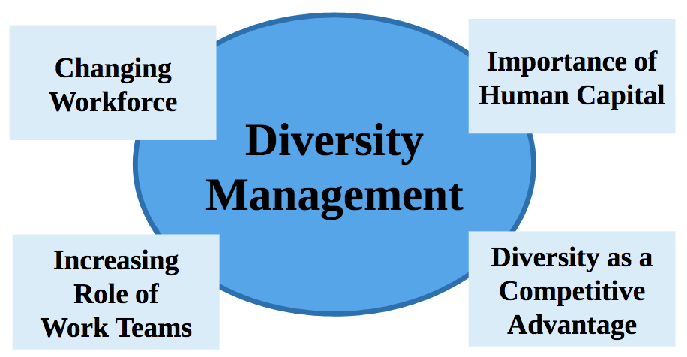
Steps in Managing Diversity
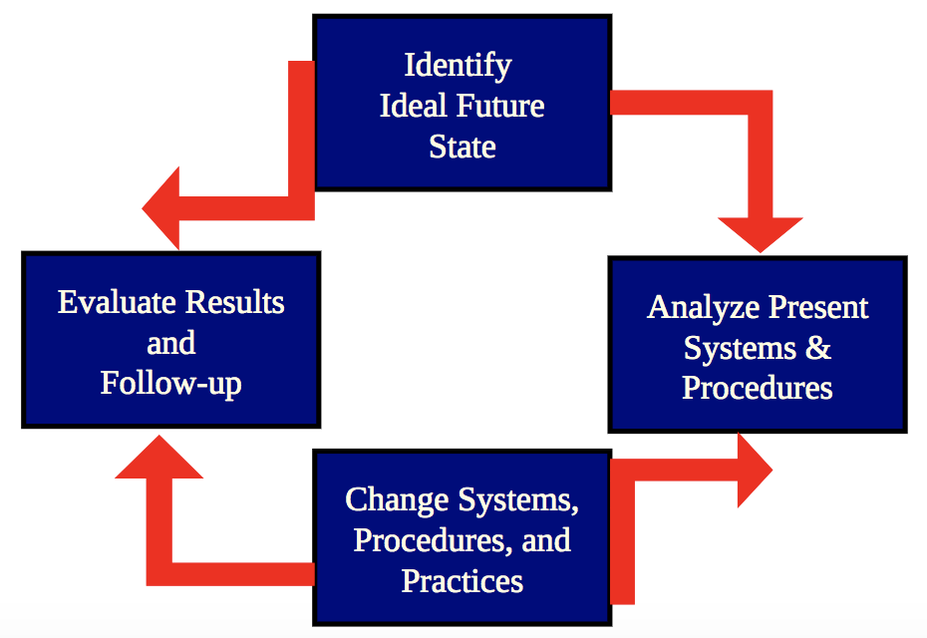
Current Industry Practices
Diversity Training Programs | Awareness training  Skill-building training  Content vs. process training
Mentoring Programs | Senior manager provides guidance  Formal or informal
Alternate Work Arrangement | Non-traditional work arrangements  Provide more flexibility to employees
Apprenticeships | A form of on-the-job training  Learn from an experienced person
Support Groups | Provide emotional support to new employee who shares a common attribute with the group
Communication Standards | Formal internal protocols  Eliminate biases in communication

Chapter 5
Recruitment Defined
- The process of finding and attracting capable individuals to apply for employment and to accept a job offer if/when one is made to them
- Includes both intentional and unintentional actions
- Recruiters are specialists within the HR department of large organizations
- Employment and Social Development Canada (ESDC): Federal department that provides programs and services for employers and present and potential employees

The Recruitment Process
- Identify job openings
- Identify job requirements
- Determine recruitment methods
- Obtain applications
- Constraints

Strategic Importance of Recruitment
- Recruitment decisions have profound implications for strategic success
- Competitive advantage from human resources
- Benefits of diversity management
- Focusing on employee development
- Investing resources into recruitment

Internal Recruiting
- Advantages
  - Employee is familiar with the organization
  - Employee is “known” thereby increasing ability to predict success
  - Improves employee morale & motivation
- Weaknesses
  - Internal competition can reduce cooperation
  - No “new blood” so can prevent creative solutions
  - Poor morale (possible turnover) of employees not promoted

External Recruiting
- Advantages
  - Able to acquire skills and knowledge that may not be available within
  - Newer ideas and novel ways of solving problems may emerge
- Weaknesses
  - Newcomers may not fit in
  - Newcomers many take longer to learn about the organization
  - Usually more expensive
  - Lower morale and motivation of current employees

Constraints on Recruitment: Organizational Policies
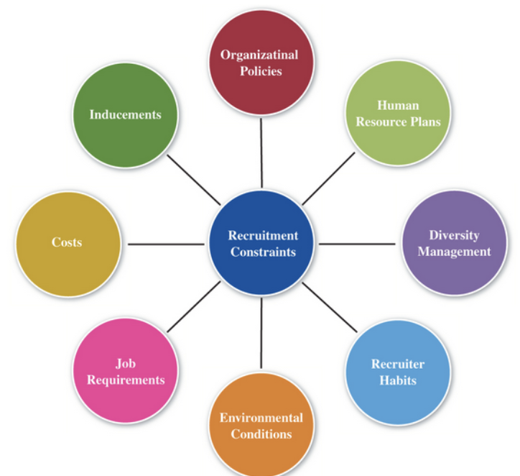
- Promote From Within Policies
  - Gives present employees the first opportunity
- Compensation Policies
  - Must adhere to stated pay ranges
- Employment Status Policies
  - E.g. limitations against hiring part-time
- International Hiring Policies
  - Foreign jobs may need to be staffed with locals
- Human Resource Plans
  - A firms overall plan to fill existing and future vacancies, including decisions on whether to fill internally or by recruiting from outside
  - Which jobs should be filled by recruiting vs. internally?
- Diversity Management Programs
  - Consider employment equity programs
- Recruiter Habits
  - A recruiter’s past success can lead to habits
- Environmental Conditions
  - Leading economic indicators
  - Predicted versus actual sales
  - Employment statistics
- Job Requirements
  - Job analysis information is useful
- Costs
  - Of identifying and attracting recruits
- Inducements
  - Monetary, non monetary, or even intangible incentives used by a firm to attract recruits
  - To simulate a potential recruits interest

Applying for a Job
- Submit a resume
  - Application tracking system (ATS)
- Job Application Form
  - Designates the information the recruiters would like to have for each applicant
  - May make education credentials and employment gaps more apparent
  - Name and Address, Work History, Employment Status, Signature Line, Education and skills, References

Recruitment Methods
- Walk-ins and Write-ins
- Employee Referrals: Recommendations by present employees to the recruiter about possible job application for a position
- Advertising: advertisements in a newspaper, magazine and so on that solicit job applicants for a position
  - Common, effective method of seeking recruits
  - Blind ads – does not identify the employer
  - Cost is determined by the size of the advertisement
  - Layout, design, and copy of advertisement should reflect the image and character of the company
- Internal Recruiting
- Social Media
- Employment and Social Development Canada (ESDC)
- Private Employment Agencies
- Professional Search Firms: Agencies that, for a fee, recruit specialized personnel for a company
- Educational Institutions
- Professional and Labour Organizations
- Canadian Forces
- Temporary-Help Agencies
- Departing Employee (buy-back)
  - A method of convincing an employee who is about to resign to stay in the employ of the organization, typically by offering an increased wage or salary
- Job Fairs
- Contract Workers/ Employee Leasing
- Partnerships with Social Agencies
- Recruitment Abroad

Choosing Recruitment Sources
- How does a recruiter choose which methods to use
  - How many recruits are needed?
  - What is the skill level required?
  - What sources are available?
  - What has worked in the past?
  - How much is the budget?
  - Are there labour agreements that specify recruitment options?
Applicant Tracking System
- Databases of potential candidates that enable good match between job requirements and applicant characteristics and also enlarge the recruitment pool
Evaluating Recruitment
- Cost per Hire: the dollar cost per person hired
- Quality of Hires and Cost: quality of people hired from various sources
- Offers to Applicants Ratio: ratio between the number of job offers and total applicants for each recruitment method
- Time Lapsed per Hire: time taken to fill position

Chapter 6
Selection Process Defined
- A series of specific steps used to decide which recruits should be hired
- Begins when recruits apply for employment and ends with the hiring decision
  - Steps involve matching the employment needs of the organization and the applicant

Strategic Significance of Selection
- Successful execution of an organization’s strategy depends on the calibre of its employees
- An organization’s selection decisions must reflect job requirements
- Selection strategy must be well integrated with organizational priorities
- Selection strategy must recognize organizational constraints
- Selection strategy should recognize labour market realities (selection ratio): The ratio of the number of applicants hired to the total number of applicants
- Selection practices must be ethical

Relationship between Selection Strategy and Other Organizational Variables
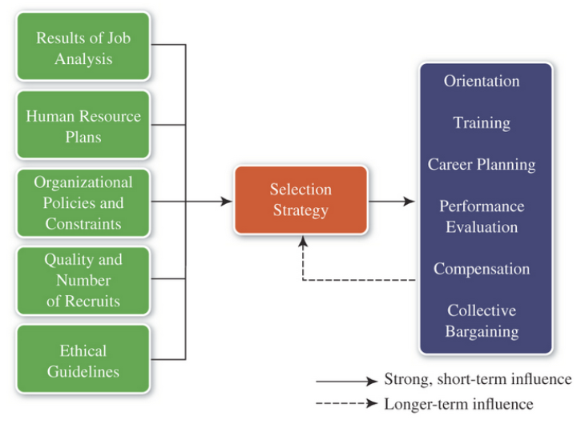
Steps in the Selection Process
- A series of specific steps used by an employer to decide which recruits should be hired
- Preliminary Reception of Applicants
- Initial contact applicants
- Walk-ins may receive preliminary interview
- Write-ins often receive letter of acknowledgment
- This step has disappeared in many organizations with the increasing use of Internet recruitment
- Applicant Screening
- Remove from consideration applicants who do not meet qualifications
- Weighted application blank (WAB): A job application form in which various items are given differential weights to reflect their relationship to criterion measures
- Ensure application is useful and meets legal requirements
- Biographical information blanks (BIB): A type of application bank that uses multiple choice format to measure a job candidates education, experiences, opinions, attitudes, and interests
- Administration of Employment Tests
- Devices that asses the probable match between applicants and job requirements
  - Reliability: A selection devices ability to yield consistent results over repeated measures. Also, internal consistency of a device or measure
  - Validity: A key attribute of selection device that indicates its accuracy and relationship to job level criteria
- Empirical approaches
  - Predictive validity
  - Concurrent validity
- Rational approaches
  - Content validity
  - Construct validity
  - Differential validity
- Types of Tests
  - Personality Tests: questionnaires designed to reveal aspects of an individuals character or temperament
  - Ability Tests; Knowledge Tests: Tests that measure a person’s information or knowledge
  - Performance Tests: Tests that measure the ability to job applicants to perform the job for which they are to be hired
  - Situational Judgement Tests: A test that places an applicant in hypothetical scenarios and asks them to indicate how they would respond from a list of alternatives
  - Assessment Centres, Computer-interactive Tests, Integrity Tests
- Employment Interviews
- Supervisors should have input into the final hiring decision
- Realistic Job Previews
- Involves showing the candidate the type of work, equipment, and working conditions involved in the job before the hiring decision is final
- Shows the candidate the type of work, equipment and working conditions
- Highlights positive and negative
- Tends to reduce employee turnover
- Verification of References
- Employment References
  - Discuss applicants work history
  - Former supervisors may not be candid, especially with negative information
  - Reference letters
  - Background checks
- Contingent Assessments
- Assessment of health and accident information
- May be scheduled after the hiring decision
- Drug tests are increasingly used but may be found to violate employee rights
- Hiring Decision
- Marks the end of the selection process
  - Update HRIS
  - Retail applications for future
- Trade-offs among predictors
  - Subjective approach: An approach where the decision maker looks at the scores received by various applicants on predictors, subjectively evaluates all of the information, and comes to an overall judgement
  - Multiple cut-off approach: An approach where scores are set for each predictor and each applicant is evaluated on a pass-fail basis
  - Compensatory approach: An approach where a higher score on the predictor may compensate a low score on another

After Selection
- When drawing up the employment contract, pay attention to:
  - Specify probationary period if applicable
  - Specify start date and terms of employment clearly
  - Specify reasonable restrictive covenants
  - Ensure that termination procedures are legally enforceable

Employment Interviews
- a formal, in depth, face-to-face, or more recently, a phone or video conference between an employer and a job applicant to assess the appropriateness of the applicant for the job under consideration
- Formal, in-depth conversation conducted to evaluate the applicant’s acceptability
- Most Widely used selection technique
  - Allows a personal impression
  - Opportunity to sell a job to candidate
  - Opportunity to answer candidate’s questions
  - Effective public relations tool
  - Popular due to flexibility and creates two-way exchange
  - Flaw relates to varying reliability and validity

Types of Interviews
- Interviews may be conducted one-to-one, panel, or group interview
  - Panel Interview: Interview using several interviewers with on applicant
- Unstructured Interviews
  - Few if any planned questions
  - Lacks the reliability of a structured interview
- Structured interviews
  - Pre-determined set of questions
  - May improve reliability and validity over traditional unstructured interviews
Types of Structure Interviews
- Behavioural Description Interviews
  - Based on principle that the best predictor of future behaviour is past behaviour
  - Interviews that attempt to find out how job applicants responded to specific work situations in the past
- Situational Interviews
  - Interviews that attempt to asses a job applicant’s likely future response to specific situations, which may or may not have been faced by the applicant in the past
  - Focus on situations likely to arise on the job
  - Applicants asked what they would do

Stages in a Typical Interview
- Interviewer Preparation
  - Develop specific questions/answers
- Creation of Rapport
  - Interviewer is responsible for establishing rapport
- Information Exchange
  - Heart of the interview
- Termination of Interview
  - Draw the session to a close
- Evaluation
  - Use of checklist

Interviewer Errors
- Halo effect
- Leading questions
- Stereotypes
- Interviewer domination
- Contrast errors

Interviewee Errors
- May be trying to cover job-related weaknesses or nervousness
- Examples include:
  - Playing games i.e. acting nonchalant
  - Talking too much
  - Boasting
  - Not listening
  - Being unprepared

Evaluating the Selection
- Quality and productivity of the workforce
  - Are supervisors/peers satisfied with hires?
  - Are training costs increasing?
  - Are managers spending too much time managing new hires?
  - Are grievances, absences, and turnover too high?
- Costs incurred are at a level appropriate to the organization

STAR technique
- S: Situation - describe the context within which you performed a job or faced a challenge at work
- T: Task – describe your responsibility in that situation
- A: Action – describe how you completed the task or endeavored to meet the challenge
- R: Result – explain the outcomes or results generated by the action taken

Chapter 7
Onboarding
- The process of integrating and acculturating new employees and knowledge to become successful and productive
- Orientation Programs: Programs that familiarize new employees with their roles, the organization, its policies, and other employees
  - Includes orientation, socialization, training and development activities
- Outcomes include:
  - Greater retention, faster time to productivity, increased motivation, and engagement.

Purpose of Onboarding
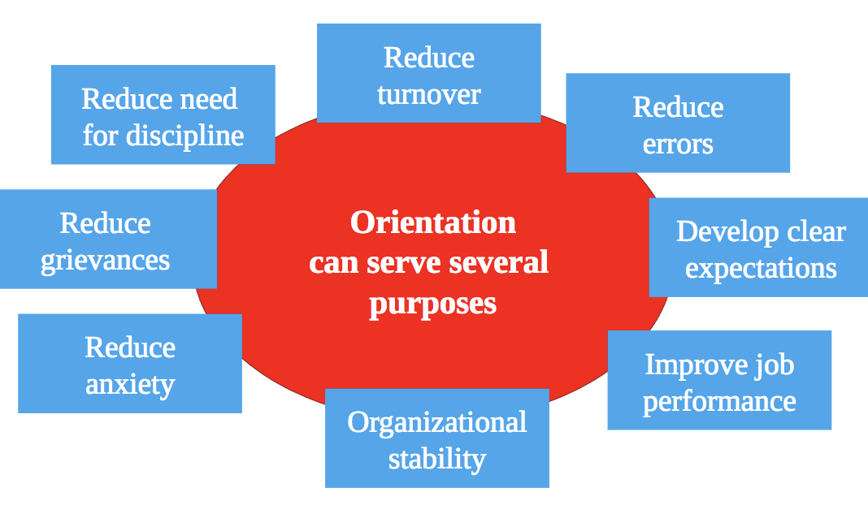

Orientation
Organizational Issues | History, names and titles, overviews  Policies, employee handbook
HR Related Topics | Pay, vacations, benefits  Services, programs, counselling
Role Expectations | Job location, job overview, safety  Job tasks, objectives, relationships

Socialization
- The continuing process by which an employee begins to understand and accept the values, norms, and beliefs held by others in the organization
- Involves turning outsiders into insiders
- May have taken place even before employees join organization

Training and Development
- Learning Organization
  - An organization that has an enhanced capacity to learn, adapt, and change
- Knowledge Management
  - The ability to use people’s knowledge, that is, information stored in employees’ heads.
- Human Resource Development (HRD)
  - A function of human resource management that integrates the use of training and employee and career development efforts to improve individual, group, and organizational effectiveness.
- Development
  - Planned activities aimed to provide employees with enhanced skills and competencies for the future

Relationship Between Training and Development
- Training: present job-related behaviour
- Development: future job responsibilities

Employee Training
- Companies compete in a global economy
- Global competition has companies to flatten structures and reduce employees
  - Need to foster life-long learning to attract multi-skilled employees.
  - Training is need to work effectively with diverse employees.
  - Developments in information technologies require new skills and training strategies.

The Training System
- Sequence of events
  - Needs assessment, objectives, content, learning principles, program implementation, and evaluation.
- Employee benefits
  - Skill improvement, self-development, self-confidence, sense of growth.
- Organizational benefits
  - Improved profitability, improved morale, lower costs, better corporate image.

Needs Assessment
- Diagnoses present problems and future challenges that can be met through training or development
  - Needs to consider each person
  - Need may be determined by the HRD function, supervisors, or self-nomination.
  - Sources of information that may indicate a need for training e.g. production records, grievances, safety reports, performance appraisal, absenteeism and turnover, etc.

Training Objectives
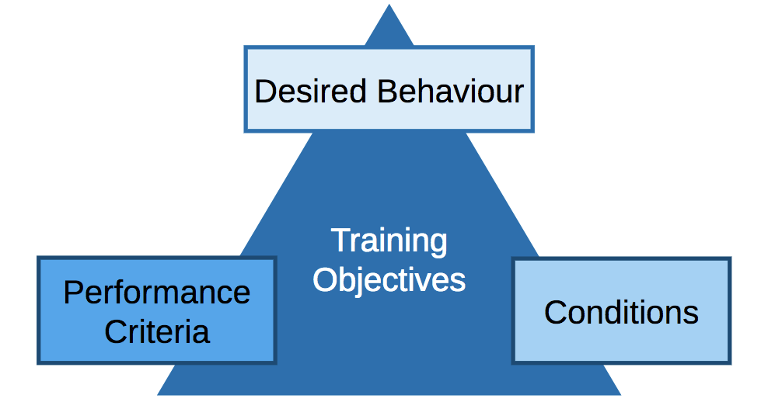

Learning Principles
- Guidelines to the ways people learn most effectively (participation, repetition, relevance, transference, feedback)
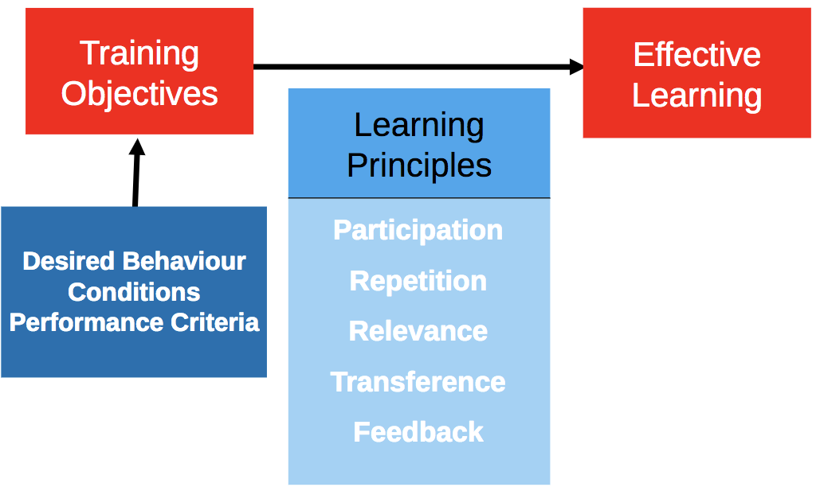
Training Techniques
- Training: Planned activities aimed to provide employees with enhanced skills to perform their current jobs

On-The-Job | Off-The-Job
Job rotation  Apprenticeships  Coaching | Lectures & Videos  Labs & Stimulations  Role-playing  Case study  Self-study & Programmed learning  Web-based learning (virtual reality)

- Role Modeling/Playing
  - A training technique that requires trainees to assume different identities in order to learn how other feel under different circumstances (definition for role playing)
  - Simulation: Simulation exercises involve a mechanical simulator that replicates the major features of the work situation

Web-based Delivery Systems
- Web/computer training
  - User interacts with only one program
- Web/electric performance support
  - Workers have access to databases, online toolds
- Web/virtual/synchronous
  - Meet at a predetermined time
- Web/virtual asynchronous
  - Classroom on the internet (accessible anytime)
Popular Web-Based Tools
- A variety of methods have been developed:
  - Blogs are websites with text and graphics
  - RSS (Rich Site Summary)
  - Webcasts consist of audio or video clips
  - Wikis are accessible web pages
  - Social networking websites

Strategic Human Resource Development
- The identification of essential job skills and the management of employees’ learning in relation to corporate and business strategies
- Talent management
- Succession Planning
  - The process of making long-range management development plans to fill human resource needs
- Who to develop?

Steps to Create Employee Development Plans (EDP)
- Assess employees’ needs
- Link competencies and skills to business goals
- Identify learning and development activities
- Determine resources
- Identify barriers

Developmental Strategies
- Cognitive: altering thought and ideas – increase knowledge and expertise, includes lectures, seminars, academic education
- Behavioural: change behaviour i.e. management style, includes role-playing, behaviour modelling etc.

Behavioural Strategies
- Behaviour Modeling
- The Leadership Grid
- Team Building
- Mentoring

Development Strategies
- Environmental: provide the setting for employees to develop, includes job rotation, OD, learning organization
  - Job rotation, organizational development, the learning organization, temporary assignments, employee exchange programs, matrix management, project teams, internal consulting, lateral consulting, lateral transfer, job redefinition, cross cultural management training , diversity training
  - Transference: Applicability of training to job situations; evaluated by how readily the trainee can transfer the learning to his or her job

Evaluation of Training and Development

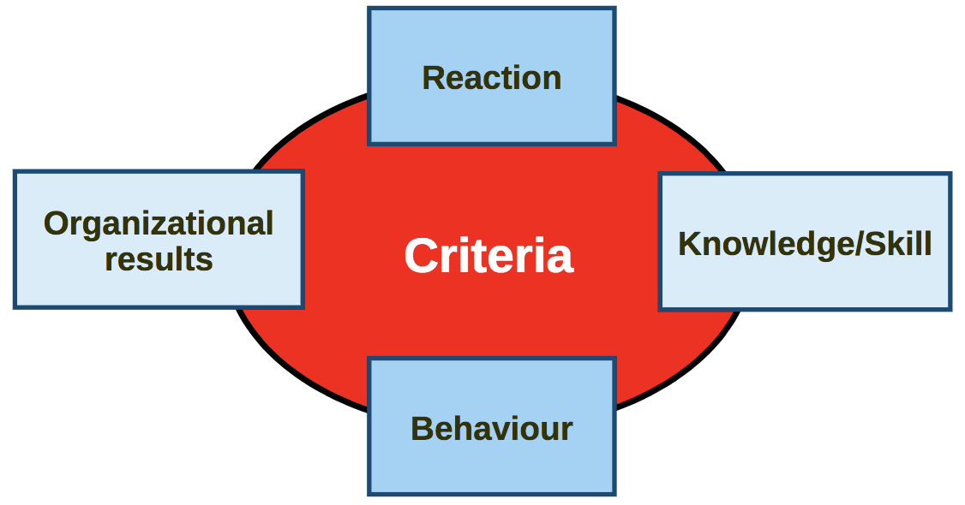

Career Planning and Development
- Career Planning: process through which someone becomes more aware of their interests, needs and motivations
- Career Management: series of formal and less formal activities – designed and managed by the organization
- Career Development: a series of activities undertaken by individuals in pursuit of their careers

A Model of Career Development
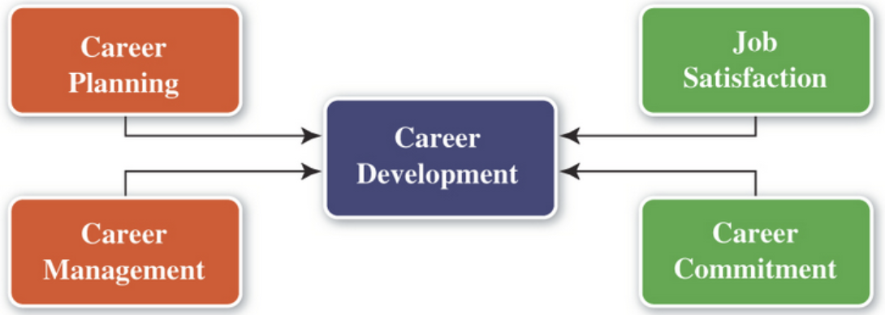
Individual Career Development
- Demonstrate exceptional job performance
- Increase visibility and exposure within the organization
- Leave the organization to see a better job
- Demonstrate organizational commitment
- Seek mentors, sponsors, and coaches
- Seek growth opportunities

How do Employees Measure Career Success?
- Advancement
- Learning
- Employability
- Evidence of positive psychological factors

Factors Affecting Individual Career Choice
- Social or environmental concern: generational difference
- Work-life balance: individual values, abilities, and attitudes
- Personality-job fit
- The RIASEC Model
  - John Holland’s occupational types: realistic, investigative, artistic, social, enterprising, and conventional

HR Department and Career Planning
- Encourages management commitment and support
- Devise communication plans through HR tools to raise awareness of career options
- Align HR processes to facilitate career planning
- Use technology to support career planning efforts
- Develops promotable employees
- Lowers turnover
- Furthers employee growth
- Reduces hoarding
- Satisfies employee needs
- Assists organizations meet legal requirements
- Taps employee potential
- Optimizes organizational potential

