Acid Base Titrations

CHM1311 Section Z4

Demonstrator:
Kelsey Fournier

Tuesday, November 6, 2018

Department of Chemistry

University of Ottawa

Introduction:
In chemistry, many procedures have been developed in order for chemists to calculate and find information about the solutions they create, one of them being titration. Titration is defined as the slow addition of one solution of a known concentration (called a titrant) to a known volume of another solution, with an unknown concentration, until the reaction reaches neutralization. Often an indicator is used to determine when neutralization has occurred. Titration is a technique commonly used to find the concentration of a solution and is a method of standardization¹. To standardize a solution means to determine the exact concentration of the solution². An acid-base indicator is often used for the titration process, and is defined as a weak acid or weak base that exhibits a colour change when the concentration of hydrogen ions (acids) or hydronium ions (base) changes in a solution. They are most often used in titration processes as they can indicate when the endpoint, or a neutralization reaction, has occurred³. A hygroscopic material is able to absorb water and carbon dioxide from the atmosphere, making it difficult to weigh precisely as the mass substance will change. These substances are usually salts, such as sodium hydroxide⁴. An acid is a substance that increases the hydrogen ion concentration when it dissociates (hydrogen ion donor). A base is a substance that accepts hydrogen ions when it dissociates, usually by forming hydroxide ions (hydrogen ion acceptor)⁵. The equivalence point of a reaction is when the ratio of the base and acid has reached the ideal relationship. Or in other words, the equivalence point is where the amount of titrant added (base) is enough to completely neutralize the solution (acid). The endpoint of a titration process is when a colour change has occurred in the solution.
In this lab, distilled water was added to a concentrated NaOH solution in order to dilute it. Then HCl (standard acid) of a known concentration was titrated with NaOH in order to determine the concentration of the NaOH solution. The exact concentration of the NaOH was found using Logger Pro software and the first derivative. Once the exact concentration of the NaOH was determined, it was used to titrate with the unknown acid in order to determine the concentration of the acid.
Chemicals and Equipment Needed:
Chemicals Equipment
6 mol/L NaOH 150 mL beaker
Standard Acid solution LabQuest 2
Unknown Acid solution 2 pH probe
Phenolphthalein Drop counter
Stirrer (stir rod)
25 mL buret and a funnel
50 mL and a 400 or 600 mL beaker
10 mL graduated cylinder
Stirrer plate

Procedure:
As per the lab manual⁶.
1. A 400mL beaker was rinsed with distilled water and dried.
2. Using a 10 mL graduated cylinder, approximately 4-5mL of concentrated NaOH was measured and the approximate value was recorded.
3. Using a 400mL beaker, approximately 245-250mL of distilled water was obtained and the approximate value was recorded.
4. The NaOH was then added to the distilled water while stirring. It was allowed to stir for an additional 2 minutes.
5. The excess concentrated NaOH was disposed of in the waste container and the beaker was rinsed well.
6. The drop counter was added to an L bar and plugged it into LabQuest 2.
7. The plastic buret was attached above the drop counter with a clamp and both taps were closed.
8. The plastic buret was filled with 40mL of the diluted NaOH solution and a graduated cylinder was placed directly below the opening (which is also below the center of the drop counter).
9. The bottom tap of the buret was opened completely and the top tap was adjusted slowly until the NaOH dropped at a rate of 1-2 drops per second. Approximately 2-3mL of NaOH solution was added to the graduated cylinder and the exact volume was recorded.
10. The LabQuest 2 device was set to calibrate and 2mL was allowed to drop into the 10mL graduated cylinder. The final volume and the number of drops indicated by the LabQuest 2 was recorded. The precise volume was inputted into LabQuest 2.
11. A glass buret was obtained and attached to an L bar using a double buret clamp.
12. Using a 50mL beaker, approximately 25mL of standard acid was obtained. The exact concentration was recorded.
13. Using a funnel, the glass buret was filled with the standard acid. 1-2 mL of the acid was then allowed to flow through the buret to remove any trapped air.
14. The initial volume of the buret was recorded and 10mL of acid was transferred into a 150mL beaker. The final volume was recorded.
15. 2-3 drops of phenolphthalein and a magnetic stir bar was added to the beaker.
16. The beaker was then placed on the stir plate such that the NaOH would drop into the beaker below.
17. The pH probe was rinsed with distilled water and was connected to the drop counter and LabQuest 2.
18. Distilled water was added until the pH probe was submerged in the solution. It was ensured that the stirrer would not break the pH probe.
19. The plastic buret was refilled to 40mL with dilute NaOH solution.
20. After it was ensured that LabQuest was plotting as a function of volume, the bottom tap was opened completely and the base was allowed to flow into the beaker at a rate of 1-2 drops per second.
21. The volume of base added when a colour change occurred was recorded.
22. The run was stopped after the pH leveled off at a pH value of approximately 11-12.
23. The pH probe was removed from the drop counter and rinsed with distilled water. The solution was disposed of in the waste container and the beaker was rinsed with distilled water.
24. Steps 7 to 23 was repeated an additional 2 times.
25. The glass buret was emptied and rinsed with warm water through the tip.
26. Using a 50mL beaker, 25mL of “unknown acid 2” was obtained and placed into the glass buret using a funnel. 1-2mL of the acid was allowed to flow through the buret to remove air bubbles.
27. Steps 7-24 was repeated 3 times with the “unknown acid 2” and standardized NaOH solution.
28. All solutions were then poured into the waste container. The glassware was rinsed with warm water and then distilled water. The counter was cleaned when needed.
29. A wet paper towel was used to wipe the inner surface of the drop counter. The probes were returned to their respective bins.

Observations and Results:
Table 1: Respective Volume and Concentrations of NaOH Solution
Initial Volume of NaOH (mL) | Concentration of NaOH (6 mol/L) | Volume of Distilled Water Added (mL)
5 | 6 | 250

Table 2: Volume of NaOH added into Graduated Cylinder
Initial Volume of Graduated Cylinder (mL) | Final Volume of Graduated Cylinder (mL)
2.2 | 8.4

Table 3: Volume and Concentration of Standard Acid
Volume Obtained (mL) | Concentration (mol/L)
30 | 0.100

Table 4: Buret Reading When Obtaining 10mL of Standard Acid
Trial | Initial Buret Reading (mL) | Final Buret Reading (mL) | Volume Obtained  (final buret reading – initial buret reading = volume obtained) (mL)
1 | 2.99 | 13.01 | 10.02
2 | 12.80 | 22.90 | 10.10
3 | 3.32 | 13.32 | 10.00

Table 5: Volume of NaOH added when Colour Change Occurs with Standard Acid
Trial | Volume Added (mL)
1 | 6.036
2 | 6.429
3 | 6.429

Table 6: Change in NaOH Volume During Titration Process with Standard Acid
Trial | Initial Volume NaOH (mL) | Final Volume NaOH (mL) | Change in Volume NaOH  (final volume – initial volume = change in volume) (mL)
1 | 40.0 | 28.3 | -11.7
2 | 40.0 | 25.1 | -14.9
3 | 40.0 | 24.0 | -16.0

Table 7: Buret Reading for Obtaining 10mL of Unknown Acid 2
Trial | Initial Buret Reading (mL) | Final Buret Reading (mL) | Volume Obtained  (final buret reading – initial buret reading = volume obtained) (mL)
1 | 3.61 | 13.61 | 10.00
2 | 13.71 | 23.72 | 10.01
3 | 4.92 | 14.94 | 10.02

Table 8: Volume of NaOH Added When Colour Change Occurred Using Unknown Acid 2
Trial | Volume Added (mL)
1 | 8.571
2 | 5.464
3 | 8.143

Table 9: Change in NaOH volume during Titration Process with Unknown Acid 2
Trial | Initial Volume NaOH (mL) | Final Volume NaOH (mL) | Change in Volume NaOH  (final volume – initial volume = change in volume) (mL)
1 | 40.0 | 28.9 | -11.1
2 | 40.0 | 8.1 | -31.9
3 | 40.0 | 0.0 | -40.0

Table 10: Partial Representation of Data Collected in Titration of Standard Acid (Run 1,2, and 3) and Unknown Acid 2 (Run 4, 5, and 6) with NaOH
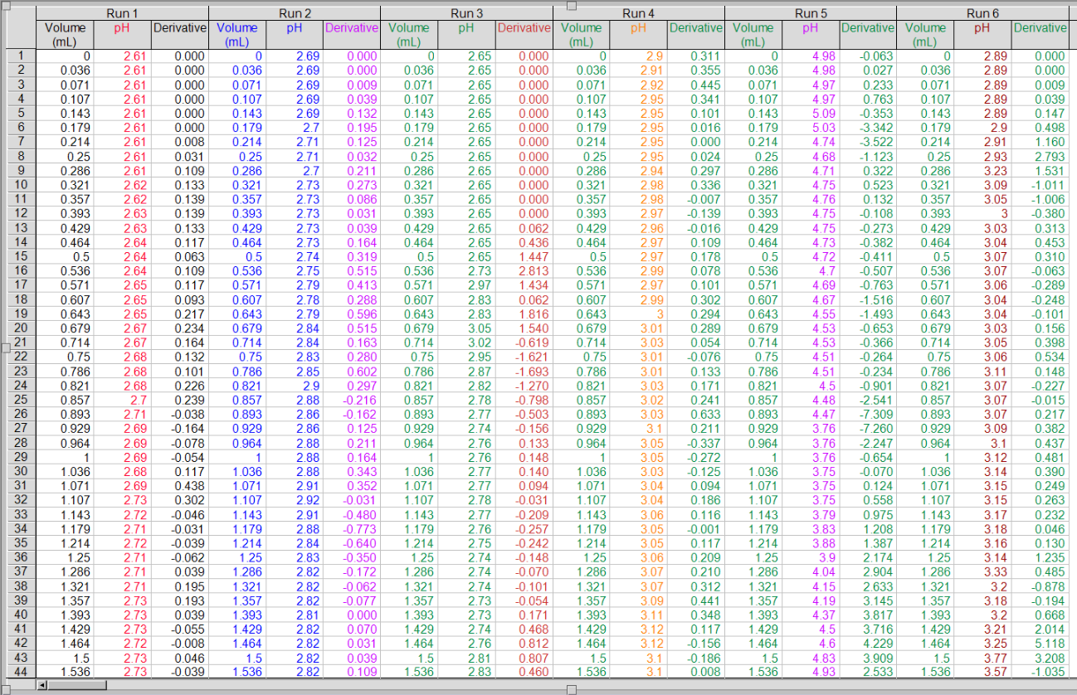

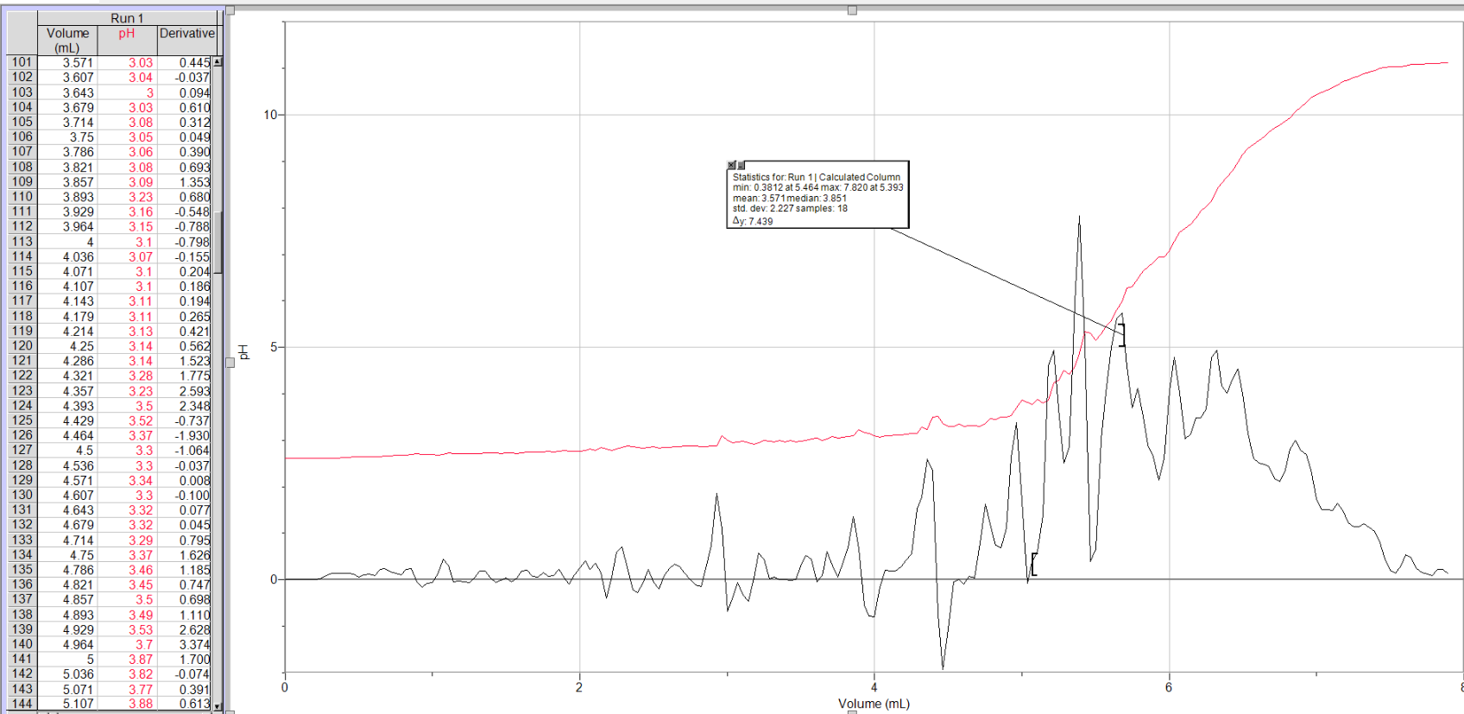
Graph 1: Volume vs. pH and First Derivative for Trial 1 using Standard Acid and NaOH

Graph 2: Volume vs. pH and First Derivative for Trial 2 using Standard Acid and NaOH
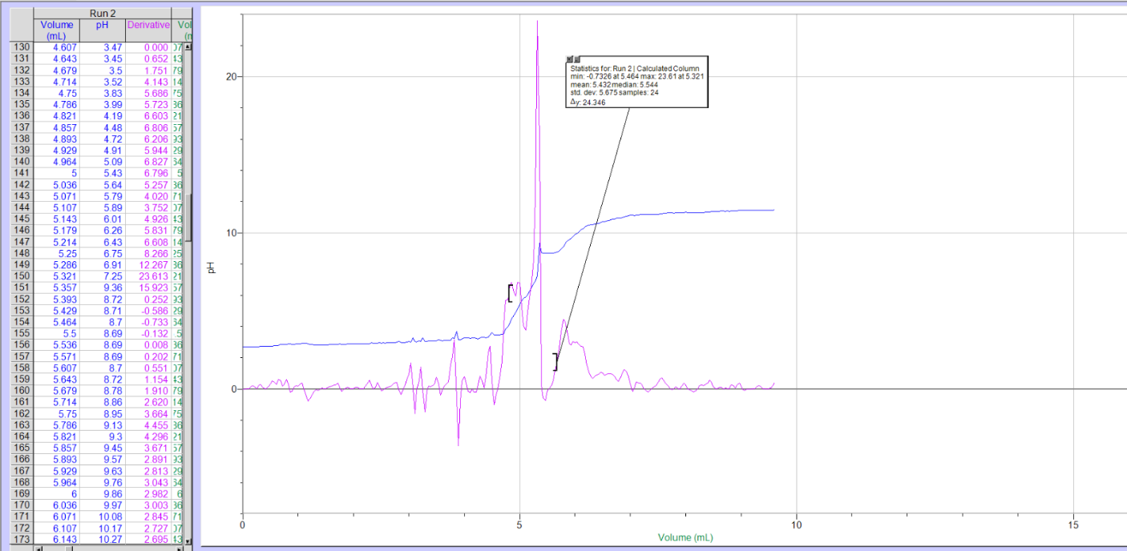

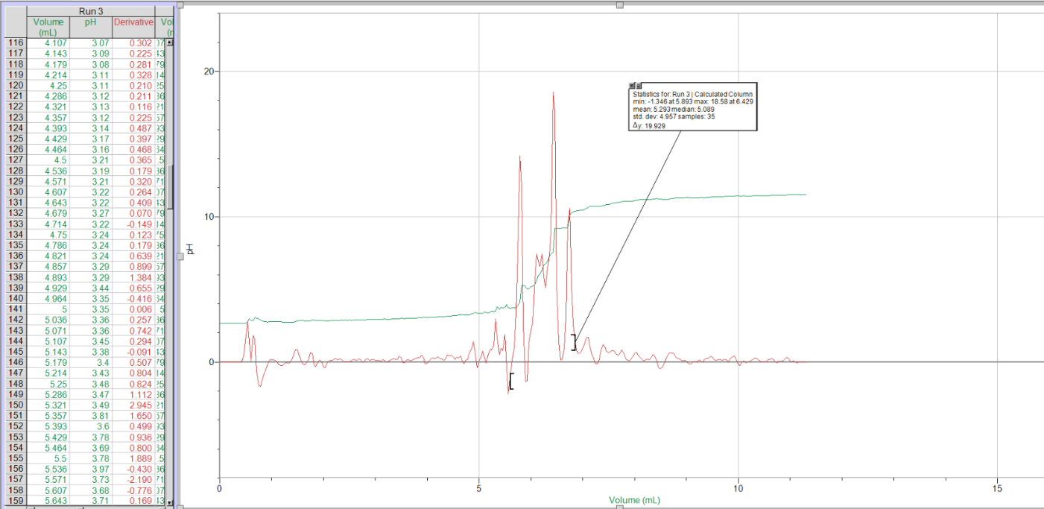
Graph 3: Volume vs. pH and First Derivative for Trial 3 using Standard Acid and NaOH

Graph 4: Volume vs. pH and First Derivative for Trial 1 using Unknown Acid 2 and NaOH
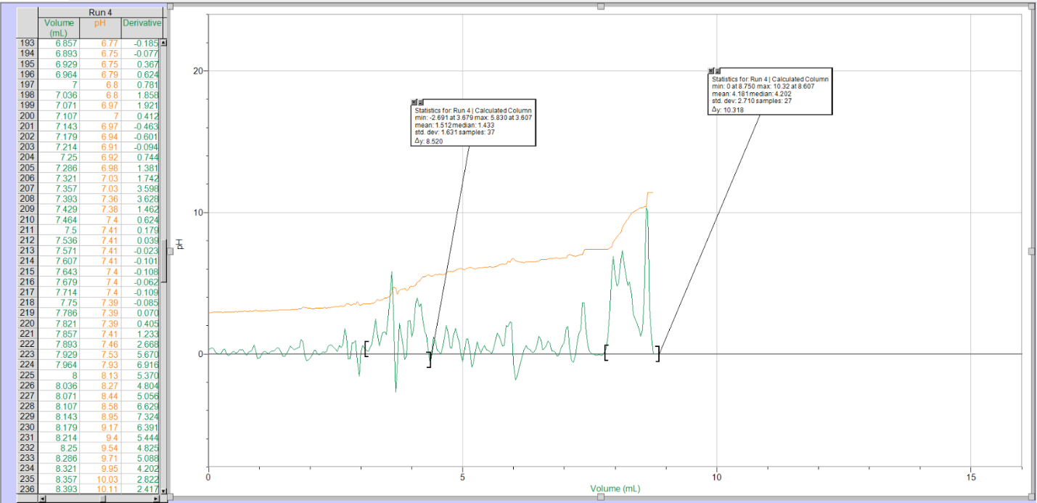

Graph 5: Volume vs. pH and First Derivative for Trial 2 using Unknown Acid 2 and NaOH
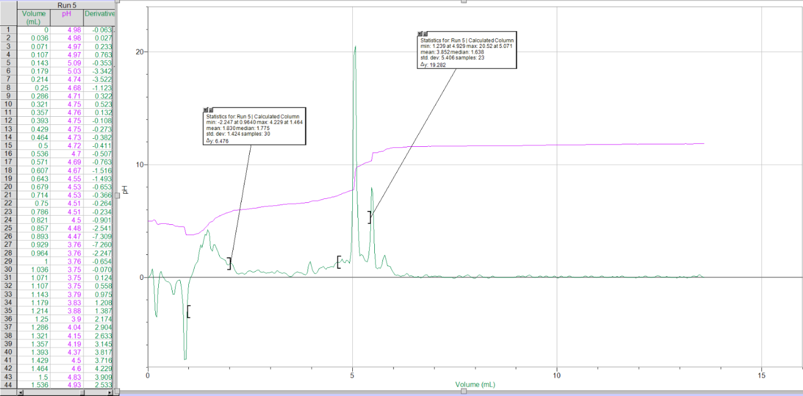

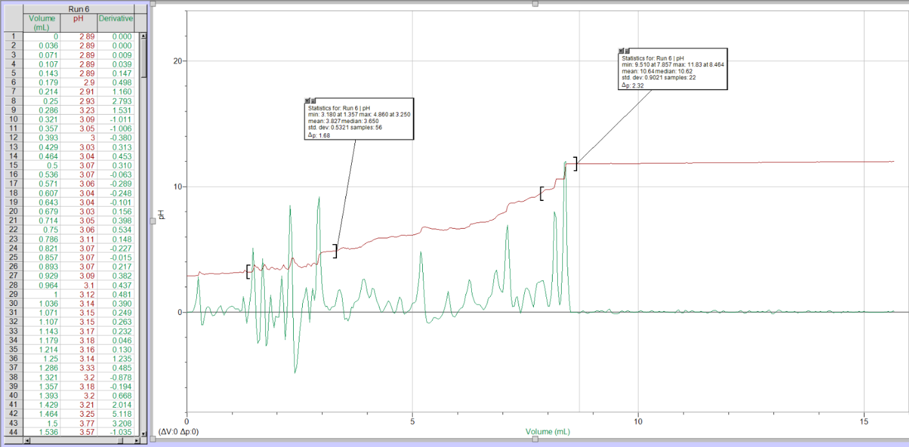
Graph 6: Volume vs. pH and First Derivative for Trial 3 using Unknown Acid 2

Discussion:
Using the provided information about the concentrated NaOH solution, as well as the volume of the diluted NaOH solution, the approximate concentration of the diluted NaOH can be calculated using the formula C₁V₁=C₂V₂ as follows.
Sample Calculation 1: Approximate Concentration of NaOH Solution
C₁V₁ = C₂V₂
(6 mol/L)(5mL) = (C₂)(5mL + 250 mL)
C₂ = (6 mol/L)(5mL) / (5mL + 250 mL)
C₂ = 0.117647058 mol/L
C₂ = 0.1 mol/L
Based on the calculations above, the approximate concentration of the diluted NaOH solution is 0.1 mol/L. This makes sense as the volume is increased by adding water to the solution, so the concentration of NaOH must decrease. It’s important to find the initial concentration of the dilute NaOH at the very beginning of the experiment as it is a hygroscopic material, meaning it will react with substances such as water and carbon dioxide in the atmosphere. This interaction causes the concentration of the NaOH solution to decrease overtime as it continues to react with the atmosphere. Using Logger Pro, the exact equivalence point of the titration with standard acid (HCl) can be used to calculate the exact concentration of the NaOH. The equivalence point can be found by taking the first derivative of the curve, and finding the maximum of the derivative function. The table below summarizes the equivalence points found using the Logger Pro Software.
Table 11: Equivalence Point for Standard Acid (HCl)
Trial | Volume of NaOH added (mL) | Equivalence Point
1 | 5.393 | 7.820
2 | 5.321 | 23.61
3 | 6.429 | 18.58

The formula which describes how sodium hydroxide and hydrochloric acid react during titration is HCl + NaOH → NaCl + H₂O. Since HCl (standard acid) is monoprotic, and the molar ratio is 1:1, the formula used to calculate change in volume or concentration is C1V1 = C2V2. Using this formula, the exact concentration of the NaOH solution can be calculated. The calculation can be seen below.
Sample Calculation 2: Exact Concentration of NaOH Solution
C_{NaOH} V_{NaOH} = C_{HCl} V_{HCl}
C_{NaOH} = [C_{HCl} V_{HCl}] / V_{NaOH}
V_{NaOH} = 5.393 mL
C_{HCl} = 0.100 mol/L
V_{HCl} = 10.02 mL
C_{NaOH} = [(0.100 mol/L)(10.02mL)] / (5.393mL)
C_{NaOH} = 0.185796402 mol/L
C_{NaOH} = 0.186 mol/L

Table 12: Exact Concentration of NaOH Solution
Trial | Concentration of NaOH (mol/L)
1 | 0.186
2 | 0.190
3 | 0.156

The calculation and table above show the exact concentration of NaOH for each trial using standard acid. In order to use the concentration of NaOH in other calculations, an average value needs to obtained. This can be seen below.
Sample Calculation 3: Average Value for the Exact Concentration of NaOH Solution
C_{avgNaOH} = [C_{NaOH1} + C_{NaOH2} + …. C_{NaOHn}] / n
C_{avgNaOH} = [ 0.186 mol/L + 0.190 mol/L + 0.156 mol/L] / 3
C_{avgNaOH} = 0.177 mol/L
This calculation shows that the average exact volume of NaOH is 0.177 mol/L. This concentration can then be used in other calculations, such as calculating the concentration of the unknown acid 2. Similarly to finding the concentration of the NaOH solution, the equivalence points will be used in the calculation. To obtain the accurate equivalence point the first derivative of the curve for each trial must be obtained, and the maximum of the derivative corresponds to the equivalence point. This can be found using the Logger Pro software, and is seen on the graphs. Based on the data obtained from graphs 4-6, the equivalence points for the unknown acid 2 are as follows.
Table 13: Equivalence Point for Unknown Acid 2
Trial | Volume of NaOH added (mL) | Equivalence Point
1 | 8.750 | 10.32
2 | 5.071 | 20.52
3 | 8.464 | 11.83

Using the equivalence points found in Table 13, the average exact concentration of NaOH, and the volume of unknown acid measured in the lab the concentration of the unknown acid 2 can be found. The reaction between NaOH and the unknown acid is NaOH + H₂A → NaA + H₂O, where H₂A is the unknown acid. Since the acid is diprotic, the concentration cannot be calculated in the same fashion as HCl (hydrochloric acid is a monoprotic acid). In this case the concentration of unknown acid can be calculated using the formula C1V1=2(C2V2). This calculation can be seen below.
Sample Calculation 4: Concentration of Unknown Acid 2
C_{NaOH} V_{NaOH} = 2 C_{Uknwn} V_{Unknwn}
C_{Unknwn} = [C_{NaOH} V_{NaOH}] / 2V_{Unknwn}
V_{NaOH} = 8.750 mL
C_{NaOH} = 0.177 mol/L
V_{Unkwn} = 10.00 mL
C_{Unknwn} = [(0.177mol/L) (8.750mL)] / 2(10.00mL)
C_{Unknwn} =0.0774 mol/L
Table 14: Concentration of Unknown Acid 2
Trial | Concentration of Unknown Acid 2 (mol/L)
1 | 0.0774
2 | 0.0448
3 | 0.0748

Sample Calculation 5: Average Concentration of Unknown Acid 2
C_{avgUnkwn} = [C₁ + C₂ + …. C_{n}] / n
C_{avgNaOH} = [ 0.0774 mol/L + 0.0448 mol/L + 0.0748 mol/L] / 3
C_{avgNaOH} = 0.0657 mol/L
This means that the average concentration of unknown acid 2 is 0.0657 mol/L. This shows how titration can be useful in determining concentrations of various substances as the lab allowed the concentration of an unknown acid to be obtained easily through simple calculations.
The volume of water added to concentrated NaOH used in the beginning does not matter as long as the concentration of the solution is known or can be calculated, and the concentration of the solution does not change throughout the experiment. For example, instead of adding 245-250mL of water to the concentrated NaOH, a different volume of water could have been added to dilute the solution. If more water was added, the concentration would become more dilute. This means that when the dilute NaOH solution is used for titration it would take more dilute NaOH to cause a colour change in the acidic solution in the beaker. If less water was added, it would take less dilute NaOH to cause a colour change in the acidic solution. However, as long as the initial concentration used at the beginning of the experiment does not change, the process will be correct and accurate. The specific concentration of NaOH does not matter, as long as it is known for the calculations.
The concentration of NaOH was calculated before being used in the experiment as it is a hygroscopic material (unstable base). A hygroscopic material is able to absorb water and carbon dioxide from the atmosphere, making it difficult to weigh precisely or find the exact concentration as the mass of the substance will change. These substances are usually salts, such as sodium hydroxide⁴. Because of sodium hydroxides hygroscopic properties, the concentration of the NaOH solution may change as it is allowed to react with the atmosphere. It can also react with the substances its in solution with. This is why it is important to find the concentration before the experiment takes place so that the actual concentration is known (water and carbon dioxide in the atmosphere cannot alter the concentration).
For each trial of the acid, the equivalence points (colour change) occurred at a relatively similar volume of NaOH compared to the equivalence points determined by Logger Pro. This makes sense as theoretically they should be the same value as the equivalence point happens at the same time regardless of what is being used to measure it. However, the equivalence point noted based on colour change was generally a lesser volume compared to the equivalence points determined by Logger Pro. This means that the visible equivalence point occurred slightly prior to the more accurate equivalence point determined by Logger Pro. This is likely because the volume was recorded as soon a light pink colour emerged, whereas if a few more drops were added and a darker pink arose it would have been a more accurate equivalence point. It is also harder to determine the equivalence point accurately by colour change as many different variants of pink occur rapidly. Logger Pro is a much more accurate method of determining the equivalence point as it uses calculations and the first derivative to find the exact volume added when the equivalence point occurred. However, to resolve this source of error the volume of NaOH should always be recorded when the solution reaches its darkest appearance. That way, the volume won’t be recorded too early and it will be easier to be consistent from trial to trial.
There are various sources of error that occur in the titration process. For example, the end point observed is not the same as the equivalence point. Although ideally these points coincide, the end point is simply the point in which the solution changes colour, whereas the equivalence point is when the ratio of the base and acid has reached the ideal relationship. Or in other words, the equivalence point is where the amount of titrant added (base) is enough to completely neutralize the solution (acid). Because these points can occur at different times, this is a source of error. In some cases, too much titrant can be added as the indicator did not change colour when the equivalence point was reached (endpoint was after equivalence point). Or conversely not enough titrant can be added and the equivalence point would not have occurred by the time the volume is recorded (the endpoint was before the equivalence point). This results in the wrong volume of titrant (NaOH) being recorded.
Another source of error would be misjudging the colour of the indicator around the endpoint. Because people perceive colour differently, they may choose the endpoint/equivalence point at different times in the experiment. This will result in different volumes of NaOH to be recorded, which would ultimately affect the calculations in the lab. If the volume of NaOH recorded is larger than the true value then the concentration of the acid will be calculated as a larger value than its true concentration. If the volume of NaOH recorded is less than the true value, then the acid concentration will be found to be less than its true concentration.
There are also many human errors that can occur in the experiment such as recording the volume incorrectly, measuring the volume of acid incorrectly, dropping in different amounts of indicator each time, using contaminated glassware or probes, and not rinsing the glassware in-between standard acid and unknown acid 2 trials. All of these errors will affect the outcome of the experiment and shows that its important to follow the procedure to minimize these errors from occurring. In the lab the second trial using the unknown acid appears to be susceptible to experimental error. The equivalence point of both trial 1 and 2 occur when over 8 mL of NaOH has been added to the beaker, whereas the equivalence point of trial 2 occurred when roughly 5 mL of NaOH was added. This discrepancy in the results is likely caused by an experimental error such as the ones listed above. This shows the importance of following the procedure to eliminate these errors. Because of this error, the average concentration of unknown acid is likely less than it should have been as the error brought down the average concentration value.
During the titration of Unknown Acid 2 using NaOH, the solution in the beaker will undergo several transformations as the base is added to the flask. In case A, when 0mL of NaOH (base) has been added to the flask, the species in the beaker are aqueous unknown acid 2, distilled water, and phenolphthalein indicator. The solution is simply a dilute acid, A. The titration has not begun and no base has been added (no reaction is occurring at this point, so no chemical formula). In case B, about midway to the first equivalence point, NaOH has begun to be added to the acid solution. This means that the NaOH is reacting with some of the unknown acid to form a salt through a neutralization reaction. This can be seen in the reaction NaOH + H₂A → NaA + H₂O. However, it is not at an equivalence point yet as the exact volume of NaOH and unknown acid to satisfy the equation NaOH + H₂A → NaA + H₂O has not yet been added (there is still acid left in the beaker to react/be titrated). The reaction is occurring and the products are being formed, but it has not begun to mix together in the same proportions the equation describes⁷. In case C, at the first equivalent point, the acid has reached what is called the half-equivalence point. At this point in the titration, the added base (NaOH) is equal to half of the original concentration of the acid (unknown acid). This is the midpoint of the titration when half of the acid has been titrated. Graphically, it is represented as the first point on the graph where the slope (or first derivative) is zero. This means that it is the first maximum of the derivative function⁸. In terms of species in the beaker, the unknown acid, NaOH, salt (NaA), and water will all be present. In case D, midway to the second equivalence point, the base will continue to be added to the acid and the reaction NaOH + H₂A → NaA + H₂O will continue to proceed and increase the concentration of salt and decrease the concentration of acid until there is no acid left. This will continue until case E, the second equivalence point. In case E, the second equivalence point, the moles of base added to the solution is equal to the number of moles of acid in solution. At this point all of the acid has been titrated and the endpoint has been reached (colour change). The endpoint may be slightly different than the equilibrium point, but the difference is negligible in most cases. Graphically, this is the second point on the graph when the slope of first derivative is equal to 0. It is also the second maximum on the function of the first derivative. In terms of species at the second equivalence point, only the base (NaOH) remains in the solution as the acid has been completely used up in the formation of salt (NaA). There will also be salt (NaA), water, and indicator in the beaker.
Conclusion:
In this lab the approximate concentration of the NaOH solution was found to be 0.1 mol/L. NaOH and HCl (standard acid) then underwent a titration process to determine the exact concentration of NaOH. Using Logger Pro software, the average exact concentration of NaOH was found to be 0.177 mol/L. NaOH was then used to titrate the unknown acid 2, which was found to have an average exact concentration of 0.0657 mol/L. The titration process is useful in chemistry as it allows for exact concentrations to be found using simple calculations. It is also useful in finding the equivalence point between the two substances using an indicator (visually) or graphically using the first derivative.

Works Cited:
(1) Al., D. et. Nelson Chemistry 12; Nelson Education: Toronto, 2012.
(2) Helemstine, A. M. What is a Standard Solution in Chemistry? https://www.thoughtco.com/definition-of-standard-solution-604658 (accessed Nov 11, 2018).
(3) Helemstine, A. M. What is an Acid Base Indicator? https://www.thoughtco.com/definition-of-acid-base-indicator-604738.
(4) Helemstine, A. M. Hygroscopic Definition (Chemistry) https://www.thoughtco.com/definition-of-hygroscopic-605230 (accessed Nov 11, 2018).
(5) Clark, J. Overview of Acids and Bases https://chem.libretexts.org/Textbook_Maps/Physical_and_Theoretical_Chemistry_Textbook_Maps/Supplemental_Modules_(Physical_and_Theoretical_Chemistry)/Acids_and_Bases/Acid/Overview_of_Acids_and_Bases. (accessed Nov 11, 2018).
(6) Venkateswaran, R. Acid Base Titrations. 2018.
(7) pH (Titration) Curves https://www.chemguide.co.uk/physical/acidbaseeqia/phcurves.html.
(8) Kanwar, A. S. What is the half point in titration? https://www.quora.com/What-is-the-half-equivalence-point-in-titration-Give-examples.

Raw Data:


