Thermochemistry

Written By:
Angelina Nguyen, 300053462

TA: Lixuan Ren

Date: October 2nd, 2018

Introduction:
The electrostatic bonds created between a metal and non-metal atom when they transfer electrons forms ionic compounds. To break bonds held between atoms in a compound, energy is either required or released by the former bonds. The heat of formation is the change in energy when one mole of a given substance is formed in their standard. The change in energy, also known as its enthalpy, can either increase (endothermic) or decrease (exothermic). The enthalpy of dissolution is the heat energy at a constant pressure when 1 mol of a substance dissolves in water. The lattice energy of an ionic compound is the energy required when 1 mol of the compound is converted into its gaseous ions. The enthalpy of hydration is the energy change when 1 mol of isolated gaseous ions is dissolved in water to form 1 mol of aqueous ions in standard conditions. The lattice and hydration energy are two factors that affect the enthalpy of dissolution; it is the sum of the lattice energy and hydration energy. The dissolution of a compound can be endothermic or exothermic. The enthalpy is negative if the hydration energy is greater than the lattice energy. If the enthalpy is positive, then the lattice energy is greater.
The thermal energy change of a substance can be calculated by the equation:
$$q=mc∆T$$
where m is the mass of the substance in grams, c is the specific heat capacity in joules per gram times $℃$ and $∆T$ is the change in temperature in $℃$. The temperature that occurs can be measured but using calorimetry. A calorimeter is an apparatus that creates a closed, isolated system in which the reaction can take place without any loss of energy to the environment.
Between the two given substances, ammonium chloride (NH₄Cl) and ammonium nitrate (NH₄NO₃) for the use in the drink product, NH₄Cl was chosen. Since the product being designed is a commercial consumer product, safety and cost must be considered. It was found that NH₄NO₃ can be harmful when ingested and in large quantities. Although the compound would never be intentionally consumed, it is still a risk that must considered. Similarly, the amount of NH₄NO₃ that would be required in the product is not enough to cause harm, but precaution is necessary to pass safety standards. NH₄NO₃ also has a higher cost in comparison to NH₄Cl.
The experimental design chosen for the product was the calorimeter. In this design the inner container would contain the drink and is placed inside a larger container that could contain the compound dissolved in water. The dissolved compound would not mix with the drink because the inner container is sealed off from the larger container. For experimental purposes, water was used as the drink.
Reference: Harris, Jerry D., Rusch, Aaron W., “Identifying Hydrated Salts Using Simultaneous Thermogravimetric Analysis and Differential Scanning Calorimetry” J. 90 (2), pp 235–238, Chem. Educ., 2013.

Procedure:
- Wear protective eye protection at all times.
- Measure out a mass off 14.60g of NH₄Cl.
- Measure out 100mL of water for the inside container of the calorimeter.
- Calculate the theoretical amount of water required to dissolve NH₄Cl.
- Set up the calorimeter.
- Put the 100mL of water into the inside container. Put a thermometer into the inside container. Record the initial temperature of the water. Ensure that water is about room temperature.
- Combine 120mL the water and salt into the outer container.
- Record the time it takes for the water in the inside cup to decrease 5$℃$
- Repeat steps 2-7 for 12.60g and 16.60g.

Data and Observations/Results:
Observations: Water was transparent, odourless and colourless. Solid NH₄Cl was powdery (in very small granules), white and mostly odourless.
Table 1: Results in Measuring the Time and Temperature Change of Dissolving Different Amounts of NH₄Cl in 120mL of Water
Trail Number: | Amount of NH₄Cl (in g) | T₁ (in $℃)$ | T₂ (in $℃)$ | ∆T (in $℃)$ | $∆t$ (in s$)$
1 | 14.60 | 24.7 | 19.6 | -5.1 | N/A
2 | 12.60 | 21.6 | 18.0 | -3.6 | 220
3 | 16.60 | 23.3 | 17.8 | -5.5 | 188
*Note: the change in time of trial #1 was not recorded. This will affect our data collection

Calculations:
Calculating the thermal energy change of the water:
m_{water} = 220g (100g_{from the inside cup}+120g_{from the outside cup})
c_{water} = 9.1J/$g℃$
$∆$T= 5$℃$
Q_{water} = m_{water}c_{water}$∆$T
= (220g) (9.1J/$g℃)$(5$℃)$
= 459860J
= 4.60kJ

Calculating the thermal energy change of the aluminum
m_{aluminum} = 9.45g
c_{aluminum} = 0.902 J/$g℃$
$∆$T= 5$℃$
Q_{aluminum} = m_{aluminum}c_{aluminum}$∆$T
= (9.45g) (0.902 J/$g℃$) (5$℃$)
= 42.61J
= 0.04261kJ

Calculating the total energy change of the system:
Q_{water} = 4.60kJ
Q_{aluminum} = 0.04261kJ
Q_{total} = Q_{water} + Q_{aluminum}
= (4.60kJ) + (0.04261kJ)
= 4.6406kJ

Calculating the moles of NH₄Cl required to react in the thermal energy change (?)
$∆H$ = 17 mol/kJ
Q_{total} = 4.6406kJ
N_{NH4Cl} = Q_{total} / $∆H$
= (4.640kJ) / (17 mol/kJ)
= 0.27298 mol

Calculating the mass of NH₄Cl required to react in the thermal energy change (?)
MM_{NH4Cl}= 53.5 g/mol
n_{NH4Cl} = 0.27298mol
m_{NH4Cl} = (n_{NH4Cl})(MM_{NH4Cl})
= (0.27298mol)(53.5 g/mol)
= 14.60g (theoretical value)

12.60g 16.60g
(experimental values)

Graph 1: 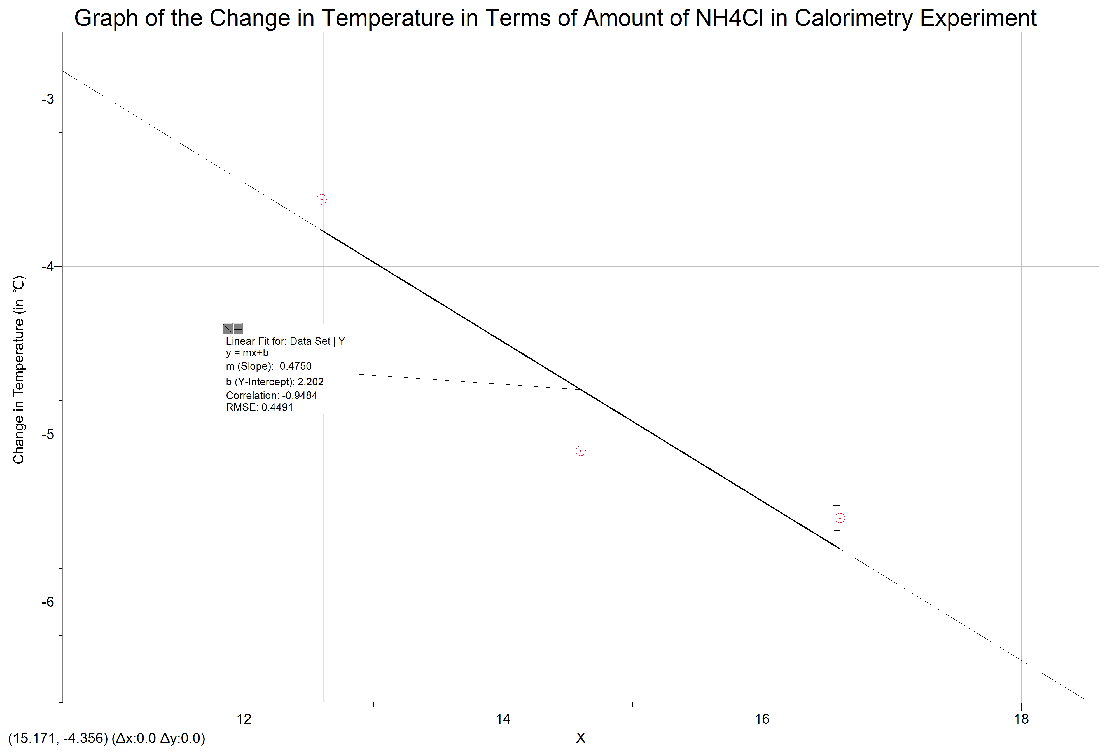
Amount of NH₄Cl (in g)

Graph 2:
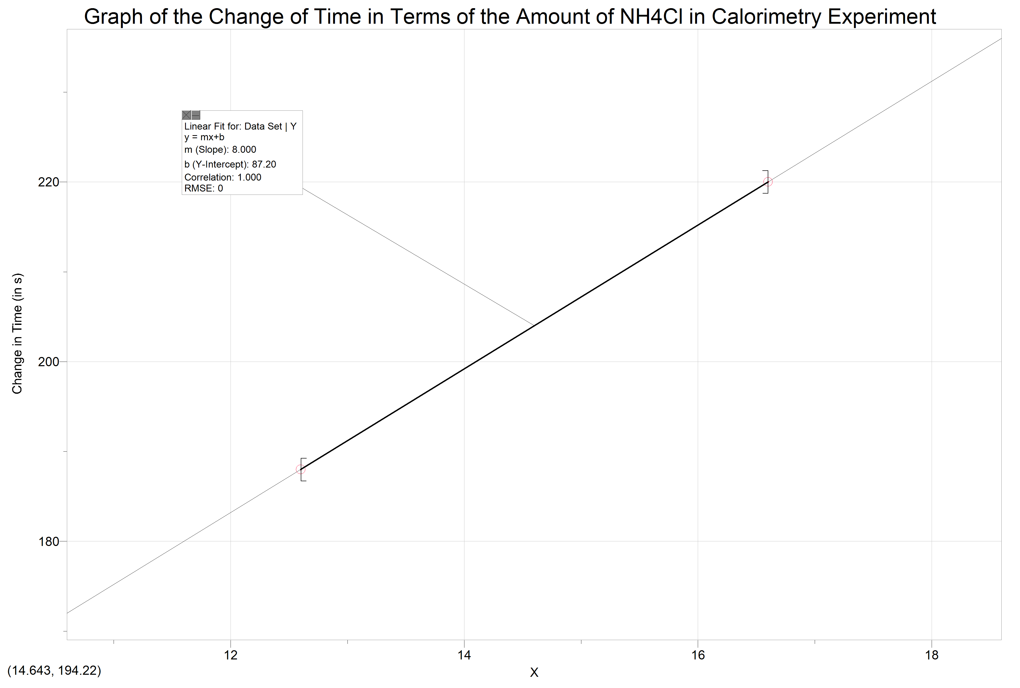
Amount of NH₄Cl (in g)

Discussion:
From our data obtained in the experiment, we found that our theoretical quantity ofNH₄Cl was also the experimental value that gave us the most accurate temperature change required for our task. We did not record the change in time of the 1st trial. This is was a human error on our part, but we could observe that a lower mass would give less of a temperature change and a larger quantity would give us a higher temperature change, both in less than 5 minutes. Therefore, our experimental data still supported our theoretical calculations for the mass of NH₄Cl that was required to change the temperature by -5$℃$.
Our experiment still contained other human errors. When we did the calorimetry, we did not properly combine the water and salt. To ensure that the salt was fully dissolved, we should have mixed the solution with a glass rod or some other piece of equipment so that the water could fully react (dissolve) the salt. This extra step could have made our data even more accurate but by not fully dissolving the salt we cannot be sure that our experimental results are accurate.
The design worked out for our experiment. By using the calorimeter, we were able to cool 100cm³ by 5$℃$. The inner container contained the drink and was sealed off from the outer container. The outer container would be where the water was contained and where the NH₄Cl would be added when you want the drink to be cooled. We based our design off the calorimeter because we knew that we would be able to conduct an energy change within a closed system and ensure that the salt would not mix with the drink.
A better design for our product might’ve included a separate receptacle that holds the salt and is able to dispense it for the consumer, rather than manually adding the salt. This could ensure that all energy stays within the system. Even though our calorimeter design is supposed to be a closed system, there is some time when it is open when the salt is first being incorporated. This could allow for some energy lost and the better design could eliminate this problem.

Conclusions:
The task was to find a product and design that would cool the temperature of a 100cm³ drink by 5$℃$. After deciding to use NH₄Cl due to the safety and cost concerns of NH₄NO₃, we conducted enthalpy calculations using the specific heat capacities of substance to calculate the mass of NH₄Cl required to react with 120mL of water to achieve the energy change. Our calorimetry-based design was capable in holding the reaction while not contaminating the drink. Although our experimental design worked, it could still have been improved to minimize energy loss.


