Acid Base Titrations

Written by:
Angelina Nguyen, 300053462

TA: Liuxen Ren

Date: Tuesday, November 6th, 2018

Introduction:
An acid base titration is a laboratory technique used in chemistry to determine the unknown concentration of an acidic or basic solution. It utilizes exact volumes of substances and the relationship between the concentration of a solution and its volume.
Acids and bases can be characterized by their interactions with each other in solution. By the Arrhenius definition of acids, they are substances that ionize in water to donate protons (H⁺). Bases are defined by their ability to dissolve in water and donate hydroxide ions (OH⁻). There are multiple other ways to characterize acids bases that can be simple, like by their taste and physical properties or by more specific properties. The Bronsted-Lowry definition of a base states that will also accept hydrogen ions as well as donate hydroxide ions. Additionally, the Lewis definition of acids and bases is in regard to the exchange of electrons between the substance. An acid is defined as accepting an electron pair in reaction while bases donate electron pairs. This is the most specific and expanded definition of acids and bases. The general dissociation equation of an acid (HA) and of a base (BOH) is
HA ⇌ H⁺ + A⁻
BOH ⇌ B⁺ + OH⁻
The strength of acids and bases is a measurement of the amount of ions that dissociate in solution of either substance. A strong acid or base will dissociate almost completely in solution, resulting in more products of ions than then original acid or base at equilibrium. Conversely, a weak acid or base is defined by its capacity to only partially dissociate in solution, resulting in some reactants and some products at equilibrium.
A titration is the addition of precise volumes of a solution with known concertation in a burette to a measured volume of a sample solution of unknown concentration. In order to determine the concentration of the sample solution, the volume of solution with known concentration can be gradually added to the sample until the solution becomes neutralized. By recording the volume of solution with known concentration required to neutralize the sample, calculations utilizing the relationship between concentration, volume and amount in moles can be done to determine the concentration of the sample. To be able to recognize when the solution has neutralized, an indicator is added to the sample. The point at which a sharp change in a measurable and characteristic property occurs is the endpoint of the titration. Regarding most indicators, the endpoint is a colour change. The equivalence point is the exact point in a titration at which neutralization is complete. In a good titration, these two points are within a very small range. In order for this to occur, the right indicator must be chosen for the reaction. Different indicators will dissociate at different pH levels; hence indicators must be chosen based on the estimated approximate pH at neutralization of the reaction. In a strong acid and strong base titration, the pH at the equivalence point will be 7 because of the full dissociation of each substance. With a weak acid or base, not all of the reactant will dissociate in solution and the remaining reactant species will affect the pH at the equivalence point.
Reference:
X. Z. Huang et al., "The Computer Simulation of the Acid-Base Titration", Advanced Materials Research, Vols. 634-638, pp. 20-24, 2013

Procedure:
As described in the lab manual (Acid Base Titrations, Dr. Rashmi Venkateswaran 2018, Exp. 4, p. 79-82)

Observations:
Part 1: NaOH is a clear, colourless and odourless liquid. Distilled water is clear, colourless and odourless. There was no reaction when the NaOH and the distilled water were combined. The resulting solution was clear, colourless and odourless.
Part 2. HCl is a clear, colourless and odourless liquid. In the first trial, the acid gradually changed to a light pink colour after approximately 7.0 mL of base was added. As more base was added, the pink colour became brighter and more distinct. The colour change as more base was added was relatively quick compared to the initial colour change. In the second trail, the acid gradually changed to a light pink colour after approximately 8.0 mL of base was added. As more base was added, the pink colour became more distinct.
Part 3. The unknown diprotic acid was clear, colourless and odourless. In the first trail, the acid very slowly changed to a light pink colour after 11.9 mL of the base was added. The colour continued to change into a brighter pink colour as more base was added but this occurred slowly. In the second trail, the acid slowly changed to a light pink colour after 13.0 mL of a base was added. The colour continued to change as more base was added and it occurred faster than in the first trial.
Data:
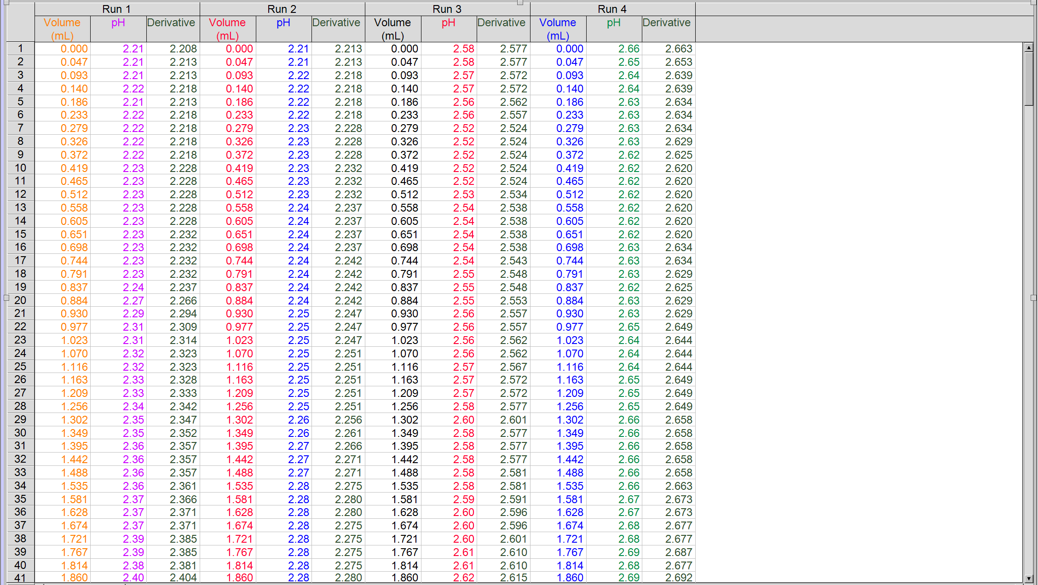
Calculations:
- Initial Volume of NaOH ($V_{1})$= 5 mL = 0.005 L
Initial Concentration of NaOH ${(c}_{1})$ = 6.0 mol/L
Total Volume ($c_{2})$ = Volume of Water + Initial Volume of NaOH = 250mL + 5mL = 255mL = 0.255 L
$$c_{1}V_{1}= c_{2}V_{2}$$
$c_{2}= \frac{c_{1}V_{1}}{V_{2}}= \frac{\left(0.005 L\right)(6.0{ mol}/L ) }{0.255 L}=0.12 {mol}/L$
- Volume of NaOH ($V_{NaOH})$ = 7.395 mL = 0.007395 L
Concentration of HCl (c_{HCl}) = 0.100 mol/L
Volume of HCl (V_{HCl}) = 9.81 mL = 0.00981 L
$c_{NaOH}V_{NaOH}=c_{HCl}V_{HCl}$
$$c_{NaOH}= \frac{c_{HCl}V_{HCl}}{V_{NaOH}}= \frac{\left(0.100\frac{mol}{L}\right)(0.00981 L)}{0.007393 L}=0.133 mol/L$$

- Volume of unknown acid (V_{A}) = 9.82 mL = 0.0982 L
Concentration of NaOH ($c_{NaOH})$ = 0.133 mol/L
Volume of NaOH ($V_{NaOH}$) = 13.256 mL = 0.013256 L
$c_{A}V_{A}={2c}_{NaOH}V_{NaOH}$
$$c_{A}= \frac{2c_{NaOH}V_{NaOH}}{V_{A}}= \frac{2\left(0.133\frac{mol}{L}\right)(0.013256 L)}{0.0982 L}=0.0359 mol/L$$

Graphs:
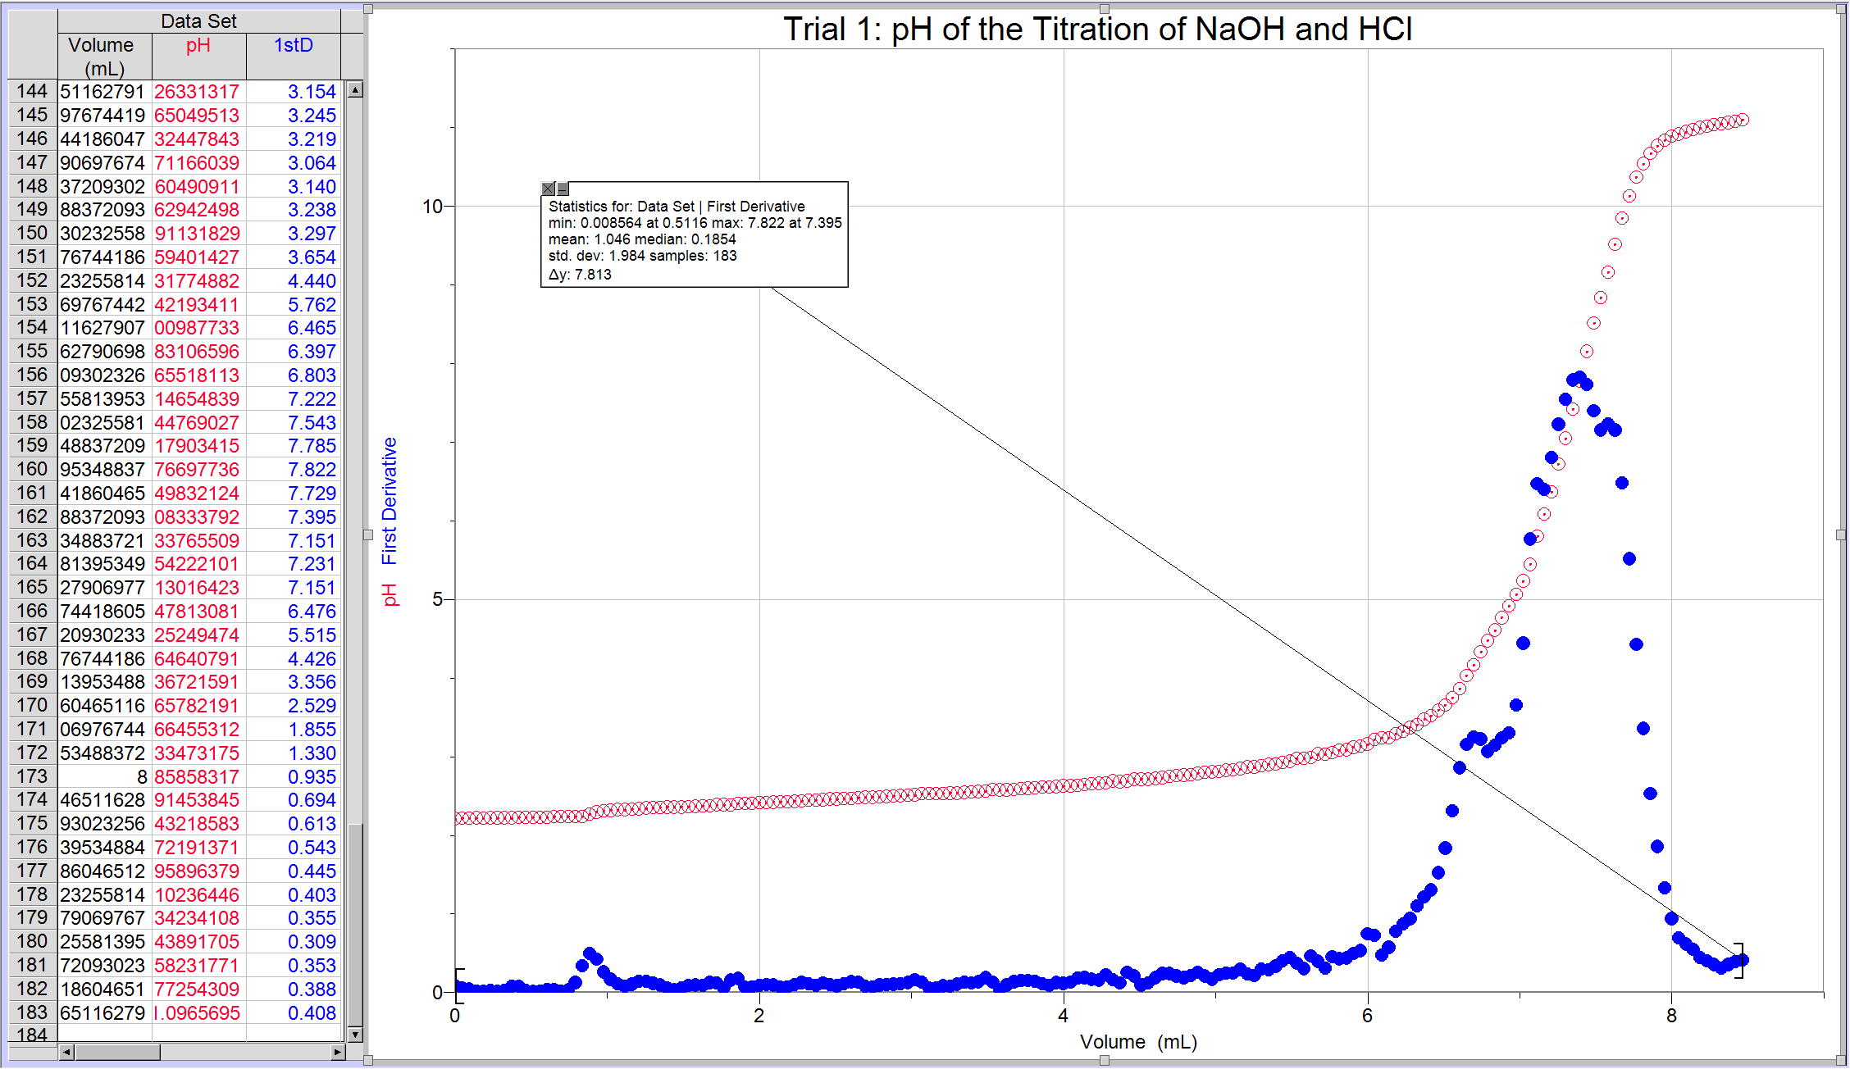
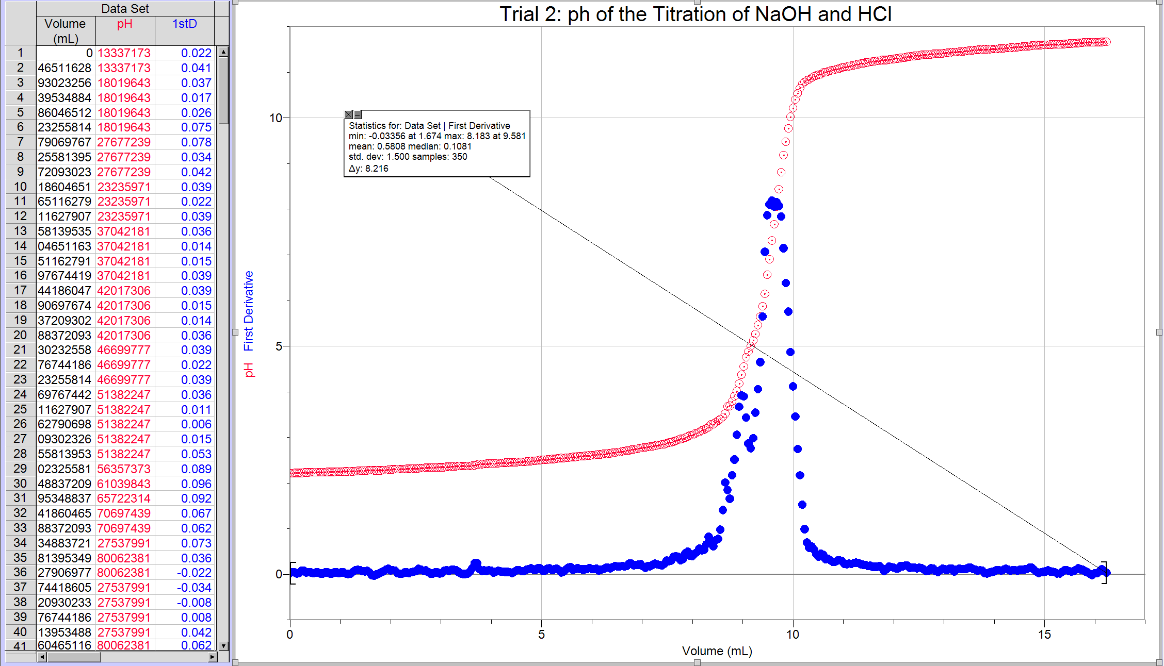
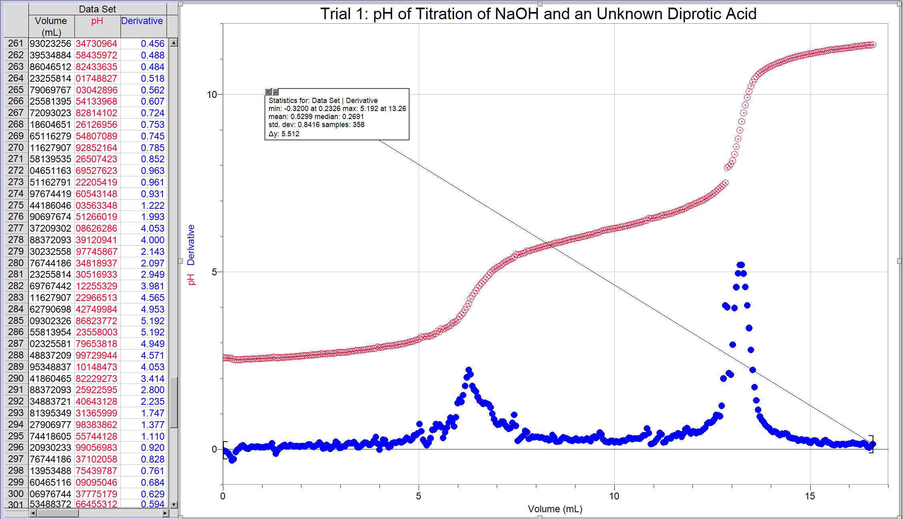
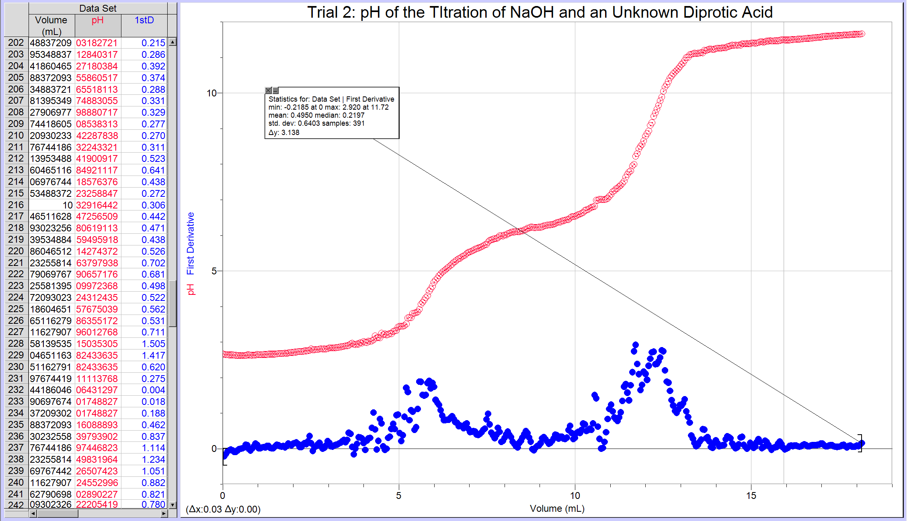
Discussion:
In the experiment, a solution of NaOH was prepared by diluting concentrated NaOH. This solution was then standardized against an acid solution of known concentration so that the exact concentration of the prepared NaOH solution could be determined. An acid of unknown concentration was then titrated with the standardized solution using volumetric titration techniques. Once titrated, the exact volume of base required to attain the endpoint of the reaction was obtained and recorded. With this information, the concentration of the acid was calculated. The experiment was successful in obtaining values of concentration to be used in the calculations. Sources of error in this experiment were inherent in the method while others were experimental. Inherent errors of the experiment include that the endpoint and the equivalence point are not the same. The endpoint is just an observation of the visible change of the solution whereas the equivalence point is the exact point at which the solution is neutralized. Additionally, the colour change of the indicator. The base solution is not stable over a long period of time, therefore it must be used quickly and the time the experiment takes could effect the titration. If the solution changed significantly during the experiment, the results would be useless. The rate of drops depended on the volume of solution in the burette, therefore the burette had to be refilled with solution for every trial to keep consistent results. If the solution destabilized over time, the value of the concentration would decrease. If the endpoint is not accurately observed, the concentration would increase, assuming that too much of the titrant was added in order to reach a more obvious colour change.
The concentration of NaOH was calculated before it was titrated to be able to have a comparable approximate concentration. In doing this, there is a value that can be used to determine the accuracy of the titration. If the values are near each other, than the titration was successful. The observed volumes at of NaOH used to reach the colour change/endpoint of the titration were relatively close to the volumes at the equivalence point determined by Logger Pro. The observed volume at the endpoint was 7.0 mL while the volume determine by Logger Pro was 7.39 mL. The volumes differ because the observed value was just an observation of the difference of volume of the burette which can have human error while Logger Pro measured the drops of NaOH that was added to the sample and therefore is more accurate.
In the titration of unknown acid, when there is 0mL of added base in the solution, it is expected that there is only unknown acid since there is no NaOH, no neutralization reaction taking place.
Key of Symbols:
Unknown Acid:

NaOH:

H⁺:

OH⁻:

B⁻ (of unknown acid):

Na⁺:

At midway to the first equivalence point, there should be some products of the reaction of the unknown acid and NaOH and some of the unknown acid undissociated (because it’s a weak acid). (have added 2 molecules NaOH).

H₂A + NaOH ⇌ HA + NaA + H₂O
At the first equivalence point, all of the molecules of unknown acid would have reacted with NaOH donating only one proton to OH⁻ to form water molecules. (Adding another 2 molecules of NaOH)

At midway to the second equivalent point, the molecules of unknown acid will lose the other hydrogen atom in the reaction with NaOH. This will form more water molecules. There will not be enough NaOH to react with all the molecules of acid so there will be some unreacted acid left over as well.

HA + NaA + NaOH ⇌ NaA₂ + H₂O
At the second equivalence point, all of the unknown acid would have reacted and lost all of its hydrogens.

Conclusion:
The concentration of NaOH was calculated to be approx. 0.12 mol/L but determined to be 0.133 mol/L though the standardization titration calculations. The concentration of the unknown acid was determined through the titration calculation to be 0.0359 mol/L. The experiment was successful in standardizing a solution of NaOH and using the standardize solution to titrate a solution of acid of unknown concentration.



