The skin accounts for 7% of the body weight
It is the biggest organ.

Thickness varies based on location Ex: Feet skin is more thicker
It is made of 2 layer
  - Epidermis
    - Avascular (no blood vessels. Gets its nutrient via diffusion)\
    - Made of epithelial tissue (keratinized stratified squamous epithelium)
    - New skin 25-45 days
    - Most epidermis cells are keratinocytes
    - Mitosis/keratin production rate is higher in areas of high friction (feet, hands)
      - Causes a thickening called Callus
    - Four cell types

  - Keratinocytes
    - Main goal = produce keratin (fibrous protein)
      - Arise from deepest layer of the skin
    - Connected by desmosomes
    - Waterproofs the skin
    - Continuous Mitosis promoted by epidermal growth factor
      - A peptide made by different cells throughout the body
    - Keratin eventually dominates
    - At the skin surface… keratinocytes are dead (keratin filled plasma membrane )

  - Melanocytes
    - Spider shaped epithelial cell
    - Found in the deepest layer
    - Main goal = make melanin
      - Melanin is contained in membrane bound granules (melanosomes)
      - Motor proteins move this granule along an actin filament to the spiders hands.
      - Granules are transferred to keratinocytes
        - They accumulate on the sunny side of the keratinocyte NUCLEUS.
          - This protects from UV light damage to the DNA
    - Tanning = increase the production of melanin

  - Dendritic cells aka Langerhans cells
    - Star shaped
    - Arise from bone marrow and come to epidermis
    - Main goal = ingest foreign substances
    - Key activators of the immune system

  - Tactile (Merkel) cells
    - Found at epidermal-dermal junction
    - Linked with a disc like sensory nerve ending
      - Sensory receptor for touch

  - 4-5 layers (Come Lets Get Sun Burnt)
    - Stratum Basale (Basal Layer) or Stratum Germinativum
      - Inner most layer of the skin
      - Attached to dermis
      - Consists of 1 row of stem cells (mitosis)
      - Each time one mitotic cell divided … one is pushed upward to become a mature keratinocyte and the one stays to divide more.
      - 10-25% are melanocytes
        - Their branches can reach into the next layer

  - Stratum Spinosum (Prickly layer)
    - Web like system of intermediate filaments
    - Keratinocytes appear to have spines (hence the name)

  - Stratum Granulosum (Granular layer)
  - Stratum Lucidum (Clear layer)
    - Absent in thin skin (low abrasion areas
  - Stratum Corneum (Horny Layer)

  - Dermis
    - Vascular
    - Made of Dense connective tissues
    - Semifluid matrix bind the entire body
    - Rich supply of nerves, blood and lymph vessels
    - Hair follicles, oil, sweat glands reside in dermis
    - Extreme stretching can tear the dermis
      - Causes different coloured scars called stretch marks
    - Has 2 layers
      - Papillary
        - Areolar connective tissue
        - Loose Interlacing collagen and elastic fibers form a mat filled with blood vessels
        - Projections = Dermal Papillae
          - Cause the indentations on epidermis
          - Contain nerves (pain & touch) and capillaries
        - Thick skin
          - Papillae lie atop dermal ridges
            - This gives rise to epidermis ridges aka friction ridges
              - Enhance grip and sense of touch
              - Have sweat pores on the crests which leave marks aka fingerprints
              - Genetically unique

  - Reticular
    - Deeper dermis & Thicc
    - Make up 80% of the dermis
    - Dense irregular connective tissue
    - Extracellular matrix has adipose cells and interlacing collagen fibers
    - Less dense areas of collagen fibers form cleavage lines
      - These line run parallel to skin surface
      - If surgery incision is done parallel to these line… it heals faster/better
    - The cutaneous plexus (blood vessels) supply it
      - Located between the hypodermis and reticular dermis
    - Collagen fiber benefits
      - Strength and Resiliency
      - Binds with water
    - Elastic fiber benefits
      - Stretch and recoil
    - Flexure line (ex: life line?)
      - Dermal folds where the dermis is tightly secured to deep structure
      - Allow for folding in areas where skin can not slide easily.
    - Burns or repeated frictions can cause blisters
      - Separation of the epidermal and dermal layer

Hypodermis (under the skin)
  - Also called superficial fascia
  - NOT really part of SKIN (but shares similar protective properties)
  - Made of areolar CT
  - Made of mostly adipose tissue
    - Stores fat, Insulates, prevents heat loss and shock absorbs
  - Anchors skin to underlying structures mostly muscles

Skin colour is determined by Melanin, Carotene, Hemoglobin
  - Melanin is the only one that is made in the skin

Melanin
  - Polymer made of tyrosine amino acid
  - 2 forms
    - Reddish yellow
    - Brownish black
  - Synthesis is dependant on the enzyme Tyrosinase
  - Melanosomes are sent to shield the DNA from UV
    - Absorbs UV and releases it back as heat
  - Found only in the deeper layer of the epidermis
  - All humans have the Same amount of melanocytes
    - Difference = amount of melanin and retainment of pigment by keratinocytes
  - Freckles and moles = Local accumulation of melanin
  - Sunlight causes keratinocytes to release chemical that stimulate melanocytes
  - Too much sun = clumping of elastic fibers
    - Leathery look
    - Depress immune system

Carotene
  - Yellow to orange pigment
  - Found in some plants (carrots)
  - Accumulates in stratum corneum and fatty tissue (hypodermis)
  - Colour is more obvious
    - corneum is the thickest (soles, palms)
    - Eat lots of carotene rich foods
Can be converted to Vitamin A (good for vision and skin health

Hemoglobin
  - Pinkish hue
  - From oxygenated hemoglobin
  - Lighter skin shows more because of the lack of melanin
  - Cyanosis
    - When hemoglobin is poorly oxygenated
    - Common during heart failure or respiratory issues
    - Darker skin people = only visible in mucosa and nail beds

Skin appendages
  - Accessory on the skin
  - Hair, Nails, Sweat and Sebaceous glands

HAIR or Pili
  - Produced by hair follicles
  - Dead, keratinized cells
  - Hair = HARD keratin
    - Tougher and durable
    - Individual cells do not flake off
  - Skin = SOFT keratin

  - Found everywhere except
    - Palms
    - Soles of feet
    - Lips
    - Nipples
    - Part of pubic area
  - Function
    - Detect insects
    - Guard head from trauma (cushion)
    - Prevent heat loss
    - Protect from sunlight
    - Nose filters
    - Eyelashes shield eyes
  - Structure
    - Shaft = keratinization is complete
      - Flat & Ribbonlike = Kinky
      - Oval = Silky/wavy
      - Perfectly round = Straight
    - Roots = Keratinization is ongoing
    - 3 layers
      - Medulla
        - Center
        - Only part in hair that contains soft keratin
        - Absent in fine hair
        - Large cells and air space

  - Cortex
    - Bulky layer
    - Surrounds medulla
    - Many layer of flattened cells
    - Hair colour is transferred here from

  - Cuticle
    - Outer most
    - Single layer of cells overlapping
    - Provides strength
    - The ends have no cuticles because of high abrasion
      - Spilt ends
  - Melanocytes at the base of the hair
    - Based on amount of melanin hair can be blonde or black
    - Red hair = pheomelanin
    - Decrease in melanin
      - Air bubbles fill up space
      - Hair turns white or gray

  - Hair follicles
    - Fold down from epidermis into dermis
      - In the scalp = into hypodermis
    - The deep end of the follicle forms a hair bulb
    - Hair bulb is surrounded by hair follicle receptors (root hair plexus)
      - Wraps around each hair bulb
    - Hair Papilla
      - Dermal tissue that protrudes into the hair bulb
      - Contains a knot of Capillaries
        - Supplies nutrient
    - Follicle Wall is made of
      - peripheral connective tissue sheath
        - Dermis
      - Thick basal lamina (glassy membrane)
      - Inner epithelial root sheath
        - Made from an invagination of the epidermis
        - Thins as it gets closer to the hair bulb
        - Only 1 layer covers the hair Papilla

  - 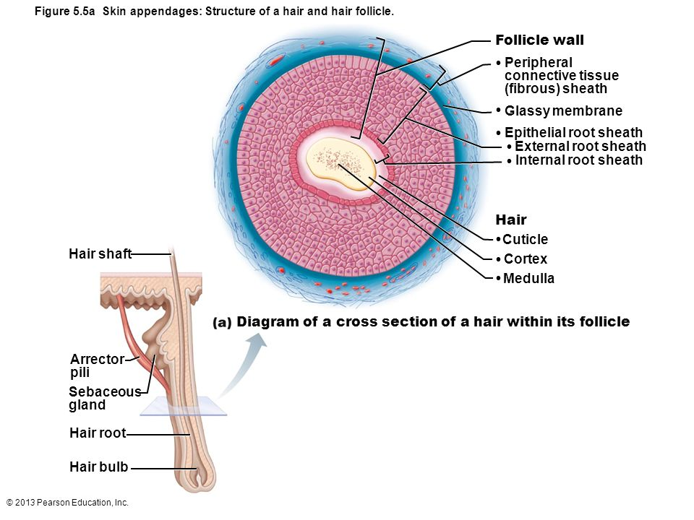

Hair matrix = Actively dividing part of the hair bulb that produces hair cells
  - Arrector pili
    - Bundle of smooth muscle cells
    - Its contractions causes the hair follicle to stand up (goose bumps)
      - Its important to other animals because
        - Retains heat
      - In humans, the contraction
        - Forces sebum out of hair follicles
          - Lubricates the skin

REST is on the power point S14

