Introduction
The purpose of this experiment was to investigate and show beyond doubt the validity of Charles and Boyle’s Laws. In this study one attempts to prove that as the volume is increased within a syringe, the pressure decreases. When the volume is decreased back to its initial amount, the pressure exerted by the gas reverts proportionally to the aforementioned volume.
During part B of this experiment, one aims to observe how volume and temperature of an ideal gas have a direct relationship to each other.

Context
Charles’ Law states that the temperature and volume of an ideal gas at a constant pressure are directly proportional. V1$÷$ T1 =V2 $÷$ T2
Boyle’s Law states that at a fixed temperature, the volume of a gas of a container is inversely related to the pressure of that gas. This means that when the volume of a gas in a container increases, the pressure exerted by that gas decreases and vice versa.
V=k($\frac{1}{p}$)

Objective :This laboratory experiment aims to verify Boyle’s Law (Part A) and Charles’ Law(Part B).

Part A

Hypothesis
By changing the volume of gas in the syringe, we will be able to see the relationship between the pressure exerted by the gas and the volume in the container. Based on Boyle’s Law, we hypothesize that as we change the amount of volume within the container, we will see an inverse relationship with pressure and volume. Thus, if we decrease the volume in the syringe, the pressure of the gas will increase. On the other hand, if the volume in the enclosed space is increased then the pressure of the gas will decrease.

Materials :
250mL Erlenmeyer flask
1 Rubber stopper
600mL Beaker
400mL water
Hot plate
1 permanent marker
2 Graduated cylinders

Procedure :

Data and Observations
- There was 0.8 mL of space inside the pressure sensor therefore we had to add 0.8 mL to our volume readings.
- Furthermore, during trial 1, the best plotted point of the pressure at the same volume of 5.8mL was the first one because there is more likely to be a discrepancy after the first reading due to human errors.
Trial 1.
Volume (mL) - Independent Variable | Pressure (kPa) - Dependent Variable
5.8mL | 101.35 kPa
7.8mL | 70.17 kPa
9.8mL | 58.49 kPa
11.8mL | 49.21 kPa
13.8mL | 41.14 kPa
15.8mL | 36.00 kPa
17.8mL | 32.47 kPa
19.8mL | 28.60 kPa
5.8mL | 101.48 kPa

Trial 2.
Volume (mL) - Independent Variable | Pressure (kPa) - Dependent Variable
5.8mL | 100.64 kPa
7.8mL | 77.00 kPa
9.8mL | 59.68 kPa
11.8mL | 49.43 kPa
13.8mL | 41.71 kPa
15.8mL | 35.99 kPa
17.8mL | 31.83 kPa
19.8mL | 28.53 kPa
Average Pressure (Trial 1 and 2)

Volume (mL) - Independent Variable | Average Pressure of Trial 1 and 2 - Dependent Variable
5.8mL | 101.16 kPa
7.8mL | 73.59 kPa
9.8mL | 60.86 kPa
11.8mL | 49.65 kPa
13.8mL | 41.43 kPa
15.8mL | 36.00kPa
17.8mL | 32.15kPa
19.8mL | 28.57 kPa

Results (analysis,graph)

Figure 1.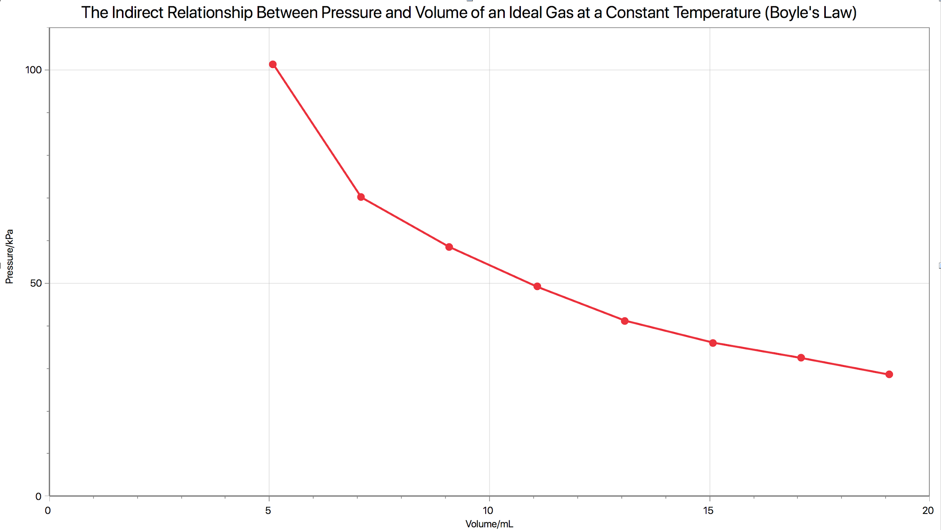

Figure 1. This graph shows that as the volume of gas was increased in the syringe, the pressure decreased. When the volume of gas was reduced in the enclosed space the pressure increased. This inverse relationship between volume and pressure applies to Boyle’s Law provided that the temperature remains constant.

Analysis

Pressure is the result of particles colliding with themselves and the container. The smaller the enclosed space is, the more frequent the collisions will be which will only create more pressure. Therefore, by decreasing the volume of gas in the syringe, the particles became more densely packed which created more pressure. Contrarily, by increasing the volume of the gas, the particles had more space and less chance to collide with one another and the container. Therefore, the collision frequency decreases as volume is increased. This means that as the volume increases, the overall pressure decreases which applies to Boyle’s Law.

Boyle’s Law Questions
- Using your data, calculate a Boyle’s law constant. Explain how you determined the constant.
PV=k
K average = (P1V1)+(P2V2)+(P3V3)..../ Total number of points
=(5.8mL*101.16 kPa)+(7.8mL*73.59 kPa) +(9.8mL*60.86 kPa) + (11.8mL* 49.65 kPa) + (13.8mL*41.43 kPa) + (15.8mL*36.00 kPa) + (17.8mL*32.15kPa) + (19.8mL*28.57 kPa) /7 points

=660.22 kPa*mL
=0.66 kPa * L

The constant can be found by PV=k. P1V1=P2V2= k since all points of pressure and volume are equal to the constant. Therefore, by averaging the results of pressure and volume at different intervals, the overall constant can be found.

- Describe the mathematical relationship illustrated by Boyle’s law, and use the constant you calculated in Step 1 to write an equation for Boyle’s law.

The mathematical relationship of Boyle’s Law can be represented by V$=(\frac{1}{p}$) or P= ($\frac{1}{V}$) under the condition that the temperature remains constant. This equation demonstrates the inverse relationship that pressure has with volume meaning that as one increases by a certain factor, the other decreases by that factor and vice versa. This entails that the pressure and volume of one point will be equal to a constant and thus be equal to another point which can be represented by P1V1=P2V2=k

V=k ($\frac{1}{p}$)
V= 660.216857 kPa*mL($\frac{1}{p}$)

The pressure is inversely proportional to volume. We know pressure multiplied by volume (PV) gives us a constant. The two factors can be put together to form the equation for Boyle’s Law.

- You were directed to take your first and last measurements at the same mark on the syringe. Speculate about the importance of taking multiple readings of the dependent variable for the same value of the independent variable.

It is important that you take your first and last measurements at the same mark on the syringe to prove that the pressure and volume remain the same, since the pressure should remain constant to the volume at all times. It is crucial to take first and last measurements at the same mark on the syringe in order to verify that the experiment is going well. Taking multiple readings can help to avoid the possibility of human errors which could have significant effects on data intake.

- Boyle’s law requires certain conditions be met for other gas variables. What are these variables? Did you take these variables into consideration? What did you do to ensure they remained constant? Does this affect your results? If so, how? If not, why not?

The four gas law variables are: temperature, pressure, volume, and moles. Upon performing the lab, it was assumed the experiment would be performed under standard atmospheric pressure and that the temperature would remain constant. Boyle’s Law states that the volume and pressure of a gas are inversely proportional under the condition that the temperature remains constant since both pressure and volume are proportional to temperature. Therefore, if the temperature fluctuated during the experiment, it could potentially hinder our results. However, it is unlikely that the temperature in the surrounding environment changed significantly. A plausible human error could have been excess warmth coming from our hands. Nonetheless, these temperature changes would be so minimal that they would not affect the verification of Boyle’s Law.

Conclusion

It was discovered that as the volume was increased within the syringe, the pressure decreased. When the volume was decreased back to its initial amount, the pressure exerted by the gas increased again. It was observed that volume of the gas varies inversely with the pressure at a constant temperature. Therefore, Boyles’ Law was successfully verified.

Part B - Charles’ Law

Hypothesis
According to Charles’ Law, the temperature and volume of an ideal gas are directly proportional at a constant pressure. Therefore, we hypothesized that as the temperature increased, so would the volume of the gas. When the temperature of the gas decreased, the volume would increase.

Material:
- Labquest
- Gas Pressure sensor
- 20 mL Gas syringe
- USB key
Procedure :
Please refer to page 7 “Verification of Charles’ Law” in the laboratory manual.

Data and Observations

The volume, V2, occupied by the gas at temperature T2 is the difference between the total volume, V1 and Vcw.

V2 = V1-Vcw
= 150-40
= 110 mL

V1 | Total Volume | 150 mL
T2 | Ice bath after submerging | 4.2°C or 277.35 K
Vcw | Water in graduated cylinder | 150 mL
T1 | Temperature of Boiling Water | 100°C or 373.15 K
V2 | Volume occupied by the gas (difference between V1 and Vcw) | 110 mL

Charles Law (with the experimental values)
v1/t1= v2/t2
150/373.15 = 110 mL /277.35 K
0.402 = 0.396
0.40$≈$0.40

Theoretical Value

Final Volume (mL) =
[ Initial Volume (mL) x Final Temperature (K) ]$÷$[ Initial Temperature (K) ]

Final Volume (mL) = 150 mL x 277.35 K $÷$373.15 K
= 111.49 mL

Verifying Theoretical Value:

v1/t1= v2/t2
150 mL /373.15 K = 111.49 mL /277.35 K
0.4019=0.4019 ✓

% Error = [ Theoretical value - Actual value $÷$ Theoretical ] x 100
=[ (111.49 - 110) $÷$ 111.49] x 100
= (1.49 / 111.49) x 100
=0.0134 x 100
$≈$1.34 %

Results
It was observed that the temperature and volume are directly proportional. When the temperature of the gas increased, so did its volume. When the temperature dropped in the ice bath, the volume decreased as well. However, there was a small percent of error upon performing the lab. It can be assumed that the sources of errors came from the assumption that the amount of gas and pressure remained constant (at STP). The percent error of this lab could have also been a result of human errors such as timing to allow the flask to cool in the ice bath or the loss of pressure whilst transitioning the flask from the burner to the water.

Conclusion
During the experiment, it was observed how volume and temperature of an ideal gas have a direct correlation with each other. The percent error was approximately 1.34%. Nonetheless, a positive correlation between temperature and volume was realized. Therefore, Charles’ Law was successfully verified.

