ANP 1107 – Digestive System Anatomy and Physiology + Metabolism
1.1 Summarize the general anatomical features of the digestive system

1.1.1. differentiate between the components of the alimentary canal and the accessory digestive organ
Alimentary Canal Organs | Accessory Digestive Organs
- Mouth  - Pharynx  - Esophagus  - Stomach  - Intestines | - Teeth  - Tongue  - Salivary glands  - Liver  - Gallbladder  - Pancreas
A continuous muscular tube from the mouth to the anus. The role is to digest food, absorb nutrient fragments from lining into blood stream and excrete waste products of digestion | Are attached to the main alimentary canal through ducts (except teeth and tongue). Most of the organs produce secretory products (ex: bile, saliva, enzymes) that aid food digestion

1.1.2. describe the relationship between the various digestive organs and peritoneum
The various digestive organs are found within the abdominopelvic cavity that is lined with slick serous membranes (the visceral peritoneum lines the organs and the parietal peritoneum lines the cavity). Between the serous membranes is the peritoneal cavity which contains serous fluid (the fluid reduces friction and prevents organs from sticking together). In addition, the mesentery (a fused double layer of parietal peritoneum) carries vessels/nerves to the organs of the GI tract, keeps organs fixed (no knots) and stores fat. Omentum is the special name for part of the mesentery extending from the curvatures of the stomach.
- Intraperitoneal: organs that keep their mesentery and remain in the cavity
- Retroperitoneal: organs that lose their mesentery and lie posteriorly to the cavity
- Peritonitis: inflammation of the peritoneum that may be caused by (piercing abdominal wound, a perforated stomach ulcer, poor sterile techniques or a burst appendix that transfers resident intestinal bacteria
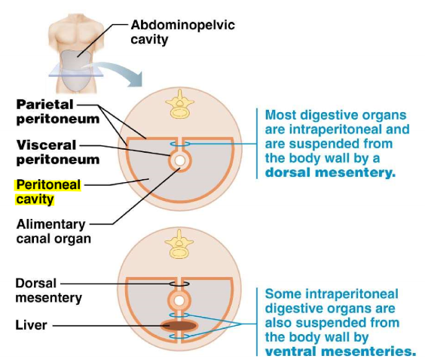
1.1.3 Outline the blood supply serving the main components of the GI tract
ARTERIAL - Splanchnic circulation branches off the abdominal aorta and serves the digestive organs and the hepatic portal circulation (following arteries are included in HPC). They usually receive about ¼ of the cardiac output and this increases after a meal.
- Hepatic artery: serves the liver
- Gastric artery: serves the stomach
- Splenic artery: serves the spleen
- Superior and inferior mesenteric arteries: serves the small and large intestines
VENOUS RETURN – Majority of the abdominopelvic region drains into the inferior vena cava. Digestive viscera drain into the hepatic portal system (to filter out nutrients, metabolic processing and detoxification) before entering the inferior vena cava.

1.1.4 Describe the histology of the GI tract wall
Four layers: mucosa, submucosa, muscularis externa and serosa (aka visceral peritoneum or adventitia in the esophagus)
- Mucosa: role to secrete mucus, digestive enzymes and hormones; absorption of digestive products, and protection against infections
  - Epithelium: simple columnar epithelia and goblet cells or stratified squamous epithelium (in the mouth, esophagus and anus)
  - Lamina propria: vascular areolar connective tissue, MALT tissue
  - Muscularis mucosae: smooth muscle cells that are responsible for local movements and maintaining the folds in the small intestine
- Submucosa: dense connective tissue layer, vascularized, highly elastic and allows the stomach to regain its shape after meals
- Muscularis externa: inner circular layer and outer longitudinal layer of smooth muscle tissue (for propulsive movements and formation of sphincters at junctions)
- Serosa: loose connective tissue covered in simple squamous epithelium
- *Adventitia*: made of fibrous connective tissue, present in retroperitoneal organs on the dorsal side that faces the rest of the body cavity alongside the serosa (replaces the serosa in the esophagus)
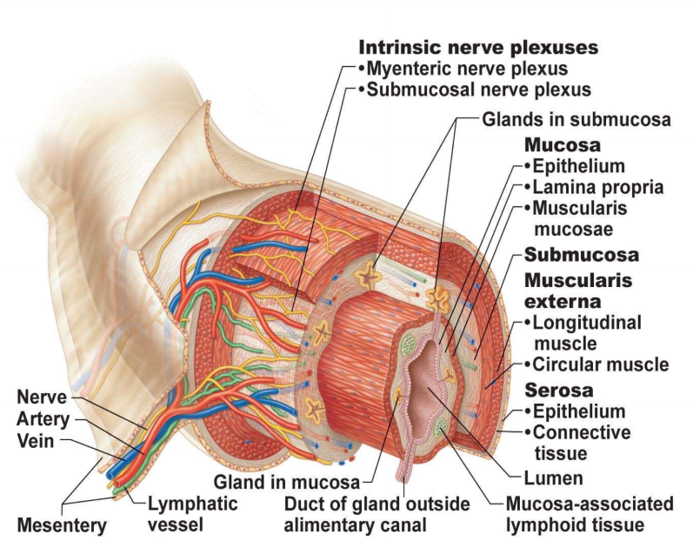

1.2 Describe the functional anatomy of the GI tract
1.2.1.describe the functional anatomy of the mouth, pharynx & esophagus
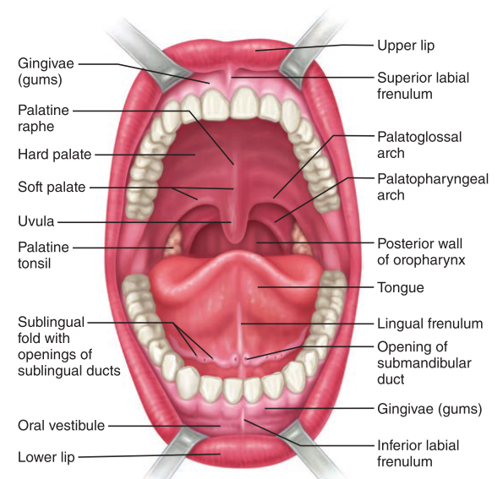
- Mouth: the tongue is covered in keratinized stratified squamous epithelium
- Lips: orbicularis oris skeletal muscle, red margin as the line of demarcation where there are no sweat or sebaceous glands
- Cheeks: buccinator skeletal muscle
- Palate: hard palate aids in chewing, soft palate with skeletal muscle blocks the nasopharynx, palatoglossal-palatopharyngeal arches connect the soft palate to the tongue and oropharynx
- Tongue: interlacing skeletal muscle fibers, taste buds and salivary glands (intrinsic skeletal muscles alter shape and extrinsic skeletal muscles alter position)
  - Filiform papillae: conical keratinized projections that provide friction and manipulate foods at the TIP
  - Fungiform papillae: mushroom-shaped projections with taste buds in the MIDDLE
  - Vallate papillae: V-row at the BACK with taste buds
  - Foliate papillae: contain taste buds at the lateral SIDES
- Salivary glands: extrinsic parotid (mostly serous), submandibular (70% of saliva) and sublingual glands (mostly mucous); intrinsic buccal glands (lingual lipase), amylase
  - Serous: watery secretion
  - Mucosal: mucous secretion (thick mucin)
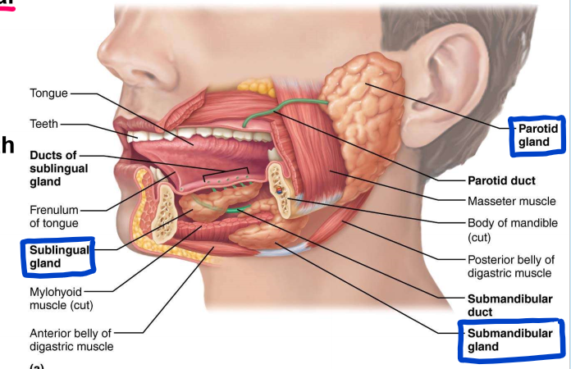
- Teeth: found in alveoli sockets in gum-covered margins of the mandible and maxilla.
  - Primary dentition: (20 teeth – 2I, 1C, 2PM, 0M in one quadrant)
  - Permanent teeth: (32 teeth – 2I, 1C, 2PM, 3M in one quadrant)
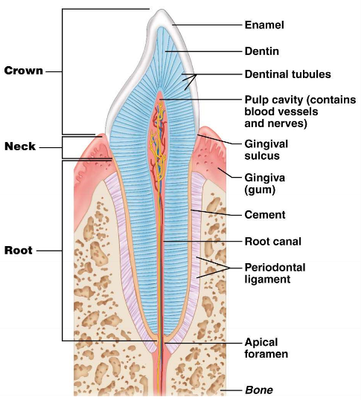
- Pharynx: oropharynx and laryngopharynx are involved in the GI tract, covered in stratified squamous epithelia, three skeletal muscles (superior, middle and inferior pharyngeal constrictors)
- Esophagus: muscular tube of 25 cm, resting=collapsed, passes through the diaphragm at the esophageal hiatus, joins the stomach at the cardial orifice, gastroesophageal sphincter (physiological sphincter as there is not thickening), it is folded when empty to allow expansion

1.2.2.describe the functional anatomy of the stomach
The stomach acts as storage tank between the small intestine and the small intestine. It has multiple regions: cardia, fundus, body, pyloric region (antrum, canal and sphincter). There are rugae that unfold as the stomach distends.
- Sympathetic: innervated with thoracic splanchnic nerves (E and NE)
- Parasympathetic: innervated with vagus nerve (ACh)
- Gastric pits (lead to gastric glands) are embedded within the mucosa:
  - Mucous neck cells: at the neck of the gland; produce acidic mucin
  - Parietal cells: secrete HCl and intrinsic factor (to activate pepsinogen and absorbs/carries B12 for blood and myelin)
  - Chief cells: secrete pepsinogen (a protease)
  - Enteroendocrine cells: secrete hormones that include gastrin, histamine, serotonin and somatostatin)
Protective mechanisms: the mucosal layer is lined with bicarbonate and mucous to prevent irritation, tight junctions between epithelial cells, replacement of the epithelial cells (via stem cells) occurs every 3-6 days.
- Ulcers: Helicobacter pylori contributes to ulcers: releases neutralizing secretions so it can survive in the acidic stomach, secretes cytotoxins that damage the mucosa cells which ruptures cell adhesion (and therefore the protective mechanisms) which causes inflammation and further tissue damage. It can be healed with antibiotics. Or cimetidine (Tagamet) to inhibit histamine-H2 receptor to block histamine action (increases HCl production) or omeprazole which has similar effects.
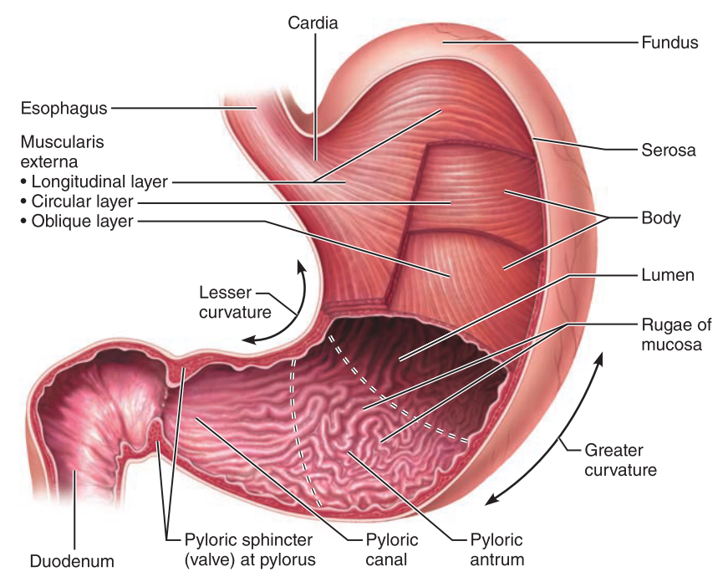

1.2.3.describe the macroscopic and microscopic anatomy of the small intestine
The small intestine is the major digestive organ (both in size and importance). It extends from the pyloric sphincter to the ileocecal valve. There are three sections (1) the duodenum – retroperitoneal, shortest division, hepatopancreatic ampulla and sphincter (2) the jejunum - intraperitoneal (3) the ileum – the longest portion, intraperitoneal. The jejunum and the ileum are attached posteriorly by the mesentery (therefore they are still intraperitoneal)
- Sympathetic: innervated by the thoracic splanchnic nerves
- Parasympathetic: innervated by the vagus nerve
To maximize mucosa surface area, the small intestine has circular folds, villi and microvilli
- Circular folds: aka plicae circulares, permanent circular folds within the mucosa and submucosa. Its purpose is to increase SA and slow down the flow of chyme
- Villi: small finger-like projections of mucosa (longest in the duodenum where there is the most absorption and shorten over the length of GI tract). At their core is a dense capillary bed and lacteals for fatty chyme absorption
- Microvilli: comprise the brush border (apical side) of the enterocytes (simple columnar cells) that makes up the mucosa. The brush border has stationary enzymes that finish the digestion of proteins and carbohydrates
- Duodenal/Brunner’s glands: secrete bicarbonate in the small intestine to prevent ulcers in the mucosa from the acid chyme that has just left the stomach
- Intestinal/Lieberkühn’s Crypts: simple tubular glands between the base of villi. They secrete intestinal juices (watery, mucous, alkaline). They have Paneth cells at their base (secrete defensins and lysozyme), active stem cells to promote the renewal of the intestinal mucosa every 4-6 days(to maintain ideal absorption), enteroendocrine cells and goblet cells
- Anticancer drugs affect rapidly-dividing stem cells: reduces the ability for the intestines to reabsorb water and this causes diarrhea
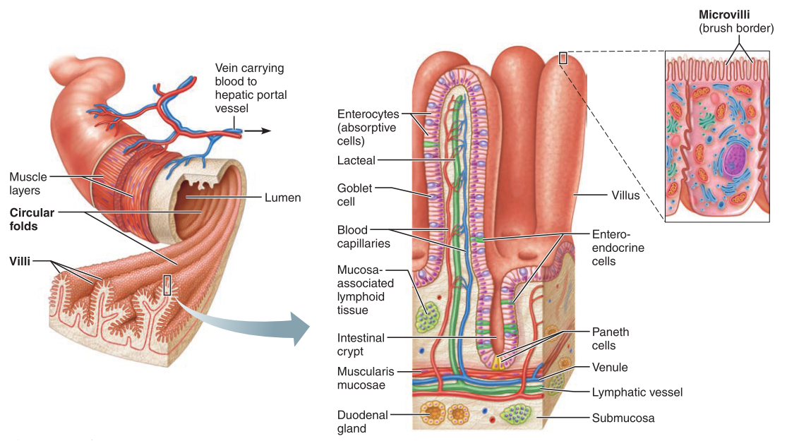

1.2.4.describe the functional anatomy of the liver & gallbladder
LIVER: the functional unit of the liver = hexagonal lobules (hepatocytes surround the central vein, which collects blood into the main hepatic veins, and the lobule is surrounded by a connective tissue septum). At the corners is the portal triad (portal arteriole, portal venule and bile duct). The digestive function of the liver is to produce bile which exits the liver through the common hepatic duct. Additional functions of it include: processing nutrients, storing glycogen, storing fat-soluble vitamins (like vitamin A), and detoxifying blood.
GALLBLADDER: a thin, green, muscular sac that stores and concentrates bile from the liver that it later secretes into the cystic duct. It is common to get gallstones (crystalized cholesterol that gets trapped in the duct system.

BILE: bile salts, pigments (bilirubin), cholesterol, triglycerides, phospholipids and electrolytes. The bile salts and phospholipids work to emulsify fats.
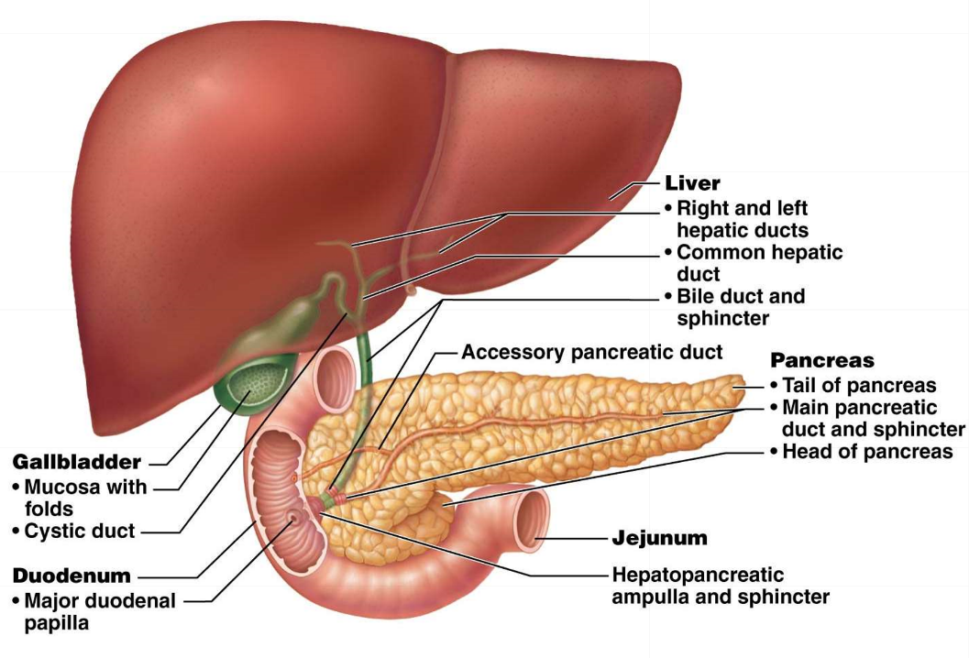

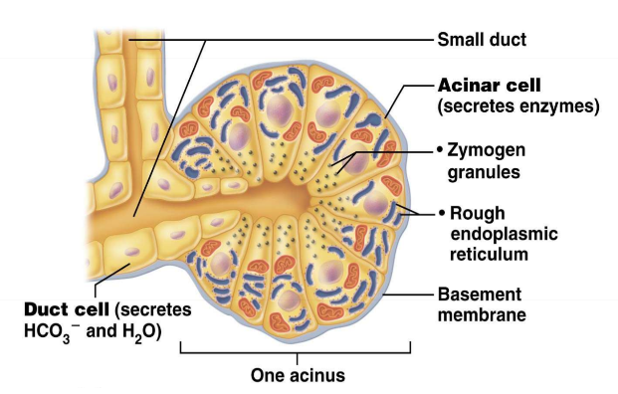
1.2.5.describe the functional anatomy of the pancreas
The pancreas is retroperitoneal. It has an endocrine function (islets of Langerhans) of producing insulin and glucagon. The exocrine function is to produce pancreatic juice:
- Digestive enzymes (acinar cells have a lot of RER for high production of concentrated zymogen granules of enzymes for quick release)
- Bicarbonate ions (duct cells), proteases, amylase, lipase and nuclease.

1.2.6.describe the anatomy of the large intestine
LARGE INTESTINE: The large intestine extends after the ileocecal valve in the small intestine. Since it has no nutrient absorptive properties (aside from water) it is not essential for life. There are 3 longitudinal bands of smooth muscle around the perimeter aka taeniae coli, fat-filled pouches aka epiploic appendages and haustra bulges. The large intestine is retroperitoneal except for the transverse and sigmoid regions. The vermiform appendix is at the cecum and contains masses of lymphoid tissues. Its structure is ideal for the accumulation of bacteria which may lead to appendicitis. It has no villi.
ANAL CANAL: outside of the abdominopelvic cavity, simple columnar in the rectum, stratified squamous in the anal canal. There are also abundant crypts that secrete mucous to ease the passage of feces. There are two superficial venous plexuses in the anal canal, when they are inflamed it causes haemorrhoids. The anal sphincters have a smooth involuntary muscle part (internal) and a skeletal voluntary part (external).

1.3 Describe the region-specific digestive activities of the GI tract and their regulation

1.3.1.list, define and provide examples of the 6 digestive processes
Name | Definition | Example
Ingestion | Voluntary intake of food into the digestive tract | Putting food in your mouth
Propulsion | Involuntary mechanical movement of food through the alimentary canal. Begins with swallowing. Contributes slightly to mixing due to alternating waves of contraction in the circular and longitudinal smooth muscle | In the esophagus, stomach and intestines
Mechanical breakdown | Prepares food for subsequent digestion. Begins with chewing. Segmentation mixes food with digestive juices and increases absorption | Chewing: in the mouth  Segmentation: in the intestines
Digestion | Series of catabolic reactions use to break down polymerized food stuff into monomers. Relies on secreted enzymes or the brush border enzymes in the intestines. | Begins in the mouth with amylase secretion, pepsin in the stomach and juices in intestines/accessories
Absorption | Process of transferring digestive end products from the GI tract into blood/ lymph | Mostly takes place in the small intestine. Large intestine for water. Nitroglycerine in mouth
Defecation | Elimination of fecal matter | Anus

1.3.2.summarize the basic concepts pertaining to the control of digestive function
- MECHANORECEPTORS (distension), OSMORECEPTORS (pH/osmolarity) and CHEMORECEPTORS (substrates and end-products): these induce reflexes to alter secretion or change mixing and propulsion rates
- Via the enteric nervous system: SHORT REFLEXES are mediated by the local enteric plexuses in response to intrinsic GI tract stimulation or LONG REFLEXES that involve the CNS and extrinsic autonomic nerves. The reflexes typically converge on the submucosal plexus that lies in the submucosa (for secretory events) or the myenteric plexus in the muscularis (for contractile events). In the enteric nervous system: excitation is produced by cholinergic and P nerves and inhibition is by VIP (vasoactive intestinal peptide) and NO nerves.
1.3.3.describe the digestive activities associated w the oral cavity and their regulation
Salivation: the role of saliva (hypoosmotic, neutral) is to cleanse the mouth, dissolve food to be tasted, prepare the bolus, and begin starch digestion. Saliva also contains electrolytes, mucin immune products and urea/uric acid. Intrinsic glands are continuously secreting slowly, but faster extrinsic glands need stimuli.
- Chemoreceptors(mostly acids) and mechanoreceptors (non-specific) signal to the salivatory nuclei in the brainstem to increase parasympathetic serous secretion (also psychological).
- Light sympathetic stimulation causes mucus secretion.
- Strong sympathetic stimulation (or dehydration) causes constriction of the blood vessels serving the salivary glands which causes dry mouth (xerostomia).

1.3.4.describe the voluntary & involuntary regulation of deglutition; define & indicate some potential causes of heartburn
- Buccal phase: voluntary and in the mouth. The tongue pushes against the hard palate to force the bolus into the oropharynx. The bolus stimulates tactile mechanoreceptors that triggers the next phase.
- Pharyngeal-esophageal phase 1: involuntary and controlled by the swallowing center in the medulla/pons (vagus nerve). The tongue, soft palate and uvula block access to the nasopharynx while the epiglottis blocks off the trachea. At this point the upper esophageal sphincter is relaxed to allow food passage.
- Pharyngeal-esophageal phase 2: The three pharyngeal constrictor muscles contract to force food downward and the upper esophageal sphincter closes to enforce unidirectionality.
- Esophageal phase: peristalsis waves push food downward past the gastroesophageal sphincter into the stomach
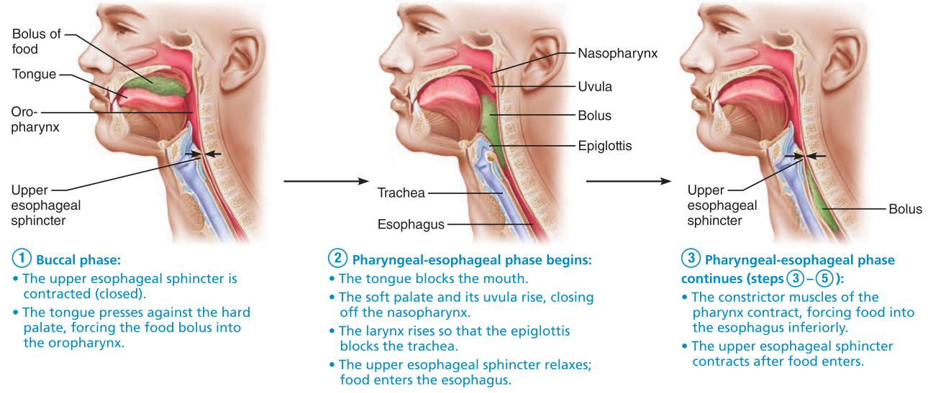
- Heartburn: gastric reflux due to excess ingestion, obesity, pregnancy, running, hiatal hernia, GERD (Gastroesophageal reflux disease). Frequent heartburn may cause Barrett’s Esophagus (metaplasia of stratified squamous epithelia into simple columnar epithelia) which increases risk for cancer, causes hiatal hernia at the diaphragm and relocates the sphincter to a more superior location.

1.3.5.describe the digestive functions of the stomach and their regulation
The food bolus is converted to chyme at the stomach. Mechanical digestion is created by the oblique muscle layer.
- Protease (pepsin) action makes up the main enzymatic form of digestion in the stomach. In children, the stomach also secretes rennin which digests casein.
- Alcohol and aspirin are easily absorbed in the stomach
- Intrinsic factor is produced in the stomach
- HCl is secreted by the stomach to denature proteins, nucleic acids and destroy bacteria
Phase | Timeline | Stimulus | Effect
Cephalic | Before food enters (mins) | Olfactory/taste buds input to the hypothalamus  Visual/conscious thought (CR) | Prepares stomach by secreting gastric juice
Gastric | 3-4 hours | Distension (mechanoreceptors - ACh), peptides, higher pH, caffeine, (protein buffer, SymNS) | Increase of gastric juice by gastrin (juice, HCl) and histamine secretions
Excitatory Intestinal | - | Low pH and chyme via intestinal mucosal cell receptors | Positive feed back of gastric emptying
Inhibitory Intestinal | - | Low pH, protein, fats etc.  (inhibit vagal nuclei, local reflexes and activate SymNS) | Secretion of secretin, CCK, VIP, GIP to close pyloric sphincter
Process of HCl Secretion: When parietal cells are appropriately stimulated, H+ is actively pumped into the stomach lumen (along with Cl⁻) by proton pumps. As acid is pumped into the stomach, base (HCO₃⁻) is exported into the blood. This is called the alkaline tide
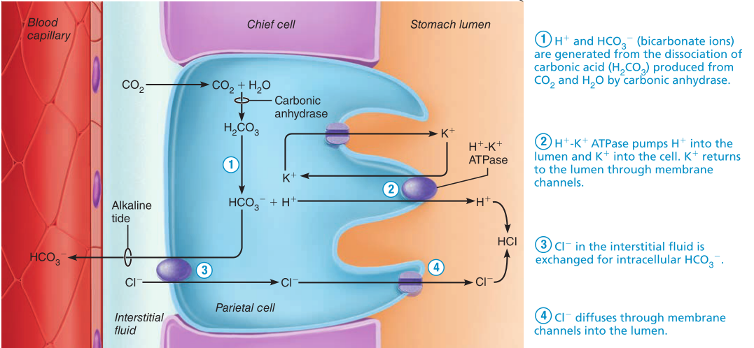
Gastric motility: receptive relaxation of smooth muscle (fundus and body) allows the stomach to stretch without increasing tension. As the peristaltic waves force chyme towards the pylorus, anything that doesn’t get through is retropulsed backwards. These stomach contractions are regulated by cells of Kajal that establish a basic electrical rhythm = subthreshold depolarizations every 20 seconds (pace varies w neural/hormones)
Secretion | Location | Cell Type
HCl | Stomach | Parietal cell
IF | Stomach | Parietal cell
Pepsinogen | Stomach | Chief cell
CCK | Duodenum | Enteroendocrine cells
Gastrin | Stomach | Enteroendocrine cells
Histamine | Stomach | Enteroendocrine cells
VIP | Duodenum | Enteroendocrine cells
Secretin | Duodenum | Enteroendocrine cells
GIP | Duodenum | Enteroendocrine cells
Motilin | Duodenum | Enteroendocrine cells
Emesis: triggered by excessive stretching of stomach/intestines, irritants, toxins, excess alcohol, spicy foods, drugs etc. The emetic center in the medulla stimulates the abdomen/ diaphragm muscle contraction, cardiac sphincter relaxation and soft palate rise.

1.3.6.summarize the digestive roles of the liver and gallbladder & their regulation
LIVER: to produce bile (increased by secretin, but main stimulus is returning bile salts)
GALLBLADDER: to release bile after stimulation by CCK in which the hepatopancreatic sphincter is opened and smooth muscle contractions. If digestion is not occurring, the bile backs up and is concentrated in the gallbladder.
- CCK stimulates gallbladder contraction, stimulates secretion of pancreatic juice and relaxes (i.e. opens) the hepatopancreatic sphincter
- Bile salts are recycled trough the enterohepatic circulation. Bile salts are secreted into the duodenum, reabsorbed in the ileum then travel through the hepatic portal vein to the liver

1.3.7.describe the exocrine function of the pancreas and its regulation
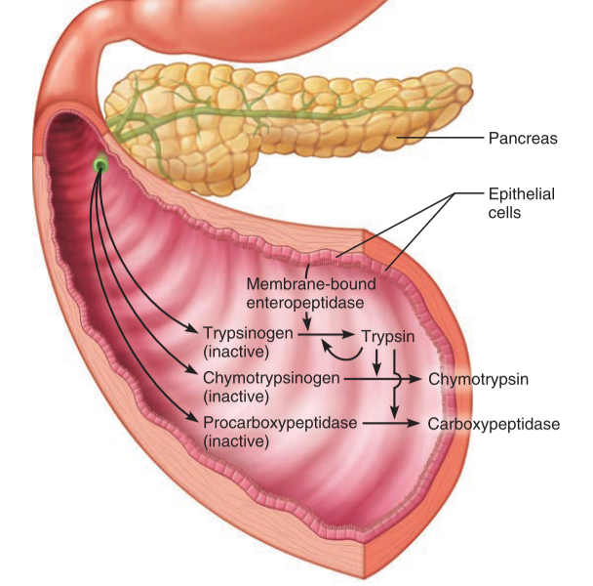
The exocrine pancreas (specifically acinar cells) produces a wide range of enzymes that digest all categories of food (lipase, amylase, protease, nuclease). The pancreas produces juice to neutralize chyme (via bicarbonate), establish optimal pH for enzymes. The proteases are secreted in an inactive form so that they do not break down the cells lining the pancreatic duct (occasionally if there is a blockage, the proteases will activate before leaving the duct and cause pancreatitis). It also releases H+ into the blood stream to neutralize the parietal cell’s alkaline tide
1.3.8.summarize the digestive functions of the small intestine and their regulation
- The role of the small intestine is to complete digestion and majority of absorption through the brush border. The intestinal glands secrete 1-2 liters of intestinal juice upon stimulation by distension and irritation by acidic/hypertonic chyme. Although intestinal juice is low in enzymes (mainly water and mucous), the affixed brush border enzymes, pancreatic and liver juices supply enough.
- Segmentation is the main motility pattern in the small intestine. It is initiated by intrinsic pace maker cells (faster in duodenum and slow down over length). The intensity is altered by reflexes and hormones.
- Once absorption is almost finished, motilin is secreted to initiate peristalsis and push chyme through the ileocecal valve. This is called the migrating mobility complex: sweeping-like peristaltic waves. IT takes about 2 hours to do an MMC.
- Illeal motility increases and the ileocecal sphincter relaxes in response to gastroileal reflex (short reflex) and gastrin (from incoming food)
1.3.9.summarize the catabolism of carbohydrates, proteins, lipids & nucleic acids
- CARBOHYDRATES: Sucrose (glucose + fructose), lactose (galactose + glucose) and maltose (glucose + glucose) are disaccharides. Glycogen is a useful storage form of glucose as its many branches increase the rate of glycogenolysis. Salivary amylase reduces polysaccharides to oligosaccharides (inactivated by HCl and pepsin). Pancreatic amylase reduces most starch into maltose, the BBE completes digestion into monosaccharides
- PROTEINS: Digestion begins in stomach with pepsin (stomach) to cleave at tyrosine and phenylalanine. Other proteases include pancreatic trypsin and chymotrypsin; carboxypeptidase, aminopeptidase and dipeptidase (pancreas and BBE). Many proteases to cleave proteins into smaller peptides for carboxypeptidase to work.
- LIPIDS: Majority of ingested lipids are triglycerides (glycerol + 3 fatty acid chains) The small intestine is the main site for fat digestion since bile is emulsified and pancreatic lipases act.
- NUCLEIC ACIDS: DNA and RNA comprise a small portion of food but need to be broken down nonetheless. Pancreatic nuclease is a key player, along with the BBE (nucleosidase and phosphatase).
1.3.10. outline the processes by which the various nutrient breakdown products are absorbed by the small intestine
90% of the food/drink/secretions that enter the GI tract are reabsorbed. Most of chyme is reabsorbed and ileum recycles the bile salts via hepatic portal circulation. Since the apical mucosa cells are connected by tight junctions, there needs carrier proteins for nutrients to enter the bloodstream.
- Active transport: for most nutrients through the intestinal villi capillaries into the hepatic portal system
- Passive diffusion: for fats through lacteals to the lymphatic system
- Absorption of carbohydrates is only possible if they are monosaccharides. Commonly using secondary active transport with sodium ions to enter the epithelial cells (except fructose) then facilitated diffusion into the blood capillaries.
- Absorption of proteins is secondary active transport with sodium ions into the epithelia then facilitated diffusion into the capillaries. In infants, sometimes whole proteins enter the capillaries (lack of tight junctions) that may trigger immune responses.
- Absorption of lipids requires a few more steps. Lipases cleave triglycerides into monoglycerides which form micelles (with bile salts and lecithin). Micelles then diffuse into the epithelial cells which form chylomicrons (reformed triglyceride, proteins, phospholipids and cholesterol) and are ejected via exocytosis into the lacteals. At the liver, the triglycerides are re-hydrolyzed by lipoprotein lipase and monoglyceride is available for cells
- Absorption of vitamins: fat-soluble vitamins are absorbed with the micelles. Water-soluble vitamins are absorbed like monosaccharides except vitamin B12 that requires IF.
- Absorption of electrolytes: most ions are absorbed throughout the entire small intestine (iron, which produces the mucosal iron barrier with ferritin protein, and calcium, PTH-calcitonin balance, only in the duodenum). Sodium is coupled with glucose/amino acid co-transporters, anions follow the sodium electrical gradient, chloride ions are actively transported with bicarbonate, potassium follows the osmotic gradient through diffusion
- Absorption of water: occurs via osmosis. The active uptake of solutes like sodium direct water from chyme into the mucosal cells, then blood

1.3.11. describe the digestive functions (& regulation) of the large intestine
The large intestine is responsible for a small amount of digestion due to residential bacteria. Materials move slowly (12-24 hours). Minimal absorption of sodium and chlorine. The major digestive function is defecation and water absorption.
- Stool at the rectum: undigested food residue, mucus, epithelial cells, bacteria, water for smooth passage
- Bacterial flora (over 700 species) in the large intestine are responsible for fermentation (which produces gas) and synthesis of vitamins B and K. C. difficile releases toxins (colitis) but at low levels usually when resident bacteria is present
- Any motility in the large intestine is sluggish and short lived. Haustra contractions (a version of peristalsis) which is triggered by distention. Mass movements (triggered by the gastrocolic reflex) which occurs just after eating, 3-4 times a day and is coupled with the gastroileal reflex.
- Fiber increases strength of colon contractions and softens the stool. Too little fiber causes contractions in on itself which leads to small herniations along the length of the colon (diverticulosis).

1.3.12. describe the neural regulation of defecation
Normally, feces distends the rectum and mechanoreceptors trigger contraction of the rectum, sigmoid colon and relaxations of the internal anal sphincters. If not able to poo, the reflexive contractions end. Valsalva maneuver aids defecation. Diarrhea and constipation affect the defecation process.

Lipids | Proteins | Vitamins | Minerals
Sources: Triglycerides, saturated fats, unsaturated fats, cholesterol and phospholipids. Liver uses interconverts fats (except for essential linoleic and linolenic acids) | Sources: animal products (complete), and legumes (incomplete) but can be paired to form complete meals | Sources: fat soluble (ADEK) and water-soluble (B complex and vitamin C) found in all kinds of foods | Sources: mostly calcium and phosphorus. Also trace minerals
Uses: fat-soluble vitamins, fuel for hepatocytes/skeletal muscle, cushioning, phospholipids, cholesterol derivatives. | Uses: structural, functional enzymes, hormones etc., energy as a last resort. NITROGEN BALANCE | Uses: coenzymes, antioxidants | Uses: give strength (Ca), cofactors (Fe), electrolytes, hormone production. Need a balance

Regulation of Metabolism and Body Temperature

2.1 Review the metabolic pathways and their interactions
Main concept to understand is redox reactions: a compound is considered REDUCED if it has electrons and OXIDIZED if it has lost electrons (LEO says GER).
- Substrate-level phosphorylation: phosphate group is directly transferred to an ADP group to form ATP from another substrate.
- Oxidative phosphorylation: Electron transport pumps create a proton (H+) gradient, ATP synthase uses this energy to bind phosphate groups to ADP.
- Glucose (or glycerol/ AA) + 6 O₂ → 6 H₂O + 6 CO₂ + 32 ATP and heat
Phase | Description | Yield (+) | Loss (-)
Glycolysis | 10-step anaerobic process | 2 pyruvate, 4 ATP, NADH & H⁺ | 2 ATP to make fructose-1,6,-bisphosphate
Krebs’s Cycle or Citric Acid Cycle (per 1 pyruvate) | Cycle that begins with acetal CoA (decarboxylation of pyruvate and attachment of CoA) | Regenerates oxaloacetate, 4 NADH & H⁺, 1 FADH₂, 1 ATP, 2 CO₂ | Shuttle cost (ATP)?
Oxidative Phosphorylation | Stepwise passage of electrons coupled with generating an H+ gradient (reverse proton pump) | 10 NADH & H⁺ , 2 FADH₂, about 28 ATP (through ATP synthase) | Shuttle cost (ATP)?
- Glycogenesis: polymerization of glycogen from glucose (high glucose levels)
- Glycogenolysis: hydrolysis of glycogen to release glucose (low glucose levels)
- Gluconeogenesis: occurs mainly in the liver to make more glucose (getting initial glucose from non-glycogen stores such as lactic acid, pyruvic acid, glycerol, AA)
FAT METABOLIC PATH
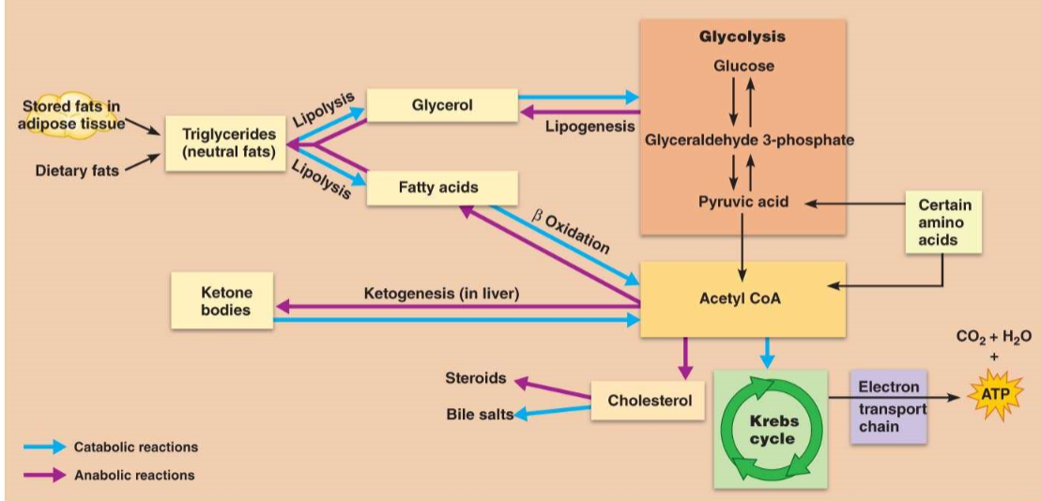
Fat is an efficient form of energy storage (2x more than glycogen). Both glycerol and the free fatty acid chains are used for energy, but they enter the metabolic pathway at different points. Glycerol enters the glycolytic pathway at the G3P phase. The fatty acids undergo beta-oxidation (forms 2 carbon pieces aka acetic acid) that is ready to receive CoA and enter the Krebs’s cycle. Fatty acids can not be used for gluconeogenesis as they can not go from acetyl CoA to glucose.
PROTEIN METABOLIC PATH
Amino acids are not stable or stored so any excess is converted to fat/burned for energy. They will undergo transamination and deamination to yield keto acids which can be used for the Krebs’s Cycle or turned into G3P and undergo gluconeogenesis. Common transamination is with alanine and a-ketoglutarate into pyruvate and glutamate.
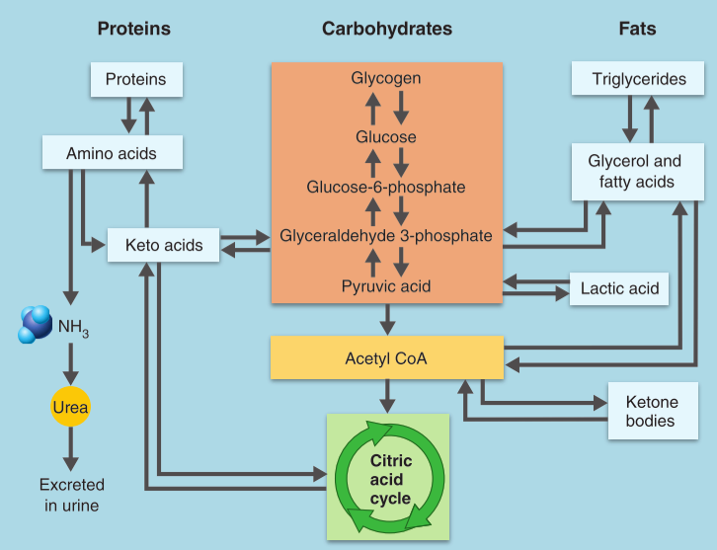
2.2 Define the absorptive state and justify the key role of insulin in its metabolic regulation
- The FED state: during and shortly after eating when nutrients are entering circulation and used more anabolically to build up fat and protein stores. Even excess metabolites are used to make adipose tissue.
- Insulin (anabolic hypoglycemic hormone) directs all events in the absorptive state (produced by beta cells in the islets of Langerhans). It is initially synthesized as proinsulin, then cleaved to make active insulin for secretion (when blood glucose rises) to
- Insulin activates carrier facilitated diffusion of glucose (via translocation of the glucose transporter onto the plasma membrane), enhances glucose oxidation, stimulates glycogenesis, increases active uptake of AA, inhibits gluconeogenesis and glycogenolysis in the liver, also inhibits lipolysis in adipose tissues
- Insulin does not affect liver, kidney, brain or intestinal epithelial cell permeability as they all readily absorb glucose
- Secretion of insulin is also stimulated by increased blood amino acid levels, GIP and parasympathetic nervous system
2.3 Define the post-absorptive state and describe the roles of glucagon and other supporting mechanisms in the maintenance of blood glucose levels
- The Fasting State: when the GI tract is empty and energy needs must be met through catabolism of food reserves (fat, protein, glycogen). Goal is to maintain blood glucose levels, especially for the brain. Need to spare glucose for brain cells and make more glucose available for the circulatory system.
- Glycogenolysis in the liver and indirectly through the skeletal muscle (sends glucose-6-phosphatase to the liver to finish the process). Lipolysis in adipose tissues and the liver to produce glycerol (the glucose via gluconeogenesis). The last resort is catabolism of cellular protein.
- Glucose sparing requires non-carbohydrate fuel (glycerol from fats) for energy to conserve glucose (except for the brain). Lipolysis, oxidation of free fatty acids and ketone bodies. In prolonged fasting, the brain will start to use ketone bodies
- Hormonal/Neural controls: interaction of the sympathetic nervous system and hormones regulates post-absorptive state (inhibition of insulin).
- Glucagon (catabolic hyperglycemic agent) polypeptide secreted by alpha cells. It promotes glycogenolysis, gluconeogenesis (from lactic acid), lipolysis in adipose.
- Sympathetic nervous system acts on the adrenal medulla (chromaffin cells) in response to drops in blood glucose to trigger release of E and NE for lipolysis, fat mobilization and stimulate glycogenolysis and protein catabolism. The adrenal cortex secretes cortisol (stress) which helps the body adapt to external changes and has similar effect

