Chapter 1

Marketing
- Marketing is managing profitable customer relationships
- Goal: attract new customers by promising superior value
- Goal #2: keep and grow current customers by delivering satisfaction
- Sound marketing: important for success
- Marketer’s want us to live their brands
- Marketing: satisfying customer needs
- Aim of marketing is to make selling unnecessary
- Marketing mix: a set of marketing tools that work together to satisfy customer needs and build customer relationships
- Selling and advertising are only part of the marketing mix
- Marketing: process by which companies create value for customers and build strong customer relationships to capture value from customers in return

The marketing process
- Process for creating and capturing customer value
- By creating value for consumers, they in turn capture value from consumers (in forms of sales, profits, and long-term customer equity)
- First four steps: create value for customers and build customer relationships
- Last step: capture value from customers in return
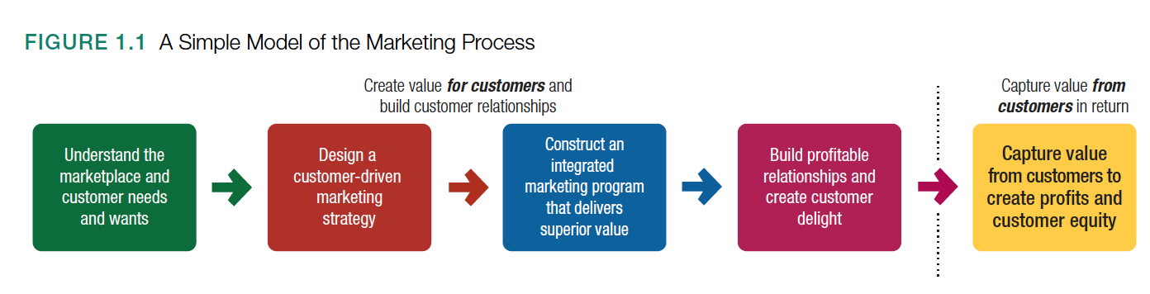

#1 Understanding the marketplace and customer needs

- 1) Needs, wants, demands
- 2) Market offerings (products, services, experiences)
- 3) Value and satisfaction
- 4) Exchanges and relationships
- 4) Markets

Each one in depth…
Customer needs, wants, demands:
- Needs: states of felt deprivation (physical needs, social needs, individual needs)
- Example: physical needs are food and clothing
- Social needs are belonging and affection
- Individual needs are knowledge and self-expression
- Wants: form human needs take as they are shaped by culture and individual personality
- Example: I need breakfast but I WANT a breakfast sandwich
- Objects that will satisfy the needs
- When backed by buying power, wants -> transform info demands
- People demand products and services with benefits that add up to the most value and satisfaction

Market offerings (products, services, experiences);
- Consumer’s needs/wants are fulfilled through market offerings
- Market offerings are some combination of products, services, information, or experiences offered to a market to satisfy a need or want
- Market offerings include physical products, services, persons, places, organizations, information, and ideas
- Marketing myopia: the mistake of paying more attention to the specific products a company offers than to the benefits and experiences produced by these products
- Smart marketers look beyond the attributes of products and services they sell – they create brand experiences for consumers (example: Disney World)

Customer value and satisfaction:
- Customers form expectations about the value/satisfaction that various market offerings will deliver and buy accordingly
- Example: satisfied customers buy again and tell others about their experience

Exchanges and relationships:
- Marketing happens when people decide to satisfy their needs and wants through exchange relationships
- Exchange: the act of obtaining a desired object from someone by offering something in return
- Marketing consists of actions taken to create, maintain, and grow desirable exchange relationships with target audiences involving a product, service, idea, object

Markets:
- Market: set of all actual and potential buyers of a product/service
- Consumers market as well: when they search for products, interact with companies, and make purchases
- Today’s marketers must deal with customer-managed relationships (how can our customers influence us?)
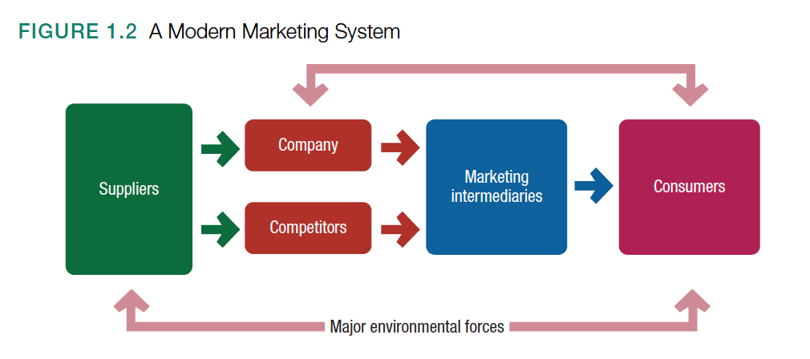
- Marketing intermediary: middle men/distributors
- Company’s success at building profitable relationships depends not only on its own actions but also on how well the entire system serves the needs of final consumers
- Example: Walmart cannot fulfill its promise of low prices unless its suppliers provide merchandise at low costs

#2 Designing a customer-driven marketing strategy

- Marketing management: the art and science of choosing target markets and building profitable relationships with them
- Aim is to find, attract, keep, and grow target customers by creating, delivering, and communicating superior customer value
- To design a winning marketing strategy: answer two questions
- 1) What customers will we serve (what’s our target market)?
- 2) How can we serve these customers best (what’s our value proposition)?

Selecting customers to serve
- Who will we serve?
- Divide the market into segments of customers (market segmentation)
- Select which segments it will go after (target marketing)
- Company wants to select only those customers whom it can serve well and profitability
- Example: Dollarama targeting families
- Marketing management is: customer management and demand management

Choosing a value proposition
- How it will differentiate and position itself in the marketplace
- Brand’s value proposition: set of benefits of values it promises to deliver to consumers to satisfy their needs
- Companies must design strong value propositions that give them the greatest advantage in their target markets
- Example: Facebook helps you connect and share, YouTube provides a place to inform, connect, and inspire

Marketing management orientations
- 5 alternative concepts under which organizations design and carry out their marketing strategies:
- 1) Production concept: idea that consumers will favour products that are available and highly affordable – the organization should focus on improving production and distribution efficiency
- Example: Chinese market is low labour costs but very risky because production concept can lead to marketing myopia
- 2) Product concept: idea that consumers will favour products that offer the most quality, performance, and features – the organization should devote its energy to making a continual product improvements
- 3) Selling concept: idea that consumers will not buy enough of the firm’s products unless the firm undertakes a large-scale selling and promotion effort
- Focuses on creating sales transactions rather than on building long-term and profitable customer relationships
- Aim is to often sell what the company makes rather than making what the market wants
- Inside-out perspective
- 4) Marketing concept: philosophy in which achieving organizational goals depends on knowing the needs and wants of target markets and delivering the desired satisfactions better than competitors do
- Customer focus and value are the paths to sales and profits
- Customer-centred sense-and-respond philosophy
- Find right products for customers
- Outside-in perspective
- Yields more profit by creating relationships with the right customers based on customer value and satisfaction
- Customer-driven! Understanding customer needs before than themselves
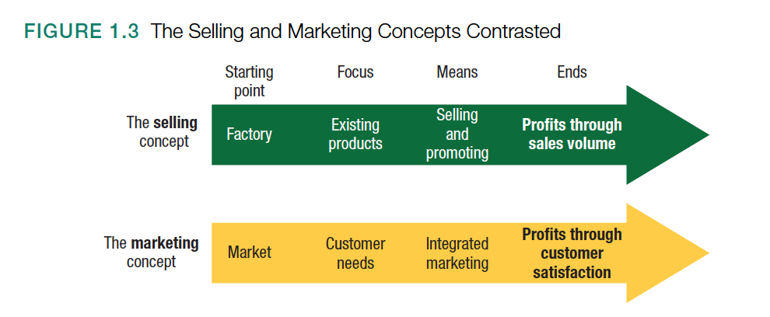
- 5) Social marketing concept: idea that a company’s marketing decisions should consider consumers’ wants, the company’s requirements, consumers’ long-run interests, and society’s long-run interests
- Marketing strategy should deliver value to customers in a way that maintains or improves both the consumer’s and society’s well-being
- Society is important as well
- Sustainable marketing: socially and environmentally responsible marketing that meets the present needs of consumers and business while also preserving or enhancing the ability of future generations to meet their needs
- Shared value: societal needs define markets as well
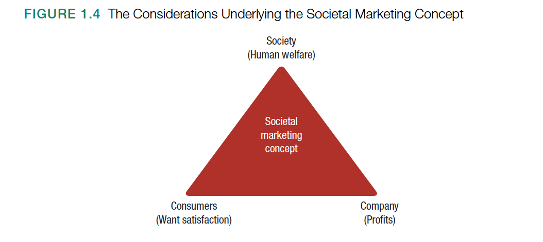

#3 Preparing an integrated marketing plan and program

- Program builds customer relationships by transforming the marketing strategy into action
- Consists of the firm’s marketing mix: set of marketing tools the firm uses to implement its marketing strategy
- Major marketing mix tools are classified into 4 groups: four Ps of marketing: product, price, place, promotion
- Product: create need-satisfying market offering
- Price: how much to charge
- Place: how to make the offering available to target
- Promotion: communicate with target about offering and persuade its merits

#4 Building customer relationships

- Customer relationship management: overall process of building and maintaining profitable customer relationships by delivering superior customer value and satisfaction
- Deals of all aspects of acquiring, keeping, and growing customers
Customer value
- Customer buys from the firm that offers the highest customer-perceived value
- Customer perceived value: the customer’s evaluation of the difference between all the benefits and all the costs of a market offering relative to those of competing offers
- Customers act on perceived value
- Example: a grill that’s expensive compared to others – hard-core grillers think it’s worth it
Customer satisfaction
- Customer satisfaction: extent to which a product’s perceived performance matches a buyer’s expectations
- Delighted customers make repeat purchases
- Customer evangelists: those who spread the word about their good experience
- Customer satisfaction comes not just from service heroics, but from how well a company delivers on its basic value proposition and helps customers solve their buying problems
- Purpose of marketing is to generate customer value profitably
Customer relationship levels and tools
- Basic relationships
- Full partnerships with key customers
- In between: other levels of customer relationships are appropriate
- Examples of marketing tools for stronger bonds with customers:
- Many companies offer frequency marketing programs that reward customers who buy frequently or in large amounts
- Airlines offer frequent-flyer programs
- Hotels give room upgrades, etc.
- Apple has club marketing programs

Engaging customers
Customer engagement and today’s digital and social media
- Old marketing involved marketing brands to consumers
- New marketing (customer-engagement marketing) fosters direct and continual customer involvement in shaping brand conversations, brand experiences, and brand community
- Customer-engagement marketing: making the brand a meaningful part of consumers’ conversations and lives by fostering direct and continual customer involvement in shaping brand conversations, experiences, and community
- Marketers are not embracing customer-managed relationships: in which customers connect with companies and with each other to help forge their own brand experiences
- Practise marketing by attraction – creating market offerings and messages that engage consumers rather than interrupt them
- Successful engagement marketing means making relevant and genuine contributions to consumers’ lives and conversations (it’s not enough to just post something)
Consumer-generated marketing
- Consumer-generated marketing: brand exchanges created by consumers themselves – both invited and uninvited – by which consumers are playing an increasing role in shaping their own brand experiences and those of other consumers
- Example: happens in social media
- Example: Starbucks has a site where customers can share their ideas on new products, etc.
- Example: Dorito asks fans to make ad to show on Super Bowl commercial

Partner relationship management
- Partner relationship management: working closely with partners in other company departments and outside the company to jointly bring greater value to customers
- Marketers must also partner with suppliers, channel partners, and others outside the company
- Marketing channels: distributors, retailers, and others who connect the company to its buyers
- Supply chain: longer channel, stretching from raw materials to components to final products that are carried to final buyers
- Supply chain management

#5 Capturing value from customers

- Final step involves capturing value in return in the form of sales, market share, profits

Creating customer loyalty and retention
- Keeping customers loyal – they spend more and stay around longer
- Customer lifetime value: value of the entire stream of purchases a customer makes over a lifetime of patronage
- An unhappy customer leaving your store can make you lose money in a way

Growing share of customer
- Good customer relationship management can help marketers increase their share of customer
- Share of customer: the portion of the customer’s purchasing that a company gets in its product categories

Building customer equity
- Companies want to “own” customers for life
- Customer equity: the total combined customer lifetime values of all the company’s customers
- Measure of the future value of the company’s customer base
- More loyal the firm’s profitable customers, the higher its customer equity
- Customer equity suggests the future
Building the right relationships with the right customers
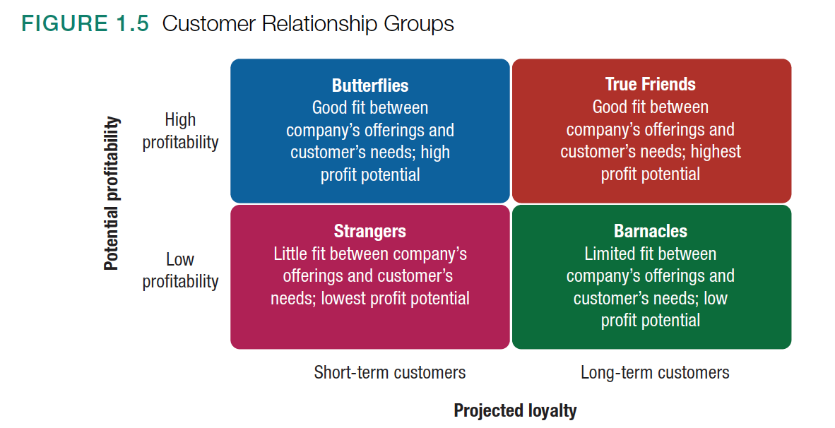
- Example: true friends are both profitable and loyal
- Barnacles are the most problematic – they create drag
- Different types of customers require different relationship management strategies

Chapter 2 p. 57-68
Company and marketing strategy: partnering to build customer relationships

Company-wide strategic planning: defining marketing’s role

- Strategic planning: process of developing and maintaining a strategic fit between the organization’s goals and capabilities and its changing marketing opportunities
- Involves adapting the firm to take advantage of opportunities in its constantly changing environment
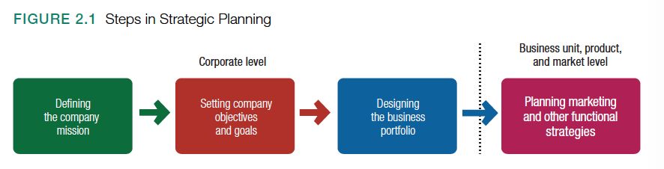

Market-oriented mission
- Mission statement: a statement of the organization’s purpose – what it wants to accomplish in the larger environment
- “We make and sell furniture” – marketing myopia
- Mission statements should be market oriented and defined in terms of satisfying basic customer needs

Setting company objectives and goals
- Vision statement: to be the best food company growing a better world
- Marketing objectives can be increasing sales to increase profits to increase more funds for research

Designing the business portfolio

- Business portfolio: collection of businesses and products that make up the company
- Strategic planning - analyze current business portfolio and determine which businesses should receive more, less, or no investment - and shape the future portfolio by developing strategies for growth and downsizing
- Portfolio analysis: process by which management evaluates the products and businesses that make up the company
- Identify the key businesses that make up the company – strategic business units
- SBU can be a company division, product line within a division, single product/brand
- Company assesses the SBUs
- Purpose of strategic planning: find ways in which the company can best use its strengths to take advantage of attractive opportunities in the environment

The Boston consulting group approach

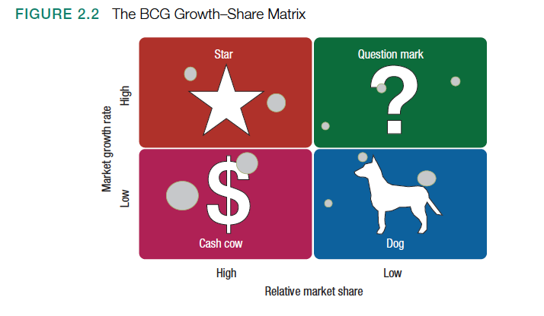

- Growth-share matrix: a portfolio-planning method that evaluates a company’s strategic business units (SBUSs) in terms of its market growth rate and relative market share – SBUs are classified as stars, cash cows, question marks, or dogs
- Market growth rate is a measure of market attractiveness
- Relative market share serves as a measure of company strength in the market

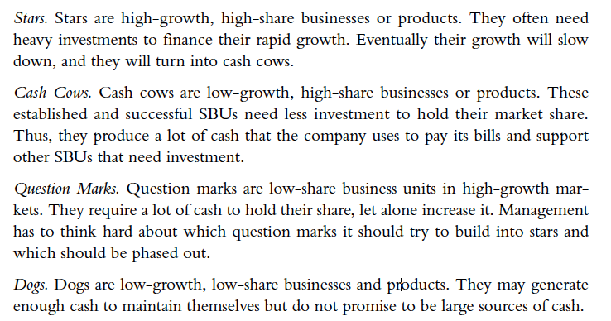

Developing strategies for growth and downsizing
- Product-market expansion grid: a portfolio-planning tool for identifying company growth opportunities through market penetration, market development, product development, or diversification

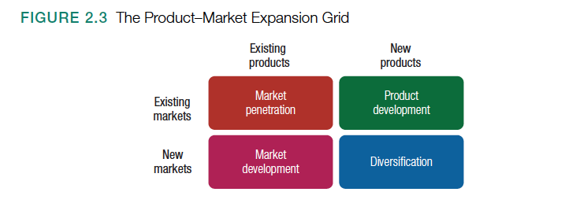

- Market penetration: a strategy for company growth by increasing sales of current products to current market segments without changing the product
- Example: adding new stores in current market areas to make it easier for customers to visit
- Market development: a strategy for company growth by identifying and developing new market segments for current company products
- Example: identifying new groups – like seniors – they could be encouraged to visit Starbucks
- Product development: a strategy for company growth by offering modified or new products to current market segments
- Diversification: a strategy for company growth through starting up or acquiring businesses outside the company’s current products and markets
- Downsizing: reducing the business portfolio by eliminating products or business units that are not profitable or that no longer fit the company’s overall strategy

Planning marketing: partnering to build customer relationships

- Partner relationship management is important
- Working with internal partners can create an effective value chain

Partnering with other company departments
- Value chain: the series of internal departments that carry out value-creating activities to design, produce, market, deliver, and support a firm’s products
- Example: Walmart needing help from IT department to know information about which products are selling in each store – for low-cost merchandise handling
- Everyone in the chain must understand how to create customer value
Partnering with others in the marketing system
- Value delivery network: the network made up of the company, suppliers, distributors, and customers who partner with each other to improve the performance of the entire system

Marketing strategy and the marketing mix

- Customers are the centre of every organization’s business
- Organization’s goals are to create value for those customers
- Build profitable relationships with them
- Marketing strategy: marketing logic by which the company hopes to create customer value and achieve profitable customer relationships
- Company decides which customers it will serve – segmentation and targeting
- Company decides how to do this as well – differentiation and positioning
- Identifies the total market, divides it into smaller segments, selects the most promising segments, focuses on serving and satisfying the customers in these segments
- Company designs an integrated marketing mix – made up of factors under its control – the four P’s – product, price, place, promotion

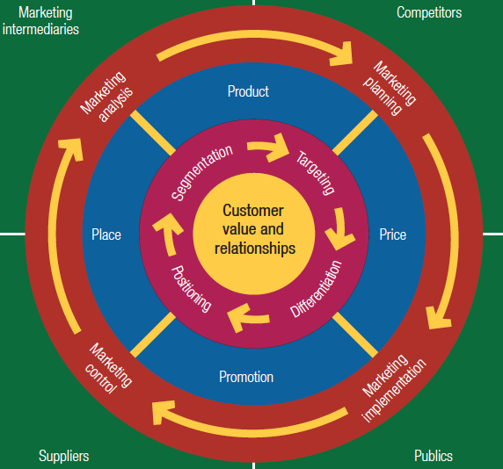

Customer-driven marketing strategy
- A company must first understand customers’ needs/wants
- Each company must divide up the total market, choose the best segments, and design strategies for profitability serving chosen segments
- This process involves market segmentation, market targeting, differentiation, and positioning (PTSD – helpful to remember)
Market segmentation
- Market segmentation: dividing a market into distinct groups of buyers who have different needs, characteristics, or behaviours and who might require separate products or marketing programs
- Market segment: a group of customers who respond in a similar way to a given set of marketing efforts
Market targeting
- Marketing targeting: the process of evaluating each market segment’s attractiveness and selecting one or more segments to enter
Market differentiation and positioning
- Product’s position is the place the product occupies relative to competitor’s products in consumers’ minds
- Marketers must develop a positioning strategy that makes it clear to the market what differentiates their brand from the competition
- Positioning: arranging for a product to occupy a clear, distinctive, and desirable place relative to competing products in the minds of consumers
- Company must identify what it is about its product that offers greater value and that would motivate a customer to choose it over its competition
- Effective positioning begins with differentiation
- Differentiation: actually differentiating the market offering to create superior customer value
- Once the company has chosen a desired position, it must take strong steps to deliver and communicate that position to target customers

Developing an integrated marketing mix
- Marketing mix: the set of controllable, tactical marketing tools – four p’s – that the firm blends to produce the response it wants in the target market

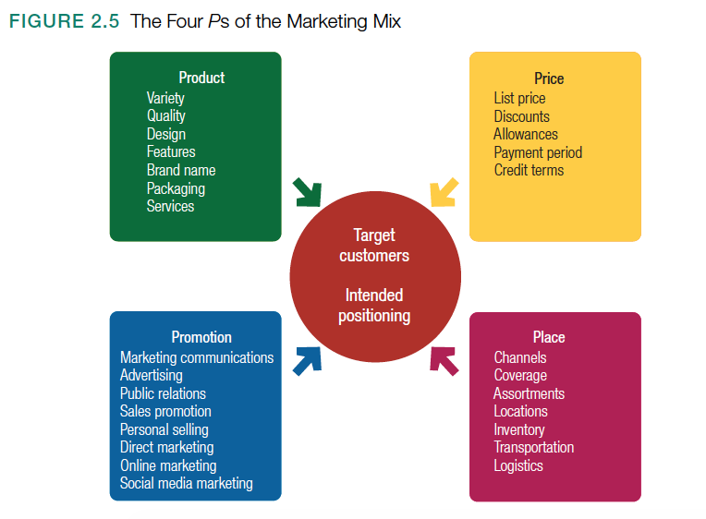

- Product: refers to the market offering
- Price: amount of money customers must pay to obtain the product
- Place: refers to the distribution of the product and the availability of the service
- Promotion: means activities that communicate the merits of the product and persuade customers to buy it

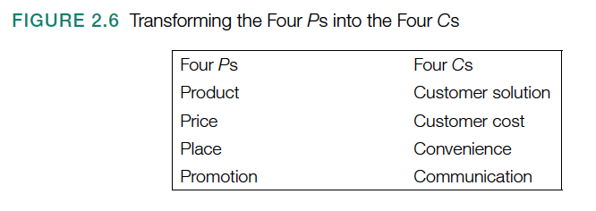
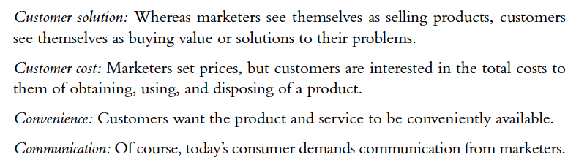

Managing the marketing effort

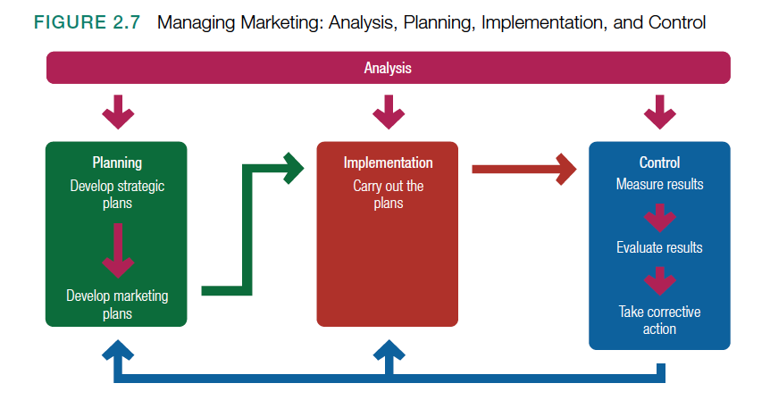

- Management functions: analysis, planning, implementation, control (APIC)

Market analysis
- SWOT analysis: an overall evaluation of the company’s strengths, weaknesses, opportunities, threats

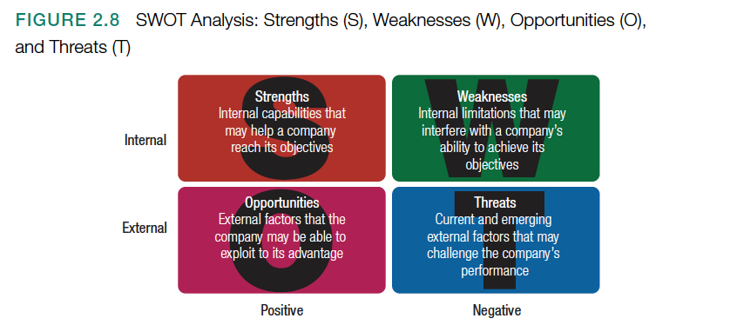

Marketing planning
- Marketing planning involves deciding on marketing strategies that will help the company attain its overall strategic objectives

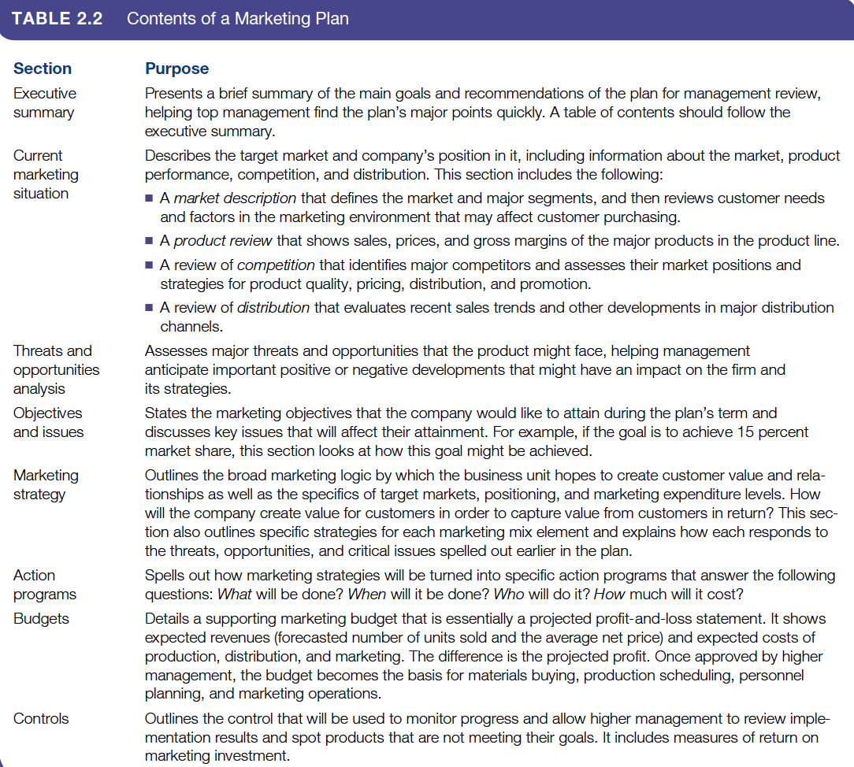

Marketing implementation
- Marketing implementation: process that turns marketing strategies and plans into marketing actions to accomplish strategic marketing objectives
- Marketing planning: what and why
- Implementation: who, where, when, how
- Doing things right (implementation)
- Doing the right things (strategy)

Marketing department organization
- Chief marketing officer is responsible for all top-level marketing functioning
- Functional organization: different marketing activities are headed by a functional specialist – a sales manager, advertising manager, marketing research manager, customer-service manager, or new-product manager
- Company that sells across the country or internationally often uses a geographic organization – its sales and marketing people are assigned to specific countries, regions, and districts
- Companies with many different products or brands create a product management organization
- For companies that sell one product line to many different types of markets and customers that have different needs and preferences: market or customer management organization
- Customer management: managing customer profitability and customer equity

Marketing control
- Marketing control: process of measuring and evaluating the results of marketing strategies and plans and taking corrective action to ensure that objectives are achieved
- Four steps
- 1) Management first sets specific marketing goals
- 2) Then measures its performance in the marketplace
- 3) Evaluates the causes of any differences between expected and actual performance
- 4) Management takes corrective action to close caps between its goals and its performance
- Operating control: involves checking ongoing performance against the annual plan and taking corrective action when necessary
- Strategic control: involves looking at whether the company’s basic strategies are well matched to its opportunities

