Newtons Law of Motion
Motion is basically change in motion.
Velocity is change in acceleration. To change velocity, you need to apply acceleration.
To generate acceleration, we need FORCE.

Force
Force is a push or a pull which can change the state of a body(position).
First law (Inertia) – Balanced forces F=0
A body at rest will stay at rest unless an external force is applied. A body in motion will stay in motion(constant velocity) unless an external force is applied.
Second Law – Unbalanced Forces (F≠0)
F≠0
According to the law,
Acceleration=Fext/mass
A=F/m
F=m×a *a is a vector, F is a vector
Quiz 5.2 An object experiences no acceleration. Which of the following
cannot be true for the object? (a) A single force acts on the object. (b) No forces
act on the object. (c) Forces act on the object, but the forces cancel.
Quiz 5.3 You push an object, initially at rest, across a frictionless floor
with a constant force for a time interval Dt, resulting in a final speed of v for
the object. You then repeat the experiment, but with a force that is twice as
large. What time interval is now required to reach the same final speed v?
- 4 Dt (b) 2 Dt (c) Dt (d) Dt/2 (e) Dt/4
Answer: (d). With twice the force, the object will experience twice the acceleration. Because the force is constant, the acceleration is constant, and the speed of the object (starting from rest) is given by v= at. With twice the acceleration, the object will arrive at speed vat half the time.

Instantaneous Velocity
The instantaneous velocity at a given point in time is represented by the slope of the tangent to the position v/s time graph.
Instantaneous speed B is the magnitude of instantaneous velocity (absolute value of the slope).

The average velocity can be greater, less than, or equal to the instantaneous velocity. For example, Figure 3-13 illustrates the case when the average velocity is greater than an instantaneous velocity.

Kinematics-1D
- Distance
- Displacement
- Speed
- Velocity
- Acceleration

- Distance ≥ Displacement

Find displacement when we have angle is given.
Disp = 2Rsin(Θ/2)
R = radius

Average speed = $\frac{Total distance}{Total time}$ Average Velocity = $\frac{Total displacement}{Total time}$

Average speed ≥ Average velocity (its only equal when distance = displacement)
Ratio of avg speed to avg velocity is $\frac{Avg speed}{avg velocity }≥1$
Average speed is not calculated by taking an average of two speeds Instead use this formula,$\frac{2v1v2}{v1+v2}$ here v1 and v2 are two speeds. [Take average only if times are the same]

Graph of Distance v/s time
Slope = $\frac{y2-y2}{x2-x2}$ = $\frac{△displacement}{△time}$ = velocity

Slope = tanΘ [when angle is given] = velocity
https://www.youtube.com/watch?v=4OgPa7MKjRA&list=PLF_7kfnwLFCHamOEHrFDSVoI6wszQQheq&index=8
When Θ is constant throughout the slope then V is constant.

Θ is increasing so slope is increasing therefore velocity is increasing and hence acceleration is taking place. [ same direction means acceleration is positive].
Θ˂90 Velocity is positive.
If Θ is decreasing over time, then velocity is decreasing. Basically -ve acceleration.
Slope is constant means acceleration is 0. Only curve means there is acceleration.
Projectile motion
Motion under gravity.
Tackling the questions, divide in two dimensions.
-Angle of projection
There are two speeds, one in x direction and one in y.
The x direction(x-axis) is ucosΘ , the one in the y axis is usinΘ
Θ is angle of projection.
It is useful to think of projectile motion in terms of a combination of two analysis models: (1) the particle under constant velocity model in the x direction and (2) the particle under constant acceleration model in the vertical direction with a
constant downward acceleration of magnitude g 5 9.81 m/s2.

X | Y
Ux= ucosΘ | Uy= usinΘ
There is no acceleration in this direction. | Here the acceleration is g and is always negative, i.e -9.81.
Velocity is x direction is always constant. (Doesn’t necessarily mean its 0) | First it decreases, then at max height its 0, then it starts increases.
In projectile motion when v= 0, this doesn’t mean the speed is zero.

Time of flight for projectile = $\frac{2usinΘ}{g}$ [Displacement in y direction is 0]

Maximum height (Displacement) of projectile = $\frac{u^{2}\sin^{2}Θ}{g}$
Uy= usinΘ
Vy = 0
Ay = -g
Sy=H
Range of projection (distance covered) = $\frac{u^{2}sinΘcosΘ}{g}$

Initial velocity in vector form,
U = xi + yj
V = xi + (-3j)

Hmax = $\frac{v^{2}}{2g}$
V= given speed/velocity

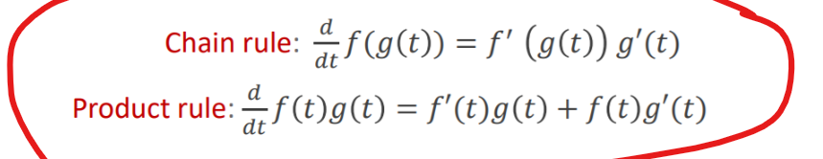
Derivative of a constant is 0.

Position in 3D
𝑟 ⃗ = 𝑥 𝚤 ̂ + 𝑦 𝚥 ̂+ 𝑧k ̂
*For more check out written notes page A.
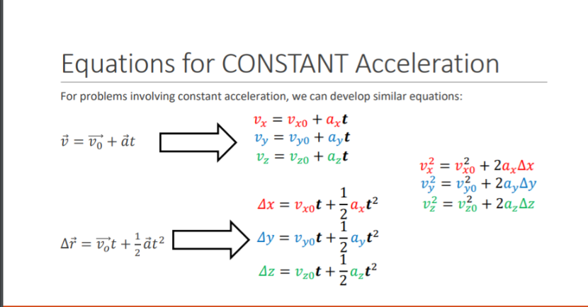
To find a projectiles angle of lunch
Use TanΘ =$\frac{y}{x}$ = $\frac{uy}{ux}$
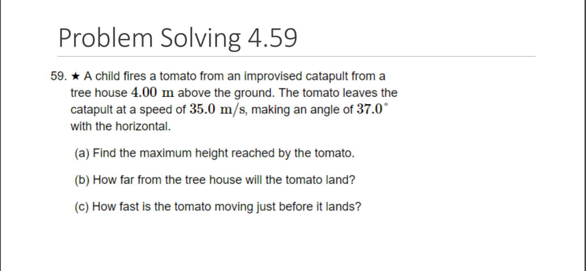
Uniform circular motion
The relationship between linear displacement along a circle is given as,
S = RΘ S here is displacement, R is radius.
Acceleration in circular motion
- Centripetal acceleration
- Tangential acceleration
- Net acceleration
- Radial acceleration
Velocity is always variable because the direction changes, therefore there is an acceleration but the speed remains constant.
Velocity → Variable
Centripetal acceleration ($a_{c})$ is basically to give the change in direction of velocity. Always pointed towards the center along the radius.
$\frac{v^{2}}{R}$ = $a_{c}$
In centripetal acceleration the velocity is same in magnitude.
2-
In tangential acceleration the velocity changes in magnitude and direction. Only exists if the particle changes the magnitude of velocity.
Defined as changed in speed of time. Not velocity because velocity without direction is basically speed.
If the particle is moving with constant velocity then tangential acceleration is zero, but the will be a centripetal acceleration.
Try solving the questions given in the ppt(sept 24).

Work and Energy

Work is defined to be the product of component of the force in the direction of the displacement.
It’s the dot product of F and d
$$W=F . d$$
$$W=FcosΘ . d$$

Case 1
Θ = 0
Displacement is in the direction of force. $W=F.d$
Case 2
Θ = 90
Displacement is perpendicular to force. $W=F.d.cos90$
We know cos90 = 0; therefore, we know the product is 0 and work done is zero.
Case 3
Θ = 180
The displacement and force are opposite to each other. $W=F.d.cos180$
Product comes out negative.

Positive Work
When the angle between F and d is acute, the work done is positive. Acute angle is an angle from 0 to 90.
Negative Work
When the angle between F and d is obtuse, the work done is negative. Obtuse angle is from 90 to 180.

Work- energy Theorem (constant force)
The theorem states that the change in Kinetic energy of a system is equal to the work done by the net force on it.
$$W= △KE$$

Conservative and non-conservative Forces
A force is said to be conservative if the work done by the force in a body from one point to another is independent of the path along which the body is taken but depends only on the initial and final position. Eg- Gravitational forces, electrostatic forces
While non-conservative forces mean that the work done is dependent on the path the body is taken along. Eg – frictional forces

Energy
It Is the capacity to do work. It is a scalar quantity. There are two types of mechanical energies-
- Kinetic Energy $KE= \frac{1}{2}Mv^{2}$
- Potential energy $PE=m.g.h$
Potential Energy of a Spring
F is directly proportional to x.
$$F= -k.x$$
Here k is called the spring constant and x is the displacement.
The work done by the spring is given by $W= \frac{1}{2}k.x^{2}$
The work done by a pulling force is given by $W= \frac{1}{2}k.x^{2}$
The work done by a pushing force is given by $W= -\frac{1}{2}k.x^{2}$
The spring force is a conservative force.

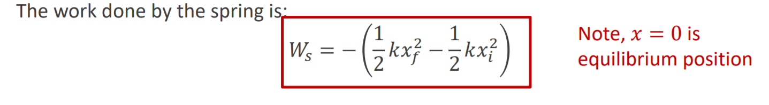

Kinetic energy of springs
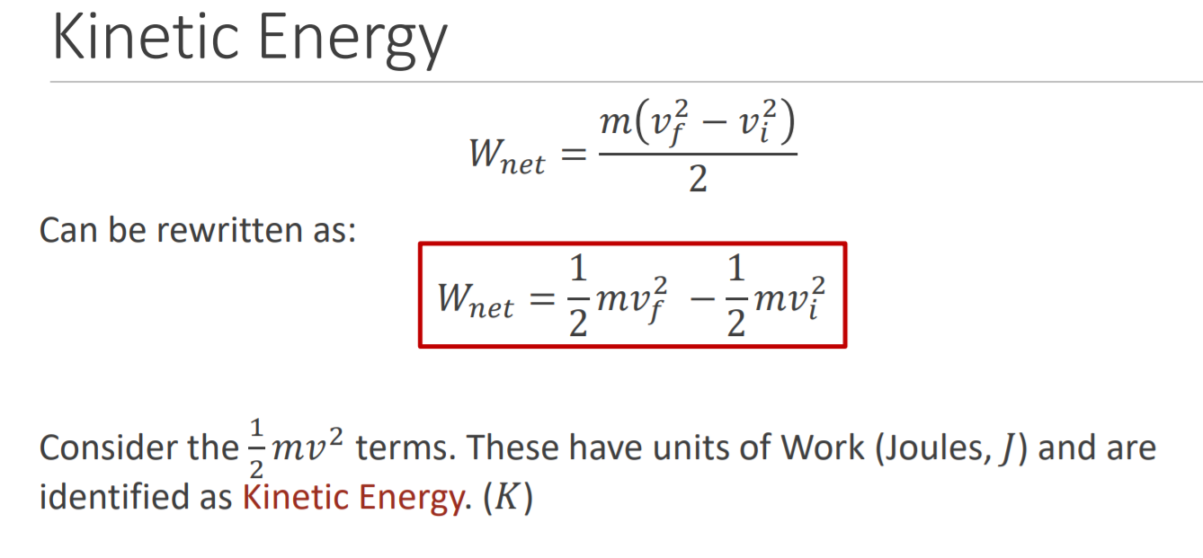
For questions with frictional force, we use the following way:
$F= μ . N$ Here N is the normal force. $N=m.g$
The above gives us maximum limiting frictional force (This is always the case if the body is on motion).
When ever we have questions regarding inclined planes/ Radius and work done. Use the following formula.
Work done by gravity.
$$W=F.sinΘ.d$$

- Work done by tension in questions with pulley in opposite direction and two masses is zero because they cancel each other out.
- the work done by a conservative force is equal to the negative of the change in potential energy of the object.
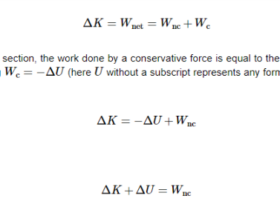
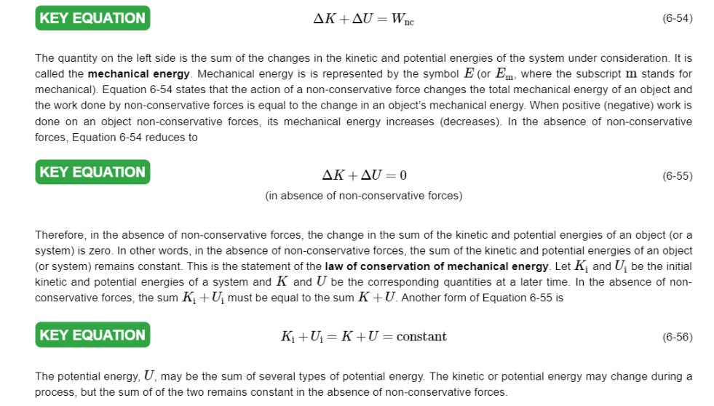

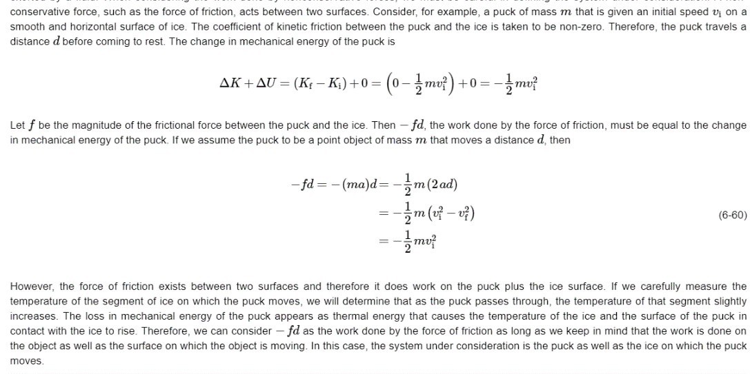
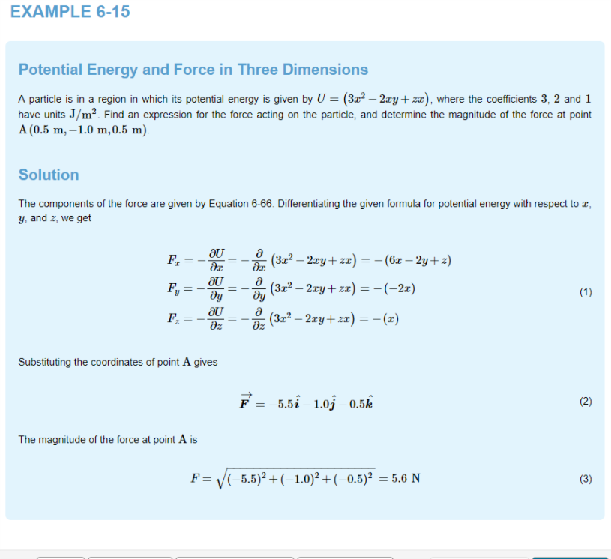

*There is no work done when we talk about radial acceleration and tangential acceleration. Still check because seems skeptical.

△E=$W_{NC}$

SPRINGSSS
The work done by a spring is positive/ negative depends on the direction of applied force. The work done by the spring is always opposite to the direction of displacement.
W α $x^{2}$
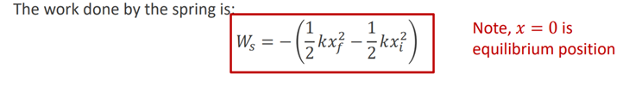
Potential Energy
$$A=-△U$$
Power
Power is defined as the rate of change of work done over time period.
$$P_{avg}=\frac{W}{t}$$
$P=$F.V.CosΘ
Power is a scalar quantity and the SI unit is watts
Important example
Suppose an electric bulb is rated at 100 W. In 1.00 h of operation, it would have energy
transferred to it by electrical transmission in the amount of (0.100 kW)(1.00 h) =
0.100 kWh = 3.60 x ${10}^{5}$ J
From this, we get the formula for power x time = Energy
If a friction force of magnitude fk acts over a distance d within a system, the change in internal energy
of the system is given by
△$E_{int}$ = fk.d
Work done when a block falls some distance on a ramp with friction(Q-75)
mgh($μ_{k}cotΘ-1)$

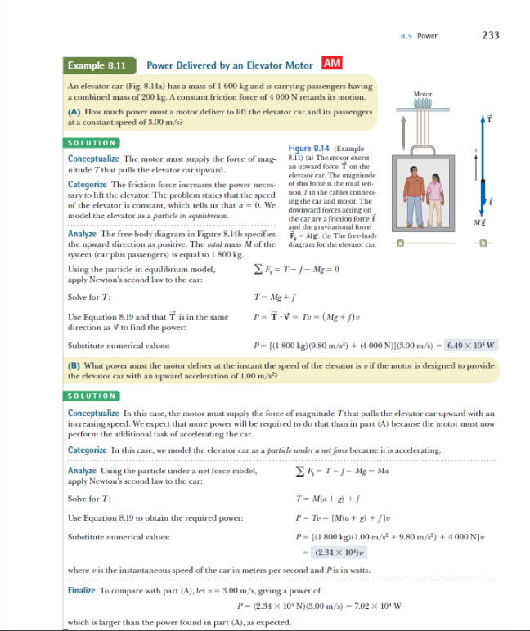
Chapter 9
Pure rolling motion


