ANP 1105 Final Exam Review
Topic 4.3 Blood Vessels & Hemodynamics
4.3.1 Compare and contrast the structure of the wall of blood vessels
- Blood moves from the heart and back via: arteries→arterioles→capillaries→venules→veins
- Arteries moves blood away from the heart and veins carry blood towards
- Only capillaries provide blood to cells
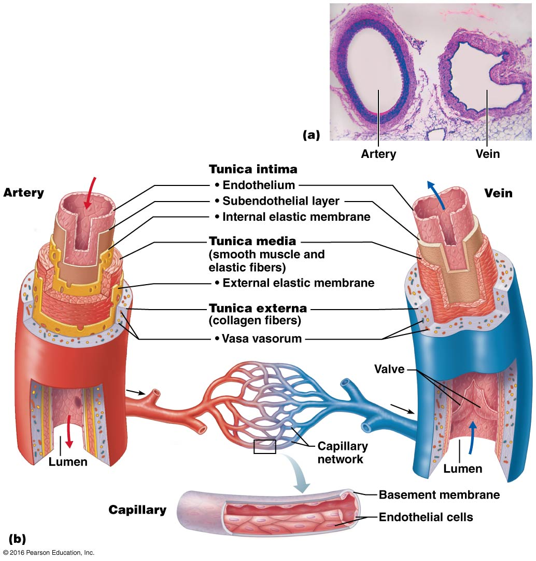
Structure of blood vessel walls (excluding the thinnest):
- Tunica intima: layer of endothelial tissue
- Tunica media: smooth muscle
- Tunica externa: collagen fiber
4.3.2 Compare the 3 types of arterial vessels
- Elastic arteries: thick walled, large diameter arteries near the heart. Highest proportions of elastin smooth out pressure fluctuations; recoil helps maintain pressure & flow of blood.
- Muscular arteries: deliver blood to specific organs. Has more smooth muscle vs. Elastin.
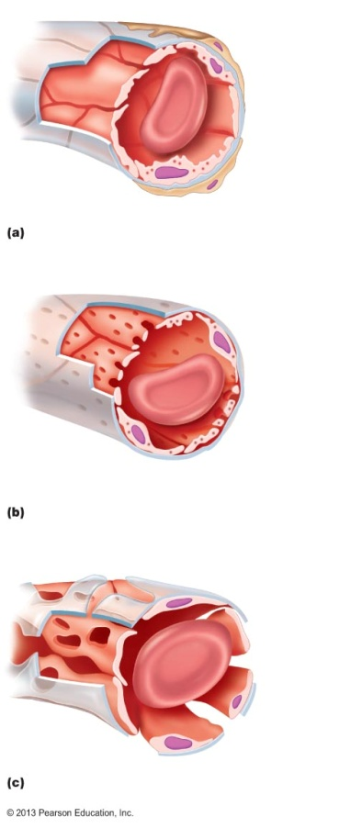
- Arterioles: the tunica media is primarily smooth muscle; single layer in smallest arterioles. Arterioles determine which capillary beds acquire blood minute-to-minute.
4.3.3 Define microcirculation and compare the 3 types of capillaries
- Walls of capillaries are only a thin tunica intima
- Function of a capillary is to exchange blood
- Continuous capillaries (top): found in skin & muscle; uninterrupted lining intercellular clefts allow limited passage of fluids, small solutes
- Fenestrated capillaries (middle): found in small intestine, endocrine organs, and kidney. similar to continuous although endothelial cells have pores(fenestrations)→increases permeability to fluids/small solutes
- Sinusoidal capillaries (bottom): Found in liver, bone marrow, lymphoid tissues, and endocrine organs. They are highly modified, leaky capillaries. They have large, irregular lumens and usually fenestrated; fewer tight junctions and large intercellular clefts for passage of proteins, RBCs.
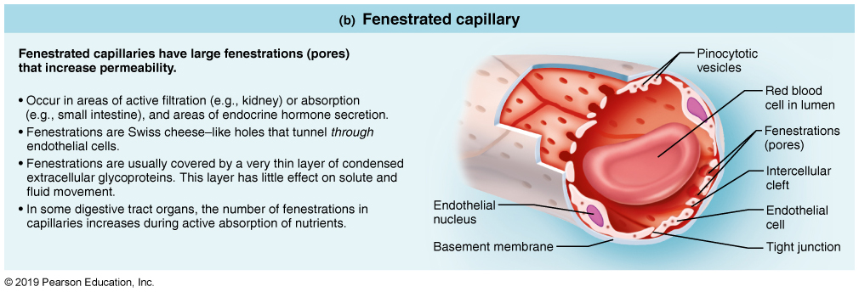
Microcirculation: flow of blood from an arteriole to a venule through a capillary bed
- Flow through a given capillary bed is regulated by the diameter of the terminal arteriole
True capillaries: actual exchange vessels (usually 10-20 per capillary bed)
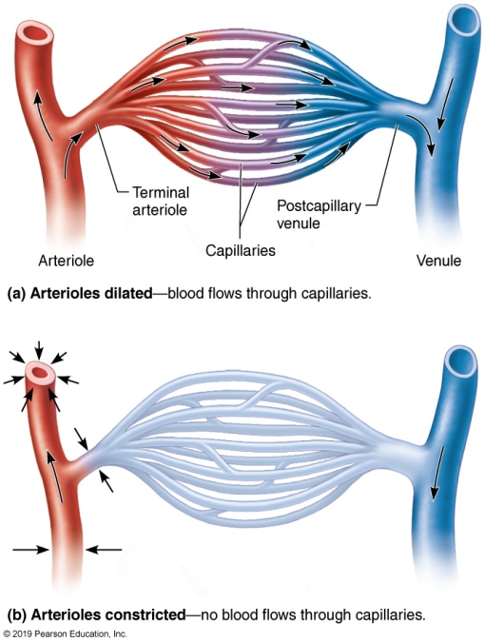
Some capillary beds (e.g. those of the mesenteric membranes) are equipped with a metarterilole, a thoroughfare channel and precapillary sphincters.
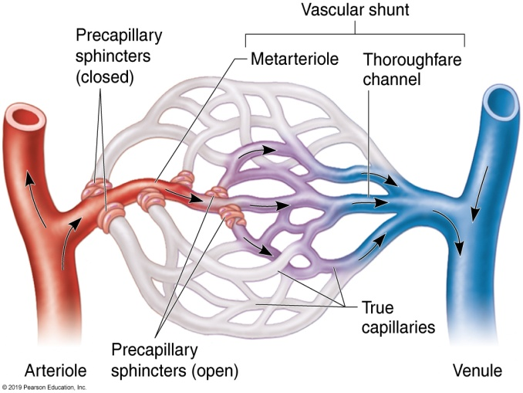

4.3.4 Describe the structure and functions of venules & veins
- Venules: post capillary venules = just endothelium + a few fibroblasts; larger venules have sparse tunica media & thin tunica externa
- Veins: 3 tunics but walls thinner & lumens larger. Relatively little elastin/smooth muscle in tunica media; tunica externa is the heaviest layer. Up to 65% of blood in veins at any one time = capacitance vessels or blood reservoirs
Two structural adaptations of veins that promote blood return?
- Valves in veins to prevent backflow
- Skeletal muscles will push blood up as well
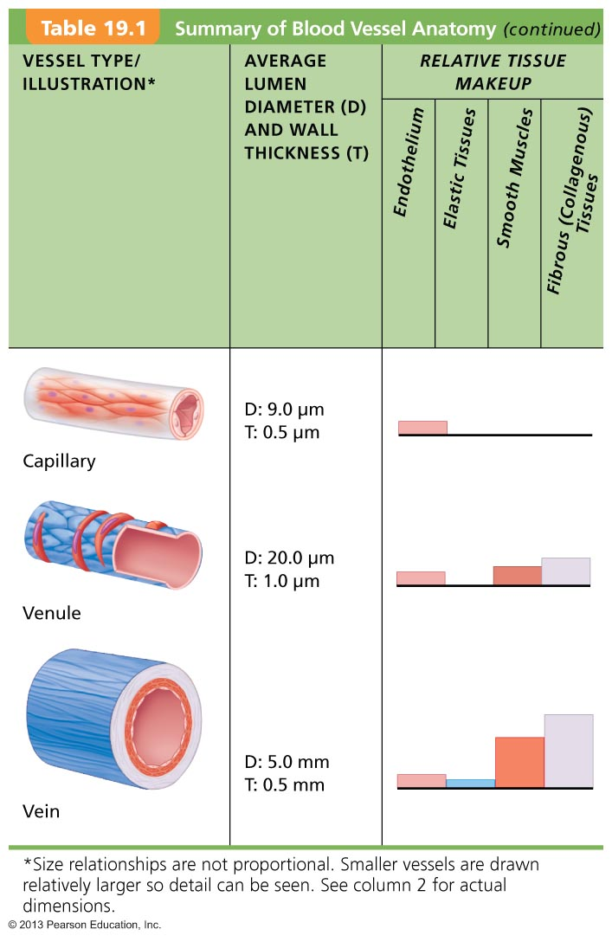
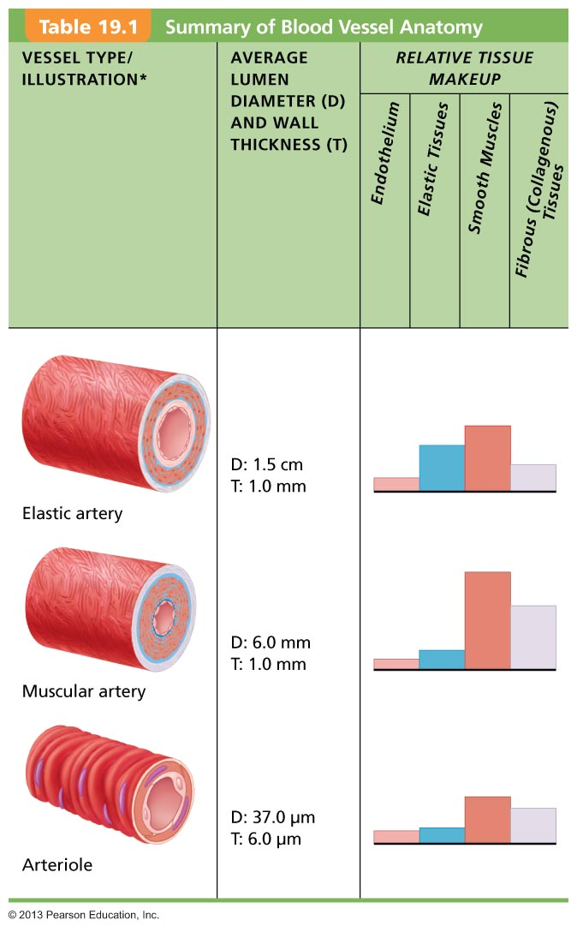
4.3.5 Define: blood flow, blood pressure, resistance, peripheral resistance
Blood Flow (ml/min): blood that passes through a specific place
Blood pressure: force per unit area exerted on the wall of a blood vessel by its containing blood (mm Hg)
- Refers to systemic arterial blood pressure in the largest arteries near the heart (ex: average aortic bp = 90 mm Hg)
Flow occurs in response to a pressure gradient

4.3.6 Illustrate the changes in blood pressure as blood travels through the various vessels of the circulatory system
$$Blood flow= \frac{Differece in blood pressure }{Peripheral resistance }$$
Resistance is the major determinant of blood flow because a change in blood vessel radius increases resistance to the 4th power
Arterioles can regulate their diameters

