Chapter 6 – Segmentation, Targeting and Positioning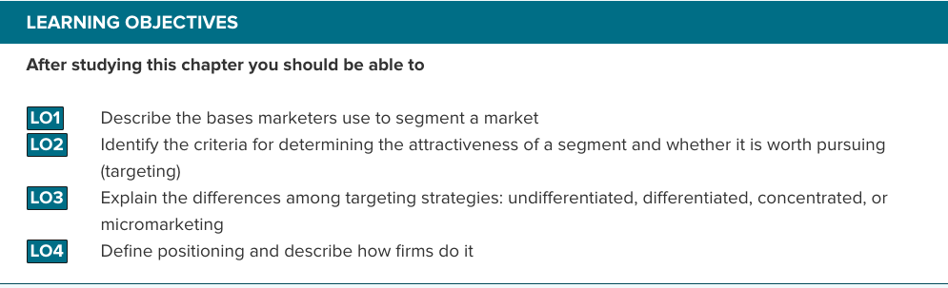

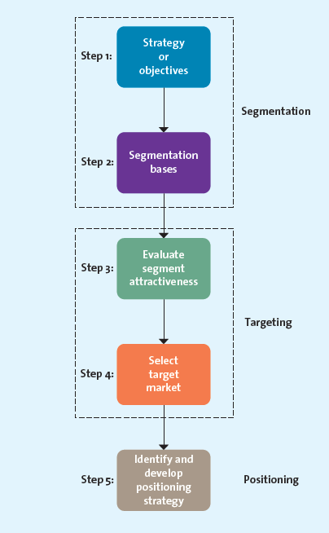
The Segmentation-Targeting-Positioning Process
- Step 1: Establish Overall Strategy or Objectives – Segmentation strategy must be consistent with and derived from the firm’s mission and objectives & SWOT
- Step 2: Segmentation bases
  - Develops descriptions of the different segments, their needs, wants and characteristics
  - Bases include:
    - Geographic segmentation – Organizes customers into groups on the basis of where they live; country, region, climate
    - Demographic segmentation – Groups consumers according to easily measured, objective characteristics such as age, gender, income, education, race, occupation, religion, marital status, family size, family life cycle and home ownership
      - Stereotyping could lead to poor STP strategies
    - Psychographic segmentation – One that delves into how consumers describe themselves
      - Using people descriptions to determine how they occupy their time and what psychological reasons determine these choices
      - Involves knowing and understanding three components of psychographics
        - Self-values – Life goals that drive how a person wants to live their life
        - Self-concept – The image that people have of themselves
          - A person that has a goal to belong may see or want to see himself as a fun-loving, gregarious type whom people wish to be around
        - Lifestyles – Ways we live
          - How we live our lives to achieve goals
      - One of the most used psychographic system is the VALS, owned and operated by SBI
    - Behavioural Segmentation – Groups consumers on the basis of the benefits they derive from products or services, their usage rates of products or services, their loyalty and the occasion for which the product or service is used
      - Occasion segmentation – Based on when a product or service is purchased or consumed
      - Benefit segmentation – Looks at the benefits customers derive from products or services
      - Loyalty segmentation – Investing in retention and loyalty initiatives to retain their most profitable customers
      - Usage rate (High users, low users, regular users)– Often use promotional coupons to target occasional visitors
    - Using multiple segmentation methods – Each have their pros and cons
      - Segmentation by demographics and geography is easy but it does not help them determine customer needs
      - Combination of geographic, demographic, and lifestyle characteristics is called geodemographic segmentation
        - One tool used is PSYTE, which groups all neighbourhoods in Canada into 60 different lifestyles clusters
          - Three clusters: Urban Lower Middle: Urban Bohemia, Suburban Affluent: Suburban Affluence, Suburban Affluent: Asian Heights
      - Knowing what benefits customers are seeking or how the product or service fits a particular lifestyle is important for designing an overall market strategy

- Step 3: Evaluate Segment Attractiveness – Involves evaluating the attractiveness of the various segments
  - Identifiable – Must determine who is within their market to be able to design products or services to meet their needs
  - Reachable – Best product or service cannot have any impact if that market cannot be reached through persuasive communications and product distribution
    - Must know the product or service exists, what it can do for them and recognize how to buy it
  - Responsive – Customers in the segment must react similarly and positively to the firms offerings
    - If the firm cannot provide products or services to the segment, it should not target it
  - Substantial and Profitable – Needs to measure size and growth potential of the target markets
    - Potential profitability key factors: Market growth, market competitiveness, market access
    - Segment profitability = (Segment size x Segment adoption percentage x Purchase behavior (Price x Number of times the customer would buy) x Profit margin percentage) – Fixed costs
    - Customer lifetime value is important to take into account for
      - How long the customer will remain loyal, defection rate, costs of replacing customers, whether they will buy other products
- Step 4: Select Target Market – Key factor will be marketers ability to pursue such an opportunity or target segment
  - Undifferentiated Targeting Strategy, or Mass Marketing – When everyone might be considered a potential user of the product or service
    - If perceived to provide the same benefits to everyone, no need to develop separate strategies
    - Common for basic items or smaller firms a
  - Differentiated Targeting Strategy – Target several market segments with a different offering for each
    - Helps firms obtain a bigger share of the market and increase the market for their products overall
    - Also helps diversify the business, lowering risk
  - Concentrated Targeting Strategy – When they select a single, primary target market and focuses all its energies on providing a product to fit that market’s needs
  - Micromarketing – When a firm tailors its product or service to suit an individual customer’s wants or needs
    - Firms that interact on a one-to-one basis with many people to create custom products are engaged in mass customization
- Step 5: Identify and Develop Positioning Strategy
  - Positioning – Mental picture or perception that people have about a company, its products and brands relative to competing products, brands or companies
    - Formed by multiple sources such as friends , family, reference groups, ads, TV, internet, personal experience
    - Positioning strategy can help communicate the firm’s or the product’s value proposition communicating the customer benefits to be received from a product or service and thereby reasons for wanting to purchase it
    - Not easy to shape a customer’s perceptions in the way marketers want
    - Effective positioning is about letting consumers know what the company’s unique value proposition is and for whom it is intended
      - Must focus on the value of a product or service offers the target, or how it is better than competitors
  - Positioning statement – Expresses how a company wants to be perceived by consumers
    - Elements include:
      - Target market, offering name or brand, product/service category or concept, unique point of difference/benefits
  - Positioning methods
    - Value – Mega Bloks uses a low-price value based strategy whereas its competitor focuses on a high-price positioning strategy
      - Some claim to offer the same value for much less money
      - May use to let consumers know that while they are getting less, they are paying much less
    - Product Attributes – Focuses on attributes that are most important to the target market
    - Benefits and symbolism – Emphasizes the benefits of the brand as well as the psychological meaning of the brand to consumers
      - Meanings created by the brands are the reasons consumers buy them rather than lesser-known
    - Competition – May choose to position their products head-to-head against a specific competitor or an entire product/service classification on similar attributes within the target market
      - Can also choose a differentiation strategy by going after a less competitive, smaller market niche
    - Market Leadership – Market leaders may emphasize their leadership position within their industry
  - Positioning by using perceptual mapping
    - Perceptual map – Displays, in two or more dimensions, the position of products or brands in the consumers mind
      - Small circles and the numbered circles denote a consumers ideal point
        - The larger the numbered circle, the larger the market size
    - Steps to derive a perceptual map:
      - Determine consumers’ perceptions and evaluations of the firm’s product or service in relation to competitors
      - Identify the market’s ideal points and size
      - Identify competitor’s positions
      - Determine consumer preferences
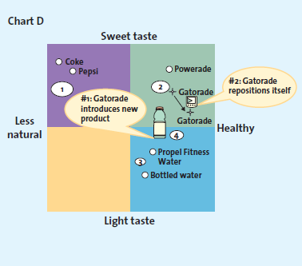
      - Select the position
      - Monitor the positioning strategy

  - Repositioning – Good marketers constantly revaluate their brand’s position to determine when to reposition it
    - Should reposition their brands to keep up with changes in the marketplace or to put a fresh spin on their stale and stodgy brand
    - Brand repositioning – Strategy in which marketers change a brands focus to target new markets or realign the brand’s core emphasis with changing market preferences
      - Could improve brand’s fit with target segment or boost old brands
        - Need to spend tremendous amounts however to make tangible changes to products and packages
        - Costs may not be recovered if the repositioned brand and messages are not credible or if they got involved in a fad

Chapter 8: Developing New Products
- Innovation – the process by which ideas are transformed into new products and services that will help firms grow
- Disruptive innovation – Generally simpler and less sophisticated and may be less expensive than existing products or services (ex: Netflix streaming vs movie rental)

- Pioneers (Breakthroughs) – new product introductions that establish a completely new market or radically change both the rules of competition and consumer preferences in a market
  - generally require higher level of learning from consumers and offer much more benefits then predecessor product (ex ipod)
- First Movers - product pioneers that are the first to create a market or product category, making them readily recognizable to consumers and thus establishing an early and commanding market share lead
  - Because pioneering products use their resources to establish the market alone, they pave the way for followers who spend less money on creating demand for the product category and more money on creating demand for their specific product.
- Diffusion/Adoption of Innovation - the adoption or diffusion of innovation is the process by which the use of an innovation, whether a product or service, spreads throughout a market or group over time and over various categories of adopters
  - The theory helps marketers understand the rate at which consumers are likely to adopt as well as giving them means to identify potential markets, and predict sales before they introduce innovations as well as design marketing campaign to push adoption through each consumer category.
Categories of Consumer Adoption
1. Innovators (2.5%) - those buyers who want to be the first to have the new product or service
- enjoy taking risks, and are regarded as highly knowledgeable, and are not price sensitive
2. Early Adopters (13.5%) - second to adopt after innovators; they generally don’t take as much risk but instead wait and purchase the product after careful review
3. Early Majority (34%) – don’t take on much risk and therefore tend to wait until all initial bugs are worked out
4. Late Majority (34%) – the last group of buyers to enter a new product market
- when they do so, the product has achieved full market potential
5. Laggards (16%) – tend to avoid change and rely on traditional products until they are no longer available
- laggards may never adopt a product or service

Factors Affecting Diffusion
- Compatibility - if a product is consistent with peoples past behaviour, their needs and what they value then the diffusion should happen relatively quickly
- Observability - when products can be easily observed in use, their benefits or applications are easily communicated to other potential consumers thus enhancing the diffusion process
- Complexity and Trialability – products that are relatively less complex are also relatively easy to try. These products will generally diffuse more quickly than products that are complex and that cannot be tested easily
- Relative Advantage - if a product is perceived to be better than substitutes, then the diffusion will be relatively quick
The Product Development Process
The new product development process begins with the generation of new products ideas and culminates in the launch of the new product and the evaluations of its success. Generally process is a team effort with the team comprised of representatives from the firms various functions (marketing, R&D, Finance etc.).
1) Idea Generation – To generate ideas for new products or services firms can use their own R&D departments efforts, licensing technology from research firms, brainstorm, research competitor’s products/services, and/or conduct consumer research
- Internal R&D
– Many firms have their own R&D departments in which scientists work to solve complex problems and develop new ideas. IBM in computer industry, Rubbermaid in the consumer goods industry and 3M in industrial goods are all examples of firms that rely on internal R&D.
- Product development costs are extremely high
- Resulting products have good chance of becoming pioneers or breakthroughs
- Firms anticipate that blockbuster breakthroughs will generate enough revenue to make up for all of the introductions that did not perform in the market.
b) Licensing
– for many new scientific and technological products, firms purchase the rights to use technology or ideas from other research-intensive firms through a licensing agreement. This approach saves costs of in house R&D, but it means that the firm is banking on a solution that already exists but has not yet been marketed.

- Brainstorming
– Firms often engage in brainstorming sessions during which a group works together to generate ideas. One key characteristic is that no idea can be immediately accepted or rejected. Moderator may direct focus but only at the end are the best ideas accepted.

- Competitors Products
– New product entry by competitor may trigger opportunity for another firm. This firm can reverse engineer to understand the competitors’ product and produce an improved version to offer to consumers
Reverse engineering – involves taking a competitor’s product, analyzing it, and creating and improved version that does not infringe on the competitors patents.

- Consumer Input
- Listening to consumer is essential for successful idea generation. The firms design and development teams work on consumer suggestions or trends to develop products that have a significantly greater chance of being adopted by the consumer
- Lead users- innovative product users who modify existing products according to their own ideas to suit their specific needs.

- Outsourcing:
- finding a company that offers services that helps clients generate new products and service ideas in industries of interest
2) Concept Testing - Ideas that show marketing potential are developed further into concepts.
Concepts - concepts are brief written descriptions of a product or service; it’s technology, working principals, and forms; as well as what customer needs it would satisfy
Concept Testing – the process in which a concept statement that describes a product or service is presented to potential buyers or users to obtain their reactions

3) Product Development/Design
- entails a process of balancing various engineering, manufacturing, marketing, and economic considerations to develop a product
Prototype – the first physical form or service description of a new product, still in rough or tentative form, that has the same properties as a new product but is produced through different manufacturing processes, sometimes even crafted individually
- they are usually tested through alpha and beta testing
Alpha Testing - an attempt by the firm to determine whether a product will perform according to its design and whether it satisfies the need for which it was intended; occurs in the firms R&D department
Beta Testing - having potential consumers examine a product prototype in a real-use setting to determine its functionality, performance, potential problems and other issues specific to its use

4) Market Testing
Premarket Test - conducted before a product or service is brought to market to determine how many consumers will try and then continue to purchase the product
Test Marketing - introduces a new product or service to a limited geographical area (usually a few cities) prior to the products national launch
- test market effort uses all of the elements on the marketing mix just as if it were being launched nationally
- costs more and is more time consuming then pre-market testing but the firm can study actual consumer behaviour
- once product demand is estimated the product is launched nationally

5) Product Launch
- If the market testing returns positive results, the firm is ready to introduce the product to the entire market. Product launch is the most critical step and requires a great deal of financial resources and extensive coordination of the firm’s functional units. If it’s a failure it may be difficult for the product as well as the firm to recover
Using the results of the market and pre-market tests the firm confirms its target and market sizes and decides how the product will be positioned.
The firm then finalizes its marketing mix variables: Promotion, Place, Price and Timing

6) Evaluation of Results
- After product is launched marketers must undertake critical post-launch review to determine whether the product and its launch were successful and what additional resources or changes to the marketing mix are needed
Product Life Cycle
- Defines the stages that new products move through as they enter, get established in and ultimately leave the marketplace and thereby offers marketers a starting point for their strategy planning
(Refer to Figure 10.7, 10.8, 10.9 / pages 283-288)

1) Introduction stage –innovators start to purchase the item; usually begins with a new innovative product from a single firm
- sensing the viability and commercialization possibilities of this market-creating product, other firms soon enter the market with improved often cheaper versions of the original pioneer
- stage is characterized by initial losses due to high start-up costs and low level of sales revenue

2) Growth stage – the product gains acceptance, demand and sales increase, and competitors emerge in the product category
- growth stage is marked by a number of product adopters, rapid industry growth and increase in number of competitors and available product versions
- market becomes more segmented and consumer preference more varied

3) Maturity Stage – industry sales reach their peak, so firms try to rejuvenate their products by adding new features or re-positioning them.
- characterized by the adoption of the late majority, and intense competition for market share
- lower prices and higher marketing costs erode the profit margins for many firms and practically all potential consumers have adopted the product at this point
Additional Strategies for extending maturity stage include:
- Entry into New Market Segments – Because original market is so saturated firms might attempt to enter new geographical areas that may be less saturated.
  - For example, in developing nations large a growing populations of middle class consumers are just beginning to purchase household goods that have been standard in North America for decades.
- Development of New Products – Despite saturation firms continually introduce new products with improved features or find new uses for existing products because they need constant innovation to defend market share.
4) Decline Stage – sales decline and the product eventually exits the market
- firms with products in the decline stage either position themselves for a niche segment of diehard consumers or those with special needs or they completely exit the market

 | Introduction | Growth | Maturity | Decline
Sales | Low | Rising | Peak | Declining
Profits | Negative or low | Rapidly rising | Peak to declining | Declining
Typical Consumers | Innovators | Early adopters and early majority | Late majority | Laggards
Competitors (number of firms and products) | One or few | Few but increasing | High number of competitors and competitive products | Low number of competitors and products

Shape of the Product Life Cycle – In theory it is assumed that the product life cycle curve is bell shaped with regards to sales and profits
- In reality however, each products cycle has its own shape depending on how different the product is from other products currently available on the marketplace
- High learning products spend much more time in the introduction stage because it takes longer for consumers to adopt them and less time than subsequent low learning products
- Fads move through the stages very quickly while fashion products tend to be cyclical in nature

Chapter 9: Product Branding, and Packaging Decisions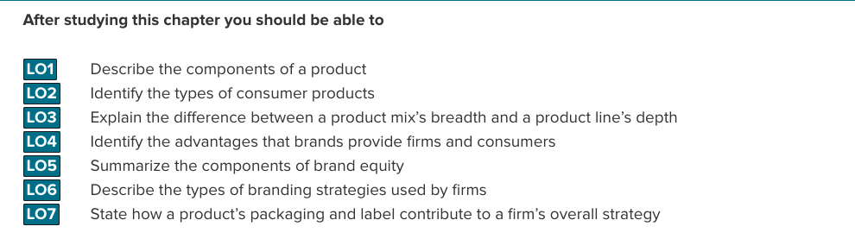
Product – anything that is of value to a consumer and can be offered through a voluntary marketing exchange
Product Assortment (Product Mix) – the complete set of all products offered by a firm
Product Lines – groups of associated items, such as those that consumers use together or think of as part of a group of similar products
Product Category – an assortment of items that the customer sees as reasonable substitutes for one another
Ex. Colgate-Palmolive Product Assortment
 | Product Lines
 | Oral Care | Personal Care | Household Care | Fabric Care | Pet Nutrition
Product Categories | Toothpaste  - Colgate Total  Toothbrush  - Colgate Plus  Whitening  - Simple White | Deodorants  - Speed Stick  Soap  - Irish Spring | Dishwashing Liquid  - Palmolive | Detergents  - Fab  Fabric Softener  - Fleecy | Dog Food  - Science Diet

Brand – the name, term, design, symbol, or any other features that identify one seller’s good or service as distinct from those of other sellers
Product Line Breadth – the number of product lines, or variety, offered by the firm
Product Line Depth – the number of categories within a product line
Stock Keeping Units (SKUs) – individual items within each product category; the smallest unit available for inventory control
Category Depth – the number of stock keeping units (SKUs) within a category

Change Product Mix Breadth
Increase Breadth
– add new product lines to capture new or evolving markets, increase sales, and compete in new ventures
Decrease Breadth
- sometimes it is necessary to delete entire product lines to address changing market conditions or meet internal strategic priorities

Change Market Mix Depth
Increase Depth
- firms may add new products within a line to address changing consumer preferences or pre-empt competitors while boosting sales
- ex. Levi’s adding a new line of low-cost jeans to boost sales and reach new target markets by selling through other retailers such as Wal-Mart
Decrease Depth
- may be necessary to delete product categories to realign resources
- unprofitable items may be removed to refocus their marketing efforts on more profitable items
Change Number of SKUs
- adding/deleting SKUs in existing categories can stimulate sales or react to consumer demand
- fashion manufacturers and their retailers change their SKUs every season
What Make a Brand?
- brand name, URLs/domain names, logos/symbols, characters, slogans, jingles

Value of Branding
a) Brands Facilitate Purchasing - easily recognized by consumers
b) Brands Establish Loyalty - consumers learn to trust certain brands
c) Brands Protect from Competition - less competition if brand has loyal customer base
d) Brands Reduce Marketing Costs - well-known brands can allow firms to spend less
e) Brands are Assets - can be legally protected through trademarks/copyrights
f) Brands impact Market Value - well-known brands can have a direct impact on bottom line
Brand Equity – the set of assets and liabilities linked to a brand that add to or subtract from the value provided by the product or service
Branding Strategies
1. Brand Ownership
2. Naming Brands
3. Brand Extension
4. Cobranding
5. Brand Licensing
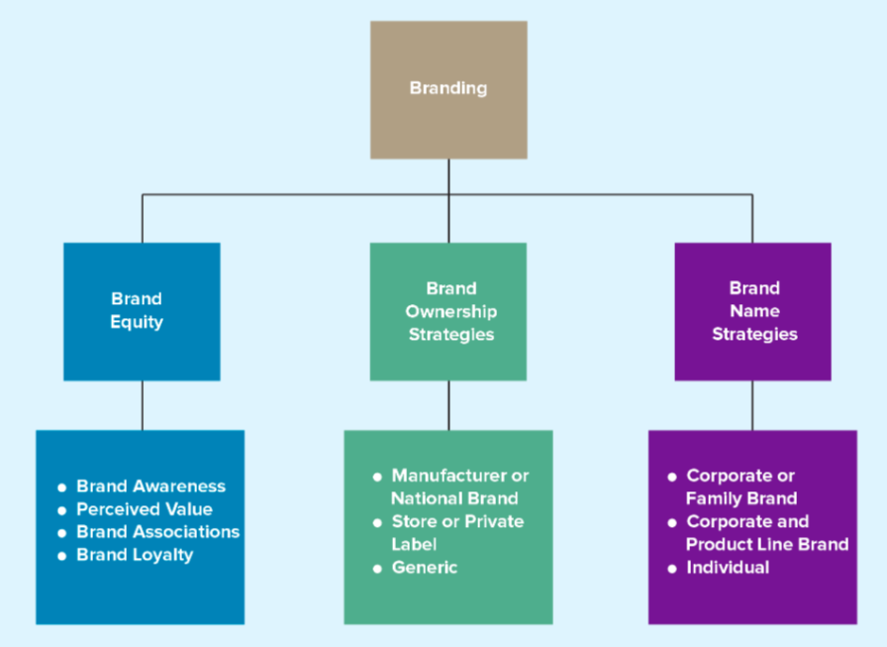

Brand Equity Strategies
1. Brand Awareness – measures how many consumers in a market are familiar with the brand and what it stands for; created through repeated exposures of the various brand elements (brand name, logo, symbol, character, packaging, slogan) in the firms communications to consumers
2. Perceived Value – the relationship between a product or service’s benefits and costs
3. Brand Association – the mental links that consumers make between a brand and its key product attributes; can involve a logo, slogan, or famous personality
Brand Personality – set of human characteristics associated with a brand, which has symbolic or self-expressive meanings for consumers
4. Brand Loyalty – occurs when a consumer buys the same brand’s product or service repeatedly over time rather than buying from multiple suppliers within the same category

Brand ownership:
Brands can be owned by any firm in the supply chain whether manufacturers, wholesalers or retailers
- There are three basic brand ownership strategies
Brand Ownership Strategies
1. Manufacturer Brands (National Brands) – brands owned and manufactured by the manufacturer
2. Private Label (Store Brands) – brands developed by a retailer and available only from that retailers
3. Generic Brands – a product sold without a brand name (typically commodities)

Brand Name Strategies
1. Corporate of Family Brand – the use of a firm’s own corporate name to brand all of its product lines and products
2. Corporate and Product Line Brand – the use of a combination of family brand name and individual brand name to distinguish a firm’s products
3. Individual Brands – the use of individual brand names for each of a firm’s products
Brand Extension – the use of the same brand name for new products being introduced to the same or new markets
Advantages include already established brand name, high quality perceptions will carry over to new product, marketing costs for a new product are lower, brand extensions used by complimentary products will boost sales and successful brand extensions can result in cross category trial and boost sales.
Not all brand extensions are successful however; some can dilute brand equity.
Brand Dilution – occurs when a brand extension adversely affects consumer perceptions about the attributes the core brand is believed to hold
Cobranding – the practice of marketing two or more brands together, on the same package/promotion
Brand Licensing – a contractual arrangement between firms, whereby one firm allows another to use its brand name, logo, symbols, or characters in exchange for a negotiated fee

Chapter 10: Services: The Intangible Product
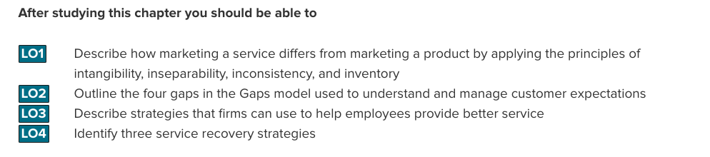
Service – Intangible customer benefits that are produced by people or machines and that cannot be separated from the producer
- involves a deed, performance or effort that cannot be physically possessed
Customer Service - specifically refers to human or mechanical activities firms undertake to help satisfy their customer’s needs and wants
Economies of developed countries have become increasingly dependent on services. This dependence and growth of service-oriented economies has emerged because
- Generally less expensive for firms to manufacture their products in less developed countries
- Household maintenance activities, which many people have performed for themselves in the past have become specialized. IE Food preparation, lawn care, cleaning, car repair
- People place a high value on convenience and leisure. Most households have little time for household maintenance activities
- As the Canadian population ages the need for healthcare professionals also increases.
Services Marketing Differs from Product Marketing – differs due to four fundamental differences that are unique to services; these differences make marketing for services considerably more difficult
Core Differences Between Services and Goods
a) Inseparable
b) Variable (inconsistent)
c) Perishable (inventory)
d) Intangible
a) Intangible – A characteristic of a service. They cannot be touched, tasted or seen like a pure product can. When you get a physical you see and hear your doctor but the benefit provided itself is intangible
- Difficult to convey the benefits of services
- Service provider offer cues to help their customers experience and perceive their service more (Doctors offices with TV’s and games etc.)
- Enhance services through providing comfortable atmospheres (Starbucks, Chapters)
- Service can’t be shown directly to potential customers without performance thus it is difficult to promote
- Images marketers use reinforce the benefit or value of the service, Professional services rely heavily on customers perception of integrity and trustworthiness.
b) Inseparable Production and Consumption – Services are produced and consumed at the same time, that is, the service and consumption are inseparable
- Because of this consumers rarely have the opportunity to try the service before they purchase it.
- Due to this the purchase risk for some services is quite high, thus they sometimes provide extended warranties and satisfaction guarantees.

c) Inconsistent (Variable) – The more that humans provide the service in question, the more likely there is to be variability or inconsistency in the services quality
- A restaurant, which offers a mixture of services and goods, generally can control its food quality, but not the variability in its preparation or delivery.
- Marketers strive to reduce variability through training and standardization of procedures
- Variability can also be used as an advantage. For example, using micro-marketing segmentation strategy to provide customized service designed to meet a specific customers needs
- Variability can be addressed by replacing humans with machines wherever possible (ATM’s, self-checkouts etc.) However some consumers either do not embrace replacing a human with machine or have problems using the technology itself.
d) Perishable (Inventory) – Services are perishable in that they cannot be held in inventory or stored for use in the future. You cannot stockpile a service as you would inventories of goods
- As long as demand for and supply of service remain close perishability is not an issue however this is rare.
- Airlines, cruises, movie theatres, resorts etc. face similar challenges and offer promotions to get through peak seasons, or even sell bundles of extra seats to websites such as HOTWIRE.COM to sell over the internet in conjunction with other items for reduced prices.

The Gaps Model – Gaps model is designed to encourage the systematic examination of all aspects of the service delivery process and prescribe the step necessary to develop an optimal service strategy
See page 304, exhibit 11.3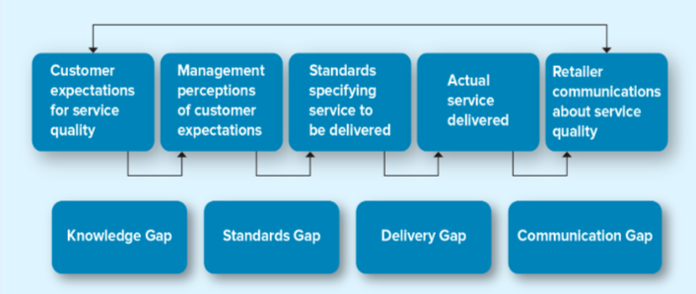
Types of Gaps
a) Knowledge Gap
b) Standards Gap
c) Delivery Gap
d) Communication Gap

a) Knowledge Gap - Reflects the difference between the customers’ expectations and the firm’s perception of those expectations.
Important early step in providing service is, knowing what the customer wants. To reduce the knowledge gap firms must understand the customers’ expectations and match those expectations will actual service through research.
- Understanding Customer Expectations – Expectations are based on their knowledge and experiences and vary according to the type of service. For instance someone’s expectations may be higher who is staying at a 5 star resort versus a Holiday Inn.
  - Also vary depending on situation
  - Service provider needs to know and understand the expectations of the customer in its target market
- Evaluating Service Quality – Service quality reflects customers perceptions of how well a service meets or exceeds their expectations. Customers generally use 5 distinct service dimensions to determine overall quality.
  - Reliability –The ability to perform the service dependably and accurately
  - Responsiveness – The willingness to help customers and provide prompt service
  - Assurance – The knowledge of and courtesy by employees and their ability to convey trust and confidence.
  - Empathy – The caring, individualized attention provided to customers
  - Tangibles – The appearance of physical facilities, equipment, personnel, and communication materials.
- Marketing Research: Understanding Customers- Marketing research provides a means to better understand consumers’ service expectations and their perception of service quality.
  - Voice-of-Customer (VOC) programs – Ongoing marketing research system that collects customer inputs and integrates them into managerial decisions. Uses various methods to collect insights and intelligence from consumers and use them to influence or drive business decisions.
  - Zone of Tolerance – Method of evaluating how well firms perform on 5 service dimensions. The area between customers’ expectations regarding their desired service and the minimum level of acceptable service. The difference what the customer really wants and what they are willing to accept before going elsewhere.
  - Consumer perceptions are effectively and inexpensively collected at time of sale
  - Essentially need to put mangers on the front lines occasionally to interact directly with customers
b) The Standards Gap – Pertains to the difference between the firms’ perceptions of customers’ expectations and the service standards it sets. Gap can be narrowed by setting appropriate service standards and measuring service performance.
- After determining its customers service expectations the next step is to set service standards and develop systems to ensure high quality service.
- Firm needs to set high service standards, enforce these standards, and train employees on how to perform to these standards. Management must also demonstrate high service standards which will permeate through the organization.
- Achieving Service Goals through Training – To deliver consistently high quality service, firms must set specific, measurable goals based on their customers’ expectations.
  - Frontline service employees can be taught specific tasks but it is not enough to tell employees to be nice to the customer
  - Quality goal should be specific: “Greet every customer you encounter with a smile and a good day Sir and Miss, whenever possible use names.
- Commitment to Service Quality – Service providers take their cues from management. If managers strive for excellent service, treat their customer well, and demand the same attitudes from everyone in the organization it is likely that the employees will do the same
  - For example employees who understand that operating on time is critical component to service quality and guest experience will work hard to improve on time performance.

c) The Delivery Gap - The difference between the firms service standards and the actual service it provides to the customers. Even if no other gaps are present, a delivery gap always results in service failure. They can be reduced when employees are empowered to act in the customers and the firms best interest and are supported in their efforts to do so.
- Empowering Service Provider – In the context of service delivery, empowerment means allowing employees to make decisions about how the service is provided to customers.
  - When frontline employees are authorized to make decisions to help their customers, service quality generally improves
  - Empowering may be difficult and costly and in industries where the work is face paced and routine such as fat food restaurants it is more efficient for employees to just follow simple rules.
  - Empowerment becomes more important as price points increase.
- Providing Service Incentives – Service providers often have to deal directly with angry customers, this makes it difficult. To ensure service is delivered properly, management needs to support the service provider
  - Managers and co-workers should provide emotional support to service providers, demonstrating care for their well-being
  - Support managers provide must be consistent and coherent throughout the organization
  - Key part is providing rewards employees for excellent service. Many firms have developed service reputations by ensuring their employees are compensated for excellent service.
- Use of Technology – Since the internet firms have invested heavily in technologies that have enabled customers to buy more quickly, more easily, and with more information that in the past.
  - Use of technology to facilitate service delivery can provide may benefits, such as access to a wider variety of services, a greater degree of control by the customer over the services and the ability to obtain more information.

d) The Communications Gap – Pertains to the difference between the service promised and the service actually delivered.
- Difficult to control service quality because it may vary from day to day and provider to provider, but they do have control about how they communicate their service package to consumers
  - If it promises more than is can deliver, customers’ expectations won’t be met.
  - Dissatisfied customers are likely to tell others about the underperforming service, using word of mouth or the internet
  - Communication gap can be reduced by managing customer expectations
  - Promising only what you can deliver and maybe a little less is an important way to manage expectations

Service Recovery – Despite a firm’s best efforts service failures often occur. When it happens’ the best course of action is to make amends with the consumer and learn from the experience. Firm has an opportunity to demonstrate its customer commitment.
- Service Recovery efforts can significantly increase customer satisfaction, purchase intentions, and positive word of mouth. However customers post recovery satisfaction levels are lower than satisfaction level prior to the service failure
  - Listen to the Customer – The customer must have an opportunity to air the complaint, whether through formal or informal complaint procedures. Customers can become very emotional after a service failure, often they just want to be heard out and this time should be provided.
  - Finding a fair Solution – customer just want to be treated fairly, however their perception of what fair means is based on their previous experience with other firms, how they have seen other customers treated , material they have read and stories
    - a) Distributive fairness - pertains to a customers’ perception of the benefits he or she received compared to the costs or inconvenience that resulted from the service failure. Must listen to consumer, one customer on vacation may just accept a voucher if a plane is booked while a business person needs a greater form of restitution for missing a meeting.
    - b) Procedural fairness - Refers to the customers’ perception of the fairness of the process used to resolve complaints about service. Consumers want efficient complaint procedures over whose outcomes they have some influence.
  - Resolving problems Quickly – The longer it takes to resolve a service failure, the more irritated the customer will become. To resolve service failures quickly, firms need clear policies, adequate training for their employees and empowerment.

Chapter 11 – Pricing Concepts and Strategies: Establishing Value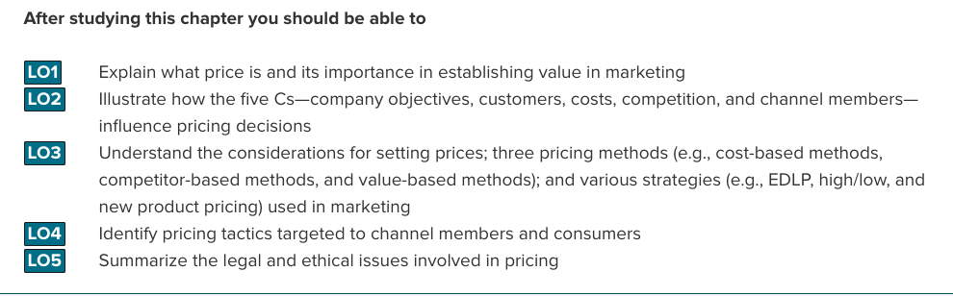
Price – The overall sacrifice a consumer is willing to make to acquire a specific product or service. This includes the money paid in exchange for the item but also other sacrifices can be non monetary, such as the value of time and energy spent acquiring item or the shipping and travel costs.
- Consumers judge the benefits a product delivers against the sacrifices necessary to obtain it
- Key is to match product or service price with the consumers value perceptions.
- A price set to low may signal poor quality or performance, or other negative attributes.
- Consumers don’t necessarily want a low price all the time for all products, they want high value for their money which may come at a high or low cost
- However consumers usually rank price as one of the most important components of their purchase decision
- Price is not just a sacrifice, but an information cue for consumers as well, price says a lot about the product or services quality.
The 5 C’s of Pricing
1) Company Objectives
2) Customers
3) Costs
4) Competition
5) Channel Members
1) Company Objectives – Different firms have different goals. Each firm embraces an objective that seems to fit where management thinks the firm needs to go to be successful. Usually reflects how the firm intends to grow; increase sales, decrease competition, build customer loyalty etc.
- Profit Orientation – Even though all company objectives may ultimately be profit motivated, firms implement profit orientation by focussing on...

  - a) Target Profit Pricing – A pricing strategy implemented by firms when they have a particular profit goal as their overriding concern; uses price to stimulate certain level of sales at a certain profit per unit.

  - b) Maximizing Profit Strategy – A mathematical model that captures all the factors required to explain and predict sales and profits, which should be able to identify the price at which profits are maximized

  - c) Target Return Pricing – A pricing strategy implemented by firms less concerned with the absolute level of profits and more interested in the rate at which profits are generated relative to their investments; designed to produce a specific return on investment. Usually expressed as a percentage of sales.

- Sales Orientation – A company objective based on the belief that increasing sales will help the firm more than will increasing profits. New firm might focus on unit sales and market share at first and be willing to accept less profit per unit to start.
  - Firms may set prices low to discourage new firms from entering the market, encourage current firms to leave the market, take market share from competitors – all to gain overall market share
  - Companies can gain market share simply by offering a high-quality product at a fair price.

- Competitor Orientation – A company objective based on the premise that the firm should measure itself primarily against its competition. Value is only implicitly considered when pursuing competitor orientation
  - Competitive Parity – set prices that are similar to those of major competitors
- Customer Orientation – Explicitly invokes the concept of value and sets prices to match consumer expectations. Could be a low price if that’s what the firms target market values or could be a high quality luxury product with a high price point.

2) Customers – The most important C because it pertains to understanding consumers reactions to different prices. To determine how firms account for customers when they develop pricing strategies must look at foundation of traditional economics.
- Demand Curves and Pricing – Demand curve shows how many units of a product or service consumers will demand during a specific period of time at different prices. Most curves are downward sloping, with price on vertical access and quantity demanded on horizontal axis. As price goes down the quantity purchased increases.
  - Knowing the demand curve for a product or service enables firms to examine different prices in terms of the resulting demand and relative to its overall objective
  - Prestige products or services - Consumers purchase for their status rather than functionality. The higher the price, the greater status associated, and greater exclusivity. Demand curve looks like a reverse C. As price goes up, so do sales, until a point where only certain people can afford it and then sales go down.

- Price Elasticity of Demand – Measures how changes in price affect the quantity of the product demanded; specifically, the ratio of the percentage change in the quantity demanded to the percentage change in price.
  - Generally consumers are less sensitive to price increases for necessary items like milk, bread etc. because they have to purchase them even if price climbs
  - When the price of milk goes up, the demand does not fall significantly. However when the price of steaks rise to a point, people will begin to buy other products because there may be cheaper substitutes.
  - Elastic – Refers to a market for a product that is price sensitive; that is relatively small changes in price will generate large changes in the quantity demanded.
  - Inelastic – refers to a market for a product that is price insensitive, that is, relatively small changes in price will not generate large changes in quantity demanded.

$$Price elasticity of demand=\frac{\% change in quantity demanded}{\% change in price}$$

- Factors Influencing Price Elasticity of Demand – What causes these differences in price elasticity of demand?
  - Income Effect – Refers to the change in the quantity of a product demanded by consumers due to a change in their income. Generally as people income increases they tend to shift their demand for low-priced products, to higher priced alternatives such as steak instead of ground beef.
  - Substitution Effect- Refers to the ability to substitute other products for the focal brand, thus increasing the elasticity of demand for the focal brand. The greater the availability of substitute products, the higher the price elasticity of demand is for a given product.
    - Getting consumers to believe that a particular brand is unique in some way makes other brands seem less substitutable
  - Cross Price Elasticity – The percentage change in demand for product A that occurs in response to a percentage change in the price of product B. For example when the price of DVD players dropped, the demand for DVD’s increased
    - Complementary Products – Products whose demand curves are positively related, such that they rise or fall together; % increase in demand for one results in % increase in demand for other.
    - Substitute products – Products for which the demand curves are negatively related; that is a % change increase in quantity demanded for A results in a % change decrease in the quantity demanded for B. For example DVD increase, VCR decrease

3) Costs – To make effective pricing decisions, firms must understand first their costs structures so they can determine the degree to which their products or services will be profitable. Consumers use just the price they will pay and the benefits they will receive to judge value, they will not pay more for an inferior product because the company cannot be as cost efficient as the competitors.
- Variable Cost – Those costs that vary with production volume. Usually labour, raw materials etc. As a firm produces more or less of a good the variable costs increases or decreases with volume. Generally expressed on a per unit basis

- Fixed Cost – these costs remain essentially at the same level, regardless of any changes in the volume of production. Typically include rent, utilities, insurance, salaries etc. Across reasonable fluctuations in volume they remain the same

- Total cost – The sum of the variable and fixed costs. TC = FC + X(VC/unit)

- Break Even Analysis – The point at which the number of units sold generates just enough revenue to equal the total costs; at this point profits are zero.
  - Contribution per unit – the prices less the variable cost per unit.
  - Helps assess pricing strategies because it clarifies the conditions in which different prices make a product or service profitable

4) Competition – there are three levels of competition, each has its own set of pricing strategies
- Oligopolistic – Occurs when there are only a few firms that dominate the market. Firms typically change prices in reaction to competition and to avoid upsetting an otherwise unstable competitive environment. Industries such as banking and retail gasoline
  - Price wars – Occurs when two or more firms compete primarily by lowering their prices. Often happen when a low cost provider enters a new market
- Monopolistic – Occurs when there are many firms that sell closely related but not homogeneous products; these products may be viewed as substitutes but are not perfect substitutes.
  - Many firms compete on the basis of product differentiation rather than pricing which appeals more to consumers
- Pure Competition – Occurs when different companies sell commodity products that consumers perceive as substitutable; price usually is set according to laws of supply and demand
  - Wheat, salt etc. When a commodity can be differentiated someone (like with a brand or label) there is an opportunity for consumers to identify that product as unique form its competitors

5) Channel Members – each of a products channel members (manufacturer, retailer etc.) can have different perspectives on pricing strategies. For example a manufacturer could be looking to build a brand as high quality or premium and want high prices while the retailer is focused on sales volume and setting low prices to sell more units regardless of consumers’ perception of the brand
- Grey Market – Employs irregular but not necessarily illegal methods. Generally it circumvents authorized channels of distribution to sell goods at prices lower than those intended by the producer

Other Influences on Pricing
a) The Internet - The shift among consumers to acquiring more and more products, services, and information online has made them more price sensitive and opened new categories of products to those who could not access them before
- Consumers ability to purchase goods online at highly discounted prices has pushed bricks and mortise locations to focus consumer attention on the quality service, expertise and consulting services.
- Search engines looking for lowest prices makes consumers more price sensitive because it reduces the cost of finding a lower cost alternative
- Online auction sites such as Ebay – brings items of all sorts to all kinds of buyers all over the world. Help people determine the value of goods.

b) Economic factors – specifically two trends, increase in consumers’ disposable income and status consciousness. Some consumers appear willing to spend money for products that can convey their status in some way.
- Products once considered only for the very rich are now being owned by working professionals who are making the financial leap to attain them
- Cross Shopping – the pattern of buying both premium and low-priced merchandise for patronizing both expensive, status oriented retailers as well as price-oriented ones
- Influence on pricing of these trends is that prices of some prestige items have become more expensive where as many other items have become cheaper.
- Global, Local and Regional levels – global thinking can seek out the most cost effective ways of bringing goods to consumers while on a regional level unemployment rates can impact the amount of disposable income families in that area have.
Pricing Strategies
1. Cost-Based Methods
2. Competitor-Based Methods
3. Value-Based Methods
1. Cost Based Method – Determines the final price to charge by starting with the cost, without recognizing the role that consumers or competitors prices play in the marketplace.
- Requires costs can be identified and quantified on a per unit basis and that they will not vary over various levels of production
2. Competitor Based Method – Attempts to reflect how the firm wants consumers to interpret its products relative to the competitors’ offerings.
- Setting a price very close to competitor implies the product is similar, pricing it higher implies better quality, more perceived benefits feature or value versus the competitor product.
  - Premium Pricing – Competitor based pricing method by which the firm deliberately sets its prices above the prices of competing products to capture those consumers who always shop for the best or for whom price does not matter
3. Value based Method – Focus on the overall value of the product offering as perceived by consumers, who determine value by comparing the benefits they expect the product to deliver with the sacrifice they will need to make to acquire the product.
- Improvement Value Method – Represents an estimate of how much more or less consumers are willing to pay for a product relative to other comparable products. (Refer to 12.6)
- Cost of Ownership Method – Method of setting prices that determines the total cost of owning the product over its useful life. Consumers may be willing to pay more for a product because over its lifetime, it will eventually cost less to own than a cheaper alternative, better carpet etc. (Refer to pg. 340 for example.)

New Product Pricing
Price Skimming - a strategy of selling a new product or service at a high price that innovators and early adopters are willing to pay in order to obtain it. After the high price market segment becomes saturated and sales begin to slow down, the firm generally lowers the price to capture the next most sensitive segment
- Process will continue until demand for the product has been satisfied even on the lowest price point
- Luxury products keep prices high to maintain prestige image
- Product or service must be perceived as ground breaking in some aspect, offering consumers benefits not currently available in alternative products.
- High initial price signals high quality to market and attempts to quickly earn back initial R&D investments with higher profit margins.
- Competitors cannot be able to enter the market easily

Market Penetration Pricing – Setting the initial price low for the introduction of the product, with the objective of building sales, market share and profits quickly.
- Encourages consumers to purchase the product immediately rather than waiting for a price decrease.
- Profits flow through volume rather than margins like with price skimming
- Experience curve affect: The drop in unit cost as the accumulated volume sold increases; as sales continue to grow the costs continue to drop allowing even further reductions in price.
- Discourages competitors from entering market because of relatively low margins.

Psychological Factors Affecting Value-Based Pricing Strategies
1. Reference Pricing
2. EDLP vs. High/Low
3. Odd Prices
4. Price Quality Relationship
1. Reference Prices – A reference price is the price at which buyers compare the actual selling price of the product and that facilitates their evaluation process.
- External Reference Price – A higher price to which the consumer can compare the selling price to evaluate the purchase. For example suggested retail prices or original prices
- Internal Reference Price – Price information stored in the consumers’ memory that the person uses to access a current price offering- perhaps the last price they paid for a similar item or what they expect to pay.
2. Everyday Low Prices (EDLP) Vs. High/Low Pricing – some consumers perceive EDLP retailers as carrying lower quality merchandise compared to high/low priced retailers because they use the initial price at the high/low store as a reference price.
- EDLP – Strategy companies use to emphasize the continuity of their retail prices at a level somewhere between the regular, non-sale price and the deep-discount sales price their competitors might offer. For example Wal-Mart uses an EDLP strategy, saves consumers time from having to search for the lowest price.
- High/Low pricing – A pricing strategy that relies on the promotion of sales, during which prices are temporarily reduced to encourage purchases.
3. Odd Prices – Are those that end in odd numbers such as 2.99, 2.95. Retailers believe that consumers mentally truncate the actual price, making the perceived price appear lower than it really is. For example $2.99 seems much cheaper than $3.00 even those it’s only a penny.
4. Price-Quality Relationship – Without information, consumers assume that higher priced items are priced that way because they are of better quality than lower priced alternatives. When consumers know the brands or have experience and can objectively judge the quality of products, price becomes less of a factor.
Pricing Tactics
– Short term methods in contrast to long term pricing strategies, used to focus on company objectives (5 p’s); can be responsive to competitive threats (lowering prices) or broadly accepted methods of calculating a final price for the customer that is short term in nature.
a) B2B Tactics
b) Consumer Tactics
B2B Pricing Tactics and Discounts
- Seasonal discounts – Offering an additional reduction as an incentive to retailers to order merchandise in advance of the normal buying season
- Cash Discounts – Tactic of offering a reduction in the invoice cost if the buyer pays the invoice prior to the end of the discount period. 3/10 net 30, buyer receives a 3 percent discount if paid in 10 days, otherwise full amount due in 30
- Allowances
  - Advertising allowance –Price reduction to channel members if they agree to feature the manufacturers product in their advertisement and purchase promotional efforts
  - Listing allowances – Fees paid to retailers simply to get new product into stores or gain more or better shelf space for their products.
- Quantity Discounts – Offering a reduced price according to the amount purchased, the more the buyer purchases the higher the discount
  - Cumulative Quantity Discount – offers a discount based on the amount purchased over a specific period and usually involves several transactions.
  - Non-cumulative Quantity Discount – offers a discount only on the amount purchased in a single order
- Uniformed delivery Versus Geographical Pricing
  - Uniformed delivery pricing – Shipper charges one rate no matter where buyer is located
  - Geographic Pricing – Setting of different prices depending on geographic division of delivery areas.
Price Tactics aimed at Consumers – When firms sell their products directly to consumers instead of through intermediaries the tactics change significantly
- Price Lining – Tactic of establishing a price floor and a price ceiling from an entire line of similar products and then setting a few other price points in between to represent distinct differences in quality.
- Price Bundling –Selling more than one product for a single, lower price that what the items would cost sold separately. Can be used to sell slow moving items, to encourage consumers to stock up so they don’t purchase competing brands, to encourage trial of a new product or to provide an incentive to purchase a less desirable product in the same bundle
- Leader Pricing – Attempts to build store traffic by aggressively pricing and advertising a regularly purchased item, often priced at or just above the stores cost.

Consumer Price Reductions – Final price paid by consumers has often been adjusted form the original price because of various techniques marketers apply.
- Markdowns – reductions retailers take on the initial price of the product or service. Retailers must get rid of slow moving merchandise that does not sell and use markdown to do so.
- Size Discounts – The most common application of the quantity discount on the consumer level, the larger the quantity bought, the less price per unit. Family value sizes, etc.
- Seasonal Discounts – price reductions offered on products and services to stimulate demand in off peak seasons. Such as reductions in prices of winter coats in spring, or bikes in the winter etc.
- Coupon – Provides a stated discount on the final selling price of a specific item; the retailer handles the discount
- Rebate – A portion of the purchase price is returned to the buyer in cash; the manufacturer, not the retailer issues the refund.

Legal Aspects of Pricing - Firms engage in pricing practices that can unfairly reduce competition or harm consumers directly through fraud and deception.
- Deceptive or Illegal Price Advertising – Price advertisements should never deceive consumers to the point of causing harm.
  - Deceptive Reference Points – If reference price is bona fide, the advertisement is informative, if the reference price has been inflated in anyway its deceptive. To imply regular price that good had to be sold at that price for some length of time.
  - Loss Leader Pricing – takes leader pricing one step further by lowering the price below the stores cost.
  - Bait and Switch – A deceptive practice of luring customers into the store with a very low advertised price on an item (the bait) only to aggressively pressure them into purchasing a higher-priced item (the switch) by disparaging the low priced item, comparing it unfavourably with the higher priced model or professing an inadequate supply of the lower-price item.
- Predatory Pricing – A firms practice of setting a very low price for one or more of its products with the intent to drive its competition out of business; illegal under Competition Act.

- Price Discrimination – The practice of selling the same product to different resellers or the ultimate consumer at different prices; some but not all form of price discrimination are illegal.

- Price Fixing – The practice of colluding with other firms to control prices

  - Horizontal Price fixing – Occurs when competitors that produce and sell competing products collude, or work together, to control prices, effectively taking price out of the decision process for consumers

  - Vertical Price fixing – Occurs when parties at different levels of the same marketing channel collude to control prices passed to consumers.

Chapter 12 – Marketing Channels: Distribution Strategy
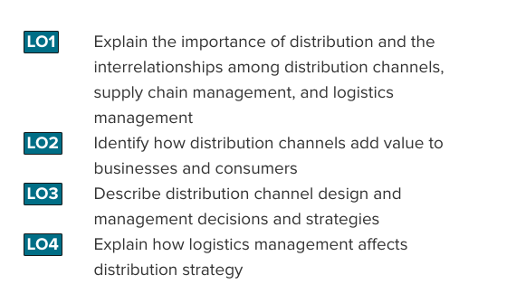
- Distribution Channel – the institutions that transfer ownership of and move goods from the point of production to the point of consumption
- Supply Chain Management – refers to a set of approaches and techniques firms employ to efficiently and effectively integrate their suppliers, manufacturers, warehouses, stores, and transportation intermediaries into a seamless value chain in which merchandise is produced and distributed in the right quantities, to the right locations, and at the right time
Zara employs a completely integrated supply chain because the company owns or at least has considerable control over each phase. As a result, it is able to conceive of, design, manufacture, transport, and ultimately sell high-fashion apparel much more quickly and efficiently than any of its major competitors.
A simplified supply chain would be one where manufacturers make products and sell them to intermediaries such as retailers or wholesalers.
Wholesalers – those firms engaged in buying, taking title to, often storing, and physically handling goods in large quantities, then reselling the goods (usually in smaller quantities) to retailers or industrial or business users
Retailers – sell products directly to consumers
Logistics Management – the integration of two or more activities for the purpose of planning, implementing, and controlling the efficient flow of raw materials, in-process inventory, and finished goods from the point of origin to the point of consumption

Designing Distribution Channels
Distribution channels are composed of various entities that are buying, such as retailers or wholesalers; selling, such as manufacturers or wholesalers; or helping facilitate the exchange, such as transportation companies. These relationships can range from close working partnerships to one-time arrangements.
Each channel member performs a specialized role. If one member believes that another isn’t doing its job correctly or efficiently, it usually can replace that member.
Distribution channels perform a variety of transactional, logistical and facilitating functions:

Transactional Functions
- Buying – purchase goods for resale to other intermediaries or consumers
- Risk Taking – ownership of inventory that can become outdated
- Promotion – promote products to attract consumers
- Selling – transact with potential customers
Logistical Function
- Physical Distribution – transport goods to point of purchase
- Storing – maintain inventory and protect goods
Facilitating Function
- Gather Information – share competitive intelligence about customers or other channel members
- Financing – extend credit and other financial services to consumers

- Channel Conflict: Results when supply chain members are not in agreement about their goals, roles or rewards

Distribution Channel Structure
a) Direct Distribution – allows manufacturers to deal directly with consumers
Manufacturer Consumer
b) Indirect Distribution – one or more intermediaries work with manufacturers to provide goods and services to consumers
Manufacturer Wholesaler Retailer Consumer (varies)
c) Multichannel Distribution – use a combination of both direct and indirect distribution channels
Sony sells via its own branded stores in some areas and in others it sells indirectly through retailers like Best Buy and Future Shop.
Marketing Channel – the set of institutions that transfer the ownership of and move goods from the point of production to the point of consumption; consists of all the institutions and marketing activities in the marketing process
Distribution Intensity – the number of supply chain members to use at each level of the supply chain
a) Intensive Distribution – a strategy designed to get products into as many outlets as possible
b) Exclusive Distribution – strategy of granting exclusive rights to sell to one or very few retail customers so no other customers can sell a particular brand
c) Selective Distribution – lies between the intensive and exclusive strategies; uses a few selected customers in a territory
Manufacturers might use an exclusive distribution policy by granting exclusive geographic territories to one or very few retail customers so no other customers in the territory can sell a particular brand.
Channel Conflict – results when supply chain members are not in agreement about their goals, roles, or rewards

Vertical Marketing System – a supply chain in which the members act as a unified system
a) Administered Vertical Marketing System – a supply chain system in which there is no common ownership and no contractual relationships, but the dominant channel member controls the channel relationship
b) Contractual Vertical Marketing System – a system in which independent firms at different levels of the supply chain join together through contracts to obtain economies of scale and coordination and to reduce conflict
Franchising – most common type of contractual vertical marketing system
- a contractual agreement between a franchisor and a franchisee that allows the franchisee to operate a business using a name and format developed and supported by the franchisor
c) Corporate Vertical Marketing System – a system in which the parent company has complete control and can dictate the priorities and objectives of the supply chain; it may own facilities such as manufacturing plants, warehouse facilities, retail outlets, and design studios
Distribution Centre – a facility for the receipt, storage, and redistribution of goods to company stores or customers; may be operated by retailers, manufacturers, or distribution specialists
Universal Product Code (UPC) – the black and white bar code found on most merchandise
Information flows from the customers to stores, to and from distribution centres, possibly to and from wholesalers, to and from product manufacturers, and then on to the producers of any components and the suppliers of raw materials.
Electronic Data Interchange (EDI) – the computer-to-computer exchange of business documents from a retailer to a vendor and back
Advanced Shipping Notice – an electronic document that the supplier sends the retailer in advance of a shipment to tell the retailer exactly what to expect in the shipment
Intranet – a secure communication system contained within one company, such as between the firm’s buyer and distribution centres
Extranet – a collaborative network that uses Internet technology to link businesses with their suppliers, customers, or other businesses

Strategic Relationship (Partnering Relationship) – a supply chain relationship that the members are committed to maintaining long term, investing in opportunities that are mutually beneficial
Strategic Relationship Requires:
a) mutual trust (the belief that the partner is honest and benevolent)
b) open communication (sharing information to develop sales forecasts and coordinate deliveries)
c) common goals (shared goals give both members of the relationship an incentive to pool their strengths and abilities and exploit potential opportunities together)
d) credible commitments (both parties make credible commitments to, or tangible investments in the relationship)
Dispatcher – the person who coordinates deliveries to distribution centres
Radio Frequency Identification (RFID) Tags – tiny computer chips that automatically transmit to a special scanner all the information about a container’s contents or individual products
Just-In-Time (JIT) Inventory Systems – inventory management systems designed to deliver less merchandise on a more frequent basis than traditional inventory systems; the firms gest the merchandise “just in time” for it to be used in the manufacture of another product
- also known as quick response (QR) systems in retailing
Quick Response – an inventory management system used in retailing; merchandise is received just in time for sale when the customer wants it
Lead Time – the amount of time between the recognition that an order needs to be placed and the arrival of the needed merchandise at the seller’s store, ready for sale

Chapter 13: Retailing and Omnichannel marketing
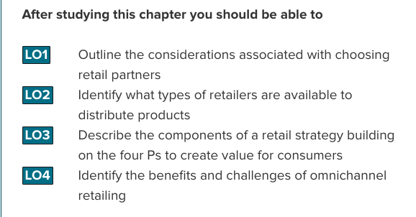
Retailing – the set of business activities that add value to products and services sold to consumers for their personal or family use; includes products bought at stores, through catalogues, and over the Internet, as well as services like fast-food restaurants, airlines, and hotels
Wholesalers – those firms engaged in buying, taking title to, often storing, and physically handling goods in large quantities, then reselling the goods to retailers or industrial or business users
The “Big Middle” refers to that part of the market in which the most successful retailers compete because the biggest potential customer base resides there. A firm does not have to be in the Big Middle to be successful in the short term, and successful firms typically do not start there. Firms get to the Big Middle through innovations in products, formats, or operational excellence or some combination of these that lead to great value.
- If firm has low-price they can move towards Big-Middle segment
- If firm has high price but is innovative, they can move towards Big-Middle segment
- If firm has high price and no premium offerings, they cannot

Factors for establishing a relationship with retailers:
- Choosing retail partners
- Identifying types of retailers
- Developing a retail strategy
- Managing a multichannel strategy

Choosing retail partners:
- Channel Structure:
  - The level of difficulty a manufacturer has in getting retailers to purchase its products is determined by the degree to which the channel is vertically integrated; the degree to which the manufacturer has a strong brand or is otherwise desireable in the market; and the relative power of the manufacturer and the retailer
- Customer expectations:
  - From a retailers perspective, it’s important to know from which manufacturer its customer wants to buy. Manufacturers in contrast, need to know where their target market customes expect to find their products and those of their competitors.
  - Customers generally expect to find certain products at some stores but not at others (Gucci isn’t sold at Walmart)
  - Companies need to stay abreast of changes in where customers buy products and what products they request, and then change their distribution strategies accordingly
- Channel member characteristics:
  - Several factors pertaining to the channel members themselves will help determine the channel structure.
  - Generally, the larger and more sophisticated the channel member, the less likely it is to use supply chain intermediaries

Types of Retailers
1) Food Retailers
a) Convenience Stores (7-Eleven)
b) Conventional supermarket (Sobey’s)
c) Big-Box Food Retailer (supercentre, hypermarket, warehouse club); larger than conventional
supermarket and carries non-food items (Costco)
2) General Merchandise Retailers
a) Discount stores – offers broad variety of merchandise, limited service, and low prices
b) Speciality stores – concentrates on a limited number of complementary merchandise categories
c) Category specialists – offers a narrow variety but a deep assortment of merchandise (Future Shop)
d) Drugstores
e) Off-Price Retailers – a type of retailer that offers an inconsistent assortment of merchandise at
relatively low prices
f) Extreme Value Retailers – a general merchandise discount store found in lower-income areas
g) Department Stores – broad variety and lots of items within each time, organized into separate
departments, offer some customer service (Zellers)
The Wheel of Retailing
1. Outlet starts with: Low prices, low margins, low status
- as time passes, outlet adds services
2. Outlet now has: Higher prices, higher margins, higher status
- as more time passes, outlet adds still more services
3. Outlet now has: Still higher prices, still higher margins, still higher status
4. New form of outlet enters retailing environment with characteristics of outlet Box 1
Value retailers – those in the Big Middle – continue to improve their “shopability”, providing more convenient store layouts and shopping experiences that make the task faster and easier.
Private-Label Brands – brands developed and marketed by a retailer and available only from that retailer; also called store brands
Share of Wallet – the percentage of the customer’s purchases made from a particular retailer

Components of a retail strategy:
- 4 P’s (same as they are in other chapters)
- personnel:
  - personal selling and customer service representatives are involved in the promotional package
  - the most successful retailers concentrate on providing more value to their best customers
  - the knowledge retialers gain from their store personnel, the internet and buying activi ties of customers as well as data can be used to in CRM
Managing omnichannel options:
- Customers want a seamless experience when interacting with onmichannel retailers.
- They want to be recognized by a retailer whether they interact with a sales associate, website or call center
- Retailers also need to offer mobile service

Done successfully when:
- Integrated CRM (allows to efficiently handle complaints, expedite returns, target future promotions etc)
- Brand image (consistent across all channels)
- Pricing: customers expect price to be consistent across all channels
- Supply chain: provide an integrated shopping experience across all their channels because unique skills and resources are needed to manage each channel
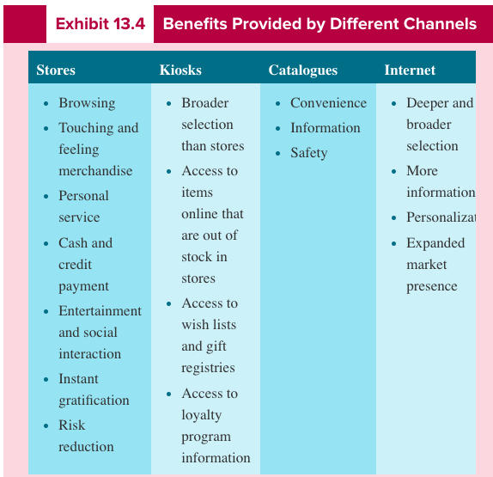

Forms of Non-Store Retailing
a) Online
b) Personal Selling
c) Direct Mail - targeted, printed form of communication sent to a prospective customers mail
d) Catalogue
e) Telemarketing
f) Direct Response TV - television commercials or infomercials with a strong call to action
g) Kiosk
Internet and Electronic Retailing
At the core of any business strategy is the ability to develop a sustainable customer advantage. Some aspects of a retailer`s strategy are more sustainable than others, whether for e-retailers or bricks-and-mortar players. Amazon.ca enhances the shopping experience by providing reviews and making suggestions based on customers’ past purchases. Many products are likely to be available at Amazon than in any single store. Some products, such as apparel, can be difficult for customers to purchase over the Internet because of their need to touch, feel, and try on these products, Amazon’s offerings do well in the Internet marketplace.
Multichannel Retailers – retailers that sell merchandise in more than one retailer channel (store, catalogue, and Internet)
Advantages of Web Retailing
- offers unlimited space to describing an item
- access to a global market and to markets without retail stores
- 24/7 ordering capability
- no postage costs associated with catalogues
- abilities to verify shipping status
- integration of video/audio
- ability to compare offerings of merchants, prices, product features
- ability to customize mailings to past and ongoing customers
- appeal to market segments that prefer Web-based shopping
- enables prices of be easily and quickly changed



