Cells and Tissues Mastering A&P Assignment Answers:

- Drag the appropriate labels to their respective targets
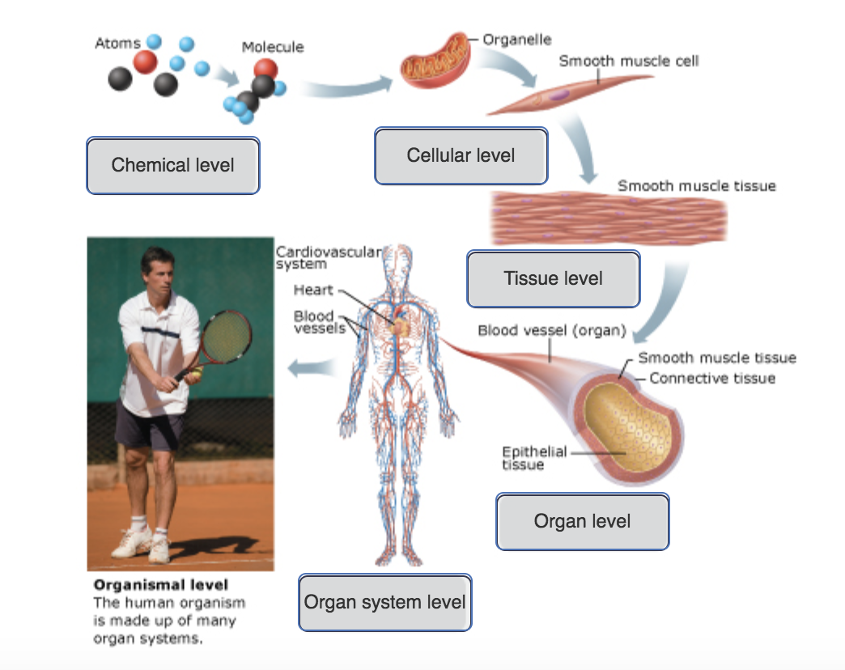
- Which of the following best demonstrates the principle of complementarity of structure and function?
- The heart and blood vessels circulate blood continuously to carry oxygen and nutrients to all body cells.
- Atoms, the tiny building blocks of matter, combine to form molecules such as water and proteins.
- The liver, the brain, blood vessels, and stomach are each responsible for a necessary activity that no other organ can perform.
- Bones can support and protect body organs because they contain hard mineral deposits.

- Drag the appropriate labels to their respective targets.

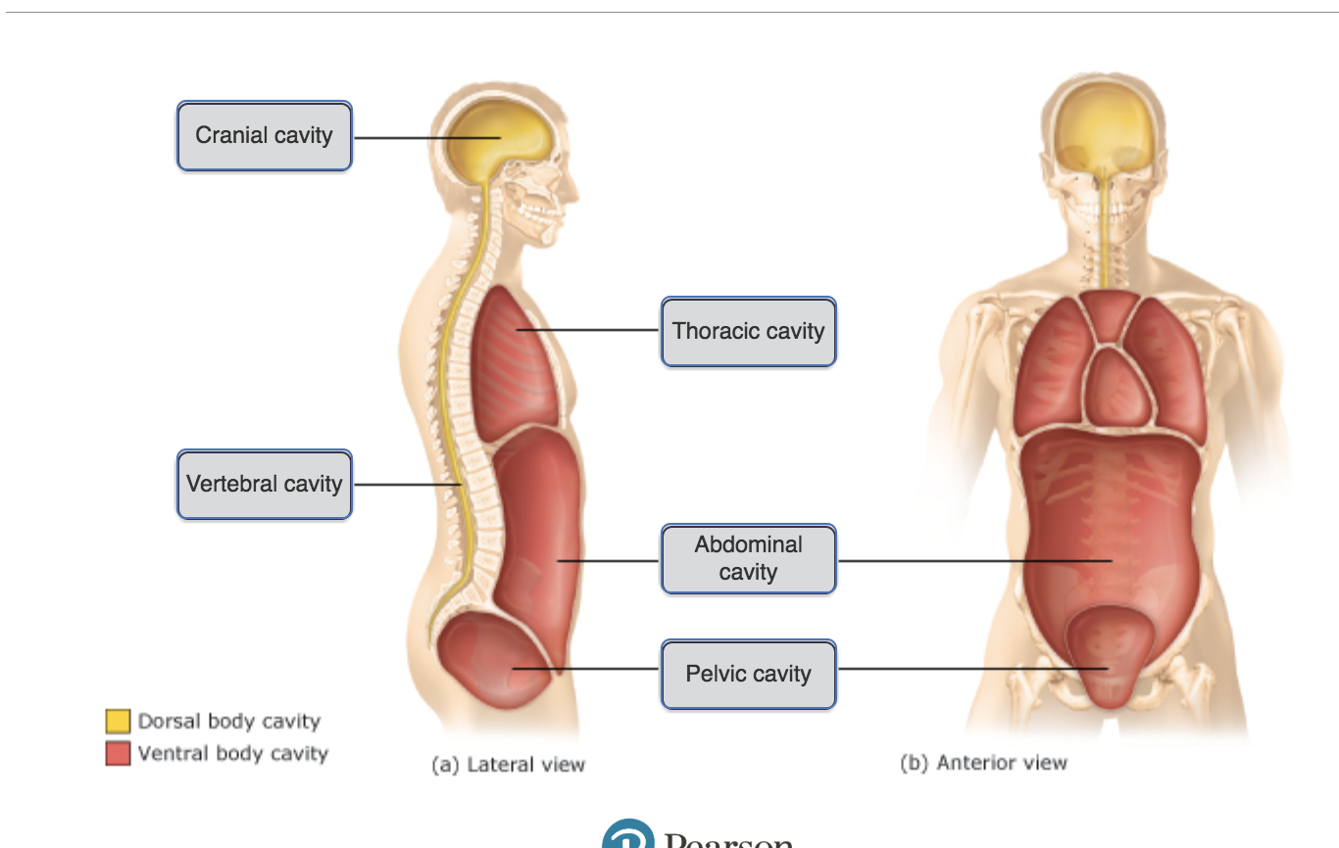
- Drag the appropriate labels to their respective targets.
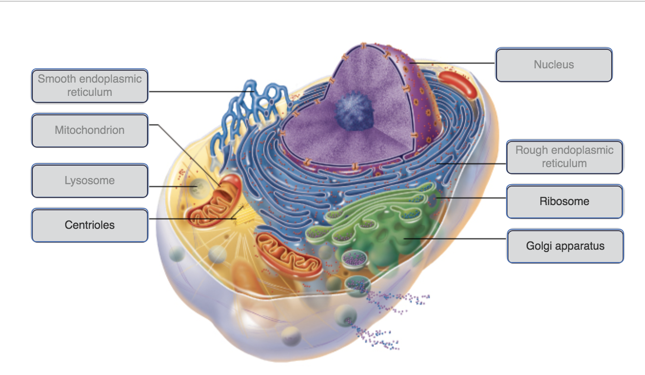

- Drag the appropriate labels to their respective targets.
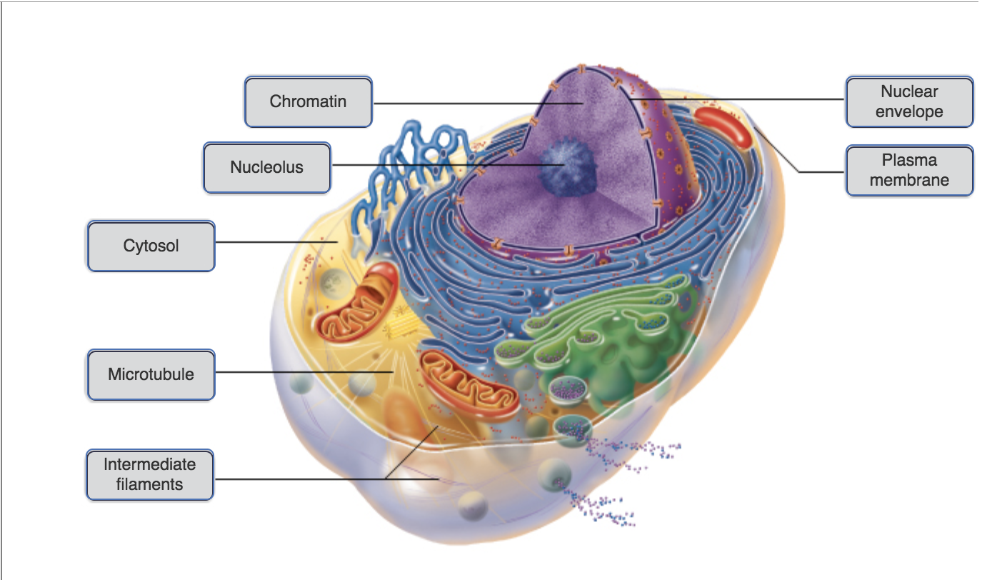

- Drag the appropriate labels to their respective targets.
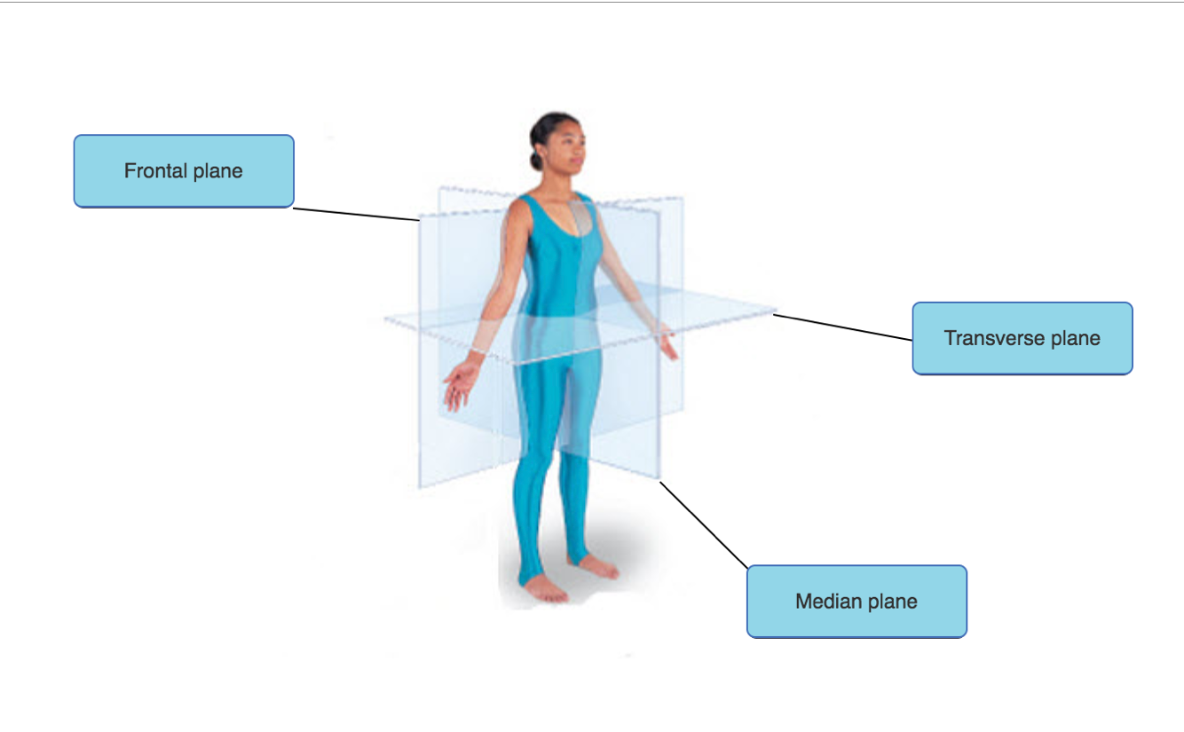
- Drag the appropriate labels to their respective targets.
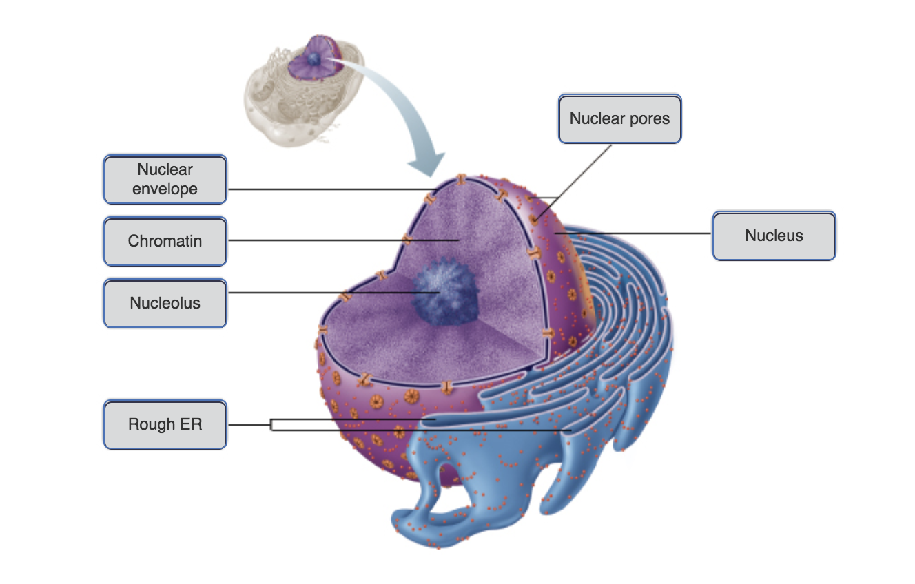
8. Choose the answer that shows the correct order for the standard preparation of a histological specimen.

(1) fixation, (2) sectioning, (3) staining
- (1) fixation, (2) staining, (3) sectioning
- (1) sectioning, (2) staining, (3) fixation
- (1) staining, (2) fixation, (3) sectioning
- (1) sectioning, (2) fixation, (3) staining

- Which tissue type consists of a sheet of cells that covers a body surface or lines a body cavity?
- connective tissue
- nervous tissue
- epithelial tissue
- muscle tissue

- Connective tissues ________.
- primarily consist of extracellular matrix
- arise from different types of embryonic tissue; therefore, they have little relationship or kinship to one another
- are all avascular
- are delicate tissues, not designed to bear weight or withstand abrasion or tension

- Which of the following is NOT a role of connective tissue?
- protection
- insulation
- absorption
- support

- Which of the following is NOT one of the subdivisions of anatomy?
- gross anatomy
- developmental anatomy
- renal anatomy
- systemic anatomy

- Which of the numbered cell types is primarily responsible for producing protein fibers found in connective tissue proper?
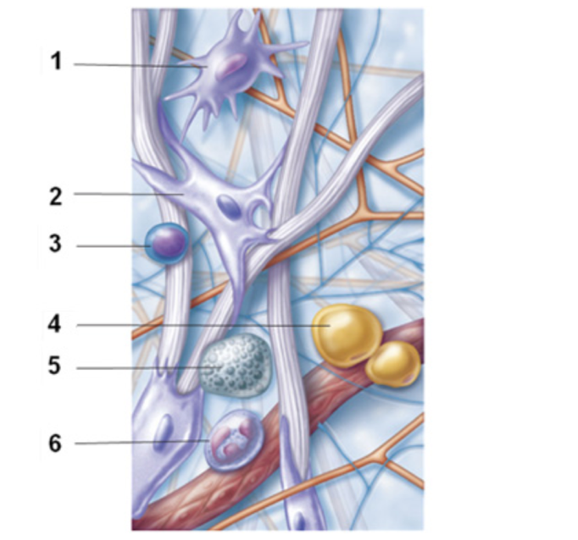
- 5
- 3
- 4
- 2

- Drag the appropriate labels to their respective targets.
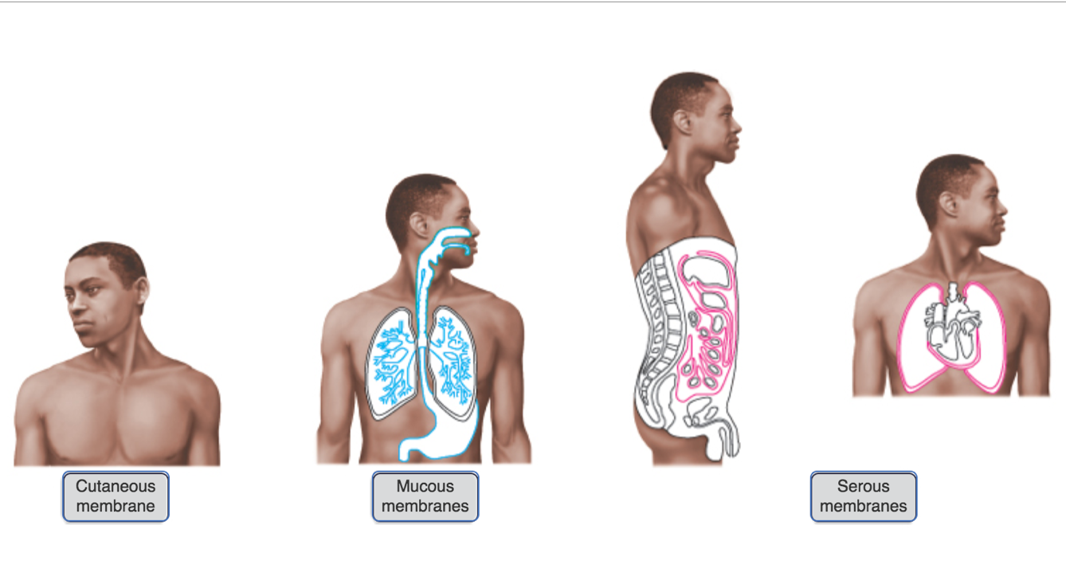
- Which cell component helps to maintain the structural integrity of the cell?
- centriole
- ribosome
- peroxisome
- cytoskeleton

- Which organelle is responsible for synthesizing proteins?
- smooth endoplasmic reticulum
- mitochondria
- Golgi apparatus
- Ribosomes

- Which of the following is characteristic of cilia?
- They move substances in any direction across cell surfaces.
- They are whiplike, motile cellular extensions that occur in large numbers on the exposed surfaces of certain cells.
- They are used for cellular adhesion.
- They are substantially longer than flagella, and are most easily seen in human sperm cells.
- Which of the following is NOT a characteristic of peroxisomes?
- They contain powerful enzymes called acid hydrolases.
- They contain powerful enzymes called oxidases.
- They aid in the neutralization of dangerous free radicals.
- They contain powerful enzymes called catalases.

- Which of the following increases the surface area of certain epithelial tissues?
- cilia
- basement membrane
- basal lamina
- microvilli
- desmosomes

- Mucous cells are ________.
- multicellular exocrine glands
- hormone-producing glands
- endocrine glands
- unicellular exocrine glands

- Which tissue is correctly paired with its primary cell type?
- cartilage: fibroblast
- connective tissue proper: chondroblast
- bone: osteoblast
- bone: fibrocyte

- The correct order of events in tissue repair, from first to last, is ________.
- organization, inflammation, and regeneration
- inflammation, regeneration, and organization
- regeneration, organization, and inflammation
- inflammation, organization, and regeneration
- Choose the anatomical topic and definition that is not correctly matched.
- Microscopic anatomy: study of structures too small to be seen by the naked eye.
- Embryology: study of the changes in an individual from conception to birth.
- Gross anatomy: study of structures visible to the eye.
- Cytology: study of the structures in a particular region.

- of the following is NOT an example of maintaining boundaries?
- The human body as a whole is enclosed and protected by the integumentary system.
- Single-celled organisms possess a limiting membrane that encloses its contents and lets in needed substances while restricting entry of potentially damaging or unnecessary substances.
- When your hand is exposed to extreme heat, you involuntarily pull your hand away from the painful stimulus.
- Each cell in our body is surrounded by a selectively permeable membrane.

- Which life process in the body sustains all others?
- movement
- reproduction
- responsiveness
- metabolism

- Which of the following is the proper description of the human body in the anatomical position?
- The body is erect with feet together, palms facing backward and the thumbs pointing toward the body.
- The body is erect with feet together, and palms facing the thighs with thumbs pointing forward.
- The body is erect with feet slightly apart and arms extending perpendicular to the torso along a straight line with the clavicle.
- The body is erect with feet slightly apart, and palms face forward with thumbs pointing away from the body.

- What is the role of the serous membranes covering some organs?
- to prevent friction between the organ and body cavity wall
- to provide a protective outer covering for the organ
- to provide passage of nutrients for the organ tissues
- to serve as extra tissue for blood flow to the organ

- Match the words in the left column to the appropriate blanks in the sentences on the right. Make certain each sentence is complete before submitting your answer.


