Chapter 1 – The Sociological Perspective

Outline
- Putting Social Life into Perspective
- Sociology and Everyday Life
- The Sociological Imagination
- The Development of Sociological Thinking
- Contemporary Theoretical Perspectives

Putting Social Life into Perspective & Sociology and Everyday Life
- The Sociological Imagination
- Sociology: The systematic study of human society and social interaction, applying both theoretical perspectives and research methods.
- Sociologists study human societies and their social interactions in order to develop theories of how behavior is shaped by group life and how, on the other hand, group life is affected by individuals.

- Why Study Sociology?
- Sociology helps us gain a better understanding of ourselves and our social world. It enables us to see how behaviour is largely shaped by the groups to which we belong and by the society in which we live.
- The discipline assists us in understanding ourselves and our social world.
- Our worlds are created for us by others as well as being created by us.
- Sociology takes us beyond the personal and assists us in gaining insights into society and the larger world order.
- It enables us to understand and analyze the societies in which we live.
- Society: A large social grouping that shares the same geographical territory and is subject to the same political authority and dominant cultural expectations.

- The Sociology of Everyday Life
- Figure 1.1: Fields that use social science research.

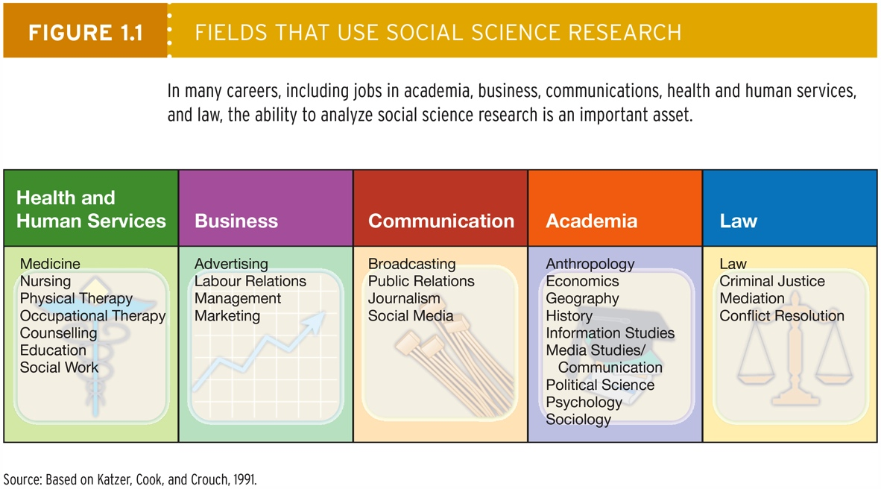

- The Importance of a Global Sociological Imagination
- The future of this country is deeply intertwined with the future of all other nations of the world on economic, political, environmental, and humanitarian levels.
- Being unemployed, running up a high credit card debt or overspending could be identified as a personal trouble.
- Using the sociological imagination, scholars link personal troubles with public issues:
- Societal overspending
- Dysfunctional social conditions

The Sociological Imagination
- Sociological imagination is defined as “the ability to see the relationship between individual experiences and the larger society” (A concept created by sociologist C. Wright Mills).
- Two dimensions of sociological imagination:
- Personal troubles: Private troubles of individuals and the networks of persons they associate with on a regular basis (e.g., being unemployed).
- Public issues: Matters beyond an individual’s own control that are caused by problems originating at the societal level (e.g., credit card interest rates).

The Development of Sociological Thinking
- Several revolutions that took place in the 18th century had a profound influence on the origins of sociology.
- The Enlightenment produced an intellectual revolution in how people thought about social change, progress, and critical thinking.
- American (1765-1783) and French (1789-1790) Revolutions.

- Industrialization
- Industrialization: The process by which societies are transformed from dependence on agriculture and handmade products to an emphasis on manufacturing and related industries.

- Urbanization
- Urbanization: The process by which an increasing proportion of a population lives in cities rather than in rural areas.
- Many people moved from being producers to being consumers.
- Problems: Inadequate housing, crowding, unsanitary conditions, poverty, pollution, and crime.

- Early Thinkers: A Concern with Social Order and Stability
- Natural scientists had been using reason, or rational thinking, to discover the laws of physics and the movement of the planets.
- Social thinkers began to believe that by applying the methods developed by the natural sciences, they might discover the laws of human behaviour and apply these laws to solve social problems.

- The Development of Modern Sociology
- Some of the early social thinkers (early to middle 19th century) were interested in analyzing social order and stability. For example:

- Auguste Comte
- Positivism: A belief that world can best be understood through scientific inquiry.
- Auguste Comte believed that objective, bias-free knowledge was attainable only through the use of science rather than religion.

- Harriet Martineau (1802-1876)
- Martineau advocated racial and gender equality.
- Analyzed how large-scale social structures influenced the lives of people, particularly women, children, and those who were marginalized by virtue of being criminal, mentally ill, disabled, poor, or alcoholic.

- Herbert Spencer (1820-1903)
- Spencer constructed an evolutionary perspective on social order and social change.
- Societies developed through a process of “struggle” (for existence) and “fitness” (for survival), which he referred to as the “survival of the fittest.”
- Used to justify the repression and neglect of minority groups in the late 19th century and beyond (known as scientific racism).
- This perspective gave rise to the belief that those species (including humans) best adapted to their environment survive and prosper, whereas those poorly adapted die out.

- Emile Durkheim (1858-1917)
- Durkheim is a crucial figure in the development of sociology as an academic discipline.
- Promoted the scientific approach to examining social facts that lie outside individuals.
- The founding figure of the functionalist theoretical tradition.
- One of Durkheim’s most important contributions to sociology: the idea that societies are built on social facts.
- Social facts are patterned ways of acting, thinking, and feeling that exist outside any one individual but that exert social control over each person.
- Social facts should be explained in relation to the social structure (i.e., other social facts).
- Durkheim coined the term anomie – a condition in which social control becomes ineffective as a result of the loss of shared values and a sense of purpose in society.
- Critics maintain the Durkheim’s focus on stability, or the “problem of order,” obscures the subjective meaning that individuals give to society.
- There appears to be an overemphasis on structure and a neglect of agency in his work.

- The Development of Modern Sociology
- Other sociologists focused on conflict and social change. For example:

- Karl Marx (1818-1883)
- Marx analyzed the struggle between the capitalist class and the working class.
- Marx’s Classes in Conflict:
- Bourgeoisie (capitalist class): Own and control the means of production.
- Proletariat (working class): Must sell their labour because they have no other means to earn a livelihood.
- Marx’s Theoretical Contributions:
- Class Conflict: History is a continuous clash between conflicting ideas and forces.
- Alienation: Exploited workers feel a sense of powerlessness and estrangement from other people and themselves.
- Believed that society should not just be studied but should also be changed because the status quo is oppressive to most members of society.
- Revolution will result from workers becoming aware of their alienation.

- Max Weber (1864-1920)
- Weber held that sociology should be value-free – conducted scientifically, excluding the researcher’s personal values and economic interests.
- Sociologists should employ verstehen (German for “understanding”) to see the world as others do.
- Importance of Weber:
- Emphasis of value-free inquiry and the necessity of understanding how others see the world.
- Important insights on the process of rationalization, bureaucracy, religion, and many other topics.
- Was more aware of women’s issues than were many of the scholars of his day.

- George Simmel (1858-1918)
- Simmel believed the main purpose of sociology should be to examine the social interaction processes within groups.
- Analyzed the impact of industrialization and urbanization on people’s lives.
- Concluded that class conflict was becoming more pronounced in modern industrial societies.
- Note: Sociology spread to North American in the 1890’s.

Contemporary Theoretical Perspectives
- Contemporary sociologists have various views on society.
- Sociologists endeavor to create theories to understand these views.
- Theories: A set of logically interrelated statements that attempts to describe, explain, and (occasionally) predict social events.

- Talcott Parsons (1902-1979)
- An influential advocate of the functionalist perspective, Parsons stressed that all societies must make provisions for meeting social needs in order to survive.
- Division of labour is necessary for this survival.
- Instrumental and expressive roles are also necessary for this survival.

- Robert K. Merton (1910-2003)
- Merton refined functionalism.
- Manifest functions: Intended and/or overtly recognized by the participants in a social unit.
- Latent functions: Unintended functions that are hidden and remain unacknowledged by participants.
- Dysfunctions: The undesirable consequences of any element of a society.

- Functionalist Perspectives and The Analysis of Consumerism
- Functionalist perspectives are useful in analyzing consumerism.
- A manifest function of shopping and consumption is purchasing necessary items.
- A latent function of shopping may be to provide a communal area in which people can visit friends and enjoy an event.

- Conflict Perspectives and Analysis of Consumerism
- According to conflict perspectives, groups in society are engaged in continuous power struggle for control of scarce resources.
- Today, advocates of conflict perspectives view social life as a continuous power struggle among competing social groups.
- A contemporary conflict analysis of consumption might look at how inequalities based on racism, sexism, and income differentials affect people’s ability to acquire the things they need and want. It might also look at inequalities regarding the issuance of credit cards.

- Feminist Perspectives
- Feminist perspectives focus on the significance of gender in understanding and explaining inequalities that exist between men and women in the household, in the paid labour force, and in the realms of politics, law, and culture.
- Feminists highlight the role of patriarchy – a hierarchical system of power in which males process greater economic and social privilege than females.

- Levels of Analysis
- Macrolevel analysis: Examines whole societies, large-scale social structures, and social systems.
- Microlevel analysis: Focuses on small groups rather than large-scale social structures – the focus of symbolic interactionism.

- Symbolic Interactionist Perspectives and Analysis of Consumerism
- Microlevel analysis: Examining people’s day-to-day interactions and their behaviour in groups.
- View society as the sum of the interactions of individuals and groups.
- Symbol: Anything that meaningfully represents something else.
- Addresses the social nature of the shopping experience, social interaction patterns in families regarding credit card debts, and why we might spend money to impress others.
- Examines emotive states in the shopper-cashier interaction.

- Postmodernist Perspectives and Analysis of Consumerism
- The sociological approach that attempts to explain social life in modern societies that are characterized by post-industrialization, consumerism, and global communications.
- Societies characterized by post-industrialization, consumerism, and global communications bring into question existing assumptions about social life and the nature of reality.
- Postmodern perspectives are characterized by:
- The decline in the influence of social institutions such as family, religion, and education on people’s lives; the pursuit of individual freedom
- Information explosion
- Rise of consumer society
- Global village image
- Post-industrial society
- Simulations

