Final- Lecture 10- Introduction to Endocrine system
Exocrine glands
Definition: Produce nonhormonal substances (examples: sweat, saliva). Have ducts to carry secretion to membrane surface
Endocrine glands
Definition: Produce hormones. Lack ducts
Endocrine glands examples: pituitary, thyroid, parathyroid, adrenal, and pineal glands
Hypothalamus is neuroendocrine organ
Some have exocrine and endocrine functions. Examples: Pancreas, gonads, placenta
There are other tissues and organs that produce hormones. Examples: Adipose cells, thymus, and cells in walls of small intestine, stomach, kidneys, and heart
Hormones
Chemical messengers of endocrine system:
  - Hormones: long-distance chemical signals; travel in blood or lymph
  - Autocrines: chemicals that exert effects on same cells that secrete them
  - Paracrines: locally acting chemicals that affect cells other than those that secrete them
  - Autocrines and paracrines are local chemical messengers; not considered part of endocrine system
Two main classes of hormones:
- Amino acid–based hormones
Amino acid derivatives, peptides, and proteins
- Steroids
Synthesized from cholesterol
Gonadal and adrenocortical hormones
A possible third class, eicosanoids, is considered a hormone by some scientists, but most classify it as a paracrine
Hormone targets
Definition: Though hormones circulate systemically, only cells with receptors for that hormone (target cells) are affected.

Hormones alter target cell activity:
  - Alter plasma membrane permeability and/or membrane potential
  - Stimulate gene transcription and/or protein translation
  - Activate or deactivate enzymes (usually by phosphorylation)
  - Induce secretory activity
  - Stimulate mitosis (cell division)
Hormones act in one of two ways, depending on their chemical nature and receptor location:
- Water-soluble hormones (all amino acid–based hormones except thyroid hormone)
    - Act on plasma membrane receptors
    - Act via G protein second messengers
    - Cannot enter cell
- Lipid-soluble hormones (steroid and thyroid hormones)
    - Act on intracellular receptors that directly activate genes
    - Can enter cell
Signal Transduction
How do cells transduce signals from hormones and respond accordingly?
Amino acid–based (peptide) hormones (except thyroid hormone) exert effects through plasma membrane receptors and second-messenger systems
Two main second-messenger systems:
- Cyclic AMP
- PIP₂- Ca2⁺
Cyclic AMP signaling Mechanism
- Cyclic AMP (cAMP) is produced from ATP through the action of Adenylate Cyclase enzyme (ON)
- cAMP is rapidly degraded by the enzyme phosphodiesterase (OFF)
- Stimulates gene transcription via the cAMP response element binding protein (CREB)

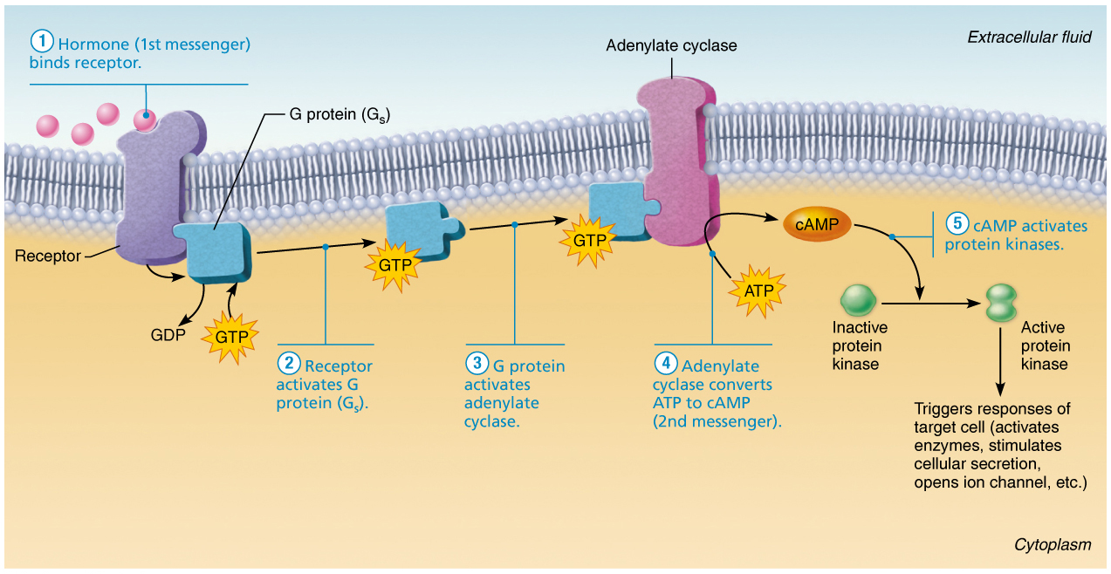
PKC Activation by DAG and CA2+
DGK turns “off” DAG signaling and turns “on” PA signaling
Receptors and second messenger systems
Other signaling mechanisms
  - cGMP (cyclic guanosine monophosphate) is second messenger for selected hormones
  - Other hormones work without second messenger system
    - Example: insulin receptor is a tyrosine kinase enzyme that autophosphorylates upon insulin binding
      - Activated tyrosine kinases provide docking sites for relay proteins that trigger cell responses
Mechanism of lipid-soluble hormones
- The steroid hormone diffuses through the plasma membrane and binds an intracellular receptor (e.g. Estrogen)
- The receptor-hormone complex enters the nucleus.
- The receptor-hormone complex binds a specific DNA region.
- Binding initiates transcription of the gene to mRNA.
- The mRNA directs protein synthesis (translation)
  - Proteins have various functions (e.g. metabolic, structural purposes, or secreted)
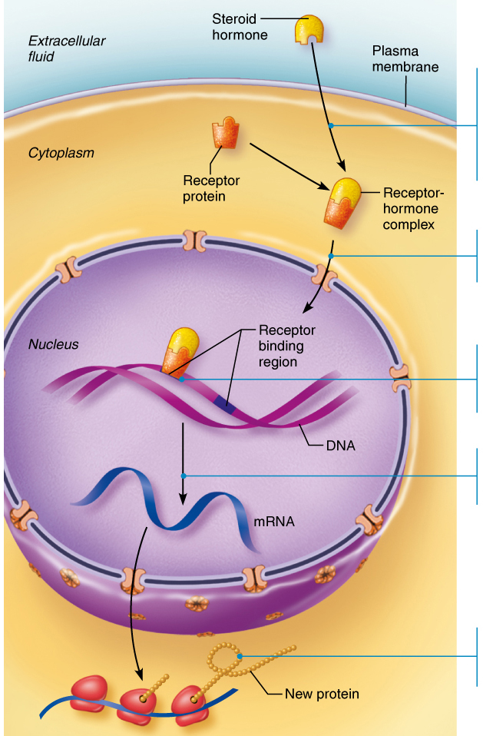
Hormone release
Blood levels of hormones are controlled by negative feedback systems
    - Increased hormone effects on target organs can inhibit further hormone release
  - Levels vary only within narrow, desirable range
Hormone release is triggered by:
- Endocrine gland stimuli
- Nervous system modulation
Endocrine Gland Stimuli
Endocrine glands are stimulated to synthesize and release hormones in response to three types of stimuli:
- Humoral
Changing blood levels of ions and nutrients directly stimulate secretion
Parathyroid hormone (PTH) blood [Ca²+]
Insulin in response to blood glucose;
Aldosterone in response to Na⁺ or K⁺
- Neural
Nerve fibers stimulate hormone release
Sympathetic nervous system fibers stimulate adrenal medulla to secrete epinephrine and norepinephrine
- Hormonal
Hormones stimulate other endocrine organs to release their hormones
Hypothalamic hormones stimulate release of most anterior pituitary hormones
Anterior pituitary hormones stimulate targets to secrete still more hormones
Hypothalamic–pituitary–target endocrine organ feedback loop
Hormones from final target organs inhibit release of anterior pituitary hormones
Nervous system modulation
- Nervous system can make adjustments to hormone levels when needed
  - Can modify stimulation or inhibition of endocrine glands
- Nervous system can override normal endocrine controls
  - Example: under severe stress, hypothalamus and sympathetic nervous system override insulin to allow blood glucose levels to increase
    - Prepare body for “fight or flight”
Target cell specificity
- Target cells must have specific receptors to which hormone binds
  - Example: ACTH receptors are found only on certain cells of adrenal cortex, but thyroxin receptors are found on nearly all cells of body
- Target cell activation depends on three factors:
  - Blood levels of hormone
  - Relative number of receptors on/in target cell
  - Affinity (strength) of binding between receptor
and hormone
- Amount of hormone can influence number of receptors for that hormone
  - Up-regulation: target cells form more receptors in response to low hormone levels
  - Down-regulation: target cells lose receptors in response to high hormone levels
    - Desensitizes the target cells to prevent them from overreacting to persistently high levels of hormone
Half life, onset, and duration of the activity
Hormones circulate in blood either free or bound
- Steroids and thyroid hormone are attached to plasma proteins
- All others circulate without carriers
Concentration of circulating hormone reflects:
- Rate of release
- Speed at which it is inactivated and removed from body
Hormones can be removed from blood by:
- Degrading enzymes, kidneys or liver
- Half-life: time required for level of hormone in blood level to decrease by half (< 1 min to a week)
Response Time: Immediate or hours to days (steroids).
- Some are inactive until they enter target cells
Response Duration: seconds to hours
- Effects may disappear rapidly as blood levels drop, but some may persist for hours at low blood levels
- Half-life, onset, and duration of hormone activity are dependent on whether the hormone is water or lipid soluble

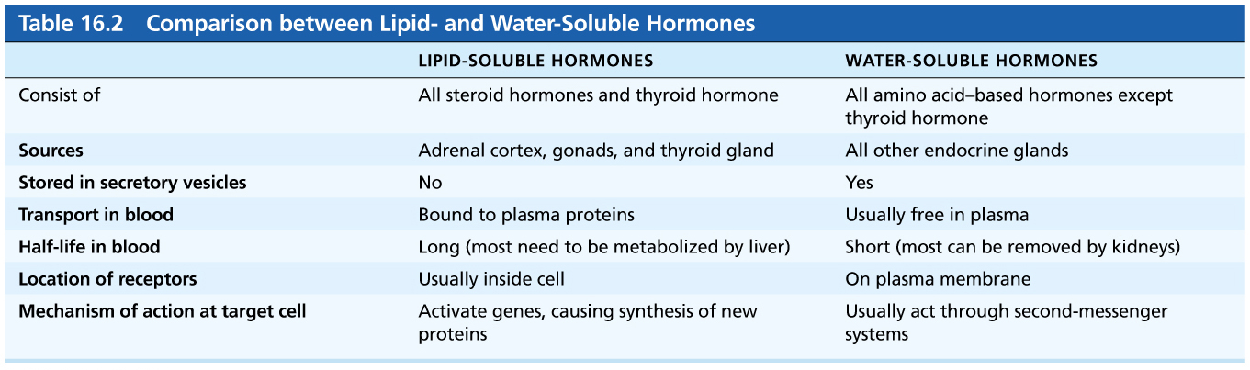

The hypothalamus
- Hypothalamus is a neurosecretory organ
- Connected to pituitary gland (hypophysis) via stalk called infundibulum
  - Pituitary secretes at least eight major hormones
  - It has two major lobes:
- Posterior pituitary: composed of neural tissue that secretes neurohormones
    - Posterior lobe, along with infundibulum make up the neurohypophysis
    - Posterior lobe is neural tissue derived from a down-growth of brain
    - . Anterior pituitary: (adenohypophysis) consists of glandular tissueDerived from oral mucosa
  - Functionally connected to hypothalamus by blood vessels.
  - Maintains neural connection to hypothalamus via hypothalamic-hypophyseal tract
    - Tract arises from neurons in paraventricular and supraoptic nuclei in hypothalamus
    - Runs through infundibulum
Anterior pituitary
Definition: The anterior pituitary gland, also called the adenohypophysis is a true hormone-producing gland made of glandular epithelium.
- When appropriately stimulated, hypothalamic neurons secrete releasing or inhibiting hormones into the primary capillary plexus.
- Hypothalamic hormones travel through hypophyseal portal veins to the anterior pituitary where they stimulate or inhibit release of hormones made in the anterior pituitary.
- In response to releasing hormones, the anterior pituitary secretes hormones into the secondary capillary plexus. This, in turn, empties into the general circulation.
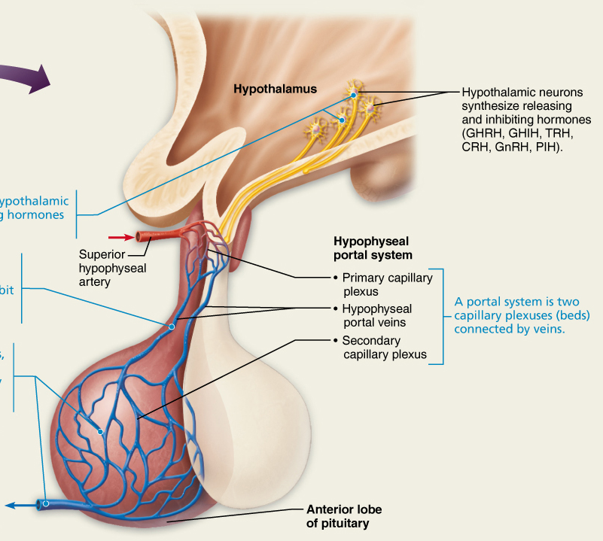

The hypophyseal portal system
Definition: Hypothalamic hormones released into special blood vessels (the hypophyseal portal system) control the release of anterior pituitary hormones.
- Parvocellular neurosecretory cells are small neurons within paraventricular nucleus (PVN). Axons project to median eminence, where their nerve terminals release peptides into hypophyseal portal system.
- The blood vessels carry the peptide hormones to the anterior pituitary – regulate hormone secretion into systemic circulation.
- Hypothalamic neurons synthesize releasing and inhibiting hormones (GHRH, GHIH, TRH, CRH, GnRH, PIH).
Anterior pituitary hormones
Definition: Hormone-secreting cells in the AP release peptide hormones into the general circulation
- All six hormones are peptide hormones
- All but growth hormone activate target cells via cAMP second-messenger system
- All but two are tropic hormones (tropins) that regulate secretion of other hormones:
  - Growth hormone (GH)
  - Thyroid-stimulating hormone (TSH) (tropic)
  - Adrenocorticotropic hormone (ACTH) (tropic)
  - Follicle-stimulating hormone (FSH) (tropic)
  - Luteinizing hormone (LH) (tropic)
  - Prolactin (PRL)
Posterior pituitary
Definition: Posterior pituitary consists of axon terminals of neurons from hypothalamic neurons and associated blood vessels.
- Paraventricular (PVN) neurons synthesize oxytocin
- Supraoptic neurons synthesize antidiuretic hormone (ADH)
- Transported down the axons of the hypothalamic-hypophyseal tract to the posterior pituitary
- Stored in axons terminals
- When neurons fire, arriving APs cause release into the blood.
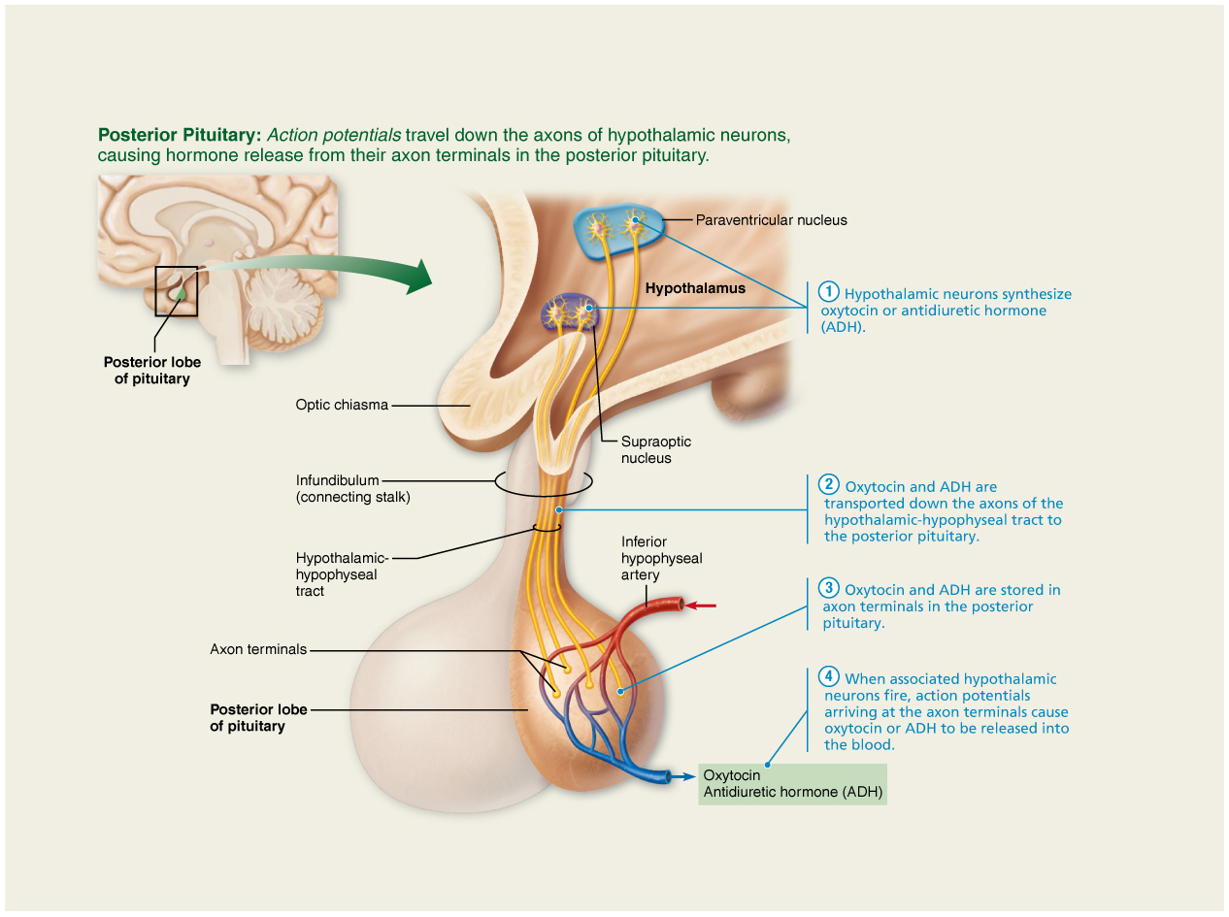

Summary of homeostatic mechanisms
Two key regulatory systems:
Autonomic nervous system
  - sympathetic versus parasympathetic
  - sensory and motor neural pathways
  - fast response
Endocrine system
  - hormones released into extracellular fluid and often travel to target organs via bloodstream
  - slower response time but response can be long-lived
  - different chemical classes of hormones with associated mechanisms of action

