Verification of Boyle’s Law

Introduction:
The data gained from this experiment should provide evidence for the proof of Boyle’s law, and through the data collected, prove the equation PV=k, k being a constant, P and V representing pressure and volume respectively. At a constant temperature and number of moles, the gas inside should pressurize at a rate that is inverse to the rate of change of volume of gas in the chamber. Boyle’s law is dependent on the fact that the temperature of the gas and the amount of moles must stay constant. The law also requires the gas to act as an ideal gas. This then means that Boyle’s law does not work at high pressure or low temperature (Levine p.10). Boyle’s law is mainly due to the interactions of the molecules of the gas. Levine states that “[the] pressure exerted by the gas is due to the impacts of the molecules on the walls. A decrease in volume causes the molecules to hit the walls more often, thereby increasing the pressure” (Ibid p.11). The following experimental data should demonstrate this phenomena.

Procedure:
1. Preparing the Gas pressure sensor and air sample
- Move the plunger 20mL syringe 20mL mark, using the first ring of the seal as the mark.
- Attach the syringe to the valve of the pressure sensor.
2. Collect and plot measurements
- Leave the plunger at 20mL mark, keep and enter the volume into LabQuest, ensuring to add +0.8mL to the volume
- Move the plunger up 1mL mark, and after the pressure reading stabilizes, record the data point
- Repeat step ii until you have taken 8 readings, then take a final reading back at the 20mL mark for a second time.
3. Decide which measurement of the original volume to keep
- Calculate the average pressure for the 20.8ml readings and keep the data point that is closest to the average for each trial.
4. Analyze the graph and determine its mathematical relationship
- Examine the graph of your plotted points carefully, and decide what type of equation best represents the relationship of the variables.
5. Repeat steps 1-2 between 4-8 times.

Table. 1 Data and Results in Determination of Boyle’s Law Constant
 | Pressure (kPa)
Volume (ml) | Trial 1 | Trial 2 | Trial 3 | Trial 4 | Trial 5
20.8 a) | 100.31 | 100.47 | 100.40 | 100.55 | 100.40
19.8 | 106.78 | 105.57 | 105.77 | 106.13 | 106.02
18.8 | 111.19 | 111.64 | 111.20 | 11.19 | 110.71
17.8 | 118.28 | 117.28 | 117.63 | 117.15 | 117.58
16.8 | 125.81 | 124.98 | 125.29 | 124.58 | 124.90
15.8 | 134.36 | 133.81 | 132.24 | 132.89 | 132.10
14.8 | 142.57 | 141.48 | 141.19 | 141.41 | 141.83
13.8 | 153.91 | 152.37 | 152.13 | 152.24 | 150.98
20.8 b) | 100.74 | 100.04 | 100.19 | 100.27 | 100.27

Observations during experiment:
The displayed pressure reading fluctuates within a tenth of a unit even after some time of stabilization, and this creates a certain degree of error in the measurements for all of the trials.
The plunger was increasingly difficult to keep in place at the milliliter mark on the syringe as the pressure increased and getting an accurate reading was harder towards the 13mL mark.
The seal on the plunger did not seem to give and neither my partner nor I noticed any gas leakage from the syringe during the compression, however the pressure was slightly lower during most of the trials after compression.

Calculations:
- Average base pressure:
Avg_{Pressure At 20.8m}= (P_{Trial 1 at 20.8ml a)}+P_{Trial 1 at 20.8ml b)} + P_{Trial 20.8ml a)}+P_{Trial 2 at 20.8ml b)}…) / n_{Samples}
= (100.47kPa + 100.04kPa + 100.40kPa + 100.19kPa…) / 8
= 100.37kPa
b) Boyles law constant calculation:
y=a*x^{b}
Pressure_{Gas} = Boyle’s_{Law Constant} * Volume_{Container}^{Constant Power}
Pressure_{Gas} = k * Volume_{Container}⁻¹
Pressure_{Gas} = k / Volume_{Container}
Pressure_{Gas} * Volume_{Containe r}= k
132.75 kPa * 15.8 ml = 2097 kPa*ml

c) Verification of constant:
Pressure_{Gas} * Volume_{Containe r}= k
Pressure_{Gas} = k / Volume_{Container}
Pressure_{Gas Trial 5 at 16.8ml} = 1978 kpa*ml / 16.8ml
Pressure_{Gas Trial 5 at 16.8ml} ≅117.7kPa

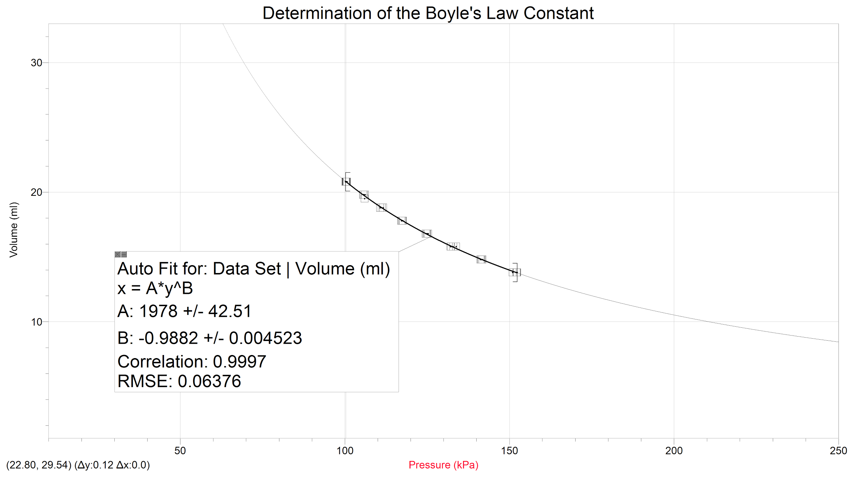
Figure 1.
Discussion:
In this experiment the data collected validates the relationship between a gas's pressure and the volume of its container. The data demonstrates pressure’s inverse relationship to volume and the existence of the Boyle’s Law constant k, which is calculated using the product of volume and pressure in the container

Using the data, a constant was calculated using the program LoggerPro, This constant is equal to 1978 kPa*ml and was calculated by the curve fitting function particular to LoggerPro. It used all of the data points from the five trials and fitted a curve to the entire data set. In the curve fitting function, the aberrant values were ignored and the curve was fit to the data points that the program thought were ideal. An equation was thus created and the a value (from y=a*x^b) represented the Boyle’s law Constant. In this equation the k value stays constant because when the pressure increases the volume decreases. Thus no change in the product occurs.

As stated earlier, the mathematical relationship by Boyle’s Law can be modeled by a power function. The initial equation that LoggerPro created was y=a*x^(-1); where a=1978 kPa*ml. Therefore Boyle’s law can be modeled by the equation: Pressure_{Gas}* Volume_{Container}= k. And if one incorporates the k value of this experiment, the relationship can also be represented by: Pressure_{Gas}* Volume_{Container}= 1978 kPa*ml. Boyle’s Law can also be modeled by the equation P₁*V₁=P₂*V₂. This equation can be used to predict a final volume or pressure of a gas.

For this experiment we made sure to take multiple readings of the dependent variable for the same value of an independent variable. We did so to be able to get a proper data set with reproducible trends, allowing us to validate the data. The ease of the procedure greatly reduces the possibility for error in the experiment, however there are still some areas where improvements to reduce errors and increase the accuracy of the data could be made. In our conduction of the experiment, we noticed that maintaining a constant volume when the air was pressurized was progressively more difficult the higher the pressure got. The data could be made more accurate using a clamp or other device that would maintain a set distance of plunger depression to ensure a constant volume when taking a reading. We also took additional steps to ensure the accuracy of our data across multiple trials. We removed and reattached the syringe after every trial to allow the pressure in the sensor to return to its natural level, ensuring that if any gas had escaped from the plunger it would not affect any of our subsequent pressure readings.

An important aspect of Boyle’s Law that was stated earlier is that for it to hold true the temperature and amount of moles of the gas must stay constant. These two factors were taken into consideration and preventive measures were taken to reduce the fluctuation of these parameters to reduce the chance of errors. First, to minimize the change in temperature of the gas while in the syringe, we held it only by the handles and the end of the plunger. Doing so to attempting to decrease the amount of heat transferred to the gas from our hands, as this could have further increased the pressure in the syringe and affected the results. Second, to minimize the loss of moles of gas the syringe was properly fastened to the pressure sensor and the rubber plunger properly inserted. With our observations it seemed like the seal on the sensor and the plunger didn't not fail and all the gas remained in the closed system (syringe and sensor).

In the end the temperature and amount of moles did not seem to change and there was no effect on the data because all the k values stayed relatively consistent.. There are many other ways to make this experiment more accurate and efficient. We could have used different equipment, ensuring a constant temperature and by preventing the loss of any mass of the gas throughout its compression. In the end our data was negligibly affected by the amount of error created by those variables and therefore the impact of these errors on our data was insignificant and the right amount of precaution was taken.

Conclusion:
This experiment gave conclusive evidence of Boyle’s Law, and using the data from it we were able to obtain a constant for the equation. The average k value calculated in this experiment is 2097 kPa*mL and the k value determined graphically by LoggerPro is 1978 kPa*mL

Reference:
Levine, I. N. Physical chemistry, Sixth Edition.; McGraw Hill Education Private Limited: New
York, 2009.



