CLASS 1: WOMEN IN SCIENCE

- How could I turn this slide into a question?
- Blue = dates,age, Green = concepts, Purple = research, Brown = bio, Red = important-might be a question

How science developped
- 16th-17th century science got more popular
- What is necessary to conduct scientific research?
- Measuring things free of bias , gathering information in an objective way to figure out what is really going on
- There are still biases because we are human beings
- Always need a hypothesis : testable
- What made science different? It is repeatable and repplicable*, the method is valid it gives similar results. Or else it is personal opinion.
  - But that is hard because you are observing people and people are weird sometimes
- So many factors that affect human behavior and psychology that it’s really hard to isolate all of them in a scientific way
Approaches to research
Quantitative and qualitative
- Very hard to publish qualitative research, so much emphasis on quantitative
- an not be intuitive
Requirements for research: both descriptive and experimental
- Info observable
- Systematic observation
1.Quantitative
- For quantitative you need to have very specific method no space for biases
- 1. Descriptive: What? You’re looking at what is going on and making observations
- 2. Experimental: Why? Cause and effect because you are manipulating
  - Find changes and infer causation
  - Ex: longitudal study
Independent and dependent variables
- You need to control everything and isolate the variable in a lab
- Ex: hunger and rats, rats-maze, how long it takes - you can control it.
- On the downside, when you isolate your variable you cancel out all the other things that could impact in normal life.
- Our current emotional feelings have a HUGE impact on behavior. Our moods have more impact on us.
- Most people are just people.
Other methods in quantitative research
- 1.Post facto studies: allow researchers to study variables they can not manipulate
Two designs for the Study of sexual orientation as a variable
- Sexual orientation as a society category
- Sexual orientation as a subject variable
- Nothing is manipulated so not true experiment
- No causal conclusion
- 2.Questionnaires, gathering info by asking people questions - opinion surveys
  - Observing self-report answers (inside) rather than observations (outside)
- 3. Correlational studies

Two designs with sexual orientation as a variable (d.22)
- 1.Experimental - test opinions of people reacting to someone for ex evaluating if they think he is gay or buy
- 2.Post Facto - ex: evaluating how your orientation affects your income
  - Gender, education, income
  - Gay men made less money than straight men but more than straight women

2. Qualitative : CIFE
- 1. Case studies: Accept research is subjective
- Ex: narcoleptics have hallucinations - they’re dreaming while they’re awake
- 2. Interviews: exchange of informations, ex: oral life stories
- 3. Ethnography: seeing it (studying groups) from the outside and trying to explain it to the public so they can understand it .
- 4. Focus groups: groups you choose should have representative views of those populations in general.
  - The focus is on the context
  - Ex: where should the university of ottawa spend its money? You would get diff responses from music students, psych students, so on…
- Almost no stats in qualitative studies: to describe your population, but main is QUALITATIVE = more complex data and less statistic analysis than quantitative methods

Gender bias in research
- Research, science and education were for a long time only for men
- ''In scientific research, you can blame the lack of female perspective on almost everything, it is something we are just getting over in the scientific community''
  - Ex: tampons are considered a luxury good - the men who made the policy thought women were receiving sexual pleasure from their tampon
- Statistical difference can lead to erroneous conclusions about gender differences
- The way you measure things (ex: prosocial behaviour) can really affect your results
- Statistical significance = publish me - ex: a 0.2% difference on a test girls vs boys could be a statistical significance

Inherent masculine bias
- Not thinking of the female perspective : TVHDR
  - Choosing topic of study
  - Choosing variables
  - Chossing hypothesis
  - Collecting and analyzing data
  - Interpreting results
How to make it less biased? Feminist standpoint epistemology, feminist empiricists, feminist methodology.
How to deal with it
- 1. Advocating transformation - standpoint epistemology: The entire structure of the education were thought is designed by men, you can NOT make it gender neutral, a thing that guys do, wanna make it a thing that ladies do
- 2. Objective study of gender - feminist empiricists: wanna fix the biases but not necessarily new methodology **?
  - Men stole findings from women - ex: DNA helixes in 1950s

CLASS 2: STEREOTYPES AND HORMONES
STEREOTYPES
- Stereotypes: generalized beliefs and attitudes about masculinity
- Synchronized swimmers - why only men not women? Beginning of questionning of ‘’gender stereotypes’’
- Aquamaid: synchronized swimming only women at olympic level
The doctrine of two spheres - men and women
- Victorian era: doctrine of two spheres developped and it got a little bit extreme
- Especially during Industrial Revolution - men working woman at home
- If you wanted own good don’t quit the sphere
Cult of womanhood:
- Perfect womanhood - had to be perfect Victorian woman
- Happiness and power to the victorian woman
- 4 virtues
  - Piety, purity, submissiveness, domesticity
- If you were reading romance = terrible, rotting your purity from the outside
- Idea that: women were not interested in sex at all, but if a man came onto a woman then she was useless and would have no idea what to do.
- Men were prone to seduction : man must BE dazzled by women
- Women weak, dependent and timid.
- Men had to project image of certainty
- Very limiting doctrine to both cultures - can’t be weak or can’t be unpure
- Cult as a woman: make the home - clean, pretty, take care of husband and children.
- Lesbians had a riot during the Victorian era because they could just become friends and no one would suspect they had sex. Women don’t like sex that’s crazy talk.
Cardinal values: PUSD
- Piety: more natural to women than men. Religious studies are compatible with femininity. Other studies, including (gasp) romantic novels, would surely lead to ruin.
- Women were fundamentally uninterested in sex but were vulnerable to seduction. The loss of “purity” was a fate worse than death. Such a woman was without value or hope.
  - Men were at best, prone to sin and seduction, and at worst, brutes. They must be DAZZLED WITH VIRTUE.
- Submissiveness. Women were weak, dependant and timid.
  - Men must never be weak, they always had to be strong, wise and forceful. Men should also never be sensitive, chicks hate that. They were the boss of the house. Domestic bliss was ensured!
- Domesticity.
  - Your job was to make the home, be the light of the house, make babies, care for babies, care for the sick (especially sick men and babies).

Masculinities: SVAT
- Guy had to handle everything else because they were man
- 4 themes: anything girly is bad (ex: makeup, high heels), Success, Agression, Toughness
  - Everytime women do something, men stop doing it
  - If you weren’t exquisit at your job then you were less of a man - virtuosity
  - Men were assume to be agressive and daring
  - Men have to be tough and can’t show any emotional weakness (can’t talk about what upsets them - not even have feelings)
Gender roles strain paradigm (Pleck,1981)
- Violating gender roles for men = contradictory + stressful
  - Worst consequences for men than women
  - Maladaptive characteristics of gender roles
- As social beings we all have needs that need to be met - Victorian era model goes against was most human beings enjoy to be doing
- Girls are expected to be more leniant in emotional disposition , so men have to hide all their weaknesses and not talk about them (leads to a lot of repressed emotions and problems overall)
Gender is a construct (Connel, 1987)
- There is no such thing as a gender - it doesn’t even exist it’s not a constant real thing
- Gender is something people do not what you are
- Anyone who isn’t the superior white male is somehow less
- Still role strains and above all no feminine behavior among men
- Each society has masculinity to adhere to = hegemonic masculinity
- Before men and pink were associated to red - power energy - but Hitler came in and put the gay people in concentration camps until pink triangles - and that’s how it happenned

Conceptualizing and Measuring Masculinity and Feminity
- Different ways on how to describe feminine or masculine
- Measurements:
  - Terman’s Attitude Interest Analysis Survey (456 items!)
    - Masculine/feminine on one dimension
    - Males (+) and Females (–)
    - Scores differentiated men from women and that’s about it.
  - Minnesota Multiphasic Personality Inventory
    - MF Scale (unidimensional)
    - Originally this scale was used to test for homosexual tendencies in men. So the “femininity” items were validated on 13 homosexual men (??)
    - Was not meant for women, got used anyway. Confused masculinity/femininity with sexual orientation, gj team.
- Unidimensional approach:
  - the score would tell you guy or girl - not very useful - never administered on women
  - trying to identify gays and mixing of feminine as a mental disorder (gender mixes with sex)
- Twodimensional approach: Made to identify personality disorders (including being gay)
  - Androgyny = high scales on both: having a mixture of both masculine and femininity (people who are successful tend to be adrogynous, but that was only because positive traits were used in the measures)
    - Androgonous people would identify with both because it was good charasteristics - put it was just picked because they were good qualities
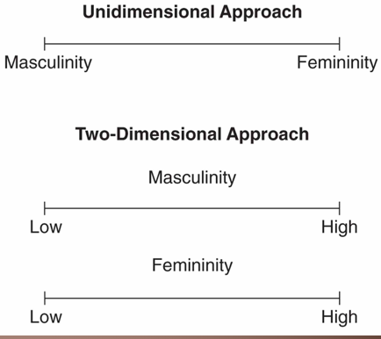
The Process and implications of stereotyping
- Perceptions of men and women = important in these processes
- They help streamline our cognition - and kids lives easier
- But also disadvantages:
  - Prejudice: negative evaluation of an entire group
  - Discrimination: behavioral component
  - Incorrect generalizations
  - perceptions and memories - we’ll remember things as fitting our own stereotypes better - we’ll fill in the blanks with our memories - borrow from other memories
  - People tend to pick a default category - ex: straight guy
  - Default category = men. Ex: in an opening of a video game or something: why is male always default? If woman , must be a reason.
  - Anything that’s not straight white man is not the default
  - God forbid a character that’s a woman and isn’t sexualized
  - When we have those perceptions and generelalizations in our minds it primes us to react certain ways
  - We create our world and on a subconscious level we expect it to confirm our lens - and that’s why its going to prime us to react a certain way
What do stereotypes affect?: POBT
- Traits
- Behaviors
- Physical appearance
- Occupations
Components: Deaux and Lewis Model of Gender Stereotyping
- When we know something about someone we will guess all the others
- How we see something and then make assumptions for all the other aspects
- Less traditional perspective than 1960s
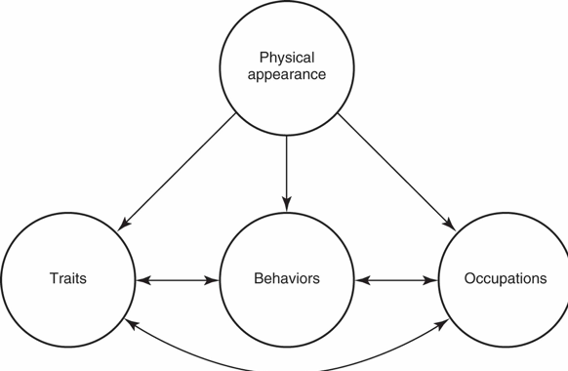
Development and Stereotypes in Children
- Form categories - stereotypes at age 3
- Children start talking about their own things - very inward - i’m a boy
- Children stereotype more strongly until 5-7, then more flexible, then more rigid again at adolescence, but overall increases with age
- In the morality development that is ‘’don’t break the rules’’ they get very stereotypical
- Hopefully people become more flexible and less stereoptypical as they grow up
- If we present kids with informations that is against a stereotype then it will change their categorization
- Men tend to have more stereotypes than women, but both genders have more stereotypes towards men
- The process: an illusory correlation
  - Correlation stronger than it is
  - Memories affected by stereotypes + contributes to its maintaining

Explicit and Implicit Stereotyping
- Attitudes - explicit
- Assessment of attitudes
- Implicit Association Test – short reaction times show bias.
  - Priming effect!
- fMRI scans confirm different brain areas responsible for explicit vs implicit stereotyping, so we’re hard-wired to make stereotypes.
Negative effects of stereotyping: Stereoptype threat
- the fear of being “justifying” a negative stereotype with your own performance (ex: eminem)
- Influences women and ethnic minorities to perform more poorly, mainly, but can be entirely dependent on situation
- Eg math tests with black / Latina women vs white men, then white men vs east Asian men. Also job review – demographic info.
- Can be nullified by pointing it out, denying it, or avoiding it.
- White men performed worse if said were stereotyped as less good at math than ex: asian men
- People who have chevaleresque ideas then also have negative sexist ideas - negative views go hand in hand
- A savior complex these poor people and white person came to see them show how to do it and now everything is good.
- Hostile Sexism
  - Negative attitudes toward women
- Benevolent Sexism
  - Positive attitudes that serve to belittle women and keep them subservient: People who believe that women deserve special treatment, should be set on a pedestal, or revered, also believe that they are weaker, need protection, and less competent than men.
  - Often the “positive” traits – like being more social, caring, nurturing – are used to justify the idea that they are “softer” and more in need of “protecting” by those hardened, strong, manly men.
  - Idea of romantic chivalry is appealing to both groups, but leads to outdated views
  - Similar to ‘benevolent prejudice’ that rationalizes racism as well, leading to white savior complex (save the poor children)
Two Dimensions Stereotype Content Model
- High and low dimensions of stereotype
  - High warmth - low confidence: admiration (admired leaders) - high competence low warmmmth - envy (buisness executives)
  - Low warmth - high confidence : pity(homemakers)-contempt(ppl in prison)
Considering Diversity
- Ex: in Japan being very assertive - is not a stereotype - because it’s a bad trait to have - not supposed to be making a scene
- Hostile attitudes correlated with benevolent ones
  - More oriented towards pears, going with the flow

HORMONES
The endocrine system and steroid hormones
- Endocrine glands secrete hormones and are important to development of the sexes:
  - Releasing hormones are produced by the hypothalamus to stimulate the pituitary gland which produces tropic hormones to stimulate the gonads, i.e., ovaries and testes
  - Know that the hypothalamus stimulated the pituitary gland which produces tropic hormones which stimulates either ovaries or testes
- The gonads secrete steroidal hormones* which relate to reproductive functioning:
  - AT: Androgens—most common is testosterone = muscles
  - EE: Estrogens—most common is estradiol = skin
  - PP: Progestins—most common is progesterone
- * Males and females produce all three but in differing proportions
  - Everyone has all of these, but we just have different levels of them
  - No testosterone = no muscles
  - No estrogens = something to do with your skin – will lack (estrogen keeps everything firm)
Stages and differences in sexes
- Sexual dimorphism: GGH
  - When does it begin? conception
    - 1.The genetic stage – determine the sex
      - Sex chromosomes (the X’s and Y’s)
  - 2.The gonadal stage – organs form = organs
    - Reproductive organs
  - 3.The hormonal stage = puberty
    - Prenatally and pubertally
- Internal and external genitalia
- Develop differentially (difference in timing)
- allows for the possibility of errors in developing either the male or female patterns
Regulation of Gonadal hormones
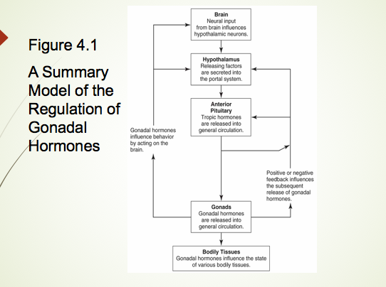
- Hyppothalamus and thalamus sends messages to other glands to do things
- PT Anterior pituitary releases growth (tropic) hormones , especially to the gonads
- Gonad release will affect everything and help everything develop (If you know a baby will be premature, you inject testosterone so that it will spike the development of their lungs)
Development of male and female reproductive organs
- Within the first 6 weeks of development, no difference exists between male and female embryos
  - XX = female chromosome pair XY = male
  - Same internal reproductive system
  - Thus, the capability of developing according to either the male or female pattern, regardless of chromosomal pattern
  - Initially, male and female external genitalia are identical
- Wolffian system = male reproductive system = wolfman
  - The capacity to develop according to the male pattern
  - Gonads into testes
  - Presence of androgens = prompts dev wolfian, degeneration Mullerian
- Müllerian system = female reproductive system
  - The capacity to develop according to the female pattern
  - Absence of androgens = allows mullerian system to develop = wolffian system degenerates
  - Gonads into ovaries
Development of internal reproductive system
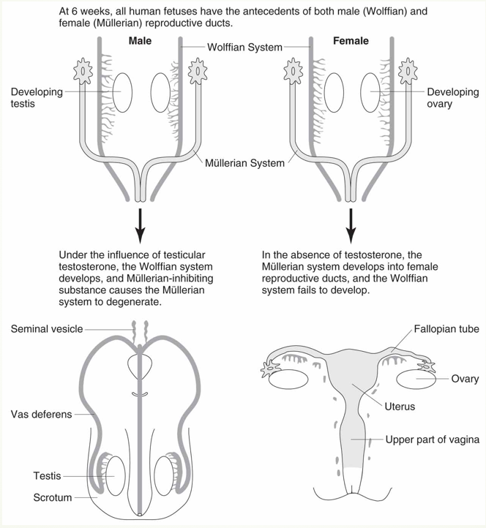
Nervous system
- Gender differences
  - May develop due to hormonal influences
  - Brain size differs with sex, but the proportion is similar to differences in body size
  - Cerebral hemispheres differ in function
    - Lateralization of function occurs
  - Gender differences in brain structures are small compared to other individual differences
  - Fewer brain differences between the sexes than what the media makes it seem
  - Brain size is proportionate to body size … boys are generally larger than girls so their brains will be larger
  - Differences in brain structures are very small compared to individual differences (for cerebral functioning)
Potential sex differences in brain structure
- *Sexually dimorphic nucleus (SDN)
  - In the hypothalamus = bigger
    - The most prominent brain difference
    - 2.5 times larger in men than in women
- Function in humans is not understood
  - The spinal nucleus of the bulbocavernosus = 25% larger in men
  - Involved in ejaculation in men
  - Involved in vaginal contractions in women
Changes during puberty
- Puberty: COM
Primary sexual characteristics
- Maturity of sexual organs
- Reproductive maturity
Secondary sexual characteristics
  - Physical features that reflect sexual maturity but are not involved directly in reproduction ex. Body hair, breasts and Adam’s apple
Changes occuring in puberty
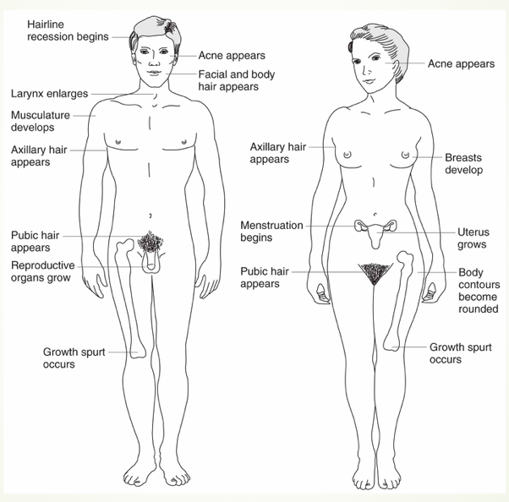
2 sex hormones:
- Stimulate gonads and increase production of androgens and estrogens
- LH-release: maturation of sperm, men and women need to reproduce - causes to release ovum
- FSH-stimulate: sperm production both sperm - stimulates maturation of an ovum
SP: Problems in sexual development per sex: sex hormones (sterile) + prenatal hormones (genitals)
- 1. Errors in meiosis can ALTER THE SEX CHROMOSOMES = sterility and fertility:
- 1.WOMEN (TURN unfertile) XO = Turner Syndrome = ovaries don’t function
    - Appear female at birth
    - No functioning ovaries
    - Born female but unable to reproduce
- 2.MEN (deKline in sterility) XXY = Klinefelter Syndrome = men are sterile
  - Male internal and external genitalia
  - Small testes, usually sterile
  - Testes stay small, don’t drop during puberty
- 2. Problems related to PRENATAL HORMONE EXPOSURE = wrong dvlpmt genitals:
  - 1. adrenal hyperplasia (HYPERmasculine = man) genitalia in woman
  - Masculinisation of genitalia for women
    - Also called adrenogenital syndrome
    - Caused by an increase in androgen production
    - For XY males, typically few problems occur
    - For XX females, causes masculinization of external genitalia – female genitalia, but the clitoris is almost like a micro penis
  - If the baby picks up too much androgen from the mother it can cause a disorder, or too much testosterone for some reason
  - 2.Androgen insensitivity syndrome (males are insensitive --- to testosterone)
    - Affects chromosomal (XY) males
    - External genitalia appear female, but have undescended testes (they didn’t come out)
    - Not typically identified until puberty
      - Fail to reach menarche
  - Androgen receptors don’t work
  - Have testes, but they don’t descend so they stay in the body
  - Which is why it appears like you have a vagina ^
  - Notice at puberty that you don’t have your period, you don’t get any pubic hair
- Intersexuality
  - Traditional term: hermaphroditism
  - Occurs when an individual has bothovarian and testicular tissue
- 5-alpha-reductase deficiency
  - Extremely rare
  - Affects XY males
  - Appear female at birth
  - Develop according to male pattern during puberty
Hormones and behavior instability
- Premenstrual Syndrome (PMS)
  - Wide publicity but not a precise definition
  - Research improved over the years
  - Most has not carefully controlled for SOCIAL PRIMING
Two well-controlled studies
  - Failed to find any evidence of PMS
    - Instead, PMDD (pre-menstrual dysmorphic disorder)
      - Variety of symptoms
      - 8% of women will report unpleasant symptoms that aren’t physical (ex. Depression) – mental and mood differences
      - significant reliable symptoms each cycle
4 PHASES MENSTRUAL CYCLE: FOML
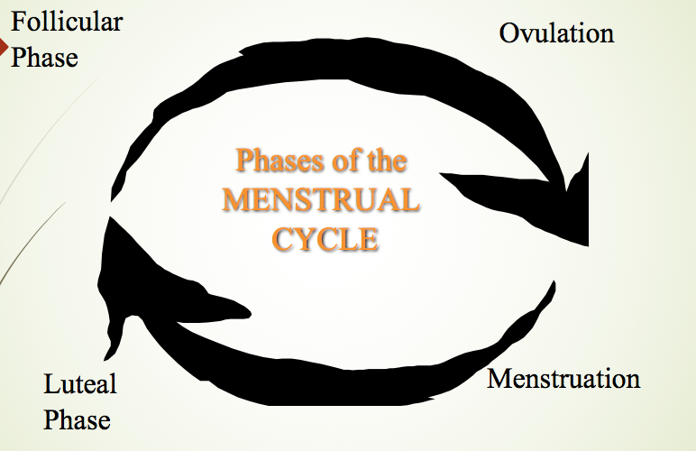
Testosterone and Aggression
- The relationship in humans is complex.
- A series of studies (Dabbs et al.)
- What did they reveal? revealed complex relationships between testosterone level and antisocial (but not necessarily aggressive)behavior.
- Testosterone also affects women's behavior; results show a complex pattern
- the relationship between testosterone & aggression may be that aggression raises the level of testosterone rather than the other way around… reinforcing patterns of aggression = stimulates that hormone
Considering diversity
- Western cultures
  - Generally a ‘male-female’ gender polarity (no in between)
- Several cultures have categories for more than two sexes:
  - Native American cultures
  - berdaches, or “two spirit” people
- India
  - hijras, or a “third sex” – you don’t have to be either a man or a woman

CLASS 3: GENDER IDENTITY + COGNITIVE ABILITIES

DEVELOPING GENDER IDENTITY
- Gender identity: how you view yourself as male or female
- Gender role: how others see you as male or female (ex: eminem and his hypermasculine gender role)
Development during childhood
- Gender identity starts around 7 months: they pay attention to things that are different
- You show them man, man, man, woman and look if you looked longer at the image of the woman: people with long hair and short hair is the level of what they distinguish
  - They don’t have an idea of a permanent gender attached to a person
- 18 months: they fail at gender labeling - they’re still trying to grasp the entire world
The sequence of childhood gender role
- 1. Gender as a stable personal charasteristic - no changes -
- 2.Gender as a consistant thing even with physical and behavior changes
- In order to grasp consistency you have to grasp stability first
- Can have stability without consistency but not other way around
- Boys are more stereotyped in their behaviors because they are more pressured too
- Girls more space in behavior ex: tomboy vs sissy
Later development in gender
- Men tend to do more men things - coded as appropriate for men
- Plateau 9-10 years old: first we learn gender roles, then learn that they can break them
Gender relates knowledge vs. roles (d.8)
- You keep your gender-related knowledge
- You apply the rules that are gender-related less and less
- When parents openly question attitudes lead to children who question attitudes
- Men who live in dorms tend to have more flexibility towards gender roles
- Less time with parents = more flexible attitudes towards gender roles
- Siblings who show stereotypical behavior
- College helps to open your mind
Influences on gender identity development (who you are)
Sources of influence
- BFPM: Biological factors, family environment, peers, media
- When you identity (parents) baby as gender is the foundation of how he will then view himself
- Evolutionary view: mothers are more nurturing - not true scientifically though
Biological factors and gender development
- Prenatal hormones and childhood behaviour: girls who are high in masculine behaviors tend to have higher levels of testosterone in prenatal woman - they’ll have more masculine traits - higher levels testosterone = link to behavior but not identity
- (Man-woman)Case of John-Joan turned into woman - didn’t work
- (Woman-man)Bradley case of woman turned into man - and she was very happy, maybe more biologically flexible
- But it’s not a choice the individual is making or a biological fact - complex and unknown
- Hard to disentangle the issue of nature vs. nurture - once a baby is born it’s given a role
Family environment in gender development
- Children mimic the parents a lot : modeling
- How your parents behave: primary belief that’s how people act
- Difference in attitudes in treatment and monitoring girl vs. boys = world more hostile towards women
  - It can feed into traditional gender roles: men more able to defend themselves
  - Different attitudes to how girls should get monitored
- Activities you put your children in
- The family context is critically important - over and covert beliefs
- Differential treatment - sports, academics, privileges, chores
- Traditional vs. non-traditional roles = diff in gender flexibility
Demographics
- Families without fathers = closer to mothers than normal - men would keep all their men qualities but gain more women qualities
Peers and gender development
- Pick up a lot of things at school
- Around age 3 - preference same-gender peers
Media
- Huge influence on how we internalize the world and how it’s real
- You’ll integrate it into how
- Synthesized realism - why don’t i have an appartment that nice ? even though people in the show could never afford it with their jobs
- The media informs our world view - absorb at subconscious level
- Gender will also get absorbed in how the world works
- Cultivating what people think of normal and desirable
- Men tend to be portrayed as older - no old woman in media - men tend to be the lead character
- Not old women - not represented as desirable
Children and media
- Children commercials is very bad in stereotyping
- Programming biases
- Commercials have a bigger impact on kids than they do on adults
- Canadian pediatric society: mediating against gender stereotypes in commercials
- By appealing to gender roles you make the children have these stronger gender roles
Considering diversity
- Disphoria: that’s not who i am this is wrong - ex: man who had hand transplant and had the hand removed because he had strong disphoria
  - Like that but with your gender: angry, trapped inside the wrong body
  - If it persists into adolescence good clue

COGNITIVE ABILITIES
- Prevailing view
  - 19th – 20th centuries
  - Women were not as intelligent as men
- Intelligence testing
  - 1916: Terman adapts Stanford-Binet Intelligence Test for use in US
    - Found no gender differences
    - Contrasted the societal assumption of women’s intellectual inferiority
- Bias towards finding difference even when none there
- Cognitive biases: women not as smart as men
- Intelligence testing: racial biases but no gender biases - women as smart
- Perception men better at math than women but actually not true
Weschler Scale’s to measure intelligence: verbal + performance
- Assess a range of abilities
- Women score higher on verbal subtests
- Men score higher on performance subtests
Verbal performance
- Includes a variety of tests related to language, reading, and writing
  - Girls and women have a small advantage
  - May be too small to be of any practical value
  - Only 1% of the variance of the scores are attributable to gender
  - 99% of the variance to something OTHER than the gender of the participants
- Females’ advantage in writing performance is larger
- 1% of differences in IQ
Mathematical and quantitive performance
- Complex pattern of findings
  - Before age 13, slight advantage for girls
  - By age 13, slight advantage for boys
  - Other assessments show no difference
- Men’s performance shows more variability
  - Standardized exams (e.g., SAT, GRE) may exhibit testing bias
  - Findings kept changing in math
  - Girls and boys have different attitudes toward math, girls:
    - See math as less important to their future
    - Feel less confident about math ability
    - Receive less encouragement from parents and teachers
    - As a result, boys and girls tend to perceive math as a male domain
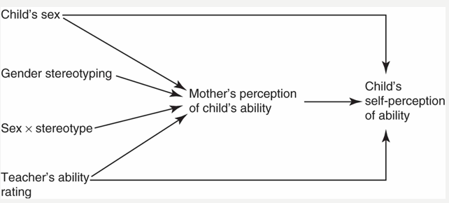
Spatial performance
- Even greater variety of tasks than verbal and math; yields a greater diversity of findings:
- Spatial perception
  - Identify and locate plane: women better
- Mental rotation
  - Visualize objects as they would appear if rotated = men beter
- Spatial visualization - men better
  - Identify the relationship of objects in space
- Spatiotemporal ability
  - Tracking objects moving through space
- Women will list all the things in the room as men will not notice it - observing things in space and memorizing
- Men better with shapes and spatial performance
Cognitive abilities - differences related to gender role expectations
- Overall, research yields no consistent gender-related differences in: MMCN
  - Memory
  - Musical ability
  - Creativty
  - Non-verbal communication
Men and women navigated differently
- Men orient to directions and forming an abstract map of the area
- Women are more likely to use landmarks to find their way.
- -- What factors are the source of gender distinctions in cognitive performance?
  - Gender roles
- -- Are these differences “hard-wired?” no
Biological evidence in gender differences
- Selection differences during evolution
  - Empirical confirmation is not possible
- Influence of prenatal hormones
  - Creates only small differences in performance
- Brain imaging technology (PET, fMRI)
  - Some differences in left hemisphere activation
- Subtle differences in how we develop hormonally
- Much of our brain differences occur because we use it all use it so differently and in many different ways for things
Evidence for other sources of gender differences
- Differences in training and experience
  - Eg., familiarity and instructions can influence performance on spatial tasks
- Stereotype threat
  - The presence of negative stereotypes affects the performance of those to whom the stereotype applies
    - Examples: math performance, spatial rotation tasks
  - Ability to see color is a learned ability
Implications of gender related differences
- Seem larger than suggested by research data
- Confidence levels may be mediated through social beliefs
  - Stereotypes lead to incorrect conclusions (generalizations - correlations)
  - Small distinctions can lead to differential expectations for boys and girl
Considering diversity
- Most of the research on cognitive abilities focuses on European Americans in the United States
- Cross-cultural research indicates that other groups show different patterns
- Few gender differences are as large as cultural differences in cognitive processes
- Culture = different, all do things differently

CLASS 4: EMOTION & RELATIONSHIPS

EMOTION
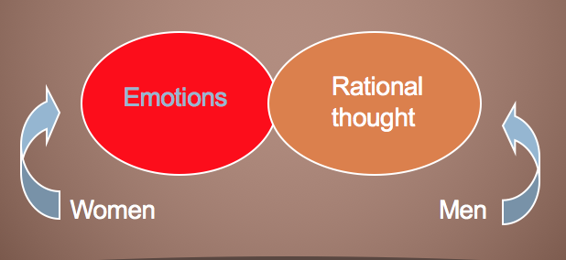
- Thought these should be separate and should never meet – originally
- But in today’s society, everything needs to be genderized … which is why we attribute emotions to women and thoughts to men
- If they are different and separate, they should be separated amongst gender also
- Display rules: overlearned habits about who can show what emotion to whom and when they can show it (ex: asians vs. french people)
  - Make it possible to experience one emotion, but display another (or none at all)
- An emotional double standard
  - Women seen as emotional
  - Men seen as rational
- These stereotypes do not apply to all emotions
  - Men more often associated with anger
- Men and women experience emotions with similar frequencies, although they differ in which emotions: Males : excitement, calm, Females : anxiety, sadness
- Stereotypes don’t apply to all emotions
- We experience the same emotions as men and women but we display them differently
- Differ in which we show more of
- Different levels of anxiousness and sadness
- Measure the amount of emotions in people they are equal – men and women have same # of emotions
The Myth of Maternal Instinct
- Nurturing behaviors of mothers
  - Very Darwinian
  - Determined by biological factors
    - Reinforces intellectual inferiority
    - Largely insensitive to environment or experiences
- The concept of instinct fell into disfavor
  - Lack of empirical support
    - Belief in maternal instinct continues
- Maternal instinct came up - built-in biological capacity for the magic touch to children
- Idea that women were inherently not capable of abstract intellectual thought as much because they were focused on caring for the children
- Unfair to men and women because men were seen as incapable of parenting thoughts
- There is an instinct to being paternal – MEN AND WOMEN both have this
- Evolutionary psychologists do not do a good job at explaining sex differences*
Maternal deprivation and its consequences for nurturing
- Series of studies by Harlow
  - Deprived baby monkeys of their mothers
  - Observed the effects
- Conclusions
  - Social isolation associated with abnormal behaviors
  - Contact with other monkeys appeared to be critical (rather than mothering)
  - Care-giving is dependent on experience
  - Raising a monkey in isolation = makes it have zero capabilities of taking care of their children when they are young, or any youngs …. They were a-social, had no idea how to interact, didn’t know how to have sex – even the women!
  - Would deny the baby comfort, they were maladaptive would rock themselves and scream if touched
  - Raised without mothers or fathers = no maternal or paternal instinct
  - Because these are all acquired behaviours
  - Still maladaptive to monkey society if they were raised with JUST their mothers
  - Raised in groups WITHOUT mothers = were fearful and abnormal as kids, eventually grew into social adults that could take care of babies
  - Complex behaviours – learned experiences if no society or not learned right, you will not react properly in society
  - No mother = you will be OK, just mother = you will be abnormal … you need to have some social circle
  - Social integration is very important
  - If you want to be a caregiver, you need to learn how to do that
Attachment
- An intimate relationship which develops between the caregiver (almost always a mother) and the child
- Critical periods of development
- A variation on maternal instinct: bonding
- Depends on innate components in the early interaction between infant and caregiver
- Physical contact is very important in development, but also as growing humans to form attachment
- Bond with infants from the second they are born
- It is important but it is not essential (as social circle is)

Gender and caring for children
- Attachment extends to a variety of relationships
- Biological foundation for nurturing
  - Mothers are primed by hormonal events surrounding birth
    - Increases their responsiveness to babies
  - Fathers who are expecting babies also undergo hormonal changes that make them more responsive and nurturing
- Socialization pressures
  - Fathers viewed as “helpers”
  - Mothers viewed as primary care-givers
- Mothers will always be primed by their hormones because they are the ones creating the baby – fathers are less aware
- But fathers can also have hormonal changes by being around the pregnant woman – primed to be more emotional, caring and responsive to the mother/child when it is born
- Pressures
  - Fathers get praised for doing things for their child, when it is just as much their job as mothers
  - Mothers don’t get this same praise
  - Mothers only need to be primary caregivers when nursing, it doesn’t always need to stay like this because fathers are just as capable of taking care of the child
  - Ex of this is splitting “parental leave” in Canada, USA doesn’t do this
    - Works for adoption too
- Evaluating the pleasure derived from child care is complicated by the situation that few men are involved in such activities in the same ways and to the same extent as are women.
- Amounts of satisfaction doesn’t depend on the man or woman doing it – it depends on who is the primary caregiver
- Men can take the same amount of satisfaction of parenting as women
- Research indicates that fathers enjoy their limited role in childcare more than women enjoy their more extensive and demanding one.
- When men are as involved as women in childcare, research suggests that they feel the same satisfactions and frustrations!
The Prominence of Male Aggression
- Aggression generally goes along with anger (aggression = physical act)
- Myth that men are more aggressive than women
Aggression
- Differences in definitions:
  - 1.Relational aggression & social aggression
    - Behaviors that harm others through damage to personal relationships
    - E.g., sulking, silent treatment, exclusion
    - Behaviours harming emotionally, for ex. But not physically
- 2.Indirect aggression
  - Harm through indirect means
    - Behind the scenes
  - Getting someone blamed for a bad outcome
    - Mocking someone’s behavior/actions
  - Not there when you are aggressing them
  - Gossiping
  - Not done to someone’s face
  - The way adults like it – because you learn that you are not supposed to say to their face – easier behind their back
- 3.Anger and agression
- Anger: internal emotion
- Aggression: behavioral reaction to anger
- Expression of anger more closely related to gender role than gender:
  - Masculinity more likely
  - Femininity less likely
Development gender difference in agression
- Longitudinal studies of aggression
  - Aggression tends to decrease
  - For some children, a high level of aggression is a stable trait
    - Boys more likely to be higher in aggression
- Affected by parenting styles/television
- We learn to self control so it decreases with age
- and we are socialized not to be aggressive
- If they watch a lot of violent TV – there is a link if they are behaving in more of an aggressive way (more so in boys, but also in girls)
Goals of aggression?
- Boys: exert control over others, gain social recognition, get money
- Boys tend to use more confrontational and direct aggression
- Girls: loss of self-control, avoid victimization
- Girls tend to use more indirect or relational aggression
- Boys kind of goes through all of life girls are more likely to indirectly say something about someone because it was done to them, whereas boys physically do it so that they are in control
Gender differences in aggression during adulthood
- Men are more aggressive: CPF
- --in everyday contacts
- --when physically attacked
- --when frustrated
- Women are more aggressive: IB
- --when responding to insults, including impolite treatment and rude comments
- When belittled
- All of these things will provoke aggression in BOTH genders, but on AVERAGE we respond more strongly to left if male and right if female
Gender and crime
- Men
  - More likely to commit crime/acts of violence
  - 3.5 times more likely to get arrested than women
  - More likely to be victims of crime
- Women
  - Behavior evaluated differently than men
  - Increase of criminal activity starting 1970s
  - More likely to fear victimization, especially sexually
  - -More likely to be victims of aggression because they are socially accepted victims (cant hit a girl)
Sexual violence
- Under-reported due to the stigma caused by it being a sexual crime, and also the tendency to blame the victim
  - Cultural differences in attitudes: Asian Americans hold more negative attitudes towards women as victims of sexual assault than European Americans do. More likely to endorse rape myths (eg. that it was the woman’s fault, that most sexual assaults are by strangers). These cultural groups under-report even more.
- Male victims of sexual assault and coercion get less attention in the media and in science, partly because they are not victimized as often, partly because some people still have difficulty believing that men can be sexually assaulted (of course they can).
  - The problem of sexual violence against women is more prevalent, and women are more traumatized by coercive sexual experiences than men are (again, in general
- Scully (1990) studied convicted “stranger rapists” by interviewing felons regarding their attitudes.
  - Sexual offenders were not more likely to have psychopathology or childhood physical/sexual abuse than other inmates.
  - Had instability and violence in family histories but similar to other inmates
  - Formed relationships with women but had a combination of sexist beliefs, like “women belong on a pedestal” as well as “men have the right to treat women with violence”.
  - These rapists often planned and executed their assaults when they were angry at their girlfriends or wives. They would find another woman to target with violence to punish women for being bad to them.
  - Targets were picked mainly on being vulnerable. Physical attractiveness was not a consideration, and most perpetrators could not remember what their victims looked like, which further shows the link between sexual assault and aggression / power, and not a sexual motive / lust.
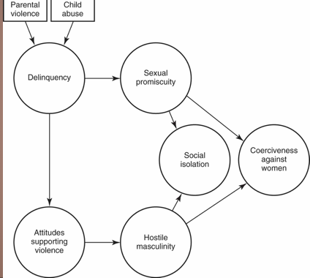
Expressivity and emotion
- The gender difference in expressivity can be understood as a difference in display rules:
  - Allow (and even demand) that people enact their gender roles
    - Results in the expression of different emotions in boys and men compared to girls and women
- Men and women are supposed to restrain displays of certain emotions yet are free to show others
- Two of the “male gender role rules” apply here:
  - No sissy stuff, and Give ‘em hell.
  - Men should not reveal “weaknesses” like sissy human emotions, and men should be proud of aggressive behaviour.
- Similarly, caring for babies is girly, but it’s fine to love your dog.
- But maybe not your cat. Cats are girly.
- Women are not allowed to express emotions except for anger, which is unladylike.
- Self reports and studies of people in public find that women are more expressively emotional than men BUT studies done unobtrusively in private usually find no differences.
- Young boys have the same nurturing capacity as girls, but they display this more so to their pets and stuffed animals because they are, by society, not supposed to be nurturing towards babies and younger children
Considering diversity
- Six universal basic human emotions: HASSFD
  - Happiness, surprise, fear, sadness, anger, and disgust
- Cross-cultural differences
- Individualistic vs. Collectivistic cultures have different amounts of the universal emotions in them. Individualistic cultures show more pride, Asian collectivistic cultures had more guilt, and African collective cultures had more pride and contentment.
- Acceptance of anger varies
- Differ in display rules: association with masculinity is not universal.
- Eg Vanatinai (South Pacific islanders) consider adult aggression an embarrassing lack of self control despite being warriors. Fighting is rare but more common for women to do even though they aren’t allowed to participate in warfare.

RELATIONSHIPS
Sternberg’s Triangular Theory of Love : IPC
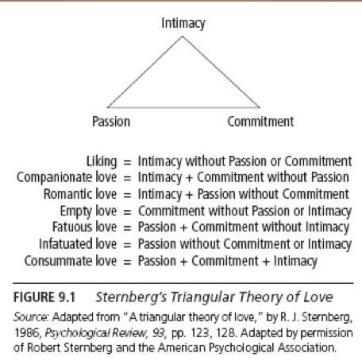
Friendships
- Development of Styles
  - Children segregate themselves according to gender early in development
  - No distinction until ~ 3+ years
    - Until then, cross-gender play
- Segregation of genders
  - 4 and after through middle childhood
  - Responsiveness and sharing reserved most for same-sex friends
    - Both sexes name friends, even best friends
Development of Styles
- Activity preferences by sex
    - Boys: larger groups, outdoors
    - Girls: seek and value intimacy more
    - Contributes to segregation
- Racial preferences
  - Not as often seen in childhood
  - More often in high school and beyond
- Children begin to have a concept of friends during elementary school, when friends begin to furnish intimacy and companionship.
- The style of friendship typical of women begins to develop during mid-elementary school; their friendships begin to include emotional intimacy.
- These talk-based friendships contrast with boys’ relationships, often based on playing games, team sports.
- Through preadolescence, children maintain gender segregation in their social interactions, and the tendency to segregate into groups extends to ethnicity as well as gender.
Friendships over the life span
- Intimacy increases during adolescence
- Men tend to avoid intimate male friendships
  - African-American men lowest in self-disclosure
  - Aloof stance
  - The “cool pose” (Hall 2009)
  - Macho overtone. Emphasis on poses, postures, humour, readiness to use violence and suppression of emotion intended to create visibility for those who have been made invisible by a racist society.
  - Violence and emotional remoteness can be toxic
  - Fear of homosexual interpretations
    - Begins in mid-childhood
  - Changes in existing friendships
    - Workplace relationships – gender matters less than race, new source of friendships as an adult with people who have similar interests and experiences
    - Committed relationships – can take time away from friendships (especially when children show up)
  - Elder years
    - Need more practical support and face diminishing friend circle
    - Sources: children, social networks
    - Many make new friends but more common to have female friends for both genders due to demographics
Flexibility of styles
- Many men’s intimate friendships are with women
- Relationship Styles
  - Defined in “feminine” terms
  - Men: role of homophobia in preventing intimacy-seeking - afraid of opening up, being vulnerable, emotional
- Cross-gender relationships
  - Boundaries of non-sexual relationships: Women feel they must be vigilant in avoiding sexual overtones in relationships with men, but not with other women
  - Men and women can adopt each other’s friendship styles with each other
Love relationships
- Historically
  - “Passionate love” bad for permanent unions
  - Warning stories of passionate love, considered a madness
  - Instead, arranged marriages more common
- Blueprints of Relationships:
  - Before the Industrial Revolution, marriages tended to fit the Family Duty blueprint
  - Equal relationship between partners
  - Formed around commitment
By the 1800s, division of labor
  - Men: Good Provider role - technical + DIY
  - Women: be good mothers and wives
  - Doctrine of Two Spheres
  - During the 1920s the Companionship blueprint arose
    - Becomes standard model
    - Focus on affection and support but with a lack of commitment (shown by rising divorce rate)
    - Romance and love became important for marriage, so dating becomes popular
Dating
- Began as a form of courtship
  - Format for behaviour
  - Provides scripts for both men and women: men do, women react
- Modern-day scripts
  - More casual than formal
  - Social activity
    - 57% US teens date regularly, one third have a SO
  - Companionship
    - Status and self esteem vs stress, depression
    - Dating as a teen can be linked to destructive behavior, especially without peer approval.
Online
- In single adults, 25% had not had a date in the past year. Adults tend to be more interested in finding long term partners when looking for dates.
- Online dating is a thing now. In 2000 only 8% of adults had tried it but now it’s more than half for both men and women. Other sources of introductions are from mutual friends, family or coworkers.
- Online socialising also creates friendships. A survey in 2002 found that 14% of teens had formed a close friendship online, and most teens are cautious and sensible online. A small mino
Evolutionary psychology
- Believes that females and males faced different evolutionary pressures: men needed to “spread their seed” and women needed to select a useful mate to help rear the child.
- According to this theory, women are less concerned with looks. Men are all about looks because beauty predicts good health and fertility.
- Except that the best predictor of fertility is recently having a child, and young mothers are not the hottest demographic.
- Also women are increasingly just as shallow as the men (progress!) – as women get more financially independent their desire for hotties increases.
- Evolutionary psychology also predicts that attraction should be more important for baby-producing heterosexual relationships but that’s not the case.
Attraction
- Sought after traits include kindness, consideration, and beauty in heterosexual and same-sex couples.
- Other characteristics include similar values, same religion, social class, ethnicity,
- The more those things are important to people, the more they will factor into relationship satisfaction
- Love and mutual attraction rank number one reason for mate selection
- Intelligence, education and pleasing personality also rate high
Marriage and committed relationships
- Types of relationships
  - Married heterosexual couples
  - Gay/lesbian couples > now referred to as “same sex” to include bi folk
  - Cohabitating (non-married) heterosexual couples
- Styles of heterosexual marriages
  - Companionship blueprint
  - Independence blueprint
  - Interdependence blueprint
  - 90% of women believe in egailtarian marriages
- Dramatic increase in couple households non-married from 1960-2008
- Less marriages more divorces
Concepts of love and marriage
- Compared to women, men…
  - Have more traditional concepts
  - Are more romantic
- Women: more likely to report physical symptoms of being in love
Both men and women are physically and mentally healthier when married
Although married females also report more stress than men do
Communications between partners
- Women create emotional intimacy through talk and self-disclosure
- Men create emotional intimacy through activity, such as sex
- Women would like their male partners to be more emotionally communicative, whereas men would like more sex
Balance and power
- Growth of egalitarian attitudes towards marriage
- Parallels trend of employment for women
- Matriarchy vs. Machismo
- Associated with African American and Hispanic cultures, respectively

- Decision making
  - The partner bringing more resources (income, status, or education) likely wields more power
Division of household labour
- Primary responsibility for household chores remains with the woman
  - “women’s work” vs “men’s jobs”
- Gendered expectations
  - Gay/lesbian couples more equitable than heterosexual couples
- Other considerations
  - Employment, education, presence of children, socio-economic status
- Conflicts between work/family obligations and an inequitable division of household labor can be major sources of conflict for couples
Conflict and violence
- Goals of conflict resolution
  - For men please their partner
  - For women avoid upsetting their husband
- Coercive styles of conflict resolution
  - Reported by 23% of women; 11% of men
  - Men and women are equally likely to be the perpetrators of violence, but women are much more likely to sustain serious injury
Stability of Relationships
- All couples experience some level of conflict
  - Contributes to lower relationship satisfaction
  - Strategies for resolving conflict are related to satisfaction and stability
- Commitment = component most strongly related to relationship stability
Dissolving relationships
- Common motives for divorce:
  - Failures to meet partners’ relationship expectations
  - Lack of shared interests
  - Problems balancing work and family demands
- Lesbian couples have the highest ratio of separation, afterwards its gays
Considering diversity
- Marriage relationships and cultural variations
- influenced by the economic contributions that men and women make
- In cultures in which women have more power, women have access to economic resources
- contribute to family subsistence
- In societies that are more male-dominated
- (i.e., cultures in which women have less power), violence against women is more common

CLASS 5: SEXUALITY

Methods of Investigation
- Surveys: best way to measure sex - difficult to measure it objectively
- Self-selection of participants: are the people who answer sex questionnaires a representative sample?
- Direct observation
  - People are less willing to participate (!)
- Research on animals may not generalize to humans
Sex surveys
- Henry Havelock Ellis
- England, 1896-1928: after victorian times but still heavily influenced by them
- Clelia Duel Mosher
- United States, 1892
- Results: people were actually sexual creatures
- Questioned prevailing Victorian social norms
- People’s views were not reflected in their sexual behavior
- Women experienced both sexual desire and orgasm!
The Kinsey Surveys
- Alfred Kinsey began collecting data in 1938
- Was a university prof teaching a brand new course in the controversial topic of sex education but had little data
- Developed extensive interview questions covering 9 areas: socioeconomic, marital history, sex ed, physiology, nocturnal sex dreams, masturbation, heterosexual activity, homosexual activity, and sexual contact with animals
- 17,500 interviews done, over 5000 men and women in the final sample used for conclusions
- Representativeness of sample? Not really representative but still important findings
- Mostly well-educated White Protestants from Indiana: made everyone feel normal,
- Results cannot be generalized to US population
- Used techniques to encourage honesty
- Wording of questions: “At what age did you first experience full intercourse?” Wording assumes that everyone has done it, relies on denial rather than volunteering information
- Follow up interviews done 18 months later yielded consistent data, suggesting good honesty rates
- Results were reported in Sexual Behavior in the Human Male (1948) and Sexual Behavior in the Human Female (1953)
- Sex was not a “polite” topic of conversation at the time
- Women were expected to be reluctant to have sex: but they found out they enjoyed
- Same sex, premarital, and extramarital sex were illegal in many areas

Sexual behavior of the time Kinsey Survey
- Sexual behavior of the time: affected by culture but also does its own thing, partially dictated by culture - study picked up on that dichotomy - doing foolish things but saying they were not - double standard
- Not always consistent with prevailing social opinions
- Sexual activity - more common than expected:
- Including same-sex activity
- For both gay and lesbian sexual relationships
- Masturbation reported by 30% of married women and 40% of married men even though it was thought to be something only horny teens did, alone
- Premarital intercourse rates were 83% for men and 33% for women by age
Results of Kinsey survey included:
- Women enjoyed sex: 90% of the women surveyed had had an orgasm by age 35. Of the 10% who hadn’t, 8% had experienced sexual arousal, leaving only 2% who did not enjoy sexual activity, much lower than expected
- Same sex experience: 37% of the men in the survey reported at least one sexual experience with another man that led to orgasm (this includes “one shots” and “teen experimenting”), and 13%-higher in men of men reported that they were primarily or exclusively interested in other men sexually.
- Same-sex experience (lowe in women): 28%of women had at least some sexual experience with other women, 7% reported primarily or exclusively lesbian activity
- Masturbation - higher in men: 14% of women and 45% of men reported masturbating before age 13
- Sexual abuse: (less % in men) 10% of men and 25% of women reported sexual abuse as a child, over half the time from an acquaintance or family member
- Really hard to quantify and measure child abuse but this study was able to have findings
- Consistent trends:
  - Double standard for sexual behavior
  - Men had a wider variety of sexual experiences than women
  - After the Kinsey reports most other sex researchers chose to do surveys as well.
Human’s Playboy Foundation Survey
- Sexual Behavior in the 1970s. An attempt to update Kinsey findings
- Another failed representative sample
- BUT this sample more closely matched the U.S. population in terms of ethnic background, education, age and marital status. 2026 participants filled out a long questionnaire and 200 of those did in depth interviews like the Kinsey ones.
Findings
- Confirmed prevalence of masturbation (94% of men and 63% of women had masturbated to orgasm)
- Decreased estimates of same-sex sexuality (Primarily homosexual responses were 2% for men and 1% for women), concluded higher numbers came from including teenage experimentation that tends to stop after age 16
- Increase in premarital (97% men, 67% women), extramarital (41% men, 18% women), and oral-genital sexual activity (linked to education levels: 60% for college educated, 20% for adults with HS education and 10% for those with only grade school; also 90% of married couples had engaged in oral-genital activity) – sexual revolution of the 70s
- 70s in general = more sex, more oral
The National Health and Social Life Survey
- Which study was first to obtain representative sample of sexuality? 1990s; First survey to obtain a representative sample
- Results:
  - Increase in more liberal sexual standards (only 30% said sex should be exclusively in marriage, for making babies)
- Behaviour pre-marital sex (high in mind): Still found gender differences: 28% of women reported not wanting to have sex their first time but doing so out of affection or being forced to, vs 8% of men. Also men were more likely to masturbate and women were more likely to feel guilty about masturbating.
- Estimated rates of homosexuality at 4.1% male, 2.2% female
- Attitudes pre-marital sex (higher in mind): Acceptance of sex for pleasure and outside the boundaries of marriage: 93% of men and 79% of women. (attitudes)
- But, higher degree of conservatism concerning sex: America was Pretty Vanilla.
  - Culture vs behaviours
  - Not freaky
- Different results for different studies, different questions for different studies
Gender differences (and similarities) in sexual attitudes and behavior
- Two large gender-related difference among men:
- Higher rate of masturbation
- Greater acceptance of casual premarital sex: dates back to pre-victorian era, women needed to be pure
- Differences in other sexual attitudes and behaviors were either small or absent
  - Men’s and women’s sexual behavior quite similar
- One problem with surveys and questionnaires is that they only assess explicit attitudes. People may hold implicit attitudes that are more conservative. (double standard), people can think a certain way but have implicit attitudes about the subject and act in another (real conflict with implicit held beliefs and ideas we express when thinking)
- Self reports might also be inaccurate. Bogus pipeline interviews (Alexaner & Fisher, 2003) showed very small differences in women’s and men’s sexual behavior: similar number of lifetime sex partners, age of first intercourse, voluntary exposure to sexually explicit material, and frequency of masturbation.
- The surveys would show very small differences in men and women behavior, the numbers get closer when you encourage people not to lie - women under playing it and men overplaying it

Masters and Johnson’s Approach
- Direct observations of sexual behavior in order to study the physiology of intercourse. Recruited married and single volunteers to have sex in a lab, wearing gear that monitored their sexual functioning.
- Definitely not representative but they believed that the physiological sexual responses were mostly universal
- Men and women have similar experiences: 4 stages: EPOR
  - Excitement
  - Plateau
  - Orgasm
  - Resolution
Female genitals during phases of sexual response cycle
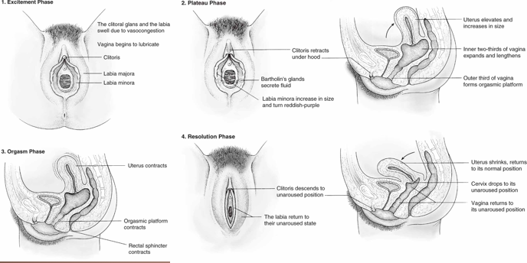
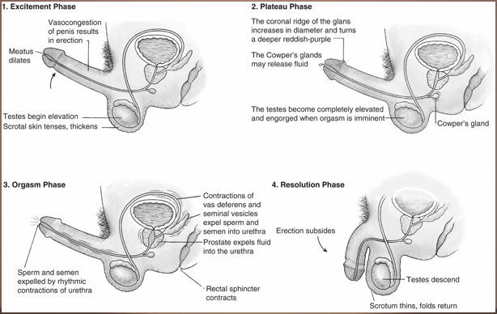

Masters and Johnson’s Approach
- Contrasted with Freudian view of sex: He claimed that women had two distinct kinds of orgasms, clitoral and vaginal. Immature women had clitoral ones, from masturbation, but mature and healthy women had vaginal orgasms.
- Masters and Johnsons findings? M&J concluded that all female orgasms were clitoral, but some women received enough clitoral stimulation via penetration to achieve orgasm
- Criticisms
  - Ignored individual variations, which are real
  - Wide acceptance of this model leads to: non-conformity being associated with sexual dysfunction

Childhood sexuality
Exploration:
- Sexuality begins at an early age, before puberty
- Different from adult sexual behavior. More focused on physiology and not on sexual arousal.
- Examination of own genitals and other children’s
- no idea of what is really going on
- Curious and want to see how things work
- Parents shouldn’t react in harsh ways or will internalize these views
- Still need to be educated on what needs to be done privately
- Includes same-sex and other-sex play (“playing doctor”)
- Approximately 80% report some sexual activity
- Parental reactions can complicate views and understanding of sex.
Abuse
- Sexual contact with an adult or adolescent at least 5 years older than the child
- Experiences with adults
- Reported by 25% of girls; 10% of boys
- Rates of abuse are difficult to determine – who do you ask?
- Both girls and boys are abused during childhood - usually will not speak up
- Most common pattern: male perpetrators and female victims, but it is important not to be blinded by that narrative.
Rates of childhood abuse
- Girls much higher in girls: 11% - 40% report childhood abuse (under 16). Average age is 10 years old. Between 94% and 100% of their abusers were male.
- Boys: between 4 and 8% report childhood abuse. Average age is 11 to 12 years old. 83 to 84% of their abusers were male.
- Tendency of majority of abusers to be males
- Of the children who were abused, 11%-50% reported a stranger, 33-49% said friend or acquaintance, 14 to 50% said a relative, reported threats or force used: 55%.
- When women are the abusers they almost always choose male victims, and younger than average. Can use the guise of “initiating” them into sex, and this behaviour is harder to report and recognize. - men are portrayed to like sex, most of the time the victim will realize later on the fuckedupness
- One estimate of father-daughter abuse put 17% of girls as being abused by a stepfather or by their mother’s boyfriend, and 2% by their own father.
Short-term and long term effects of abuse
- Short term:
  - Fear, anxiety, epression, anger, sexually inappropriate behavior, academic problems
- Long term:
  - PTSD or cPTSD (it piles up- my childhood was fucked), depression, suicide, suicide attempts, sexual adjustment poblems, substance abuse disorders, marriage problems.,
- Few gender differences exist between boys and girls who have been the victims of sexual abuse
- Rates of abuse may be declining but it remains difficult to measure

Heterosexuality
- Attraction to people of the opposite sex
- The sexual orientation of the majority
- It is important to resist the narrative that one mental category is the “Default” and that others are “abnormal”
- 78% of the earth’s atmosphere is nitrogen. It forms three bonds, has a molecular weight of 14.
- 21% is oxygen. These oxygen molecules clearly chose to have an extra proton, neutron, and electron. They only make two bonds. And they oxidize really aggressively, it’s not healthy. Have you seen what oxygen does to iron? It’s destructive.
- 0.9% of molecules self report as Argon but what even is Argon, that sounds made up, those molecules need to stop trying to be special snowflakes and just admit they’re Nitrogen with identity issues. Nitrogen has an atomic weight of 14, Argon is 40. It’s just weird. Who has an atomic weight of 40? I don’t get it. That makes no sense. Noble gasses can’t even form covalent bonds, they’ll be lonely forever.
Heterosexuality in adolescence
- Typical period of sexual initiation
- Societal messages regarding sex
- Promotes pleasures of sex, but direct messages urge young adults not to participate
- Sexuality education generally happens in a formal way at this age
- Abstinence-only vs comprehensive programs = abstinence only = doesnt educate
  - Sex ed often promotes dangers of sex:
  - Acquaintance rape (aka “Date rape”) , STDs, unwanted pregnancy
Dangers of sex
- Messages about the dangers have some basis in fact:
- It is entirely possible to get pregnant after only one instance of vaginal intercourse (but this risk can be very, very mitigated by appropriate contraceptive techniques)
- STDs are common (but most are treatable, and all can be screened for by responsible people)
- Date rape – forced sexual activity between people who are dating or otherwise acquainted.
- A 2006 survey found that 27% of college women experienced unwanted sexual activity on campus

Gender differences and attitudes
- Some gender differences with attitudes towards coercive behaviour
- Men see flirting as more sexual than women do (La France 2009)
- Men’s expectancy for sex is set early in a romantic encounter and resists change (Willan 2003)
- International survey (Geiger 2004) found high school boys had widespread attitudes that supported sexual coercion, like blaming the situation instead of the perpetrator, minimizing the seriousness of the rape, justifying it by saying the victim intended to have sex.
- Anxiety about pregnancy is more common in girls than boys.
- In 2014, a total of 249,078 babies were born to women aged 15–19 years, for a birth rate of 24.2 per 1,000 women in this age group. This is another historic low for U.S. teens and a drop of 9% from 2013. – from cdec.gov Apr 26, 2016
- US had highest teen pregnancy rate in any industrialized country in 2008 (72.2 in 1000 teens).
Ontario sex ed: grade 4,5,6
- Grade 4 = just puberty
- Grade 5 = see genitals, menstruation, stresses in puberty
- Grade 6 = look at relationships, stereotypes
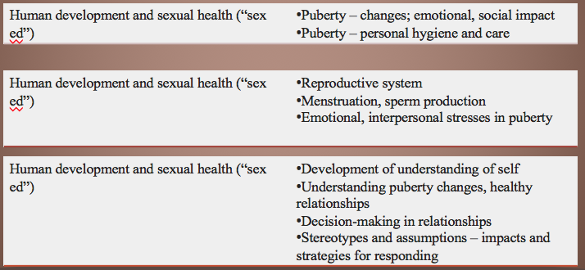

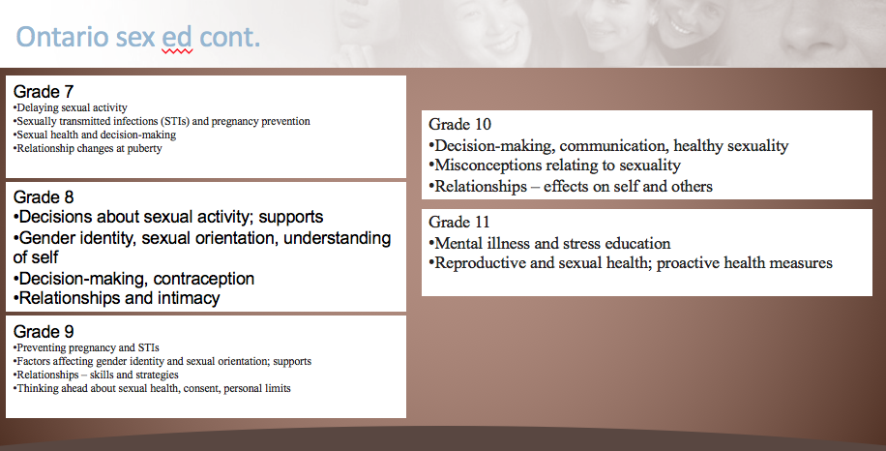
Heterosexuality during adulthood
- Often referred to as “Straight” but “Straight” also implies cisgender.
- Gender differences: ATRA
  - Acceptability of casual sex
  - Timing of intercourse
  - Reactions to sexual betrayal
  - Application of double standard
Sexuality in Adulthood
- Different sexual styles in young adults and throughout the adult lifespan:
  - Celibacy :Refraining from sexual activity. Can be due to lack of opportunity (30% of college students), voluntary (2.9% of adults), and spikes sharply in older widows / widowers (after 60 years old)
  - Monogamy : Having one sexual partner, committed love.
  - Serial monogamy : Having a series of partners, one at a time
- Infidelity: Evidence once again stumps evolutionary psychologists predictions, that women are more upset by emotional infidelity and men by sexual ones
  - Both genders hate sexual ones more, women hate both types more than men.
- Casual sex partners
  - Hooking up is becoming more common. 2008 study found that 50% of sexually active college students had had at least one casual sex partner. Still more acceptable to men but gender gap is narrowing.
- Polyamory
  - Having multiple partners at once, simultaneously or as a group
- Polygamy
  - Multiple spouses – history of problematic social structures
  - Eg Bountiful, British Columbia’s “Celestial marriages”
  - Winston Blackmore, husband to 27 and father to 145.
Homosexuality
- Incidence, same-sex sexual gender role experience
  - Kinsey et al., 1953 Men - 37% Women - 28%
- As primary sexual orientation Kinsey Men – 13% Women - 7%
- “Heteroflexible” aka “rounding up to straight”
Homosexuality during adolescence
- Process of developing sexual identity varies between individuals: LEA
  - Labeling self
  - Engaging in sex
  - Acknowledging orientation
- “Coming out”
  - Personal recognition/public acknowledgement
  - Time difference of up to 10 years
  - Can pose challenges as well as offer benefits
Bi-pansexuality
- Attraction to individuals of both genders
- Difference of views
  - Continuum versus category
  - Some claim it is those who have not accepted that they are gay or lesbian which invalidates it as an identity
  - Others claim this orientation represents an integration of same- and other-gender sexuality
- Frequency difficult to assess
  - NHSLS results: 0.8% of men; 0.5% of women
Aro-Ace - demisexualities
- The Asexual spectrum
  - Aromatic – no romantic attachments, no desire for one
  - Asexual – no sexual or limited sexual activities, no or limited desire for them
  - Demisexual or Grey asexual – no sexual attraction to strangers / acquaintances / hotties. Sexual desire can come rarely and generally only after falling in love with someone.
  - Allosexual = regular – someone who feels sexual desire and enjoys sexual activity.
- Frequent confusion between sexuality and romantic inclinations
  - It is possible to be an aromantic bisexual (hookups abound, no steady partner is desired) or a biromantic demisexual (crushes and cuddles for all, sex only after love). They are two different spectrums.
- Asexuals frequently face discrimination among the LGBTQA+ community, especially heteroromantic ones, as being “not really queer”. Can also be treated as a medical problem – lack of awareness.
The Kinsey Scale - 0 to 6
0 Exclusively heterosexual
1 Predominantly heterosexual, only incidentally homosexual
2 Predominantly heterosexual, but more than incidentally homosexual
3 Equally heterosexual and homosexual
4 Predominantly homosexual, but more than incidentally heterosexual
5 Predominantly homosexual, only incidentally heterosexual
6 Exclusively homosexual
X No socio-sexual contacts or reactions
Further studies
- Lisa Diamond (2003) – Separates erotic attraction and romantic attraction
- Hyde & Jaffee (2000) – Question “compulsory heterosexuality” – reflected in the scientific bias that homosexuality requires study but heterosexuality doesn’t.
- The Heterosexual Questionnaire is attributed to Martin Rochlin, Ph.D., 1972 (1977 in some sources).
Theories of homosexuality
- 1. Genetics
  - Inheritance for sexual orientation – unclear
  - Role of prenatal exposure to testosterone
- 2. Exotic-Becomes-Erotic Theory
  - Daryl Bem’s hypothesis
  - combines social and biological factors
Considering diversity
- No universally accepted or rejected set of sexual behaviors
- Sexuality is culturally specific
- A behavior forbidden in one culture may be required in another
- Behaviour normal in one time or place can be abnormal in another (ex asexual women in the Victorian era)
- E.g., childhood sexuality is restricted in some cultures, allowed in others, yet forbidden in others

