- Proxemics:
  - Edward T. Hall
  - Proxemics: culturally specific relations in time and space
    - Time – 5 mintue rule – 5 mins for class you will come in quietly and if you come in 15 or an hour late you will say sorry for coming in late or you will not even show up
    - Space- territorially, physical space and personal space
    - Every culture has specific rules/ norms regarding what is appropriate based on timing and spatiality
    - Every culture has their own ideas about space. French people go up and kiss people on both checks.
    - Space – when you walk into class your not going to give your prof a hug, but when you see your friends your gonna give them a hug

- Social Distance:
  - Social distance includes “body space” and “comfort zone”
  - We regulate the distance between ourselves and others for a variety of reasons
    - Safety
      - If you are walking alone at night and you see a stanger behind you, you will walk a lot faster and distance yourself
    - Communication
      - If your talking to someone you want to be in a certain distance with them
    - Affection
      - With your bf or gf you want to be close to show you affection
    - Threat
      - You see someone as a threat and you get freaked out and want to space yourself
  - Social Distance includes:
    - Physical territory
    - Personal territory

- Class exercise:
  - When someone gets really close to them in their personal space, we don’t feel comfortable
  - Larger distance between 2 males walking towards each other
  - Shorter distance is with women because they feel more comfortable with eachother
  - And a shorter girl and a taller guy they have a larger distance too

- Intimate Distance:
  - Intimate distance is usually : 0 to 1 feet
  - Someone that you are in an intimate relationship with
  - Touching is the primary sense with intimate distance
  - Often involves nonverbal communication
  - Can be threating if not wanted.
  - High comfort level with the person that you are engaging with
  - You can see their body language more

- Personal Distance:
  - Personal distance is usually 1 to 4 feet
  - Involves friends, family, etc
  - Can involve equal verbal and visual communication
  - Waiting in line at the grocery store or bank and have someone stand so close to them and they start to feel really uncomfortable
  - No one wants anyone in their personal space

- Social Distance
  - Social distance is usually 4 to 12 feet
  - Ex. Business meeting, interpersonal relations, dinner table
  - Close so can talk without shouting, but maintain a safe distance

- Public Distance
  - Usually 12 + feet
  - The space we keep between ourselves and others when in public
  - Visual communication reduced
  - Might not beable to see everyone in your public space
  - You don’t want to be walking too close to some stranger
  - You go and sit somewhere when there is more space

- What is culture?
  - Culture: system(similarities) of values and beliefs, behavior and material objectives that constitutes a peoples way of life
  - They all have some type of similarity
  - Cultures vary but they all have 5 common elements
    - Symbols
    - Language
    - Values
    - Beliefs
    - Norms
  - Dating is known as people in all cultures

- Symbols:
  - Symbol: anything that carries a particular meaning recognized by people who share a culture
  - Symbols are a shared group experience
  - Culture is transmitted through symbols
  - Can be tangible or intangible
  - They can be something that is physical or something that u cant physically see
  - Ex. Maple leaf= Canada
  - Intangible – talking to someone and saying lol, bff, etc

- Language:
  - Language: a system of symbols that allows people to communicate with one another.
  - Sapir-Whorf Hypothesis
  - Language allows for the continuity of culture
  - Language preceves thought

- Beliefs and Values:
  - Beliefs: specific statements that people hold to be true or false. Based on our values
  - Values: abstract ideas or generally accepted standards of behavior. Standard of goodness and badness in a society
  - Collective ideas about what is right/wrong, good/ bad, desirable/undesirable in a particular society
  - Ideal vs. Real values
  - Canadian Values: Equality, tolerance, support for diversity, compassion, natural environmental beauty

- Norms:
  - Norms: defining principles by which a society comes to govern
- Itself
  - established ways of behaving
  - Differ from values - they are more precise rules
  - Norms aren’t all formally codified as laws, but many are!
  - 2 types of norms:
    - Prescriptive Norms – state what behavior is acceptable, having safe sex, not talking white the prof is talking
    - Proscriptive Norms- state what behavior is unacceptable, not acceptable to go out and murder someone
  - Going to see a play it is normative to go aplode after the play is over

- Three types of norms (William Sumner)
  - . Folkways
    - Informal customs (etiquette)
    - Norms for routine, casual interaction
    - Ex. Brushing your teeth, you wont get a punishment for not doing it
    - More rules of conduct for our every day lives
    - They are mild so it is not a big deal if you violate them
  - 2. Mores (Mos)
    - Customs considered to be correct or necessary for group survival
    - Widely observed and have great moral significance
    - Ie. Taboos
    - Based on cultural values
    - Bad behaviors and seen as awful
    - These norms apply at all times

- Laws:
  - Laws: formal rules with sanctions/punishments
  - Are codified (written in Criminal Code)
  - Civil law: deals with disputes among persons/ group (divorce)
  - Criminal law: the state deals with public safety & wellbeing of society

- Sanactions- reaction to someone engaging in a norm, can be positive or negative
- 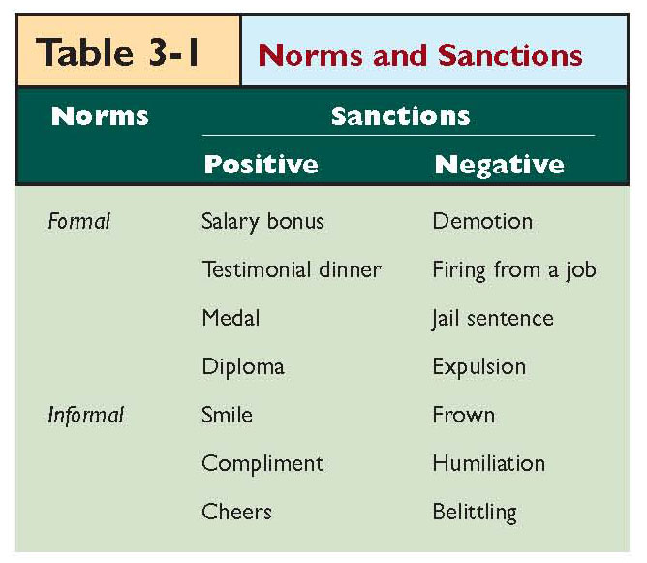
- Subcultures and Countercultures:
  - Subculture: A group of people within a single society who possess, in addition to the cultural practices that they share in common with members of the larger society, certain distinct cultural practices that set them apart
  - Not against a general culture, group of friends that you hang out with
  - Ex. Could be a sorority
  - ‘Argot’
  - Counterculture: A group of people within a single society who strongly oppose the cultural patterns widely accepted within that society.
    - Nazis, kkk

Cultural Universals:
- Cultural universals: customs that are shared across much of the world
- Incense- seen as taboo in other cultures
- People engage in sexual behavior
- Murdock – 70+ cultural universals
- Drinking ages
- Cultural diversity is much more prevalent:
  - Natural
  - Social

Cultural Diffusion
- Cultural diffusion: the transmission of cultural items & practices from one group/ society to another
- Via:
- Exploration
- Military encounters
- Media
- Tourism
- Migration
- Expanding Global Economy

Cultural Lag
- Cultural lag: Period of maladjustment when nonmaterial culture is still struggling to adapt to new material conditions
- Ie. privacy & censorship issues have not caught up with Internet use and technology.

Ethnocentrism
- Ethnocentrism: the belief that one’s own
- cultural view is superior or the only correct view
- Ie. Judging other cultures in terms of our own culture’s standards
- Eurocentrism: domination of European cultural patterns in Canada
- Cultural Imperialism: the influence or imposition of the material or nonmaterial elements of a culture on another culture or cultures
- Culture shock: Feeling disoriented, uncertain, out of place, or fearful when immersed in an unfamiliar culture

Cultural Relativism
- Cultural relativism: the practice of judging a culture by its own standards
- Opposite of ethnocentrism
- Requires understanding the values & norms of another society as we come into contact with members of it
- Includes having a holistic understanding of a culture

Cultural Materialism
- Cultural materialism: cultural beliefs are a rational adaptation to material conditions
- The idea that cultural beliefs are adaptations to material condition, raditional adaptations, based on whats available on society
- Ie. E.g. Hinduism and “Cow Love” (Harris, 1974)

Urban Legends
- Stories with four characteristics:
- Passed along by word of mouth
- People who repeat them believe them to be true
- Associated with some nearby geographical location
  - The idea that the setting is haunted.
- The stories are almost always completely false
- Video: how often urban legends have some sort of morality to them

Theories and Cultures:

Structural Functionalism:
- Shared norms = stability
- Norms & values necessary
  - Are slow to change
- Society depends on culture for order
- Emphasizes the way norms & values:
- Are institutionalized
  - Create stability in society
- - culture is ll the norms and values in society that we have
- -they are built to keep society running
- - they have certain norms and laws
- - society depends on culture for stability

- Conflict Theory:
  - Norms and values are set & used by the dominant social class to maintain social control and their power
  - Dominant ideology maintains & legitimizes the existing social structure
  - Ideology: a systematic view of the way the world ought to be
  - A system of beliefs, ideas, attitudes and opinions which are characteristic of a particular social group/ class
  - Used to justify their behaviour
- - norms and values, basically culture are created by the dominant class by the dominant class
- - having social control and power
- create laws that are in their favor
- - sustain the privillage that are in their power
- - maintain the power of the people who are in power
- - ideology: who ever has is it is dominant
  - they have a way they want the world to be

- Conflict Theory: Cultural Heroes
  - Why do we define certain people as heroic?
  - Ie. Mother Teresa, Martin Luther King Junior, etc
  - Hero-making” in the media functions to protect elite interests
  - Rosa parks

Symbolic Interactionist
- Mostly concerned with the symbolic expression of any culture
- Culture influences people & people influence culture
- People create, maintain & modify culture as they go about their daily interactions
- Norms & values create group identity & attract others
- Society = sum of interactions

- Feminism:
  - Analyze how dominant ideology contributes to control and marginalization of women
  - Ie. The Barbie Debate
  - Does ‘Barbie’ set impossible standards for girls to maintain?
  - How culture is defined on gender

- Barbie Phenomenon:
  - Reinforces:
    - Middle-class values
    - Patriarchal values
    - Elitist values
  - Why is Barbie especially appealing to young girls?

Some Conclusions:
- Conceptual Dangers in study of culture:
- Ethnocentrism
- Androcentrism: viewing something through a male perspective
- Gynocentricity: viewing something through a female perspective
- Barbie is a cultural invention

- Mother Cow
  - Author talking about the western view point
  - Of the hindu culture
  - India is a poverty country
  - Slaughtering cows
  - Ethonictrisum
    - Seen as ritaual and makes no scene why they wouldn’t eat the cows
    - Western judging another culture
    - Cultural materialism- adapting functions based on surroundings
    - Producing milk can make a nurtrianol difference
    - If we try to figure out/ understand their culture from our perspectives it makes more sense

- Nacirema
  - Group of people, who have a lot of body ritual
  - They bake their heads in a small oven- tanning every lunar cycle
  - Shrins and charm boxes
  - Parody- American culture
  - Seem ridiculous from an outside perspective

