Topic 3
Vesicular Transport
- Transport of large particles, macromolecules, and fluids across membrane in membranous sacs called vesicles
- Includes:
  - Endocytosis; transport INTO cell. These include phagocytosis, pinocytosis, receptor-mediated endocytosis
  - Exocytosis; transport out of cell
  - Transcytosis; transport into, across, and then out of cell
  - Vesicular trafficking; transport from one area or organelle in cell to another

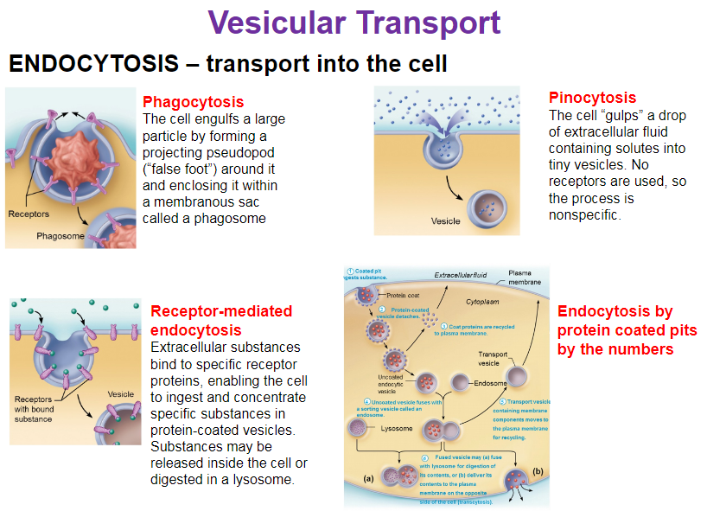
- Phagocyte – eater
- Macrophages, cells of the immune system.
- Pino, drinking (drinking pinot wine)
- Cell gulps fluid. No receptors are being used, therefore not specific. This is how liquids get internalized
- Receptor mediated is specific, receptor binds only to its specific lygome
- Protein coated pits, involution of the plasma membrane, coated with proteins on the cytoplasmic side

- 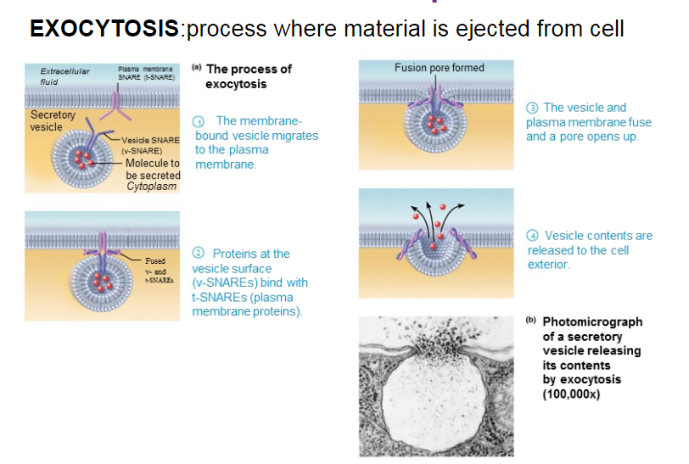

- Membrane bound vesicle migrates to plasma membrane
- Proteins at vesicle surface bind to plasma membrane proteins (v-snare – t-snare) (like lock and key model)
- The vesicle and plasma membrane fuse and a pore opens up
- Vesicle content are released to the cell exterior

Resting Membrane Potential
- Electrical potential energy produced by separation of oppositely charged particles aceoss plasma membrane in all cells
  - Difference in electrical charge between two points is referred to as voltage
  - Cells that have a charge are said to be polarized
- Voltage occurs only at membrane surface

K+ is Key Player In RMP
- RMP maintained by the Na+ -K+ pump
- Neuron and muscle cells upset this steady state RMP by intentionally opening gated Na+ and K+ channels

Neurons
- Structural units of nervous system
- Large, highly specialized cells that conduct impulses
- Impulses through movement of Na and K through channels is how communication occurs
- Worker bees of nervous system
- 3 regions
  - Receptive region (dendrites) (receiving messages) (body of neuron)
  - Conducting region (axon)
  - Secretory region (axon terminals)

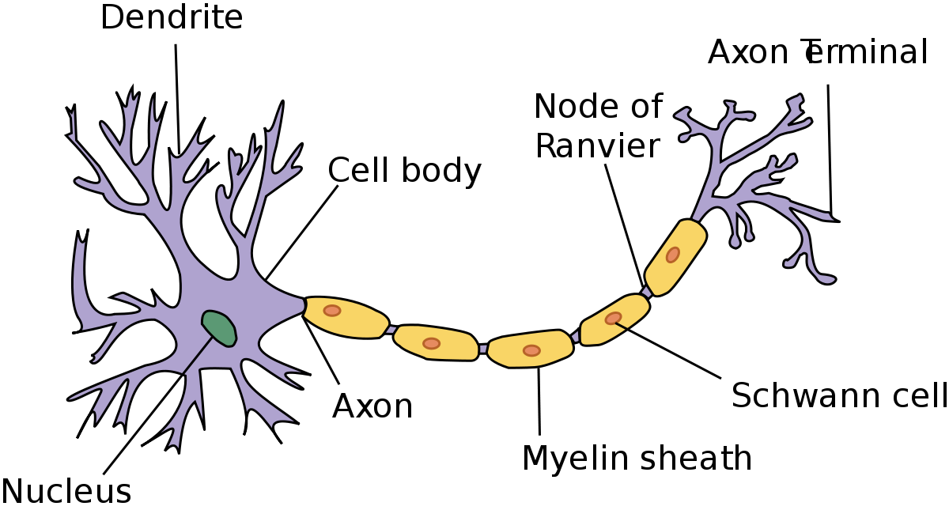

- Special characteristics
  - Extreme longevity (lasts a person’s lifetime)
  - Amitotic, with few exceptions
  - High metabolic rate, requires continuous supply of oxygen and glucose
  - All have cell body and one or more processes

Neuron Cell Body (Perikaryon or Soma)
- Large, spherical nucleus + granular cytoplasm
- Biosynthetic centre
- Synthesizes proteins, membranes, chemicals
- Extenvsive RER + ribosome clusters (Nissl bodies)
- Elaborate Golgy & lots of mitochondria
- Most neuronal cell bodies are located in CNS (central nervous system)
  - Nuclei: clusters of neuronal cell bodies in CNS
  - Ganglia: clusters of neuronal cell bodies in PNS

Neuron Processes
- Arm like processes that extend from cell body

Dendrites
- Receptive (input) region
- Convey incoming messages toward cell body
- Short, tapering, branched extensions; usually hundreds
- Enormous SA for reception from other neurons
- Conducts impulses toward cell body
- Short distance, graded potentials
- Neurons will synapse on all processes and sendinh messages constantly

Tracts:
- Bundles of neuronal processes in CNS

Nerves:
- Bundles of neuronal processes in PNS

Axon
- Conducting region
- Blue sections are myelieantion, kinda like insulation.
- Made by Schwann Cells in PNS
- In CNS its made by oligodendrites
- Arises from axon hillock, variable length (cann be less than 1m)
- Connection from cell body to rest of nerve
- Rate of conduction increases with axon diameter
- Neurotransmitters convey information from one axon to the next
- Axon has same organelles as cell body ,but NO Nissl bodies
- Axons quickly degenerate if cut
- A group of axons make nerves
- Anterograde vs retrograde
- Organelles to be degraded/recycled

Myelin Sheath
- Composed of myelin, a whitish, protein-lipid substance
- Functions include
  - Protect and electrically insulate axon
  - Increase speed of nerve impulse transmission

Resting Membrane Potentials
- Like all cells, neurons have a resting membrane potential
- Neurons are highly excitable
- Means that it has ability to reverse polarity of inside of the cell from outside
- All cells have resting membrane potential from moving potassium ions
- Inside is negative, outside is positive. An excitable cell, with a stimulus can reverse that
- Ex muscle & nerve cells
- -70 milivolt difference

Fundamentals of Electricity
- Voltage; electrical potential energy due to separation of oppositely charged particles
- Resting Membrane Potential; all cells polarized (normal state of being in terms of charge distribution)
- Current; flow of electrical charge between two points
- Resistance; hindrance to charge flow

Role of Membrane Ion Channels

- Large proteins serve as selective membrane ion channels
- K+ ion channel allows only K+ to pass through
- Two Types of Ion Channels
  - Leakage (nongated) – always open
  - Active gated – part of the protein changes shape to open/close the channel the 3 main types are

- Chemical Gated
  - Open only with binding of a specific chemical (hormone)
- Voltage
  - Open and closed in response to changes in membrane potential
- Mechanically Gated
  - Open and close in response to physical deformation of receptiors, as in sensory receptors

- Channels ion-specific: channels open P ions move in response to electrochemical gradients

Potential Generated in Resting Potential by:
- Differences in ionic composition of intracellular fluid and extracellular fluid vs intracellular
- Extracellular – sodium is dominant
- Intra – potassium
- A voltemeter can measure potential charge difference across membrane of resting cell

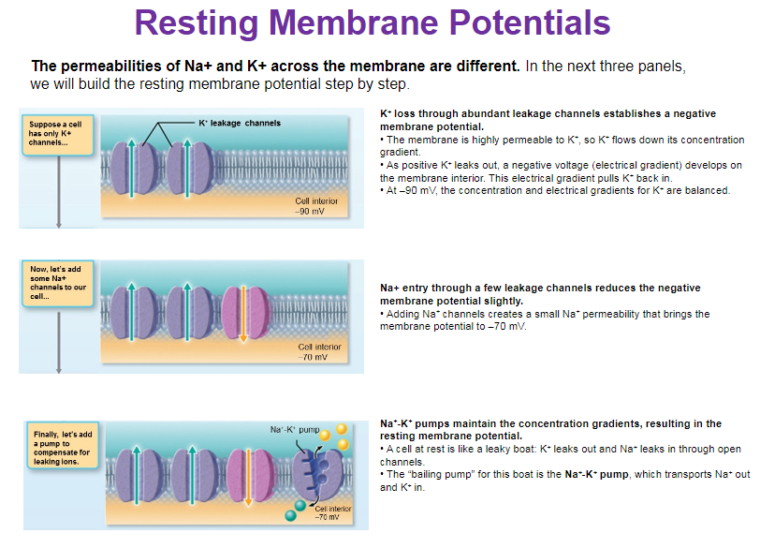
Changing the Resting Membrane Potential
- Changes produce two types of signals
  - Graded potentials incoming signals that act over short distances with variations in strength. Signals received on dendrites and cell bodies will result in graded potentials
  - Action potentials long distance communication, always have same strength
- Changes used as signals to receive, integrate, and send information
- Changes when theres a difference in permeability
- Depolarization
  - Decrease in membrane potential (towards – and above)
  - Inside of membrane becomes less negative than RMP
  - Increases probability of producing impulse
- Hyperpolarization
  - Increase in membrane potential (away from 0)
  - Inside of membrane becomes more negative than RMP
  - Decreases probability of producing impulse

Graded Potentials
- Short lived, localized changes in membrane potential
  - Triggered by stimulus that opens gated ion channels
  - Results in depolarization or sometimes hyperpolarization
  - The stronger the stimulus, the more voltage changes and the farther the current flows
- Decremental movement of ions on either side of membrane are propagates signal for short distances
- Named according to location and function
  - Receptor potential (generator potential): graded potential in receptors of sensory neurons
  - Polysynaptic potential: neuron graded potential

Action Potentials
- Principal way neurons send signals
- Means of long-distance neural communication
- Brief reversal of membrane potential with a change in voltage of around 100mV
- Do not decay in amplitude while distance traveled as graded potentials do
- Occur only in cells with excitable membranes (neurons and muscle cells); in neurons, only axons can generate action potentials
- In neurons, also referred to as a nerve impulse
- Voltage-gated channels on axons open and close in response to local currents (graded potentials)

Four Main Steps of Generation of an Action Potential
- Resting state: all gated Na+ and K+ channels closed
- Depolarization: Na+ channels open (transient increase in Na+ permeability)
- Repolarization:

