Topic 2: Cellular Physiology of Nerve & Muscle
Readings
- Plasma Membrane: Chapter 3: p63-81
- Neurons: Chapter 11: p394-396, p400-420
- Muscle: Chapter 9: p279-310

Plasma Membrane
- Aka cell membrane
- Barrier separating intracellular fluid from extracellular fluid (flexible but sturdy)
- Selectively permeable – controls what enters and what leaves the cell
- Allows communication; site of cell-cell interaction (main function when it comes to muscle and nerve physiology)
- Fluid mosaic model
  - Fluid – because it is not rigid
  - Mosaic because it has many parts and different proteins etc
  - Mainly phospholipids
  - The proteins differentiate the cell membranes from one another
  - Phospholipid bilayer
  - There are membrane proteins
  - Surface sugars
  - And membrane structures help to hold cells together

Membrane Lipids
- Phospholipids (75%)
  - Phosphate group and lipid group
  - Lipid is the non-polar, hydrophobic part (the tail)
  - The phosphate, (the head) is hydrophilic, is polar
  - This bilayer separates the inside of the cell from the outside
- Glycolipids (5%) (glycogen – sugar)
  - Lipids with sugar groups on outer membrane surface
- Cholesterol (20%)
  - Increases membrane stability
  - Dispersed inbetween the bilayer

Membrane Proteins
- Attached into the membrane
- Either integral proteins or peripheral proteins
- Make up about half the mass of the plasma membrane
- Pores, enzymes carriers are some specialized functions
- Other function is cell-to-cell communication
- Some float freely or some are attached
- Integral Protein
  - Firmly inserted in membrane
  - Most are transmembrane proteins (span membrane)
  - Have both hydrophobic and hydrophilic regions
  - Lipid tails – hydrophobic
  - Hydrophilic areas interact with water
  - Function as transport proteins (channels and carriers), enzymes or receptors
- Peripheral Protein
  - May be attached to cytoskeleton
  - Loosely attached to integral proteins
  - Include filaments on intracellular surface used for plasma mebrane support
  - Enzyme in second messenger system
  - Functions Motor proteins for shape change during cell division and muscle contraction
  - Cell-to-cell connections
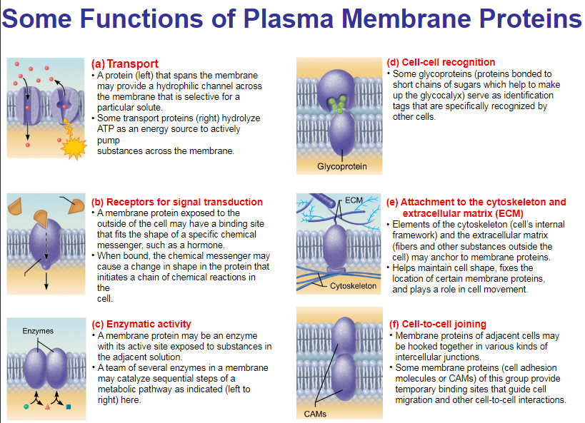
Membrane Carbohydrates and Glycocalyx
- Consists of sugars (carbohydrates) sticking out of cell surface
  - Some sugars are attached to lipids (glycolipids) and some to proteins (glycoproteins)
- Every cell type has different patterns of this glycocalyx (sugar coating)
  - Functions as specific biological markers for cell-to-cell recognition
  - Allows immune system to recognize self vs nonself
Question what about autoimmune diseases

Cell Junctions
- Tight junctions
  - Impermeable junctions
  - Form continuous seals around the cell
  - Prevent molecules from passing between cells
  - Epithelia
- Desmosomes
  - Formed when linker proteins (cadherins) of neighboring cells interlock like the teeth of a zipper
  - Allow “give” between cells, decrease the possibility of tearing under tension
  - Good question to answer what would happen if we didn’t have enough?
  - The whole structure would break/fall apart ^
- Gap Junctions
  - Transmembrane proteins (connexons) form tunnels that allow ions & small molecules to pass from cell to cell
  - Electrical signals to be passed quickly from one cell to next cell/cardiac and smooth muscle cells

Membrane Transport
- Substances must constantly move across the plasma membrane
  - Some molecules pass through easily, some do not
- Plasma membrane is selectively permeable allowing only certain molecules to cross
- Two essentials ways substances cross plasma membrane
  - Passive Transport (no energy required)
  - Active Transport (ATP required)

Passive Transport
- Three types
  - Simple diffusion
  - Facilitated diffusion
  - Osmosis
- They all involve diffusion
- Natural movement of molecules from areas of high concentration to low concertation
- Also referred to as moving down a concentration gradient
Diffusion
- Movement down a concentration gradient what’s a gradient
- Molecules in higher concentration areas collide more resulting in molecules being scattered to lower concentration areas
- Speed of diffusion is influenced by
  - Concentration the steeper the gradient, the faster diffusion occurs
  - Molecular Size smaller molecules diffuse faster
  - Temperature higher temps increase kinetic energy, resulting in faster diffusion
- Equilibrium is reached when there is no net movement of molecules in one direction only
- What determines whether a substance can cross the plasma membrane?
  - Lipid soluble and nonpolar substances (O₂, CO₂, fats, urea, alcohol)
  - Very small molecules that can pass through membrane or membrane channels

Simple Diffusion
- Nonpolar lipid soluble (hydrophobic) substances diffuse directly through phospholipid bilayer (ex O₂ & CO₂, steroid hormones, fatty acids)
- Small amounts of very small polar substances, such as water, can even pass
- Non-polar, lipid soluble can pass through, high concentration to low concentration

Facilitated Diffusion
- Larger or non-lipid soluble or polar molecules can cross membrane but only with assistance of carrier molecules
- Certain hydrophobic molecules are transported by either a carrier or a channel
  - Carrier mediated facilitated diffusion is when substances bind to protein carriers
  - Channel mediated diffusion are substances move through water filled channels

Carrier Mediated
- Lipid-insoluble molecules too large to pass through membrane pores/channels
- Carriers are transmembrane integral proteins
- Features of facilitated diffusion
  - Its specific, ex if it transports glucose, it ONLY transports glucose
  - Not ATP requiring
  - Limited by carrier saturation and the transport maximum is the fasted possible rate at which diffusion can occur
  - Movement down concertation gradient
  - Can be inhibited by certain substances
- The most well-known substance that is transported by carrier-mediated facilitated diffusion is Glucose

Channel Mediated
- Channels with aqueous-filled cores are formed by transmembrane proteins
- Channels transport molecules such as ions or water down their concentration gradient
  - Selective due to pore size, charges of amino acids that line channels
  - Water channels are called aquaporins
- Two types
  - Leakage channels are always open
  - Gated channels opening is controlled by chemical or electrical signals
  - Movement is always DOWN concentration gradient
  - Can be inhibited, can show saturation and are usually specific

Osmosis
- Special name for movement of solvent (not molecules), such as water, across a selectively permeable membrane
  - Through lipid bilayer (even though water is polar, it is so small that some molecules can sneak past nonpolar phospholipid tails)
  - Through specific water channels called aquaporins
- Flow occurs when water or other solvents concentration is different on the two sides of a mebrane

Osmolarity
- Measures the concentration of the total number of SOLUTE particles in solvent
- Solutions of different osmolarities separated byt a membrane permeable to all molecules
- Diffusion of solutes & osmosis of H2O occur across membrane equilibrium of solutes and H2O is reached
- Solutions of different osmolarities separated byt a membrane permeable only H2O
  - Only osmosis will occur until equilibrium is reached

Tonicity
- Ability of a solution to change the shape or tone of cells by altering the cells’ internal water volume
  - Isotonic solution has sam osmolarity as inside the cell, therefore volume remaisn unchanged
  - Hypertonic solution has higher osmolarity than inside cell, therefore water flows out of cell resulting in cell shrinking
    - Shrinking is referred to as crenation
  - Hypotonic solution has lower osmolarity than inside the cell, therefore water flows into cell, resulting in cell swelling
    - Can lead to cell bursting, referred to as lysing

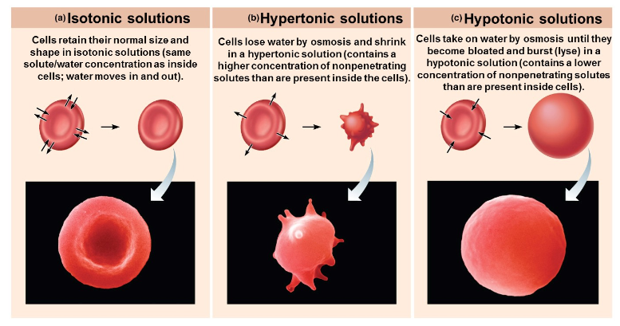

Active Transport
- Active transport or vesicular transport
- Like facilitated diffusion, they require carrier proteins (solute pumps); combines specifically & reversibly with substance
- Solute pumps move substances (amino acids, Na⁺, K⁺, Ca⁺) against concentration gradients
- ATP is required because substance is
  - Too large for channels, or
  - Not lipid soluble, or
  - Moving against a concentration gradient
- Many active transport systems are coupled systems
  - Antiporters transport one substance into cell while transporting a different substance out of cell
  - Symporters transport two different substances in the same direction

