COMM 210 MIDTERM

CHANDLER

- Economics of
- Scale: proportionate savings in costs gained by INCREASE lvl of production
Cost/unit ↓ = volume output ↑
- E.g.: High fixed cost of a national network (tap water) large investment in a huge network of water many households need water, meaning that the cost per unit decreases, while output increases!

- Scope: proportionate savings gained by producing two or more distinct goods when the cost of doing so is less than that of producing each separately.
- E.g.: A firms produces soft drinks uses marketing and distribution

BOTH economies require flow of materials to be constant to assure capacity utilization.
major objective: improve productivity.

- MAJOR claims:
- "Coordinated management and related diversification improve an organizations' long-term success by enhancing their ability to take advantage of economies of scale and scope."
- For firms to benefit from economies of scale and scope
- Innovation & Strategy (R&D) major investments ↑ size
- National/international marketing & distribution functions must be created distribution systems = national/international markets
- Teams of lower and middle management are needed

- Secondary claims:
- Once a firm loses the opportunity to be a FIRST MOVER, it is hard to regain competitive advantage
- FIRST MOVER: Competitive advantage earned when company is the first to enter a particular market or industry
- CHALLENGERS: Create distribution + sales to try and capture markets where first movers are already established
- Entrepreneurial companies that don’t make investments to grow organizational capabilities cannot achieve long-term success
- Growth through unrelated diversification is a poor corporate strategy (DQ hot food vs ice cream)
- Business ownership patterns decrease potential for long-term success (DQ partnership)

- CONCEPT LIST:
- Scale vs Scope
- Functional division, management hierarchy (low-lvl, middle-lvl, high-lvl), geographical expansions (national +international expansions globalization)
- First movers vs. Challengers
- R&D – innovations
- Related & Unrelated diversification
- Entrepreneurial enterprise (staying small)
- Separation of top and middle management (in the case of unrelated diversification) provides coordination + control
- Stock market pressure (due to ownership pattern)
- Short-term thinking (due to market pressure)

Geographical expansions based on economies of scales;
Expanded product markets (RELATED DIVERSIFICATION) based on economies of scope.

- OWNERSHIP PATTERN: Many different owners = AGAINST Chandler because then decisions are difficult to make, and people disagree
Diminished the likelihood of many firm’s long-term success
- UNRELATED DIVERSIFICATION: AGAINST idea of owning array of different products

- RELATED DIVERSIFICATION: FOR making products that are related

GREINER

- Organizations grow/expand throughout the years
- Major Claims:
- Organizations grow through a series of evolution and revolution phases that are a function of the AGE and SIZE of the organization
- Management practices that go well in one phase bring about a crisis in another

- Secondary Claims:
- Organizations should not skip phases
- Growth is NOT inevitable
- Top management whose style is no longer appropriate should remove themselves

- Concept list
- Age of the organization: the life span of the organization
- Size of the organization: company’s problems/solutions tend to change as the number of employees and sales volume increase
- Stages of evolution: period of prolonged growth
- Stages of revolution: time of crisis and turmoil between periods of evolution
- Growth rate of industry: speed rate at which industry goes through stages related to the market environment of the industry
- Management style
- Organizational structure
- Five phases of organizational growth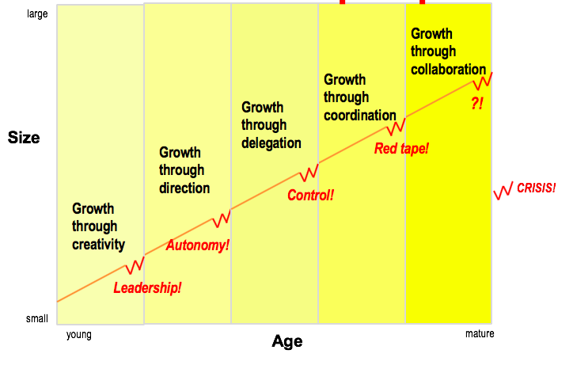

- PHASE 1: CREATIVITY
- Entrepreneurial (externally invested – interest in new clients)/small
- Informal communication
- Low profits/long hours/modest salaries/promise of ownership benefits
- Reactive to customers
- Emphasis on creating product & market
- Disdain on managerial activities
- Decisions/motivations based on customers
- Growing too fast + ↑ complex
- Flat organizational structure
- ISSUES: Larger productions requires knowledge about efficiencies of manufacturing, standardization, employee & management motivation, more capital and unwanted management responsibilities.
- CRISIS OF LEADERSHIP: who will lead the company out of confusion and solve the managerial problems confronting it
coordination & internal control cannot longer be carried by 1 person
- SOLUTION: Strong manager needed + improved structure

- PHASE 2: DIRECTION – period of sustained growth b/c directive leadership
- Functional organizational structure introduced to separate manufacturing from marketing activities + functional managers
jobs assignments ↑ specialized
- Incentives, budgets (bonuses), work standards are adopted
- Formal/impersonal communication + hierarchy + position growth
- Top-level managers must delegate more responsibilities to lower-level management
- New management assumes most of responsibility; lower-level supervisors are treated like functional specialists
- ISSUES: too much control, employees feel torn between following procedure and taking initiative, employees have more direct knowledge than management
- CRISIS OF AUTONOMY: employee want more responsibility and ability to take initiative
middle management needs more autonomy
- SOLUTION: delegating responsibility to lower-level managers

- PHASE 3: DELEGATION
- Need to decentralize, give employees more responsibility, top management steps back
- Top management monitors
- Top managers handle exceptional reports only
- Managers in decentralized organizations with greater authority & incentives are able to penetrate larger markets/respond faster to customers/develop new products
- Management concentrates on acquiring outside enterprises
- Communication from top infrequent & by phone/correspondence
- Bonuses for motivation = achieving growth through resource allocation +profit
- ISSUES: top executives loss of control, information isn’t received over highly diversified field operations
- CRISIS OF CONTROL: management is trying to regain control, need new techniques some might attempt return to centralize management
- SOLUTION: Special coordination techniques

- PHASE 4: COORDINATION
- Use of formal systems to achieve better coordination + top level executives taking responsibility for new systems
- Decentralized units become product groups
- Capital expenditures carefully weighted + parceled out across organization
- Certain techniques centralized/decentralized
- Managed through formal programs & rigid systems
- Formal planning – procedures established + reviewed
- Control & review
- Centralize certain function
- Use profit-sharing = achieve growth through resource allocation
- ISSUES: lack of confidence grows between staff, all controls become a burden & very time consuming
- RED TAPE CRISIS: producers take over problem solving, becomes too bureaucratic (overly concerned with procedure at expense of efficiency or common sense), no innovation
- E.g.: each department has its own agenda, departments do not cooperate to help each other to get the job done
- Top management = misinformed and insulated from what is happening on front-line
- Quantity over quality
- Employees/ customers = treated like numbers
- SOLUTIONS: collaboration to overcome red tape crisis

- PHASE 5: COLLABORATION
- Focus solving problems quickly through team action
Teams across functions
Interdisciplinary teams
- Strong interpersonal collaboration
- Spontaneous action through teams
- Self-discipline
- Formal control simplified & combined into single multipurpose systems
- Flexible, behaviour approach to management
- Matrix structure (for senior management) to assemble right team for appropriate problem
- ISSUES: organizations begin to look outside for partner/opportunities, to sell itself to a larger company
- SOLUTIONS: ?
BURNOUT

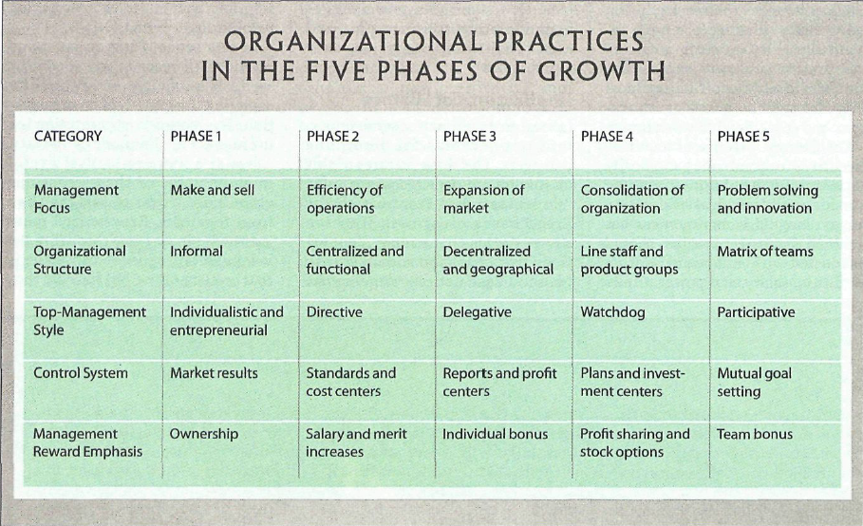

- Advantages of large, bureaucratic organizations
- Hierarchical authority: promises control & responsibility
- Specialization of sub-units: promises accountability, control & expertise
- Management by rules: promises control & consistency
- Being impersonal: promises objectivity, consistency & equality
BARNEY

- SWOT analysis (NOT BARLEY’S FRAMEWORK)
- Traditional tool for strategic environment analysis
- Two components: internal & external environment analysis:
- Internal: internal resources and capabilities of the firm (strengths & weaknesses)
- External: business and social trends, industry conditions and competitive environment (opportunities & threats)
- Barney provides a tool to assess company’s INTERNATL resources capabilities
- Major claims STRENGHTS & WEAKNESSES
- Firm will have a sustained competitive advantage if its resources/capabilities are VRIO (valuable, rare, inimitable and organized) in a way that allows it to achieve potential opportunities
- A firm will be successful if it has resources with the right attributes/characteristics
- The most careful/complete analysis of firm’s competitive environment cannot (by itself) define their success
- Strategists also need to analyze the competitive implications of firm’s internal strengths/weaknesses
- Firm’s resources/capabilities: FINANCIAL, PHYSICAL, HUMAN, ORGANIZATIONAL assets used to develop & deliver products/services to consumers
- Financial: debt, equity, retained earnings, etc.
- Physical: machines, manufacturing facilities, buildings, etc.
- Human: experience, knowledge, judgement, wisom, etc.
- Organizational: history, relationships, trust, culture, formal reporting structure, patents, etc.
- FOUR important questions about resources/ capabilities (VRIO)
- Question of VALUE: do they enable a firm to achieve an opportunity and/or neutralize a threat?
- Question of RARENESS: how many competing firms already possess them?
- Question of IMITABILITY: do firms without a resource/capability face a cost disadvantage in obtaining it to firms that already possess it?
- Importance of HISTORY: valuable/rare resources acquired through unique historical circumstances can be considered sustainable, competitive advantages
- Importance of NUMEROUS SMALL DECISIONS: firm’s competitive advantage depends on several small decisions through which resources/capabilities are developed/achieved.
- Importance of SOCIALLY COMPLEX RESOURCES: reputation, trust, friendship, teamwork, culture; while not patentable, they are difficult to imitate
- Question of ORGANIZATION: is a firm organized to achieve the full competitive potential of its resources/capabilities

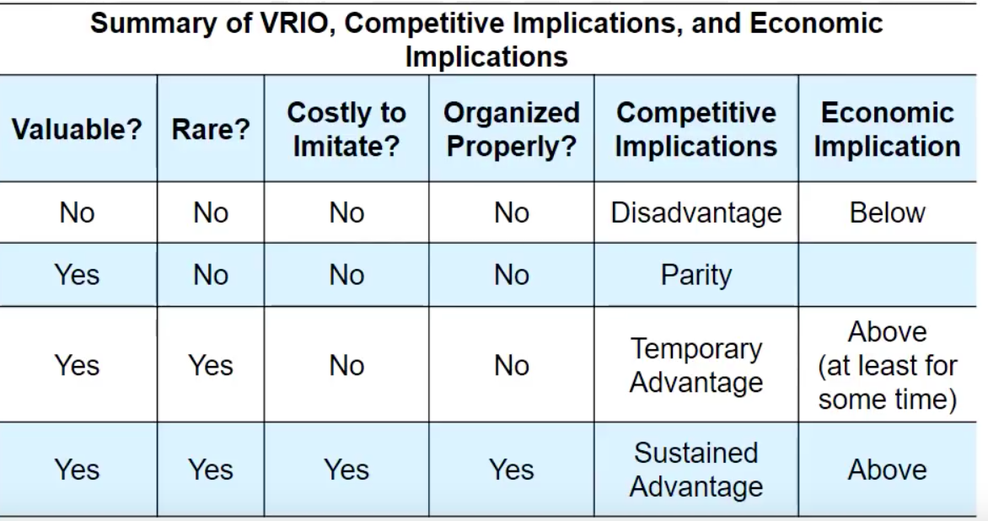

COLLINS & PORRAS
- Terminal Values signify the objectives of the life of a person – the ultimate things the person wants to achieve through his or her behaviour (the destination he wants to reach in life)
- Instrumental Values indicate the methods an individual would like to adopt for achieving his life’s aim (the path he would like to take to reach his destination).
- Values of managers:
- People in the same occupation tend to hold similar values
- Corporate managers say:
- Self-respect and security are their top-ranked terminal values
- Truthfulness and dependability are their top-ranked instrumental values
- VISION: provides guidance about what CORE to preserve + what FUTURE to stimulate towards progress
- 1.CORE IDEOLOGY:
- Enduring character of the organization; consistent identity that transcends product/market life cycles, technological breakthrough, management fads & individual leaders
- Glue that holds the business together
- CORE VALUES
- 3-5 values (max)
- Essential/enduring tenets of belief
- Require no external justification
- Small set of timeless guiding principles
- Beliefs about what is important
- “Code of Ethics”/ “How we do business”
- Does it depend on external conditions? Would you maintain this value in the future when there are different external conditions?
- CORE PURPOSE
- 100-year test
- Organization’s reason for being or “raison d’etre”
- The idealistic motivations for doing a company’s work
- Can never be fulfilled
- Captures the soul of the organization – “WHY do we exist?”
- “why do we do what we do?”
- If an investor was to buy the company and give all employees compensation and the company says no
- 2.ENVISIONED FUTURE (constantly changing, that is flexible)
- Creative process
- What we aspire to become
- Audacious/vivid goals that stimulate progress
- BHAGs : Big, Hairy, Audacious Goals (which is a BIG goal)
- 10—30 years (more flexible than core purpose)
- Powerful way to stimulate progress
- Clear/compelling: a unifying focal point of efforts
- Promotes team spirit
- Takes a little or no explanation
- Not a sure bet…!
- Vivid description
- What the organization would look like upon achieving that BHAG goal
- Something people can carry around in their mind that transmit passion and conviction that will help the employees envision achieving that big goal help motivation

- Goal achievement
- Vivid description
- Beware of the “we’ve arrived” syndrome: what happens when u achieve the big goal? How do you motivate people afterwards? Then what? Falling apart of the team?
- What it would feel like to achieve BHAG
- Picture people can carry around
- Passion, emotion, conviction: essential

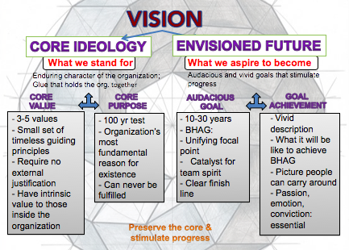

- “Discovering” core ideology
- You do not create/set core ideology
- Description of what actually is, not what we wish existed
- Meaningful/inspirational only to people within organization
- Find people who are inclined to share organization’s core values/purpose
- More than creating a “perfect statement”
- Not marketing or branding its independent of external trend

HERZBERG

- How to motivate employees CONCEPTS:
- Hygiene factors
- Motivators
- Dissatisfaction/satisfaction
- Job enrichment/ vertical job loading
- Job enlargement/ horizontal job loading
- Negative KTA
- Positive KTA
- Principles of vertical job loading:
- Remove some control while retaining accountability
- Increase accountability of individuals for own work
- Give person a complete natural unit of work
- Grant additional authority; job freedom
- Make periodic reports directly available to workers themselves rather than supervisors
- Introduce new, more difficult tasks
- Assign workers to specialized tasks, enabling them to become experts

- Some steps of job enrichment:
- Select jobs + approach them without the conviction they can be change
- Brainstorm changes
- Screen to remove hygiene suggestions + horizontal job loading
- Avoid direct participation by the employees whose jobs are to be enriched
- Be prepared for an initial drop in performance
- Expect first-line supervisors to suffer from anxiety
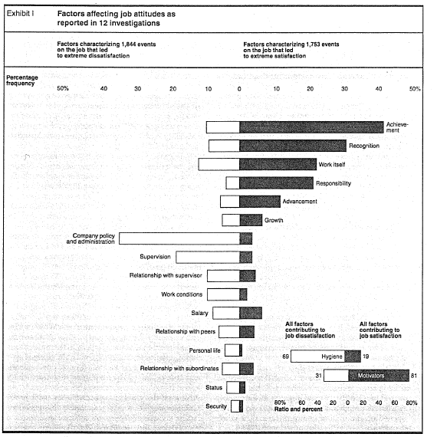

MINTZBERG

- Manager’s roles
- MYTHS: managers plan, organize, coordinate and control
- REALITIES:
- Interpersonal roles:
- Figurehead – nominal leader without real power – performs ceremonial duties
- Leader: responsible for work of people in their unit
- Liaison (cooperation/relationships): contacts people outside the vertical chain of command
- Informational roles:
- Monitor: scanning environment for information
- Disseminator: passes privileged information to subordinates
- Spokesperson: passes information to people outside of the unit
- Decisional roles:
- Entrepreneur: seeks to improve unit
- Disturbance-handler: responds to conflicts
- Resource-allocator: decides who will get that resource
- Negotiator: deal-making

FRENCH & RAVEN
- “POWER” – it is a relationship, NOT an attribute
- Types of powers:
- Reward: based on one’s perception that the other has the ability to mediate (bring out) rewards for him
- Coercive: based on one’s perception that the other has the ability to mediate punishments on him
- Legitimate: based on one’s perception that the other has a legitimate right to prescribe a behavior to him
- Referent: based on one’s identification with the other
- Expert: based on one’s perception that the other has some special knowledge/expertise

KAPLAN & NORTON
- Balanced scorecard
- Performance measurement system/tool
- What you measure is what you get
- Traditional financial performance measures worked well for the industrial era, but the “bottom line” isn’t enough
- FOUR perspectives for balanced scorecard:
- Customer perspective: what matters most to customers
- Internal business perspective: how we can meet customer expectations
- Innovation and learning perspectives: how can we make continual improvements
- Financial perspective: how can we ensure profitability for shareholders

HANDY
- S-Shaped curve:
- Empires, corporations, product life cycles, love and relationships, personal career, etc.
- The 2 curves: when should the 2nd curve begin?
- Who should lead the 2nd curve?
- Turmoil: time of great confusion!
- “Discipline” of the 2nd curve
- Always assume you ARE near the peak of the 1st curve (POINT A) and start preparing for the 2nd curve. Even if you are on the 1st curve for much longer, preparing for the downturn offers alternatives to spur on the start of the 2nd curve.
- Keeping the 2 curves going should be a HABIT
- Benefits of the discipline of devising the 2nd curve: always prepared for the downturn
- Traditional four-stage discovery:
- Questions: What if X Y Z happens?
- Ideas: come up with alternatives
- Test + Review: possible scenarios
- Essential: let go of past
- “Curvilinear logic”
- Conviction: the world – and everything in it – is a sigmoid curve
nothing lasts forever, it means starting life over again
- Paradox of success: “What got you where you are won’t keep you where you are”
- Starting life again harder as you get older
- Entrust curvilinear logic to the next generation
- Be careful not to abandon 1st curve too soon
- Fertilizing the 2nd curve
- Seniors: permission & encouragement
- New ideas can co-exist with old
- The paradox of time
- By the time you know where you have to go, it’s too late to go there
- If you keep going the way you are, you will miss the road to the future
- Easy to explain things looking backwards we think we can predict them going forward

TANNEN-BAUM & SCMIDT
- How to lead:
- Forces in a manager:
- Value system
- Confidence in subordinates
- Own leadership inclinations
- Feelings of security
- Forces in the subordinate:
- High need for independence
- Readiness to assume responsibility
- High tolerance for ambiguity
- Identify with the organizations problems and goals
- Have knowledge and experience
- Learned to be a part of decision making
- Forces in the situation:
- Type of organization
- Group effectiveness
- Nature of the problem
- Time pressures
- Long-run strategy
- Objectives to be obtained

DYLE BOOK:

CHAPTER 2: CLAIMS

- Claims: major conclusion author is trying to persuade you to accept
- Implicitly stated: not directly expressed
- Explicitly stated: clear and in detail
- Cue words: “therefore”, “thus”, “in summary”, “I believe that”, “clearly”, “in short” …
- Presenting claims: concept lists/maps
- Concept maps: simple boxes-and-arrows figured that highlight main issues and show relationship
- Unproblematic claim
- Consistent with our own experience/observations
- Facts independent of interpretation
- Strongly supported general claims (common sense)
- Technical/mathematical claims
- Contestable claim
- Not commonly accepted knowledge
- Often introduce new idea awaken curiosity
- Sometimes presented as if it were a fact
- Cannot stand on their own

**Note: a once uncontestable claim can be re-examined years later **
- Critical thinking: analyzing validity of arguments presented in text
- Argument = claim + evidence
- Identify author’s claim
- Describe and evaluate supporting evidence

CHAPTER 3: EVIDENCE
- Evidence: any statement that is a response to the question “why is this true?”
- Criteria (SPAARC)
- Sufficiency:
- How much evidence
- Importance of claim
- Potential damage
- Fallacy of hasty generalization
- Precision: creates the impression of accuracy
- Creates the impression of accuracy
- Comes from numbers and quotes
- 18.4% is better than “quite well” or “almost 20%”
- Ambiguous words shouldn’t be overused
- Numbers & direct quotes should be provided
- Beware of over-precision
- Authority:
- Training, credentials, experience of others
- Classics or current writing
- Context-dependent
- Fallacy of false appeal to authority
- Fallacy of argumentation ad populum (bandwagon)
- Accuracy: difficult to judge without an independent source of information
- 2 ways to process
        - Do your own research to verify accuracy
        - Use proxies to evaluate accuracy: trivial errors, grammar/spelling mistakes, inaccurate quotes or lack of precision
- Representativeness: fallacy of hasty generalization
- Variety in the sources of evidence should match the variety in the population
- Fallacy of hasty generalization
- Clarity of expression (quotations, etc.)
- Quantitative data should be interpreted
- Direct quotations should also be interpreted
- Other objections: issues of relevance related to underlying assumptions

CHAPTER 4: UNDERLYING ASSUMPTIONS
- Underlying assumptions: logical link that fills the gap between the evidence and the claim
- Implicit/explicit principles that form the basis of our beliefs and reasoning
- Tell us whether evidence provided for claim is relevant or not
- E.g.:
- Claim: Canada should be boycotted
- Evidence: Canada goose kills coyotes to make fur-lined hoods
- Underlying assumption (gap): wearing fur is wrong
- Reality assumption: our beliefs about reality: about the way things are
- Value assumption: our ideals, standards or right/wrong, way things “ought to be”

CHAPTER 5: PERSUASION
- Techniques of persuasion
- Anticipate objections based on:
- Negative evidence
- Alternative causes
- Conflicting assumptions
- Counter-argue objections
- Limit claims you cannot rebut
- Acknowledging limitations makes your writing more persuasive
- Limit generalizations
- Level of probability less than 100%
- Re-defining terms
- Rhetoric use of language to convince
- Detail (evidence and assumptions)
- Tone (clarity vs. narrative)
- Vividness (being concrete draws attention)

CHAPTER 6: WRITING A PERSUASIVE ESSAY
- Outline your (contestable) claim and sub-claims
- Ask yourself: “why do I think this claim is true?” List reasons
- Logic of your argument must be clear
- Arrange evidence
- 2-3 pieces of evidence for each sub-claim (sufficient, accurate)
- Views of experts, quotes from interviews (authoritative; precise)
- Examples from your own experience, diverse, variety of others (representative)
- Detailed description/background information (precise)
- Give each section of your essay a meaningful subtitle (clarity)
- Ask yourself: any negative evidence? Anticipate reader objections? Need more evidence?
- Write your 1st draft
- Not perfect
- Don’t plagiarize
- Revise
- Team contribution have to be integrated similarly
- Introductory sentences engage reader’s interest/ attention
- Concluding sentences strong, summarizes
- Visual aids charts, photos, clipart, concept maps
- Full list of references

