Photosynthetic Animal: Elysia
- Kleptoplasty
  - Stolen plastid (chloroplast)
  - Ex. Elysia Chloriotica (sea slug)
    - Phylum: Mollusca (invertebrate but has bodily systems)
    - Retains chloroplasts (functional) from digested specific algae – green in colour (no chloroplasts when young – brown in colour)
- Heterotrophy
  - Cannot fix carbon
  - Get energy by breaking down already reduced organic forms of carbon (sugars, carbohydrates, proteins)
  - Ex. Animals
- Autotrophy
  - Get energy by fixing inorganic forms of carbon (carbon dioxide)
  - Ex. Plants
  - Ex. Photoautotroph, chemoautotroph

Electron Micrographs Of Chloroplasts
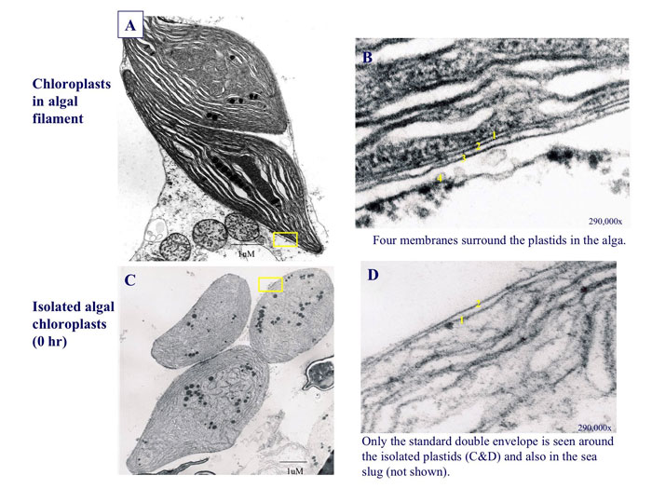

Only retains two membranes out of four

Vaucheria Litorea
- Filamentous Yellow-Green Algae (Xanthophyceae)
- Retaining chloroplasts relationship with Elysia

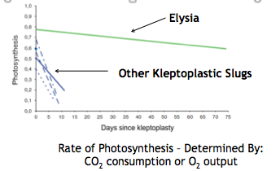
Photosynthesis In Elysia
- Photosynthetic function ceases as time goes on in isolated chloroplasts
- Elysia’s chloroplasts retain function

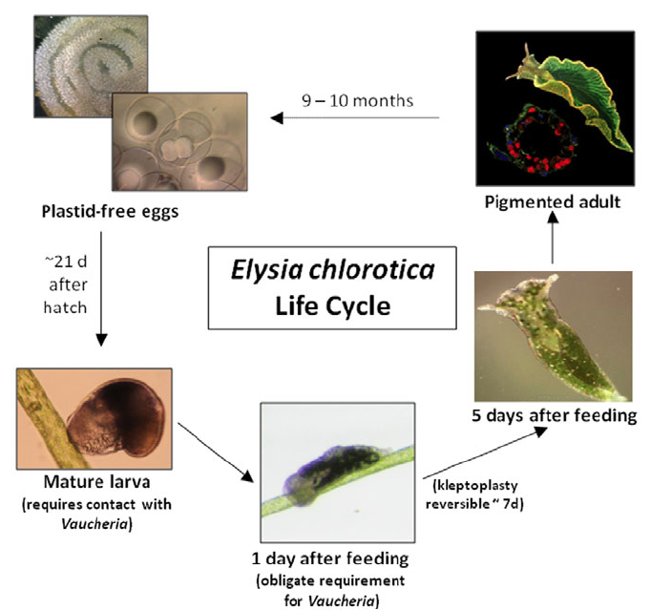
Elysia Life Cycle
- Sexual organism (hermaphrodites but need partners)
- To complete life cycle it HAS to interact with Vaucheria (obligate requirement)
- Cannot live heterotrophically

Elysia Is Infected By Virus (Crystallized)
- All adults die at the same time after laying eggs in the spring
  - Filled with retroviruses
  - Always expressed at same time
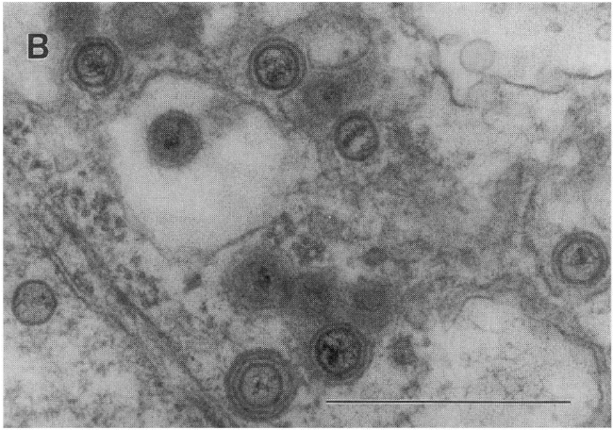
    - (Reverse transcribed and then transcribed)
- Endogenous (inherited viruses)
  - Trapped within host cannot infect new cells
  - Keep infecting the same host


