LECTURE 1: GENERAL PRINCIPLES OF MICROBIOLOGY
Micro = small
Bio = life
Logy = study (of) or science
Immunology = study of our protection from foreign macromolecules or invading organisms and our responses to them
Different classes of organisms
- Viruses / chlamydia which is more complex than viruses (grow only in living cells)
- Mycoplasma (grow on non-living media)
- Bacteria (no separate nucleus; unicellular)
- Parasites
- Small (microscopic)
  - 1-2 microns (1mm=1000 microns)
  - Address them by their proper names
    - i.e. not “germs”, “bugs”
What are they made of?
Viruses
- Nucleic acid (either RNA or DNA… never both)
- Surrounded by protein shell (a capsid)
- Attach, inject nucleic acid (penetration), hijack the host cell by entering and diverting synthetic processes inside cells to make more viruses (for their own replication), package, get out while going is good
Bacteria (prokaryotes)
- They have a rigid cell wall to keep things in place
- Their genetic material is organized into a circular chromosome
- No nucleus (nucleoid)
- Both DNA and RNA
- Binary fission
- Some bacteria do not have a rigid cells wall and are more fragile (i.e. Mycoplasmas which are similar to bacteria)
Eukaryotes (nucleus)
- All unicellular and multicellular animals and plants
- The genetic material is organized into a nucleus
Are all bacteria bad? No, some bacteria are helpful in everyday life such as:
- Biotechnology, spoilage of foods (some bacteria can outcompete the spoilers), bioremediation (break down toxins making them less toxic), functional foods, etc...
Can we live without bacteria? No some bacteria can protect us from harmful substances
“Normal” flora (the good guys) - IMPORTANT
- In general normal flora is harmless with one condition; they have to stay where they belong - you can’t pass your bacteria onto someone else because it may be harmful to them
- Bacterial populations can be considered as being resident or transient
  - Resident (your own bacteria - long term bacteria eg. when washing hands dead skin comes off which exposes the resident flora containing much more bacteria)
  - Transient (found in a specific location, often as a result of displacement of resident flora, human behaviour, or injury - short term bacteria e.g. bacteria of things you touch)
  - Takes much longer to get rid of resident bacteria - important to wash hands for a long time to get rid of resident bacteria when performing surgery
- Examples of resident and transient:
  - GI-tract: colon is inhabited by anaerobes and coliforms
  - Skin: mostly coagulase negative staphylococci
- Where should there be NO bacteria? Heart, blood
What can they do for us?
- Protection from invasive (bad) bacteria (competitive exclusion - constantly fighting between what's in and what's trying to come in)
- The normal flora of the gut participates in the metabolism of the host (certain microorganisms synthesize vitamin K), immune stimulation
What protects us from the bad guys?
Mechanical barriers:
- Skin
  - Barrier to the invasion of deep tissues by bacteria, many organisms on the surface of the skin that normally do not gain access to deeper subcutaneous tissues, however a break in the integrity of the skin barrier allows them to gain access to deeper layers
  - Low temperature that is suboptimal for some bacteria
  - Acid pH: sebaceous secretions and sweat contain unsaturated fatty acids (bactericidal)
- Saliva, mucous, tears, hairs, etc.
Other helpers include:
- Antibodies
  - People may naturally form antibodies against bacteria
  - Antibodies may function as an opsonin when certain bacterial organisms surround themselves with a polysaccharide capsule
  - The antibody binds to (and can sometimes) alter the surface of the capsule making the bacteria more susceptible to phagocytosis and permits the phagocyte to take up the capsulated organism this is referred to as opsonization
  - Antibodies may also kill organisms directly
- Complement
  - Plasma proteins that work together to resist bacterial infection and enhance the immune response
- Immune cells
  - T-cells, NK cells, macrophages - ingest bacteria killing them and the defence against invasion by bacteria
- Immune system
→ Particular infecting organisms are divided into two major systems (both are specific) :
  - Cell mediated immunity: cells trained to attack specific invading organisms
    - Exposure to an antigen induces production of “trained” cells active against that antigen or any organism that carries it. The main different is that soluble antibodies are NOT involved
    - CMI is active in most microbial infections and is essential in the defense against intracellular organisms (including viruses), as well as parasites, tumor cells and foreign cells (e.g. transplants)
  - Humoral immunity: specific circulating antibodies in body fluids
    - Is based on circulating antibodies which are modified serum globulins (proteins) that react when coming in contact with particular chemical components of previously encountered invading organisms. In order to make antibodies which are produced by B-lymphocytes, they need antigen-presenting cells
How do the bad guys get in?
- Adherence
  - The first requirement for bacterial invasion to occur is that the bacteria need to adhere to the host, and they have developed specific mechanism to achieve this. Ligands (usually small molecules) are present on the surface of bacteria, able bind to specific receptors on the cells surface
- Toxin production (destroys some of our defenses)
- Opportunism: microorganism takes advantage of certain opportunities to cause disease
- Compromised host (how does this happen?)Some patients may be deficient in some of the antimicrobial defenses the body has, these deficiencies may be due to a disease process or to medical/surgical procedures including the administration of medication (e.g. administration of immunosuppressive drugs to transplant patients may suppress their immune system to the point where it is no longer effective as a defence
- Bacteria may become distributed around the body from a single focus of infection through the bloodstream (Bacteraemia vs. septicaemia, amia = blood)
  - Bacteremia is the simple presence of bacteria in the blood (can enter slowly)
  - Septicemia is the presence and multiplication of bacteria in the blood.
Microbial disease (infectious diseases)
- INFECTION: penetration of a microorganism, or a part of it capable of multiplication, into a host organism, producing apparent or inapparent changes.
- Infectious diseases are the result of the interaction between microorganisms - majority are harmless (adhering, penetrating and multiplying) and the host (us) is continuous battle
  - They need to enter-live-multiply
- In order to enter, they need to colonize (establish and multiply) in/on body of a microorganism
  - Do not produce any apparent or inapparent change
- Clinical infection (microbial disease) occurs when changes result in functional damage to the infected host
- Contamination = deposition of microorganisms without multiplication (e.g. contamination of drinking water with sewage)
- Clinical disease = easy to recognize (disease)
- Sub-clinical infection = hard to diagnose (no symptoms) - inapparent/asymptomatic
How do we measure how dangerous a bacteria/virus/parasite is?
Microorganisms capable of producing clinical or subclinical infection are classified based on terms such as:
- Pathogenicity = the ability of a microorganism to produce disease
- Virulence = relative capacity of a microorganism to cause damage (i.e. the degree of pathogenicity) - how sick you get
- Opportunistic = microorganism that do not normally cause disease in healthy humans but can do so when defense mechanism(s) have been breached or compromised (e.g. a burn)
Pathogenesis of infectious diseases
- A pathogenic microorganism enters your body...two things happen:
- Microorganism (invader) tries to multiply/invade and cause disease (2º event)
- Host tries to prevent #1
- Whether the invader wins or not is dependent on several factors
Transmision: the transfer of an effective challenge amount from a source to a host
- Routes of entry: Inhalation, igestion, break in protective barrier, direct deposit
- Pathogenicity: the capacity to inflict damage as a result if invasiveness
  - Ability to overcome host defenses and multiply
- Invasiveness: Microorganisms overcome their host’s immediate defence mechanisms through the ability to:
  - Adhere and persist on body surfaces
  - Protect themselves against bactericidal substances present in body fluids
  - Avoidance of immune system (avoid ingestion and destruction by phagocytes)
- Toxigenicity (ability to make toxins)
How does a pathogen adhere to us?
- A bacteria needs to adhere, evade the defence mechanisms and invade the host
- Tools used to achieve these huge objectives:
  - Surface structure (pili, fimbriae)
    - Adhere to specific receptors present on the body cell surfaces
  - Capsules (protect)
    - Usually polysaccharides protect the microorganisms against leukocytes
  - Enzymes
    - Although not toxic, may contribute towards the virulence of the pathogen that elaborates them. Examples include:
- Coagulase: enzymes accelerating the clotting of plasma, the clot formed around the focus of infection constitutes a barrier against leukocytes and body fluids
- Hyaluronidase: an enzyme which hydrolyses the hyaluronic acid; also known to help bacteria by liquefying the viscous polymer and facilitating the spread of fluids carrying bacteria
Toxigenicity - production of toxins
- Toxins are substances (usually proteins) secreted by bacteria with the hope to cause damage host tissues or upset systems vital to the host (bacteria is actively modifying giving off toxic waste in your body)
- Two classes of toxins:
  - Exotoxins
    - Proteins that are synthesized by bacteria then excreted by living bacterial cells
    - They have specific affinities for host systems
    - Thermolabile - sensitive to heat
    - Potent (active in very small concentrations - some can even kill with 0.0001 mg of a dose)
    - The host defence against exotoxins is antibody
  - Endotoxins
    - Toxic substances associated structurally with the bacterial cell and liberated ONLY when the cell wall disintegrates
    - Less specific and less potent than exotoxins
    - May produce marked clinical effects such as fever, malaise, shock (vasomotor disturbances)
    - Thermostable - resistant to heat

LECTURE 2: IMMUNITY, INFECTION, AND IMMUNIZATION
What is Immunity?
- Immunity: the protection against infectious disease conferred either by immune response generated by immunization or previous infection or by other nonimmunologic factors...a.k.a. body’s ability to resist infection
- 2 types of immunity:
  - Non-specific (innate)
  - Specific (adaptive, acquired)
Innate Immunity
- Skin
  - What characteristics of the skin make it an effective mechanical barrier?
    - Keeps everything out including good and bad bacteria (non-specific)
- Mucous membranes (mechanical)
  - Cilia in respiratory tract
  - Lysosomes, pH
- Iron-binding proteins
  - Some bacteria require iron for growth
  - Transferrin, lactoferrin
- Phagocytosis
  - PMNs, monocytes and macrophages
  - Look for living things that should not be there and get rid of them as quickly as possible (non-specific). Still very effective and important.
- Complement (set of reactions that nonspecifically remove organisms that shouldn’t be there)
Specific Immunity
- Humoral and Cell-Mediated (CMI)
- What is the difference between innate immunity and adaptive immunity?
  - Innate: protects against ANY invader, does not discriminate
  - Adaptive: directed against one type of invader, dependant on past exposure (targeted specifically for one pathogen)
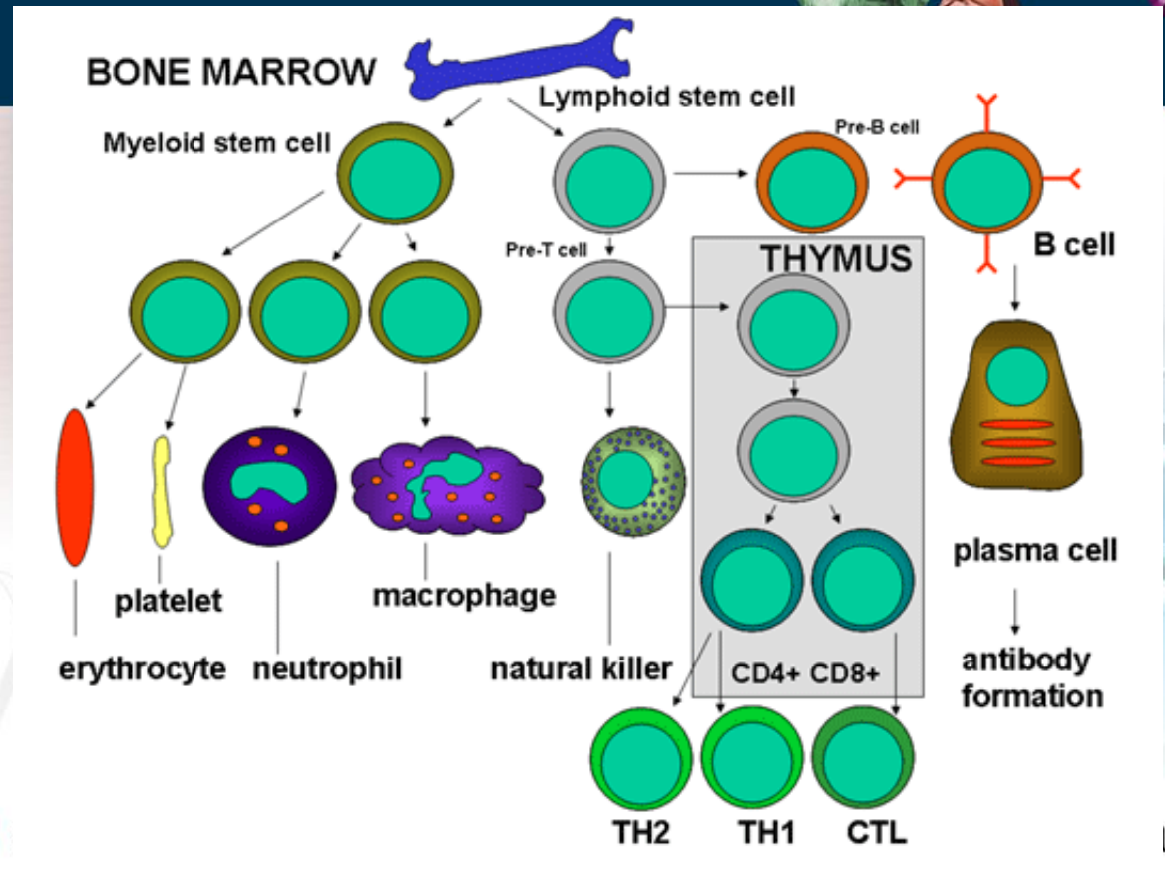
Where do immune cells come from?

Humoral Immunity (production of antibodies)
- Circulating antibodies
- Antibody: protein that binds to a substance (its antigen)
  - Igs or immunoglobulins
  - Produced by B-lymphocytes upon stimulation from antigen presenting T-cells
  - Recognize toxins, capsules, some viral proteins
- Antigen (foreign to the body)
  - “Non-self”
  - Protein, glycoprotein, lipoprotein, polysaccharide
  - What structures could be “antigenic” in a bacteria? Virus?
Antibody Binding: how does it occur?
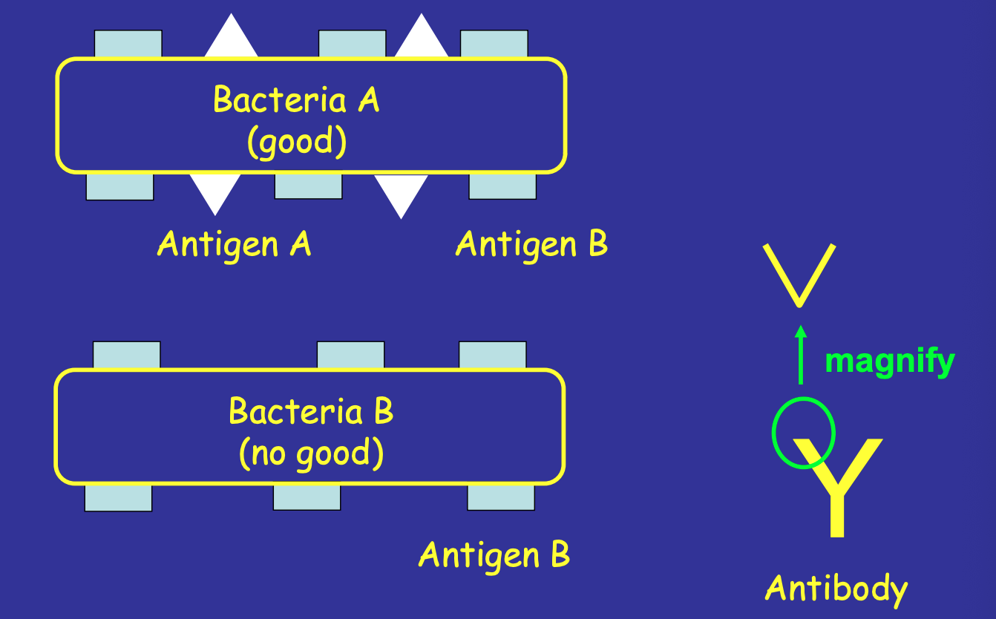
Specific receptor for antigen on the end of the antibody - therefore will only recognize bacteria A
Binding does not kill the bacteria
Molecules start clumping the bacteria together (“choking the bacteria” - takes a few days to weeks to kill the bacteria from this cross-linking)

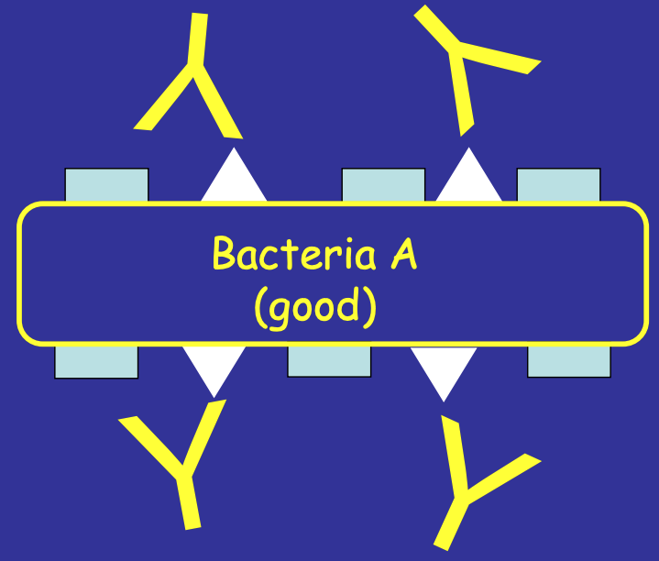
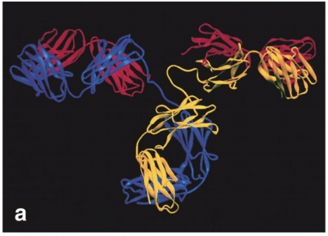

Immunoglobulins (Igs) a.k.a. Antibodies
- Antibody: Ig produced in response to stimulation by an antigen and reacting specifically with it
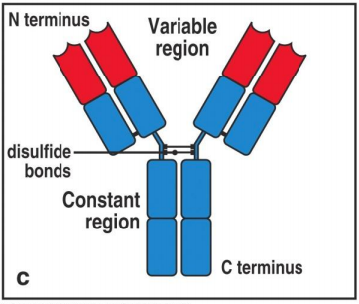
- Distinguish “non-self” from “self”
- Constant and variable region
  - Variable region is responsible for antigen recognition

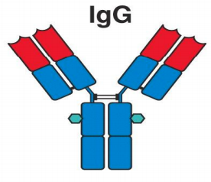
Classes of Igs
- 5 classes: IgG, IgA, IgM, IgE, IgD
- IgG
  - Host defense
  - Crosses placenta and protects newborn (only Ig that can do this)
- IgD
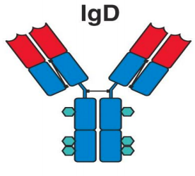
  - Role is unknown
- IgA
  - Host defense
  - Much more effective than IgG and IgD
  - Found in secretions
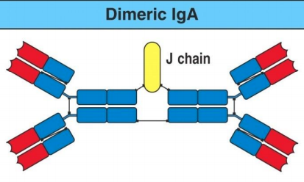
    - Tears, saliva, milk, respiratory, GI and genitourinary tract
  - Dimer
- IgM
  - Host defense
  - Early immune response
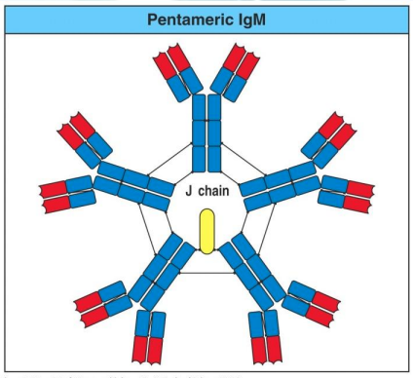
  - Pentamer (much more effective than previous - kills bacteria much quicker with a greater amount of “prongs”
- IgE
  - Hypersensitivity (allergies) - things that cause reactions
  - Defends against parasites
1º and 2º Immune Response
- 1º Response
  - Ab production triggered on first antigen introduction
  - Latent period of several days
  - Circulating antibody detectable after 5-10 days
  - Antibody in serum is maximum at ~21 days, then drops to low levels
- 2º Response (much faster - no latent period)
  - Basis for Immunizations (tricks your body after having first exposure)
  - Occurs when Ab is introduced 2nd, 3rd, 4th time
  - More efficient each time that your exposed
  - Lag, rapid Ab increase (2-3 days), slow decrease
  - Booster injections to maximize Ab levels
  - Possible to get “life-long protection” to a disease after having been exposed to that disease
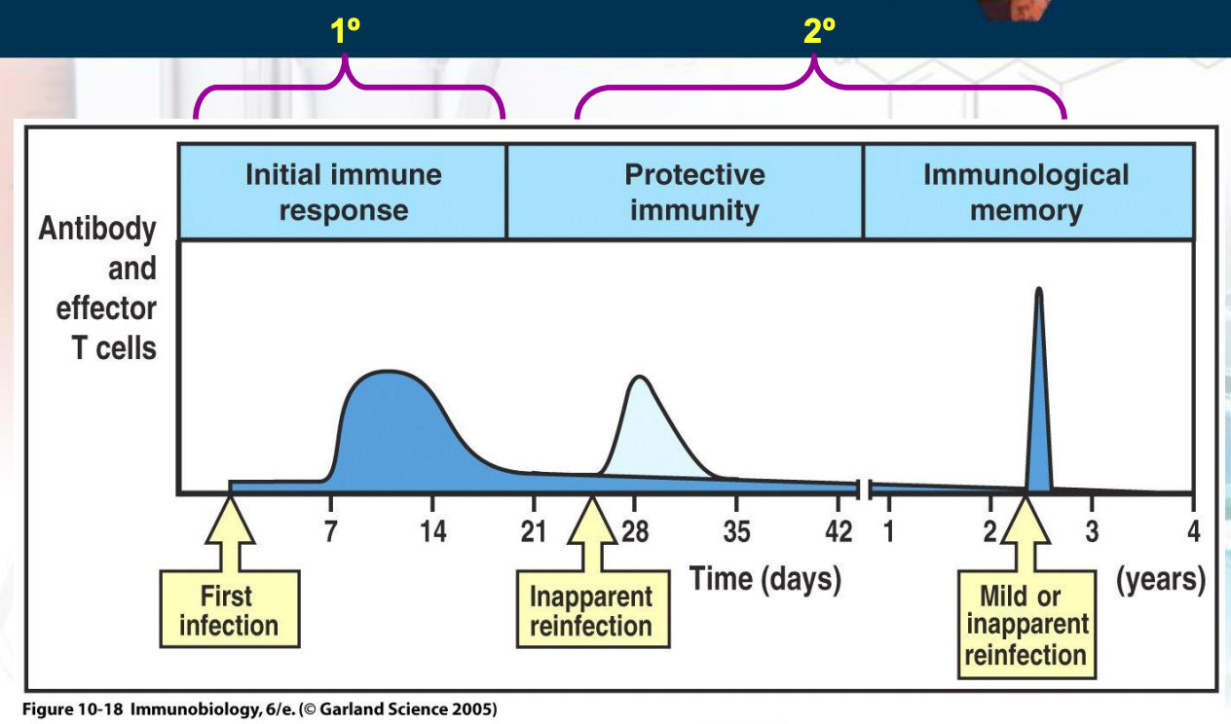
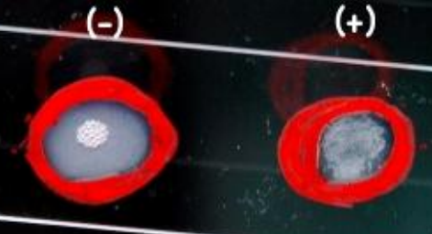
Antibody Detection
- Serological Reaction
  - Detects presence of antibodies in serum sample
  - Antigen and antibody interact: agglutination
  - If the antibody (specific to the antigen their looking for) binds to an antigen we can tell that this antigen is present and we know that this disease is present in the patient
  - Antibody titration (measure how much antibodies there are)
    - take blood - dilute the blood - drop IN antigens, see how many antibodies there are come back 2 days later if the amount of antibodies goes up there is an infection going on
  - Detect unknown microorganisms using known antisera
Cell-Mediated Immunity (CMI)
- T-cells NOT antibodies!
  - Helper, suppressive, cytotoxic (killer) generated from memory T-cells
  - Have a way to recognize a host cell that has been infected
- Immune system will fail to get rid of the parasite if there is no CMI (viruses / parasites)
- Exposure to antigen induces response from trained T-cells
- Essential for defense against intracellular organisms, parasites, tumors and other foreign cells (i.e., transplants, grafts)
- Immune-suppressive medication for transplant recipients
Disorders of Immunity
- Allergy and Hypersensitivity
- OVER-reaction to antigens in absence of true infection
- Can be fatal… ANAPHYLAXIS
- Auto-immune diseases
- Immune system reacts to its own “self” antigens
- “Auto-antibodies”
- Type 1 diabetes, MS, rheumatoid arthritis, lupus
- Immunodeficiency states
- Inability to produce antibodies and/or disfunctional CMI
- Congenital, disease, AIDS
- Graft rejection
- NORMAL immune reaction to “non-self”
- Control by immune-suppressive medication
Immunization
- Passive Immunization
  - Administration of pre-formed antibody against a specific microbial agent
  - IgG animal origin: short lived, risk of hypersensitivity reaction
  - IgG human origin: short lived, no risk of reaction
  - Gamma globulin (IgG): pooled from large grouped of blood donors and has antibodies to many common infections
  - Hyperimmune globulins (IgG): specific for a particular microbe
  - Purifying of antibodies is very expensive - very rare
  - Not efficient and doesn’t last long (but it gives you some time)
- Active Immunization (e.g. flu shot)
  - Stimulates immune system by administration of antigen
  - Longer Lasting - sometimes lasts a lifetime if not we need a booster
  - Live-attenuated vaccine (sometimes not 100% so the bacteria can still be a little pathogenic)
    - Sub-clinical or mild illness mimicking the disease
    - Local (IgA) and humoral (IgG) immunity
    - Rapid immunity development
    - Serious illness in immuno-compromised individuals
  - Killed vaccines, sub-unit vaccines and toxoids
    - Antigens without infectivity (kill bacteria or takes a part of the bacteria)
    - May require boosters (may not be as effective or longer lasting)
    - Adjuvant with toxoids
    - Polysaccharide vaccines can be conjugated to protein (see conjugate vaccines)
  - Recombinant vaccines (produced in lab - purify it and make it a vaccine)
    - DNA recombinant technology
    - Attenuates microorganism
    - Hep B vaccine
  - Adsorbed vaccines
    - Vaccine mixed with inorganic salt for slower adsorption and longer-lasting immunity
    - Tetanus, diphtheria
  - Conjugate vaccines
    - Designed for poorly antigenic microorganisms
    - Conjugate antigen of interest to immunogenic, non-toxic protein
    - Haemophilus influenzae type B
  - Combined vaccines
    - For ease of administration
  - Combined Active-Passive Immunization
    - Immediate protection after possible exposure to microbe
    - Hyperimmune Igs and vaccine injected at DIFFERENT sites
    - Tetanus, Rabies, Hep B
Introduction
- The first antibiotic penicillin
  - Discovered in 1929 by Sir Alexander Fleming
- World War II
  - Penicillin used to treat staphylococci and streptococci (1946)
- How effective was penicillin?
  - Only act on bacterial cells - NEVER on human cells
- Resistance to penicillin recognized almost immediately
  - Certain strains of bacteria were resistant to penicillin
    - Resistance was a result of a genetic mutation in the bacteria (change in binding site for the antibiotic)
  - 80% of all strains of Staphylococcus aureus
  - Streptococcus pyogenes (Group A step) still treated with penicillin
  - Interestingly, penicillin has never been effective against Gm-negatives (Salmonella, Shigella, Bordetella pertussis, Yersinia pestis, Pseudomonas) - why?
    - Penicillin is effective only against Gram-positive bacteria because Gram negative bacteria have a lipopolysaccharide and protein layer that surrounds the peptidoglycan layer of the cell wall, preventing penicillin from attacking.
  - Mutation that cause resistance alone are fine
  - Mutation coupled with the use of antibiotic results in selective pressure - putting pressure on the population and give advantage to the few bacteria that are resistant
  - The more you use an antibiotic the more you give an advantage for the resistant bacteria to take over
- Late 1940s and early 1950s?
Antibiotic therapy
- ONLY use when necessary - (antibiotics only kill bacteria NOT viruses)
- Effective chemotherapy depends on selective toxicity
  - Good against pathogen, does not affect host
- Exploit pathogen processes not seen in humans
  - Cell wall, metabolism, etc.
- Knowledge of likely microorganism is crucial
  - Site
  - Organism
  - Allergy to host?
- Other considerations…
  - Route of administration
- Monitoring therapy
- Adverse effects
  - GI-tract, skin, haemopoietic system, renal system, liver
Acquired resistance
- Three major mechanisms of resistance (pg. 127 - LOOK AT EXAMPLES)
  - Alteration in drug target (change in binding site for the antibiotic)
  - Production of inactivating enzymes
  - Decreased uptake of antibiotic
Antibiotic resistance
- Resistance occurs when a susceptible microorganism is no longer inhibited by an antibiotic agent
- Many reasons why this can happen (know intrinsic vs. acquired resistance)
  - Intrinsic - characteristics of microorganism vis-à-vis antibiotics mechanism of action (inherent or “natural”)
  - Acquired (unexpected - by chance there may be resistance) - new or added (driven by two genetic processes in bacteria...mutation and selection (vertical evolution); and exchange of genetic material (horizontal evolution)
The chromosome: role in antibiotic resistance…
- Mutations lead to
  - Change it site of antibiotic target (but protein for bacterial still works fine!)
  - Regulatory genes
    - Turn on alternative path
    - Turn on efflux mechanisms
  - Change cell permeability
Post-antibiotic era: is it possible?
- With current overuse of antibiotics, we are forcing bacteria to change (evolve) in order to survive (to control resistance you must use selective pressure)
- How is this achieved/helped by us? Giving antibiotics to increase the resistance and bacteria

Decreasing antimicrobial resistance?
- Withhold antibiotics
  - Self-limited viral infections (i.e. the “common cold”)
- Use narrowest spectrum antimicrobial agents
- Base decision about broadness of empiric antibiotic coverage on severity of illness
  - Clinically stable and not at risk for significant morbidity...may be appropriate to wait culture results and MIC testing
- Prevention of infection
  - Hygiene, handwashing
- Education
  - Helps to achieve therapeutic and preventative goals
  - When are antibiotics needed?
  - How to take them? Finish the entire prescription so that the bacteria that is more resistant will also be killed off my the larger does (because thw accumulation goes up and by day 10 it will kill it all off)
  - Proper duration!!
- Earlier detection of therapeutic failure
  - Good for patients with antibiotic-resistant pathogens

