The digestive system

Two main groups of organs: Alimentary canal vs the accessory digestive organs
The organs of the digestive system fall into two main groups:
- Alimentary canal (gastrointestinal tract or gut)
Mouth, pharynx, esophagus, stomach, small intestine, large intestine
→ continuous muscular tube from mouth to anus
- Digests food
- Absorbs digested fragments through lining into the bloodstream
- Excretes end products of digestion

- Accessory digestive organs
Teeth, tongue, gallbladder, salivary glands, liver, pancreas
- All except digestive glands and gallbladder are connected to the GI tract by ducts
- Most of these accessory organs produce secretory products such as saliva, bile, enzymes to aid in the digestion of food

Food in the lumen of the GI tract is said to be outside the body, because it is open to the external environment at both ends

Relationship between digestive organs and the peritoneum
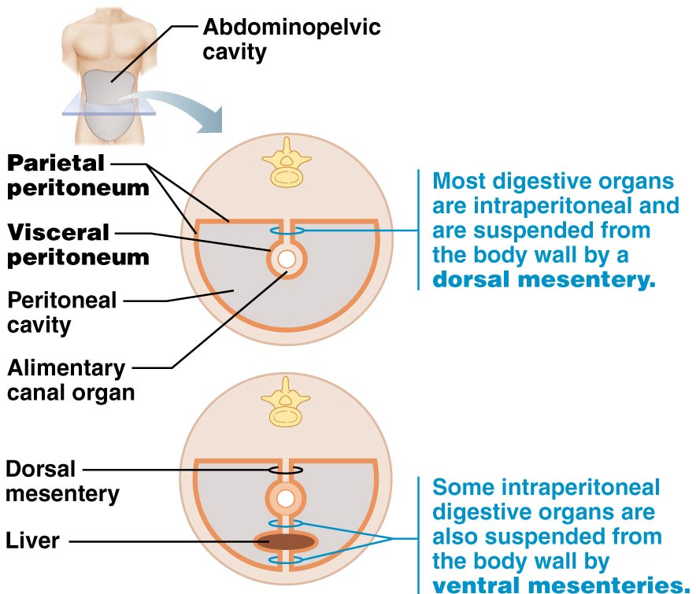
Most digestive organs are in abdominopelvic cavity which is lined with slick, friction-reducing serous membranes.
The peritoneum is the most extensive of these serous membranes:
- Visceral peritoneum: covers external surfaces of digestive organs and is continuous with the parietal peritoneum
- Parietal peritoneum: lines walls of abdominopelvic cavity

- Peritoneal cavity: slit like space between visceral and parietal peritonea- contains fluid secreted by the serous membranes. This serous fluid allows the mobile digestive organs to glide easily across one another and along the body wall as they carry out function

Mesentery: fused double layer of parietal peritoneum. Carries blood vessels, lymphatic vessels and nerves to organs of the GI tract

Most digestive organs keep a mesentery and remain in the peritoneal cavity (=peritoneal organs). Others, like the pancreas, lose their mesentery during development and come to lie posterior to the peritoneal cavity. Such organs are referred to as retroperitonea

Peritonitis
inflammation of the peritoneum
It can arise from:
  - a piercing abdominal wound
  - A perforating ulcer that leaks stomach juices into the peritoneal cavity
  - Poor sterile technique during abdominal surgery
Most commonly it results from a burst appendix that sprays bacteria- containing feces all over the peritoneum
Treatment includes removing as much infectious debris as possible and administering mega doses of antibiotics

Outline the blood supply serving the main components of the GI tract
Splanchnic circulation: includes arteries that branch off abdominal aorta to serve digesting organs and hepatic portal circulation

Arteries: hepatic, gastric, splenic, superior and inferior meserentic
Organs served: liver, stomach, spleen, small and large intestine

These arteries usually receive about ¼ of the cardiac output; this increases after a meal

venous return from much of the abdominopelvic region is via inferior vena cava. However, venous return from the digestive viscera is indirect via the hepatic portal circulation.

The hepatic portal circulation collects nutrient-rich venous blood draining from the digestive viscera and delivers it to the liver. The hepatic portal circulation is the venous portion of the splanchnic circulation.
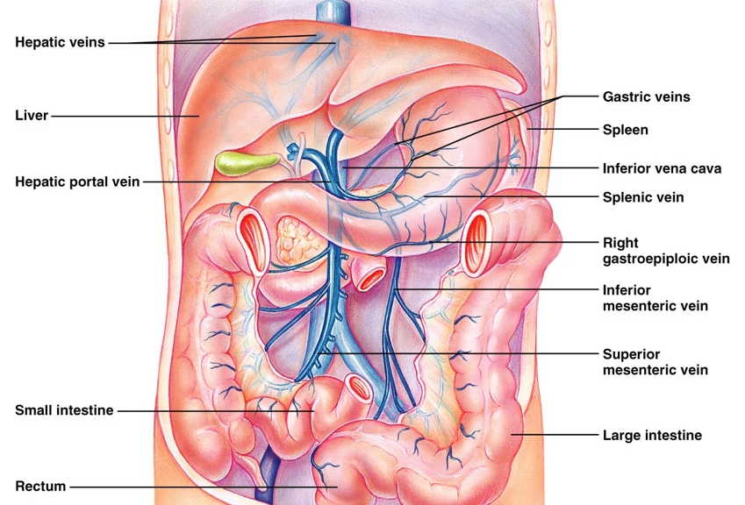

Describe the histology of the GI tract wall
Four layers are typical for most of the GI tract
Each layer contains a predominant tissue type that plays a specific role in food breakdown
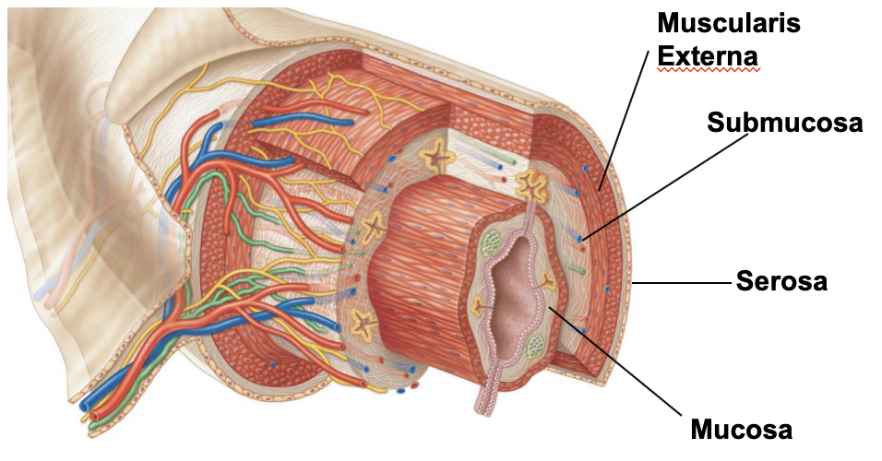

- The mucosa (innermost)
Secretions: mucus, digestive enzymes and hormones
Absorptions: end products of digestion
Protection: against infections
- The mucosa in a particular region of the GI tract may perform one or all three functions

Mucosa consists of 3 sublayers:
- A lining (surface) epithelium
Columnar epithelium + goblet cells (especially abundant in stomach) also cells that secret enzymes and hormones in the stomach and small intestine

GOBLET CELLS

- A lamina propria
Loose connective tissue with capillaries, isolated lymph nodules to help defend against bacteria and other pathogens which have free access to our digestive tract, and some bunches of these nodules (tonsils, appendix) in key areas

- A muscularis mucosae
Thin layer of smooth muscle cells- responsible only for local movements of mucosa. Also causes the mucosa to form extensive folds in the small intestine- this increases the contact of mucosal layer with food

- Submucosa
Moderately dense connective tissue layer containing blood & lymphatic vessels, lymph nodules, nerve fibers. Highly elastic which allows stomach to regain shape after large meals

- Muscularis externa
- Mixing, propulsive movements of GI tract
- Inner circular layer + outer longitudinal layer; thickens to form sphincters at organ-organ junctions. Sphincters act as valves to control food passage from one organ to the next and prevent backflow

- Serosa
Outermost, protective layer= visceral peritoneum.
Loose CT covered by a single layer of squamous epithelial cells

The esophagus (thoracic rather than abdominal cavity) is surrounded by an adventitia instead of serosa. This is a fibrous connective tissue which “bind” the esophagus to surrounding tissues.

Retroperitoneal structures have both: a serosa on the side facing the peritoneal cavity and an adventitia on the side against the dorsal body wall

Describe the functional anatomy of the mouth, pharynx & esophagus
The mouth
- Vestibule and oral cavity proper
Oral or buccal cavity; bounded by lips, cheeks, tongue and palate. The tongue is covered by a stratified squamous epithelium; epithelium on gums, hard palate and back of tongue is also modestly keratinized- for an extra protection against abrasion during eating

Lips and cheeks
- Core of skeletal muscle
  - Orbicularis oris- lips
  - Buccinators- cheeks
- Hold food in place during chewing; role in speech
- What is the red margin and why is it red?

Palate: hard palate anteriorly; soft palate posteriorly

hard palate underlain by palatine bones and palatine processes of maxillae; tongue pushes food against rigid surface during chewing

soft palate mostly skeletal muscle; closes nasopharynx when we swallow

Palatoglossal/ palatopharyngeal arches join soft palate to the tongue and oropharynx

Tongue:
Interlacing masses of skeletal muscle fibers and taste buds + some mucous and serous glands.
Important for chewing, mixing of food with saliva; forms a bolus to swallow.
Important during speech
- Intrinsic skeletal muscles: within tongue, not attached to bone, 3 planes (transverse, longitudinal, vertical); FUNCTION
- Extrinsic skeletal muscles: attach bones of skull or soft palate to the tongue; function; FUNCTION

Median septum divides tongue into two identical halves; lingual frenulum attaches tongue to floor of mouth

Four types of papillae (projections) on tongue:
- Filiform papillae: conical, contain keratin, numerous in parallel rows. Provide friction for manipulating foods
- Fungiform papillae: mushroom-shape, widely scattered, vascular core with a reddish hue; contain; contain taste buds
- Vallate papillae: V shaped row at back of tongue; like fungiform but with an additional surrounding furrow; contain taste buds
- Foliate papillae: primarily on the sides of the tongue; contain taste buds

Salivary glands:
3 pairs of extrinsic salivary glands
- Parotid glands- anterior to ear between masseter muscle and skin; parotid duct enters estivule next to 2nd molar., upper jaw
- Submandibular glands- along medial aspect of mandible; duct runs beneath mucosa of oral cavity floor; opens at base of lingual frenulum
- Sublingual glands- under tongue; anterior to submandibular glands; opens via many ducts into floor of mouth

WHAT ARE BUCCAK GLANDS

Two types of secretory cells in the salivary glands:
- Serous (watery secretion)
- Mucous (thick mucin secretion)
Proportion depends on gland

