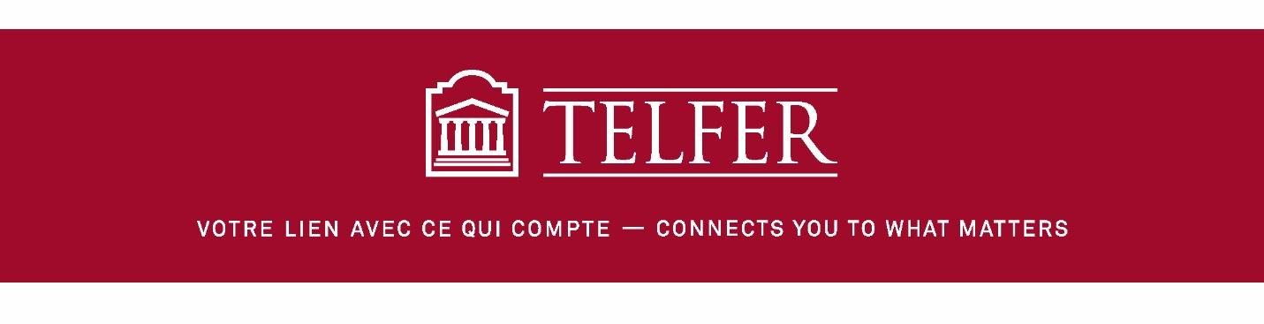

MBA5270
KNOWLEDGE AND INFORMATION MANAGEMENT
PROF. SAGAR KULKARNI

I&KM BRITISH TELECOM
GROUP ASSIGNMENT
FALL 2017

Jad Chami
Nitin Gupta
Lakshya Kapoor
Lethania Martinez

Due: Oct. 5, 2017

Contents
Overview 3
Organization’s Orientation and Strategy 3
Existing I&KM Resources 4
Articulate an I&KM Strategy 6
SWOT Analysis 7
I&KM Initiative Recommendations 8
Appendix A 9
References 10

I&KM British Telecom

Overview

For this report, we will be developing an information and knowledge management strategic plan for British Telecom (BT), a multinational communications provider headquartered in the UK. We chose this company since one of our team members has some experience working with them. The company was established in 1981 and has been at the forefront of the communication revolution, and were actually the first company to set up a nationwide communication networks. ^{[1]} We will begin this analysis by providing details regarding the organization’s strategic outlook and what existing I&KM systems are in place, to help give us a view of what our strategic plan should align with.

Organization’s Orientation and Strategy

The organization does a great job of identifying its orientation very clearly, and provides a full breakdown of what its vision, mission, objectives, and KPIs are. Here is their strategy as outlined by its most recent Annual Report (2017) and visualized by Figure 1 in the Appendix ^{[2]}.
Vision: To use the power of communication to make a better world
Mission: Growth - to deliver sustainable profitable revenue growth
In order to achieve this, it has highlighted “broaden and deepen our customer relationships” as the crucial strategy path, and has set 3 main strategic objectives to go about doing that:
- Deliver great customer experience
- Invest in growth
- Transform our cost

Knowing these objectives, it set 4 KPIs, with revenue, share returns, and cash flow being financial, and improving customer service (measured with Right First Time %) as the customer KPI. This combines their mission statement of continued financial stability with its strategy of focusing on customer relationships as the foundation.
To implement its strategy, the organization dedicated resources on the community and environmental impact it can achieve by providing products and services that can enable individuals and communities to have access to the best communication infrastructure available, thus equipping them with the tools they need to feel empowered. Being heavily involved in communities helps build trust and create shared value. The organization takes many initiatives in sharing its technology and resources to help increase tech literacy, raise awareness for social causes, and provide methods of communication for those in need. These all play a vital role in the company’s ultimate vision of making use of it’s resources to make the world a better place. The organization sets short and long-term initiatives of what it wants to accomplish for its KPI breakdowns of its social and financial requirements (ex. Inspire more volunteering from our employees, or setting investment ambitions) and compares past records of success/failure and monitor trends of whether the targets set are being met annually, or if changes need to be made on the long-term aspect.
As BT states in its annual report, “Everything we do influences our customers’ opinion of BT”. Therefore, they stress the importance of reflecting this throughout the entire organization, from the process of new product/service development (engineering side), to marketing and even executive level.
Organization Structure BT Group
British Telecom is a leading communication service company that has operations in 180 countries and has recently reorganized the company to six lines of business under this structure, Two line of business serve consumers, two focus on businesses and the public sector – one in the UK and Ireland markets. Finally, one globally, and two will provide wholesale services to other industry players.
- Consumer: The largest ISP in the UK, BT Consumer Corporation is going to continue to serve more than 10 million of households with a mix of superfast broadband, telephony, TV and mobile services.
- EE: Includes Orange and T Mobile is a line of business that focuses largely on the consumer market. Line of business that serves its customers with advanced mobile services, broadband and TV. Emergency Services Network contract was awarded to EE late in 2015 and is also part of their portfolio of business.
- Business and Public Sector: This is a new division with around £5 billion of revenues a year and it focuses in the UK and Ireland markets.
- Global Services: Serves the communications needs of multinational companies and financial services organisations. The Global Services headquartered are located in the UK and some other offices in different multinational locations across the world.
- Wholesale and Ventures: The division provides wholesale services to more than 1400 communications providers and some specialist businesses.

- Openreach: It provides all companies with access to the British Telecom’s local network in UK and is heavily regulated with more than 90 per cent of its revenues coming from price regulated services.

Existing I&KM Resources

In this section we are going to discuss the current Information and Knowledge management systems used by BT.
- CRM: Customer Relationship Management
British Telecom recently upgraded their CRM applications. They moved from major CRM giants like SAP Salesforce, Siebel to SugarCRM. Their customer service mechanisms such as cloud contact centres, contact recording and analytics, inbound services, onsite contact centres, self-service and queue management platforms, calls & line services, etc. are all integrated with SugarCRM.
- ERP: Enterprise Resource Planning
Oracle e-business suite is the enterprise wide ERP system of British Telecom. HR information comes from SAP successfactor, CRM information comes from SugarCRM. These are then integrated with Oracle EBS. BT’s general ledger, accounts payable, projects and expenditures, fixed assets,etc. resides in Oracle e-business suite.
- Human Resources - Hire to Retire
Talent Acquisition: Marketing and talent tapping for resources are done via varied sources viz a viz social media, referral programs, job portals, university job fairs and of course BT career site. BT uses Taleo tool for saving profiles, hiring and onboarding process. It enables them to keep a repository of all the candidates along with their skill sets. The toll helps in efficient and quick talent tracking and hiring.
Employee Core Data: Once the employee joins the organisation, he/she is tagged to an assignment. BT uses SAP successfactor for employee assignment. This tools enables HR to tag employee to a particular department, job, designation, location, billing project, primary line manager, HR manager, etc.
Employee Performance Evaluation: BT uses SAP Successfactor for talent management. The organisation opens mid-year and year end reviews for tracking employee’s performance and hence awarding bonuses. All employees are required to set their goals during the goal setting period. The employees are reviewed on department level competencies and the set goals. Final rating are then provided and stored in the system based on reviews. These remain in the system for reporting and other compensation decision needs.
Benefits and Leave management: BT uses SAP Successfactor benefits and leave management systems. Using these tools, employee can apply for leaves, accrue leaves, etc. Employee's manager receives notification for leave approval, has option to approve/reject leave, can view employees leave history, generate reports for his direct and indirect reports, etc.
Using Benefit management, benefit administrator configures different programs and plans for employees in different legal entities. Employees assigned to relevant legal entities can log into the system and chose relevant benefit plans, create their life events, etc.
Employee Exit: BT has a third party form for employee resignation. This form is accessible from the organization network homepage. The form captures basic details for resignation, calculates last working date of employee, and notifies manager by picking assignment data from success factor ERP. Once the resignation is accepted, data flows into SAP Success factor and employee's last working date is stored in the assignments. In case of employee retention, another form pushes the data into ERP to revoke the termination.
Release Process: As employee moves closer to his/her last working day, notifications are triggered to various departments for clearance such as IT, finances, etc for smooth exit process.
- Data management system - Oracle Spatial Network Data Model
- Oracle 9i centralised the processing from a logistic point of view.
- It includes high performance, enterprise-scale, commercial spatial and graph database and analytics
- GIS - It supports enterprise business and business intelligence, large-scale Geographic Information Systems, and location-based services applications in the cloud on premises
- Knowledge management
- BT Academy: BT has humongous internal resources in terms of e-Library such as BT Academy through which employees can enhance their skillset related to any field.
- WebEx and Skype Meetings enable the attendees to share screens and share knowledge effectively.
- Oracle Learn is being used for sharing and storing knowledge artifacts and specifications.

Articulate an I&KM Strategy

Our approach in developing an I&KM strategy was based on the Strategic Information Systems Planning Process ^{[3]}.
By doing the above background research for BT’s orientation and strategy, as well as existing I&KM resources, we have actually completed the first 2 steps of the strategic planning process, which are:
- Strategic Business Planning (orientation and strategy)✔
- Information Systems Assessment (existing resources)✔
The next 2 steps of the process will help us articulate the strategy. This involves:
- Stating what the Information Systems Vision should be
- Setting the Information Systems Guidelines.
The final step of the process is:
- Providing Strategic Initiatives, which we will do in the final section of this report.

In order to determine our IS vision, we will use the Strategic Impact Grid methodology^{[5]}, as illustrated in Piccolo’s Information Systems for Managers (see Figure 2 in appendix). Using this tool will help identify what role I&KM systems play in British Telecom, as well as evaluating what the current and future needs should be in order to align with the company’s strategy. With BT being a telecommunications provider with a massive consumer base, it is evident that, from the 4 quadrants of the strategic impact grid (Factory, Support, Turnaround, Strategic), that BT falls in the Strategic quadrant. This means that I&KM systems are crucial for the company’s current operations, and will play a vital operation’s role in the future as well. Any downtime British Telecom's IT infrastructure has a direct impact on the services it is providing (mobile, internet, TV etc.), and will have a negative effect on the company reputation. Therefore consistent improvement to its existing information systems and integrating new systems, is a must in both todays and future market. Knowing that BT lies in the Strategic quadrant, we can now combine this with its overall strategy to determine its I&KM system vision. Therefore, the role of these systems in the organization should be to aid in improving customer relations, by helping collect, store and analyze customer data in order to have a better understanding of what customers want and provide the best products/services that fit their needs. This will help achieve the overall strategy of broadening and deepening customer relationships, with the goal of increasing sustainability of the business.
Also, to identify priority business objectives, we will use the Critical Success Factors (CSF) methodology. With CSF, we can narrow down our focus to the key areas that are important to the success of the organization, in order to determine what guidelines we should choose. Based on BT’s strategy of customer relationship focus, we propose the following business objectives:
- Improving customer satisfaction
- Strategic pricing, to stay competitive in the market while offering highest quality
- Employee engagement, since employees are on the front-line of customer interaction, it is crucial for create an atmosphere of purpose and pride
- Continued charitable and environmental work for social causes
- High availability and scalability
- Improving marketing strategies
Now that we know the information systems vision and key business objectives, the next step in the Strategic IS planning process is setting the guidelines. These will be divided into 2 parts: organizational and technical guidelines.
Organizational Guidelines
- Establishing long-term partnerships with customers (B2B, B2C)
- Setting a target for SMB acquisitions for expansion in new markets
- Facilitate knowledge transfer for new employees
- New innovations focused on reducing environmental impact
- Aligning products and services developed to future customer needs.

Technical Guidelines:
- Infrastructure must be able to meet growth of client base, as well as support advances in technology across all services offered
- Focus on CRM functionality and modules for integration to expand customer data reporting
- Data security protocols always above standards, consumer records protected at all costs
- Prioritize speed of network for both hardware and software components

Current vs. Future I&KM systems strategy:
These guidelines apply to both current and future needs. Currently BT has most I&KM systems in place, but because it operates in such a constantly changing and innovating market which is telecommunication, being proactive in planning for the future is demanded in order to remain a sustainable industry leader. Therefore flexibility of infrastructure, long-term partnerships, and adjusting for environmental impact may be more for setting the foundation for the future, whereas targeting acquisitions, facilitating knowledge transfer, and data security have more of a current application.

SWOT Analysis

Strengths  - Market dominance and brand recognition as a leading telecommunication provider worldwide  - Received Knowledge management Recognition by KPMG in 2000  - Diversified revenue sources of 24 billion pounds  - Adaptability to innovation  - Global expansion techniques through acquisitions | Weaknesses  - Lack of a Single Customer Review module in CRM system  - Inefficient Document Management System.  - Lack of standard processes across the organization.  - Legal issues resulting into additional costs.  - Still offering fixed-line service
Opportunities  - Reliance of IT in today’s environment, broadband solutions  - Advancing Big Data technologies  - Future of Web and Semantic Intelligence  - IoT possibilities  - Cyber Security | Threats  - Dependency on third-party providers  - Legislation or Regulations changes  - Phishing/Customer Data Leaks/ Hacks  - Potential risk of dip in share value

I&KM Initiative Recommendations

Based on our guidelines and SWOT analysis, we have divided our initiatives into 2 categories: Customer Centric, and Learning & Development.
Customer Centric Strategies
- Implement a system to understand customer behavior, perform customer sentiment analysis and perform market segmentation based upon demographics, geography and then tailor the solutions based on the analysis. This will:
  - Improve the NPS (Net Promoter Score)
  - Enable the organization to lower the customer attrition rate.
- Improve the current CRM to add one module for individual customer profiling details. This has came across as one of the weakness due to which the customer details are not extracted in an efficient manner.
- Return to review financial KPIs in order to provide a foolproof pension deficit resolution. (Kaplan’s Balanced Scorecard)^{[6]}A lot of problems regarding the employee pension has been encountered in the quarterly financial report which needs to be resolved.
- Improve the customer service experience by enhancing the document management system. This is vital as the current system is not streamlined due to bottlenecks in knowledge transfer among two employees at different locations.
- Migration to a cloud management system to
  - increase the flexibility
  - reduce the turnaround time for customers
- Introduce customer loyalty programs and incentivize them in case someone switches to BT network. This will:
  - increase the market acquisition rate
  - make the customers feel special and valued
Learning and Development Strategies
- There should be customized trainings based upon a particular group of clients/projects in order to prevent the same process being followed for different kind of problems.
- Share and spread the organizational/executive strategy at the transactional level. (Tesco’s steering wheel)^{[7]}
- Security - Develop cyber security capability in order to prevent the data, information and various other Phishing email attacks.
- Reduce Rework - Analyse the areas/projects in which Rework is consistently prevailing, and redesign the process or approach used for those kind of cases.
  - This will improve the profitability by reducing customer complaints.
- A face to face employee and customer interaction should be bolstered to explicitly discuss the requirements.
  - Helping to deliver a positive customer experience.

Implementing these initiatives, which are now aligned with its strategy of improving customer relationships, will help BT in its mission to achieve sustainable profitable revenue growth, and eventually its vision of making the world a better place through the power of communication.

Appendix A

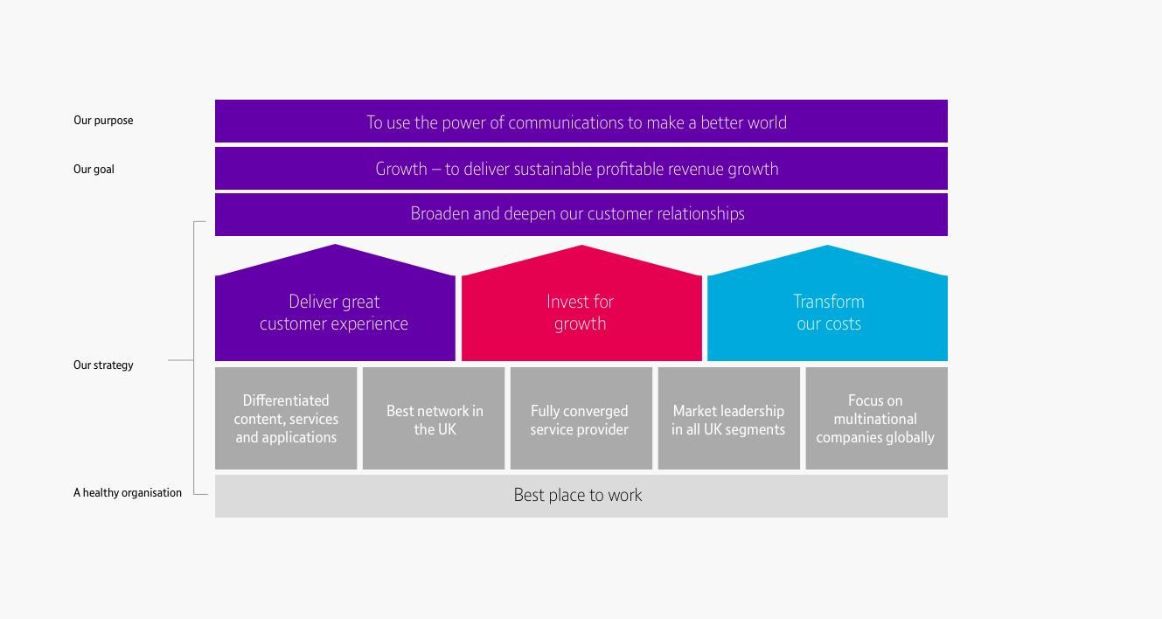
Figure 1- Visualization of BT vision, mission, and strategy objective

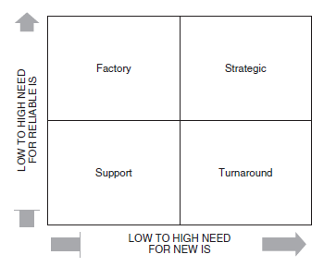
Figure 2- The Strategic Impact Grid

References

[1] “Our History”, BT plc, Retrieved on Sept 27, 2017 at http://www.btplc.com/Thegroup/BTsHistory/index.htm
[2] “BT Group plc Annual Report and Form 20-F 2017”, BT Group plc, Retrieved Sept 27, 2017 at http://www.btplc.com/Sharesandperformance/Annualreportandreview/pdf/2017_BT_Annual_Report.pdf
[3] “Information Systems for Managers: Text and Cases”, 2nd ed.” Gabriele Piccoli, John Wiley & Sons, 2012, pp. 196-209.
[4] Ross, Jeanne W., and Weill, Peter (2002). “Six IT Decisions Your IT People Shouldn’t Make,” Harvard Business Review, November, pp. 84–92.
[5] Nolan, Richard, and McFarlan, F. Warren (2005). “Information Technology and the Board of Directors,” Harvard Business Review, 83, no. 10 (October), pp. 96–106.
[6] Kaplan, Robert S., & Norton, David P. (2007). Using the balanced scorecard as a strategic management system. (Managing for the Long Term: Best of HBR)(Reprint). Harvard Business Review, 85(7 8), 150.
[7] Marr, Bernard (2009). Delivering Success: How Tesco is Managing, Measuring and Maximising its Performance. Accessed on Sept. 18, 2017 at: http://www.ap-institute.com/perfomance-management-case-studies.aspx

[8] CommsBusiness UK, (2016). BT Announces New Organisational Structure. At http://commsbusiness.co.uk/news/bt-announces-new-organisational-structure/

