Extraction

CHM 1311 - Lab B04

Ethan Chan

TA – Vanessa Suseuk

300018027

Wednesday, February 28th, 2018

Experiment 3: Extraction
Procedure: For the procedure of the distillation experiment, refer to page 32-33 of the CHM 1321 lab manual and pages 28-32 for additional background information on distillation (CHM 1321 Introductory Organic Chemistry Laboratory Manual 2017, Dr. William Ogilvie and Dr. Tony Durst, 2017, Exp.1 p.28 to 33).
There were no modifications done to this experiment.
Observations:
1-Butanol – Transparent and colourless compound with a strong smell
Benzophenone – Small white crystals that are odourless and dissolve in dichloromethane
Biphenyl – Small white crystals that are odourless and dissolve in dichloromethane
Crystal Violet – Strong purple colour that is a translucent solution
Dichloromethane – Transparent and colourless compound with a faint smell
Ether – Transparent and colourless compound with a strong smell
2:8 Ethyl Acetate and Hexanes – Transparent and colourless compound with an extreme smell
Hydrochloric Acid – Transparent and colourless compound with a faint smell
Methyl Red – Crimson red colour that is an opaque solution
Methylene Blue – Dark blue colour that is a translucent solution
Sodium Chloride – White solid crystal without a smell
Sodium Hydroxide – Transparent and colourless compound that is odourless
Unknown Sample #2 – White and thin flaky crystals that is odourless
Water – Transparent and colourless compound with no smell

Part A

Extraction of water soluble dyes
After the three solutions (ether, distilled water and methylene blue) were mixed together in a test tube, two layers are formed
Two layers were created, water at the bottom (aqueous phase) and ether at the top (organic phase)
This is determined by adding water to the test tube to see which layer would increase
When methyl red is mixed with the other two solutions, two layers are formed
The clear solution was aqueous (water on the bottom) and the light pink colour (ether on the top) was organic, same result
Blue dye extracts with the aqueous phase whereas the red dye extracts with the organic phase
Blue dye extracts with water because it is polar and miscible with water whereas red dye is less polar and extracts with ether

When the two test tubes were mixed together, none of the phases were changed
The solvents were the same in both test tubes so extraction will be the same when shaken

Salting Out
Used approximately 1g of NaCl
In both test tubes, the violet dye was strong
When salt was added to one of the test tubes, the violet dye rose up
Violet dye rose to the organic phase because the salt saturated the aqueous layer
In the unsalted mixture, the violet dye was vibrant in both layers
The cause is due to violet dye being miscible in both phases

Part B
0.90 g of Unknown Sample #2

Dichloromethane and sodium hydroxide were both used in this extraction process
Dichloromethane is the organic phase and sodium hydroxide is the aqueous phase
The sample is extracted into the aqueous phase, which caused the phase to be a bit less transparent
Dichloromethane is more polar than sodium hydroxide
The sample is not as polar as dichloromethane and is extracted into the sodium hydroxide
Hydrochloric acid is added to the aqueous to assist in creating the precipitate
The flask is also heated up to assist in creating the white precipitate
After cooling the sample, the final mass was 0.07 g

TLC Plates
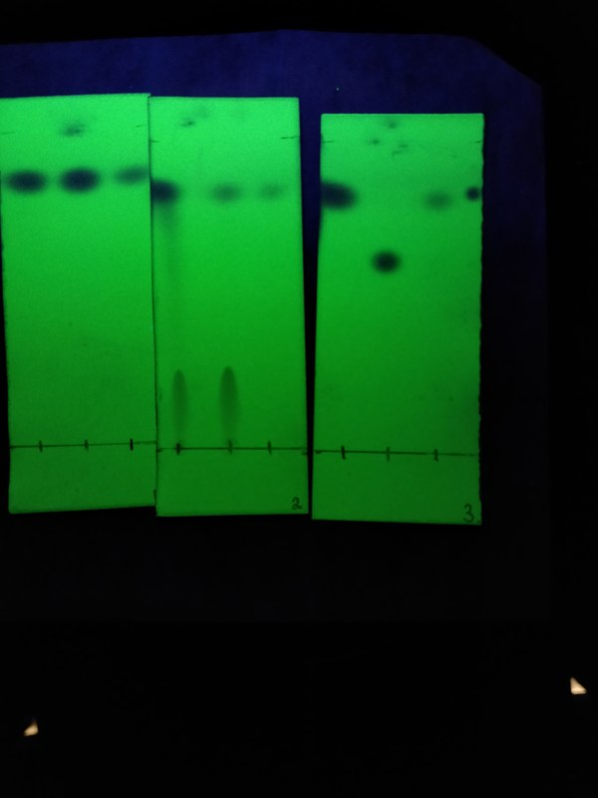
Reference: Unknown Sample #2
Co-Spot: Unknown Sample #2 and Organic phase
Sample: Organic Phase
Rf value (Reference): 0.87
Rf value (Co-spot): 0.87 and 1
Rf value (Sample) : 0.87

Reference: Unknown Sample #2
Co-Spot: Unknown Sample #2 and Aqueous Phase
Sample: Aqueous Phase
Rf value (Reference): 0.23 and 0.85
Rf value (Co-spot): 0.23 and 0.85
Rf value (Sample) : 0.85

Reference: Biphenyl
Co-Spot: Benzophenone
Sample: Unknown Sample #2
Rf value (Reference): 0.83
Rf value (Co-spot): 0.58
Rf value (Sample) : 0.83

Rf Calculation
In TLC Plate #1, the endpoint of the reference was at 5.8 cm and the endpoint of the solvent was at 6.7 cm

Rf value = endpoint reference/endpoint solvent
Rf value = 5.8 cm/6.7 cm
Rf value = 0.86567
Rf value = ~0.87

Flow Chart
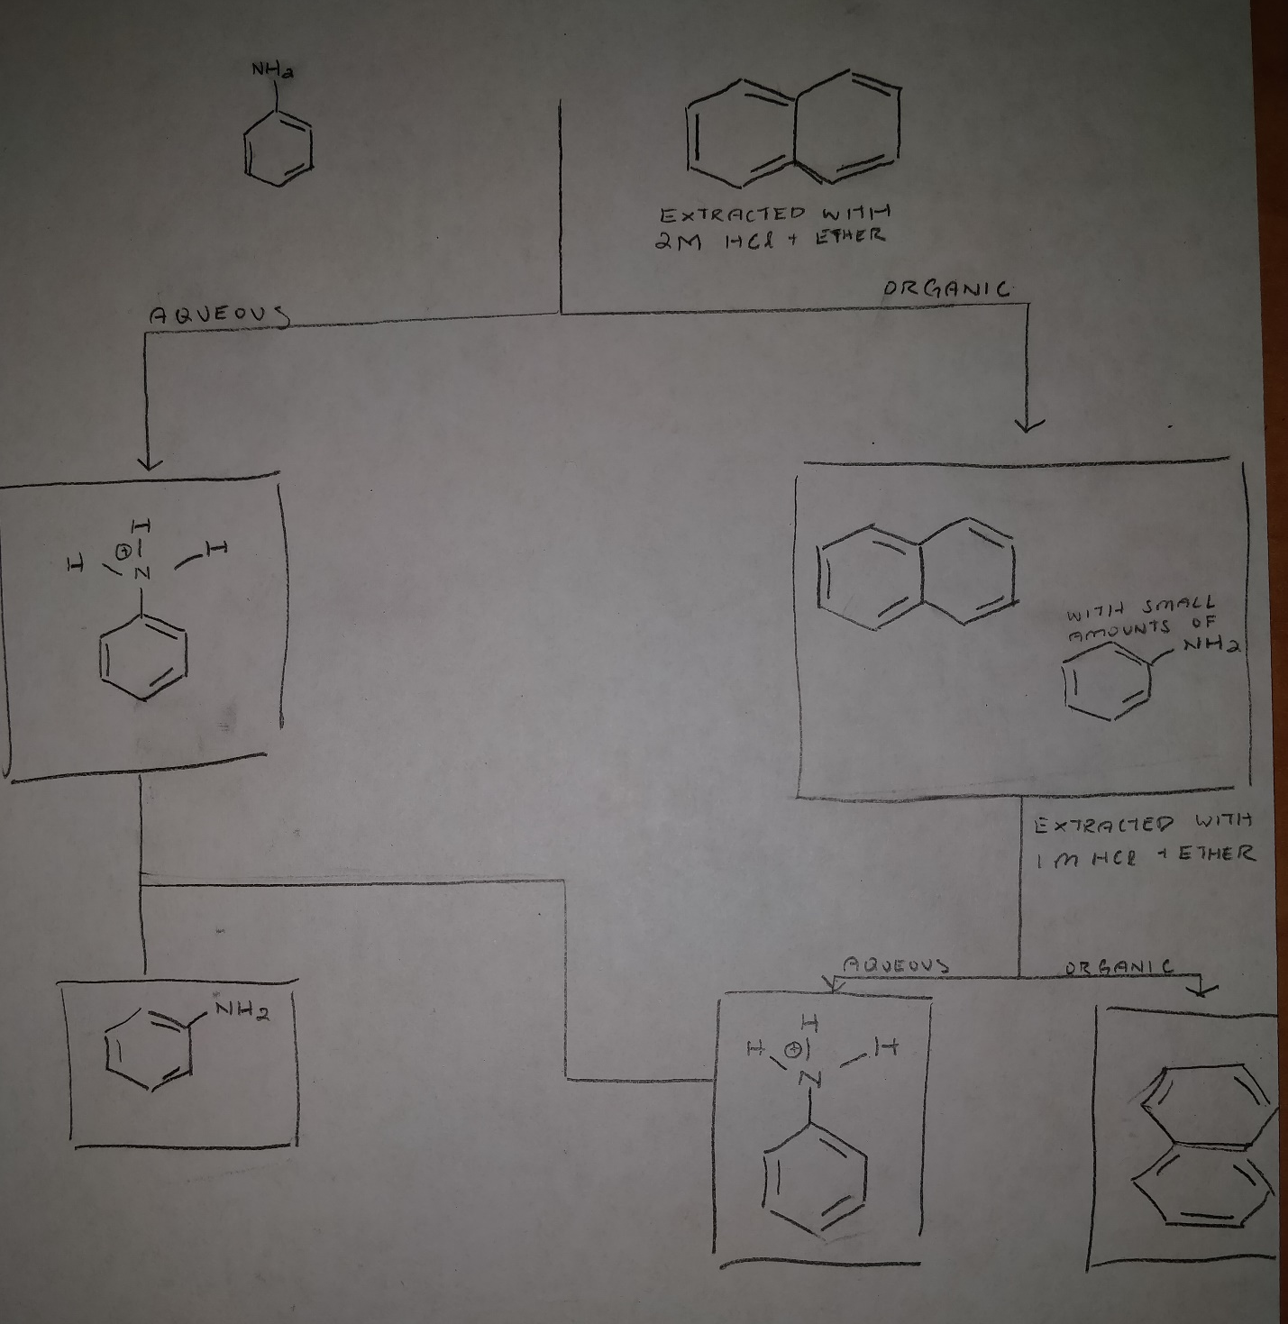

Results

 | Initial Mass | Obtained Mass | Composition | Percent Yield
Unknown Sample #2 | 0.90 g | 0.07 g | Biphenyl | 7.78 %

Percent Yield Calculation

Yield for Sample #2
Percent Yield = Actual/Theoretical x 100%
Percent Yield = 0.07g/0.90g x 100%
Percent Yield = 7.78%

Discussion

Justification
Part A
The methyl red the methylene blue separation is demonstrating the difference in polarity or miscibility of these solutions in a solvent
Methyl red was less polar than the methylene blue, resulting in methyl being extracted in ether
Methylene blue was extracted into the water because it was more polar

When mixed, the extracted compounds did not change phases because as stated earlier, the solvents remained the same
The volume changed, but this does not affect the change in phases

During the part of the experiment where salt was incorporated into a test tube, the purpose was to determine the reaction to the solution since both were originally the same
Crystal violet is miscible in both ether and water, which would explain why both test tubes were storing violet solutions
The salt added pushed the violet dye into the organic phase
This occurred because the over saturation of the salt in the solution does not allow the violet dye to dissolve in water
The dissolved salt took all the space in the water which causes the dye to go to the organic phase (ether)
The excess salt was left at the bottom of the water since the water was already saturated with the dissolved salt

Part B

In this section of the lab, the second unknown sample was taken
A separatory funnel was used to extract and purify the unknown sample
Solutions such as dichloromethane and sodium hydroxide were used to purify the unknown sample
This was done multiple times to make sure the purity level was higher
After the sample was heated up and dried, the precipitate was left to be used
The percent yield was calculated and was found to be around 8%, a lot lower than expected
TLC plates were then used to determine what the unknown sample was
Benzophenone and biphenyl were used as references to determine whether the unknown sample was one of them

Analysis

According to the results, the percent yield was extremely low
Even though TLC plate 3 provided the answer for which unknown the sample was, not a lot of precipitate was found to determine this
The unknown sample was determined as Biphenyl, since the rf values matched on the TLC plate
Biphenyl is found to be very nonpolar and will not dissolve in water but in hexanes
Since it is nonpolar, it is expected that biphenyl would extract into the aqueous solvent, sodium hydroxide
During the separation, the precipitate was collected, and the initial mass of 0.90 g dropped to 0.07 g
The theoretical mass should have been the final mass, but due to many errors, the final mass was very different, resulting in an 8% yield

Errors

One of the huge mistakes in this lab was when the precipitate was stuck in the flask
More than half the precipitate could not be retrieved, which causes the percent yield to be found inaccurate
Even though the percent yield was inaccurate, this does not affect the TLC plates
The droplets onto the reference, co-spot and sample area were not consistent throughout the TLC plates
Human error was in play since two different people were doing the spotting and this results in a higher chance for inconsistency
The result was that the TLC plates were not very clean, even though they were readable
During the filtration duration, some of the gas might not have been released during the agitation of the solution in the separatory funnel
Many small inconsistencies would cause the percent yield to decrease
Without these mistakes, the result would have been closer to the theoretical yield

Questions

- Why would it be difficult to perform an extraction using ethanol and water?
A: Since ethanol is miscible in water, the organic solvent and the aqueous solvent would bind together and there would be no clear layers

- Would adding NaCl to a test tube containing water, ether and methylene blue increase or decrease the amount of dye in the aqueous layer?
A: The addition of salt into the system would decrease the amount of methylene blue because the over saturated water from the salt pushed the methylene blue out of the aqueous phase and into the organic phase. The salt will dissolve instead of the dye.

- Compound Y has a solubility of 2.0g/100 mL in water and 20.0 g/100 mL in ether. What mass of compound Y would be removed from a solution of 1.8 g of Y in 100 mL of water by a single extraction with 100 mL of ether?
A: The mass from water to ether increases by ten. Therefore the mass of Y will turn from 1.8 g to 18g.

- What mass of compound Y would be removed from the original water solution in Question 3 by two extractions using 50 mL of ether each time?
A: The mass would still be 18g. The extractions are done so 50 mL + 50 mL still equals 100 mL. 9 grams of Compound Y will be taken each extraction.
- During an extraction a student loses track of which layer is the organic layer. How could she determine which layer is the aqueous phase?
A: You can add water to the separation system and watch which layer increases in volume. The separation line will be visible, and you can use this to determine where the water went and find the aqueous layer.
- Describe how you would separate a mixture of benzyl amine (an organic base) and naphthalene. Both compounds are insoluble in water and soluble in ether.
A: Since benzyl amine is a base, the addition of an acid will create a salt that is miscible in water and ether. The benzyl amine would then be able to be extracted into the aqueous phase while the naphthalene would remain the same in the ether.

Raw Data



