PSY3109
Social Motivation WEEK 2
Brain Elements
Three Principles
- Brain structures generate specific motivational states.
- Biochemical agents (neurotransmitters) stimulate these brain structures.
- Day-to-day events stir these NTs into action.
- Food deprivation (environmental event) -> ghrelin production (biochemical) -> brain structure (stimulation of hypothalamus) -> aroused motivation (hunger).
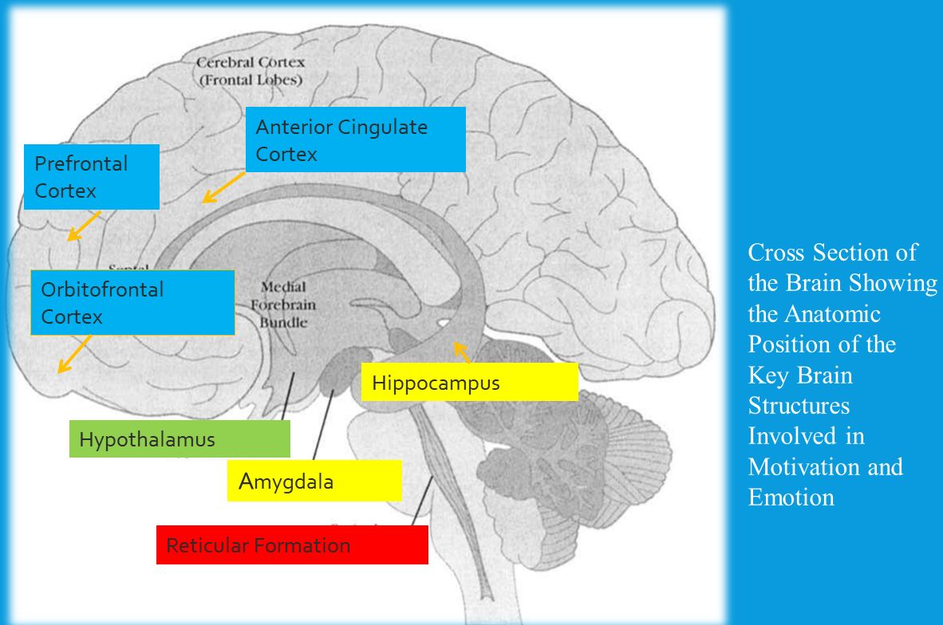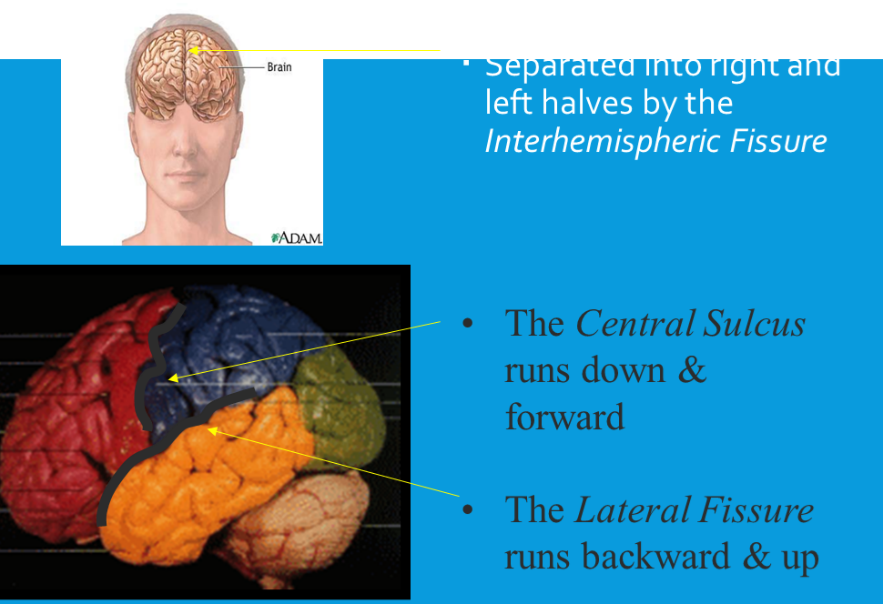
FRONTAL LOBE:
  - Thought
  - Voluntary movement
  - Speech
TEMPORAL LOBE:
  - Memory
  - Auditory function
PARIETAL LOBE:
  - Sensation (touch, pressure, pain, temperature, texture)
  - Position/spatial orientation
OCCIPITAL LOBE:
  - Vision
  - Visual processes (reading)
MEDULLA:
  - Respiration
  - Heart rate
  - Continuous with spinal cord (2.5cm)
CEREBELLUM:
  - Large muscle coordination
  - Balance (walking, writing)
PONS:
  - Relay btwn cerebral hemispheres and cerebellum
LIMBIC SYSTEM:
  - Attention
  - Sensory gateway
  - Memory processing
  - Rage
  - Aggression
  - Sexuality
  - Appetite
AMGYDALA:
  - Almond-shaped
  - Major function to respond to stimuli with emotional component
  - 3 Nuclear components
    - Sensory cortices -> basolateral (attach emotion signif. To stimulus) -> limbic association cortex, prefrontal, hippocampal formation (for learning emotion significance).
    - Central Nucleus (mediates emotional responses)
    - Corticomedial nuclei (mediates behaviors triggered by olfactory stimuli),
  - Detects environment threat
  - Generates threat-elicited defensive responses (related to fear)
  - Also detects rewards
  - Impact of amygdala damage in removing fear of risk (like gambling)
BASAL GANGLIA & THALAMUS:
  - “The Brakes”
    - Modifies movement on a min-to-min basis
    - Inhibits movement
    - Coordination
  - Substantia nigra & globus pallidus energize or inhibit response
  - Caudate nucleus & putamen associated with incorp of intention and coordination of associated actions
  - All coordinate action plans with motor area
  - Thalamus regulates alertness
  - Basal Ganglia Cont.
    - Reward centre
    - Activated Ventral Striatum & Nucleus Accumbens origin of experience of reward
    - Basis for liking, wanting, preferring
    - Ventral Tegmental Area (VTA) manfactures dopamine; = reward
BRAIN REWARD CIRCUIT:
  - Stimulus to which dopamine rewards attached is evaluated and anticipated in amygdala and ventral striatum
  - Activation of VTA & Nucleus Accumbens pathway, initiates reward value experience
  - VTA & Nucleus Accumbens pathway extends into prefrnontal -> conscious experience of pleasure
  - When things are good dopamine is up, when not good go down. Essence of rewarding stimuli vs less rewarding.
HYPOTHALAMUS:
  - 20 connected nuclei
  - Regulates eating,d rinking, sex, satiety, regulates endocrine via pituitary
  - Regulates ANS
  - Generates arousal + recovery
  - Regulates body’s internal environment to adapt to external stressors
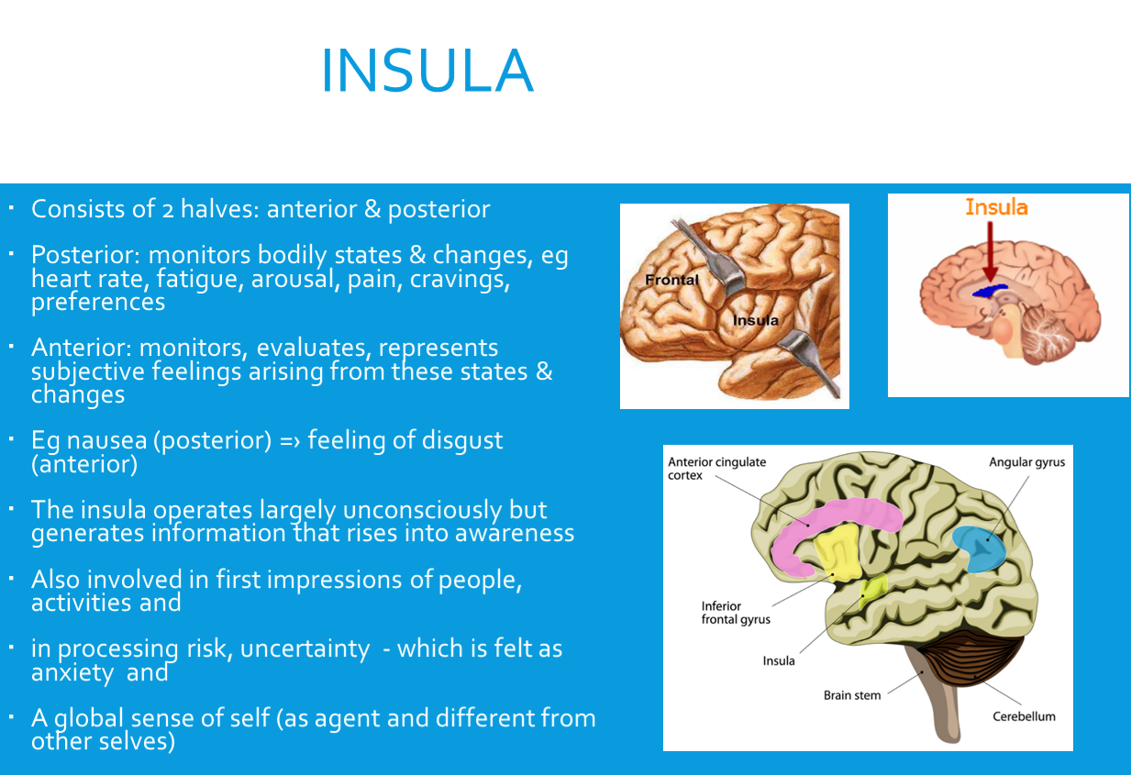
PREFRONTAL:
  - Immediately behind forehead, one on right one on left
  - Conscious emotional awareness within limbic
  - Right lobe = negative emotion + avoidance, left = positive emotion + approach
  - Associated with goals, intentions, strivings
ORBITOFRONTAL:
  - Monitors options
  - Comparison btwn past rewards
  - Inhibits inappropriate actions
  - Role in delay of gratification and self-control
VENTROMEDIAL PREFRONTAL:
  - Integrates affect-related info from sensory/social
  - Constant updates on emotions related to internal body states
  - Cognitive evaluation of emotional inputs
  - Dense bidirectional connection with subcortical brain
DORSOLATERAL PREFRONTAL:
  - Evaluates learned emotional value / meaning of enviro events and possible actions and responses
  - Involved in resisting distractions in long-term goals
  - Inhibits urge to act self-interestedly
ANTERIOR CINGULATE CORTEX:
  - Involved in cognitive control
  - Prioritizing focus of attention
  - Monitors choice, conflicts, consequence
  - Self-regulation
  - Triggers increased cognitive resources + efforts to resolve difficult or involved challenges
NEUROTRANSMITTERS:
  - SEROTONIN
    - Emotions, judgment, sleep. Depression, suicidal thoughts, anxiety, impulses, E.D.
  - GLUTAMATE/GABA
    - Most facets of brain function. Memory + sleep disturbances and anxiety. Can take valium.
  - DOPAMINE
    - Memory, mood, movement. Parkinson’s, schizo, addiction.
  - ENDORPHINS
    - Relief of pain. Can change brain stem/limbic/block pain messages which isn’t always good!
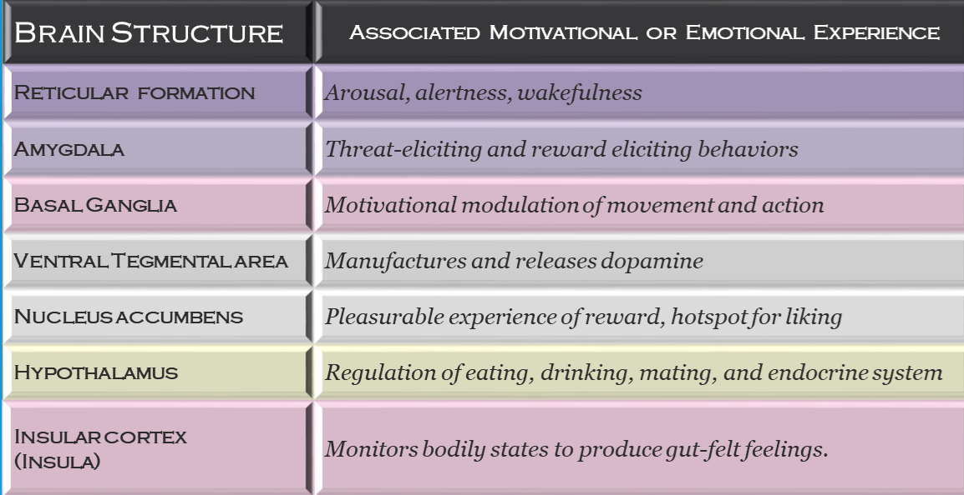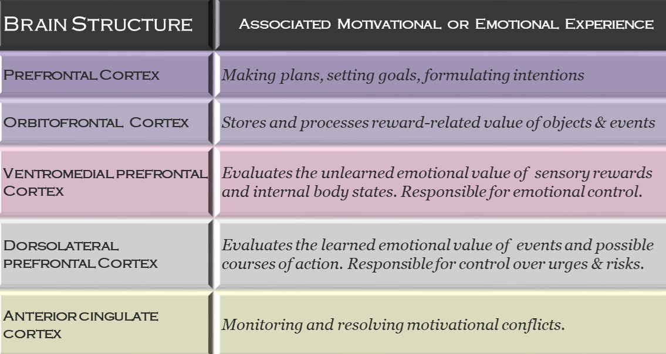
NEUROTRANSMITTER PATHWAYS:
  - Cluster of neurons which communicate w/ other neurons by using ONE particular neurotransmitter
    - Dopamine, Serotonin, Norepinephrine, Endorphin
DOPAMINE:
  - Release + Incentives: incentives trigger dopamine release
  - Release + Reward: releases teaches which events are rewarding
  - Motivated Action: activates goal-directed approach responses.
  - Addiction: addictive drugs potent reinforces because repeated usage products hypersensitivity to dopamine stim.
  - Liking + Wanting: full experience of reward, wanting + liking need to occur together.
HORMONES:
  - Cortisol (stress hormone, associated with poor intellectual functioning, poor health)
  - Testosterone (high sexual motivation, underlies mating effort)
  - Oxytocin (bonding hormone, motivates seeking counsel + support + nurturance of others during times of stress)
MOTIVATION CANNOT BE SEPERATED FROM SOCIAL CONTEXT.
ENVIRONMENTAL EVENTS ACT AS NATURAL STIMULATORS.
WE ARE NOT ALWAYS CONSCIOUSLY AWARE OF THE MOTIVATIONAL BASES!

